 | United Nations | ECE/TRANS/WP.29/2012/42
 | Economic and Social Council |  | Distr.: General  5 April 2012  Original: English
Economic Commission for Europe
Inland Transport Committee
World Forum for Harmonization of Vehicle Regulations
157th session
Geneva, 26-29 June 2012
Item 4.7.2 of the provisional agenda
1958 Agreement – Consideration of draft amendments
to existing Regulations submitted by GRSP
Proposal for Supplement 4 to the 07 series of amendments to Regulation No. 14 (Safety-belt anchorages)
Submitted by the Working Party on Passive Safety *
The text reproduced below was adopted by the Working Party on Passive Safety (GRSP) at its fiftieth session to align UN Regulation No. 14 with the provisions of draft Regulation on Child Restraint Systems (CRS). It is based on document ECE/TRANS/WP.29/GRSP/2011/22, not amended (ECE/TRANS/WP.29/GRSP/50, para. 20). It is submitted to the World Forum for Harmonization of Vehicle Regulations (WP.29) and to the Administrative Committee (AC.1) for consideration.
The title of the Regulation, amend to read:
"Uniform provisions concerning the approval of vehicles with regard to safety-belt anchorages, ISOFIX anchorages systems, ISOFIX top tether anchorages and i-Size seating positions"
The table of contents,
Insert the reference to a new Annex 10, to read:
"Annex 10 - i-Size seating position"
The text of the Regulation,
Paragraph 1, amend to read:
"1. Scope
This Regulation applies to:
(a) Vehicles…
(b) ....
(c) Vehicles of any category with regard to their i-Size seating positions, if any are defined by the vehicle manufacturer."
Paragraph 2.2., amend to read:
"2.2. "Vehicle type" means a category …, if the anchorages strength is tested according to the dynamic test, as well as the vehicle floor strength when tested according to the static test in case of i-Size seating positions, the characteristics of any component of the restraint system, especially the load limiter function, having an influence on the forces applying to the safety-belt anchorages."
Paragraph 2.17., amend to read:
"2.17. "ISOFIX" means a system….
…
(e) …
(f) or an i-Size child restraint system as defined in Regulation No. [XXX],
(g) or a specific vehicle ISOFIX child restraint system as defined in Regulation No. [XXX]."
Paragraph 2.20., amend to read:
"2.20. "ISOFIX attachment" means one of the two connections, fulfilling the requirements of Regulation No. 44 or Regulation No. [XXX], extending from the ISOFIX child restraint system structure and compatible with an ISOFIX low anchorage."
Paragraph 2.21., amend to read:
"2.21. "ISOFIX child restraint system" means a child restraint system, fulfilling the requirements of Regulation No. 44 or Regulation No. [XXX], which has to be attached to an ISOFIX anchorages system."
Paragraph 2.22., amend to read:
"2.22. "Static force application device (SFAD)" means a test fixture that engages the vehicle ISOFIX anchorages systems and that is used to verify their strength and the ability of the vehicle or seat structure to limit the rotation in a static test. The test fixture for lower anchorages and top tethers is described in the figures 1 and 2 annex 9, as well as an SFAD_{SL (Support Leg)} to assess i-Size seating positions with regard to the vehicle floor strength. An example for such an SFAD_{SL} is given in Figure 3 of Annex 10."
Paragraph 2.23., amend to read:
"2.23. "Anti-rotation device"
…
(b) … during a frontal impact.
(c) An anti-rotation device for an i-Size child restraint system consists of either a top tether or a support leg intended to limit the rotation of the restraint during a frontal impact.
(d) For ISOFIX, i-Size, universal and semi-universal, child restraint systems the vehicle seat itself does not constitute an anti-rotation device."
Paragraph 2.29., shall be deleted
Paragraphs 2.30., renumber as paragraph 2.29.
Insert new paragraphs 2.30. to 2.32., to read:
"2.30. "Support leg foot assessment volume" means the volume, as shown in figure 1 and 2 of Annex 10 of this Regulation, in which the support leg foot of an i-Size child restraint system defined in Regulation No. [XXX] will rest and therefore the vehicle floor has to intersect.
2.31. "Vehicle floor contact surface" means the area which results from the intersection of the upper surface of the vehicle floor (incl. trim, carpet, foam, etc.) with the support leg foot assessment volume and is designed to withstand the support leg forces of an i-Size child restraint system defined in Regulation No. [XXX].
2.32. "i-Size seating position" means a seating position, if any defined by the vehicle manufacturer, which is designed to accommodate an i-Size child restraint system, as defined in Regulation No. [XXX], and fulfils the requirements defined in this Regulation."
Paragraph 3.1., amend to read:
"3.1. The application for approval of a vehicle type with regard to the belt anchorages, the ISOFIX anchorages systems, the ISOFIX top tether anchorages and i-Size seating positions, if any, shall be submitted by the vehicle manufacturer or by his duly accredited representative."
Paragraph 3.2.1., amend to read:
"3.2.1. drawings of the general vehicle structure on an appropriate scale, showing the positions of the belt anchorages, of the effective belt anchorages (where appropriate), of the ISOFIX anchorages systems, of ISOFIX top tether anchorages if any and in case of i-Size seating positions, the vehicle floor contact surface and detailed drawings of the belt anchorages, of the ISOFIX anchorages systems if any, of the ISOFIX top tether anchorage if any, and of the points to which they are attached and in case of i-Size seating positions, the vehicle floor contact surface;"
Paragraph 3.2.2., amend to read:
"3.2.2. a specification of the materials used which may affect the strength of the belt anchorages, of the ISOFIX anchorages systems and ISOFIX top tether anchorages if any and in case of i-Size seating positions, the vehicle floor contact surface;"
Paragraph 3.3., amend to read:
"3.3. At the option of the manufacturer, a vehicle representative of the vehicle type to be approved or the parts of the vehicle considered essential for the belt anchorages test, for the ISOFIX anchorages systems, of ISOFIX top tether anchorages test if any and in case of i-Size seating positions, the vehicle floor contact surface test, by the technical service conducting approval tests shall be submitted to the service."
Paragraph 4.4.1.,footnote ², amend to read:
"² The distinguish numbers of the Contracting Parties to the 1958 Agreement are reproduced in Annex 3 to Consolidated Resolution on the Construction of Vehicles (R.E.3), document TRANS/WP.29/78/Rev.2."
Paragraph 5.2.2., amend to read:
"5.2.2. Any ISOFIX anchorages system and any ISOFIX top tether anchorage, installed or intended to be installed, for ISOFIX child restraint systems, as well as the vehicle floor contact surface of any i-Size seating positions, shall be so designed, made and situated as to:"
Paragraph 5.2.2.1., amend to read:
"5.2.2.1. Any ISOFIX anchorages system and any top tether anchorage, as well as the vehicle floor contact surface of any i-Size seating positions, shall enable the vehicle, in normal use, to comply with the provisions of this Regulation.
Any…"
Insert a new paragraph 5.2.2.3., to read:
"5.2.2.3. An ISOFIX anchorage system, ISOFIX top tether anchorage and vehicle floor contact surface of i-Size seating positions shall be designed for i-Size child restraint system as defined in Regulation No. [XXX]."

Paragraph 5.2.3.3., amend to read:
"5.2.3.3. For any ISOFIX anchorages system installed in the vehicle, it shall be possible to attach either the ISOFIX child restraint fixture "ISO/F2" (B) or "ISO/F2X" (B1) as defined by the vehicle manufacturer, described in Regulation No. 16 (Annex 17, Appendix 2).
i-Size positions shall accommodate ISOFIX child restraint fixtures of size classes "ISO/F2X" (B1), and "ISO/R2" (D) together with the support leg installation assessment volume, as defined in Regulation No. 16 (Annex 17, Appendix 2)."
Paragraph 5.2.3.4., amend to read:
"5.2.3.4. The bottom surface …
…
(c) Yaw: 0° ± 10°
For i-Size positions, providing the limits specified in paragraph 5.2.3.4. are not exceeded, it is acceptable for the shortest support-leg length, according to the support-leg foot assessment volume, to result in a pitch angle greater than would otherwise be imposed by the vehicle seat or structure. It shall be possible to install the ISOFIX child restraint fixture under the increased pitch angle."
Insert a new paragraph 5.2.3.7., to read:
"5.2.3.7. The requirements of paragraph 5.2.3.6. do not apply to the i-Size seating position. I-Size seating positions shall be marked according to paragraph 5.2.5.1."
Insert new paragraphs 5.2.5. to 5.2.5.3., to read:
"5.2.5. i-Size seating position requirements
Each i-Size seating position, as defined by the vehicle manufacturer, shall conform to the requirements defined in paragraphs 5.2.2. to 5.2.5.3."
5.2.5.1. Markings
Each i-Size seating position shall be permanently marked adjacent to the ISOFIX low anchorages system (bar or guidance device) of the respective seating position.
The minimum marking shall be the symbol of Annex 10, figure 4 consisting of a square with a minimum size of 13 mm and containing a pictogram and meeting the following conditions:
(a) the pictogram shall contrast with the background of the square;
(b) the pictogram shall be located close to each bar of the system.
5.2.5.2. Geometrical requirements for i-Size seating positions connected to i-Size support legs.
In addition to the requirements defined in 5.2.3. and 5.2.4. it shall be verified that the upper surface of the vehicle floor (incl. trim, carpet, foam, etc.) intersects with both of the limiting surfaces in the x- and y-directions of the support leg foot assessment volume, as shown in figures 1 and 2 of Annex 10 of this Regulation.
The support leg foot assessment volume is characterized as follows (see also annex 10, figure 1 and 2 of this Regulation):
(a) In width, by the two planes parallel to and 100 mm apart from the median longitudinal plane of the child restraint fixture installed in the respective seating position; and
(b) In length, by the two planes perpendicular to the plane given by the child restraint fixture bottom surface and perpendicular to the median longitudinal plane of the child restraint fixture, 585mm and 695 mm apart from the plane passing through the centerlines of the ISOFIX lower anchorages and being perpendicular to the CRF bottom surface; and
(c) In height, by two planes which are parallel to and 270 mm and 525 mm below the child restraint bottom surface.
The pitch angle used for the geometrical assessment above shall be measured as in paragraph 5.2.3.4.
Compliance with this requirement may be proven by a physical test or computer simulation or representative drawings.
5.2.5.3. Vehicle floor strength requirements for i-Size seating positions.
The entire vehicle floor contact surface (see Annex 10, figures 1 and 2) shall be of sufficient strength to withstand the loads imposed when tested in accordance with paragraph 6.6.4.5."
Insert a new paragraph 5.3.8.8., to read:
"5.3.8.8. Notwithstanding the provisions of paragraph 5.3.8.1. to 5.3.8.4., one or more of the mandatory ISOFIX positions may be replaced by i-Size seating positions."
Paragraph 6.6.1., amend to read:
"6.6.1. The strength of the ...
In case of ISOFIX top tether anchorage an additional test shall be performed as prescribed in paragraph 6.6.4.4.
In case of an i-Size seating position, an additional support leg test shall be performed as described in paragraph 6.6.4.5.
All the ISOFIX positions and/or i-Size seating positions of a same seat row, which can be used simultaneously, shall be tested simultaneously."
Paragraph 6.6.2., amend to read:
"6.6.2. The test may … structure.
…
The test may be restricted to the ISOFIX or i-Size position relating to only one seat or group of seats on the condition that:
(a) The ISOFIX or i-Size position concerned has the same structural characteristics as the ISOFIX or i-Size position relating to the other seats or group of seats and;
(b) Where such ISOFIX or i-Size positions are fitted totally or partially on the seat or group of seats, the structural characteristics of the seat or group of seats or floor in case of i-Size seating positions are the same as those for the other seats or groups of seats."
Insert a new paragraph 6.6.4.5., to read:
"6.6.4.5. Test for i-Size seating positions:
In addition to the tests specified in paragraphs 6.6.4.3. and 6.6.4.4., a test with a modified static force application device, which consists of a SFAD and includes a support leg test probe as defined in figure 3 of annex 10, shall be performed. The support leg test device shall be adjusted in length and width to assess the vehicle floor contact surface, as defined in paragraph 5.2.5.2. (see also figures 1 and 2 of Annex 10 of this Regulation). The height of the support leg test device shall be adjusted in a way that the foot of the support leg test device is in contact with the upper surface of the vehicle floor. In case of incremental height adjustment, the first notch where the foot rests stable on the floor shall be chosen; in case of a non-incremental/continuous adjustment of the support leg test device height, the pitch angle of the SFAD shall be increased by 1.5 +/- 0.5 degrees due to the height adjustment of the support leg test device.
The horizontal excursion (after pre-load) of point X of the SFAD during application of the 8 kN ± 0.25 kN force shall be limited to 125 mm and permanent deformation including partial rupture or breakage of any ISOFIX low anchorage and the vehicle floor contact surface, or surrounding area shall not constitute failure if the required force is sustained for the specified time."
Annex 1,
The text of the Communication, amend to read:
"COMMUNICATION
…
of a vehicle type with regard to safety-belt anchorages and ISOFIX anchorages systems, and ISOFIX top tether anchorages and i-Size seating positions if any pursuant to Regulation No. 14
…"
Item 9, amend to read:
"9. The following documents, filed with the administration service which has granted approval and available on request are annexed to this communication:
.... drawings, diagrams and plans of the belt anchorages, ISOFIX anchorages systems, of the top tether anchorages if any, vehicle floor contact surface of i-Size seating positions if any, and of the vehicle structure;
.... photographs of the belt anchorages, of the ISOFIX anchorages systems, of the top tether if any, vehicle floor contact surface of i-Size seating positions if any, and of the vehicle structure;
…"
Insert a new Annex 10, to read:
"Annex 10
I-Size seating position
Figure 1
3D view of the support leg foot assessment volume

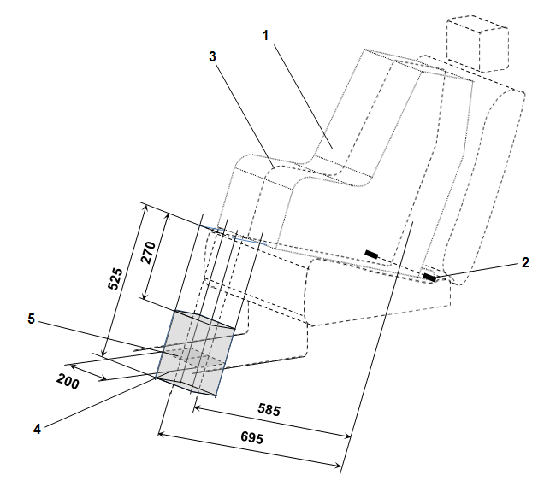

Key:
1. Child Restraint Fixture (CRF).
2. ISOFIX low anchorages bar.
3. Median longitudinal plane of the CRF.
4. Support leg foot assessment volume.
5. Vehicle floor contact surface.
Notes:
Drawing not to scale.

Figure 2
Side view of the support leg foot assessment volume

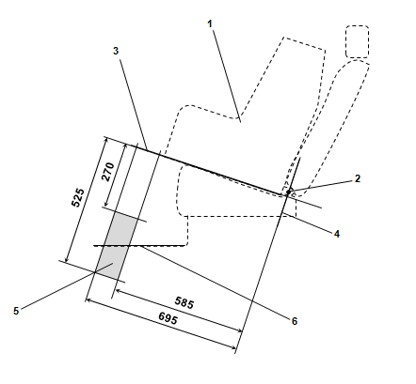

Key:
1. Child Restraint Fixture (CRF).
2. ISOFIX low anchorages bar.
3. Plane formed by the bottom surface of the CRF when installed in the designated seating position.
4. Plane passing through the lower anchorage bar and oriented perpendicular to the median longitudinal plane of the CRF and perpendicular to the plane formed by the bottom surface of the CRF when installed in the designated seating position.
5. Support leg foot assessment volume within which the vehicle floor has to be located. This volume represents the length and height adjustment range of an i-Size child restraint system support leg.
6. Vehicle floor.
Notes:
Drawing not to scale.
Figure 3
Example for a modified Static force application device with support leg test probe (SFAD_{SL}) showing the required adjustment range and dimensions of the support leg foot

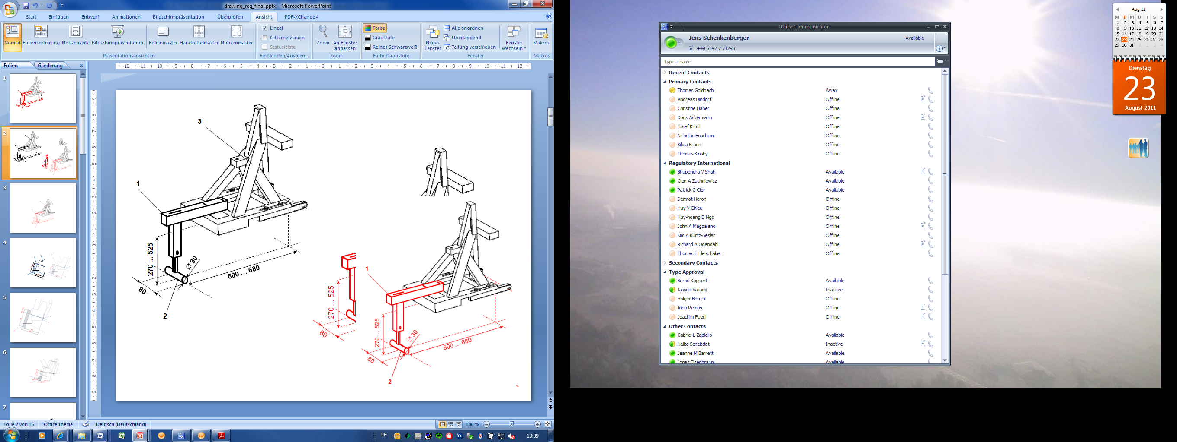

Key:
1. Support leg test device.
2. Support leg foot.
3. SFAD (as defined in annex 9 of this Regulation).
Notes:
1. Drawing not to scale.
2. The support leg test device shall:
(a) Ensure testing within the entire vehicle floor contact surface defined for individual i-Size seating positions;
(b) Be rigidly fixed to the SFAD so that the forces applied to the SFAD will directly induce test forces into the vehicle floor, without reduction of the reactive test forces due to damping within or deformation of the support leg test device itself.
3. The support leg foot shall consist of a cylinder, having a width of 80 mm, a diameter of 30 mm and on both side faces rounded edges with a 2.5mm radius.
4. In case of incremental height adjustment, the distance between the steps for adjustment shall not be more than 20 mm.
Figure 4
Symbol used to identify an i-Size seating position

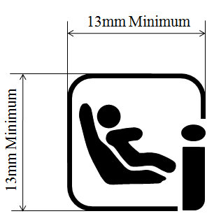

Notes:
1. Drawing not to scale.
2. Colour of the symbol is the manufacturer's choice.

* * In accordance with the programme of work of the Inland Transport Committee for 2010–2014 (ECE/TRANS/208, para. 106 and ECE/TRANS/2010/8, programme activity 02.4), the World Forum will develop, harmonize and update regulations in order to enhance the performance of vehicles. The present document is submitted in conformity with that mandate.

