 | United Nations | ECE/TRANS/WP.29/2012/11
 | Economic and Social Council |  | Distr.: General  22 December 2011  Original: English
Economic Commission for Europe
Inland Transport Committee
World Forum for Harmonization of Vehicle Regulations
156th session
Geneva, 13–16 March 2012
Item 4.9.5 of the provisional agenda
1958 Agreement – Consideration of draft amendments
to existing Regulations submitted by GRE
Proposal for the 06 series of amendments to Regulation No. 48 (Installation of lighting and light-signalling devices)
Submitted by the Working Party on Lighting and Light-Signalling *
The text reproduced below was adopted by the Working Party on Lighting and Light-Signalling (GRE) at its sixty-sixth session to cover the installation of approved exterior courtesy lamps according to Regulation No. 48. It is based on ECE/TRANS/WP.29/GRE/2011/61, as amended by Annex III to the report (ECE/TRANS/WP.29/GRE/66, para. 23). It is submitted to the World Forum for Harmonization of Vehicle Regulations (WP.29) and to the Administrative Committee (AC.1) for consideration.
Paragraph 4.2., amend to read:
"4.2. An approval number shall be assigned to each type approved. Its first two digits (at present 06, corresponding to the 06 series of amendments) shall indicate the series …"
Paragraphs 6.24. to 6.24.3., amend to read:
"6.24. Exterior courtesy lamp
6.24.1. Presence
Optional on motor vehicles
6.24.2. Number
Two, however further exterior courtesy lamps to illuminate steps and/or door handles are permitted. Each door handle or step shall be illuminated by not more than one lamp.
6.24.3. Arrangement
No special requirement, however the requirements of paragraph 6.24.9.3. apply"
Paragraphs 6.24.9. and 6.24.9.1., amend to read:
"6.24.9. Other requirements
6.24.9.1. The exterior courtesy lamps shall not be activated unless the vehicle is stationary and one or more of the following conditions is satisfied:
(a) The engine …
…"
Insert new paragraphs 6.24.9.2. and 6.24.9.3., to read:
"6.24.9.2. Approved lamps emitting white light with the exception of main beam head lamps, day time running lamps and reversing lamps may be activated as courtesy lamp function. They may also be activated together with the exterior courtesy lamps and the condition of paragraphs 5.11. and 5.12. above may not apply.
6.24.9.3. The technical service shall, to the satisfaction of the authority responsible for type-approval, perform a visual test to verify that there is no direct visibility of the apparent surface of the exterior courtesy lamps, if viewed by an observer moving on the boundary of a zone on a transverse plane 10 m from the front of the vehicle, a transverse plane 10 m from the rear of the vehicle , and two longitudinal planes 10 m from each side of the vehicle; these four planes to extend from 1 m to 3 m above and parallel to the ground as shown in Annex 13.
At the request of the applicant and with the consent of the Technical Service this requirement may be verified by a drawing or simulation."
Insert new paragraphs 12.30. and 12.31., to read:
"12.30. Contracting Parties applying this Regulation shall continue to grant approvals to those types of vehicles which comply with the requirements of this Regulation as amended by the preceding series of amendments during the 60 months' period which follows the date of entry into force of the 06 series of amendments. Existing approvals under this Regulation granted before this date will remain valid indefinitely and extensions of these approvals shall continue to be granted after.
12.31. No Contracting Party applying this Regulation shall refuse national or regional type approval of a vehicle type approved to the 06 series of amendments to this Regulation."
Annex 1,
Insert a new item 9.27. (renumber 9.27. and 9.28. as 9.28. and 9.29.), to read:
"9.27 Exterior courtesy lamps: yes/no ^{1/"}

Items 9.27. to 9.28. (former), renumber as items 9.28. to 9.29.
Annex 2, amend to read:
"Annex 2
Arrangements of approval marks
Model A
(See paragraph 4.4. of this Regulation)
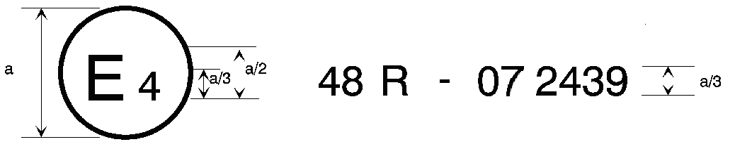
06 2439
a = 8 mm min.
The above … Regulation No. 48 as amended by the 06 series of amendments. The approval number indicates that the approval was granted in accordance with the requirements of Regulation No. 48 as amended by the 06 series of amendments.
Model B
(See paragraph 4.5. of this Regulation)
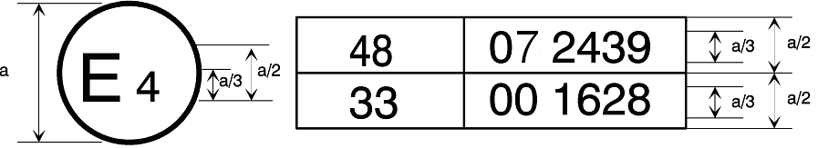
06 2439
a = 8 mm min.
The above … Regulation No. 48 as amended by the 06 series of amendments and Regulation No. 33.^{1/} The approval number indicates that, at the dates when the respective approvals were given, Regulation No. 48 was amended by the 06 series of amendments and Regulation No. 33 was still in its original form."

Annex 13, the title, amend to read:
"Annex 13
Observing area towards the apparent surface of manoeuvring and courtesy lamps
…"
________________

* * In accordance with the programme of work of the Inland Transport Committee for 2010–2014 (ECE/TRANS/208, para. 106, ECE/TRANS/2010/8, programme activity 02.4), the World Forum will develop, harmonize and update Regulations in order to enhance the performance of vehicles. The present document is submitted in conformity with that mandate.

