Proposal for amendments to Draft new Regulation on uniform provisions concerning the approval of enhanced Child Restraint Systems used onboard of motor vehicles

The text reproduced below was prepared by the expert from France, on behalf of the informal working group on Child Restraint Systems. It is based on ECE/TRANS/WP.29/GRSP/2011/15. The modifications to the current text of the new ECE on Child Restraint Systems are marked in bold or strikethrough characters.

- Proposal

On paragraph 1, amend to read:
This Regulation applies (in its Phase 1) to Integral Universal ISOFIX Child Restraint Systems (-Size) and Integral “Specific vehicle Isofix” Child Restraint systems for child occupants of power driven vehicles.

On paragraph 2.3, amend to read:

"-Size" (Integral Universal ISOFIX Child Restraint Systems) is a category of Child Restraint System for use in all -Size seating position of a vehicle -Size ready vehicles, but not necessarily in all seating positions, as defined and approved according to Regulation No. 16 including its suitability for such a category of Child Restraint System. This does not preclude the fitting of such an -Size Child Restraint System in specific ISOFIX seating positions specified by vehicle manufacturer according to regulation 16.

On paragraph 2.5, amend to read:

"ISOFIX" is a system that provides a method of connecting a Child Restraint System to a vehicle. It is based on two vehicle anchorages and two corresponding attachments on the Child Restraint System in conjunction with a means to limit the pitch rotation of the Child Restraint System. All three vehicle anchorage [and the vehicle floor contact area surface] are to be approved according to Regulation No. 14.
On paragraph 2.6, amend to read:

"ISOFIX Universal" is an ISOFIX comprising either a top-tether or a support-leg, to limit the pitch rotation of the Child Restraint System, attached to, or supported by, the corresponding vehicle.

On paragraph 2.7, amend to read:

"Specific vehicle ISOFIX or ‘built in’" is an indication for the system of connecting a a category of Child Restraint System connecting to specific vehicle types. All vehicle anchorages are to be approved according to Regulation No. 14. It is also an indication for Child Restraint Systems including dashboard as a vehicle contact zone.

On paragraph 2.12, amend to read

"Anti-rotation device" means a device intended to limit the rotation of the Child Restraint System during a vehicle impact and consisting of:
(a) a top-tether strap; or
(b) a support-leg.
meeting the requirements of this Regulation and fitted to an ISOFIX anchorage system and ISOFIX top tether anchorages or vehicle floor contact area surface meeting the requirements of Regulation No. 14.
An "Anti-rotation device" for a “specific vehicle ISOFIX” Child Restraint System may comprise a top tether, a support-leg or any other means capable of limiting the rotation.

On paragraph 2.15.1 amend to read

"Support-leg foot [feet]" means the device or surface one or more part[s] of the support-leg of the Child Restraint System intended (by design) to engage with the vehicle contact area and designed to transmit the loading from the support-leg to the vehicle structure during a frontal impact.

On paragraph 2.15.3 amend to read

"Support-leg foot contact assessment volume" describes a spatial volume which denotes both the extent and limitations for the movement of the support-leg foot.
On paragraph 2.16 amend to read

"Vehicle contact volume" means a volume defined in (X, Y, Z) in relation to the ISOFIX anchorage system, in which he vehicle floor contact area surface must fully lie.
On paragraph 2.17, amend to read

"Vehicle floor contact area surface" means the part of the vehicle floor designed to withstand the compression forces transmitted by a Child Restraint System support-leg foot during a frontal impact.
On paragraph 2.54, amend to read:

"ISOFIX position" means a location which allows for the installation of:
(a) either an universal ISOFIX Child Restraint System as defined in Regulation No. 44;
(b) or a “specific vehicle or a "built in" ISOFIX” Child Restraint System as defined in Regulation No. 44 or in this Regulation
(c) or -Size Child Restraint System in specific ISOFIX seating positions specified by vehicle manufacturer according to Regulation 16.

Insert new paragraph 3.2.2 to read

3.2.2. The applicant shall indicate the kind of application:
- Application for a -Size Integral Universal ISOFIX child restraint systems, or
- Application for a “Specific vehicle ISOFIX” child restraint systems

Insert new paragraph 3.2.3 to read
3.2.3. The applicant needs to submit documentation (drawings and/or pictures) regarding the car or the ISOFIX seating position and the relevant car environment for which the manufacturer likes to obtain a “Specific vehicle ISOFIX” approval.

Renumber paragraph 3.2.2 in 3.2.4.
3.2.4. samples of the Child Restraint System requested by the Technical Service Responsible for conducting the test;

Renumber paragraph 3.2.3 in 3.2.5.
3.2.5. a 10-metre length of each type of strap used in the Child Restraint System; and

Insert new paragraph 3.2.6 to read

3.2.6. In case of a “Specific vehicle ISOFIX” application for a forward facing child restraint system, a body of the vehicle, including adult seats and the relevant parts of the car environment shall be available.

On paragraph 4.5, insert new drawing

[Diagram to be defined]

In paragraph 4.6.1., replace the logo by one of the following


Insert new paragraph 4.8 to read

4.8. The “Specific vehicle ISOFIX” child restraint system must have a permanently attached label, visible to someone installing the child restraint system in the car, containing the following information:
This is a “Specific Vehicle ISOFIX” Child Restraint System

On paragraph 5.4.2.1., amend to read

5.4.2.1. The word(s) "-Size" or ["integral Specific vehicle ISOFIX"] depending on the category of Child Restraint System;

On paragraph 6.1.1., amend to read

6.1.1. The use of Child Restraint Systems in the -Size category is permitted in -Size ready vehicles, if the Child Restraint Systems are fitted in conformity with the vehicle manufacturer's instructions.
The use of Child Restraint Systems in the Integral "Specific vehicle ISOFIX” category is permitted in all ISOFIX positions and also in the luggage area, if the restraints are fitted in conformity with the vehicle manufacturer's instructions.

On paragraph 6.1.2.2., amend to read

6.1.2.2. For "Integral Specific vehicle ISOFIX" category: this shall be by means the ISOFIX attachments designed by the manufacturer of the Restraint System as specified in this regulation, secured to ISOFIX anchorage system as designed by the vehicle manufacturer as specified in ECE Regulations No. 14.

On paragraph 6, Table 1, amend to read

Table 1
Possible configurations for type approval
 | Orientation | Category
 |  | -Size CRS | “Specific Vehicle ISOFIX” CRS
INTEGRAL | Lateral facing (Carry-cot) | A | A
INTEGRAL | Rearward facing | A | A
INTEGRAL | Forward facing | A | A

On paragraph 6.3.2.2., insert new item (c)

(c) -Size Lateral facing Child Restraint Systems must fit in ISO/L1 or ISO/L2 envelope dimensions for a reduced-size rearward-facing toddler CRS ISOFIX SIZE CLASS F & G

Renumber item (c) of paragraph 6.3.2.2. in item (d)

On paragraph 6.3.2.3; amend to read

6.3.2.3. Mass
The mass of an integral ISOFIX Child Restraint System (-Size Child Restraint System included) combined with the mass of the largest child intended to use the Child Restraint System shall not exceed 33kg. This mass is also applicable for “Specific vehicle ISOFIX” Child Restraint Systems.

On paragraph 6.3.5.1., item (c) amend to read:
… [190] by 270mm …

On paragraph 6.3.5.1., item (d) amend to read:
… [490] by 525mm …

On paragraph 6.3.5.1., item (g) amend to read:
… [620] by 585mm …

On paragraph 6.3.5.1. item (h), amend to read:
… [820] by 695mm …

Replace Figure 0 (d) by drawing below

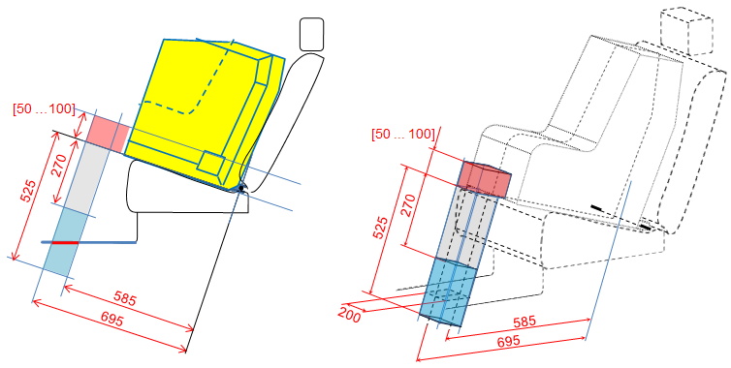

On paragraph 6.6.4.1.2., amend to read

6.6.4.1.2. Child Restraint Systems of the Integral "Specific vehicle ISOFIX” category shall be tested with each vehicle model for which the Child Restraint System is intended. The Technical Service responsible for conducting the test may reduce the number of vehicle models tested if they do not differ greatly in the aspects listed in paragraph 6.6.4.1.2.3. The Child Restraint System may be tested in one of the following ways:

On paragraph 6.6.4.1.2.1., amend to read

6.6.4.1.2.1. Rearward facing child restraint systems (ISO/R3), on the test trolley by means of the test bench prescribed in Annex 6 and in conformity with paragraph 7.1.3.1. or in a vehicle body shell in conformity with paragraph 7.1.3.2.

On paragraph 6.6.4.1.2.2., amend to read

6.6.4.1.2.2. Forward facing child restraint systems (ISO/F2 and ISO/F3), on the test trolley in a vehicle body shell in conformity with paragraph 7.1.3.2. or in a complete vehicle in conformity with paragraph 7.1.3.3.

On paragraph 6.6.4.1.4., amend to read

6.6.4.1.4. If an Integral "Specific vehicle ISOFIX” Child Restraint System is installed in the area behind the rearmost forward facing adult seat positions (for example, the luggage area), one test with the largest dummy/dummies, as allowed by the Child Restraint System, on a complete vehicle as prescribed in paragraph 7.1.3.3.3. shall be performed. The other tests, including the conformity of production, may be done as prescribed in paragraph 7.1.3.3.2., at the request of the manufacturer.

Renumber .6.6.4.4.1.2 to 6.6.4.4.1.1.1 for paragraph:

‘Where a test is conducted in accordance with paragraph 6.6.4.1.6.2, a tolerance of +10 per cent shall be applicable to the head excursion value -distance between Cr point and plane AB’
Insert at the end of paragraph 6.6.4.4.1.2.1:
Where a test is conducted in accordance with paragraph 6.6.4.1.6.2, only the second configuration without 100 mm diameter bar will be considered.
On paragraph 6.6.4.4.2., amend to read

6.6.4.4.2. Child restraint systems of the “-Size Specific vehicle ISOFIX” of the category forward facing child restraint systems (ISO/F2 and ISO/F3): when tested in a complete vehicle or a vehicle body shell, the head shall not come into contact with any part of the vehicle. However, if there is contact, the head impact criterion HIC and the Head Acceleration 3ms shall be used as assessment criteria. In tests with complete vehicles it shall be possible to remove the manikins from the child restraint system without the use of tools after the test.

Insert new items on paragraph 7.1.3. to read

7.1.3. Dynamic testing for frontal, rear and lateral impact

(a) Frontal impact tests shall be performed on “-Size" (Integral Universal ISOFIX Child Restraint Systems) and “Specific vehicle ISOFIX” child restraint systems.

(b) Rear impact test shall be performed on -Size and “Specific Vehicle ISOFIX” Rearward facing Child Restraint Systems

(c) Lateral impact test are performed only on the test bench for -Size" Integral Universal ISOFIX Child Restraint Systems and “Specific vehicle ISOFIX” child restraint systems

7.1.3.1 Testing using the trolley and test bench
….

On paragraph 7.1.3.6.3., item (c), amend to read

(c) In the case of “integral Specific vehicle ISOFIX” category, the support leg shall be adjusted as specified by the child restraint system manufacturer.

On paragraph 14.2.2., amend to read

14.2.2. for "-Size Specific vehicle ISOFIX" category Child Restraint Systems information on the applicable vehicle shall be clearly visible at the point of sale without removing the child restraint from its packing;

Annex 6 – Appendix 1

On paragraph 7.3, delete the remark:
[Remark: the contents of paragraph 7.3. will be replaced by the certification derived from the work done by NPACS.]
Delete the brackets on paragraph 7.3.1 and paragraph 7.3.3

Delete the both drawings

Figure 5
3-Dimensional view of test bench
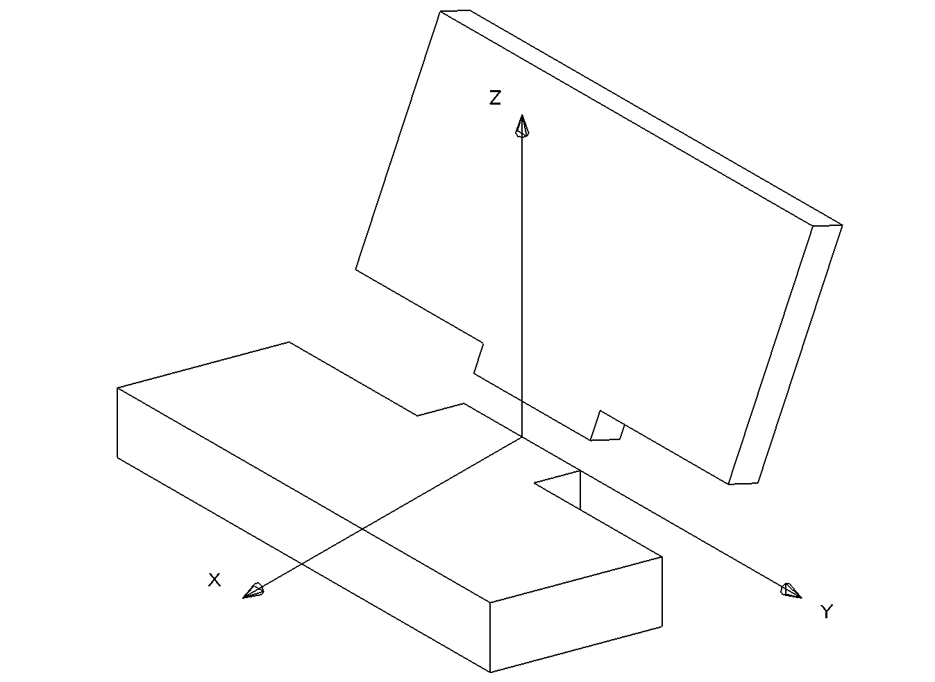
– Isometric View – Bench seat
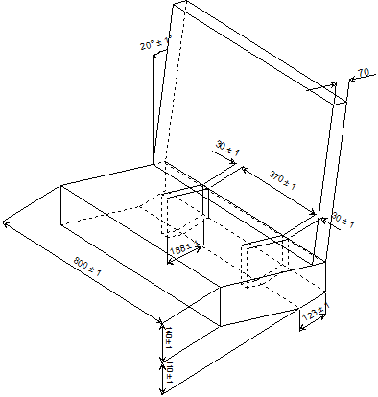

Annex 7 – Appendix 3
Delete the paragraph and drawing corresponding to “Definition of door maximum intrusion”.

Maximum Intrusion]

50 mm
At t0
Bench Centreline
350 mm

-----

