Diagrams for amendments to ECE/TRANS/WP.29/GRSG/2011/19 - Regulation No. 58（Rear underrun protection)

Diagram 1: Cases where the change in the RUPD height from 100 mm to 150 mm will be difficult (Vehicles with retractable tailgate lift)
Due to the size of Japanese registration plates, the RUPD cannot be extended upwards, and if it is extended downwards, it will result in an undesirable departure angle which causes the RUPD to come in contact with the road surface. Even in the case of vehicles with a short ROH, the RUPD will come in contact with the road surface when the vehicle enters parking lots. (Contact with the road surface occurs when the departure angle is 10° or below.)

In the case of fixed bumpers such as equipment bumpers, it is possible to place the registration plate behind the bumper.
In contact with the registration plate at sliding
Bumper height above ground
420
Bumper height above ground
370
Sliding
Sliding
No contact at sliding
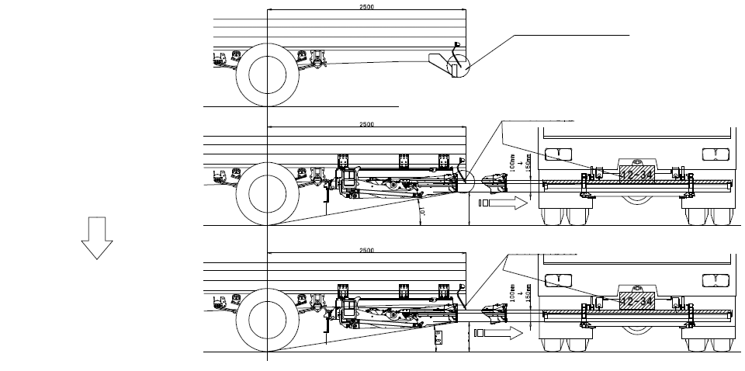
1. Fixed bumper:
2. Tailgate retractable under the floor:
* If the bumper is extended upwards to keep the departure angle, the tailgate will come in contact with the registration plate when it slides backwards.
* If the tailgate installation position is lowered by 50 mm in order to avoid contact with the registration plate, the departure angle will be below 10°, making some vehicles unable to run.
* If the bumper is extended downwards without lowering the tailgate installation position, it will still result in the situation depicted at right.

Diagram 2: Cases where the departure angle of 10° or above is necessary
From the standpoint of practicability on the market, the departure angle of 10° is specified. If it is 8°, the RUPD will come in contact with the road surface while the vehicle is running, making it unable to keep running. For medium-sized vehicles, some manufacturers in Japan have established voluntary regulations regarding the departure angle as these vehicles often enter parkng lots and/or narrow streets. (The cases where they came in contact with the road surface at a departure angle of 9° or below have been reported.)

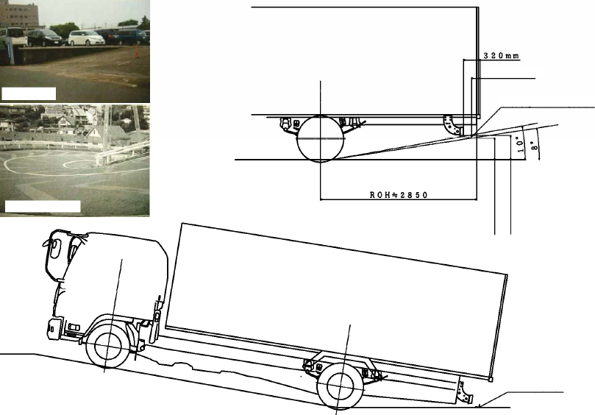
An example of parking lots
An example of steep slopes in mountains
No more than 200 mm
Position proposed by Germany taking the rated load into account
Standard size of vehicles with GVW of 8 t - 12 t
(overall length of slightly less than 8 m and overall width of 2.2 m)
No more than 500 mm when unladen
No more than 550 mm when unladen
Position proposed by Germany
in contact with the road surface

Diagram 3: Cases where the departure angle of 10° or above is necessary (Car carrier vehicles)
The RUPD will come in contact with the road surface while the vehicle is running, making it unable to keep running. (The device will come in contact with the road surface when the vehicle enters parking spaces in urban areas, etc.)

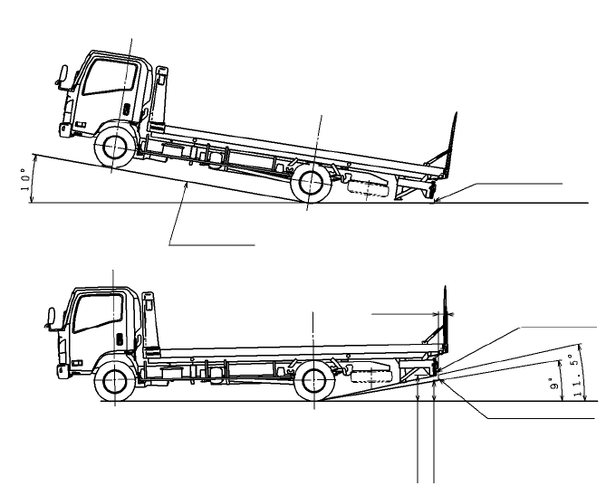
Parking lot uphill slope
Parking lot slope
Proposed position in contact with the road surface
Specifications applicable on the flat ground
Current R58-02
Position proposed by Germany taking the installation tolerances into account
No more than 550 mm
No more than 450 mm
No more than 200 mm

Diagram 4: Cases where the RUPD installation position of 200 mm will cause technical problems in constructing the vehicle structure (Vehicles with platform tailgate lift)
If the horizontal distance between the vehicle’s rearmost part and the RUPD installation position is set at 200 mm or less:
The registration plate will be located behind the RUPD, which leads to non-compliance with the registration plate visibility requirement. The proposed amendment to paragraph 25.2 says “For vehicles fitted with a platform lift at the rear the distance may not exceed 300 mm.” However, the current distance 330 mm does exceed 300 mm, and the reality is that the registration plate is placed in such a limited space. For this reason, the distance of 350 mm is necessary for vehicles with tailgate lift. )

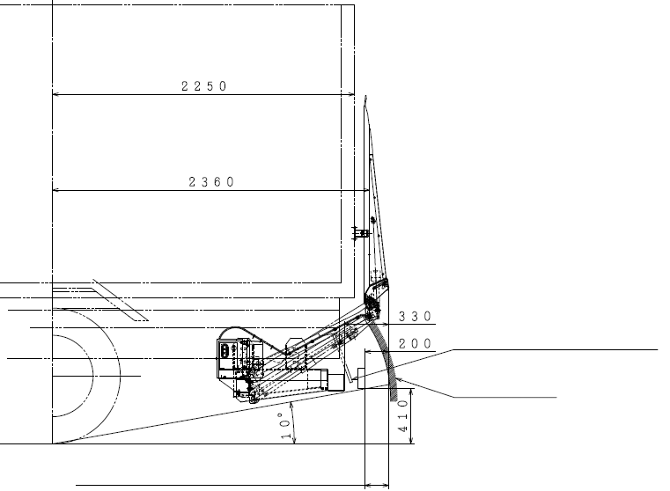
Difficult to place the registration plate as it would be positioned behind the bumper.
Tailgate lift's movable range
Difficult to place the registration plate in this area.

Diagram 5: Cases where the RUPD installation position of 200 mm will cause technical problems in constructing the vehicle structure (Dump trucks)

1. The bed will come in contact with the RUPD when it rises for dumping, which makes the structure impossible. (Figure 1)

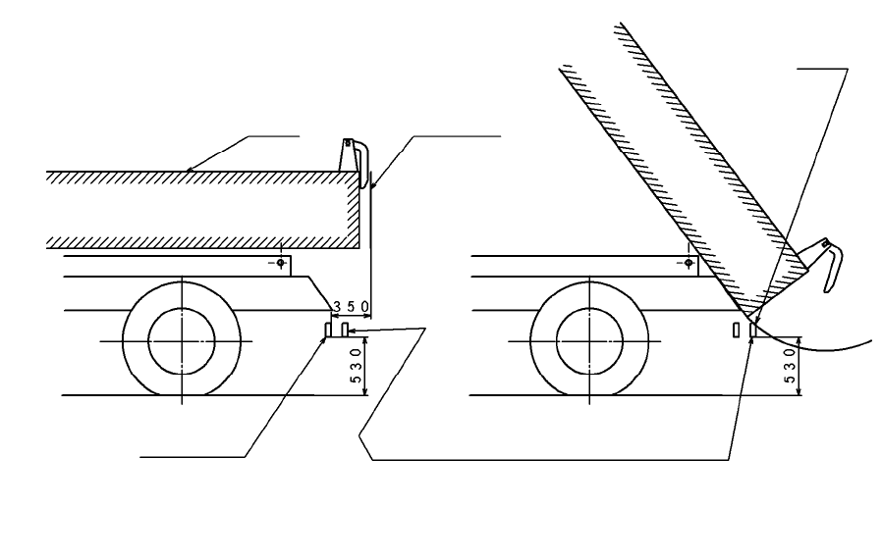
Bed
Rearmost part of the vehicle
In contact
Position under the current regulation
If the height requirement is ignored and
the depth after loading is required to be 200 mm
Figure 1 Contact Caused by Dumping

2. If the bumper is lowered, the dumped deposits will push the RUPD and cause danger. It will also enter the deposits of dirt and cannot escape easily. (Figure 2)
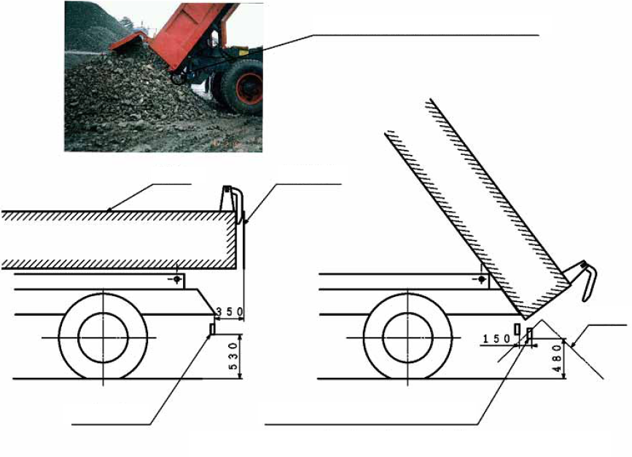
Bed
Rearmost part of the vehicle
Position under the current regulation
At the position proposed by Germany, the RUPD will enter the deposits of dirt.
Deposits of dirt
If the bumper height above ground in Figure 1 is lowered
Figure 2 RUPD Entering the Deposits of Dirt at Dumping

* Even in the current R58-02, the following problems have been pointed out:
(1) The load gets stuck between the bed’s rearmost part and the RUPD, which may prevent the bed from rising for dumping.
(2) The stuck load damages the bumper.
(3) The RUPD enters the dumped deposits.
Hence, the strengthening of the regulation is undesirable from the standpoint of structure of dump trucks.
3. The possibility of the dumped deposits damaging the RUPD will increase, which will raise the frequency of the vehicles running with the damaged RUPD, compromising safety. (Figure 2)
4. With the distance from the RUPD being shorter, the distance from the dump hinge will also be made shorter. This will lead to malfunctioning of the stopper function in the event of over-dumping, causing damages to the chassis and risk of turnover. (Figure 3)
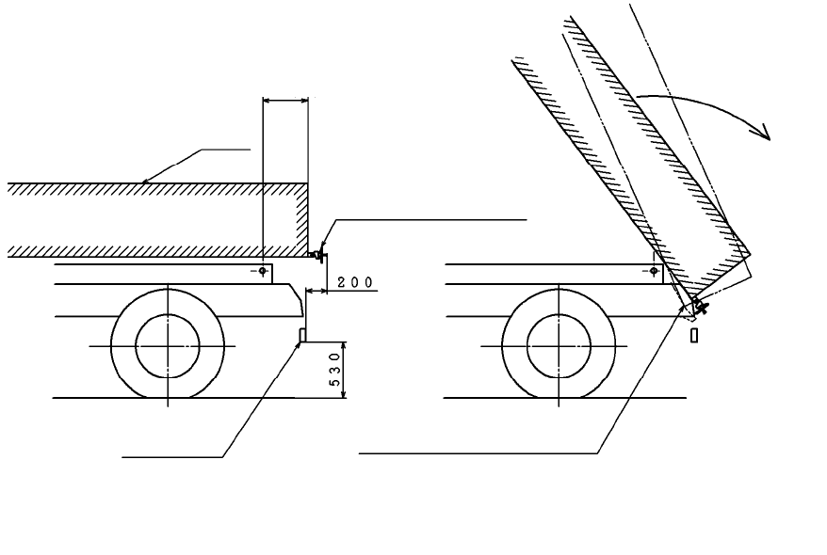
Bed
Position under the current regulation
If this length is shortened
Equipped with a handle for preventing spillage of dirt
Risk of turnover
The contact area between
chassis and bed will be
reduced, causing the chassis to be unable to withstand the bed.
Figure 3 If the Dump Bed Length Is Shortened

5. On unpaved roads (construction sites), the RUPD will come in contact with uphill slopes to work sites, ruts, etc., making it difficult for the vehicle to keep running. (Figure 4)

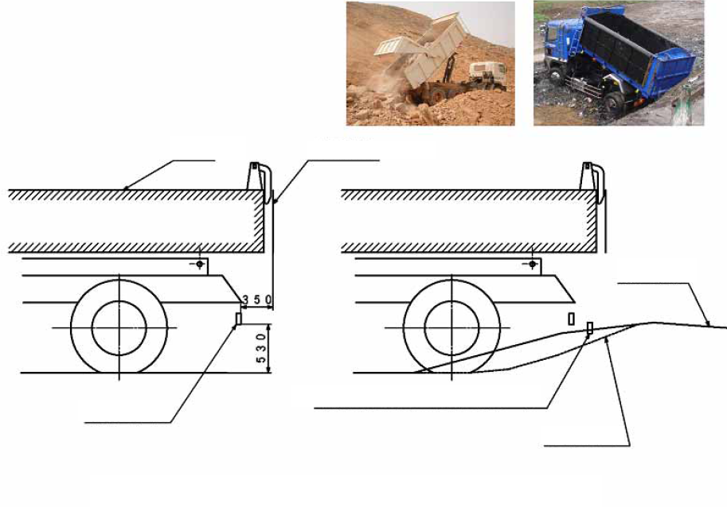
Bed
Rearmost part of the vehicle
Position under the current regulation
Dumping area
Unable to run on the construction ground
Rut
Figure 4 Unable to Run on Unpaved Roads in Construction Sites, Dump Yards, etc.

6. In the case of dump trucks for industrial waste that perform pit dumping, the RUPD will come in contact with the fence for the prevention of falling, causing difficulties in dumping work. It will also cause danger if the fence on the pit side is lowered. (Figure 5)

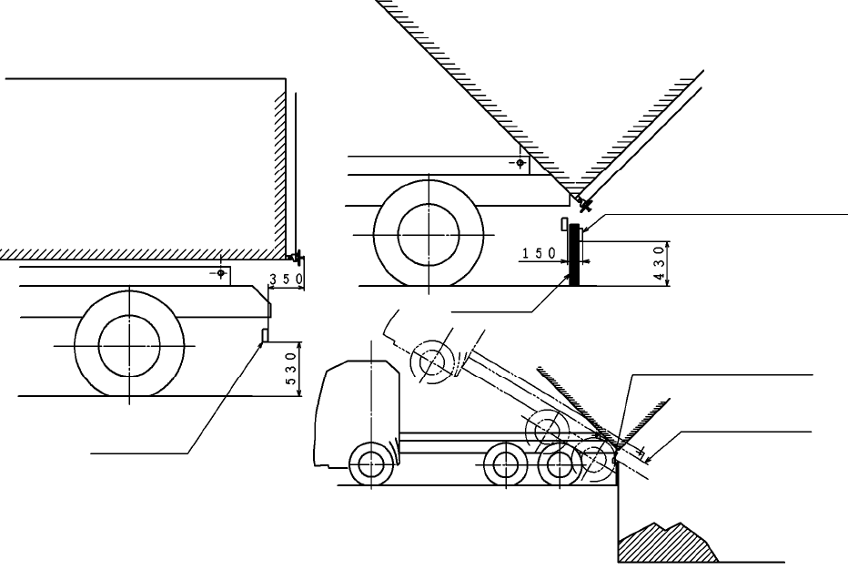
Position under the current regulation
The proposed position (at 200 mm) will come in contact with the fence, making dumping work impossible.
Pit fence
Protected by bumper
Without the fence, there will be grave risk of falling.
Figure 5 Pit Dumping Diagram (showing why the proposed depth of 200 mm is difficult)

Diagram 6: Cases where the RUPD underside height of 500 mm will cause difficulties in usage (Concrete mixers)
In Japan, some of these vehicles are stored on hills, where the maximum gradient can be around 15°. The RUPD will come in contact with the road surface while the vehicle is running, making it unable to keep running to enter the site.

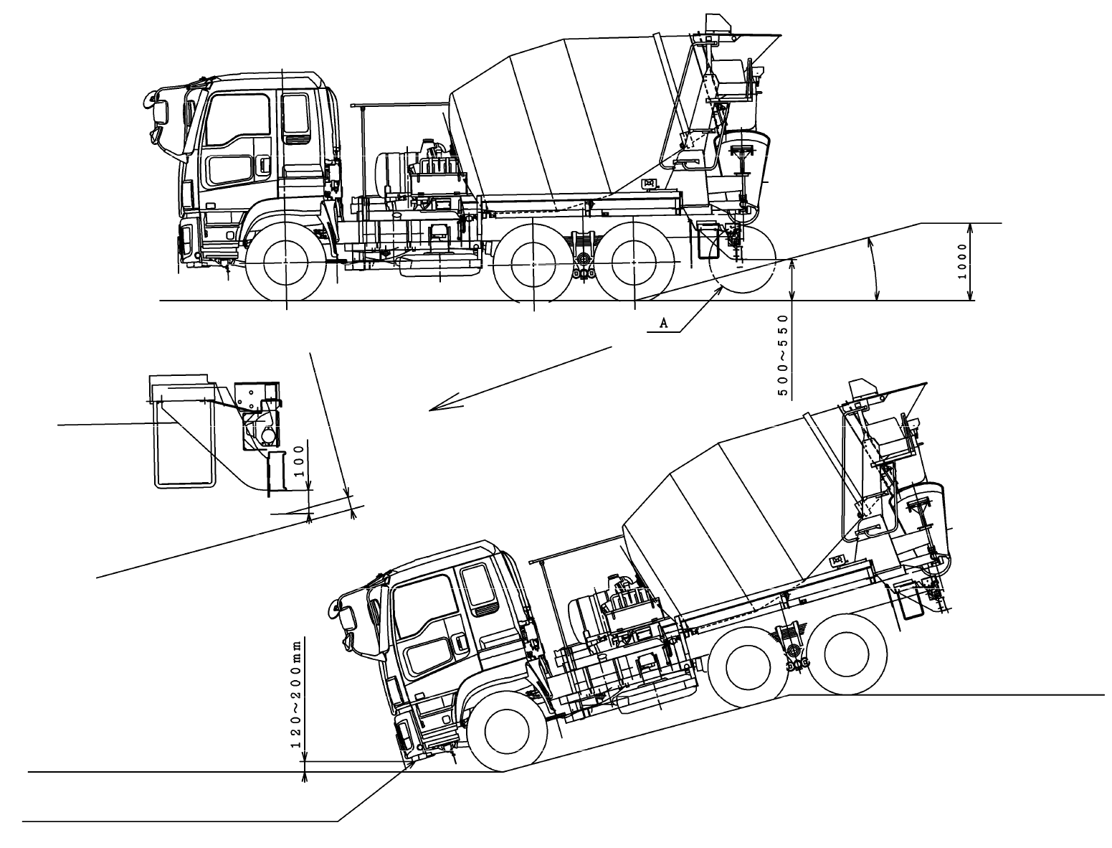
Work site
Work site
About 20 mm when unloaded; Will come in contact when loaded.
Arriving at the site
Details of Section A
FUP height
450 mm max. allowed for dumpers/mixers
15° max.

Diagram 7: Cases where the RUPD installation position of 200 mm (from the rearmost part of the vehicle) will cause difficulties in usage

Vacuum Trucks: When the truck dumps the load, it will come in contact with the RUPD, making the dumping work difficult. With the RUPD being located too close to the vacuum hose, handling of the hose will be difficult when the truck vacuums the load.
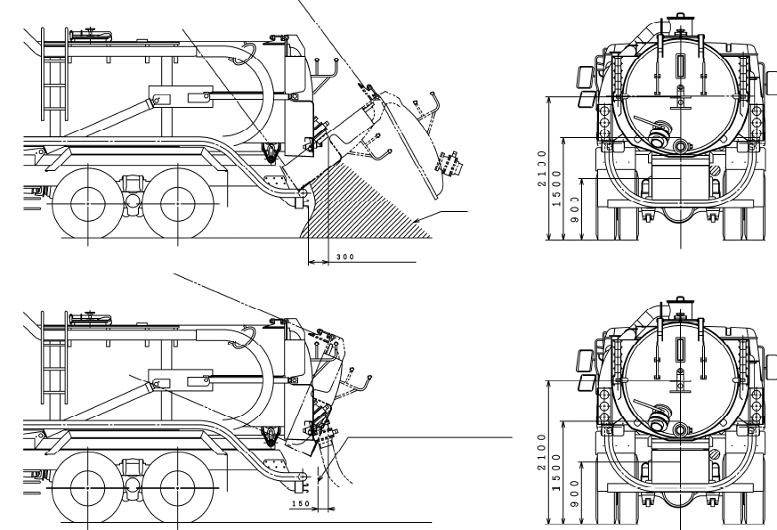
Dirt
(Installed at 300 to 350)
On rare occasions, vacuuming will be done with slight dumping, in which case the bumper and the vacuum hose may come in contact.

Concrete mixers: When the concrete is discharged, the RUPD location will be farther away than the current position, which will cause danger in the discharge work.
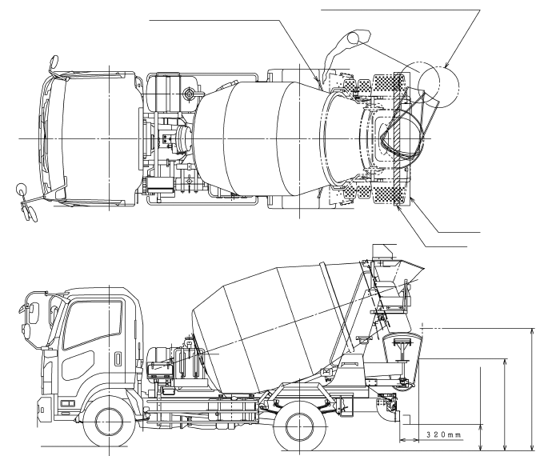
Operation lever
For safety reasons, it is operated by wire, and under this circumstance it is difficult to be placed more rearwards.
Dangerous as the concrete discharge location will be far away.
Proposed position
Position under the current regulation
1,500 mm under Safety Regulations
2,000 mm under R58
No more than 500 mm

-----

