Document from VBG, JOST and BPW | ACV-03-02
Proposal for amendments to Regulation No. 13 (Heavy vehicle braking)
The text reproduced below was prepared by the experts of the informal working group ACV to be inserted into Regulation No. 13. This is to produce:
- a robust text structure with respect to Brake Electric/Electronic Interface to ensure that the evolving new technology may be handled safely and without risk for misunderstanding.
- provisions for new technologies such as Automatic Couplings for Vehicles, ACV, and fully integrated drivetrain control including propulsion and braking implemented in the towed vehicles.
The modifications to the existing text of the Regulation are marked in bold characters. As the proposal for text revision under section "I" is fairly extensive it is recommended to start reading section "II. Justification" starting on page 10”.
I. Proposal
Main text
Insert new paragraph 2.34., to read:
"2. DEFINITIONS"
2.34. "Brake electric/electronic interface" {§5.3 ISO7638}
A dedicated and unique bundle for all braking system related electric functions within the electric connection between towing and towed vehicle. This bundle has to provide contacts for the following functions:
- Voltage supply for electrovalve (Braking), referred to as Pin 1
- Voltage supply for electronics (Braking), referred to as Pin 2
- Voltage return for electronics (Braking), referred to as Pin 3
- Voltage return for electrovalve (Braking), referred to as Pin 4
- Signal for Warning device (Braking), referred to as Pin 5 (Open connection on the towed vehicle during normal operation)
- Communication lione for CAN_High (Braking) referred to as Pin 6 (to conform to ISO11992-1 and ISO11992-2)
- Communication lione for CAN_Low (Braking) referred to as Pin 7 (to conform to ISO11992-1 and ISO11992-2)

Amend paragraph 5.1.3.6., to read:
"5. SPECIFICATIONS"
5.1.3.6 Brake electric/electronic interface
5.1.3.6.1 The electric control line of the Brake electric/electronic interface shall conform to ISO 11992-1 and 11992-2:2003 and be a point-to-point type using the seven pin connector according to ISO 7638-1 or 7638-2:1997 x/. . exclusively allocated contact pins in the specified connector according to 5.1.3.6.3.1 to 5.1.3.6.3.3 below. The data contacts functions of the Brake electric/electronic interface, (Pin 6 and 7) of the ISO 7638 connector shall be used to transfer information exclusively for braking (including ABS) and running gear (steering, tyres and suspension) functions as specified in ISO 11992-2:2003. The braking functions have priority and shall be maintained in the normal and failed modes. The transmission of running gear information shall not delay braking functions. The power supply, provided by the ISO 7638 connector through the Brake electric/electronic interface, shall be used exclusively for braking and running gear functions and that required for the transfer of trailer related information not transmitted via the electric control line. However, in all cases the provisions of paragraph 5.2.2.18 of this Regulation shall apply. The power supply for all other functions shall use other measures.

Insert new paragraph 5.1.3.6.2, 5.1.3.6.2.1 to 5.1.3.6.2.6, 5.1.3.6.3, 5.1.3.6.3.1 to 5.1.3.6.3.3, to read:
5.1.3.6.2 Brake electric/electronic interface general requirements
5.1.3.6.2.1 The Brake electric/electronic interface shall in a specified integrated connector shall be kept together in a separate region.
5.1.3.6.2.2 The data communication contacts (Pin 6 and Pin 7) of the Brake electric/electronic interface may be left uninstalled provided that physical arrangements are made such that towed vehicles requiring connection according to ISO 11992-1 and 11992-2 may not be connected.
5.1.3.6.2.3 The electric control line according to ISO 11992-1 and 11992-2 between the brake ECU (electronic control unit) on the towing vehicle and the towed vehicle has to be point-to-point to ensure an explicit and unequivocal correlation.
Active connections shall not have any bypasses or dead ends.
For installations having only two cable sections the length of the middle cable section (according to ISO 11992-1) may be prorated to the two remaining cable sections as long as the electrical specifications according to ISO 11992-1 are met.
Vehicles shall in general at the most have one singular socket according to ISO 7638:1997
Vehicles having more than one mechanical coupling e.g. one fifth wheel and one drawbar coupling shall have one and only one socket according to ISO 7638:1997
Vehicles having more than one socket according to ISO 7638:1997 installed shall have means to exclude (See fifth wheel example in Annex 21) more than one socket according to ISO 7638:1997 from being active at one given moment in time. Such an installation is accepted as being one singular socket according to ISO 7638:1997.
5.1.3.6.2.4 The contacts for voltage supply for electrovalves (Pin 1 and Pin 4) of the Brake electric/electronic interface shall be physically realized such that leads with 4 mm² cross section may be used. z/ The remaining contacts in the Brake electric/electronic interface shall handle at least 1.5 mm². {§5.5 ISO7638}
Insert new footnote , to read:
z/ In case of vehicles with a lower nominal working voltage than 24V contacts for voltage supply for electrovalves (Pin 1 and Pin 4) of the Brake electric/electronic interface shall be physically realized such that leads with 6 mm² cross section may be used.

5.1.3.6.2.5 The connector for the Brake electric/electronic interface is a part shall per se fulfill the technical requirements of the ISO4091. The endurance test shall be extended to 10 000 cycles. {§6.1, §6.4 ISO7638}
5.1.3.6.2.6 The connector where the Brake electric/electronic interface is a part shall have a geometrically excluding interface or be part of a geometrically excluding interface such that unintended incompatible connection is not possible. {§6.2 ISO7638}
5.1.3.6.2.7 Automatic coupling processes shall only be used on vehicle combinations where:
- both, towing vehicle and trailer work on same voltage
Alternatively:
- the trailer can handle both voltage levels
- the towing vehicle can supply both voltage levels
Voltage compatibility has to be ensured by the operator.

Renumber paragraph 5.1.3.6.1 to 5.1.3.6.2.8
Renumber paragraph 5.1.3.6.2 to 5.1.3.6.2.9

5.1.3.6.3 The embodiment of the brake electric/electronic interface:
5.1.3.6.3.1 A vehicle intended to be part of a vehicle combination where the electric connection between vehicles is engaged/disengaged manually shall have a brake electric/electronic interface implemented using the ISO7638-1/ISO7638-2 connector x/
The ISO 7638 connector may be used for 5 pin or 7 pin applications, as appropriate.
5.1.3.6.3.2 A vehicle intended to be part of a vehicle combination where the engaging/disengaging of the mechanical, the electrical and the pneumatic connections are implemented as parts of one automatic process shall have a brake electric/electronic interface that is part of a fully integrated electrical connector. This connector shall fulfill the technical specifications defined in ISO13044-x. {cover ISO7638}
Vehicles with an implementation of an automated process according to this paragraph shall also have an implementation according to paragraph 5.1.3.6.3.1 of this Regulation. This is to enable coupling of a vehicle equipped only with manually operated connectors for the electric/electronic and pneumatic interface to a vehicle equipped with automatically operated electric/electronic and pneumatic connectors.
While implementing this manual option, the point-to-point connection requirement shall also be ensured for the manually operated connection option.
The active connection shall not have any bypasses or dead ends. (For example see Annex 21, Figure A to D) {Figure 4 ISO7638}

5.1.3.6.3.3 A vehicle intended to be part of a vehicle combination where the engagement/disengagement of the mechanical, the electrical and the pneumatic connections are implemented as parts of one automatic process and where the geometric interface excludes mating with vehicles being equipped for manual engagement/disengagement may have a Brake electric/electronic interface that is part of a unique dedicated fully integrated electrical connector provided that:
- Requirements of paragraph 5.1.3.6.2.1 and 5.1.3.6.2.7 are fulfilled. {ISO7638}
- The function allocations to the pins the integrated electrical connector are documented in the type approval documentation for the ECE R55 type approval. {§5.3 ISO7638}
- The excluding geometry shall be unique to the coupling type approval according to ECE-R 55. {§6.2 ISO7638}

Insert footnote x, to read: (relocation of deleted footnote 16 page 47)
x/ The wiring specifications of ISO 7638:1997 for the trailer not equipped with an electric control transmission may be reduced if the trailer is installed with its own independent fuse. The rating of the fuse shall be such that the current rating of the conductors is not exceeded.
Amend paragraph 5.1.3.8, to read:
" ... part of the power-driven vehicle. In all other cases, the flexible hoses and cables shall be a part of the trailer. For vehicle combinations with a FACS automation level there may be a short flexible hose on either side of the coupling in order to enable automatic operation."

Amend paragraph 5.2.1.23., to read:
5.2.1.23. "... an anti-lock system shall also be equipped with a special electrical connector, conforming to ISO 7638:1997 7/ have an electric connection realizing the Brake electric/electronic interface as defined in this regulation (paragraph 2.34), for the ... "
Delete foot note 7/ on page 31.
7/ The ISO 7638:1997 connector may be used for 5 pin or 7 pin applications, as appropriate.
Amend paragraph 5.2.1.29.2., to read:
5.2.1.29.2. " ... The function shall be activated from the trailer via pin 5 of the electric connector conforming to ISO 7638:1997 9/ towed vehicle via the signal line for a warning device (Pin 5) of the Brake electric/electronic interface as defined in this regulation (paragraph 2.34) and in all cases ... "
Delete foot note 9/ on page 39.
9/ The ISO 7638:1997 connector may be used for 5 pin or 7 pin applications, as appropriate.
Amend paragraph 5.2.2.15.2.1., to read:
5.2.2.15.2.1. "... addressed by this Regulation and failures of energy supply available from the ISO 7638:1997 15/ connector through the Brake electric/electronic interface shall be indicated to the driver by the separate warning signal specified in § 5.2.1.29.2.1 via pin 5 of the electrical connector conforming to ISO 7638:1997 15/ the signal line for a warning device (Pin 5) of the Brake electric/electronic interface as defined in this regulation (paragraph 2.34). In addition ... "
Amend paragraph 5.2.2.16., to read:
5.2.2.16. "...The separate yellow warning signal specified in paragraph 5.2.1.29.2. shall also be activated via pin 5 of the electrical connector conforming to ISO 7638:1997 15/ the signal line for a warning device (Pin 5) of the Brake electric/electronic interface as defined in this regulation (paragraph 2.34), to indicate to the driver ... "
Amend paragraph 5.2.2.17., to read:
5.2.2.17. " ... anti-lock system, shall be fitted with a special electrical connector for the braking system and/or anti-lock system, conforming to ISO 7638:1997 15/ have an electric connection realizing the Brake electric/electronic interface as defined in this regulation (paragraph 2.34) 16/. Failure warning signals required from the trailer by this Regulation shall be activated via the above connector Brake electric/electronic interface. The requirement to be applied to trailers with respect to the transmission of failure warning signals shall be those, as appropriate, which are prescribed for motor vehicles in paragraphs 5.2.1.29.4., 5.2.1.29.5. and 5.2.1.29.6.
Trailers equipped with an ISO 7638:1997 connector as defined above having an electric connection as defined above realizing the Brake electric/electronic interface as defined in this regulation shall be marked in indelible form to indicate the functionality of the braking system when the Brake electric/electronic interface is connected and disconnected. The marking is to be positioned so that it is visible when connecting the pneumatic and electrical interface connections. "
Delete foot note 15/ on page 47.
15/ The ISO 7638:1997 connector may be used for 5 pin or 7 pin applications, as appropriate.
Amend foot note 16/ on page 47.
"The wiring specifications of ISO 7638:1997 realizing the Brake electric/electronic interface as defined in this regulation (paragraph 2.34) for the trailer not equipped with an electric control transmission may be reduced if the trailer is installed ... "
Amend paragraph 5.2.2.17.1., to read:
5.2.2.17.1. "...stability system indicate the failure by the separate yellow warning signal specified in paragraph 5.2.1.29.2. above via pin 5 of the ISO 7638:1997 connector the signal line for a warning device (Pin 5) of the Brake electric/electronic interface as defined in this regulation (paragraph 2.34). "
5.2.2.17.2. "It is permitted to connect the braking system to a power supply in addition to that available from the ISO 7638:1997 connector above Brake electric/electronic interface. However, when an additional power supply is available the following provisions will apply:
(a) In all cases the ISO 7638:1997 Brake electric/electronic interface power supply is the primary power source for the braking system, irrespective of any additional power supply that is connected. The additional supply is intended to provide a backup should a failure of the ISO 7638:1997 Brake electric/electronic interface power supply occur.
...
(c) In the event of a failure of the ISO 7638:1997 Brake electric/electronic interface power supply the energy consumed by the braking system shall not result in the maximum available power from the additional supply being exceeded.
...
(g) Should a failure exist within the electrical supply of energy from the ISO 7638:1997 Brake electric/electronic interface the requirements of paragraphs 5.2.2.15.2.1. and 4.1. of Annex 13 with respect to failure warning shall apply irrespective of the operation of the braking system from the additional power supply. "
Amend paragraph 5.2.2.18., to read:
5.2.2.18. "...power supplied by the ISO 7638:1997 connector Brake electric/electronic interface is used for the functions defined in paragraph 5.1.3.6.1 above, ... "
Amend paragraph 5.2.2.20., to read:
5.2.2.20. "...specified in paragraph 5.2.1.29.2. shall be activated via pin 5 of the ISO 7638:1997 17/ connector the signal line for a warning device (Pin 5) of the Brake electric/electronic interface as defined in this regulation. In addition, trailers ... "
Delete foot note 17/ on page 49.
17/ The ISO 7638:1997 connector may by used for a 5 pin or 7 pin applications, as
appropriate.
Annex 6
Insert new paragraph 3.3.1.1 to read:
3.3.1.1 In case of testing of a trailer with a pneumatic connector that is operated in an automated process the volume in paragraph 3.3.1 shall include these connectors and their attaching tubing. The connectors designated TA and TC in this annex shall in this case be these automatically operated connectors.
Amend paragraph 3.4.1., to read:
3.4.1 "... shall provide the appropriate information to the trailer via pins 6 and 7 of the ISO 7638:1997 connector the communication lines for CAN_High and CAN_Low (Pin 6 and Pin 7) of the Brake electric/electronic interface as defined in this regulation (paragraph 2.34). For the ... "
Amend paragraph 3.5.1.1., to read:
3.5.1.1. "...be checked with the electrical power supplied to the trailer via the ISO 7638:1997 connector (5 or 7 pin) Brake electric/electronic interface (Pin 5 or Pin 7) "
Annex 6,. Appendix, amend the text of Example 3 page 91, to read:
" ... ECL = electric control line corresponding to ISO 7638 or the Brake electric/electronic interface ..."
Annex 10
Annex 10, amend the foot note 1/ on page 106, to read:
"... shall only apply when the trailer is electrically connected to the towing vehicle by the ISO 7638:1997 connector an electric connection realizing the Brake electric/electronic interface as defined in this regulation (paragraph 2.34). "
Annex 13
Amend paragraph 4.2., to read:
4.2. "...used for this purpose, activated via pin 5 of the electrical connector conforming to ISO 7638:1997 4/ the signal line for a warning device (Pin 5) of the Brake electric/electronic interface as defined in this regulation (paragraph 2.34). "
Delete the foot note 4/ on page 185:
4/ The ISO 7638:1997 connector may be used for 5 pin or 7 pin applications, as appropriate.
Annex 17
Amend paragraph 1.1., to read:
1.1 "… Performance requirements referred to in paragraph 5.1.3.6.1 5.1.3.6.2.1 of this …"
Amend paragraph 1.2., to read:
1.2. "The references to ISO 7638 Brake electric/electronic interface within this annex apply to ISO 7638-1:1997 for 24V applications and ISO 7638-2:1997 for 12V applications to an electric connection realizing the Brake electric/electronic interface as defined in this regulation (paragraph 2.34) whether it concerns 12V or 24V installations".
Amend paragraph 3.1.1., to read:
3.1.1. "...have a connector meeting ISO 7638:1997 (7 pin) a 7 pin electric connection realizing the Brake electric/electronic interface as defined in this regulation (paragraph 2.34) to connect to the vehicle under test. Pins 6 and 7 of the connector the communication lines for CAN_High and CAN_Low (Pin 6 and Pin 7)of the Brake electric/electronic interface shall be used to transmit and receive messages complying with ISO 11992:2003 "
Amend paragraph 3.2.2., to read:
3.2.2. "...the simulator connected to the motor vehicle via the ISO 7638 interface Brake electric/electronic interface and whilst all ... "
Amend paragraph 3.2.2.3.1., to read:
3.2.2.3.1. "Simulate a permanent failure in the communication line to pin 6 of the ISO 7638 connector the communication line for CAN_High (Pin 6) of the Brake electric/electronic interface as defined in this regulation and check that the ... "
Amend paragraph 3.2.2.3.2., to read:
3.2.2.3.2. "Simulate a permanent failure in the communication line to pin 7 of the ISO 7638 connector the communication line for CAN_Low (Pin 7) of the Brake electric/electronic interface as defined in this regulation and check that the ... "
Amend paragraph 4.1.1., to read:
4.1.1. "...have a connector meeting ISO 7638:1997 (7 pin) a 7 pin electric connection realizing the Brake electric/electronic interface as defined in this regulation (paragraph 2.34) to connect to the vehicle under test. Pins 6 and 7 the communication lines for CAN_High and CAN_Low (Pin 6 and Pin 7) of the connector Brake electric/electronic interface shall be used to transmit and receive messages complying with ISO 11992:2003 "
Amend paragraph 4.2.2., to read:
4.2.2. "...the simulator connected to the motor vehicle via the ISO 7638 interface Brake electric/electronic interface and whilst all ... "
Amend paragraph 4.2.2.1.2., to read:

4.2.2.1.2. " ...
EBS 12, Byte 3,  Bit 1-2 | Pressure in the brake chambers or reaction of the trailer
01b | 0 kPa (service brake released)
00b | The trailer is automatically braked to demonstrate that the combination is not compatible. A signal should also be transmitted via Pin 5 of the ISO 7638:1997 connector the signal line for a warning device (Pin 5) of the Brake electric/electronic interface as defined in this regulation (yellow warning).

Amend paragraph 4.2.2.2.1.1., to read:
4.2.2.2.1.1. "...A signal should also be transmitted via pin 5 of the ISO 7638 connector the signal line for a warning device (Pin 5) of the Brake electric/electronic interface as defined in this regulation (paragraph 2.34) (yellow warning). "
Amend paragraph 4.2.2.2.1.2., to read:
4.2.2.2.1.2. "Reduce the voltage on pins 1 and 2 of the ISO 7638 connector of the voltage supply for electrovalves and electronics (Pin 1 and Pin 2) of the Brake electric/electronic interface as defined in this regulation (paragraph 2.34) to below a value ... ... A signal should also be transmitted via pin 5 of the ISO 7638 connector the signal line for a warning device (Pin 5) of the Brake electric/electronic interface as defined in this regulation (paragraph 2.34) (yellow warning). "
Amend paragraph 4.2.2.2.1.3., to read:
4.2.2.2.1.3. "...A signal should also be transmitted via pin 5 of the ISO 7638 connector the signal line for a warning device (Pin 5) of the Brake electric/electronic interface as defined in this regulation (paragraph 2.34) (yellow warning). "
Annex 19, Appendix 6, amend paragraph 2.3., to read:
  - "Methods of powering: ISO 7638 the Brake electric/electronic interface as defined in this regulation (paragraph 2.34), ISO 1185 etc. "
Add Annex 21, reading:
Annex 21
fifth wheel Example of layout of Electric connections between automatic coupling vehicles (ACV)

I. Fully ACV equipped
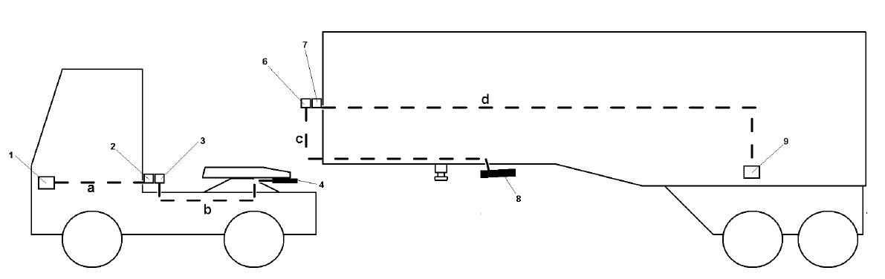
Electrical control line point-to-point in manual and ACV mode
ACV mode

Figure A: Point-to-point connection ECU Tractor (1) and ECU Trailer (9) when Fifth Wheel is closed
ACV mode: No helix cables installed, Connection 3 to 6 when 4 and 8 connected (i.e. fifth wheel coupled)

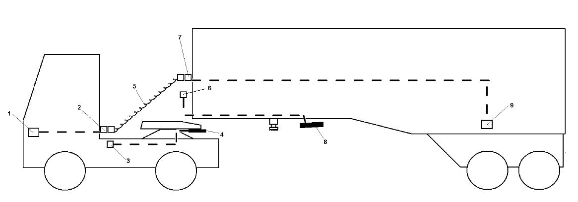
Manual mode

Figure B: Point-to-point connection ECU Tractor (1) and ECU Trailer (9) when Fifth Wheel is closed
Manual mode: Helix cables installed, Connection 3 to 6 and 4 and 8 are all offline (passive)

Key

1 ISO 11992-2 node on the towing vehicle, i.e. ECU ABS/EBS
2 Bottom connector for helix cable, mounted on towing vehicle
3 Connector socket to the ACV on towing vehicle acc. to ISO7638
4 Towing vehicle-side of the brake electric/electronic and pneumatic interface embodiment
5 Helix cable
6 Connector socket from the ACV on the towed vehicle acc. to ISO7638
7 Towed vehicle-sided connector for helix cable
8 Towed vehicle-side of the brake electric/electronic and pneumatic interface embodiment
9 ISO 11992-2 node on the towed vehicle, i.e. ECU ABS/EBS
a Cable harness from 1 to 2
b Cable harness from 3 to 4
c Cable harness from 8 to 6
d Cable harness from 7 to 9

II. PARTly ACV equipped

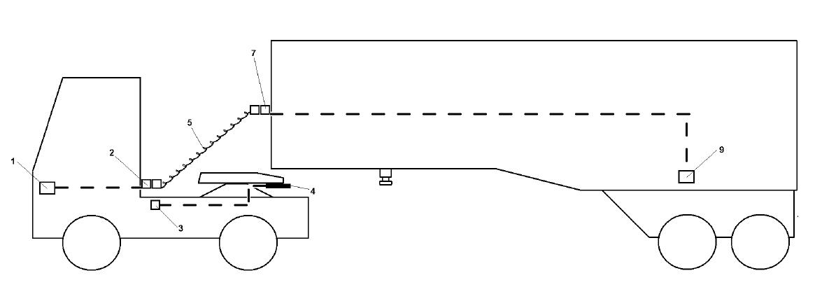
Manual mode A (only the truck ACV equipped)

Figure C: Point-to-point connection ECU Tractor (1) and ECU Trailer (9) when Fifth Wheel is closed
Helix cables installed, Line 3 to 4 offline

Manual mode B (only the trailer ACV equipped)
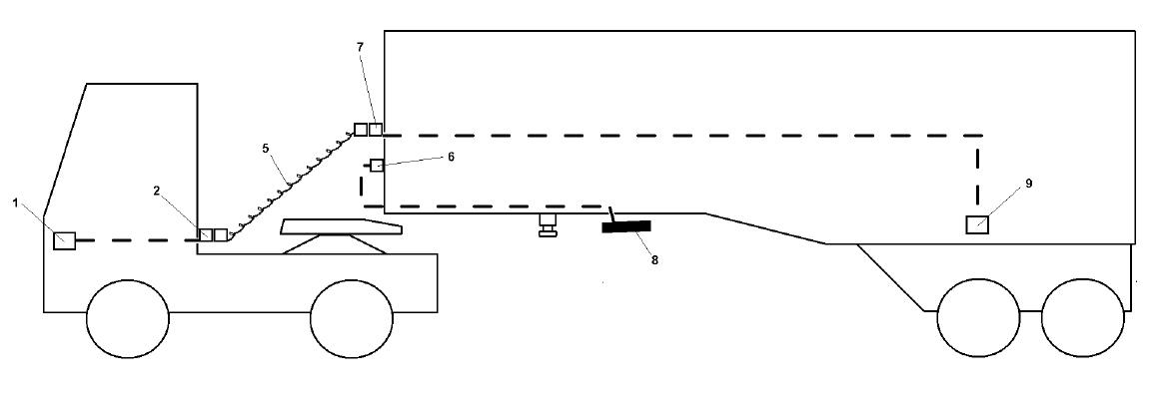

Figure D: Point-to-point connection ECU Tractor (1) and ECU Trailer (9) when Fifth Wheel is closed
Helix cables installed, Line 6 to 8 offline

II. Justification
Summary of the proposal

- Introduce an explicit definition of the “Brake electric/electronic interface”. This definition includes the functions currently managed through the ISO7638 connector.
- Introduced a new structure to §5.1.3.6 to enable differentiation of the implementation of the brake electric/electronic interface depending on the level of automation. Include explicit requirements equivalent to those of ISO7638 as applicable.
- Exchanged all references to numbered pins of the connector ISO7638 to references to numbered pins of the realization of the brake electric/electronic interface.
- Exchange in the main text all references to the ISO7638 with “Brake electric/electronic interface”.
- Delete all footnotes commenting the difference between 5-pin and 7-pin ISO7638 connectors. This is a matter to be handled once in the requirement of when the ISO7638 connector shall be used.
- Introduce requirements stating when the “Brake electric/electronic interface” shall be handled with the ISO7638 connector and when and how it may be handled through other means.
- An amendment is made to adapt the measurement procedure of the response delay
- An Annex 21 has been introduced to show an example alternative installations and coupling alternatives.
- Define how to act with 12V and 24V while using automated systems.
Detailed justification of the proposal
New technologies like Fully or partly Automated Coupling Systems, FACS or ACS respectively are introduced into the market. These technologies address Safety, Efficiency, Environment and Work related illness. (F)ACS and other applications will in the future create situations where the ISO7638 connector can not be used. Other solutions will evolve. Those solutions will safely handle the functions handled through the ISO7638 connector. However in those cases references to ISO7638 for a definition of the functions is inappropriate and prone to misunderstanding. Hence an explicit definition of the Brake electric/electronic interface is introduced in a new § 2.34.
All references in the main text where the ISO7638 is used as a substitute for lack of nomenclature have been exchanged for “brake electric/electronic interface.
Regulation No. 13 is in paragraph 5.1.3.6 requiring the use of ISO7638. Hence the paragraph 5.1.3.6 has been restructured such that the performance relevant requirements of ISO7638 are included together with the prerequisites for the use of alternative embodiments of the brake electric/electronic interface. Hence the §5.1.3.6.3.1 to §5.1.3.6.3.3 are introduced.
Footnote 16 on page 47 concerning reduced wiring has been deleted and relocated in connection with paragraph 5.1.3.6.
The deletion of all the footnotes concerning 5 pin and 7 pin applications is justified through the fact that in this proposal the details of the physical realization is the subject of a separate paragraph, e.g. 5.1.3.6.3.1
A new paragraph §3.3.1.1 is introduced in Annex 6 to address the fact that most automated coupling equipment is not readily accessible for the response time measurements procedure described in Annex 6.

{From ISO7638 the §1;§2;§3;§§4.x;§5.1;§5.2 and §6.3 are not applicable for the automated connectors. Above within curly parentheses highlighted in blue colour are indications wher the remainder of the requirements from ISO7638 are accounted for.}

