Amendments to paragraph 7.6.1.7. of R.107.03 SDWEE-03-04-Rev.1

7.6.1.7. If the driver’s compartment does not provide access to the passenger compartment by means of a passageway complying with one of the conditions described in paragraph 7.7.5.1.1., the following conditions shall be met: | 7.6.1.7. If the driver’s compartment does not provide access to the passenger compartment by means of a passageway complying with the following requirements, the conditions described in paragraphs 7.6.1.7.1. to 7.6.1.7.4. shall be met:  the front edge of the cylindrical gauge defined in paragraph 7.7.5.1. shall reach at least the vertical plane tangential to the foremost point of the driver’s seat back (this seat being situated in its rearmost longitudinal position). From this plane, it must be possible to move the panel shown in Annex 4, figure 7, in such a way that starting from the contact position with the cylindrical gauge, the panel is displaced forwards until its side facing the exterior of the vehicle reaches at least the vertical plane tangential to the foremost point of the driver’s seat cushion.

Figure 7

FORWARD LIMITATION OF THE GANGWAY
(see Annex 3, paragraph 7.7.5.1.1.1.)

None of the above conditions are applicable to the driver’s compartment. The first is the most suited but in most vehicles it is impossible to move the panel forward by 660 mm as the facia in front of the driver is usually curved so that the controls are within the driver’s reach. The proposal that the gangway test gauge is moved to coincide with the driver’s seat back (as for paragraph 7.6.1.9.3. describing how a driver’s door can be used as an exit for passengers) and then the panel is moved forward to the foremost point of the driver’s seat cushion. This is to ensure that the driver has sufficient free height and width when accessing or leaving his seat.
7.6.1.7.1. The driver’s compartment shall have two exits, which shall not both be in the same lateral wall; when one of the exits is a window, it shall comply with the requirements set out in paragraphs 7.6.3.1. and 7.6.8. for emergency windows.  7.6.1.7.2. One or two seats are permitted alongside the driver for additional people, in which case both of the exits referred to in paragraph 7.6.1.7.1. shall be doors.  The driver’s door shall be accepted as the emergency door for the occupants of those seats, provided that it is possible to move a test gauge from the occupants’ seats to the exterior of the vehicle through the driver’s door (see Annex 4, figure 27).  Verification of the access to the driver’s door shall be subject to the requirements of paragraph 7.7.3.2., by using the test gauge having a dimension of 600 x 400 mm, as described in paragraph 7.7.3.3.  The door provided for the passengers shall be in the side of the vehicle opposite to that containing the driver’s door and shall be accepted as the emergency door for the driver. | 7.6.1.7.1. The driver’s compartment shall have two exits, which shall not both be in the same lateral wall; when one of the exits is a window, it shall comply with the requirements set out in paragraphs 7.6.3.1.3. 7.6.3.1. and 7.6.8. for emergency windows.  Paragraph 7.6.3.1. deals with all exits. The requirements for emergency windows are given in paragraph 7.6.3.1.3.  7.6.1.7.2. One or two seats are permitted alongside the driver for additional people, in which case both of the exits referred to in paragraph 7.6.1.7.1. shall be doors.  The driver’s door shall be accepted as the emergency door  for the occupants of those seats, provided that it is possible to move a test gauge from the occupants’ seats to the exterior of the vehicle through the driver’s door (see Annex 4, figure 27).  Verification of the access to the driver’s door shall be subject to the requirements of paragraph 7.7.3.2., by using the test gauge having a dimension of 600 x 400 mm, as described in paragraph 7.7.3.3.  The door provided for the passengers shall be in the side of the vehicle opposite to that containing the driver’s door and shall be accepted as the emergency door for the driver.

Figure 27

ACCESS TO DRIVER’S DOOR

(See Annex 3, paragraph 7.6.1.7.2.)

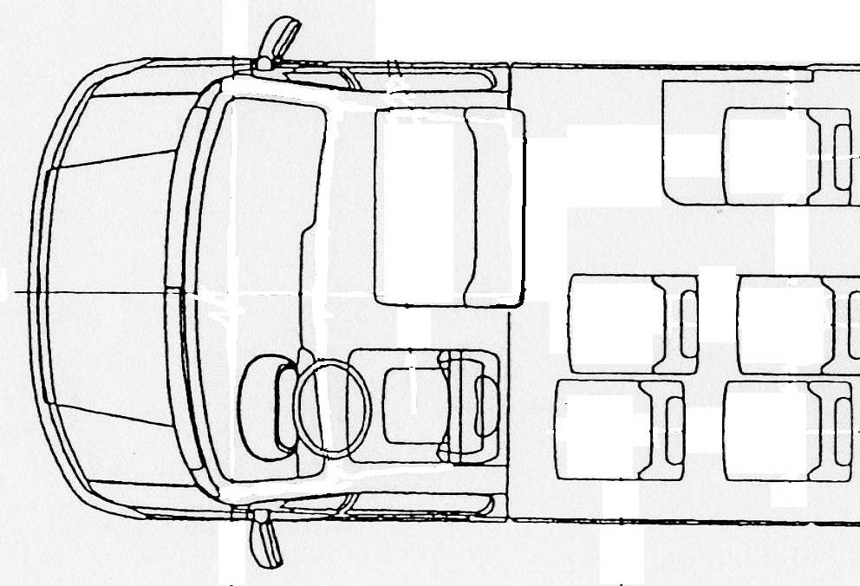
Test gauge of 600 mm x 400mm as in Annex 3, paragraph 7.7.3.3.

Gangway test gauge

Up to five additional seats may be fitted in a compartment incorporating the driver’s compartment, provided that the additional seats and the space for these seats comply with all requirements of this Regulation and at least one door giving access to the passenger compartment complies with the requirements of paragraph 7.6.3. for emergency doors.  7.6.1.7.3. In the circumstances described in paragraphs 7.6.1.7.1. and 7.6.1.7.2., the exits provided for the driver’s compartment shall not count as one of the doors required by paragraphs 7.6.1.1. to 7.6.1.2., nor as one of the exits required by paragraph 7.6.1.4., except in the case mentioned in paragraphs 7.6.1.7.1. and 7.6.1.7.2. Paragraphs from 7.6.3. to 7.6.7., 7.7.1., 7.7.2. and 7.7.7. shall not apply to such exits.  7.6.1.8. If the driver’s compartment and any seats adjacent to it are accessible from the main passenger compartment by means of a passageway complying with one of the conditions described in paragraph 7.7.5.1.1., no external exit is required from the driver’s compartment. | Up to five additional seats may be fitted in a compartment incorporating the driver’s compartment, provided that the additional seats and the space for these seats comply with all requirements of this Regulation and at least one door giving access to the passenger compartment complies with the requirements of paragraph 7.6.3. for emergency doors.  It is clearer if paragraph 7.6.1.7.2. only deals with the driver’s seat and seats alongside which do not have a passageway to the passenger’s compartment and to put the requirements for the five additional seats in a new paragraph 7.6.1.7.5.  - Paragraphs 7.6.3. to 7.6.7., 7.7.1., 7.7.2. and 7.7.7. shall not apply to such exits.  Having prescribed when and where exits are required it is better to fix their technical requirements immediately, rather than to “hide” them in the last sentence of a following paragraph. So, I propose to move the last sentence of paragraph 7.6.1.7.4., which defines the technical requirements for the exits specified in paragraphs 7.6.1.7.1. & 7.61.7.2., from that paragraph and put it alone in a revised paragraph 7.6.1.7.3.  - In the circumstances described in paragraphs 7.6.1.7.1. and 7.6.1.7.2., the exits provided for the driver’s compartment and any seats alongside the driver shall not count as one of the doors required by paragraphs 7.6.1.1. to 7.6.1.2., nor as one of the emergency exits required by paragraph 7.6.1.4. for a passenger compartment , except in the case mentioned in paragraphs 7.6.1.7.1. and 7.6.1.7.2. Paragraphs from 7.6.3. to 7.6.7., 7.7.1., 7.7.2. and 7.7.7. shall not apply to such exits.  The text of existing paragraph 7.6.1.7.3. is virtually incomprehensible. I believe that the intention is that when the driver’s compartment and any passenger seats alongside the driver do not have an acceptable passageway to a passenger compartment, then the driver’s door and the passenger’s door on the opposite side of the vehicle shall not be counted as exits for the passenger compartment since they are not accessible to the passengers.  - Up to five additional seats may be fitted in a compartment incorporating the driver’s compartment, provided that these the additional seats and the space for them these seats comply with all requirements of this Regulation and at least one of the exits required by paragraph 7.6.1.7.1. is an emergency door complying complies with the requirements of paragraph 7.6.3.1.2. 7.6.3. for emergency doors. giving access either to the passenger compartment or to the exterior of the vehicle.  Moved from paragraph 7.6.1.7.2. and modified to make it clear :  a) that the five seats include any passenger seats alongside the driver;  b) that this compartment must have at least two exits, one of which must be an emergency door giving access to the main passenger compartment or to the exterior of the vehicle.  - If the driver’s compartment is accessible from the main passenger compartment by means of a passageway complying with the requirements of paragraph 7.6.1.7. and any seats adjacent to it are accessible from the main passenger compartment by means of a passageway complying with one of the conditions described in paragraph 7.7.5.1.1., no external exit is required from the driver’s compartment.  It is necessary to introduce into this paragraph the reference to paragraph 7.6.1.7. which now specifies the passageway from the driver’s compartment.

7.6.1.9. If a driver’s door or other exit from the compartment is provided in the circumstances described in paragraph 7.6.1.8. it may only count as an exit for passengers provided:  7.6.1.9.1. it satisfies the requirements relating to the dimensions of emergency door indicated in paragraph 7.6.3.1.;  7.6.1.9.2. it fulfils the requirements indicated in paragraph 7.6.1.7.2.;  7.6.1.9.3. the space reserved for the driver’s seat shall communicate with the main passengers’ compartment through an appropriate passage; such requirement shall be deemed to be fulfilled if the test gauge described in paragraph 7.7.5.1. can move unobstructed from the gangway, until the front end of the gauge reaches the vertical plane tangential to the foremost point of the driver’s seat back (this seat being situated in its rearmost longitudinal position) and, from this plane, the panel described in paragraph 7.6.1.7.2. could be moved to the emergency door in the direction established by such paragraph (see Annex 4, figure 28) with seat and steering wheel adjustment in their mid position.  7.6.1.10. Paragraphs 7.6.1.8. and 7.6.1.9. do not preclude there being a door or other barrier between the driver’s seat and the passenger compartment provided that this barrier can be released quickly by the driver in an emergency. A driver’s door in a compartment protected by such a barrier shall not be counted as an exit for passengers. | 7.6.1.9. If a driver’s door or other exit from the driver’s compartment is provided in the circumstances described in paragraph 7.6.1.8. it may only count as one of the required exits an exit for passengers in vehicles of Class A or B provided:  If a door or exit is voluntarily provided and complies with paragraph 7.6.1.8., it can be counted as an exit for the passengers. However, this should be limited to vehicles of Class A or B as this possibility came from R.52 and did not exist in R.36.  7.6.1.9.1. it satisfies the requirements relating to the dimensions of emergency door indicated in paragraph 7.6.3.1.2. 7.6.3.1.;  The requirements for emergency doors are specified in paragraph 7.6.3.1.2. so it is more precise to specify this paragraph rather than paragraph 7.6.3.1., which applies to all exits.  7.6.1.9.2. it fulfils the requirements indicated in paragraph 7.6.1.7.2.;  7.6.1.9.3. the space reserved for the driver’s seat shall communicate with the main passengers’ compartment through an appropriate passage; such requirement shall be deemed to be fulfilled if the test gauge described in paragraph 7.7.5.1. can move unobstructed from the gangway, until the front end of the gauge reaches the vertical plane tangential to the foremost point of the driver’s seat back (this seat being situated in its rearmost longitudinal position) and, from this plane, the test gauge panel described in paragraph 7.6.1.7.2. can could be moved to the emergency door in the direction established by such paragraph (see Annex 4, figure 28) with seat and steering wheel adjustment in their mid position.  Paragraph 7.6.1.2. mentions a test gauge and not a panel. “Can” is better than “could”  7.6.1.9.4. If there is a door opposite the driver's door, the provisions of paragraph 7.6.1.9. shall apply to it, provided that there is not more than one passenger's seat beside the driver.  Paragraph 7.6.1.9.4. is introduced to allow a door for 1 passenger seated alongside the driver to be used as an emergency door for the main passenger compartment. This is taken from paragraph 5.7.2.5. of R.52.  7.6.1.10. Paragraphs 7.6.1.8. and 7.6.1.9. do not preclude there being a door or other barrier between the driver’s seat and the passenger compartment provided that this barrier can be released quickly by the driver in an emergency. A driver’s door in a compartment protected by such a barrier shall not be counted as an exit for passengers.

