 | United Nations | ECE/TRANS/WP.29/GRSG/2010/27
 | Economic and Social Council |  | Distr.: General  27 July 2010  Original: English  English and French only
Economic Commission for Europe
Inland Transport Committee
World Forum for Harmonization of Vehicle Regulations
Working Party on General Safety Provisions
Ninety-ninth session
Geneva, 19-22 October 2010
Item 3(a) of the provisional agenda
Regulation No. 107 (Construction of M₂ and M₃ vehicles) -
Proposals for further amendments
Proposal for amendments to Regulation No. 107
Submitted by the expert from the International Organization of Motor Vehicle Manufacturers *
The text reproduced below was prepared by the expert from the International Organization of Motor Vehicle Manufacturers (OICA) in order to incorporate a 50mm radius at the base of the gangway gauging device. It is based on informal document GRSG-98-10. The modifications to the current text of the Regulation are marked in bold for new or strikethrough for deleted characters.
I. Proposal
Annex 4, Figure 6, amend to read:

“Figure 6:
Gangway Mannequin.
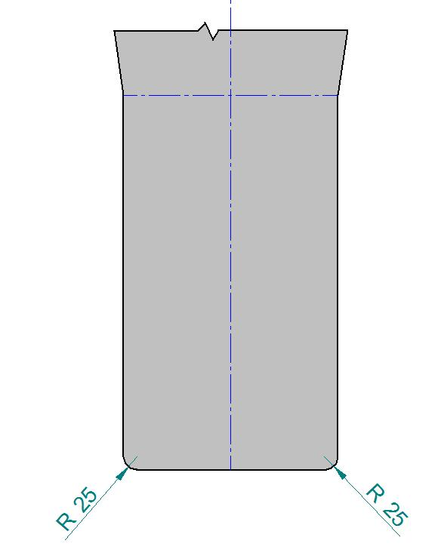
”
II. Justification
1. It is desirable to incorporate a “Clean-Easy” floor covering arrangement to reduce/eliminate dirt traps, e.g. by wrapping the gangway floor covering up onto seat bases/seat boxes/plinths; this creates a small radius at the transition from horizontal gangway floor covering to vertical seat base/box/plinths, thereby eliminating the dirt trap created at a square transition.
2. Existing Regulation No. 107 “Gangway Mannequin” has square transition from vertical to horizontal planes at its base, preventing “Clean-Easy” floor covering arrangement from being employed. Following the initial proposal (Informal document GRSG-98-10), comments returned suggested that 25mm radius would be more appropriate than the initially proposed 50mm at base of mannequin in order to allow “Clean-Easy” flooring.
3. The proposal is thus modified to reflect these views.

* * In accordance with the programme of work of the Inland Transport Committee for 2006-2010 (ECE/TRANS/166/Add.1, programme activity 02.4), the World Forum will develop, harmonize and update Regulations in order to enhance the performance of vehicles. The present document is submitted in conformity with that mandate.

