Particle Measurement Programme (PMP) Heavy-duty Inter-laboratory Correlation Exercise (ILCE_HD) Final Report

Jon Andersson, Athanasios Mamakos, Barouch Giechaskiel, Massimo Carriero, Giorgio Martini

January 2010
Contents
1. INTRODUCTION 10
2. OBJECTIVES 11
3. NATURE AND SCOPE OF THE ILCE_HD 11
3.1 Background to the PMP 11
3.2 PMP Phase 3 Inter-laboratory Exercise for Light-duty Vehicles 11
3.3 Brief Overview of the Inter-laboratory Correlation Exercises for Heavy-duty Engines 13
3.4 Test Engine and Emissions Control System 14
3.4.1 CRT: Pt-based Oxidation Catalyst and Wall-flow DPF 15
3.5 Fuel and Lubricant 16
3.6 Gaseous Emissions Measurement Systems 16
3.7 Dilution Approaches 17
3.7.1 Principles of the Dilution Systems 17
3.8 Particulate Mass Measurements 20
3.8.1 Full Flow Measurements 20
3.8.2 Partial flow Measurements 21
3.9 Particle Number Measurement Systems 22
3.9.1 Principles of the Measurement System 22
3.9.2 Golden Particle Measurement Systems 22
3.9.3 Other PMP type systems 24
3.9.4 PMP like systems: 24
3.9.5 Additional Instrumentation 25
3.10 Test Programme 25
3.10.1 Participating Laboratories 25
3.10.2 Summary of Preliminary Experiments 26
3.10.3 Daily Protocol 34
4. STATISTICAL ANALYSES 35
4.1 Definitions 35
4.1.1 Basic statistical concepts 35
4.1.2 Intra- And Inter-Laboratory Variance Estimators 36
4.1.3 Statistical outliers 36
5. CALIBRATION AND VALIDATION 38
5.1 Mass systems 38
5.2 Number systems 38
5.2.1 SPCS Calibration 39
5.2.2 3010D Calibration 44
5.2.3 Validation Exercises 44
6. EMISSIONS RESULTS 45
6.1 Full Flow and Partial Flow PM 45
6.1.1 PM - Repeatability 45
6.1.2 PM - Reproducibility 47
6.1.3 PM – Filter Weights, Background Levels and Background Subtraction 48
6.1.4 PM – Emissions Levels 51
6.1.5 PM – Daily Trends 56
6.1.6 Overview of PM Results 57
6.2 Full Flow and Partial Flow PN 57
6.2.1 PN – Tunnel background Levels 57
6.2.2 PN - Repeatability 59
6.2.3 PN - Reproducibility 67
6.2.4 PN – Emissions Levels 68
6.3 Gaseous Emissions 75
6.3.1 General Observations 75
6.3.2 Inter-Laboratory Variability 75
6.4 Long-Term Trends in Engine Operation 76
6.4.1 Regulated Gases 76
6.4.2 Particle Number Emissions 78
7. ADDITIONAL TESTWORK OVERVIEW 81
7.1 Mass Contributed by EC and by Particles 81
7.2 Further Filter Media Evaluations 83
7.3 Particle Number Measurements from PFDS at Constant Dilution Factors 85
8. COMPARISONS OF MEASUREMENT SYSTEMS 88
8.1 Comparison of Particle Number Measurements from CVS and PFDS 88
8.2 Comparison of Particulate Mass Systems 91
8.3 Mass vs. Number full flow 93
8.4 Mass Vs. Number Partial Flow 94
8.5 Comparisons of PMP type and PMP like systems 95
8.5.1 PMP type and PMP- Like Systems 95
8.5.2 Particle Losses 96
8.6 Results from Golden Engine equipped with DPF 97
8.6.1 PMP type systems 97
8.6.2 PMP like systems 99
8.7 Engine out and open flow emission levels 100
8.8 Gaseous Emissions 103
9. DISCUSSION AND OVERVIEW 103
9.1 Particulate Measurements 103
9.1.1 Validation Exercises 103
9.1.2 Tunnel Background Mass Levels - CVS 103
9.1.3 Tunnel Background Mass Levels - PFDS 104
9.1.4 Emissions Levels 104
9.1.5 Tunnel Background Subtraction 104
9.1.6 Partial Flow or Full Dilution 105
9.2 Particle Number Measurements 105
9.2.1 Golden Systems – PCRF Correction 105
9.2.2 Particle Number Tunnel backgrounds 105
9.2.3 Real-time Particle Emissions Elevated at Cold Start 105
9.2.4 PN Emissions Levels Compared with Backgrounds 106
9.2.5 PN Emissions levels 106
9.3 Simultaneous Particle Number and Particulate Mass Measurements 106
9.3.1 Required Corrections 107
9.4 Repeatability and Reproducibility 108
9.4.1 PM and PN – Repeatability 108
9.4.2 PM and PN – Reproducibility 108
9.4.3 Repeatability and Reproducibility Overview 109
9.5 Elemental carbon and non-volatile particle contributions to PM 109
9.6 Filter Media Effects 109
9.7 Other PMP type / like Systems 109
9.8 Should Solid Particles <23nm be Considered for European PN Legislation? 110
9.9 Achievable PN Limit for this Engine 111
9.10 An Alternative Approach to Sampling for PN Measurements 111
10. CONCLUSIONS 111
10.1 Engine Operation 111
10.2 Measurement Systems 111
10.3 PM Emissions 112
10.3.1 Levels 112
10.3.2 Repeatability / Reproducibility 112
10.4 PN Emissions 112
10.4.1 Levels 112
10.4.2 Repeatability / Reproducibility 113
10.5 Relationships Between Measurement Approaches 113
10.5.1 Full Vs Partial Flow Mass 113
10.5.2 Full Vs Partial Flow Number 113
10.5.3 Mass Vs Number 114
10.6 Other PMP type / Like Systems 114
10.7 General Conclusions 114
11. RECOMMENDATIONS 115

List of Figures

Figure 1: Typical Engine and Emissions Control System Installations 14
Figure 2: Schematic of Exhaust and Emissions Control System Layout 15
Figure 3: Schematic of Full Flow, Double Dilution System for PM Measurements 17
Figure 4: Schematic of Partial Flow Dilution System for PM Measurements 18
Figure 5: PFDS – Principle of Dilution 19
Figure 6: Flow schematic of the prototype SPCS 23
Figure 7: PM Sampling Set-up for Experiment 1 28
Figure 8: Experiment 1 - Background and Sampling Parameters for PM 28
Figure 9: Minimal Impact of Heated Line on PN Results 30
Figure 10: Minimal Impact of Cyclone on PN 30
Figure 11: DPF Preconditioning –Regeneration (Mode 10) and Fill (Mode 7) 32
Figure 12: Stable Mode 7 Selected for the Continuity Protocol 32
Figure 13: Particle Number Emissions <23nm 33
Figure 14: Weighing Room Validation Exercises - Ricardo 38
Figure 15: Apparatus for the Evaluation of Volatile Particle RE 39
Figure 16: VPR RE of 99.99% for 30nm n-C₄₀ particles 40
Figure 17: Apparatus for Evaluation of Solid Particle Penetration (Polydisperse) 41
Figure 18: Size Distributions (downstream dilution correction of 1050 applied) 41
Figure 19: Penetration at Different Dilution Ratios (Polydisperse) 41
Figure 20: Apparatus for Evaluation of Solid Particle Penetration (Monodisperse) 42
Figure 21: SPCS Penetration of 30nm Particles 42
Figure 22: SPCS Penetration of 50nm Particles 43
Figure 23: SPCS Penetration of 100nm Particles 43
Figure 24: Dilution Ratio Calibration – Fixed Secondary Dilution 44
Figure 25: Dilution Ratio Calibration – Fixed Primary Dilution 44
Figure 26: Repeatability of the CVS PM Method 46
Figure 27: Repeatability of the PFDS PM Method 47
Figure 28: Reproducibility of PM Methods 48
Figure 29: Sampled Filter Masses – Various Cycles, Both Measurement Systems 48
Figure 30: Filter Masses - Samples and Tunnel Backgrounds Compared 49
Figure 31: Tunnel Background and Sample PM levels - CVS 50
Figure 32: Background and Sample PM levels - PFDS 51
Figure 33: Maximum and Minimum Ranges of Emissions – CVS PM 54
Figure 34: Maximum and Minimum Ranges of Emissions – PFDS PM 55
Figure 35: CVS PM Emissions through the Test Sequence – All labs 56
Figure 36: PFDS PM Emissions through the Test Sequence – All labs 57
Figure 37: Tunnel background Impacts PN Results – CVS Systems at 3 Labs 58
Figure 38: Tunnel background Effect on PN Results Minimal– PFDS Systems at 3 Labs 59
Figure 39: Particle Number Tunnel backgrounds – 3 Labs; CVS and PFDS Facilities 59
Figure 40: Real-time Data – Cycle-to-cycle Repeatability, Cold WHTC 61
Figure 41: Real-time Data – Cycle-to-cycle Repeatability, Hot WHTC 62
Figure 42: Real-time Data – Cycle-to-cycle Repeatability, Hot WHSC 63
Figure 43: Passive Regeneration During the WHSC 64
Figure 44: Real-time Data – Cycle-to-cycle Repeatability, Hot ESC 65
Figure 45: Repeatability of Particle Number Measurement Systems 67
Figure 46: Reproducibility of Particle Number Measurement Systems 68
Figure 47: Maximum and Minimum Ranges for CVS-measured PN 70
Figure 48: CVS PN Results – Effect of Eliminating Outliers 71
Figure 49: Maximum and Minimum Ranges for PFDS-measured PN 73
Figure 50: All Labs’ Mean of Means PN Results - PFDS Systems 74
Figure 51: CO₂ – Consistency Across The Validation Exercise 77
Figure 52: NOx – Consistency Across The Validation Exercise 78
Figure 53: PN from cold-WHTC: Consistency Through The Test Programme 79
Figure 54: Real time PN Production from the CVS- Cold WHTC (JRC#1) 80
Figure 55: Real time PN Production from the CVS- Cold WHTC (JRC#2) 80
Figure 56: Fraction of PM Mass Contributed by Solid Particles (>300°C) 82
Figure 57: Fraction of Mass Contributed by EC 82
Figure 58: PM results obtained using TX40 and TEFLO filters – JRC CVS 84
Figure 59: PM results obtained using TX40 and TEFLO filters – JRC PFDS 84
Figure 60: Cycle Averaged PN Results: Proportional Vs. Constant Dilution 85
Figure 61: PN from Proportional and Constant Dilution Sampling Compared 86
Figure 62: Correlation of PN from Proportional and Constant Dilution Sampling 87
Figure 63: PM Sampled From Proportional Dilution and Constant Dilution 87
Figure 64: Correlations between PN Measured from CVS and PFDS Systems 89
Figure 65: Correlations between Real-time PN from CVS and PFDS Systems 89
Figure 66: Percentage Differences in PFDS Emissions Compared to CVS – All Labs 91
Figure 67: Correlations between PM Measured from CVS and PFDS Systems 92
Figure 68: PFDS PM results: % Difference to CVS PM Data 92
Figure 69: Relationship between Mass and Number Measurements (CVS) 93
Figure 70: Relationship between Mass and Number Measurements (PFDS) 94
Figure 71: No Correlation Exists PM & PN Even in a Very Low Emissions PFDS 95
Figure 72: Correlation between the GPMS and other PMP type systems 97
Figure 73: Comparison of real time PN in the CVS from the GPMS and from a dual ejector plus ET system over Cold and Hot WHTCs 98
Figure 74: Correlation between the GPMS and PMP like systems 100
Figure 75: Correlation between the GPMS and other PMP type systems at engine out emission levels 101
Figure 76: Correlation between the GPMS and PMP like systems at engine out emission levels 101

List of Tables

Table 1: Test Engine and Specification 14
Table 2: Exhaust System Installation Variability at the Test Laboratories 15
Table 3: Fuel specifications 16
Table 4: Lubricant Properties 16
Table 5: Principal Differences Between CVS Systems – Test Labs 21
Table 6: Principal Differences Between PFDS Systems – Test Labs 22
Table 7: Test Laboratories and Timeline 26
Table 8: Matrix for Emissions Testing 34
Table 9: Limits of Detection – PM Methods at JRC and EMPA (mg/kWh) 51
Table 10: Maximum and Minimum Ranges for CVS-measured PN 69
Table 11: Maximum and Minimum Ranges for PFDS-measured PN 72
Table 12: Contribution of soot and solid airborne particles on the PM collected on filters as determined by the Soot Sensor and the DMM, respectively 81
Table 13: Particle penetrations through the various PMP type / like systems used in the PMP HD validation exercise. 96
Table 14: Percentage difference between the different CPCs employed and the Golden CPC of SPCS19. 97
Table 15: Percentage differences in the number concentrations measured with the GPMS, PMP type and PMP-like systems 102

List of Appendices

Appendix 1: ILG_HD 117
Appendix 2: Certification of PNC Performance 150

Executive Summary

The Heavy Duty Inter-Laboratory Correlation Exercise has conducted testing at 5 test laboratories in the Europe in order to demonstrate the practicality, robustness, repeatability and reproducibility of the particle emissions measurement techniques proposed by the Particle Measurement Programme (PMP). The exercise involved testing a Golden Engine (a Euro III Iveco Cursor 8, equipped with a wall-flow Diesel Particulate Filter), at all participating laboratories to allow the inter-laboratory reproducibility of measurements to be assessed. Each laboratory tested the engine over multiple repeats of the heavy duty World Harmonised Transient Cycle (both cold and hot start) and World Harmonised Steady state Cycle (WHSC) as well as current EU regulatory cycles the European Transient Cycle (ETC) and European Steady state Cycle (ESC). Measurements of solid particle number emissions, particulate mass and regulated gaseous emissions were taken over each test. Particle emissions measurements were taken from both full flow (CVS) and partial flow (PFDS) dilution systems at each laboratory. Two ‘Golden’ particle number measurement systems were circulated between the test laboratories, one for use in CVS measurements one for use in PFDS measurements. In addition laboratories made particle number measurements using several alternative, PMP type systems to compare the performance of different measurement systems. The Golden Measurement systems performed reliably at all laboratories and agreed within 5% when making measurements in parallel.
Particulate mass (PM) emissions levels from the Golden Engine using CVS sampling systems were below 6mg/kWh across all test cycles after exclusion of outlying test results. High tunnel background contributions in some laboratories CVS systems resulted in higher outlying results. PFDS systems returned slightly lower PM results (below 4mg/kWh). In this exercise tunnel background PM measurements were generally found to be similar to engine measurements, although ESC cycle results sampled from PFDS systems could be discriminated from tunnel background levels by all laboratories. PM measurement repeatability from PFDS was 20-30% for all test cycles and rather higher 35-56% for CVS measurements after exclusion of outliers. Reproducibility between laboratories was 35-45% for PFDS measurements and 35-55% for CVS measurements.
Particle number (PN) emissions levels from the Golden Engine varied significantly from cycle to cycle. The cold start WHTC gave the highest PN levels, approximately 4x10¹¹/kWh from both CVS and PFDS dilution systems. At these levels tunnel background PN concentrations did not significantly influence measurements. Hot start WHTC and ETC cycles gave PN levels around 5-9x10⁹ /kWh, steady state cycles gave higher results (2-3x10¹⁰ /kWh on the WHSC and 6-8x10¹⁰ /kWh on the ESC) possibly due to higher exhaust temperatures resulting in some passive regeneration and resulting reduction in filtration efficiency as the soot cake on the Diesel Particulate Filter is reduced. On these test cycles tunnel background levels were found to have a significant impact in the case of some laboratories CVS systems, PFDS tunnel background levels however were significantly lower in did not influence PN results. Where tunnel background concentrations were low correlation between CVS and PFDS measurements was excellent.
PN repeatability levels across the different test cycles ranged from 20-60% for CVS sampling with best repeatability being on the cold WHTC (where PN levels were highest) and worst on the WHSC where partial passive regeneration of the Diesel Particulate Filter may result in less stable PN emissions from the engine. PFDS repeatability ranged from 20-70%, with best and worst results again on cold WHTC and WHSC respectively, however, as noted above, on the lower emissions cycles PFDS measurements were less influenced by tunnel background levels than was the case for CVS measurements. PN reproducibility between laboratories was generally similar to repeatability. Across the different test cycles PN reproducibility ranged from 30-80% for CVS sampling and 50-86% for PFDS sampling.
Results from alternative PN measurement systems conforming to PMP principles generally correlated to the Golden System measurements within 15% although some systems showed greater offsets. Additional experiments conducted during the exercise for investigative purposes showed that, contrary to results from some US research, reported concentrations of solid particles of less than 23nm diameter were low relative to those of larger than 23nm particles. This confirms the suitability of the 23nm lower size cut-off for the particle number counter.
The results of this exercise demonstrate that the PM measurement method is suitable to confirm that engine emissions are below 10mg/kWh. PM measurements of an engine equipped with an efficient wall-flow Diesel Particulate Filter were similar across all test cycles. In this exercise PM measurements could not generally be discriminated from tunnel background PM measurements. The PN emissions measurement method was able to discriminate between the emissions levels on different test cycles of an engine equipped with an efficient wall-flow Diesel Particulate Filter. PN was also able to discriminate engine emissions from tunnel background levels in this exercise except in the case of high tunnel background sampling systems during testing on cycles with lower emissions levels.
Particle Measurement Programme (PMP) Heavy-duty Inter-laboratory Correlation Exercise (ILCE_HD) Final Report

INTRODUCTION
The effect of exhaust emissions from road vehicles on public health has long been a concern. Legislation limiting the pollutant emissions of new vehicles is well established in many regions of the world. One emission of special concern is particulate matter. In vehicle exhaust this consists of tiny solid particles and liquid droplets ranging in size from a few nanometres to up to around one micrometre in diameter. Current legislative emissions standards regulate particle emissions in terms of the total mass of particulate matter emitted per kilowatt hour. This is effective at controlling emissions of larger size particles, but particles at the smaller end of the size range contribute little to the total mass of particulate matter emitted.
There is a growing consensus amongst health experts that particles in the ultrafine (<100nm diameter) size range may be those which are having the greatest adverse effect on human health. The main driver behind Particle Measurement Programme (PMP) is the impact of particles on human health. The PMP has no medical expertise and does not seek to pre-judge the advice that may emerge from medical experts with respect to the most crucial particle characteristics affecting human health. Nonetheless, current medical opinion suggests that reductions in particle emissions will lead to improved air quality and health and the PMP has therefore moved forward on the basis of the precautionary principle. This and the potential limitations of current regulatory procedures at forcing technology that would control these particle emissions led to the setting up of the PMP as a Working Group of the UN-ECE GRPE. PMP is essentially a collaborative programme of Government sponsored research projects. However the Working Group, chaired by the UK, exists to co-ordinate the research and ensures that the programme is open to contributions from a wider audience. National Governments, individual laboratories, exhaust aftertreatment, automotive industry and fuel industry representatives have all provided significant input to the programme.
The mandate given to the PMP Working Group by GRPE was to develop new particle measurement techniques to complement or replace the existing particulate mass measurement, with special consideration to measuring particle emissions at very low levels. These techniques should include a detailed specification of test procedures and equipment, be suitable for Light Duty Vehicle and Heavy Duty Engine type approval testing and be suitable for use in transient testing. Since, within the EU, type approval testing to demonstrate compliance with emissions standards involves a limited number of tests which could take place at one of many laboratories, good repeatability and reproducibility from laboratory-to-laboratory are key requirements for regulatory measurement techniques. PMP has therefore sought to demonstrate the repeatability and reproducibility of the proposed techniques. PMP was also tasked with accumulating data on the performance of a range of engine/vehicle technologies when tested according to the proposed procedures.

OBJECTIVES

NATURE AND SCOPE OF THE ILCE_HD

Background to the PMP
In 2001, the French, German, Netherlands, Swedish and United Kingdom Governments agreed to a collaborative programme aimed at developing new methods and procedures to facilitate the control of ultrafine particles within a regulatory framework. This programme was designed to deliver a regulatory procedure that would either replace or complement the existing procedure used for particulate mass measurement.
The resulting Particle Measurement Programme (PMP) working group, chaired by the United Kingdom’s Department for Transport, operates under the auspices of the UN-ECE, where the government of Switzerland joined the consortium. Japanese and Korean governments have also contributed.
The PMP working group devised a three-phased approach to the PMP Programme.
In the first two phases of the programme, a wide range of measurement instruments and sampling systems were assessed over standard regulatory tests:
In the PMP Phase 1 study, measurement systems addressing several key particle properties including mass, number, active surface and chemistry were evaluated along with appropriate dilution methods, sample conditioning and consideration of cost and logistical aspects.
Phase 2 subjected the best performing systems from Phase 1 to more rigorous evaluations. Aims were to confirm the results of Phase 1 and determine fundamental levels of repeatability within a single laboratory during a variety of steady state and transient tests with both engine-out and post-DPF exhaust aerosols. The testing from Phase 2 enabled the conclusions that a revised filter mass measurement method and a particle number method both, based upon sampling from a standard dilution system, best met the original objectives of the programme. The two recommended systems were:
- A filter method based broadly upon those currently used in Europe and the US and that proposed for the US for 2007 type approvals
- A particle number method using a Particle Counter, a selected size range and sample pre-conditioning to eliminate volatile particles

Draft revised versions of the light-duty vehicle (DR83 []) and heavy-duty engine (DR49 []) particulate regulatory sampling annexes were prepared from the existing regulatory documents: R83 [] and R49 [].
The new documents integrated the PMP particulate and particle number approaches into the existing regulatory framework and also formed the bases for two test protocol documents written as laboratory guides for testing. The PMP Phase 3 “Inter-Laboratory Correlation Exercises” (ILCE) for light-duty vehicles (ILCE_LD) and heavy-duty engines (ILCE_HD) then commenced with the light duty vehicles’ exercise.

PMP Phase 3 Inter-laboratory Exercise for Light-duty Vehicles
The light duty vehicles’ exercise circulated a Euro 4 light-duty Diesel vehicle equipped with an OEM fit Diesel Particulate Filter (DPF) plus a reference “Golden” particle measurement system (GPMS) between laboratories. In addition, each lab was invited to employ other particle measurement systems constructed to meet the design criteria of the GPMS, and to test other Euro 4 vehicles. Testing followed the procedures described in the inter-laboratory guide for light-duty vehicles (ILG_LD) [] and comprised the measurement of regulated gaseous emissions, particulate mass and particle number from repeat NEDC tests. To ensure maximum consistency of testing between laboratories, the Golden Engineer and project manager visited the participating labs to advise on facility modifications, how to undertake the test protocols and installation and operation of the GPMS. Low sulphur fuel and lubricant from the same batches were also used at all labs.
The ILCE_LD has now completed, with the final report published in June 2007 [] and extended data analyses published in the scientific literature [], [].
The general conclusions of the ILCE_LD are presented below:
- The revised PMP mass method provides repeatable measurements at well below 2.5 mg/km, but the method collects a large gaseous volatile fraction that may be 20 times the mass of the solid particles collected.
- Both mass and number measurement approaches appear to have detection limits low enough to discriminate between a highly efficient wall-flow DPF equipped Diesel and non-DPF equipped Diesel vehicles. In this testing, the mass method proved unable to discriminate a porous wall-flow DPF from a more efficient one.
- The PMP Particle Number method proved to be less variable than the PMP mass method for Euro-4 non-DPF diesel cars, with repeatability levels from 6 vehicles at ≥5%.
- Comparing the lowest emissions of the non-DPF Diesels and the highest emissions of the efficient wall-flow DPF equipped Diesels, the number method showed a difference of >300 times and the mass method a difference of ~18 times. This can be expressed as a difference in discriminating power approximately 20 times greater for the number method than for the mass method.
- Mass and number measurement equipment presented no significant functional challenges during the 2 year programme. Minor maintenance issues did occur but these were dealt with as normal service issues.
- The PMP number method presents improvements over the PMP mass method in terms of limit of detection, accuracy, discrimination power and variability when measuring a stable particle source. For these reasons, the number method is a superior alternative to the existing or a revised mass method for future regulatory procedures.
The conclusions of the final report, and consultations with stakeholder groups including national Governments, the European Commission, the automotive industry, Tier 1 suppliers and the test houses were used to finalise a new Annex for the R83 which introduced the particle number procedure for certification testing. Modifications to the particulate mass measurement procedure were also integrated. The new procedures came into force with the official publication of the procedures during February 2009.

Brief Overview of the Inter-laboratory Correlation Exercises for Heavy-duty Engines
Following the successful completion of the ILCE_LD, the PMP working group determined the scope of the heavy-duty exercise. This essentially comprises 3 parts:
- Investigative work to develop and finalise a robust inter-laboratory guide for heavy-duty engines testing. Experiments included identifying background PM and PN levels, effects of different filter media, impacts of filter face velocity changes, exhaust and engine preconditioning effects, comparisons of different particle number systems and investigation of the golden instruments. .A full report of the experimental work has been published previously [,] and an overview is given in Section 3.10.2. The final inter-laboratory guide [] is included in this report as Appendix 1.
- The validation exercise: analogous to the ILCE_LD, this programme investigated particle number repeatability and reproducibility by transporting a Golden engine to each test laboratory in turn. Along with the engine, two Golden Particle Measurement Systems (GPMS) were shipped to permit particle number measurements to be made simultaneously from both full flow constant volume sampler (CVS) dilution and partial flow dilution (PFDS) systems. As in the ILCE_LD, participating laboratories were also invited to test their own particle measurement systems, or other commercially available particle numbers systems. PM and gaseous emissions were also measured. The Golden Engineer and the project manager ensured that participating labs correctly followed the measurement protocols defined in the inter-laboratory guide. Low sulphur fuel and lubricant from the same batches were used at all labs. The participating labs were JRC (Ipsra, Italy), AVL_MTC (Sweden), Ricardo (UK), UTAC (France), and EMPA (Switzerland). Each test laboratory was funded by its respective national government. JRC undertook duplicate measurement campaigns – at the start and end of testing - to monitor consistency of emissions through the programme. Testing in the validation exercise completed at JRC in October 2009.
- The round robin exercise: adhering to the principles of an automotive industry round-robin exercise, this programme is complementary to the validation exercise, but subtly different. Its objective is purely the evaluation of particle number repeatability and reproducibility using different measurement systems. In the round robin, a reference engine is circulated, but each lab uses its own particle number systems from full or partial flow dilution tunnels. All labs will use fuel and lubricant of the same types (but not necessarily from the same batches). PM and regulated gaseous emissions will also be measured. Laboratories from the EU, Japan, Korea and Canada are all participating in the programme. While testing in the round-robin exercise has completed at several laboratories, work is on-going, with completion anticipated during 2011.
This report describes the procedures, results and conclusions of the PMP Phase 3 validation exercise in detail. Once it has completed, the round-robin exercise will be reported separately.

Test Engine and Emissions Control System
The engine employed in the test programme was a series production IVECO Cursor 8 engine in EU III specification; a modern 7.8 litre , 6-cylinder engine used in heavy-duty vehicle and bus applications. Further details can be found in Table 1.
Table 1: Test Engine and Specification
IVECO Cursor 8 (Euro 3)
Details | 7.8 l, 6 cylinder, 4 valves/cylinder
Compression ratio | 17:1
Maximum power | 295 kW @ 1900 to 2400 rpm
Maximum torque | 1280 Nm @ 1000 to 1900 rpm
After-treatment | Continuous Regenerating Trap (CRT)
Oxicat | Pt-based: 10.5x3" catalyst section; approx 4.25 litres.
DPF | Wall-flow DPF: 11.25x14"; approx 24 litres

Figure 1 (below left) illustrates a typical installation of the engine, in this case the first test laboratory, JRC. The right-hand part of Figure 1 illustrates the exhaust system layout at JRC which was used to devise a set of benchmark dimensions for installations at all the other test laboratories.

A guide to installation and commissioning was supplied with the test engine and a support engineer visited each test laboratory to facilitate these processes. After testing at JRC this guide was updated to include the exhaust system layout and sampling positions for the PFDS, raw gas analysers and temperature and pressure sensors. A schematic representation of the engine and exhaust layout is given in Figure 2.
Figure 1: Typical Engine and Emissions Control System Installations
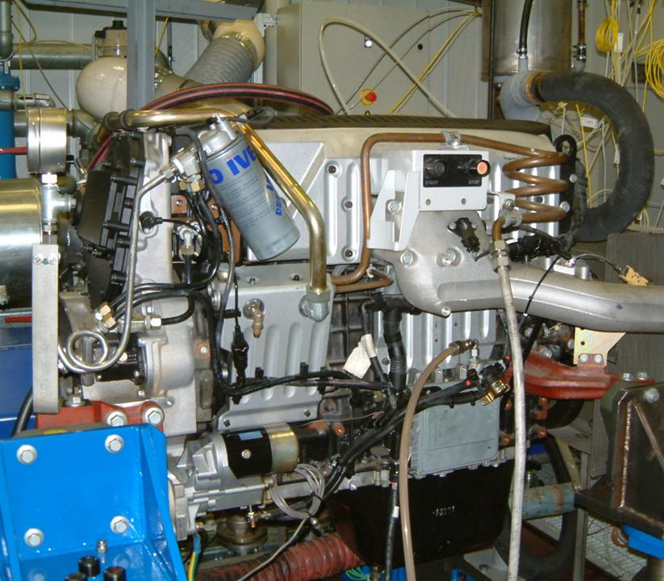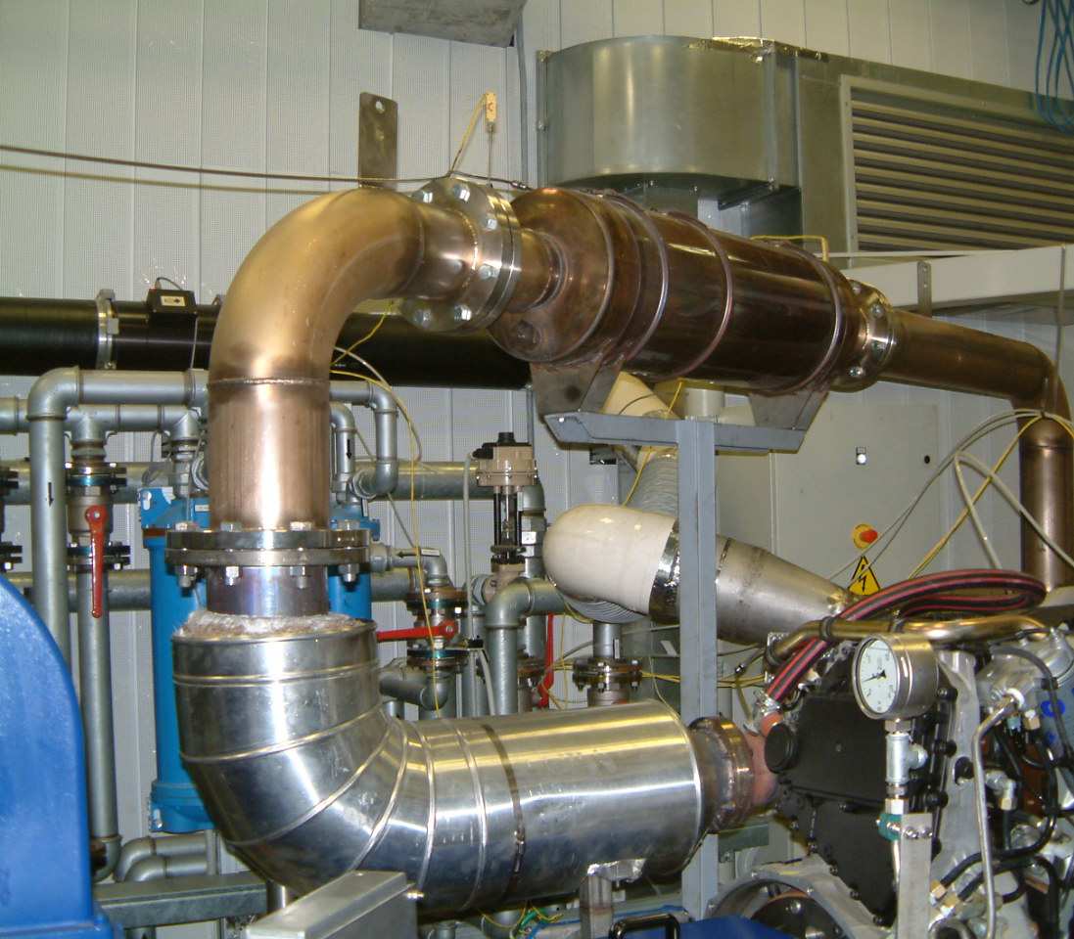

A degree of variability, due to the constraints of test cell size and orientation, was expected during engine, exhaust system and PM / PN measurement system installations. Differences are summarised in Table 2. Generally, differences between labs were small and are not expected to have impacted results.
Figure 2: Schematic of Exhaust and Emissions Control System Layout
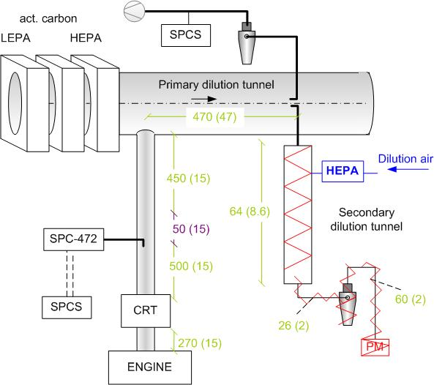

Numbers in Figure 2 indicate component lengths (and diameters in parentheses) in cm.

Table 2: Exhaust System Installation Variability at the Test Laboratories
Sampling Dimensions :length in cm  diameter (cm) | AVL MTC | JRC | Ricardo | UTAC | EMPA
Engine-CRT | 250 (15) | 270 (15) | 165 (15) | 100 (15) | 299 (10)
CRT-PFDS | 700 (15) | 500 (15) | 395 (15) | 350 (15) | 934 (12.5)
CRT-CVS | 1100 (15) | 950 (15) | 930 (15) | 750 (15) | 1469 (12.5)
CRT-CVS Insulated | 1100 (15) | 600 (15) | 200 (15) | 450 (15) | 1045 (12.5)
PFDS-SPCS20 | 150 | 150 | 400 | 150 | 320
CVS sampling point – CVS mixing point | 500 (50) | 470 (47) | 500 (45) | 575 (45) | 470
CVS-SPCS19 | 400 | 400 | 360* | 400 | 202

* Ricardo used a heated line at 47°C to extend the 1m Horiba sampling line to ~4m.

CRT: Pt-based Oxidation Catalyst and Wall-flow DPF
The DPF employed in the test programme was a cordierite wallflow filter of approximately 24 litres volume and originally supplied by Johnson-Matthey. The ratio of DPF volume to engine size is therefore approximately 3, which is larger than the 1.5 to 2.5 typically employed in current HD applications.
The DPF is preceded in the exhaust system by a close-canned Pt-based oxidation catalyst (Eminox) of approximately 4.25 litres volume.

Fuel and Lubricant
Fuel and lubricant were supplied to the PMP programme by members of Concawe.

The test fuel was provided by Total, who isolated a large batch of the certification reference fuel RF06-03 and nominated it RF06-03-PMP. Participating labs purchased quantities of this batch directly from the supplier. This fuel fully complies with Annexes 3 and 4 of Directive 2003/17/EC describing fuel specifications to be employed after 1st January 2009 (i.e. sulphur content of < 10 ppm). Selected properties are given in Table 2 and the detailed specifications can be found on the final page of Appendix 1.

Table 3: Fuel specifications
Properties | Units | Value
Cetane Number | [-] | 53.1
Density | [kg/m³] | 834.9
Sulphur | [ppm] or [mg/kg] | 7
Polycyclic aromatics | [%] by mass | 5.1

The test lubricant (Table 4: Lubricant Properties) was a BP Vanellus E8 fully synthetic, 5W/30 PAO (polyalphaolefin) based oil with <0.2% sulphur content. Defined oil change and conditioning procedures were employed at each laboratory to standardise oil conditioning and eliminate this as a source of variability in the results.

Table 4: Lubricant Properties
Density @ 15°C | 0.860kg/litre
Kinematic viscosity @100°C | 12.03mm²/s
Viscosity Index | 163
Viscosity CCS @ -30°C | 5260 CP
Total Base Number | 15.9 mg KOH/g
Sulphated Ash | 0.19%

Gaseous Emissions Measurement Systems
During emissions tests at all laboratories selected gaseous emissions were measured on a continuous basis from both raw and diluted exhaust. In addition, some laboratories supplied cumulative 'bagged' sample results.
Raw exhaust samples were drawn directly from the exhaust line, while diluted samples and bagged analyses were made from the full-flow dilution system.
Regulated exhaust gases and their methods of analysis are given below:
- Total hydrocarbons (THC): performed using a heated Flame Ionisation Detector (FID)
- Oxides of Nitrogen (NOx): conducted using a Chemiluminescence Analyser (CLA). CLA detects photons that are emitted by excited NO₂ molecules generated in the instrument reaction chamber from NO. Excited NO₂ emits photons of a specific wavelength. The light generated in the reaction is proportional to the NO present in the sample. All the NO₂ in the sample gas is reduced to NO prior to the reaction chamber. The combined concentration of NO+NO₂ is measured. As most oxides of nitrogen are generally in one of these two forms, this measurement is expressed as NOx
- Carbon Monoxide (CO) using a Non-Dispersive Infra-red (NDIR) instrument
- Though currently unregulated, carbon dioxide emissions were also measured: using a Non-Dispersive Infra-red (NDIR) instrument.

During the validation exercise, instrumentation provided by the following analyser suppliers was used for gaseous emissions analysis:

- Horiba
- AVL (both own branded and Pierburg)

Dilution Approaches

Principles of the Dilution Systems
In Europe since the implementation of Euro IV legislation, two dilution approaches have been considered equivalent for the measurement of particulate mass during certification testing. These full and partial flow dilution approaches are shown in schematic form in Figure 3 and Figure 4 respectively.
Figure 3: Schematic of Full Flow, Double Dilution System for PM Measurements
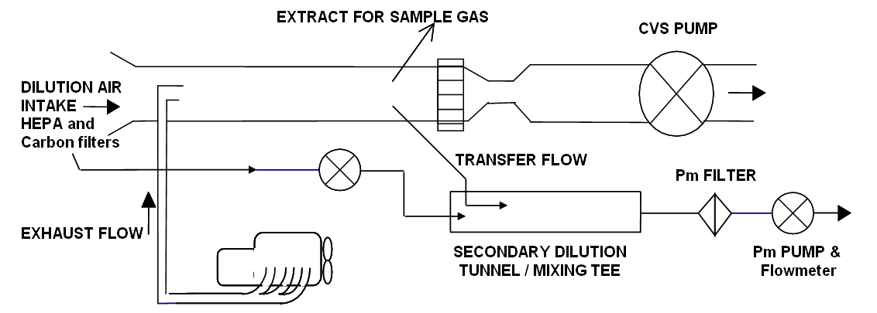

Figure 4: Schematic of Partial Flow Dilution System for PM Measurements
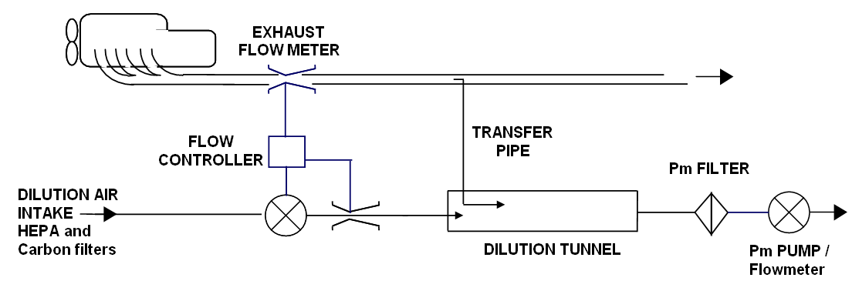

Full flow dilution
In a full flow dilution system, the entire exhaust is sampled and diluted but the total flow through the dilution system is maintained at a constant level. This is known as constant volume sampling and the dilution tunnel is often referred to as the constant volume sampler (CVS). Since the exhaust flow varies with engine operation but the total flow through the CVS is fixed, the dilution ratio varies during a test.
Heavy-duty dilution systems in Europe tend to be twin stage systems with a small secondary dilution system in series from the main CVS. This secondary dilution system takes a fixed proportion of the flow from the CVS and dilutes it by a preselected ratio. The main aim of this step is to reduce the temperature of the diluted exhaust.
Diluted exhaust is drawn from the secondary dilution system through a filter. The sampled flow rate must be virtually constant and, by definition, proportional to the total flow through the CVS.
In the validation exercise, all the full-flow dilution systems were employed with secondary dilution systems for mass measurements, but particle number measurements were drawn directly from the primary CVS.
The main issues with CVS dilution systems are:
- The transfer time between engine emission and measurement of real time diluted gases in the CVS makes the identification of real time emissions effects complex
- Hydrocarbons and PM are known to deposit and release from the transfer system between the exhaust manifold and CVS
- Finally, the full flow CVS is a large, often ceiling-mounted, tube which is difficult to remove and consequently to clean. Carryover of PM emissions from previous tests may result in high background levels
Full flow dilution systems provided by Horiba and AVL were tested in this work.

Partial Flow dilution
Partial flow dilution systems (PFDS) are simpler, more compact and less expensive than CVS.

In a PFDS, a fraction of the raw exhaust (a partial flow) is sampled and diluted. However, the transfer flow from exhaust to tunnel must be proportional to the total flow through the exhaust: In Figure 5; Q1 must constantly change during the transient cycle and this is achieved by varying the flow of dilution air that is added (Q3). As in the CVS, the total flow, Q2, remains constant, but unlike the CVS the entire tunnel flow is drawn through the PM filter.

If an additional flow (Q4) is drawn for further mass or number measurements, an identical increase in the transfer flow, Q1 occurs. This reduces the dilution ratio in the tunnel and would increase the measured PM, so an equivalent flow to Q4 must either be added back upstream of the flow measurement device (which is positioned downstream of the PM filter) or the changes in dilution corrected automatically by the software.

During preliminary work for this programme, JRC performed a comparison of PN measurements from partial flow systems which had both physical correction for the removal of Q4 (i.e. the flow was replaced) and software correction for the removal of Q4Error: Reference source not found. These two approaches were shown to give equivalent results, but during the actual test programme only the software correction approach was employed.

Figure 5: PFDS – Principle of Dilution
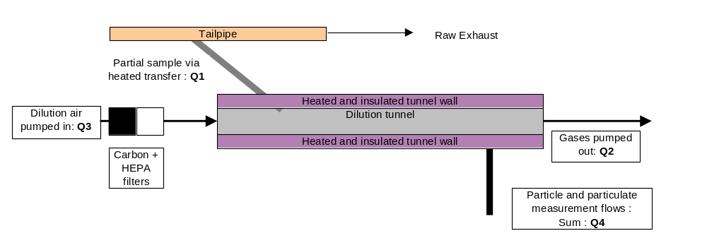
To facilitate the changes in exhaust flow rate and dilution flow (Q3), real-time fast flow measurement and rapid changes in flow rate are required.

The main challenge for partial flow dilution systems is maintaining proportionality with the exhaust flow rate. Measurement procedures for particulate emissions using partial flow dilution systems and of gaseous emissions from raw exhaust gases under transient test conditions are defined in an International Standards Organisation publication ISO16183:2002 [].

Partial flow dilution systems provided by Horiba [], AVL [] and Control Sistems [] were tested in this work. A PFDS system is also available from Sierra [].

All these systems are fully compliant with ISO16183:2002 and in principle operate almost identically. The main differences between systems are the methods by which flow is measured and controlled.

Particulate Mass Measurements

Full Flow Measurements
In the PMP ILCE_LD the filter-based PMP particulate mass measurement method was employed as the reference method. For conventional Diesels this has been shown to give results consistent with the current regulatory particulate mass measurement method [].
The development philosophy of the PMP particulate mass measurement system was to adapt the readily achievable elements of the mass method proposed for heavy-duty approvals in the US for 2007, along with selected amendments to improve data quality, to create an enhanced European light-duty procedure. Consequently, the approach developed for light-duty vehicles in the ILCE_LD was considered directly transferrable to heavy-duty engines' full flow dilution system sampling and the main additions to the standard European method are described in the following sections.
- Application of highly efficient dilution air filters for particles and hydrocarbons that reduces mass contributions from the dilution air to near zero
- The application of a cyclone pre-classifier with a 50% cut-size at between 2.5µm and 10µm to limit the contribution of re-entrained and wear materials to the filter mass
- External heating of the filter holder and transfer tubing to permit aerosol stabilisation of >0.2s at 47°C +/-5°C prior to sampling and to ensure close control of the filter face temperature to 47°C +/-5°C. External heating was achieved by either direct surface heating (most labs) or by situating the cyclone, transfer tubing and filter holder in an enclosed vessel. In the second case, the sample probe in the CVS was also heated.
- The use of a single 47mm filter rather than primary and back-up filters to eliminate weighing errors and the back-up filter as a source of volatile artefact
- The filter medium provides at least 99% filtration efficiency for 0.3µm particles at 35l/min (~50cm/s filter face velocity).
- Controlled filter face velocity range (50cm/s to 80cm/s) to improve reproducibility

Definition of PMP Particulate Mass

Despite the changes introduced to the method, the PM definition remains broadly unchanged from that used previously: all materials sampled from a dilution tunnel using the prescribed method on to a single filter at between 42°C and 52°C.

Test Facilities
The particulate measurement equipment employed by the participating test labs was constructed to meet the requirements of the ILG_HD. All laboratories used full flow dilution systems equipped with secondary dilution tunnels. The dimensions of these systems, flow rates and residence times were subject to some differences as shown in Table 5.
CVS tunnel residence times were controlled to 1.6s to 2.3s range, but there was a much larger range in secondary tunnel dimensions and residence time (0.4s to 7.8s). As discussed later, these differences did not have a measurable impact on observed PM levels.
Table 5: Principal Differences Between CVS Systems – Test Labs
 | AVL MTC | JRC | Ricardo | UTAC | EMPA
CVS flowrate [Nm3/min] | 72 | 80 | 60 | 80 | 80
CVS length [cm] | 500 | 470 | 450 | 575 | 470
CVS diameter [cm] | 50 | 47 | 45 | 45 | 47
CVS Heat exchanger | No | Yes | Yes | Yes | Yes
Preclassifier cutpoint [um] | 2.5 | 2.5 | 2.5 | 2.5 | 2.5
Secondary tunnel flowrate [lpm] | 50 | 50 | 60 | 50 | 40
Secondary tunnel DR | 2:1 | 2:1 | 2:1 | 2:1 | 2:1
Secondary tunnel length [cm] | 30 | 64 | 100 | 30 | 200
Secondary tunnel diameter [cm] | 8 | 8.6 | 10 | 8 | 1.4

For physical collection of PM, all labs used TX40 filters, but some labs used current PM holders without a back-up and other labs used US07 style holders. Different filter holders did not have a measurable impact on observed PM levels.

Partial flow Measurements
Partial flow dilution measurements of PM were not undertaken in the ILCE_LD, but development work was undertaken to refine the procedure in the working group that developed the ISO standard [Error: Reference source not found]. This procedure has many parallels with the PMP full flow method:
- Efficient dilution air filtration
- Filter face temperature control is permissible
- 47mm filters are permitted
- The same filter media are mandated

On these bases, it was considered wise to conduct partial flow testing during the HD_ILCE according to the requirements of ISO16183, but to align sampling parameters where possible with the full flow method. Parameters to be matched were prescribed in the inter-laboratory guide, but these included: filter face velocity, filter medium, filter diameter and dilution air quality.

The definition of PM sampled from a partial flow dilution system: all materials sampled from a dilution tunnel using the prescribed method on to a single filter at 47°C +/-5C.

Test Facilities
The particulate measurement equipment employed by the participating test labs was constructed to meet the requirements of ISO16183, with operating parameters specified in the ILG_HD. All laboratories used commercially available PFDS systems. The dimensions of these systems, flow rates and residence times were subject to only minimal differences as shown in Table 6.
Table 6: Principal Differences Between PFDS Systems – Test Labs
 | AVL MTC | JRC | Ricardo | UTAC | EMPA
System | Smart Sampler | Smart Sampler & PSS-20 | Horiba Mini Dilution Tunnel | PSS-20 | Smart Sampler
PM flowrate [g/s] | 1.08 | 1.08 | 1.205 | 1.08 | 0.86
Split ratio | 0.06% | 0.06% | 0.09% | 0.06% | 0.06%

As seen with the CVS data, using different filter holders did not result in measurable differences in PM levels.

Particle Number Measurement Systems

Principles of the Measurement System
Description and diagram of PMP particle number measurement system: elements and function. Touch upon PCRF and dilution factor-based systems.

Golden Particle Measurement Systems
Two nominally identical particle number measurement systems were circulated across the participating laboratories for the concurrent determination of the particle number emissions from a full flow CVS tunnel and a partial flow system. These are referred to as Golden Particle Number Systems (GPMS), as they served as an internal standard providing a link between testing at the various laboratories.

The GPMSs selected for this study were two prototype Solid Particle Counting Systems (SPCS) developed by Horiba []. The selection of this particular system was not based on its performance in terms of the criteria specified in the light duty regulations, but rather on the intention to evaluate alternative candidate systems to the GPMS that had been employed in the PMP Light Duty Interlaboratory Correlation Exercise [Error: Reference source not found].

SPCS description
The SPCS unit consists of a hot-diluter (PND1), an evaporation tube (ET), a cold diluter (PND2) and a condensation particle counter (PNC). A flow schematic of the SPCS unit is shown in Figure 6. The aerosol first enters a temperature controlled cabinet where it is diverged into a bypass flow, the sole purpose of which is the decrease of the residence time in the sampling line, and the sample flow. The sample mass flowrate is measured in real time by an orifice flowmeter (CFO), taking into account the temperature and the pressure of the sample as determined with a thermocouple and a pressure transducer, respectively. The sample is then diluted in a temperature controlled mixer (HD) with heated – filter dilution air supplied at an adjustable flowrate by means of a mass flow controller (MFC1).

A small fraction of the diluted aerosol exiting the PND1 passes through an orifice flowmeter and then enters an externally heated evaporation tube (EU) whose wall temperature is controlled in the range of 300 to 400 °C. During the ~0.5 s residence of the aerosol inside the EU, the volatile particles are vaporized to gas phase. Immediately after exiting the EU the thermally treated aerosol enters a mixer (CD) where it is cooled by filtered-dilution air supplied at an adjustable flowrate by means of another mass flow controller (MFC3). The concentration of the aerosol exiting this secondary diluter is then measured in real time in a TSI’s 3010D condensation particle counter (CPC).
The excess flow from the two dilution stages is sampled with a pump. The dilution ratio of the two diluters is kept constant by supplying make-up air in the two excess lines. Two mass flow controllers (MFC2 and MFC4) continuously adjust the make up air to account for small fluctuations of the sample flowrates measured in real time with the two flowmeters.

Operating parameters
All labs participated in this study operated the two Golden SPCS units at the same settings. The temperatures at the units were set at:

- Cabinet temperature: 47°C
- Hot dilution air temperature for PND1: 170°C
- Mixer temperature (HD): 170°C
- Evaporation tube (ET): 350°C

In these prototype units, the user has to specify the desired dilution ratio of each diluter as well as the dilution air flowrates and the bypass flow. The values employed in the campaign were:

- Primary dilution ratio (PND1): 10
- Primary dilution air flowrate (MFC1): 11.5 lpm
- Secondary dilution ratio (PND2): 15
- Secondary dilution air flowrate (MFC3): 10.5 lpm
- Bypass flowrate: 2 lpm

These values were selected after preliminary experiments conducted at JRC. The dilution ratios fulfill the specifications laid down in R83 and the resulting sample flowrate (~1.3 lpm) is high enough for pressure fluctuations to have an insignificant effect on the stability of the achieved dilution ratios.

Figure 6: Flow schematic of the prototype SPCS
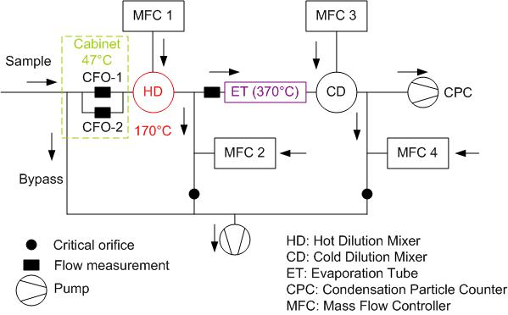

Other PMP type systems
A number of alternative candidate systems operating on the pre-conditioning and measurement principles required by PMP have also been used in parallel by the participating labs. However, calibration data demonstrating compliance with PMP performance requirements has not necessarily been provided for all of these systems. These are briefly described below.

Nanomet:
This system consists of a primary rotating disk diluter heated at 150°C, a 1m transfer line, an evaporation tube operating at 300 °C and a secondary simple mixer diluter. Two Nanomet systems were tested at JRC (one of which was the GPMS employed in the ILCE_LD) and one at Ricardo. The LD_GPMS system used a TSI 3010D CPC as did the Nanomet employed at Ricardo. The second Nanomet system tested at JRC employed a TSI 3010 CPC modified to replicate the performance of a 3010D (operating at evaporator - condenser temperatures that provided 50% detection efficiency at 23nm) in some tests, and a TSI 3790 CPC in other tests.

APC:
This system consists of a primary chopper diluter, a 2m transfer line heated at 150°C, an evaporating tube operating at 350 °C and a secondary dilution stage operating with dilution air at ambient temperature. One APC system was tested at JRC during the second measurement campaign and one at AVL MTC. These systems utilize TSI 3790 CPCs.

Dekati dual ejector and evaporating tube system:
In this system the first dilution is applied by a Dekati ejector diluter equipped with a heating mantle (150°C) using heated, conditioned (dehumidified, HEPA filtered) dilution air at 150°C. The diluted sample is then thermally treated in an evaporation tube heated to 330°C and then further diluter in a secondary Dekati ejector using conditioned dilution air at ambient temperatures. This system was employed at JRC during both measurement campaigns, and was tested with three different CPC models: a TSI 3010D, a TSI 3010 and a Grimm 5.404 (the latter two modified in order to shift the 50% detection efficiency to 23 nm).

EMPA’s dual ejector and evaporating tube system:
This system consists of a Palas ejector diluter (Palas VKL-10E) heated at 150°C (by means of a heating mantle) operating on conditioned dilution air at 150°C, an evaporation tube operating at 350°C, and a secondary Palas ejector diluter (Palas VKL-10) operating on conditioned air at ambient temperature. Two nominally identical systems were employed at EMPA, one of them sampling from the CVS tunnel (using a TSI 3790 CPC for particle detection) and the other directly from the exhaust (using a TSI 3010 CPC for particle detection).

PMP like systems:
Some tests were also conducted at JRC using sampling systems employing a Dekati thermodenuder operating at 300°C for the thermal treatment of the aerosol. This replaced the evaporation tube of the PMP type systems. The carbon absorbent section of this particular thermodenuder has an annular design. During the tests, the inner cylinder was cooled by forced convection (using compressed air) and the outer one by natural convection. The thermodenuder operated at a flow rate of 10 lpm which corresponds to a residence time of 0.3 seconds in the heating section and 2.7 seconds in the denuder. The thermodenuder sampled from the CVS tunnel either directly or via a heated (heating blanket at 150°C) Dekati ejector operating with heated dilution air at 150°C. A TSI 3790 CPC was employed for particle detection.

Additional Instrumentation
In addition to the aforementioned PMP type systems, the participating laboratories have also employed additional aerosol instrumentation in order to get a better insight into the characteristics of the emitted particles. These included:

EEPS:
A 3090 Engine Exhaust Particle Sizer Spectrometer (EEPS) (TSI Inc.) was used during a limited number of tests. EEPS measured particle size distributions with a maximum data rate of 10 size distributions per second (although averages over 1 second were used in the graphs of this study). It measured particle sizes from 5.6 to 560 nm with a sizing resolution of 16 channels per decade (a total of 32 channels). At the instrument’s inlet there was a cyclone with a 50% cut-size at 1 μm (inlet flow rate 10 lpm).

Dekati Mass Monitor:
A Dekati Mass Monitor (DMM) was employed at JRC during some tests conducted after the second measurement campaign. The DMM sampled from the CVS tunnel via a Dekati thermodenuder operating at 300°C, and was used to measure the mass concentration of non-volatile particles in real time.

AVL Soot Sensor:
An AVL’s 483 soot sensor was employed during some of the formal tests conducted during the second measurement phase at JRC, measuring the mass of soot in real time. The soot sensor sampled directly from raw exhaust at a constant dilution ratio of about 2.

TSI SMPS:
A TSI’s 3936L SMPS (consisting of a TSI 3080L DMA and a TSI 3010 CPC) was employed during some preliminary tests at JRC operating at sample/sheath flowrates of 0.9 and 9 lpm respectively.

TSI 3025A CPC:
During some of the preliminary tests conducted at JRC two TSI 3025A CPC units having a 50% counting efficiency at 3 nm were employed. One of them was used to sample directly from the CVS tunnel, and the other to sample from the GPMS connected to the CVS tunnel, and in parallel to the Golden CPC (50% efficiency at 23nm). These tests allowed for the determination of the number concentrations of volatile and non-volatile particles in the 3-23 nm size range. This provided the means to investigate whether significant emissions of non-volatile particles smaller than 23 nm, suggested by recent studies [], are also observed with the Golden engine.

Test Programme

Participating Laboratories
Four laboratories in EC member states, and one in Switzerland, were participants in the test programme. The test labs, timing and final test order are given in Table 7. JRC also conducted additional experiments prior to and following the formal testing, these experiments are not included in the assessment of measurement repeatability and reproducibility.. Preliminary experiments, undertaken to refine the inter-laboratory guide are discussed in the next section.
Table 7: Test Laboratories and Timeline
Dates | Test Laboratory | Location | Testing
Jan – Feb 2008 | JRC | Ispra, Italy | Preliminary Experiments
Mar-Apr 2008 | AVL-MTC | Sweden | Formal Testing Lab#1
May – Jun 2008 | JRC | Ispra, Italy | Formal Testing Lab#2
Dec 2008 – Jan 2009 | Ricardo | UK | Formal Testing Lab#3
Feb - Apr 2009 | UTAC | France | Formal Testing Lab#4
Apr – Aug 2009 | EMPA | Switzerland | Formal Testing Lab#5
Aug– Oct 2009 | JRC | Ispra, Italy | Formal Testing Lab#2rpt
Nov-09 | JRC | Ispra, Italy | Additional Experiments

Summary of Preliminary Experiments
A number of experiments were conducted in order to better define the measurement approaches described in the inter-laboratory guide. These were based upon concerns regarding the possible differences in emissions between the light duty vehicles that the measurement procedures were developed for, and the heavy-duty engines to be the subject of the next phase of PMP work. Further details can be found elsewhere [Error: Reference source not found]. In particular, the differences in PM chemistry, the aftertreatment devices to be used, characteristics of different dilution systems and possible differences in the nature of particles: their sizes and origins, were of concern. These experiments can be classified into four groups as follows:
- Expt 1 - Background and filter tests
These experiments considered the CVS and partial flow systems’ background levels for mass and the effect of the filter medium and filter face velocity (ffv) on the PM emissions
- Expt 2 - Sampling parameters
These experiments considered the impact and necessity of using a pre-cyclone with the Horiba SPCS systems. In addition, the two SPCS systems supplied by Horiba had different transfer lines lengths (1m insulated, 4m heated). The impact of these lines on the PN results was determined.
- Expt 3 - Pre-conditioning and continuity protocol
In the ILCE_LD, it was determined that to improve the repeatability of particle number results a purge of pre-existing particles from the exhaust system and a standardised DPF fill-state was required. Experiments were undertaken to determine the minimum required pre-conditioning for the exhaust and after treatment for repeatable measurements.
- Expt 4 - Real time PN emissions
Concerns have been raised in the US that high levels of solid particles may be present, in the exhaust from HD Diesel engines, in the size range below the PMP cut-off (d50) of ~23nm. Measurements were undertaken to determine the presence and magnitude of <23nm solid and <23nm volatile particles from the golden engine.
All experiments were conducted on the golden engine and emissions control system and using the fuel and lubricant described in Section 3.5.

Experiment 1 - Background and Sampling Parameters for PM
A schematic of the sampling system used in these experiments is shown in Figure 7.
Evaluations of filter media and face velocity effects were undertaken during repeat WHSC testing. In all cases tests were conducted using a primary and back-up filter to enable the magnitude of volatile ‘slippage’ from the primary filter to the secondary filter to be quantified. The following measurements were made from the CVS, with results shown in Figure 8.
(a)
- One background (BG) PM measurement followed by 3 hot WHSC repeats
- 70mm TX40 filters, PM sample flow of 60l/lmin (ffv = 43cm/s)
(b)
- One background PM measurement followed by 3 hot WHSC repeats
- 47mm TX40 filters, PM sample flow of 60l/lmin (ffv = 103cm/s)
(c)
- One background PM measurement followed by 3 hot WHSC repeats
- 47mm TX40 filters, PM sample flow of 40l/lmin (ffv = 69cm/s)
(d)
- One background PM measurement followed by 1 hot WHSC
- 47mm TX40 filters, PM sample flow of 40l/lmin (ffv = 69cm/s)
- PM filters baked in an oven at 47°C for 3 hours to remove residual volatiles
(e)
- One background PM measurement followed by 1 hot WHSC
- 47mm Teflon membrane filters, PM sample flow of 40l/lmin (ffv = 69cm/s)

Figure 7: PM Sampling Set-up for Experiment 1
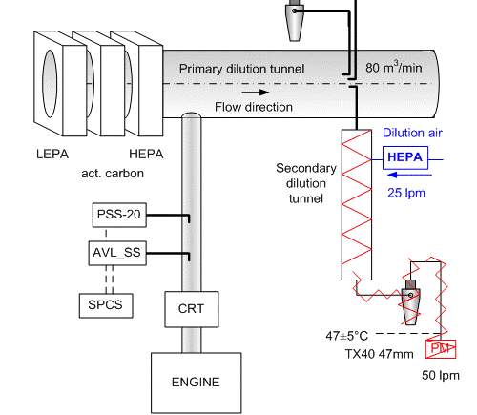

Figure 8: Experiment 1 - Background and Sampling Parameters for PM
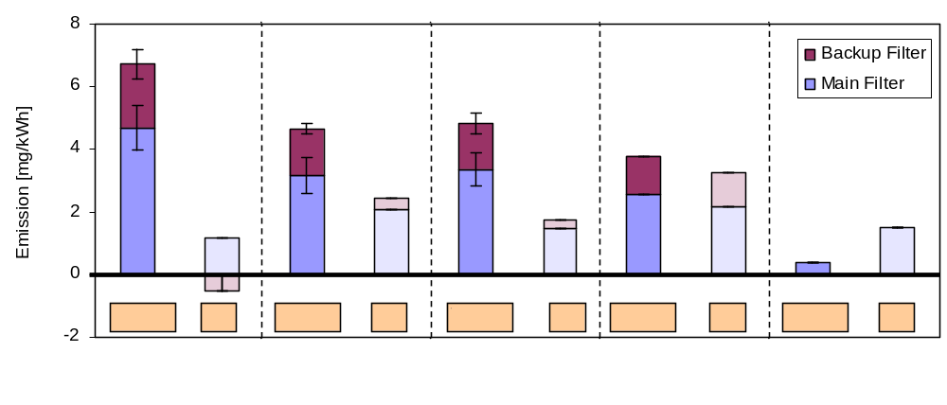
a
b
c
d
e
The conclusions of these experiments were:
- PM emissions were slightly higher than background levels
- Highest PM mass was collected on 70mm filters with a sample flow of 60l/min (ffv of ~40cm/s)
- Similar masses were collected on 47mm filters at ffvs of ~70 to 100cm/s (40 to 60l/min)
- Baking TX40 filters has no beneficial effect
- Teflo filters appear to collect less mass than 47mm filters
- Secondary (backup filters) collect ~ 30% of primary filter mass from sample filters
Contributions to test protocol
- No substantive changes to light-duty PM protocol
- Employ 50 l/min flow rate for PMP tests (for full flow and partial flow systems with 47 mm TX40 filters).

Experiment 2 – PN Sampling Parameters
In these experiments 2 SPCS systems were used in parallel during various periods of transient engine operation.
(f) Transfer line effects (Figure 9)
- One SPCS sampling directly from the CVS with a 1m insulated line
- One SPCS sampling directly from the CVS with a 4m heated line
(g) Cyclone effects (Figure 10)
- One SPCS sampling directly from the CVS with a 1m insulated line
- One SPCS with 4m heated line sampling from the CVS via a cyclone operating with a 4μm cut
Figure 9: Minimal Impact of Heated Line on PN Results
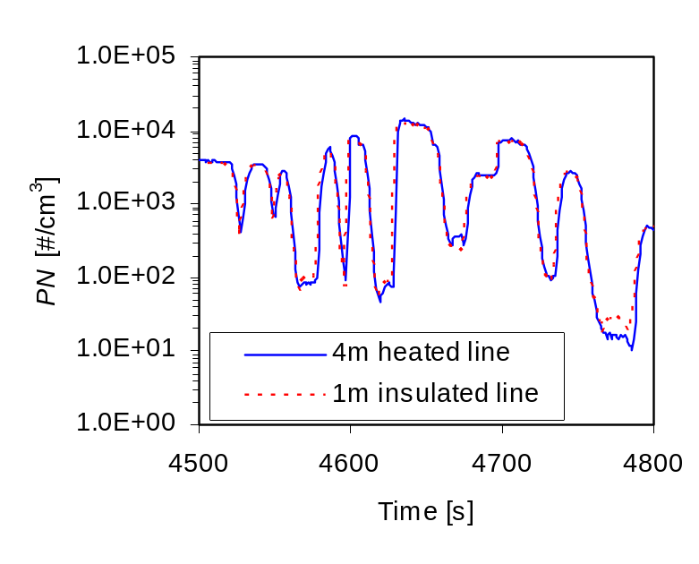
Figure 10: Minimal Impact of Cyclone on PN
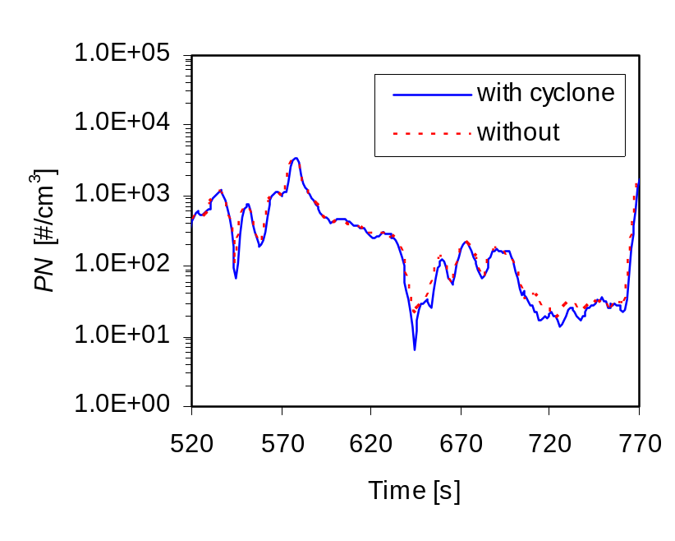
The conclusions of these experiments were:
- The differences in PN emissions measured with a 4 m heated line (at 47°C, with 1.8s residence time) and a 1m insulated line (0.5s residence time) were minimal (<5%). This means that one SPCS can be connected to the CVS through 4 m line (heated at 47°C), while the other SPCS can be connected to the partial flow system with a short (insulated) line without adjustment of results for transport losses.
- The cyclone had a negligible effect on the particle number emissions, so for number measurements it is not necessary. However, it is recommended to use one in order to protect instruments’ primary diluters from contamination through deposition of larger particles. Insulation of the cyclone and transfer tubes is required to limit thermophoretic losses during high temperature operation.
Contributions to Test Protocol
- Cyclone mandatory for CVS sampling
- Cyclone optional for partial flow sampling
- Insulation of cyclone and external sampling system to limit thermophoretic losses
- Dedicated SPCS (Serial no. 19) for full flow sampling (with heated line)
- Dedicated SPCS (Serial no. 20) for partial flow sampling (with 1m insulated line)

Experiment 3 – Preconditioning Protocols
A daily preconditioning protocol was required that first used a high exhaust temperature steady state (~600°C) to passively regenerate the DPF, and then used a lower temperature non-regenerating condition to add a standardised quantity of soot to the DPF. This protocol was used at the end of each day to re-baseline the loading state of the DPF prior to the next day’s run-through of the test matrix. To avoid very long test days, it was desirable that the entire process was shorter than 2 hours.
- 15 minutes at mode 10 was determined as the suitable engine operation and minimum time required to passively regenerate the DPF, eliminating the stored soot. This was determined by running ESC 10 and monitoring how long it took for post DPF solid particle emissions to stabilise (Figure 11, green line, 400s to 900s).
Mode 10 operation for 15 minutes showed particle number levels consistent with those seen during the 2 hours of mode 10 running used to condition the lubricating oil, thus indicating that the DPF was indeed ‘emptied’ by the 15 minutes period (Figure 11, red and blue lines).
- ESC Mode 7 has a stabilised exhaust temperature of well below 300°C, so passive regeneration at this temperature, even with an oxidation catalyst, is minimal. 30 minutes of operation was chosen to add soot to the DPF (Figure 11, green line, 1500s to 3300s)
The daily test matrix comprised both cold and hot start tests and it was desirable that each lab tested the cycles with the exhaust and emissions control system at the comparable temperatures. This would reduce variability due to pre-conditioning effects and allow a better assessment of the repeatability of gaseous and particle emissions measurement procedures. To ensure this, cycles without regulatory defined warm-ups were preceded by the continuity protocol.
The hot WHTC was preceded only by the cold WHTC and a 10 minute soak while the WHSC, was preceded by the hot WHTC and the mandatory 10 mins at WHSC Mode 9. No continuity protocols were required for these cycles.
The continuity protocol comprised 5 min at Mode 7 of the ESC and 3 min at idle. Mode 7 was selected after repeat size distribution measurements at this condition showed no evolution in magnitude or size – indicating stability of both volatile and solid particles (Figure 12). By comparison a slightly hotter steady state, ESC Mode 4 showed obvious evolution, related to some passive regeneration.
Idle followed the Mode 7 operation to permit preparation of the exhaust emissions analysers and to limit emissions and fuel consumption without stopping the engine.
Figure 11: DPF Preconditioning –Regeneration (Mode 10) and Fill (Mode 7)
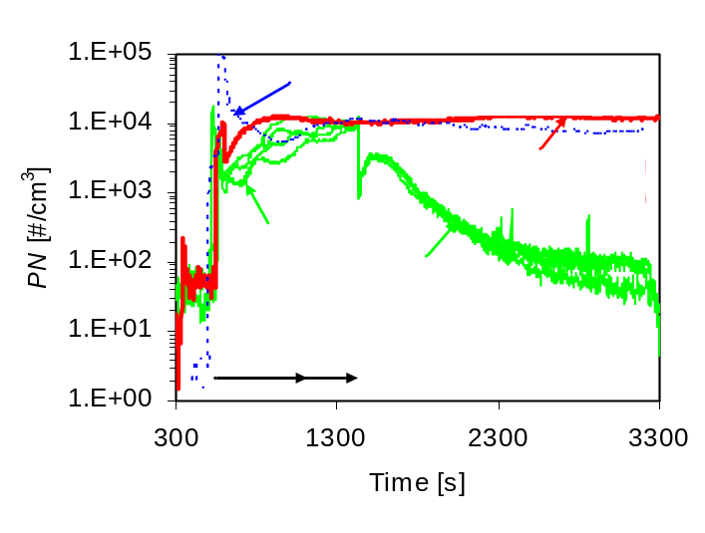
Figure 12: Stable Mode 7 Selected for the Continuity Protocol
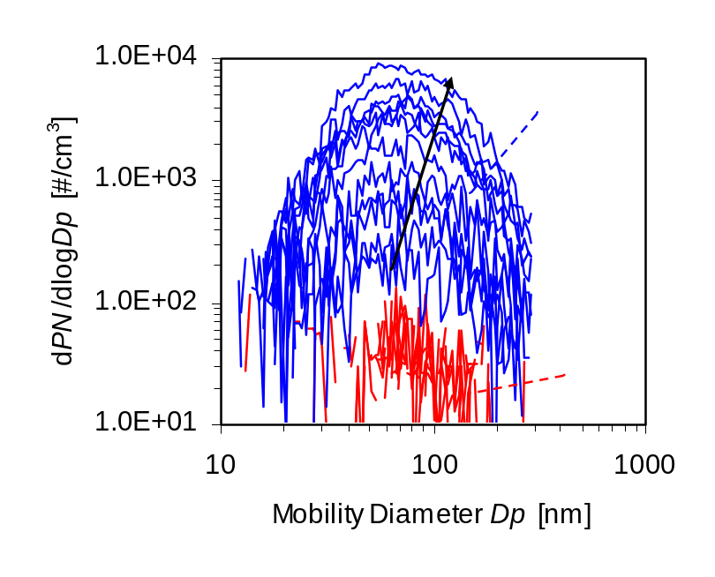
Contributions to test Protocol

- 15 mins ESC Mode 10 plus 30 mins ESC Mode 7 for the daily preconditioning
- 5 mins ESC Mode 7 plus 3 mins at idle for the continuity protocol

Experiment 4 – Real-time PN Emissions
Concerns have been raised in the US that high levels of solid particles may be present, in the exhaust from HD Diesel engines, in the size range below the PMP cut-off (d50) of ~23nm. Measurements were undertaken to determine the presence and magnitude of <23nm solid and <23nm volatile particles from the golden engine.
A variety of steady state and transient emissions tests were performed measuring solid particles from the CVS with an SPCS system equipped with both a TSI 3010D CPC (measuring particles >23nm) and a TSI 3025A CPC (measuring particles >3nm). The difference between the results of these two particle counters indicated the presence of solid particles in the size range 3nm to 23nm. In addition, the same 3025A CPC was used to measure particles directly from the CVS. This permitted the number of volatile particles smaller than 23nm to be determined. Results are summarised in Figure 13.
Figure 13: Particle Number Emissions <23nm
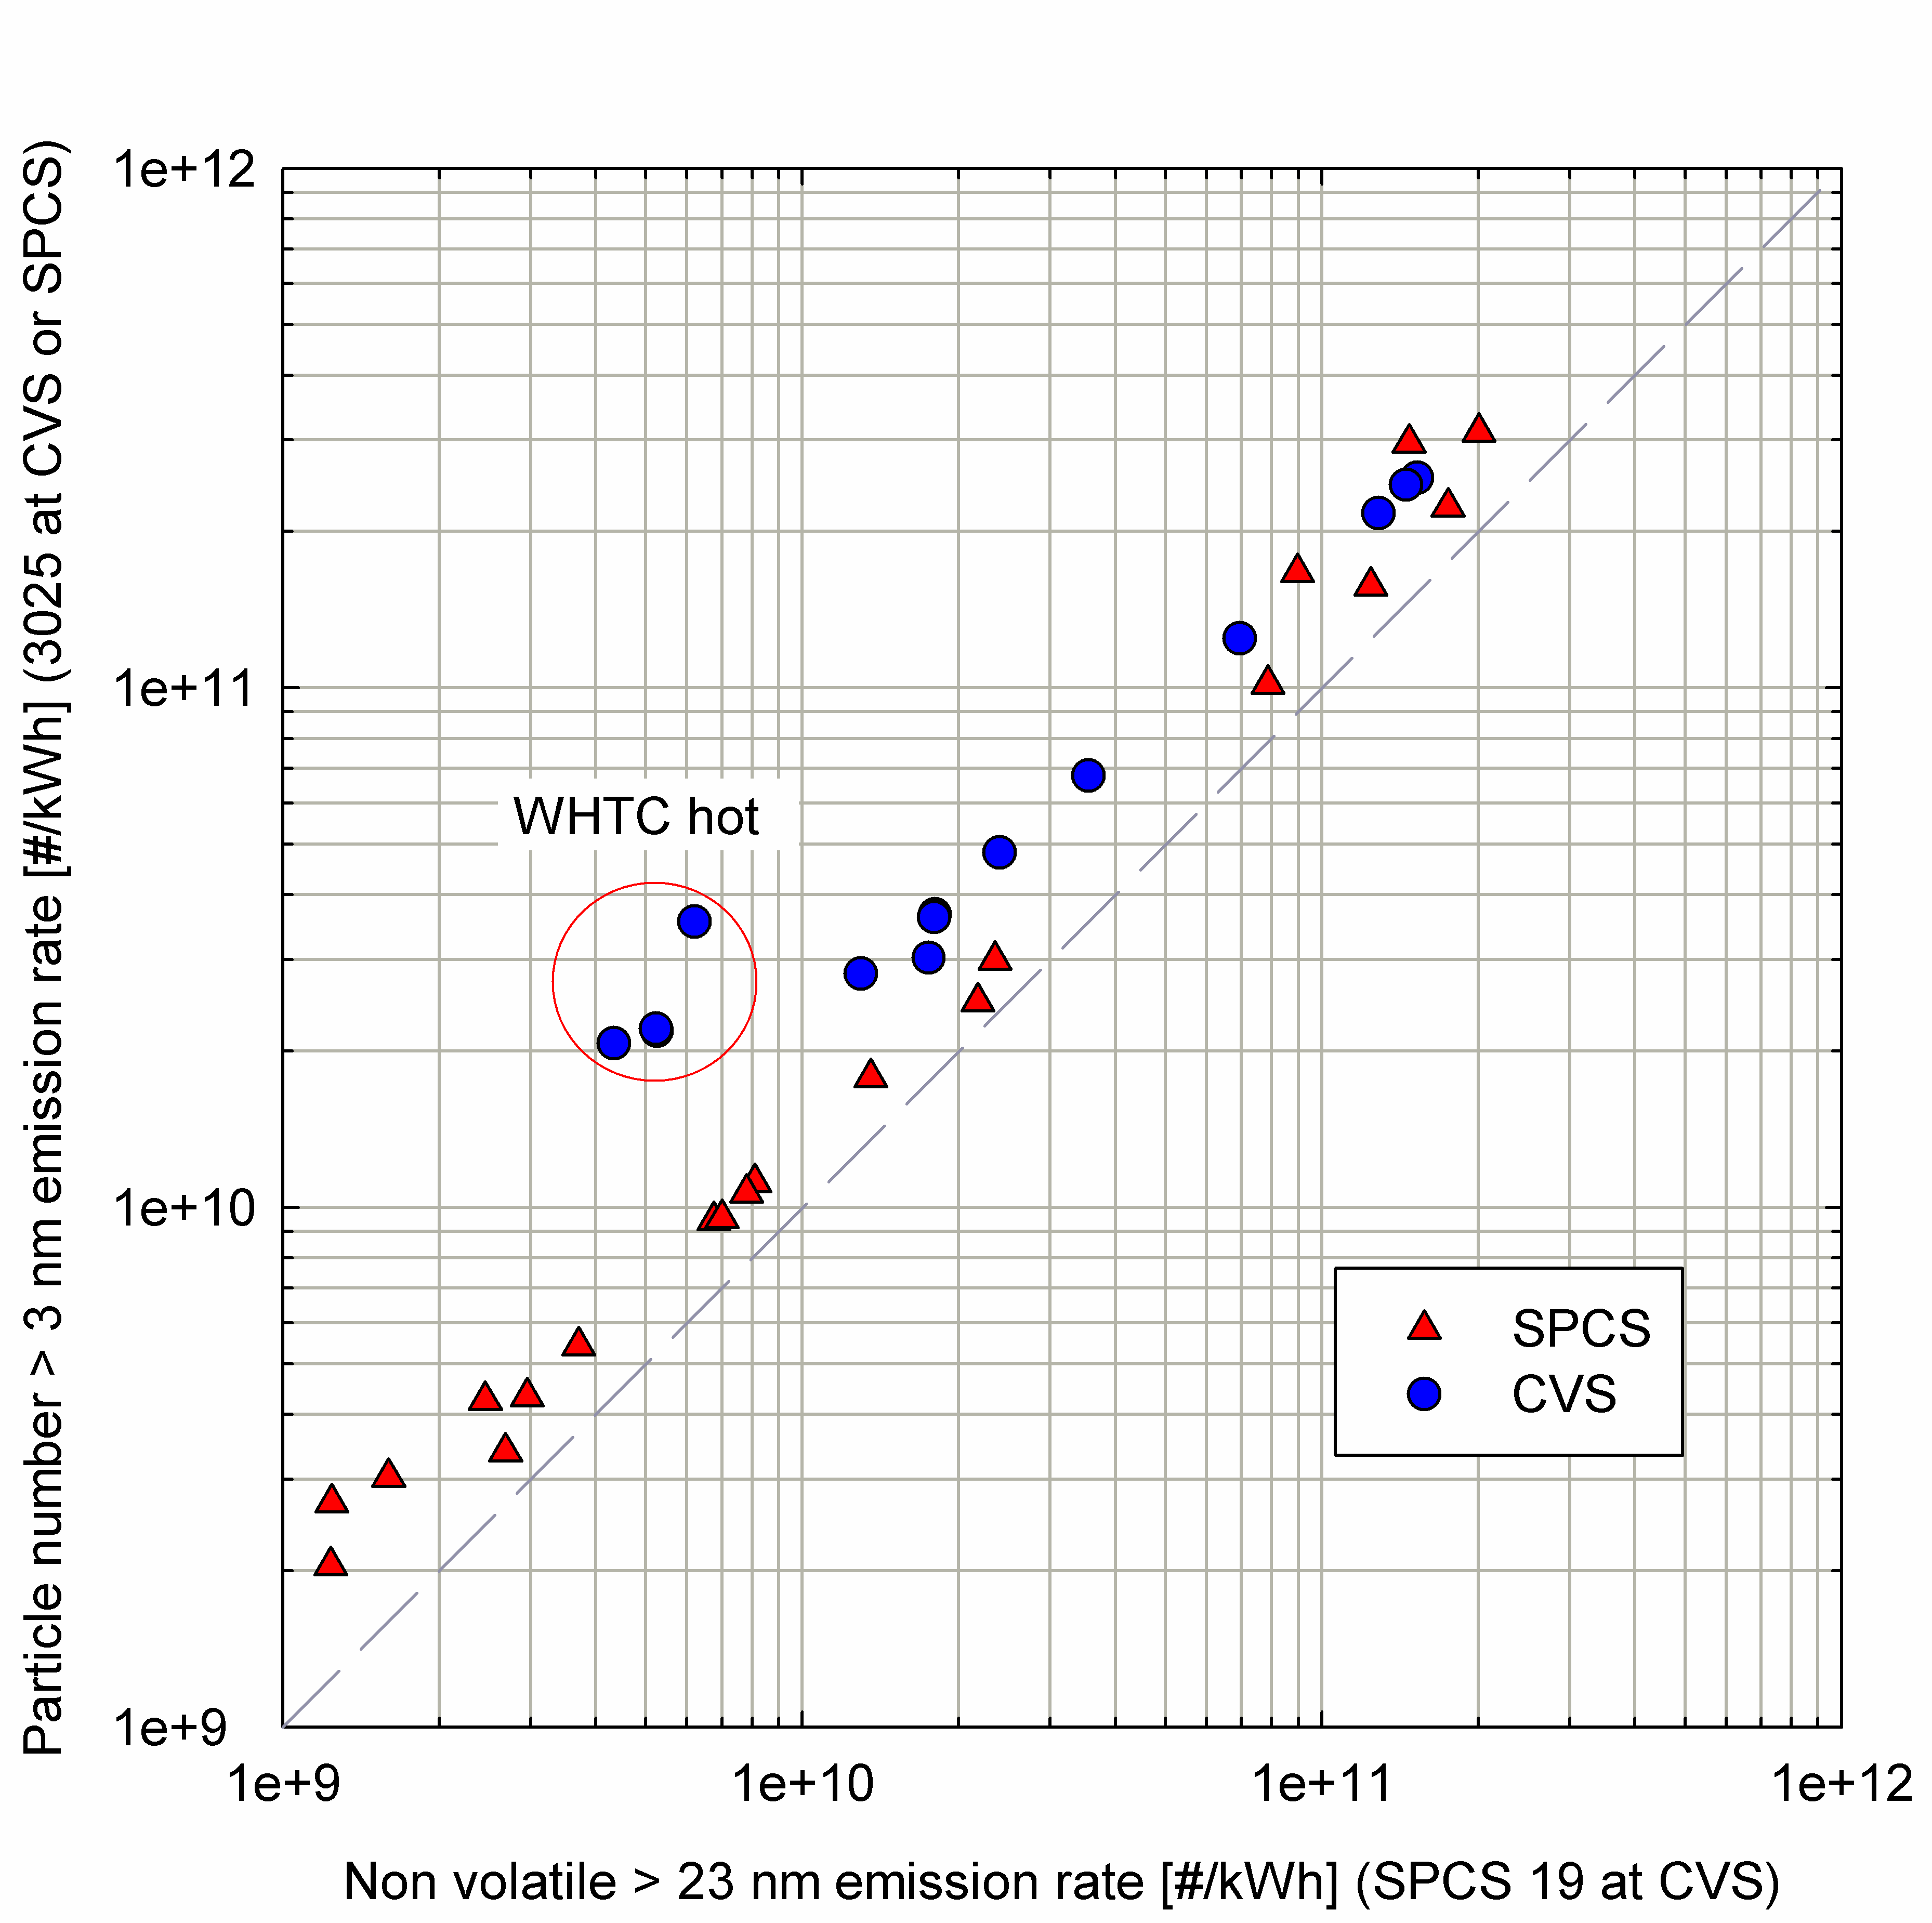
The implications of this figure can be summarised as follows:

- For the cycles examined, the concentration of total particles >3 nm measured from the SPCS was generally 50-95% higher than the >23nm non-volatile particles. The difference appears to be higher over the hot WHTC cycle, measuring particle concentrations direct from the CVS (300%). CVS measurements include both solid and volatile particles and this result is therefore likely to be indicative of a higher proportion of volatile particles over this cycle

- For the cycles examined the concentration of the non-volatile particles <23 nm was 15-45% higher than the non-volatile particles >23 nm (85% for the cold WHTC).

Impact of Experimental Result on the Test Protocol for the Validation Exercise

- While there was some evidence that solid particles <23nm were present, the levels seen were not consistent with the orders of magnitude increases relative to >23nm particles reported from US engines. On this basis, it was considered reasonable to retain the size and volatility range of particles measured in the ILCE_LD for measurements from heavy-duty engines.

Daily Protocol
Following the completion of the preliminary experiments, the test protocol for the inter-laboratory exercise was finalised and used to update the ILG_HD. The baseline test matrix comprised at least 8 repeats of each of the following tests:
- Cold WHTC
- Hot WHTC
- WHSC
- ETC
- ESC
Test order followed the defined matrix (Table 8), with preconditioning for each cycle set as the regulatory requirement, or the continuity protocol if no regulatory requirement exists. The continuity protocol was defined as 5 minutes operation at ESC Mode 7 plus 3 minutes at idle (as described in experiment 3 of Section 3.10.2).
Table 8: Matrix for Emissions Testing
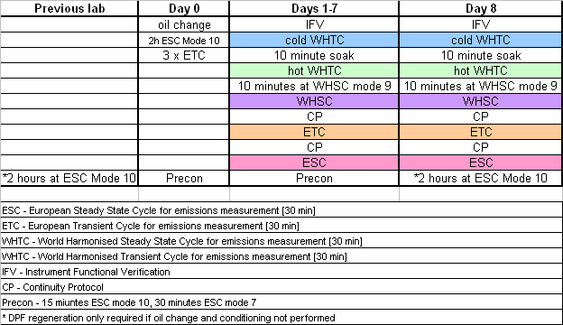

STATISTICAL ANALYSES
The variability of the results collected in the PMP Heavy Duty Validation Exercise was quantified using the “random effects analysis of variance” model []. This analysis provides the means for a separate quantification of the repeatability and reproducibility of the measurements.

On the other hand, the equivalency between the results (PM and particle number) obtained from the CVS tunnel, the partial flow system and the alternative particle number systems employed, was investigated by means of calculating the average value and the standard deviation of the percentage differences of each individual result. It has been decided not to employ paired t-tests for this type of checks as the particular methodology is prone to identifying statistically significant differences when in fact the result are practically equivalent [], with the ability to discriminate between statistically and practically significant differences strongly affected by the sample size.

Definitions

Basic statistical concepts
Before describing the statistical analysis used for the evaluation of the PMP methodology it is important to distinguish between the statistical concepts of accuracy, precision and trueness.

Accuracy represents the degree of agreement between the results obtained from a test method and the true or ‘accepted’ true value. On the other hand, precision refers to how closely the independent measurements agree with each other, while trueness refers to the closeness of agreement between the arithmetic mean of a large number of test results and the “accepted” reference value. In most cases, however, the true value is unknown and therefore only precision statements can be developed. Precision is a qualitative concept which can be expressed numerically only in terms of its opposite, that is the variance or standard deviation.

The variance in the results obtained from a test method is due to some random variations of the properties being measured but also due to the fluctuation of some factors affecting the outcome of the test method. These factors are generally the equipment used, the calibration of the equipment, the operators using the equipment and the environmental variables.

When the test method is performed in one laboratory in the shortest practical period of time, by the same operators, using the same equipment on – ideally – materials taken from a single quantity of homogeneous material, then the aforementioned factors remain reasonably constant and the variance in the results is referred to as the within laboratory (intra-laboratory) variability (σ²). However, when the test method is performed at different laboratories these factors vary considerably, leading to even greater variability. The variability induced because of performing the tests in different physical environments is the between laboratories (inter-laboratory) variability.

The results obtained from one laboratory are said to be satisfactory if they are both repeatable and reproducible. Repeatability is ensured when the above mentioned factors remain reasonably constant. This would be reflected where inter-laboratory variance was similar to intra-laboratory variance. Furthermore, the results obtained from one laboratory are said to be reproducible if the divergence of their mean value is not significantly greater than the variability range which would be expected on the basis of the inter-laboratory variability.

Intra- And Inter-Laboratory Variance Estimators
The random effects analysis of variance model provides the means for the quantification of the intra-laboratory and inter-laboratories variances σ² and σ_{τ}², respectively. If y_{ij} represents the j^{th} result obtained from the i^{th} laboratory participating in an interlaboratory correlation exercise (also known as round robin) conducted at p different laboratories, and n_{i} is the number of results provided from the i^{th} laboratory then the estimators of σ and σ_{τ}² are [Error: Reference source not found]:
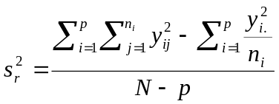

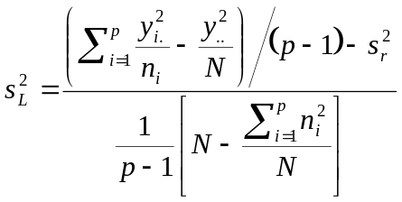

Where:
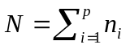, 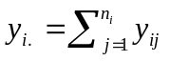 and 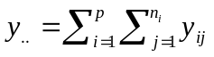

Statistical outliers
One of the basic assumptions of the analysis of variance model is that the results obtained from each laboratory are equally variable (an situation known as homogeneity of variance). If the variability in one particular laboratory is significantly different from the rest of the laboratories the particular laboratory is said to have repeatability problems and can be characterized as an outlier. The ASTM 691-99 and the ISO 5725-2:1994 standards provide the means for identifying the laboratories having repeatability problems, by utilizing the repeatability index (k). The k statistic for the results obtained from a laboratory z is defined as

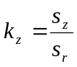

where s_{z} represents the standard deviation of the results obtained from laboratory z, while s_{r} is the estimated intra-laboratory standard deviation (square root of s_{r}²).

Furthermore, the two standards suggest the use of the reproducibility index (h) in order to identify laboratories measuring significantly higher or lower results. The h statistic for the results obtained from laboratory z is defined as:

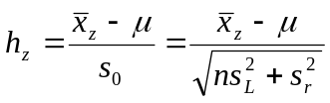

where 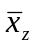 represents the average value of the results obtained from laboratory z, μ is the pooled mean value from all labs and s₀ represents the range where the difference 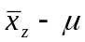 is expected to vary due to the intra and inter-laboratory variabilities (s_{r}² and s_{L}², respectively).

The statistical analysis underlying the definition of these two statistics is the hypothesis testing of two variances and two means respectively, and therefore some critical h* and k* values can be derived by assuming a type-I error (a). Any h or k value greater or equal to the corresponding critical h* or k* is indicative of reproducibility or repeatability problems, respectively. There are also additional patterns indicating problems like one lab having positive (or negative) h values and all the rest negative (or positive), or one lab having too high or too low k values for all tests compared to the rest of the labs.

The two aforementioned standards provide the equations and critical values for the case of balanced samples (equal number of results from each lab). However, in this exercise not all labs performed exactly 8 repetitions of the test protocol. Additionally, for various technical reasons, some of the data were excluded and therefore the final sample ended up statistically unbalanced. The following equations apply in the more general case of unbalanced samples []:

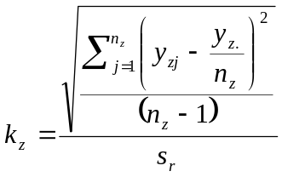

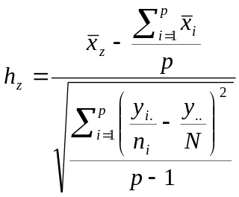

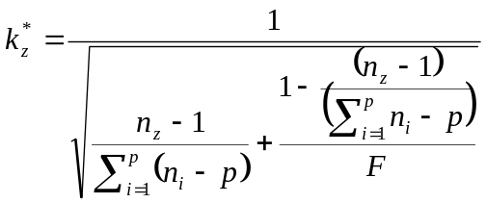

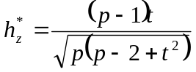

where t is the α/2 percentage point of the Student’s t-distribution with p-2 degrees of freedom, and F the α percentage point of the F-distribution for n_{z}-1 degrees of freedom for the numerator and [N-p-(n_{z}-1)] degrees of freedom for the denominator.

Following the recommendations of the ISO standard, the critical h and k statistics were calculated at a significance level (α) of 1 %.

The standard deviations contain information on the absolute level of each property tested. In order to compare the variability of properties differing by orders of magnitude it is necessary to normalize the standard deviation with respect to the average emission levels. For this purpose, the within-laboratory (s_{r}/μ) and between variability (s_{L}/σ) coefficients of variation (CoV) are used instead in this document. For convenience these quantities are also referred to as within and between laboratories variability.

CALIBRATION AND VALIDATION

Mass systems
Filter mass measurement procedures in the weighing room (or chamber) were conducted according to the requirements of the ILG_HD. During the entire exercise, no substantive issues were reported with the weighing procedures of the HD_ILG at any of the test labs.
Figure 14 shows the results of weighing environment validation exercises undertaken at Ricardo. During a calendar month there are typically no deviations from temperature range (19°C to 25°C), relative humidity range (37% to 53%) or in the performance of the balance (50.002µg ± 5µg). However, several borderline results from reference filter weighings suggests that variability (of 47mm TX40 filters) increases such that ± 10µg range could be required instead of the ± 5µg used in the R83. This is in line with the requirements of the WHDC.
Figure 14: Weighing Room Validation Exercises - Ricardo
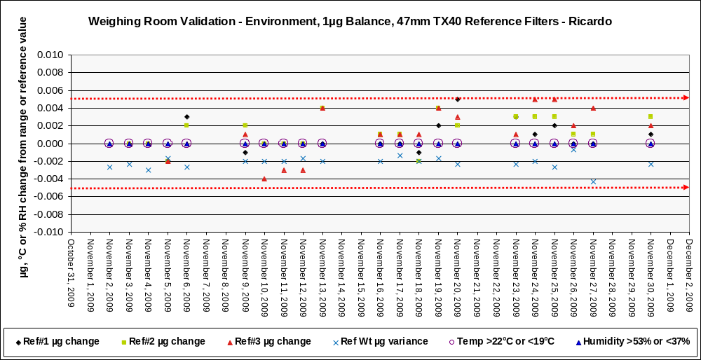

Number systems
Prior to the commencement of the ILCE_HD, the two SPCS systems and their PNCs (3010D) were calibrated by their manufacturers. These calibrations were performed prior to the finalisation of the PMP calibration methodologies, including that for particle concentration reduction factor (PCRF). The calibrations performed are outlined in the following sections.

SPCS Calibration
The two SPCS systems used as Golden Instruments during the ILCE_HD were supplied by Horiba and calibrated according to their own internal procedures.
SPCS-20 was subjected to a comprehensive characterisation, while SPCS-19, built in parallel with identical componentry, was subjected to a dilution ratio gas calibration only but compared with the SPCS20 within the main PMP programme and shown to be highly similar.
The calibration approach used for the SPCS-20 has been published by Horiba [] and is briefly outlined below. This included determination of VPR penetration using polydisperse aerosol and monodisperse aerosols and dilution ratio validation using a propane span gas and a flame ionisation detector. The removal efficiency of the VPR for 30nm tetracontane (n-C₄₀) particles was determined according to the procedure previously described by Horiba [].

Removal Efficiency for Tetracontane Particles
The apparatus used by Horiba to determine the volatile particle removal efficiency (RE) of SPCS-20 is shown in Figure 15. The C40 aerosol generator heats up to the boiling point of tetracontane and the neutraliser and DMA are used to select monodisperse 30nm particles. The concentration of these particles is reduced by a room temperature ejector diluter to below 10,000/cm³ and they then enter the evaporation unit (EU) at 300°C. Upstream and post-EU concentrations are compared to evaluate the RE
Figure 15: Apparatus for the Evaluation of Volatile Particle RE
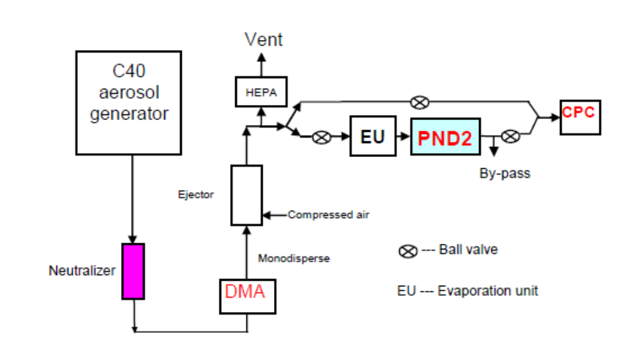
A typical result for this particle removal test, showing efficiency of 99.99% for 30nm n-C₄₀ particles is given in Figure 16.
Figure 16: VPR RE of 99.99% for 30nm n-C₄₀ particles
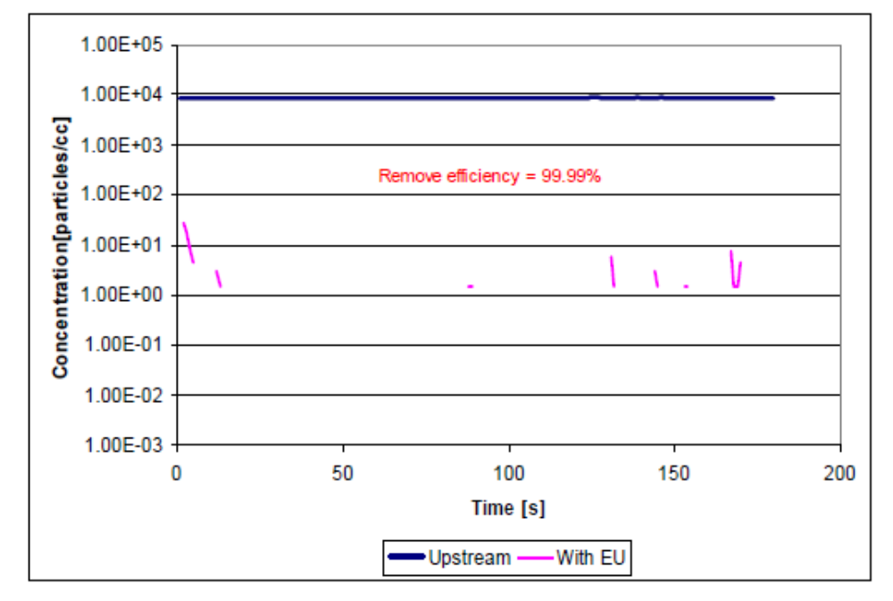

Solid Particle Penetration Using Polydisperse Aerosol
The apparatus used by Horiba to determine the solid particle penetration of SPCS-20 using polydisperse NaCl is shown in Figure 17. Temperatures of the PND1 dilution air, mixer, EU, and sample flow were controlled to 150°C, 150°C, 320°C, and 47°C, respectively. These temperatures were used for normal SPCS operation at the time of these experiments.
Sodium Chloride (NaCl) aerosol is generated with the atomizer and residual moisture in the aerosol is then removed with an efficient diffusion dryer. A by-pass is placed upstream of the diffusion dryer to vent excess aerosol flow. In the neutralizer, the aerosol is charged to Boltzmann equilibrium. An ejector diluter is used to provide an aerosol at the correct concentration level and to enable the flow to be controlled by the SMPS. The concentration and the size distribution then remain constant while the upstream (raw) and the downstream (diluted) size distributions of the VPR are measured. Comparisons of these distributions for specific size ranges (Figure 18) and at different dilution ratios provide the penetration efficiencies (Figure 19).
At the typical dilution factor used in the PMP work (~150), the polydisperse penetration was >98%.
Figure 17: Apparatus for Evaluation of Solid Particle Penetration (Polydisperse)
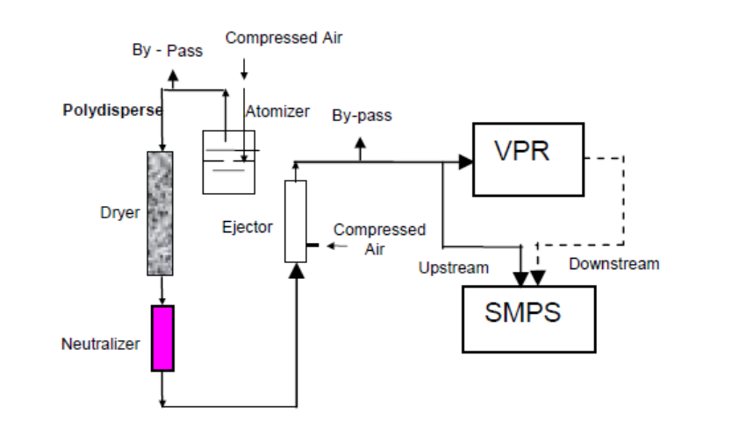
Figure 18: Size Distributions (downstream dilution correction of 1050 applied)
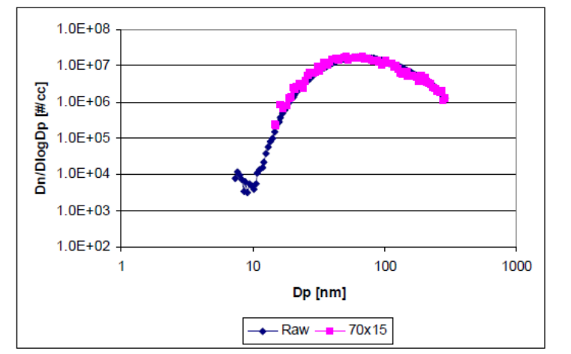
Figure 19: Penetration at Different Dilution Ratios (Polydisperse)
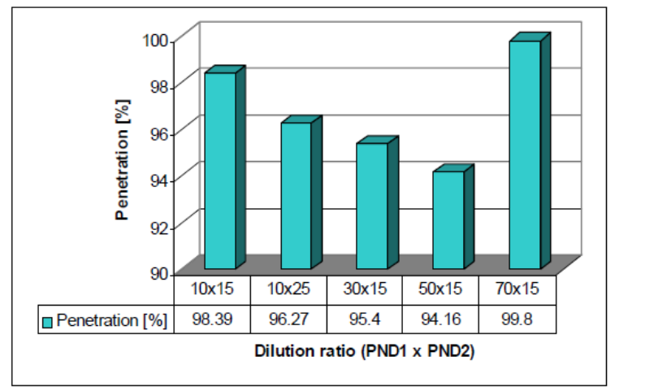

Solid Particle Penetration Using Monodisperse Aerosol
The apparatus used by Horiba to determine the solid particle penetration of SPCS-20 using monodisperse NaCl is shown in Figure 20. Temperatures of the PND1 dilution air, mixer, EU, and sample flow were controlled to 150°C, 150°C, 320°C, and 47°C, respectively. These temperatures were used for normal SPCS operation at the time of these experiments.
Sodium Chloride (NaCl) aerosol is generated with the atomizer and residual moisture in the aerosol removed with an efficient diffusion dryer. A by-pass is placed upstream of the diffusion dryer to vent excess aerosol flow. In the neutralizer, the aerosol is charged to Boltzmann equilibrium. An ejector diluter is used to provide an aerosol at the correct particle concentration level (less than 10,000/cm³ upstream of the VPR for each monodisperse particle size) and to enable the flow to be controlled by the CPC. The DMA is employed to select particles of 30nm, 50nm and 100nm electrical mobility diameter.
Pre and post VPR concentrations are compared to determine penetration levels. Results of these comparisons at several dilution ratios are shown in Figure 21, Figure 22 and Figure 23 for 30nm, 50nm and 100nm particles respectively.
Figure 20: Apparatus for Evaluation of Solid Particle Penetration (Monodisperse)
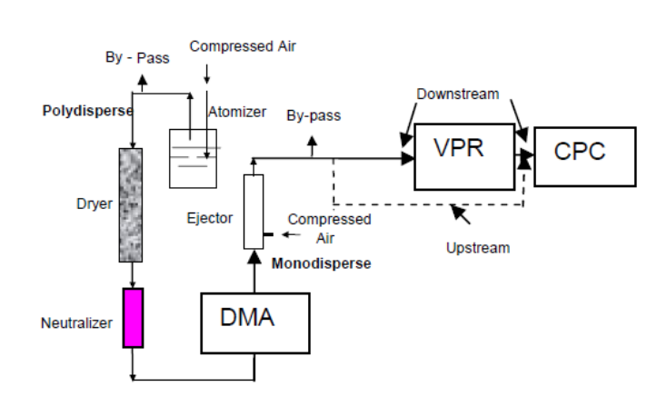
Figure 21: SPCS Penetration of 30nm Particles
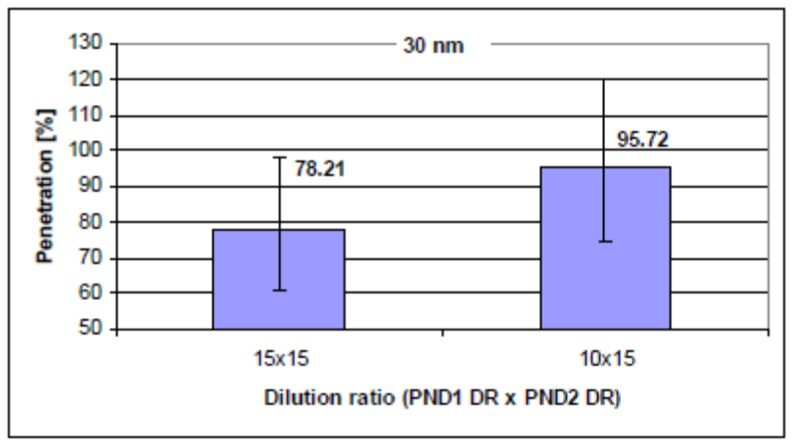
Figure 22: SPCS Penetration of 50nm Particles
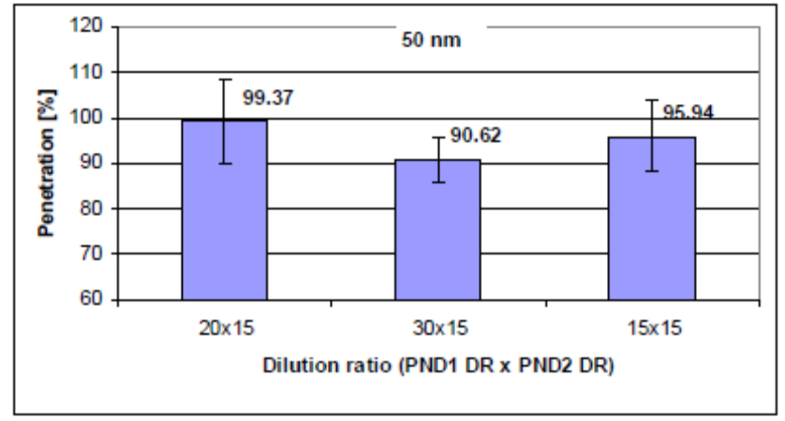
Figure 23: SPCS Penetration of 100nm Particles
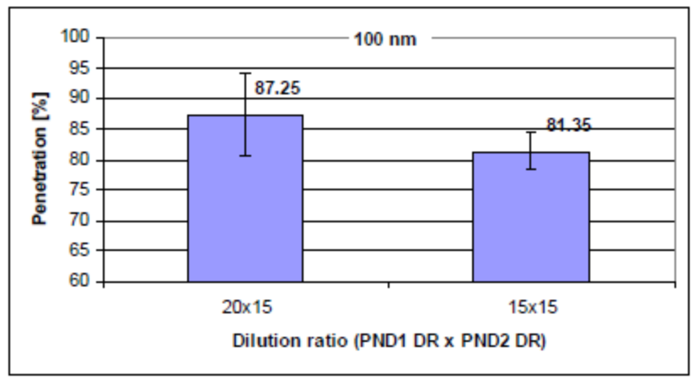
These data convert to a range of PCRF values from 1.06 (taking all the highest results irrespective of dilution ratio) to 1.20 (all the lowest penetrations). This compares reasonably well with the value of 1.25 obtained at JRC (Table 13) using the finalised PCRF procedure.

Dilution Ratio Calibration Using Propane Span Gas
Comparisons of HC concentrations, corrected for ambient levels, were made upstream and downstream of the VPR at a range of dilution ratios, using a flame ionisation detector. One series of experiments was performed with a fixed primary dilution ratio and another with a fixed secondary dilution ratio. Results are shown in Figure 24 and Figure 25.
Results showed that dilution ratio settings were within ±4% of the nominal value.
Figure 24: Dilution Ratio Calibration – Fixed Secondary Dilution
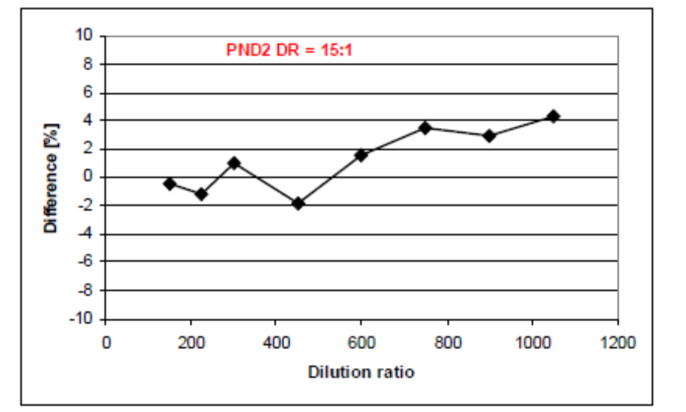
Figure 25: Dilution Ratio Calibration – Fixed Primary Dilution
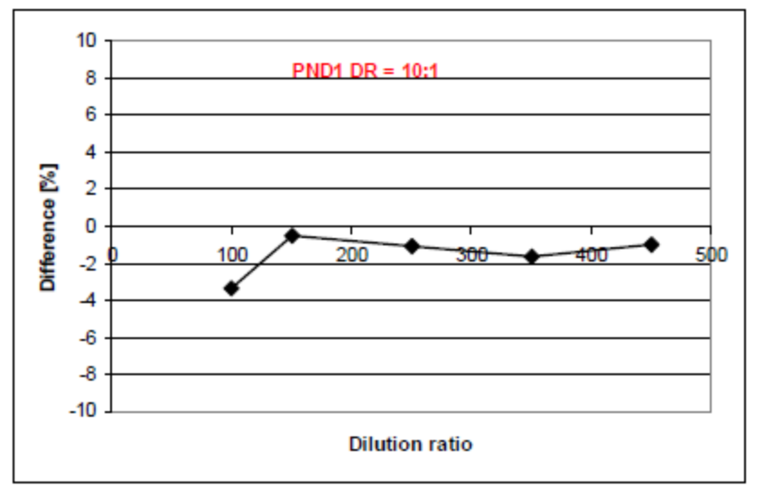

3010D Calibration
Particle number counters used with the two SPCS systems were calibrated according to the procedures described by TSI []. This uses the primary method in which particle counting is verified by comparison with the response of a electrometer. The counting efficiencies of the PNCs were determined through the use of an electrospray generated polyalpholefin aerosol classified in a DMA.
Certificates of conformity for the two PNCs used with the SPCS systems are given in Appendix 2. These data were supplied directly by TSI [].

Validation Exercises
No substantive issues were observed with the PN validation procedures of the HD_ILG at any of the test labs during the programme. These included zero checks of the PNC and SPCS systems and flow checks of the PNC. Functional checks (indicative monitoring of flows and temperatures) were undertaken on a continuous basis and any issues resolved via routine maintenance.

EMISSIONS RESULTS

Full Flow and Partial Flow PM
Phase II of PMP made recommendations for introducing a solid particle number measurement procedure and also for improving the current EU and ECE regulatory particulate mass measurement procedure. The aim of Phase III of PMP was to validate the measurement techniques recommended in Phase II. The ILCE_LD validated both measurement techniques for use in light duty vehicle emissions measurement. The ILCE_HD also included measurements to evaluate the revised particulate mass measurement technique recommended by PMP Phase II when applied to heavy duty engine emissions measurement. However, international agreement on improvements to particulate mass measurement techniques for heavy duty engine emissions testing has already been reached within Global Technical Regulation No.4. Many of the particulate mass measurement improvements adopted in GTR No.4 are consistent with the PMP Phase II recommendations. For these reasons it is not the intention of the PMP informal group to propose amendments to regulatory, heavy duty particulate mass measurement procedures. However the results and conclusions of the measurements made using the revised particulate mass measurement procedures during the ILCE_HD are reported here for completeness.
Particulate mass data from full and partial flow dilution systems are both discussed in this section.

PM - Repeatability
Repeatability levels for all labs are expressed as single CoV values that express overall intra-lab variability for each emissions cycle (see Section 4.1.2).
Figure 26 shows the repeatability of the 5 test matrix cycles and the composite weighted WHTC result for the CVS-based PM method.
Three results are shown for each cycle, and these include:
- PMCVS1: All data from all labs (excepting tests excluded for technical reasons)
- PMCVS2: Outlier analysis iteration 1
- PMCVS3: Outlier analysis iteration 2
Outlier analyses found no exclusions.

The best repeatability of ~34% was seen from the cold start WHTC cycle, with all other cycles showing between 50% and 56%. Filters from emissions tests revealed that the cold start WHTC showed both the highest sample masses and visible grey staining indicating the presence of some elemental carbon. Other cycles’ filters did not show the same discoloration.

Figure 26: Repeatability of the CVS PM Method
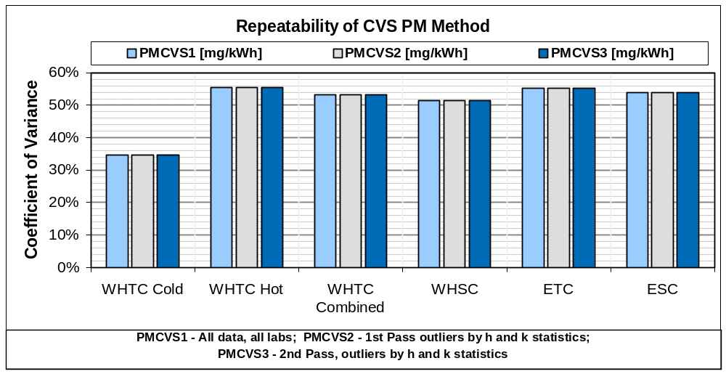
Figure 27 shows the repeatability of the 5 test matrix cycles and the composite weighted WHTC result for the PFDS-based PM method.
Three results are shown for each cycle, and these include:
- PMPFDS1: All data from all labs (excepting tests excluded for technical reasons)
- PMPFDS2: Outlier analysis iteration 1
- PMPFDS3: Outlier analysis iteration 2
Outlier analyses led to the exclusion of all PM results from UTAC which showed PM levels significantly higher than PFDS results from any other lab. Interestingly, this lab’s PFDS results showed very similar levels to its CVS-measured results. Following this analysis, the resulting repeatability levels were typically 20% to 30% across all emissions cycles.

Figure 27: Repeatability of the PFDS PM Method
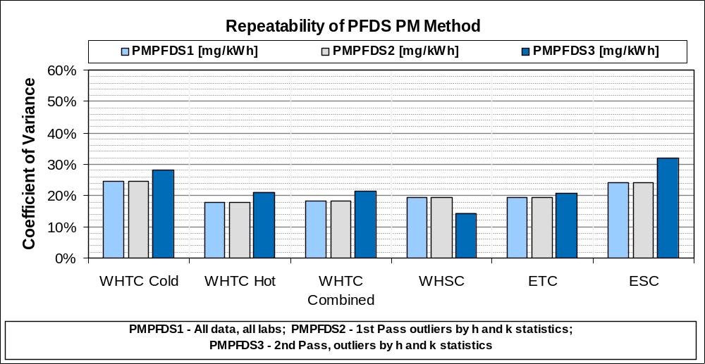

PM - Reproducibility
Reproducibilities are given as single CoV values that express overall inter-lab variability for each emissions cycle (see Section 4). Reproducibility levels for the CVS and PFDS PM methods are shown in Figure 28. Data generated following two rounds of outlier iterations are shown.
CVS PM reproducibility levels were typically in the range 35% to 55%, averaging 42.7% for the 5 emissions cycles in the test matrix. PFDS PM reproducibility levels ranged from ~30% to ~45%, averaging 36.1%.
The lower CoVs from the PFDS systems probably reflect the greater consistency of tunnel background levels in the partial flow system compared to the CVS.

Figure 28: Reproducibility of PM Methods
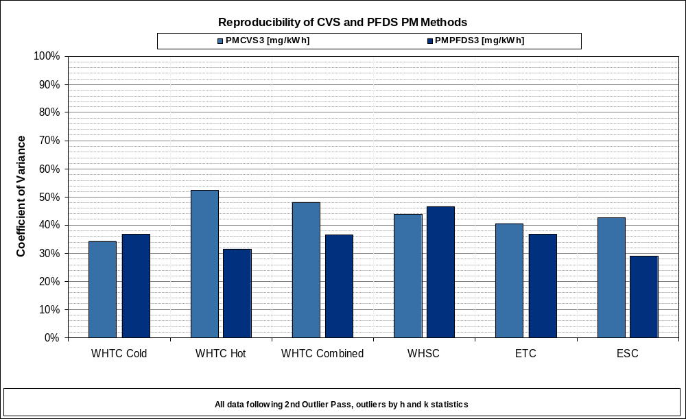

PM – Filter Weights, Background Levels and Background Subtraction
Testing at Ricardo included both CVS and PFDS PM measurements, and a comparison has been made of the filter masses collected from background and cycle testing.

Filter Weights
In all cases filter masses proved to be higher from the CVS than from the partial flow system (Figure 29). The greatest differential between measurement systems proved to be from the WHTC cycles, with results between the systems closest from the ESC cycle.
Filter loadings seldom exceeded 50µg with partial flow sampling (collected masses ranged from a high of 59µg (ESC) to a low of zero (also ESC)). CVS levels were both higher and covered a wider range: from 346µg over one cold WHTC down to 31µg (ESC).
Figure 29: Sampled Filter Masses – Various Cycles, Both Measurement Systems
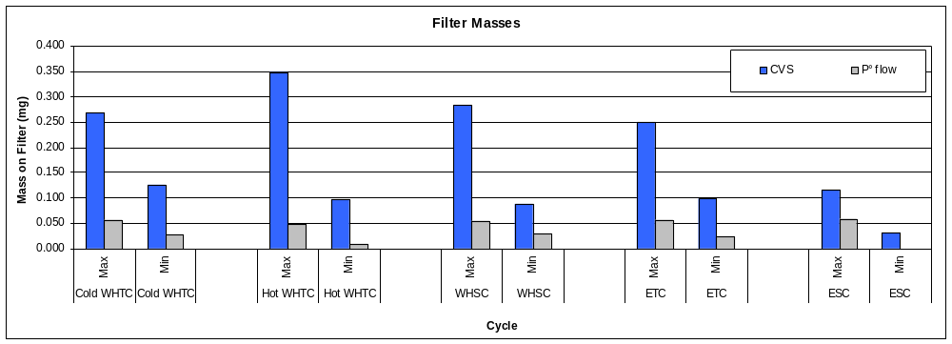
Figure 30 puts measured filter masses into context of the tunnel background filter levels recorded:
- It is clear that from the CVS, the highest sample mass is higher than the highest tunnel background, but the lowest sample mass is lower than the lowest tunnel background.
- From the partial flow system, the highest and lowest sample masses are roughly equivalent to the highest and lowest tunnel background masses.
The observations from this testing were as follows:
- Mass emissions measured by the partial flow system may be indistinguishable from the dilution tunnel background. In which case, mass emissions from all cycles are effectively zero.
- Mass emissions measured by the CVS system were in some cases higher than the tunnel background levels, but it is also possible that the CVS tunnel background levels at this laboratory may be unrepresentative.
If the first observation and comment (all mass emissions measured by the partial flow system were effectively zero) is correct, and the partial flow results are valid, then the highest CVS results must have been seeing a greater tunnel background contribution during the test than from the pre-test measurement.
Figure 30: Filter Masses - Samples and Tunnel Backgrounds Compared
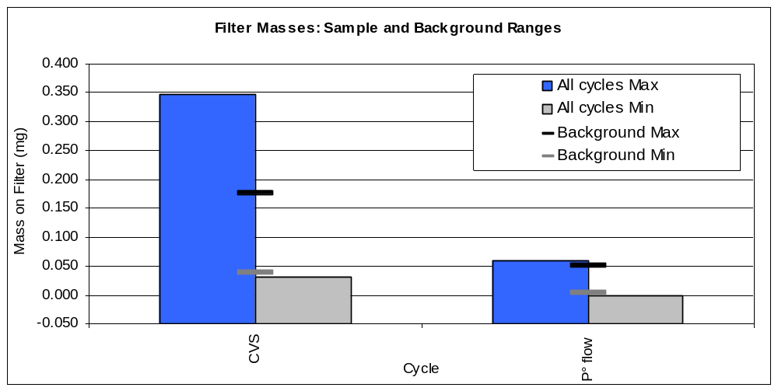
This testing suggested that tunnel background subtraction of filter masses from partial flow and a substantial number of full flow tests is likely to give net PM results of 0 mg/km. This may be a true indication of the mass emissions of this engine with DPF when the resolution of the mass method is considered.
Tunnel background PM was also frequently measured at EMPA and JRC.
Tunnel background PM filters were drawn prior to the cold start WHTC emissions test each day. The mass on each tunnel background filter was then treated as a cycle emissions result (masses were adjusted for differences in sample times between cycles) and the corresponding mg/kWh emissions figure calculated using engine data from that day's emissions tests.

CVS PM Tunnel Background
As Figure 31 shows for CVS-sampled PM data from both EMPA and JRC, only measurements from ESC cycles were above tunnel background levels. The ESC cycle has a substantial period of operation at high exhaust temperatures and this may lead to emissions of low volatility compounds that are efficiently collected and then retained by the filter. Filters from other cycles collect higher volatility materials from the exhaust and dilution air, but these can be released following acquisition through volatilisation or through a washing effect as further aerosol is drawn through the filter.
It is worth noting that except for hot start WHTC measurements at EMPA, both samples and during the ILCE_HD results were above the limits of detection (3 standard deviations of the blank measurement) for the various cycles.
Figure 31: Tunnel Background and Sample PM levels - CVS
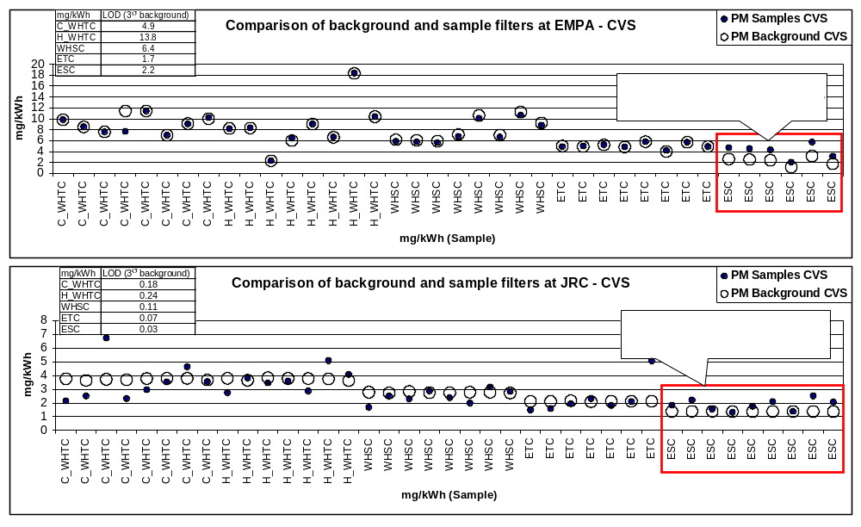
Comparison of Tunnel Background and Sample Filter Masses at EMPA
Comparison of Tunnel Background and Sample Filter Masses at JRC
These data suggest that the CVS PM method is capable of resolving PM emissions from ESC tests from tunnel background levels. Results from other cycles, including the cold WHTC are subject to high uncertainty and would reduce to zero if tunnel background subtraction was undertaken.

PFDS PM Tunnel background
Tunnel background and sample filter comparisons were also made from partial flow dilution systems at JRC and EMPA (Figure 32).
EMPA results reflected the CVS results, where all cycles’ data except ESC were similar to the tunnel background levels.
JRC results, conversely, showed that it is possible to discriminate PM samples from the tunnel background, but this discrimination is poorest from the hot and cold WHTC cycles.
Tunnel background correction of the JRC PFDS results would reduce the emissions levels from cold start WHTC to (generally) <1mg/kWh, hot start WHTC to 0.5g/kWh or less, WHSC to ~1.2g/kWh, ETC to 0.5g/kWh or less and ESC to <2mg/kWh.
Figure 32: Background and Sample PM levels - PFDS
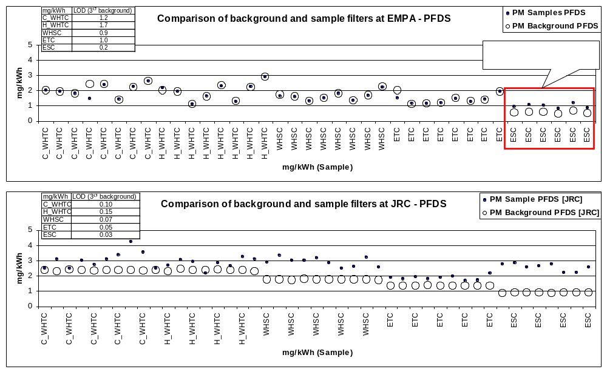
Comparison of Tunnel Background and Sample Filter Masses at EMPA
Comparison of Tunnel Background and Sample Filter Masses JRC

Limits of Detection (LOD) for Mass Methods –CVS and PFDS
LOD from tests at EMPA and JRC show that for the hot-start WHTC at EMPA only, the limit of detection was above the Euro V limit (10mg/kWh) for the weighted WHTC cycle. However LOD for partial flow systems were always below 2mg/kWh.
Table 9: Limits of Detection – PM Methods at JRC and EMPA (mg/kWh)
 | EMPA CVS | EMPA PFDS | JRC CVS | JRC PFDS
C_WHTC | 4.9 | 1.2 | 0.18 | 0.10
H_WHTC | 13.8 | 1.7 | 0.24 | 0.15
WHSC | 6.4 | 0.9 | 0.11 | 0.07
ETC | 1.7 | 1.0 | 0.07 | 0.05
ESC | 2.2 | 0.2 | 0.03 | 0.03

PM – Emissions Levels
Figure 33 (CVS) and Figure 34 (PFDS) show the maximum to minimum ranges of Particulate Matter emissions levels seen from each emissions cycle at each laboratory. Ranges are shown as error bars above and below the mean values. These data are not corrected for tunnel backgrounds.

PM emissions from CVS Systems
Emissions levels from the CVS (Figure 33) showed the largest ranges from Ricardo and EMPA, where tunnel background levels were substantially higher than other laboratories. These laboratories also showed some of the lowest emissions values as well as some of the highest, but were sampled according to the prescribed protocols using compliant equipment and thus were not be eliminated as outliers by simple statistical techniques.
The contribution of high and variable tunnel background PM to the results from EMPA and Ricardo is believed to be responsible for the variable PM results from these two labs and this may be related to the recent test history of the facility. In particular, Ricardo had undertaken testing on high bio-content fuels, active regeneration strategies for DPF regeneration and undertaken substantial amounts of non-DPF testing on low NOx calibration engines. All these types of testing would be expected to contribute substantially to both volatile and carbonaceous CVS tunnel backgrounds.
The test protocols were designed to help purge the CVS system of residual tunnel backgrounds, but it is clear that in some cases extreme measures may be required to eliminate historical PM from full flow dilution systems. For this reason it may be necessary to permit the subtraction of a tunnel, rather than dilution air, tunnel background for regulatory PM purposes.
Tunnel background levels of PM in other laboratories were very low (typically <1mg/kWh).
Generally speaking, and excepting some results from Ricardo and EMPA which were higher, PM emissions from all cycles were <6mg/kWh, with no obvious difference in emissions between the cold and hot start WHTC cycles. These levels are substantially below the 10mg/kWh limits set for the weighted WHTC and WHSC at Euro V and expected for Euro VI.
Tunnel background correction of the PM results from Ricardo [] (which showed the highest emissions of all labs) brought them in line with other labs: reducing Cold WHTC results to ~8mg/kWh, hot WHTC results to ~7mg/kWh, WHSC to ~4mg/kWh, ETC to ~1mg/kWh and ESC to <1mg/kWh.

PM Emissions from PFDS Systems
PM emissions measured by PDTs (Figure 34) showed narrower ranges than those measured from CVS systems.
Statistical analyses identified PM results from UTAC as systematically higher, with mean values from all cycles at between 4mg/kWh and 7mg/kWh. It is possible that the PFDS used by UTAC had been employed for non-DPF testing and was contributing particles during emissions tests. This is analogous to the high tunnel background PM levels observed by Ricardo from their CVS.
By contrast, PFDS emissions levels from other laboratories, and considering all emissions cycles, rarely exceeded 4mg/kWh.
As seen in the CVS PM data, the emissions levels from cold and hot start WHTC do not appear to differ.
Comparisons between CVS and PFDS mass data are discussed in Section 8.5, but emissions from the same engine measured simultaneously from CVS and PFDS appear, in general, to be lower from the PFDS. This is likely to be related to the fact that almost all the PDTs tested were relatively new and one, tested at Ricardo, had never been used before. Newer dilution systems are less likely to have been exposed to old technology higher PM engines. Tunnel background contributions to PM are therefore likely to be low.
It is widely assumed that dilution systems reach a deposition and entrainment equilibrium where losses to the dilution tunnel walls are balanced by resuspension. This follows a period where particle deposition to tunnel walls is favoured. ‘Clean’ systems may be within the deposition-dominated phase and this may explain the directionally lower PM results seen with the PFDS data from Ricardo.
Figure 33: Maximum and Minimum Ranges of Emissions – CVS PM
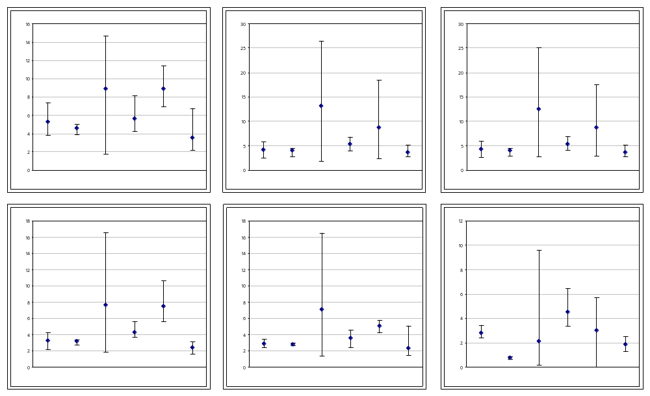
Figure 34: Maximum and Minimum Ranges of Emissions – PFDS PM
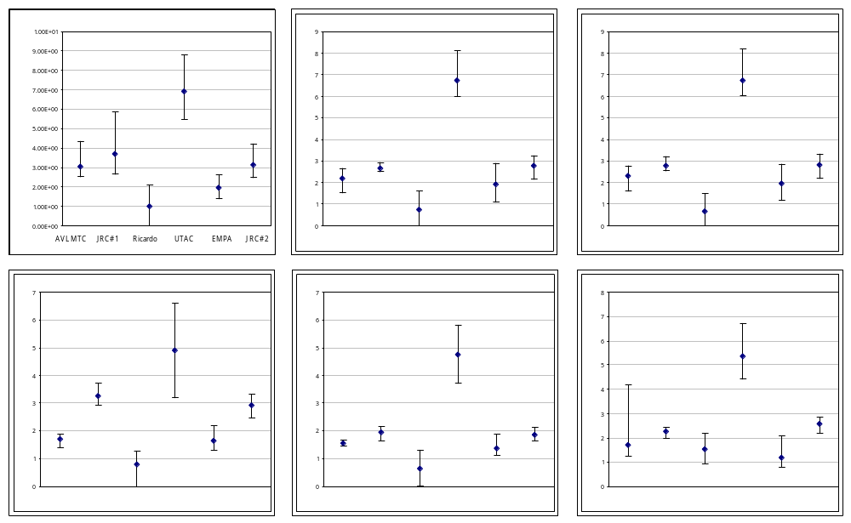

PM – Daily Trends
The trends in PM emissions across the day’s test sequence are shown for CVS PM in Figure 35 and for PFDS PM in Figure 36. Data are shown from all test labs, with concurrently sampled data from the CVS and PFDS shown.
From the CVS (Figure 35), profiles from the JRC, UTAC and AVL-MTC tests are relatively similar, with PM levels remaining relatively flat through the test sequence. The labs with the high tunnel backgrounds show different profiles. These results suggest that if any changes in emissions levels occur due to cycle-to-cycle variations or changes to DPF fill state occur with passive regeneration within individual cycles, CVS PM is insensitive to them. Alternatively, the results suggest that in this testing any effects that do occur have been masked by tunnel background levels even in the labs with low emissions.
Figure 35: CVS PM Emissions through the Test Sequence – All labs
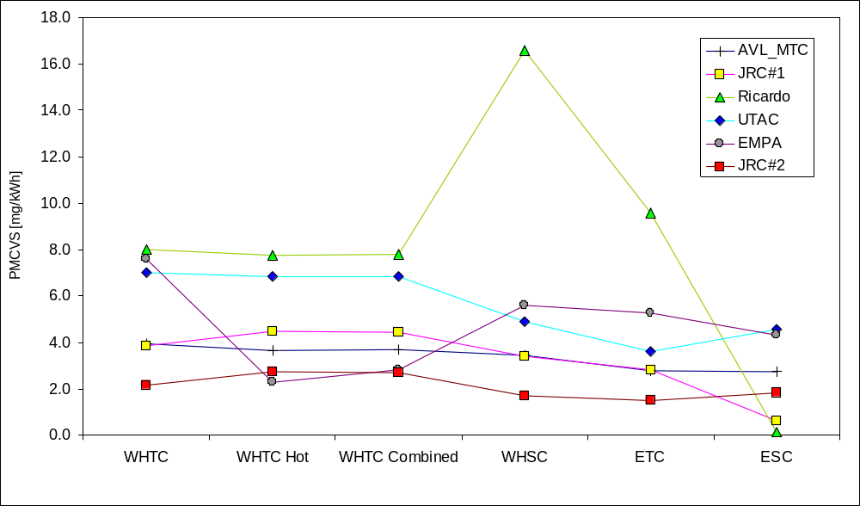
From the partial flow system (Figure 36), PM levels were relatively consistent through the test sequence from all labs except UTAC where the tunnel background levels were higher. It is possible that the PM method detects a reduction in cycle PM between the cold and hot WHTC cycles, but as with the CVS data, the PFDS PM measurements in this testing were either insufficiently sensitive to detect changes in DPF fill state through the day’s test sequence, or the effects were masked by tunnel background levels.
Figure 36: PFDS PM Emissions through the Test Sequence – All labs
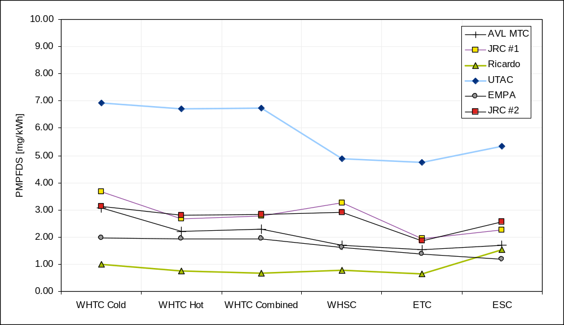

Overview of PM Results
- CVS PM results, after elimination of the high tunnel background labs data, showed emissions levels of <6mg/kWh across all cycles
- Emissions levels from the PDTs were generally lower at 4mg/kWh or less from all cycles, with the exception of UTAC’s results which were in the range 4mg/kWh to 7mg/kWh. This may have been due to a higher PFDS tunnel background than other labs, but there is insufficient data to draw a firm conclusion
- CVS PM tunnel backgrounds were generally at the same level as samples except from ESC cycles, as ESC PM contains low volatility HCs which, once collected, remain on the filter. As a consequence, the CVS PM measurements in this testing only appeared capable of resolving engine emissions from the tunnel background for ESC tests.
- Tunnel background PM levels in PFDS systems were at the low end of levels seen from CVS systems. Even so in only one of 3 systems, in which tunnel background levels were determined, was it possible to discriminate data from any more cycles than the ESC.
- In the one PFDS system that enabled discrimination between tunnel background and sample levels, emissions from all cycles were <2mg/kWh and specifically ~1.2mg/kWh from the WHSC and <1mg/kWh from the weighted WHTC.

Full Flow and Partial Flow PN

PN – Tunnel background Levels
PN tunnel background levels appear to vary substantially between CVS systems in different laboratories, but appear highly similar between partial flow systems. While data are not available for tunnel backgrounds in all labs, comparisons of hot transient cycle results from different labs, where particle emissions are low, clearly shows the offsets due to tunnel backgrounds.
As Figure 37 shows, particle number emissions measured from the CVS from different labs across the hot WHTC can vary by a factor of 100 or more. In contrast (Figure 41), particle number emissions from PDTs sampled simultaneously to the CVS data appear to overlay.
JRC, AVL and Ricardo (RCE) also supplied particle number data from 30 minutes dilution system tunnel background acquisitions taken prior to the cold start WHTC on each test day. A typical tunnel background from each of the PFDS and CVS facilities at these labs was calculated to particles/kWh and the values obtained were compared. These data are shown in Figure 38.
The CVS tunnel background at Ricardo was >4x10¹⁰/kWh. This was ~60 times higher than the CVS tunnel background at AVL-MTC and ~140 times higher than the CVS tunnel background at JRC. These differences are in line with the differences in emissions levels seen from the hot start transient test shown in Figure 37, and indicate that from Ricardo and to a lesser extent AVL, the tunnel background predominates in the particle numbers measured on these tests.
The tunnel background levels from the 3 PFDS systems are almost identical: at <3x10⁸/kWh. This indicates that the small variations in particle number levels seen in Figure 38 are probably related to real engine or DPF variability rather than tunnel background contributions.
As noted in Section 6.1.4, where PM tunnel background was discussed, the Ricardo facility is a working facility which had recently experienced testing on high bio-content fuels, work on active regeneration strategies for DPF regeneration and substantial amounts of non-DPF testing on low NOx calibration engines. An elevated PM tunnel background was seen from this lab and it is apparent the tunnel background also contributes substantially to PN.
Figure 37: Tunnel background Impacts PN Results – CVS Systems at 3 Labs
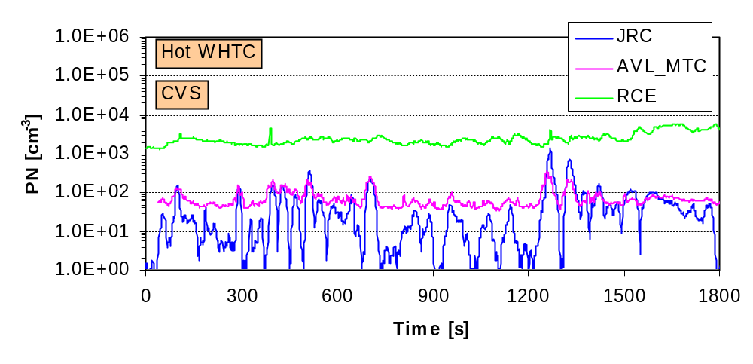

Figure 38: Tunnel background Effect on PN Results Minimal– PFDS Systems at 3 Labs
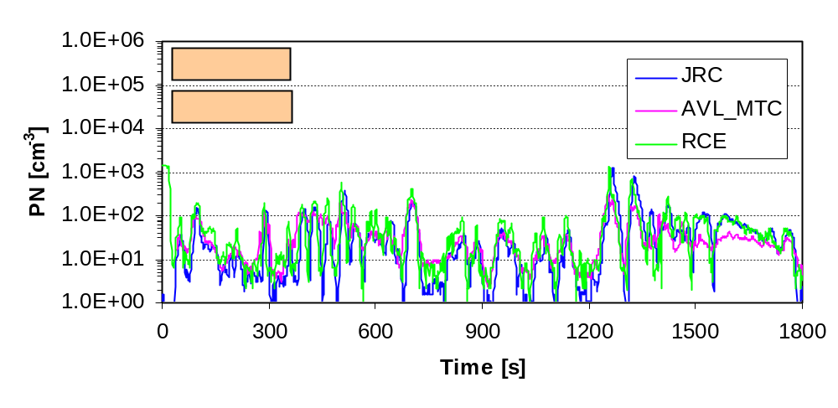
Figure 39: Particle Number Tunnel backgrounds – 3 Labs; CVS and PFDS Facilities
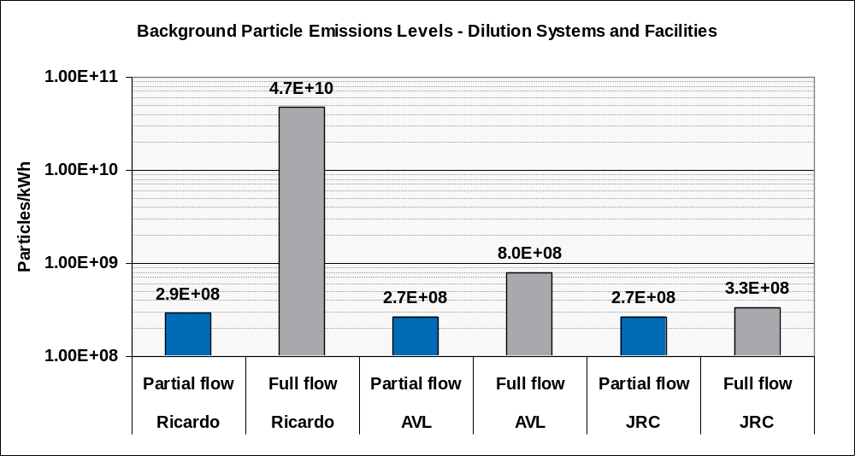

PN - Repeatability

Transient Particle Production
Figure 40 to Figure 44 inclusive show real-time repeatability traces for cold WHTC, hot WHTC, WHSC and ESC tests. Each figure shows PN results from a lab with the highest CVS particle number tunnel background (upper), results from the lab with the lowest CVS PN tunnel background (middle) and typical results from a partial flow system (lower). The bottom and middle charts' data are drawn from the same test laboratory.
Data from the cold start WHTCs shown in Figure 40 (upper) covers approximately two orders of magnitude, but the range seen in the middle and lower figures covers more than 4 orders of magnitude. It is also clear that data in the top figure shows little similarity to the engine speed after the first 700s, but the middle and lower figures reflect changes in engine operation throughout the emissions cycle.
The high levels of tunnel background seen in the CVS (Figure 40, upper) do not have a substantial effect on repeatability, because the overall emissions levels from the cycle are dominated by those of the first 700s. Repeatability levels from the data shown, based upon mean cycle results, would be relatively similar to those seen for Figure 40, middle and lower.
The contrast between the upper and middle parts of Figure 40 is clear: while the profiles of emissions coincide at the peaks, the less transient parts of the emissions cycles can be masked if the tunnel background is high. Results from the lower figure are highly similar to those of the middle figure, indicating that there are not fundamental differences in either emissions levels or transient measurements from full and partial flow systems as long as tunnel background levels are similar.
The sensitivity of the measurement is obviously affected by the tunnel background, but as mentioned above, the dominance of the peaks seen in the first 700s makes even a high tunnel background almost irrelevant to results from the cold WHTC emissions cycle.
Results from the hot start WHTC (Figure 41) were substantially affected by the high CVS tunnel background. A comparison between high (upper figure) and low (middle figure) tunnel background CVS facilities shows that the transient traces from the high tunnel background lab bear little or no relationship to the transient events of the cycle and span less than a factor of 10. Conversely, the emissions of the low tunnel background CVS (middle figure) and from the partial flow system (lower figure) indicate transient events corresponding to engine operation and emissions ranges that span 2 to 3 orders of magnitude. Once again, results from the flow tunnel background CVS and partial flow systems appear very similar.
Peak emissions levels from the partial flow system (and low tunnel background CVS) were ~ 1000 times lower than the peaks from the cold start WHTC, but in the high tunnel background CVS, cold WHTC emissions only appeared to be 10 times higher than the hot start WHTC. Clearly, the hot WHTC repeatability from the high tunnel background CVS system reflects little more than the repeatability of the tunnel background levels.
Emissions from the WHSC cycle (Figure 42) were at a similar level to those seen from the hot WHTC (Figure 41), but the emissions profile from the high tunnel background CVS (upper figure) tracks the engine speed trace well. This suggests that the tunnel background is less significant during this cycle than in the hot WHTC, so running the previous two cycles in the test matrix may have had a ‘cleaning’ effect on the CVS.
From all three dilution tunnels, it appears that particle number emissions are very low from the WHSC until ~1200s. The exhaust temperature of the WHSC is sufficient to enable passive regeneration (where NO₂ reacts with soot on the DPF to produce N₂ and CO₂) during ~60% of the emissions cycle (Figure 43, left).
It is possible that after ~1200s of the WHSC, the soot loading of the DPF has reduced sufficiently to have a substantial impact on filtration efficiency. The exhaust temperature has also increased to ~450°C at this point in the cycle (Figure 43, right) and this might lead to the thermal release of low volatility components from the exhaust system. Both these mechanisms could increase particle number emissions and variability.
The ETC cycle is tested following the WHSC in the test sequence. Results, emissions levels and repeatability from this cycle were very similar to those from the hot WHTC. The ETC runs at relatively low exhaust temperatures, so during this cycle additional soot is added to the DPF following passive regeneration in the WHSC. This may have the effect of increasing filtration efficiency for the start of the ESC.
Figure 40: Real-time Data – Cycle-to-cycle Repeatability, Cold WHTC
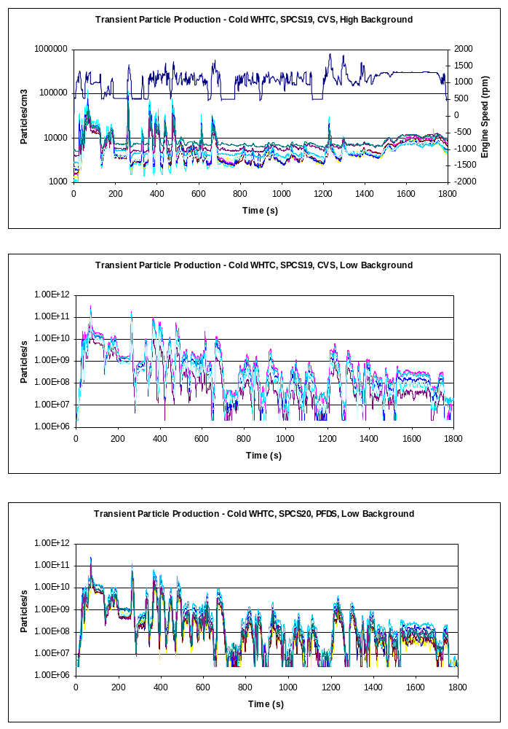
SPCS19 – High CVS Tunnel Background
SPCS19 – Low CVS Tunnel Background
SPCS20 – Low PFDS Tunnel Background
Figure 41: Real-time Data – Cycle-to-cycle Repeatability, Hot WHTC
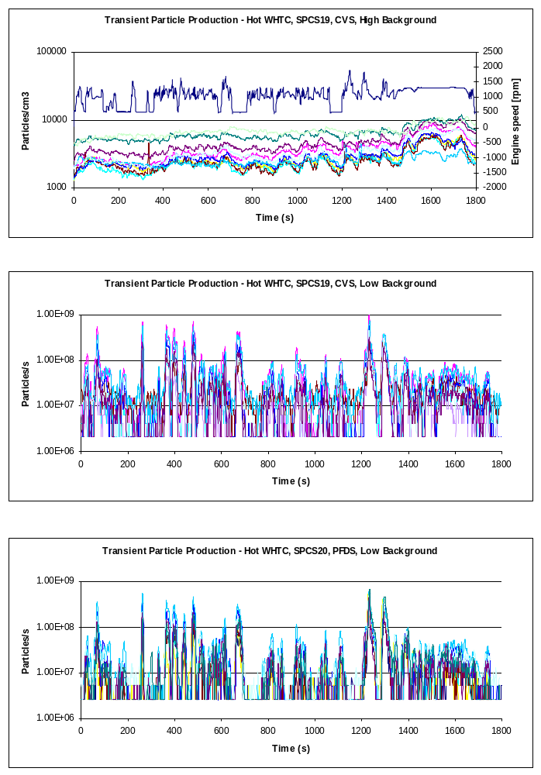
SPCS19 – High CVS Tunnel Background
SPCS19 – Low CVS Tunnel Background
SPCS20 – Low PFDS Tunnel Background
Figure 42: Real-time Data – Cycle-to-cycle Repeatability, Hot WHSC
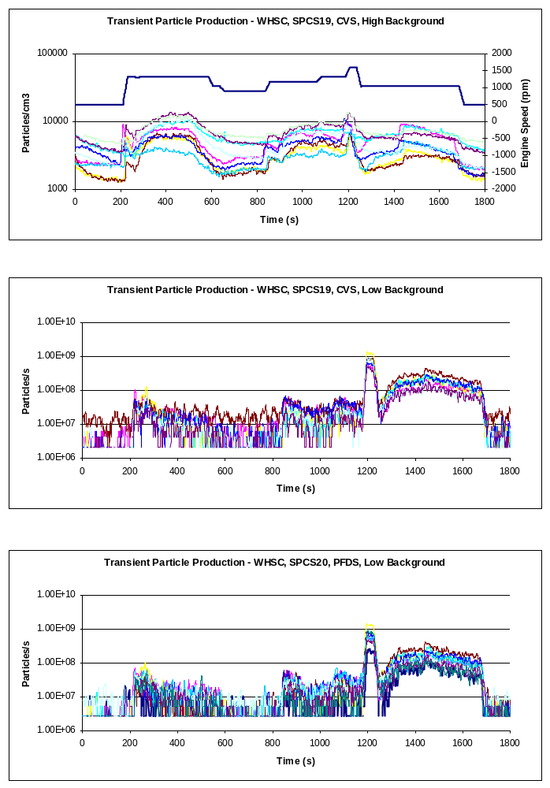
SPCS19 – High CVS Tunnel Background
SPCS19 – Low CVS Tunnel Background
SPCS20 – Low PFDS Tunnel Background
Figure 43: Passive Regeneration During the WHSC
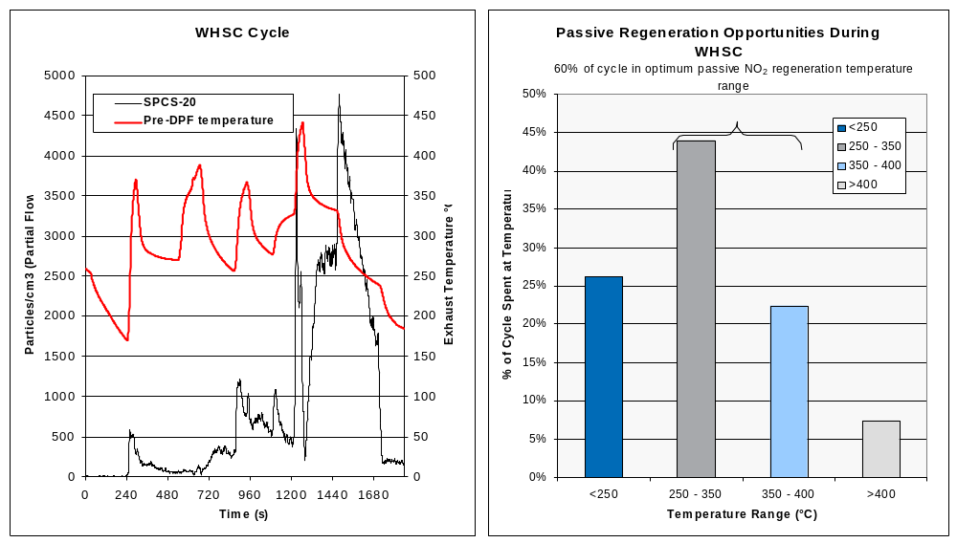
Emissions during the 4 minutes of idle at the start of ESC cycle (Figure 44 upper, middle and lower) were very low and probably indistinguishable from tunnel background in all dilution systems. As with the WHSC cycle, most of the modal transitions of the ESC are visible even in the high tunnel background data (upper figure), but the range of emissions seen in this system (~100 from low to high) compares poorly with the 4 orders of magnitude from the low tunnel background CVS and PFDS and indicates lowered sensitivity of this measurement system.
The ESC shows the highest variability levels on a cycle-to-cycle basis, and these appear to worsen after 1000s of the cycle: at this point exhaust temperatures rise substantially, reaching >600°C after ~1300s. Passive regeneration in this cycle may eliminate the soot replaced during the ETC cycle and further eliminate soot from the DPF. Any variations in initial soot loading during the previous night's preconditioning may manifest as variability in the ESC.
Figure 44: Real-time Data – Cycle-to-cycle Repeatability, Hot ESC
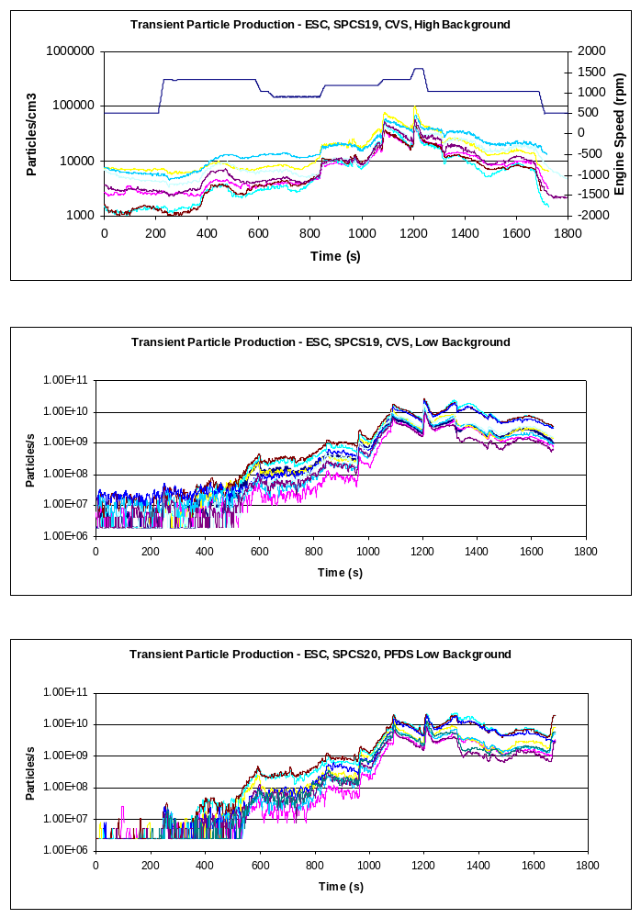
SPCS19 – High CVS Tunnel Background
SPCS19 – Low CVS Tunnel Background
SPCS20 – Low PFDS Tunnel Background

Repeatability as CoV
Repeatability levels for all labs are given as single CoV values that express overall intra-lab variability for each emissions cycle (see Section 4).
Figure 45 shows the repeatability of the 5 test matrix cycles and the composite weighted WHTC result for the CVS-based and PFDS-based PN methods.
Three results are shown for each cycle, and these include:
- PMCVS1: All data from all labs (excepting tests excluded for technical reasons)
- PMCVS2: Outlier analysis iteration 1
- PMCVS3: Outlier analysis iteration 2
Outlier analyses excluded the CVS PN results from both Ricardo and EMPA on the first pass iteration excepting: cold WHTC data from both labs and ESC data from EMPA.

On the second pass analysis, the ETC data from the first batch of tests at JRC were excluded.

Considering all cycles (Figure 24), and following the outlier iterations, repeatability levels were broadly similar: CVS CoVs ranged from ~20% to ~60% and PFDS CoVs from ~20% to ~70%.

Focusing on the Euro VI legislative cycles in isolation shows that the CVS approach has better repeatability over the weighted WHTC (21.1% Vs. 22.8%) and over the WHSC (59.2% Vs. 74.4%) than the PFDS approach.

Figure 45: Repeatability of Particle Number Measurement Systems
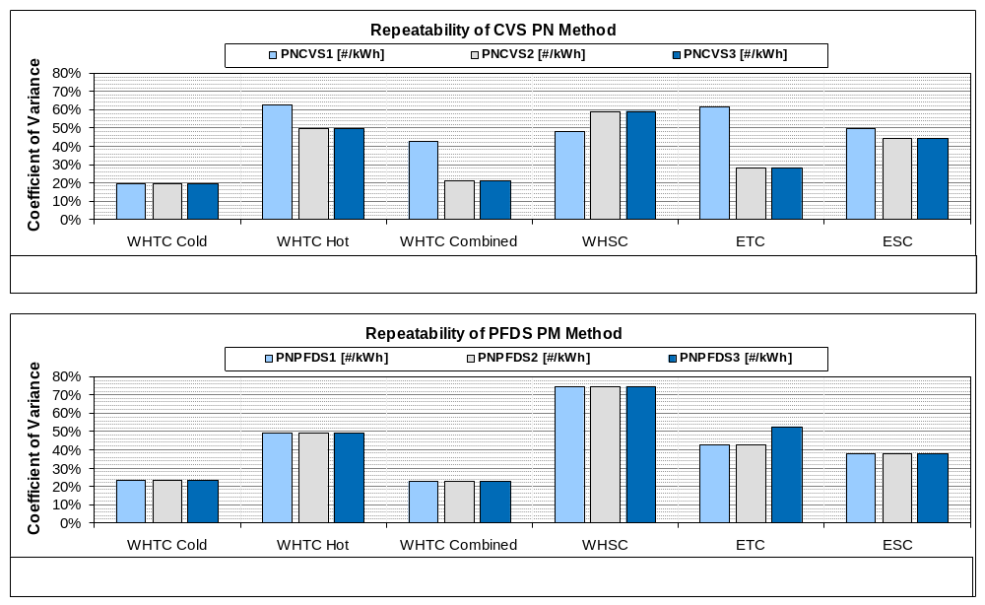

PN - Reproducibility
Reproducibility levels for all labs are given as single CoV values that express overall inter-lab variability from each emissions cycle (see Section 4).
Figure 46 shows the reproducibility of the 5 test matrix cycles and the composite weighted WHTC result for the CVS-based and PFDS-based PN methods.
The outlier analysis has a substantial effect on reducing the variability of the CVS system’s results (Figure 46 upper), but has little impact on the PFDS results, except in the ETC where the first results from JRC were eliminated from the dataset.
Considering just the Euro VI legislative cycles shows that the CVS approach has better reproducibility over the weighted WHTC (41.4% Vs. 45.8%) and over the WHSC (81.7% Vs. 86.3%) than the PFDS approach.

Figure 46: Reproducibility of Particle Number Measurement Systems
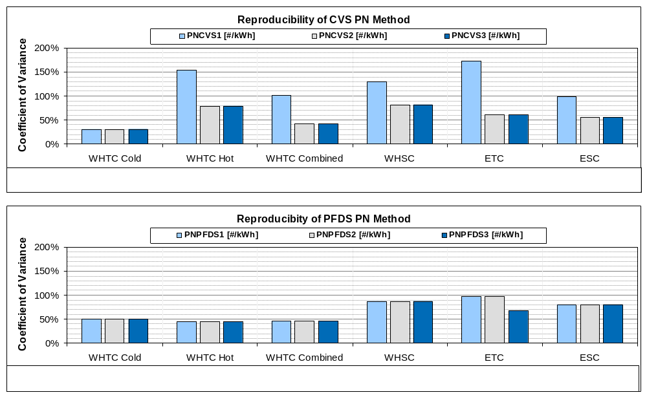

PN – Emissions Levels
Particle number emissions from the various test cycles are shown for CVS measurements in Table 10 and Figure 47 and for PFDS measurements in Table 11 and Figure 49. These Tables and Figures include all test results including those rejected as outliers by the statistical analyses.

PN Emissions from CVS Systems
Particle number emissions from the cold WHTC cycle ranged by approximately an order of magnitude across all laboratories – from ~6 x10¹⁰/kWh to ~7x10¹¹/kWh with the all-labs mean at ~4x10¹¹/kWh.
Hot WHTC results ranged from 10⁹/kWh (JRC 2nd campaign) up to ~5x10¹¹/kWh at Ricardo, a difference from low to high of 500 times. The all labs mean, at ~6x10¹⁰/kWh, was substantially impacted by the labs with high emissions levels.
Table 10: Maximum and Minimum Ranges for CVS-measured PN
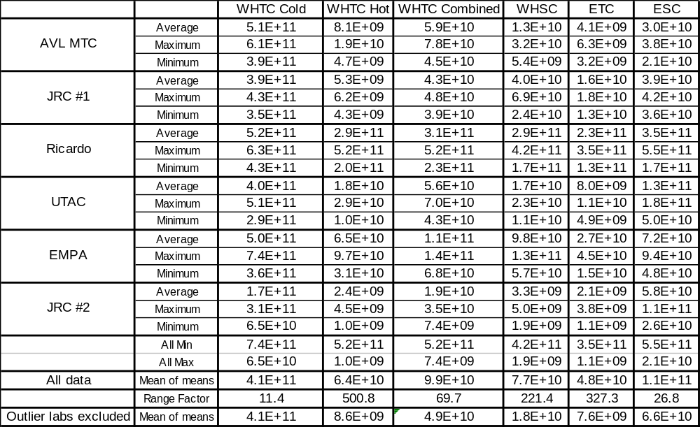
Weighted WHTC results, based upon the cold and hot WHTC data providing 10% and 90% contributions respectively, ranged from ~7x10⁹/kWh to ~5x10¹¹/kWh with an all labs mean of ~10¹¹/kWh.
WHSC and ETC results reflected the results of the hot WHTC, with lowest emissions levels at JRC and highest at Ricardo. WHSC emissions levels ranged by more than 200 times: from 2x10⁹/kWh up to ~4x10¹¹/kWh and ETC ranged by a factor of >300, from ~10⁹/kWh up to ~3..5x10¹¹/kWh.
ESC results showed a narrower range than any of the emissions cycles except the Cold WHTC. Low to high range covered a factor of <30, from ~2x10¹⁰/kWh up to ~5.5x10¹¹/kWh.
Figure 47: Maximum and Minimum Ranges for CVS-measured PN
As described in Section 4, statistical methods were used to eliminate individual PN data and a majority of data from several cycles at two specific laboratories in the dataset. Excluded data are:
- Ricardo CVS data from WHTC Hot, WHSC, ETC, ESC
- EMPA CVS data from WHTC Hot, WHSC, ETC
- ETC data from the first set of tests at JRC
The effects on the mean of means (the average PN emissions across all labs) of eliminating the outlier data is shown in Figure 48. The Cold WHTC data are unaffected since no data are excluded, but the hot WHTC result is substantially reduced, resulting in a weighted WHTC reduction of >50% to~5x10¹⁰/kWh. The WHSC result drops to <2x10¹⁰/kWh, the ETC to below 10¹⁰/kWh and the ESC to <7x10¹⁰/kWh.

Figure 48: CVS PN Results – Effect of Eliminating Outliers
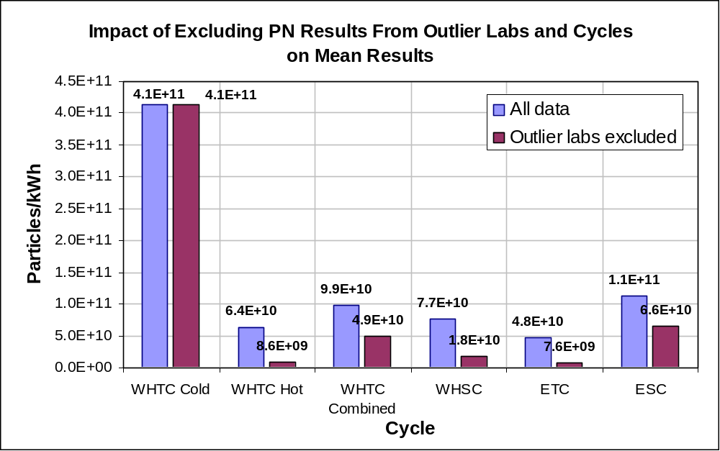

PN Emissions from PFDS Systems
Particle number emissions from the cold WHTC cycle ranged by approximately an order of magnitude across all laboratories – from ~6x10¹⁰/kWh to ~7x10¹¹/kWh with the all-labs mean at ~3.7x10¹¹/kWh. From the PFDS, cold WHTC emissions levels were substantially higher than from any other cycles.
Table 11: Maximum and Minimum Ranges for PFDS-measured PN
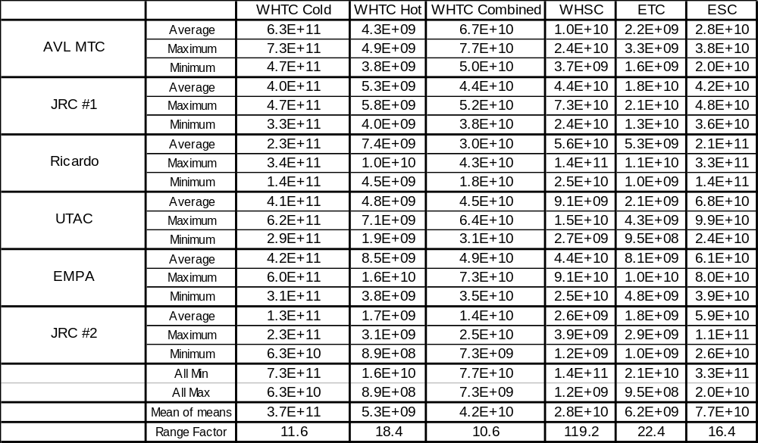
Hot WHTC results ranged from <10⁹/kWh (JRC 2nd campaign) up to ~1.6x10¹⁰/kWh, a difference from low to high of less than 20 times. The all labs mean was ~ 5x10⁹/kWh, almost 2 orders of magnitude lower than the cold start emissions.
The low emissions levels measured from PFDS during the hot WHTC cycle resulted in a substantial reduction in the weighted WHTC result relative to the cold start cycle. Emission ranged from ~7x10⁹/kWh to ~8x10¹⁰/kWh with the all labs mean at ~4.2x10¹⁰.
Emissions from the WHSC showed the greatest range, a factor of ~120, which reflects the substantial period of operation spent in passive regeneration during this cycle and the influence that has on DPF fill-state and filtration efficiency. Low-end emissions levels were close to 10⁹/kWh increasing to 1.4x10¹¹/kWh.
The range and absolute emissions levels from the ETC were similar to those seen from the hot WHTC: ~10⁹/kWh up to ~2x10¹⁰/kWh with the all labs mean at ~6x10⁹/kWh.
ESC data from Ricardo were highest of all the labs, but not identified as an outlier. Emissions ranged from ~2x10¹⁰ to ~3x10¹¹/kWh with the all labs mean at just below 8x10¹⁰/kWh.
Figure 50 shows the mean of all labs PN emissions from PFDS systems. Data are shown for all emissions cycles.
Figure 49: Maximum and Minimum Ranges for PFDS-measured PN
Figure 50: All Labs’ Mean of Means PN Results - PFDS Systems
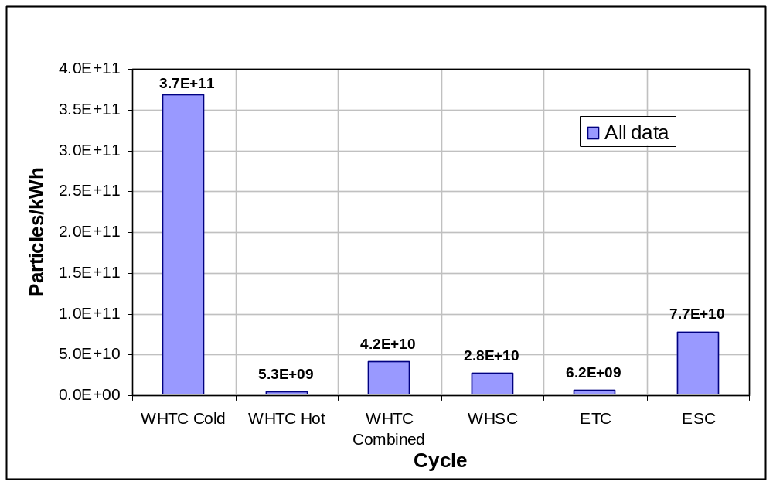

PN Emissions Levels Overview
In both CVS and PFDS cases, and considering mean of means data, emissions were highest from the cold start WHTC at ~4x10¹¹/kWh. At this level of emissions, contributions from the tunnel background, even from labs with very high tunnel backgrounds, do not have a substantial impact on emissions.
Lowest emissions were observed from hot cycles which do not have substantial periods of passive regeneration: hot WHTC and ETC. These cycles showed emissions levels of 5 - 6x10⁹/kWh from the PFDS and 8 - 9 x10⁹/kWh from the CVS once outlier laboratories were excluded. Laboratories considered to be outliers reported emissions levels from these cycles substantially above 10¹¹/kWh.
Weighted WHTC results were of the order 4 - 5x10¹⁰/kWh from the PFDS and CVS (outliers excluded) and ~10¹¹/kWh from the CVS when all labs data were considered.
ESC and WHSC cycles results were generally more variable than the hot start ETC and WHTC due to the presence of passive regeneration during these cycles. Passive regeneration may reduce filtration efficiency by reducing or removing the filter cake but high temperatures may also liberate low volatility HCs which contribute to solid particles: both of these result in higher PN emissions from the ESC and WHSC than from the ETC and hot WHTC. The ESC cycle, which has a 2 minutes period of operation at full load, and other modes with very high exhaust temperatures, sees a higher contribution of low volatility HC ‘solid particles’ than the lower temperature WHSC. Emissions from the WHSC were around 2-3x10¹⁰/kWh from PFDS and CVS (outliers excluded) and 6 - 8x10¹⁰/kWh from the ESC with outliers excluded from the CVS data.

Euro VI Certification
Certification testing for Euro VI will include both WHTC and WHSC. From the emissions levels seen in this study a limit set mandating PFDS and excluding CVS could be lower than a limit set that permits either dilution system. If either dilution system is permitted, the test laboratory or OEM would face substantially higher risk of non-compliance when using a full flow system, unless that CVS was well characterised beforehand.

Achievable PN Limit for this Engine
Across this test programme the highest single PN emissions result seen from any cycle across all labs was 7.4x10¹¹/kWh from a cold WHTC. If this engine and its DPF are considered to have representative PN emissions and both CVS and PFDS dilution approaches are used, a PN limit of 8x10¹¹/kWh would be achievable for all emissions cycles tested.

Gaseous Emissions

General Observations
Gaseous regulated emissions results were generally more repeatable when measured directly from raw exhaust than when measured as dilute emissions. Substantial differences in raw vs. dilute emissions levels also exist, even for ‘high emissions’ gases such as CO₂. Evaluations of these differences were not the focus of this programme, but data from this work will be made available for consideration in relevant studies.
Some labs had high levels of CO and HC backgrounds even when these emissions were measured from raw exhaust. This presents a challenge for the measurement of, in particular, carbon monoxide and hydrocarbons at low levels.
It is clear that few labs regularly measure ‘bagged emissions’ from HD testing. This approach of accumulating a dilute sample permits a true, simultaneously sampled, background to be quantified and subtracted. Even so, HC and CO emissions are so low from modern engines that even this approach, since it samples from diluted exhaust, may lack accuracy.

Inter-Laboratory Variability
During the ILCE_LD, the inter-laboratory variations of regulated gases over the cold start NEDC were found to be ≤5% for CO₂, 35-50% for HC and 10-30% for NOx and >40% for CO.

Considering raw emissions measurements during the ILCE_HD, inter-lab variations were at broadly similar levels from the Cursor 8 engine, with some emissions cycles showing lower variations than others. Highest variations were seen from CO and HC, where actual g/kWh emissions levels were low. Ranges of variation encompassing all test cycles are given below:

- CO₂ emissions across the labs: inter-lab variation range (all test cycles) 6% - 13%
- CO emissions across the labs: inter-lab variation range (all test cycles) 63% -91%. CO emissions range from 13mg/kWh to 400mg/kWh
- NO_{X} emissions differences across the labs: inter-lab variation range (all test cycles) 26% - 38%
- HC emissions differences across the labs: inter-lab variation range (all test cycles) 68% - 82%. Emissions range from 6 to 120mg/kWh
- Cycle work differences across the labs: inter-lab variation range (all test cycles) 2.5% - 12.8%
The reproducibility levels observed in this work were consistent with expected levels. Background contributions to CO and HC measurements influenced the variability of these two gases, despite measurements of raw exhaust.

Other factors contributing to inter-laboratory variability: some differences in dynamometer settings and exact configurations of how each test bed drives a particular emissions cycle will contribute, and another source of variation will be the difference between analysers from different manufacturers and the different technology levels of analysers used by different laboratories.

Overall the gaseous emissions data from this work were considered valid for comparative purposes.

Long-Term Trends in Engine Operation

Regulated Gases
There were no obvious progressive trends in gaseous emissions across the test programme e.g. CO₂ (Figure 51) and NOx (Figure 52), rather there were some step changes between laboratories that indicate true lab-to-lab variations.

Gaseous emissions data from JRC was generally similar between the two measurement campaigns: which demonstrates an absence of drift during the programme.

Figure 51: CO₂ – Consistency Across The Validation Exercise
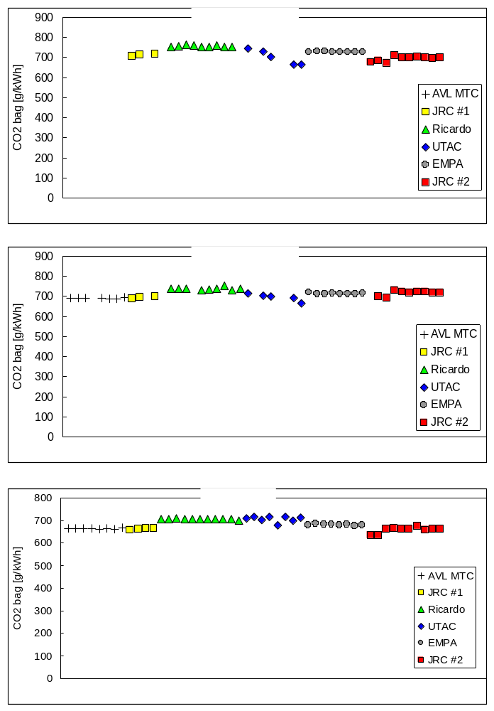
Figure 52: NOx – Consistency Across The Validation Exercise
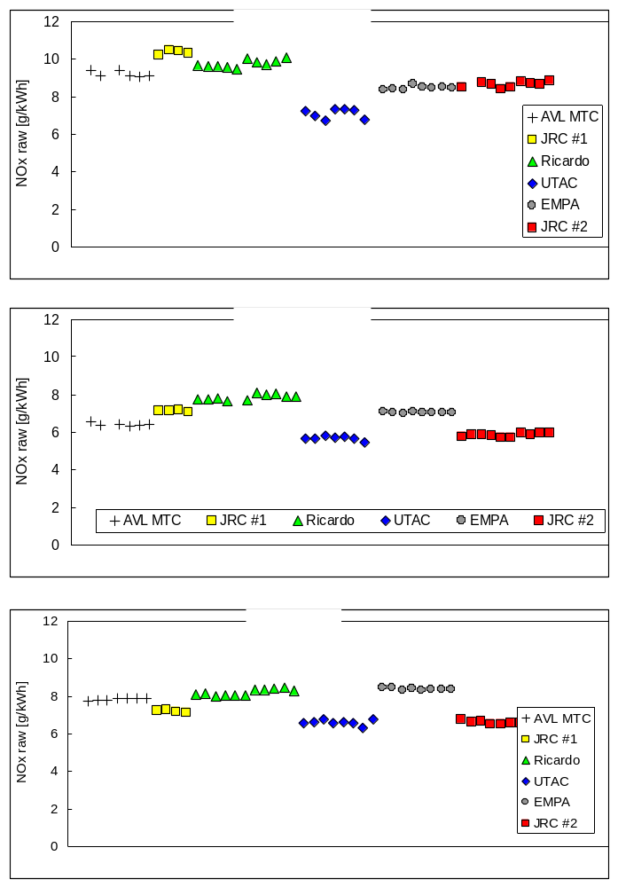

Particle Number Emissions
The programme-wide emissions of particle number measured from the CVS over the cold start WHTC cycle are shown in Figure 53. Similar levels of solid particle number emission rates were determined from all labs, with the exception being the final tests conducted at JRC. The levels measured during the second (and last) measurement campaign at JRC were systematically lower. This discrepancy holds for all test cycles and for both CVS and PFDS-measured particle number emissions.

Figure 53: PN from cold-WHTC: Consistency Through The Test Programme
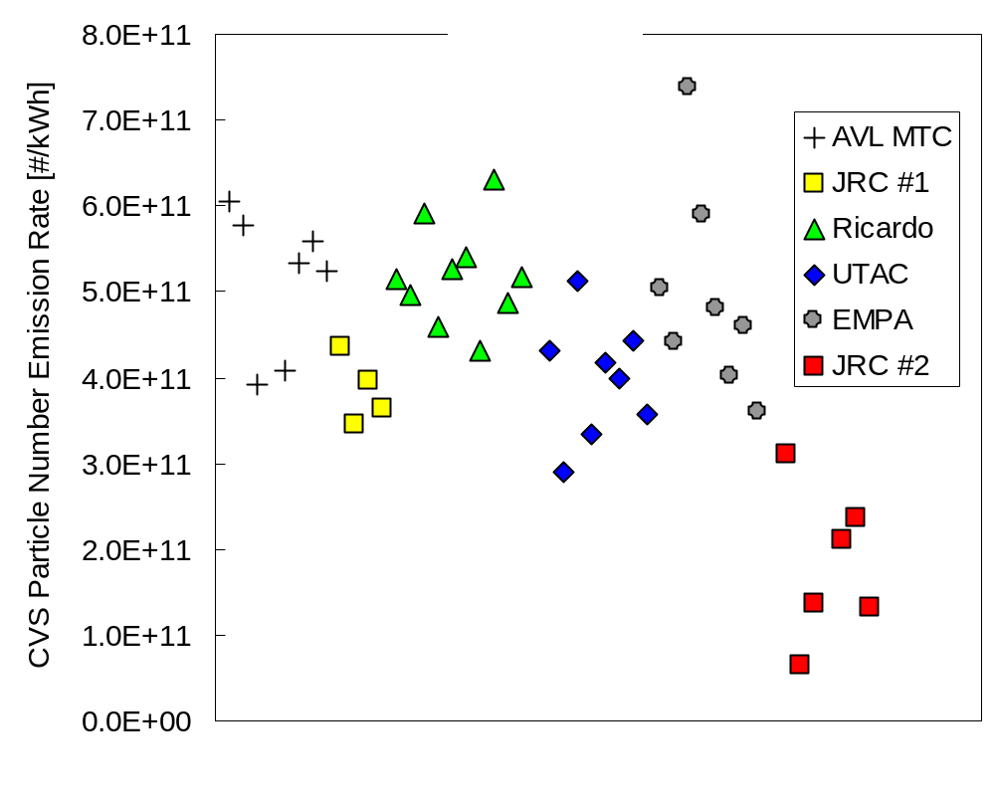

A comparison of the real-time particle number emission rates measured during the first (Figure 54) and second campaigns (Figure 55) at JRC suggests that an apparent increase of the filtration efficiency of the DPF filter was seen during the second measurement campaign. Results in the first phase were typically in the range 3x10¹¹ to 5x10¹¹/kWh, while emissions in the second phase dropped to between 1x10¹¹ and 3x10¹¹/kWh. An examination of the back pressure and temperature data revealed only marginal differences.

In order to further investigate this issue, the entire daily test protocol was repeated twice after an extended preconditioning consisting of 2 hours operation at ESC mode #10. The intention of this exercise was to passively regenerate the DPF to ensure a complete purge of soot and then, without adding any additional soot, run through the daily matrix.

Emissions levels over the cold WHTC from the two days’ testing were unchanged after this extended conditioning of the DPF, showing emissions levels of ~2x10¹¹/kWh – in the middle of the band of emissions levels seen in the second formal test phase.

If the engine-out PM had increased, this might have led to a more rapid generation of a filter cake, reducing particle numbers. However, since PN was still reduced relative to the first JRC measurement campaign following an extensive passive regeneration, this can be discounted. Consequently there are three possible explanations for the reductions in PN seen.

- Reduction in engine-out PN leading to lower post DPF emissions
- Change in the performance of the SPCS or CVS
- Increase in the filtration efficiency of the DPF leading to lower post-DPF emissions

From cold start cycles, PN emissions are generally associated with elemental carbon, which in turn relates to PM. Therefore, in order for engine-out PN to reduce between the two measurement campaigns at JRC, engine-out PM should also reduce. Since NOx and PN trade-off, any reduction in engine-out PN would be accompanied by an increase in engine-out NOx. In fact, NOx is generally lower from tests in the second measurement campaign at JRC. As a consequence, it is unlikely that a reduction in engine-out PN is due to a change in the engine-out emissions.

Emissions levels from the PFDS and CVS correlated equally well from the two JRC measurement campaigns. This eliminates issues from the CVS and SPCS as responsible for the change in emissions levels observed.

Consequently, the most likely explanation is a change in the filtration performance of the DPF. Soot has been ruled out as the key factor, so it is possible that the ash level in the DPF reached a critical point during preconditioning at JRC prior to the test programme and this resulted in a step change in filtration efficiency.

Figure 54: Real time PN Production from the CVS- Cold WHTC (JRC#1)
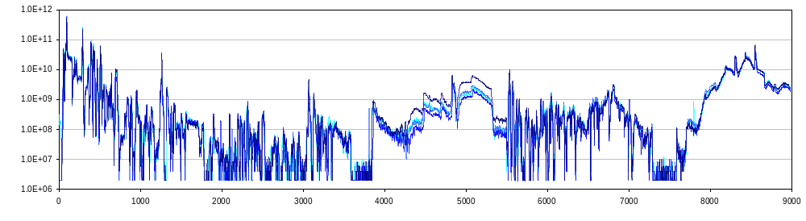
Figure 55: Real time PN Production from the CVS- Cold WHTC (JRC#2)
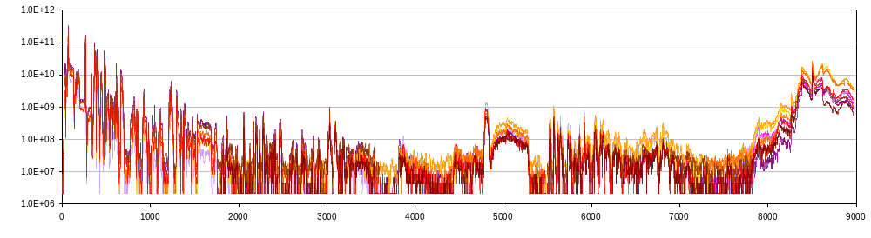

ADDITIONAL TESTWORK OVERVIEW

Mass Contributed by EC and by Particles
During some of the tests conducted in the second measurement campaign in JRC, an AVL 483 soot sensor was employed to determine the mass of soot emitted and a Dekati Mass Monitor was used to measure the mass of aerosol.

The Soot Sensor sampled directly from raw exhaust at a constant dilution ratio of about 2, while the DMM sampled from the CVS tunnel via a Dekati thermodenuder operating at 300°C. In parallel for these tests, PM was collected on TX40 filters.

The mass measured as soot (AVL 483) and contributed by solid particles (DMM) was only a small portion of that determined gravimetrically. Table 12 summarizes the average and the standard deviation of these fractions for the different test cycles while Figure 56 and Figure 57 indicate the percentage contributions of solid particles and soot respectively to measured PM.

Over the cold start WHTC, both AVL483 and DMM measured mass concentrations ~10% of those determined gravimetrically. This fraction is similar to that determined for cold NEDCs during the light duty inter-laboratory correlation exercise.

During hot start test cycles, the DMM signal was at the zero levels of the instrument which is around 300 #/cm³. Consequently, mass estimates from these cycles constitute a maximum level. Concurrently measured SPCS data verifies that the PMP particle number concentrations were also below 300#/cm³ in the CVS. Even though DMM data will have overestimated the contribution of solid particles to PM from hot cycles, the calculated mass emission rates were still only ~0.5% of that determined gravimetrically.

The mass concentrations determined with the AVL483 suggest a ~7% to ~19% soot content in the PM collected on filters from hot start cycles. These figures suggest higher soot fractions than seen from the cold start tests, an observation which is not substantiated by any other measurement method. These high results might indicate that measurements were made below the sensitivity levels of the AVL483 ~ 5µg/m³, but since the concentration range of emissions was 5µg to 125µg/m³ this is unlikely. It is also possible that there was interference from gaseous components in the AVL483 signal.

Table 12: Contribution of soot and solid airborne particles on the PM collected on filters as determined by the Soot Sensor and the DMM, respectively
 | WHTC Cold | WHTC Hot | WHSC | ETC | ESC
Soot content (CVS) | 11.2% ± (3.81%) | 7.31% ± (1.13%) | 18.81% ± (4.79%) | 15.52% ± (3.03%) | 14.89% ± (3.39%)
Soot content (PFDS) | 12.33% ± (2.29%) | 9.53% ± (1.5%) | 15.2% ± (1.26%) | 15.76% ± (1.28%) | 10.22% ± (1.01%)
Airborne mass (DMM) | 10.4% ± (3.52%) | 1.38% ± (1.05%) | 0.93% ± (0.65%) | 0.54% ± (0.2%) | 1.51% ± (1.22%)

Figure 56: Fraction of PM Mass Contributed by Solid Particles (>300°C)
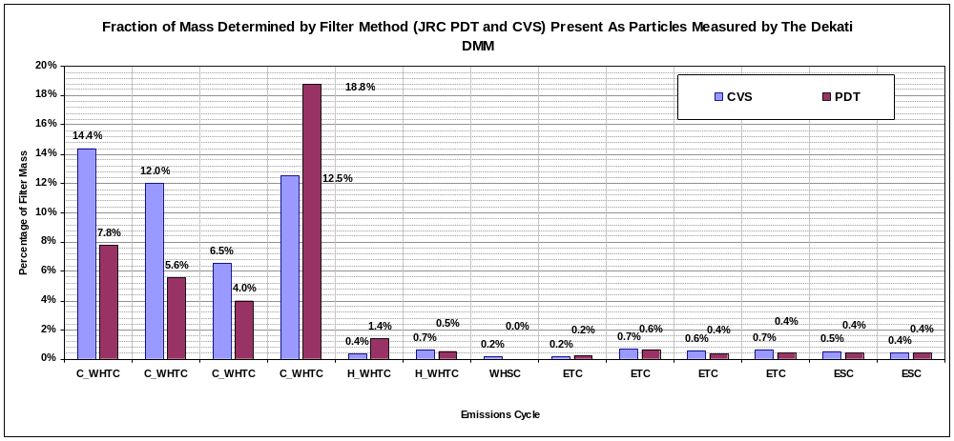
As Figure 56 shows, in the Cold WHTC, 4 to 20% of PM is contributed by solid particles. These are probably carbonaceous particles. A possible contributing mechanism is through ‘blow-off’ contributions as seen in the ILCE_LD during the first 200s of the NEDC [Error: Reference source not found], or transient reduction in filtration efficiency related to filter-cake cracking [Error: Reference source not found].
Other cycle emissions show the contribution of mass from particles as ≤0.5%, so in the majority of cycles tested, ≥99.5% of PM mass from hot start cycles is from volatile particles or gases.
Figure 57: Fraction of Mass Contributed by EC
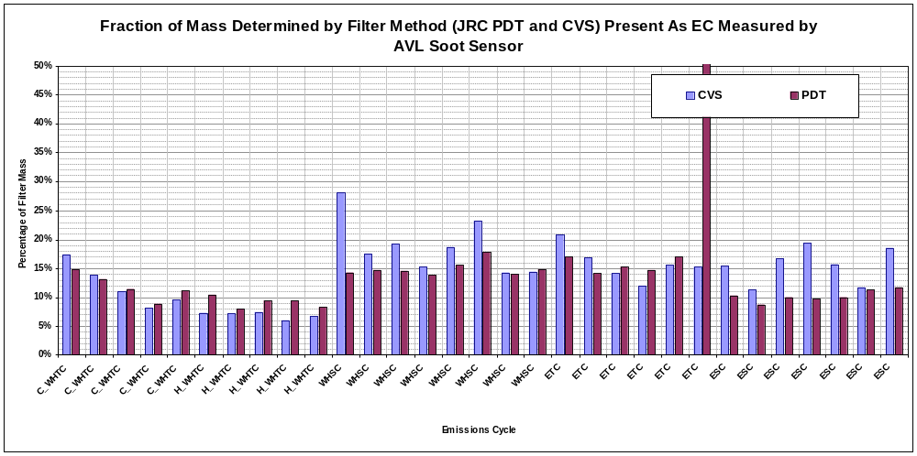
The elemental carbon fraction of PM (Figure 57) determined by the AVL soot sensor from the Cold WHTC was ~10%. This is consistent with the solid particle mass determined by the DMM.
Other cycles PM, measured by the AVL soot sensor, comprise on average ~17% EC. This is inconsistent with DMM data and may suggest an interference in the soot sensor, at very low mass levels, that reports a gaseous compound as elemental carbon.
Overall
Observations in this work regarding the contribution of EC and particles to PM are consistent with the findings of the light duty ILCE: the majority of PM mass is not contributed by either solid (including EC) or volatile particles.

Further Filter Media Evaluations
In the second measurement phase conducted at JRC, following completion of the validation exercise, the daily test protocol was repeated three times employing Teflo filters. Sampling was undertaken from both the CVS secondary tunnel and from the PFDS.

The PM results collected during these three sets of tests have been compared to the data from the main measuring campaign (JRC#2) where TX40 filters were used.

In both CVS (Figure 58) and PFDS testing (Figure 59) the levels determined using TEFLO filters were systematically lower than results using TX40 filters.

Mass emissions were on average 63% (ETC) to 81% (ESC) lower from TEFLO filters than from TX40 filters when samples were taken from the CVS - secondary tunnel. Similar results, showing a range of 31% (WHTC cold) to 88% (ETC) reductions were observed from PFDS samples’ results.

Particle number emissions recorded with the two Golden SPCS instruments (from primary CVS and PFDS) during these tests were found to lie within the range of values recorded during previous TX40 filter sampling. Therefore, the observed difference between TEFLO and TX40 results indicates a true directional effect. As TEFLO filters are less prone to volatile adsorption artifacts, these results suggest that a significant amount of the mass collected on the TX40 filters results from adsorption of gaseous compounds – either from tunnel background or from exhaust emissions - and that the TEFLO filters collect less of this artefact. However, the levels of PM observed even on the TEFLO filters are substantially higher than the mass attributed to solid particles (Section 7.1), so it is likely that this filter medium still collects some volatile or semi-volatile material.
Figure 58: PM results obtained using TX40 and TEFLO filters – JRC CVS
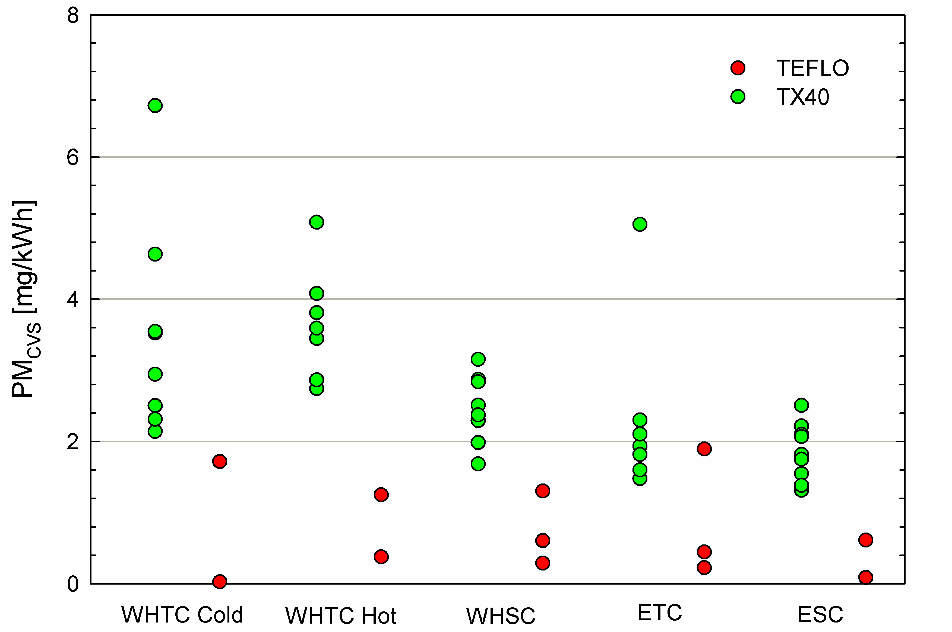
Figure 59: PM results obtained using TX40 and TEFLO filters – JRC PFDS
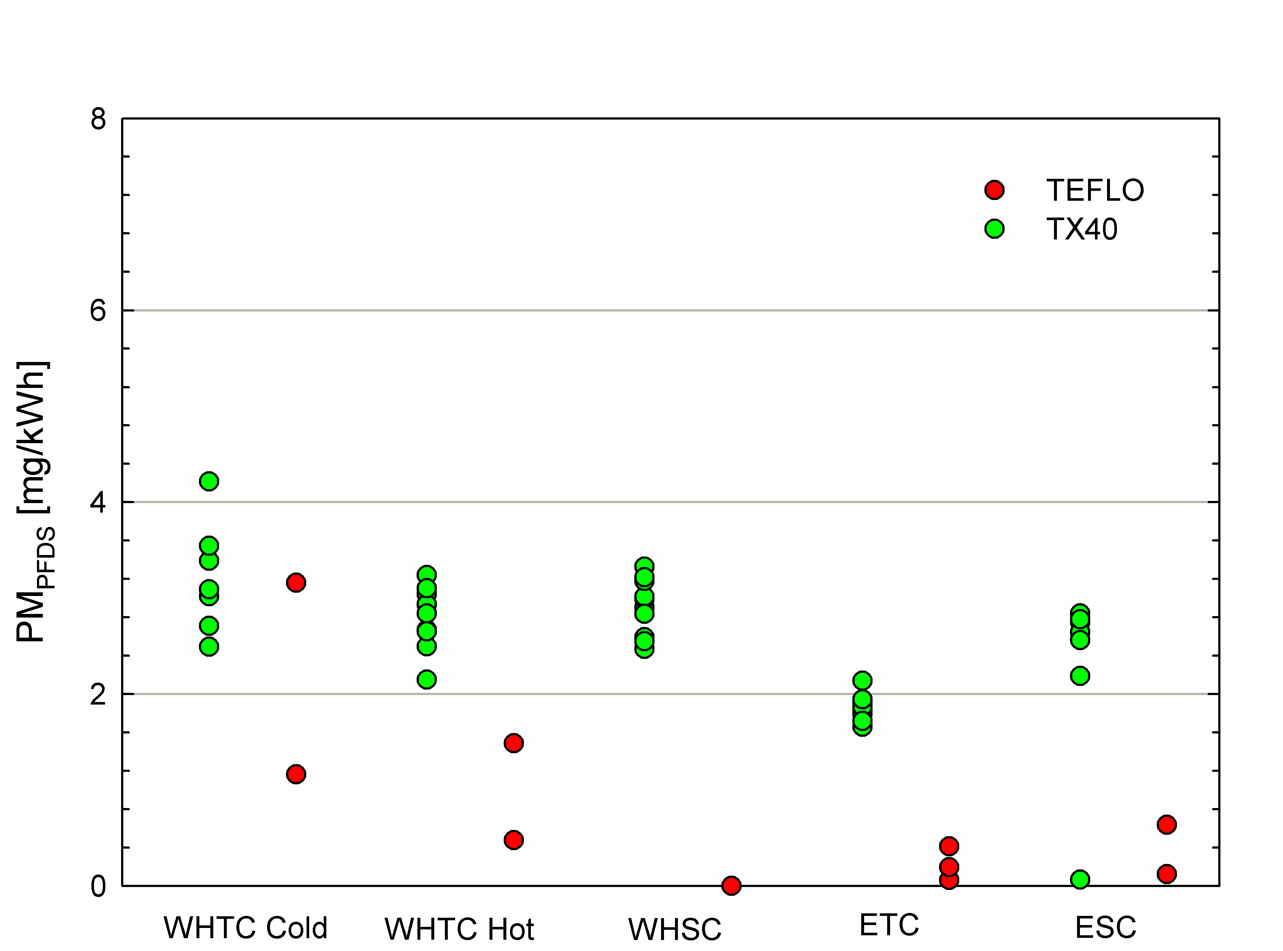

Particle Number Measurements from PFDS at Constant Dilution Factors
There is a possibility that particle number emissions from DPF equipped engines may, especially when the DPF is highly loaded, be delayed in reaching the exhaust due to transit through the filter substrate and filter cake. If this is the case, the dilution ratio in the PFDS, which varies with engine exhaust flow could be incorrect at the time (following transit delay) the particles and PM actually reach the dilution tunnel. If this is the case, there is actually no merit, specifically for post-DPF PN tests, to undertake proportional sampling. Consequently, a fixed dilution ratio PFDS measurement combined with a real-time exhaust flow measurement would be an inexpensive alternative.
In order to investigate the possibility of employing a simpler partial flow system operating at constant dilution ratio, the test protocol was repeated twice at JRC employing constant dilution ratios of 15 and 4, respectively, in the partial flow system (AVL SPC-472 Smart Sampler). These two values correspond to the average and minimum, respectively, dilution ratio in the CVS tunnel over the WHTC cycle. Unfortunately, due to some problems with the control software, the SPC did not sample correctly in some of the tests, but sufficient data were still acquired to perform a comparison.
The use of a constant dilution ratio in the PFDS system does complicate the calculations: the particle number emission rate (number of emitted particles per second) requires a second-by-second multiplication of the particle number signal with the measured exhaust flow rate after careful alignment of these two signals.
The percentage difference between the calculated PFDS and CVS results for all valid tests are compared to those determined during the main measurement campaign in Figure 60. This shows percentage differences between the cycle average particle number emissions measured from the CVS tunnel and the partial flow system, when the PFDS sampled at a flow proportional to the exhaust flow rate and also at constant dilution ratios of 15 and 4.
Figure 60: Cycle Averaged PN Results: Proportional Vs. Constant Dilution
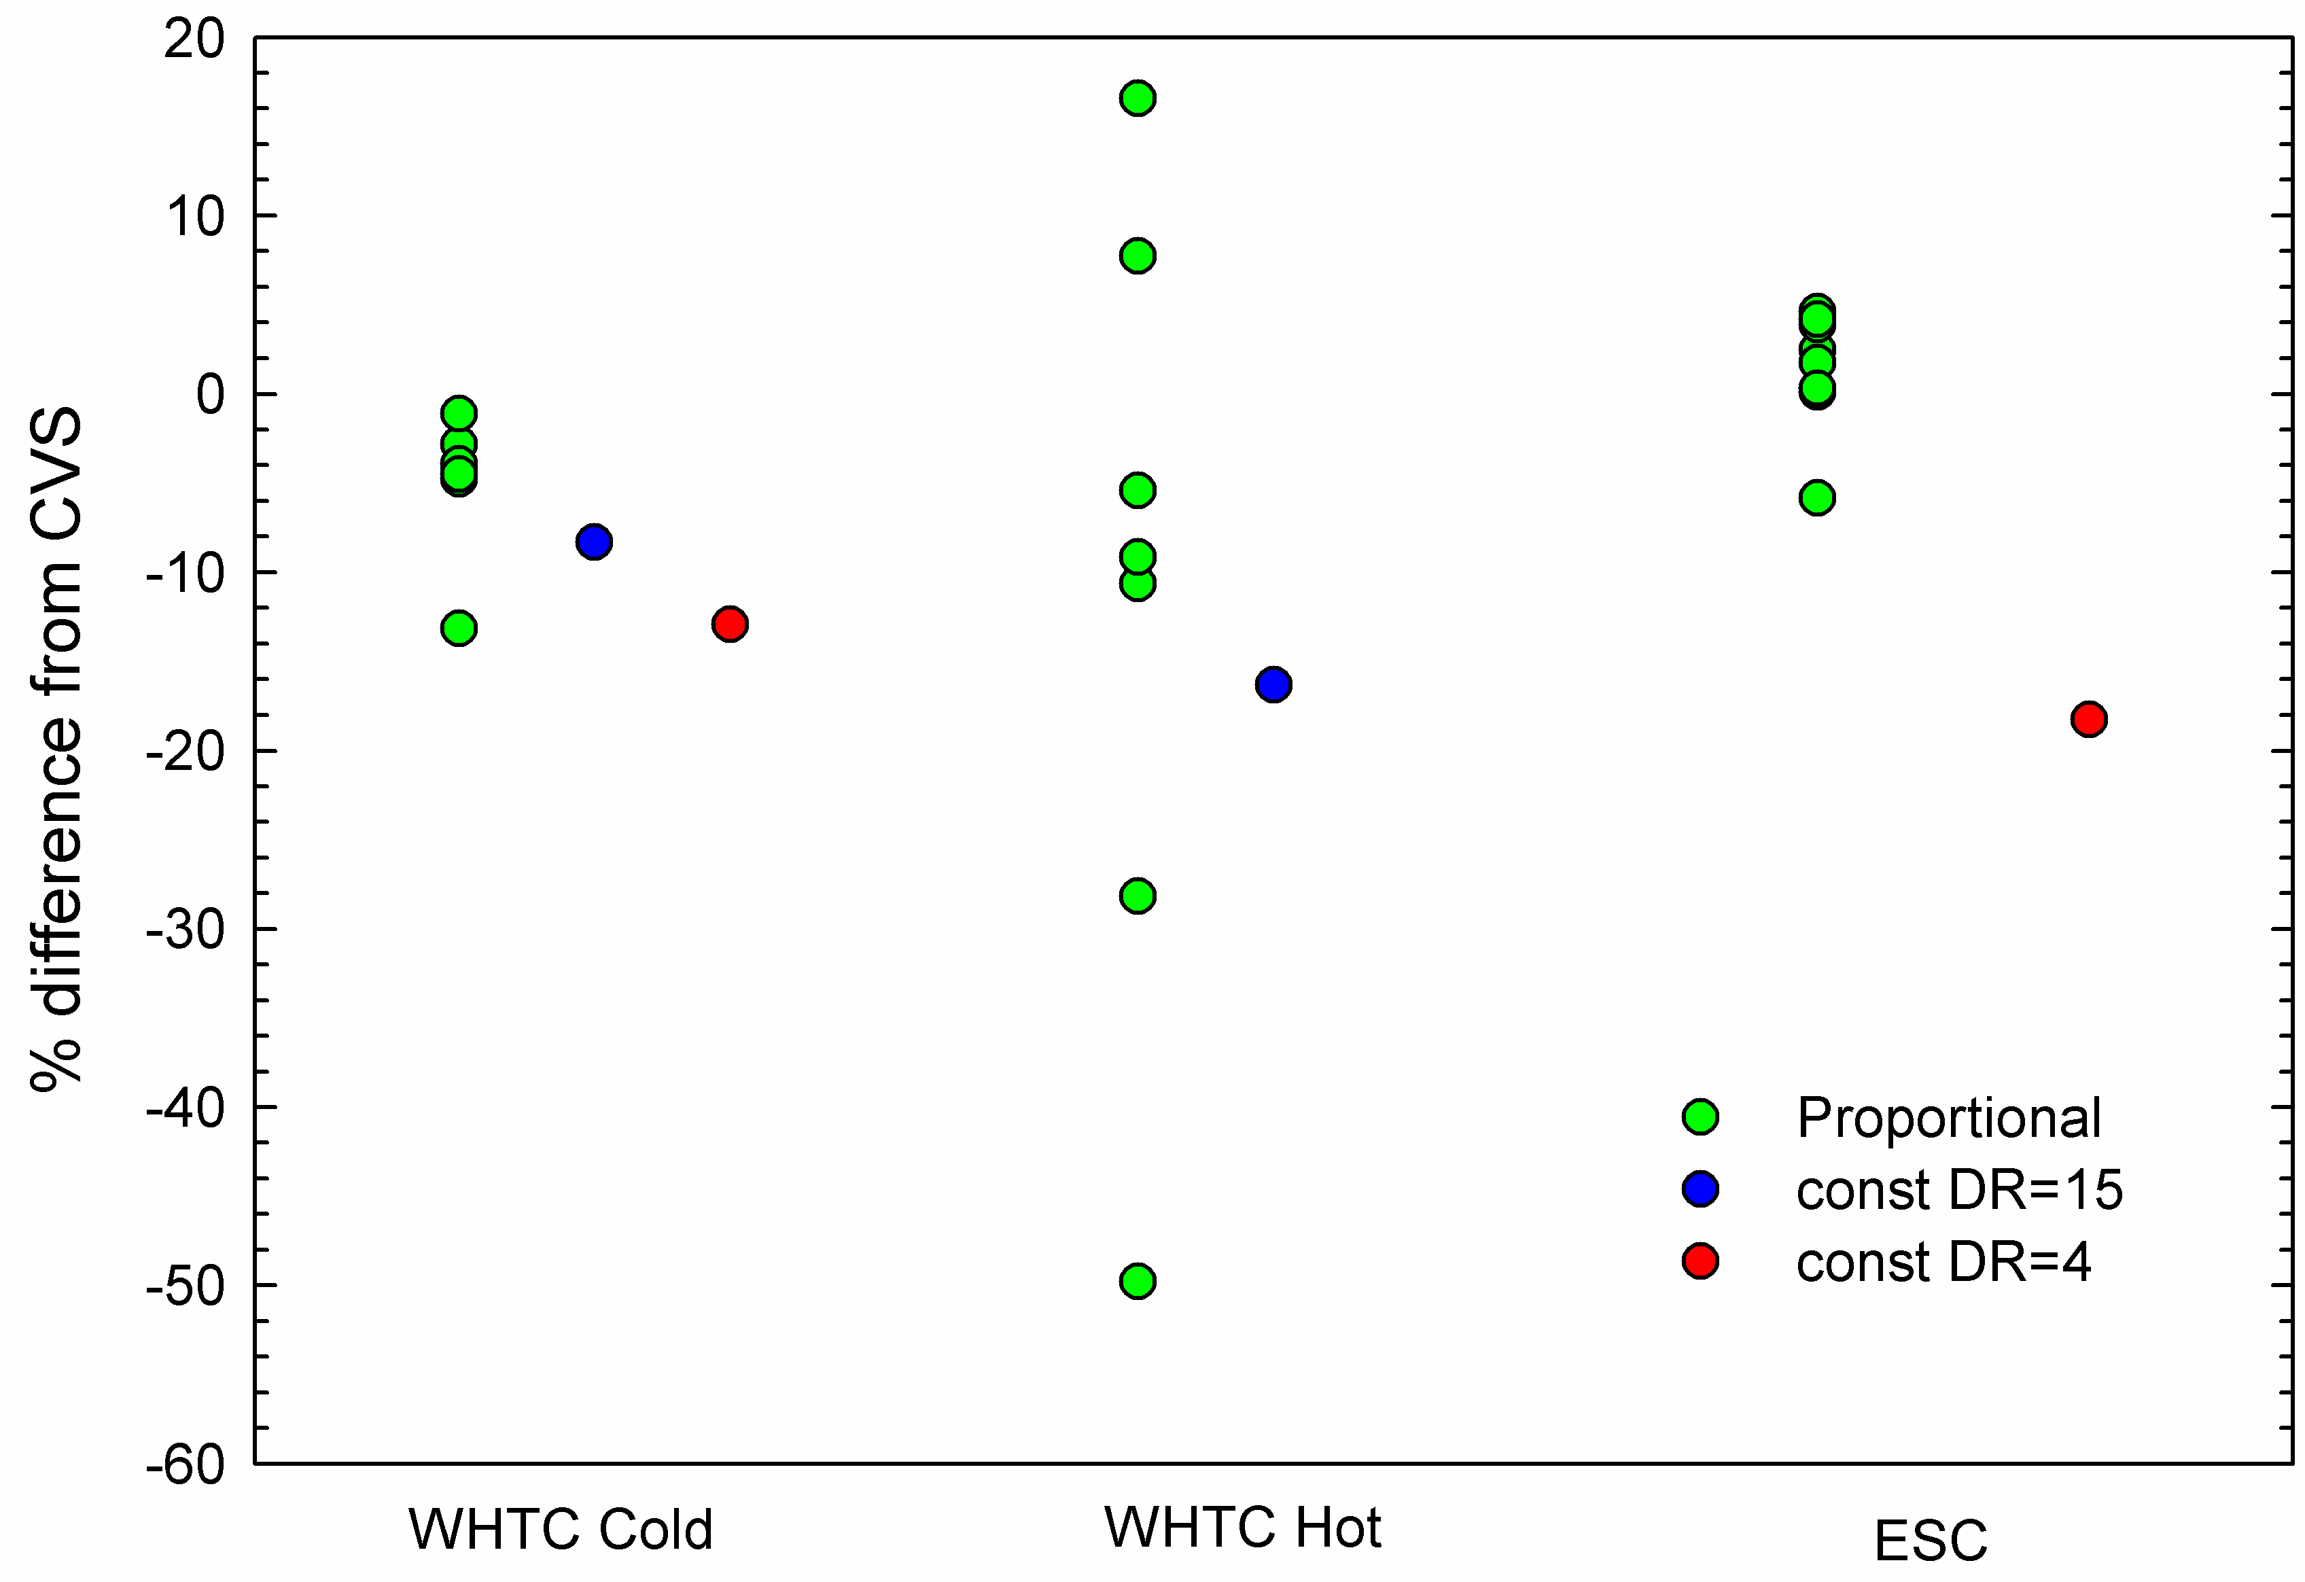
The limited data available suggests that PN emission levels can be determined with acceptable accuracy (better than ~15%) when sampling from the exhaust at constant dilution ratio. In general though, this approach seems to systematically underestimate the emission levels measured from the CVS tunnel.
The good agreement with the CVS tunnel data is also evident in the real time recordings. As an example, Figure 61 shows the real time particle emission rates over ESC measured from the PFDS running at a constant DR of 4 compared with data from the CVS tunnel. This is the test which gave the largest difference, but still the number concentrations measured from the two SPCS units are very similar, as seen in Figure 62.
Figure 61: PN from Proportional and Constant Dilution Sampling Compared
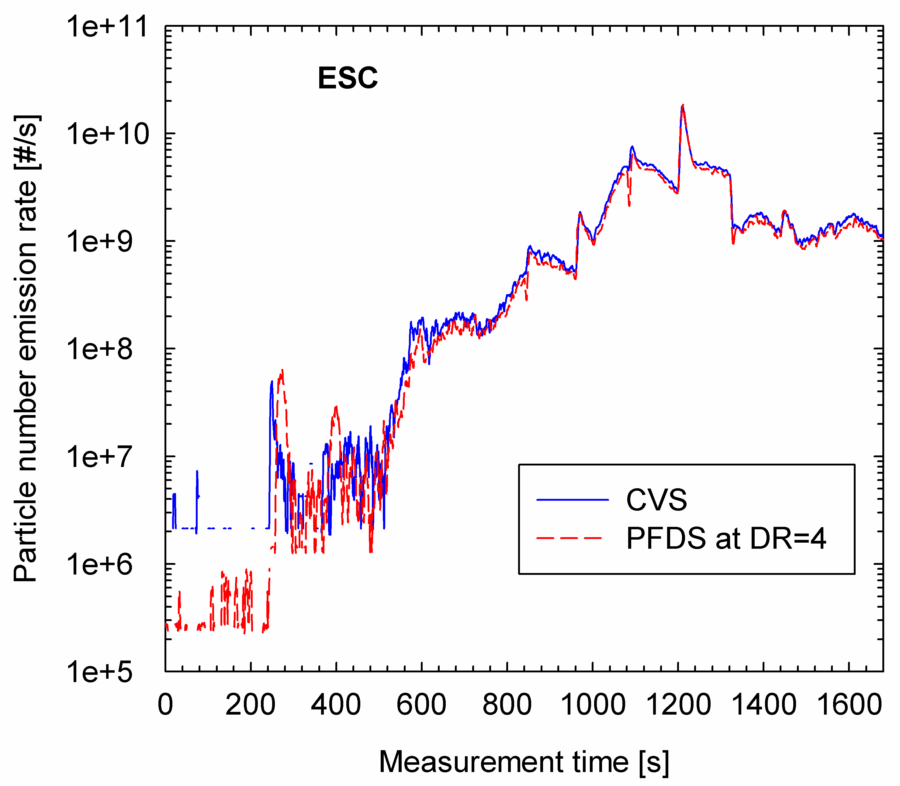

Figure 62: Correlation of PN from Proportional and Constant Dilution Sampling
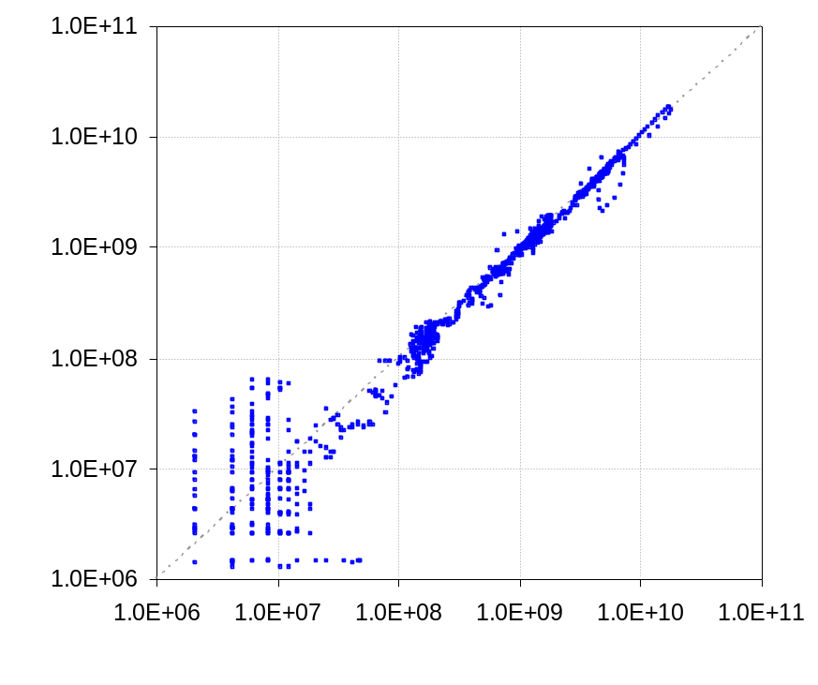
Since PN levels from a PFDS at constant dilution ratio seem to be similar to PN levels drawn during proportional sampling, it is interesting to assess the impact of these approaches on PM. Figure 63 shows a comparison for one-off cold WHTC tests at dilution ratios of 15 and 4 with cold WHTC data from the CVS and PFDS.
Figure 63: PM Sampled From Proportional Dilution and Constant Dilution
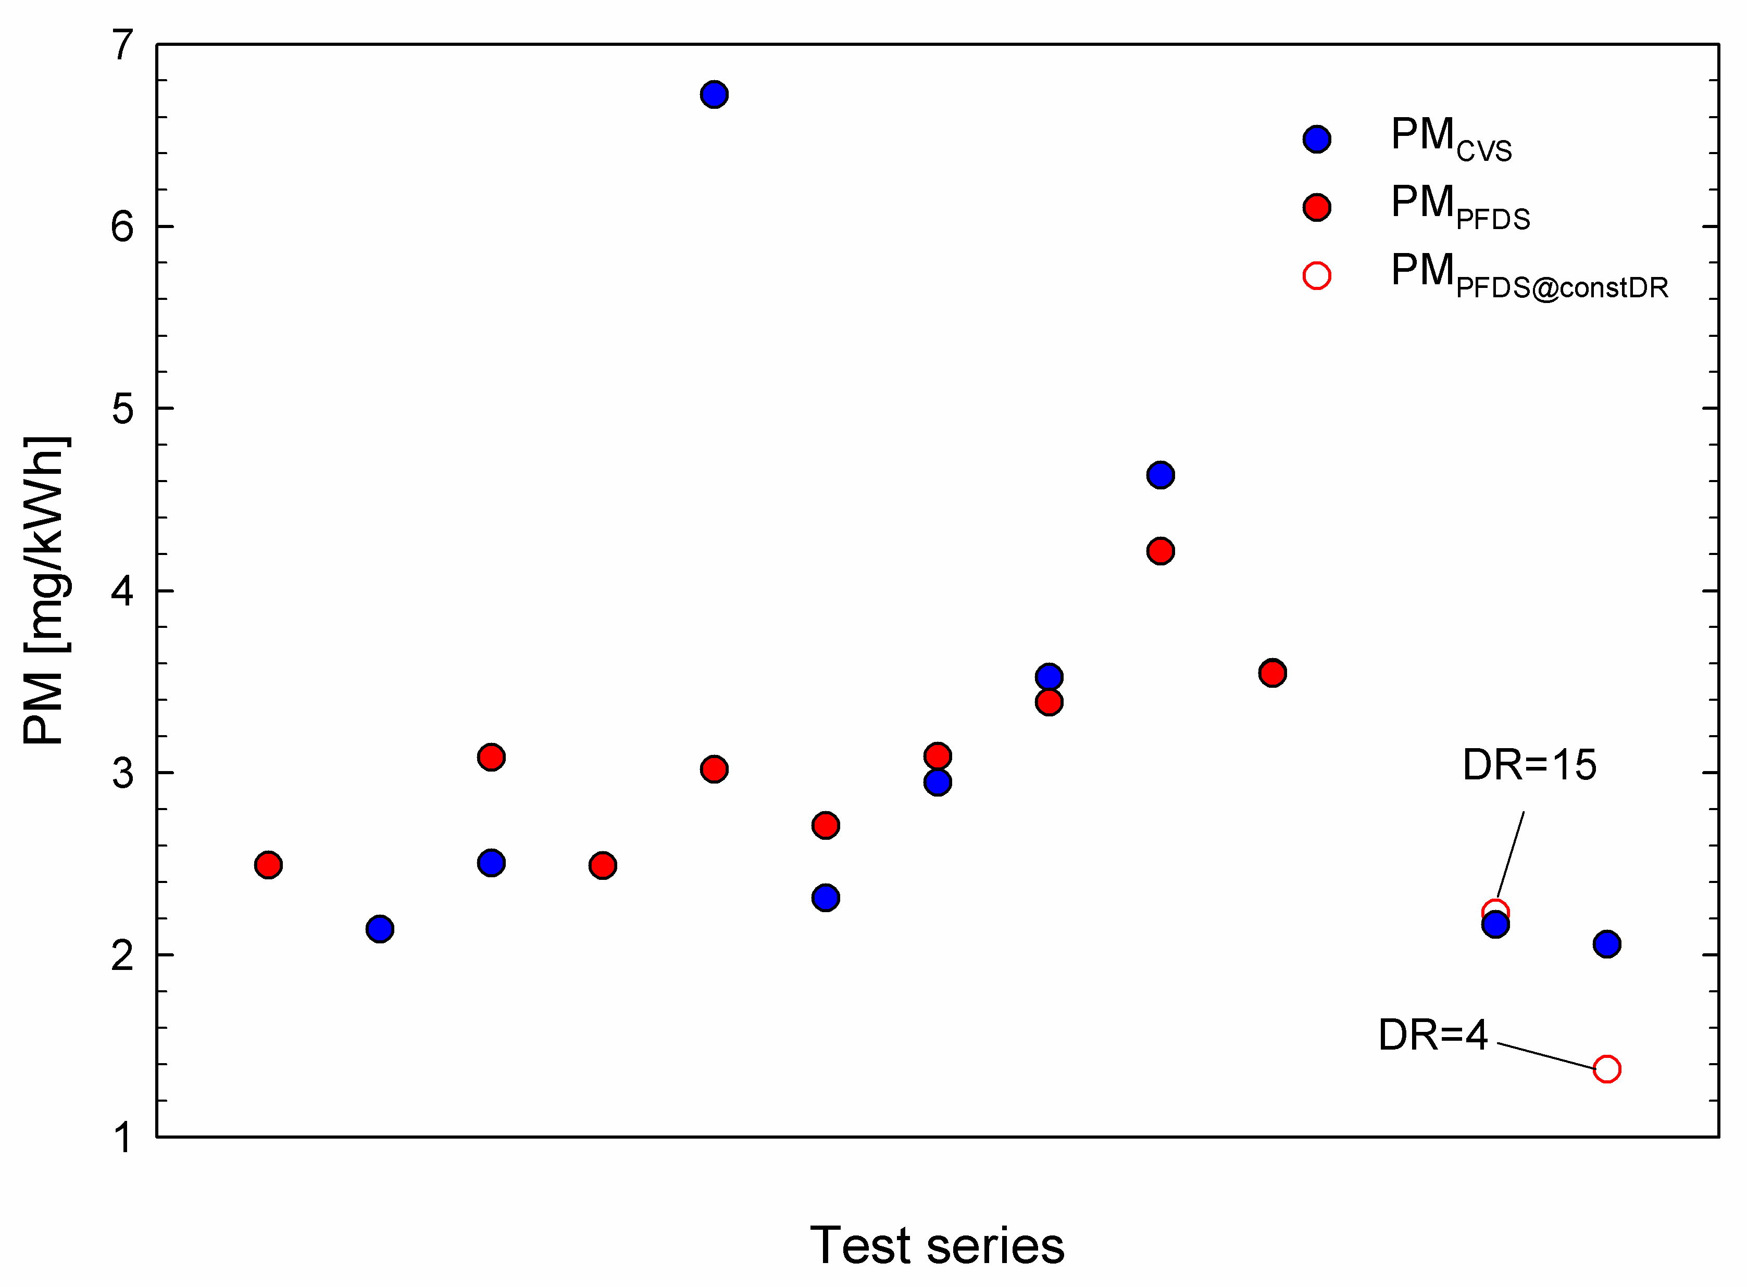
The mass measured at fixed DR=4 is substantially lower than seen from either the partial flow or full flow systems (proportionally sampled), but the mass measured at fixed DR=15 is similar to the low-end results from the CVS.
The indications are that mass is underestimated by the constant dilution approach (and it can’t be corrected because there are no real time data). However, the mass emissions from many labs appear to be indistinguishable from zero if the background is subtracted. On this basis, mass as a metric is of little value and if particle number was the only metric, the constant DR PFDS approach would be a valid and cost-effective approach.

COMPARISONS OF MEASUREMENT SYSTEMS
This section discusses the relationships between particle and particulate measurements made from full and partial flow dilution systems. Comparisons are made between mass and number metrics from full and partial flow dilution systems.

Comparison of Particle Number Measurements from CVS and PFDS
Figure 64 shows the correlation between PN emissions measured simultaneously from the full and partial flow systems at JRC only (lhs) and all labs (rhs). Data are shown from all emissions cycles. It's clear from the JRC data that during both measurement campaigns, despite the shift observed in the levels, the same correlation between full and partial flow measured PN was present. This correlation seems to hold over almost 3 orders of magnitude.
The background levels in the JRC CVS and partial flow systems are known to be low (Section 6.2.1) and similar. This was not true at all labs, and the differential between the backgrounds of CVS and PFDS systems at the same labs leads to poorer correlations, as the right hand figure shows.
The differences in background levels can be compared by considering the lowest recorded cycle emissions from each lab, as these must be higher than or equal to the background. Levels are overlaid in Figure 64, with the red line indicating the lowest emission at Ricardo (~10¹¹/kWh), the orange EMPA’s lowest emission (~10¹⁰/kWh), violet the lowest levels at UTAC (~7 x10⁹/kWh) and green UTAC’s results (~3 x10⁹/kWh). The background at JRC was at or below 10⁹/kWh.
In general, above ~5x10¹¹/kWh all labs data are broadly similar.
These data show that full and partial flow dilution systems can provide almost identical results, but that these will be dependent on the level of background present in the system. From the results of this work, partial flow systems seem to have inherently lower backgrounds than full flow systems.
Figure 64: Correlations between PN Measured from CVS and PFDS Systems
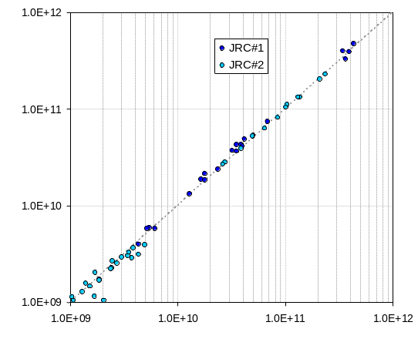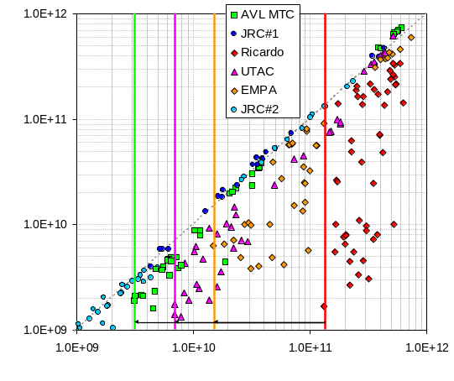
Considering the JRC results in more detail, Figure 65 shows the results of cross-plotting the CVS and PFDS sampled real-time data (>1000 points) from several emissions cycles. These charts demonstrate that the real time responses of the PFDS and CVS, as well as the cycle averaged data, correlate well. This demonstrates that:
- Low background dilution facilities provide almost identical data, irrespective of whether they are CVS or PFDS
- That the principal differences between CVS and PFDS, such as a PFDS’s flow control and response time, do not significantly impact particle measurements sampled at 1Hz
Figure 65 also shows that as measured particle numbers reduce, the correlation between PFDS and CVS weakens.

Figure 65: Correlations between Real-time PN from CVS and PFDS Systems
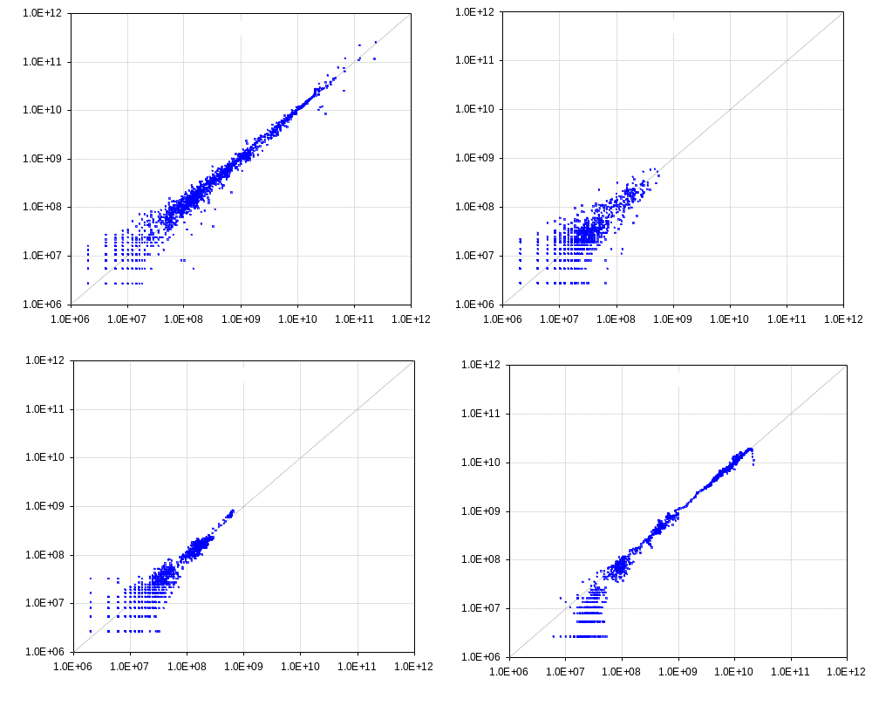
Figure 66 illustrates the percentage change in PN emissions from the partial flow system relative to the levels measured from the CVS. These are calculated as follows
((#/km PFDS - #/km CVS) / (#/km CVS)) x100
In this comparison, zero emissions from the PFDS represents -100% difference between systems, the same emissions from the two systems represents 0% difference and higher emissions levels from the PFDS appear as +ve % differences.
With the exception of JRC, which shows a range from -12% to ~0% from ~10⁹/kWh right up to 10¹²/kWh, and Ricardo, which has a best result of ~40% at >10¹¹/kWh, all labs results were better than -20% at emissions levels above 10¹¹/kWh.

Figure 66: Percentage Differences in PFDS Emissions Compared to CVS – All Labs
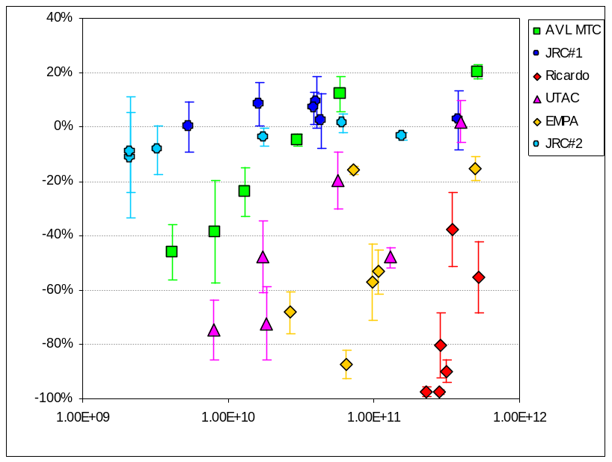

Comparison of Particulate Mass Systems
Figure 67 shows the correlation between PM emissions measured simultaneously from the full and partial flow systems at all labs (lhs) and all labs except Ricardo and EMPA (rhs).
In general, PM results from all cycles were between 1 and 10mg/kWh, except in labs with the highest background particle numbers (EMPA and Ricardo, Section 8.1) where emissions as high as 18mg/kWh were observed.
Considering only the labs with lower backgrounds (Figure 67 rhs), PM levels were broadly similar if not correlated, and in the range 1mg/kWh to 9mg/kWh. UTAC’s results tended to be towards the high end from both the CVS and PFDS and reasonably well correlated, while JRCs results were generally lower.
Overall, both CVS and PFDS are capable of measuring PM emissions at levels below 10mg/kWh, but as with particle number, background contributions are important and should be minimised.
It is worth noting that additional experiments at JRC with TEFLO filters and real-time instruments characterising the contributions of solids and volatiles to PM, revealed that <10% of the Pm mass can be attributed to non-volatile materials from cold start tests and that as much as 99.5% of PM from hot start tests is volatile material. As a consequence, the PM method is quantifying dilution system volatiles - whether these come from the engine or not - rather than particulate emissions from the engine.
Figure 67: Correlations between PM Measured from CVS and PFDS Systems
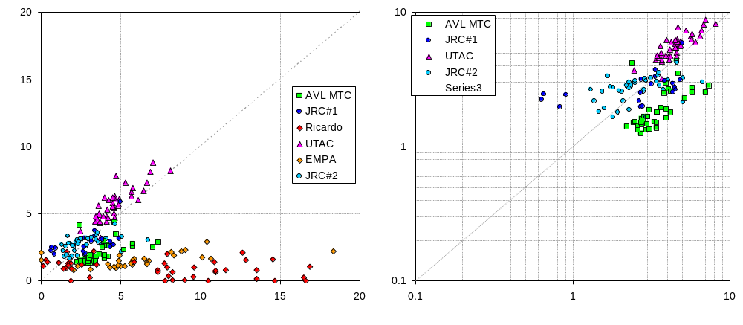
Figure 68 illustrates the percentage changes in PM emissions from the partial flow system relative to the levels measured from the CVS. These are calculated as follows
((#/km PFDS - #/km CVS) / (#/km CVS)) x100
In this comparison, zero emissions from the PFDS represents -100% difference between systems, the same emissions from the two systems represents 0% difference and higher emissions levels from the PFDS appear as percentages greater than zero.
Figure 68: PFDS PM results: % Difference to CVS PM Data
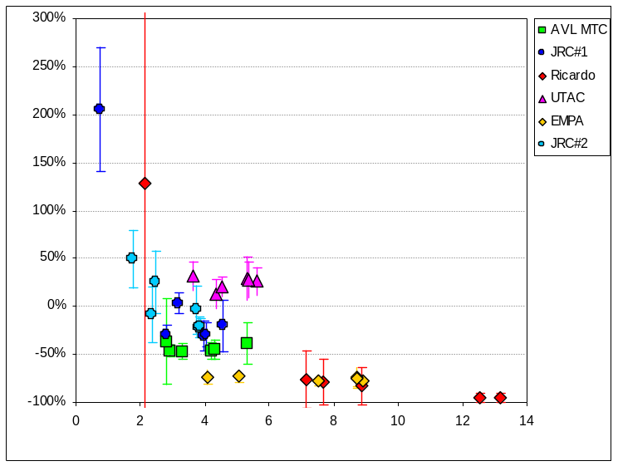
In general, emissions ranged from 50% higher in the CVS than in the partial flow system to 50% higher in the PFDS than in the CVS. Labs either showed one trend or the other and these results were seen in the mass range from ~2mg/kWh to ~6mg/kWh.

On average, CVS and PFDS Pm levels broadly agree, but so do CVS and PFDS backgrounds (Section 6.1.3). In addition (with the exception of ESC cycles), filter mass levels on both sample and background filters are the same from many dilution systems at several labs. On this basis, the fact that CVS and PFDS agree and they can be repeatable, but results are the same as the background, means that both PM methods may just be reporting background that varies in response to the emissions cycle's pressure and temperature transients. The actual PM emission is effectively zero in many cases.

Mass vs. Number full flow
In the low background facilities at JRC, partial flow PN and full flow PN correlated well and agreement between solid particle number emissions from the two dilution systems was very good
A comparison between PN and PM from all CVS systems (Figure 69, lhs) shows that highest number samples do have highest mass, but that this relationship is tenuous and, in any case, non-linear. Comparing just JRC data (Figure 69, rhs) this relationship is not apparent. The apparent tenuous mass vs. number relationship would disappear if PM data was background subtracted (all PM data except ESC reduced to zero)
Particle number appears to be much more readily measured with high sensitivity than mass (a factor of >300 covering the PN emission corresponds to a difference of ~5mg/kWh):
- Considering all labs’ data (Figure 69, rhs) it appears that :

either:
- Participating labs show similar results to JRC – a factor of at least 100 range of PN levels in a narrow band of PM values
or
- The high tunnel background labs show a wider range of PM values confined to a narrower (but still factor of 10 or more) band of PN values.
- In both cases there is no obvious relationship between number and mass from CVS systems.

Figure 69: Relationship between Mass and Number Measurements (CVS)
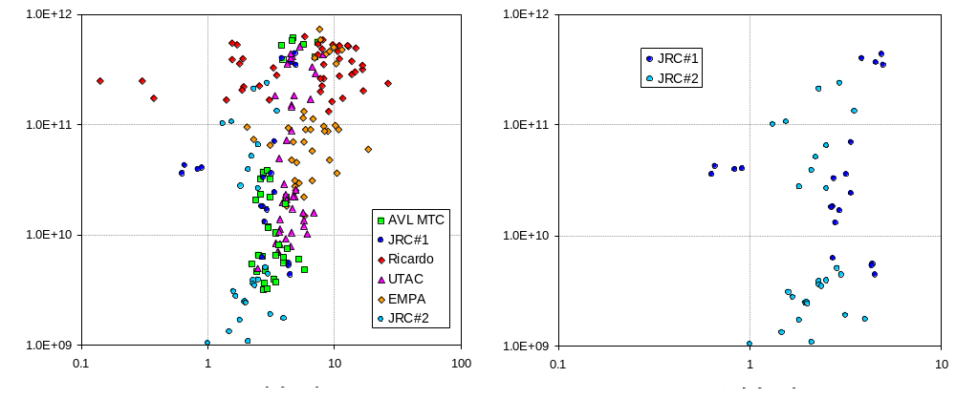

Mass Vs. Number Partial Flow
In the low background facilities at JRC, partial flow PN and full flow PN correlated well and agreement between solid particle number emissions from the two dilution systems was very good
The JRC PFDS was the only system in this project in which PM could be definitively discriminated from the PM background, so if this system shows no relationship between mass and number it is highly unlikely that one exists.
Comparison between PN and PM (Figure 70) shows that the highest mass samples do not necessarily correspond to the highest particle number results and that individual labs appear to occupy discrete, narrow mass emissions bands while spanning a wide PN range.
- The poor relationship between PFDS mass and PFDS number must be related to a variable volatile contribution to PM or to a variable solid and/or volatile PFDS tunnel background.
- There is no mass vs. number relationship apparent for PFDS (Figure 70): generally PN is sensitive but PM only varies slightly across all test cycles and absolute levels are different from different labs.

It is possible that a relationship could exist between PFDS PM and PN if an accurate background could be subtracted from all PFDS PM results, but this is not achieved even by the low background JRC PFDS data (Figure 71).

Figure 70: Relationship between Mass and Number Measurements (PFDS)
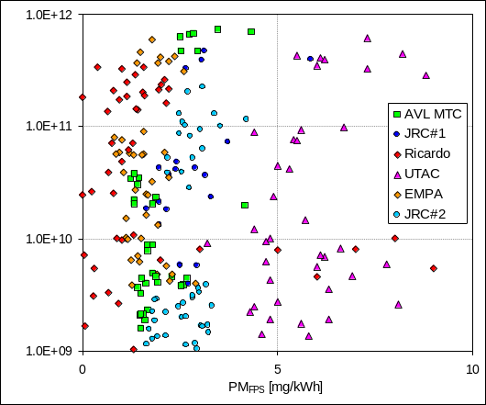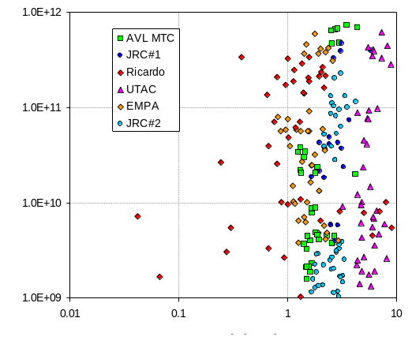
Figure 71: No Correlation Exists PM & PN Even in a Very Low Emissions PFDS
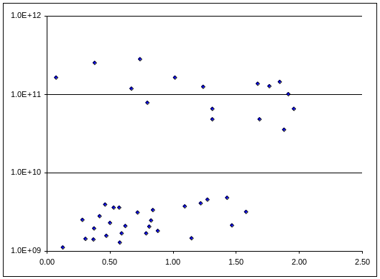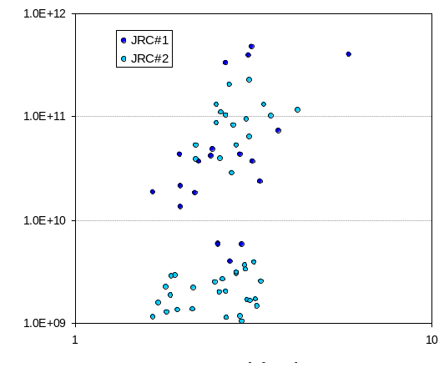
These data strongly suggest that either there is no relationship between PM and PN downstream of a highly efficient wall-flow DPF, or that substantial improvements in dilution air and tunnel cleanliness will have to be made in order to make any relationship detectable.

Comparisons of PMP type and PMP like systems

PMP type and PMP- Like Systems
In addition to the two GPMS systems used with the SPCS, a number of PMP type systems (which operate according to the principles specified in R83), and PMP like systems (which use different concepts for the dilution and thermal treatment of the aerosol) were evaluated in this work.

The other PMP type systems employed were:

- Nanomet by Matter Engineering
- Dual ejector plus evaporating tube system by Dekati
- Homemade dual ejector (Palas) plus evaporating tube from EMPA
- AVL Particle Counter (APC)

PMP like systems were:

- Dekati thermodenuder (TD): employed sampling from the CVS tunnel either directly or downstream of a Dekati ejector diluter.
- Dual ejector (Dekati) plus evaporating tube system developed at EMPA: employed sampling aerosol directly from the tailpipe

Particle Number Counters
PMP type and PMP-like systems were tested using particle number counters (PNCs) of different models and from different manufacturers. All were condensation nucleus counters (CNCs) from GRIMM or TSI. TSI models are known as condensation particle counters (CPCs). PNCs used were:

- TSI 3010D
- TSI 3790
- TSI 3010
- Grimm’s 5.404

TSI 3010 CPC’s were operated at a condenser-evaporator temperature difference of 9°C in order to effectively shift the 50% counting efficiency to 23 nm as required by the legislation. Grimm’s CPC also operated in PMP mode by appropriate modification of the instrument firmware. It should be stressed though that the particular CPC did not fulfil the requirements of maximum allowable coincidence correction and operation in full flow mode (issues resolved in model 5430 of Grimm). TSI 3010D and TSI 3790 CPCs are supplied by the manufacturer to be compliant with PMP requirements.

Particle Losses
Particle losses within the measurement systems vary, so in order to make fair comparisons, these need to be taken into account. Of all the PMP type and PMP like systems examined, only AVL’s APC units were calibrated by their manufacturer for particle losses. AVL incorporate this correction in the reported particle concentration results.

To enable particle penetrations through the two Golden SPCS units, two of the three different Nanomet systems, Dekati’s ejectors and the Dekati TD to be determined, evaluations using NaCl particles were undertaken at JRC before their first measurement campaign. These have been published elsewhere []. EMPA also calibrated their two homemade systems using NaCl particles. The penetration values determined in these studies, and which were also used for the comparisons shown in this section, are summarized in Table 13.

Particle losses inside the Nanomet system tested at Ricardo were not thoroughly investigated. However, preliminary work conducted by AEAT on this system suggested similar losses to those of an identical specification system measured at JRC.

The Dekati dual ejector plus evaporating tube system was not calibrated as an entire system, and as a consequence only the particle losses inside the two ejectors can be accounted for in the calculations. Thermophoretic losses in the evaporating tube of this system should be low as the thermally treated sample exiting the evaporating tube is immediately diluted in the second ejector diluter.

Table 13: Particle penetrations through the various PMP type / like systems used in the PMP HD validation exercise.
 | P (30 nm) | P (50 nm) | P (100 nm) | Correction
SPCS | 71% | 83% | 86% | 1.25
Nanomet JRC & RCE | 68% | 88% | 95% | 1.20
Nanomet LD GPMS | 52% | 65% | 90% | 1.45
TD | 67% | 73% | 77% | 1.38
EMPA’s homemade (CVS) | 70% | 71% | 72% | 1.41
EMPA’s homemade (direct) | 61% | 63% | 65% | 1.59
Ejector (heated) | 96% | 98% | 100% | 1.02
Ejector (not heated) | 100% | 99% | 100% | 1.00

As the different CPC units employed might exhibit different correlations relative to the primary calibration (indicated as the slope of a direct cross-plot between the two) it is also important to account for this difference in the comparisons. Most of the CPCs employed in the study were cross-compared with the Golden 3010D PNC employed with the SPCS usually connected to the CVS tunnel in the validation exercise (SPCS19). This was the ideal reference as the slope of this particular unit is 0.99. A direct comparison with this PNC provided the means to determine the slope of the individual CPCs employed with alternative and additional systems, and also with the PNC used with the second SPCS. The results of these comparisons are summarized in Table 14.
Table 14: Percentage difference between the different CPCs employed and the Golden CPC of SPCS19.
Grimm (JRC) | -5%
TSI’s 3010 (JRC)* | -10%
3010D (SPCS-20) | -1%
TSI’s 3790 | +11%
LD GPMS Golden CPC | +5%
* Operated at a condenser-evaporator temperature difference of 9°C which effectively resulted in a shift of the 50% counting efficiency to 23 nm

No information is available for the two CPC units employed in EMPA’s homemade systems and for the TSI 3010D CPC employed in the Nanomet system tested at Ricardo. Based on the observed differences, an additional ±10% uncertainty is to be expected from the results obtained from these systems. The manufacturer’s calibration of the APC systems takes the CPC slope into account so there was no need to correct the results of these systems.

Results from Golden Engine equipped with DPF

PMP type systems
Data from all individual tests with other PMP type systems are compared to the GPMS results (SPCS19 or SPCS20 depending on the sampling position of the systems) in Figure 72Error: Reference source not found.
Figure 72: Correlation between the GPMS and other PMP type systems
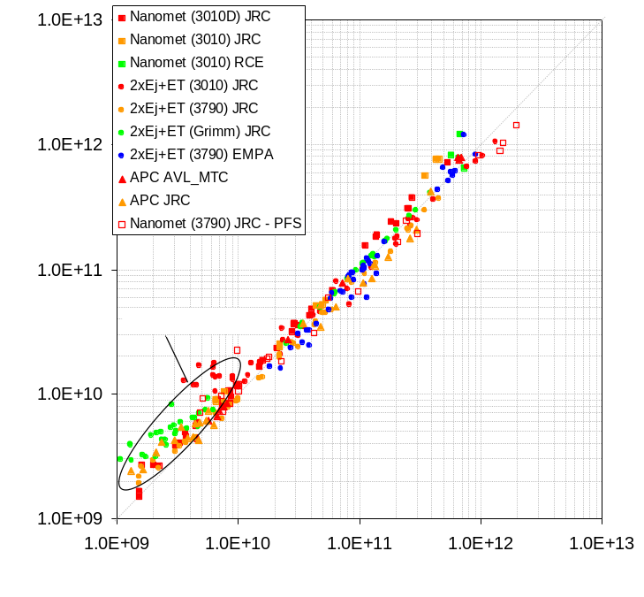

All data sit very close to the x=y line suggesting a reasonable agreement between all PN measurement systems employed. The correlation tends to break down for some systems (such as the dual ejector and evaporation tube used at JRC) at the lower emission levels. This is due to the higher background levels seen with these systems.

As an example of this effect of elevated system backgrounds, Error: Reference source not found shows a comparison of the real-time particle number concentrations from the SPCS and from a dual ejector plus ET with Grimm CPC. These data are from cold and hot WHTC tests measured from the CVS at JRC.
Figure 73: Comparison of real time PN in the CVS from the GPMS and from a dual ejector plus ET system over Cold and Hot WHTCs
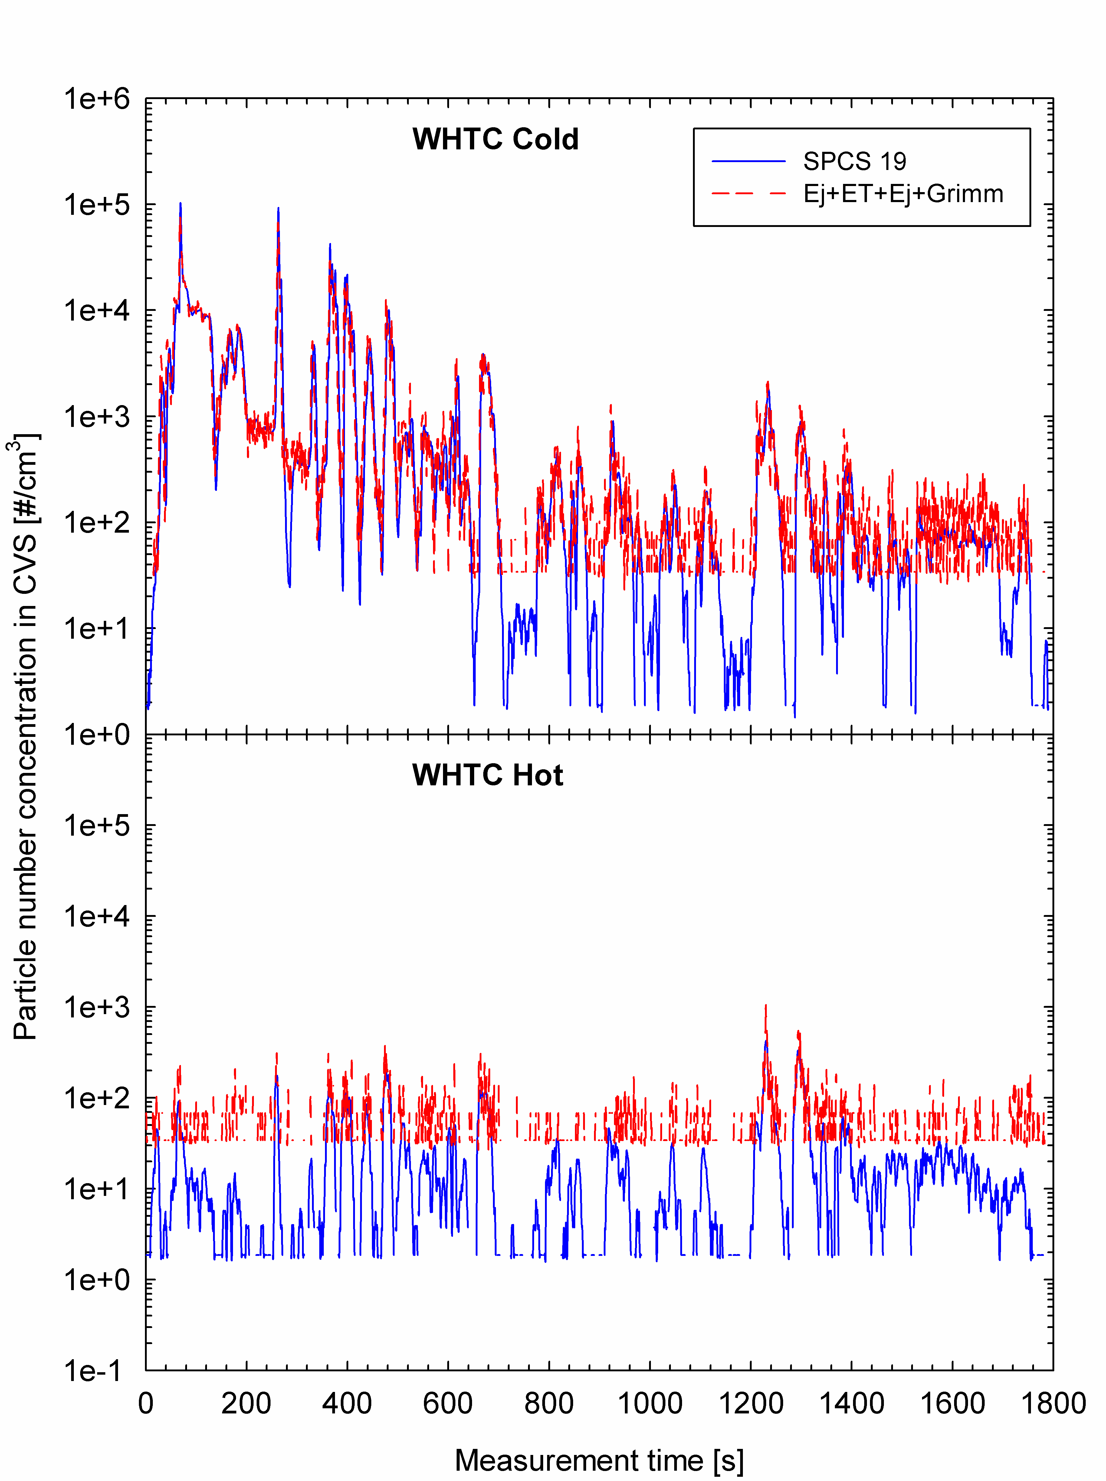

It can be seen that the dual ejector system has 20 times higher background levels than the SPCS. However, the levels measured from the two systems are in excellent agreement at levels above the dual ejector system background. Over the cold start WHTC, where the number concentrations are up to three orders of magnitude above the background levels, the cycle average results calculated with the two systems agree to within 1%. From hot start WHTC however, the particle emissions levels are below the dual ejector system background from most of the test cycle, but when the concentrations do rise above the background level of the ejector system, the good agreement is maintained.

The cycle average emissions from the dual ejector system over the hot start cycle were more than twice the levels (+111%) of those from the SPCS. The two GPMS units incorporate a much more efficient dilution air filtration system than any alternative systems employed in this study, and therefore the comparisons at the lower range of measured emission rates are affected by this artefact. As a consequence, only the results obtained over the higher emissions WHTC cold and ESC test cycles are considered in the following analyses, as the emission levels form these were sufficiently high to be relatively unaffected by background particle contributions.

Table 15 summarizes the average and standard deviation of the individual percentage differences between the different systems employed and the GPMS. The results obtained with the different PMP type systems over the WHTC cold and the ESC test cycles agreed within ±30% and ±15%, respectively.

All Nanomet systems connected to the CVS tunnel measured systematically higher number concentrations than the GPMS (by about 30% over WHTC Cold and 10% over ESC). Both JRC and Ricardo found that the background levels of the Nanomet systems increased during the measurement campaign. This has been attributed to production of wear particles from the diamond-like carbon (DLC) rotating disk of the primary diluter and the manufacturer has developed an alternative disc coating to avoid this. The disc coating deterioration could partly explain the observed overestimation in the particle number emissions determined with those systems. Additionally, the three Nanomet systems employed in the particular study are of an older design that does not take into account the pressure at the sampling point. When the sampling location is from a depression (which is the case in both CVS and PFDS) the indicated dilution ratio may be incorrect and this may also have contributed to the observed overestimation of the particle number emissions. This may also explain the differences observed when the Nanomet was sampled from the CVS and from a PFDS. This discrepancy might also be associated with errors in the setup of the PFDS (e.g. errors associated with the control of the flowrate extracted by the PN measurement system and/or the make up air that compensates for this flow).

Particle number results measured by the Dekati dual ejector system were found to be from 0 to 20% lower than the levels seen from the SPCS. This consistent underestimation of the particle number concentrations determined with the Dekati system is probably associated with particle losses inside the evaporating tube (as discussed in section 8.5.2) which have not been accounted for.

The results obtained from two APC systems agreed within ±15% with the GPMS ones. This can be considered to represent the uncertainty levels from PN measurement systems produced and calibrated in accordance with the requirements of the R83 regulations.

PMP like systems
The PMP like systems investigated were also found to be in good agreement with the GPMS systems (Figure 74).

Those systems utilizing Dekati’s TD gave about 10% lower emission levels than SPCS over all test cycles. These particular systems utilize lower or even no dilution and this has the advantage of minimizing the effect of particle background. This explains the consistency of the results obtained over all test cycles.

EMPA’s system connected directly to the tailpipe also gave comparable results to the SPCS, with the differences being on average 1% and -7% over WHTC cold and ESC, respectively. This is a very interesting finding, as the setup employed simplifies the measurement procedure considerably. Care needs to be taken for the accurate calculation of the true particle emissions, as the measured particle number concentration signals need to be precisely time aligned with the exhaust flow rate traces. Additionally, the dilution ratio of the ejector diluter is known to be strongly affected by pressure and temperature variations at the sampling point []. The use of a trace gas for a real time determination of the dilution ratio (as performed by EMPA) can resolve this problem, but this approach usually results in a noisy DR signal which introduces some uncertainty in the exact determination of the cycle average results. These two issues might be responsible for the relatively high variability observed in the results (of the order of ±30%).
Figure 74: Correlation between the GPMS and PMP like systems
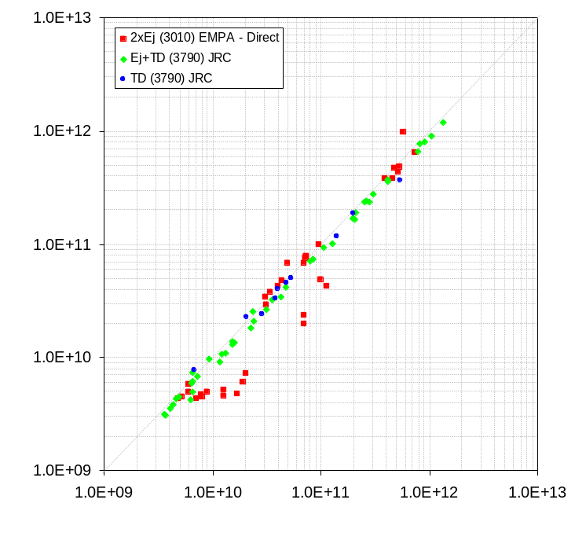

Engine out and open flow emission levels
A limited number of tests were conducted at JRC in which the DPF was replaced with an EMITEC Partial Flow Deep Bed Filter “Open filter” and from engine-out exhaust. This provided the means of comparing some of the other PMP type and PMP like PN measurement systems at higher particle number emission levels.

The results obtained with the other PMP complaint and the PMP like systems are compared with the GPMS units in Figure 75 and Figure 76, respectively. The average and standard deviations of the individual differences determined are summarized in Table 15.

Similar trends were observed at these higher emission levels. In particular, the Nanomet systems were found to systematically overestimate the particle number emissions. The dual ejector and the thermodenuder systems gave slightly lower particle number concentrations (~10%). This consistency in the results over a 4 orders of magnitude variation of the vehicle emissions suggests that the observed differences are associated with errors in the calibration of the systems.
Figure 75: Correlation between the GPMS and other PMP type systems at engine out emission levels
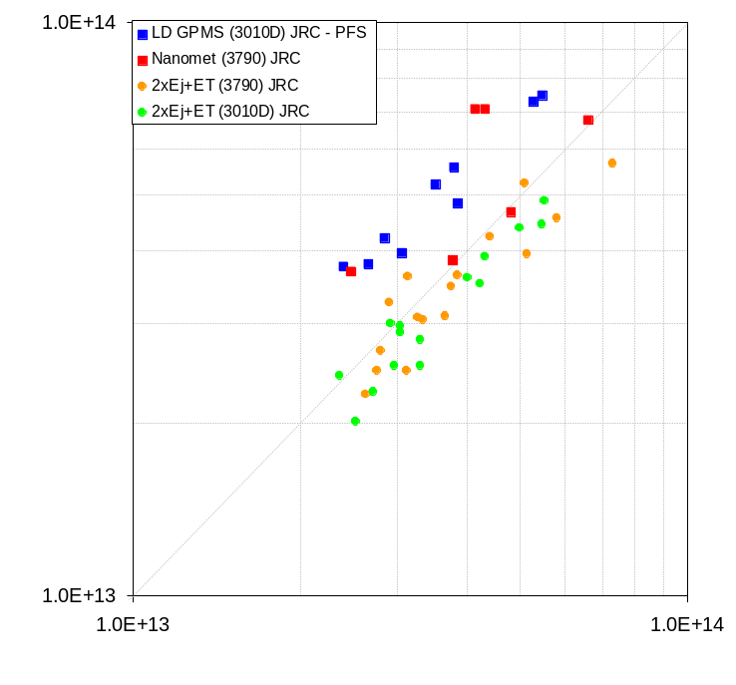
Figure 76: Correlation between the GPMS and PMP like systems at engine out emission levels
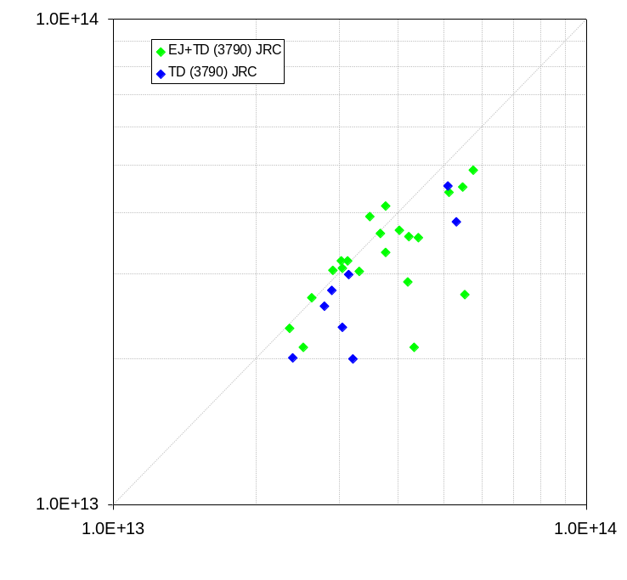
Table 15: Percentage differences in the number concentrations measured with the GPMS, PMP type and PMP-like systems
 |  | WHTC Cold | WHTC Hot | WHSC | ETC | ESC
 | Golden Engine (with CRT)
PMP type | Nanomet (3010D) JRC | 30.62% ± 7% (8) | 29.4% ± 16% (9) | 15.72% ± 9.09% (8) | 16.38% ± 7.18% (8) | 11.95% ± 2.52% (5)
PMP type | Nanomet (3010) JRC | 66.84% ± 7.49% (3) | 34.28% ± 3.06% (3) | 14.89% (1) | 8.01% ± 3.92% (2) | 5.68% ± 1.81% (2)
PMP type | Nanomet (3010D) Ricardo | 30.72% ± 38.33% (4)
PMP type | 2xEj+ET (3010) JRC | -19.09% ± 4.26% (5) | 162.99% ± 55.73% (9) | 13.43% ± 19.3% (7) | 16.62% ± 23.58% (11) | -16.26% ± 9.96% (10)
PMP type | 2xEj+ET (3790) JRC | -19.37% ± 2.97% (8) | 20.81% ± 19.52% (10) | -6% ± 12.37% (8) | -5.46% ± 8.89% (8) | -16.69% ± 5.49% (8)
PMP type | 2xEj+ET (Grimm) JRC | -0.03% ± 3.7% (9) | 118.08% ± 60.64% (10) | 70.17% ± 44.62% (9) | 74.52% ± 44.06% (9) | 1.54% ± 2.33% (11)
PMP type | 2xEj+ET (3010) EMPA | 7.42% ± 24.62% (8) | -14.28% ± 9.83% (8) | -11.29% ± 10.58% (8) | -19.68% ± 11.09% (8) | -6.46% ± 22.29% (8)
PMP type | APC AVL MTC | 14.99% ± 4.06% (3) | 4.87% ± 1.39% (2) | 2.13% ± 5.8% (2) | 0.67% ± 7.79% (2) | 6.32% ± 1.19% (2)
PMP type | APC JRC | -16.22% ± 17.77% (6) | 49.15% ± 30.68% (5) | 21.7% ± 25.93% (5) | 30.24% ± 33.74% (4) | -15.79% ± 17.03% (7)
PMP type | Nanomet (3790) JRC - PFDS | -29.58% ± 10.32% (4) | 7.58% ± 14.95% (5) | -0.4% ± 32.23% (4) | 55.23% ± 56.26% (4) | -22.93% ± 16.36% (4)
PMP type | Golden Engine (without CRT)
PMP type | Nanomet LD GPMS (3010D) JRC - PFDS | 48.07% ± 16.31% (3) | 32.66% ± 11.01% (2) | 45.09% ± 3.78% (2) | 36.68% ± 1.08% (2) | 47.72% ± 1.32% (2)
PMP type | Nanomet (3790) JRC - PFDS | 63.97% (1) | 70.56% (1) | 24.73% ± 32.43% (2) | 1.84% (1) | -3.17% (1)
PMP type | 2xEj+ET (3790) JRC | -11.45% ± 5.3% (4) | -1.51% ± 10.82% (4) | -6.23% ± 16.68% (3) | -14.62% ± 14.92% (3) | -13.24% ± 12.58% (2)
PMP type | 2xEj+ET (3010) JRC | -11.53% ± 12.24% (3) | -14.2% ± 10.49% (3) | -6.08% ± 8.83% (3) | -14.36% ± 4.21% (3) | -12.57% ± 3.95% (3)
PMP like | Golden Engine (with CRT)
PMP like | 2xEj+ET (3010) EMPA - Direct | 0.56% ± 30.42% (7) | -39.31% ± 29.45% (7) | -13.14% ± 32.67% (8) | -45.34% ± 16.26% (6) | -7.67% ± 35.65% (8)
PMP like | Ej+TD (3790) JRC | -12.42% ± 3.01% (7) | -8.31% ± 11.88% (9) | -10.2% ± 8.25% (8) | -15.41% ± 8.29% (10) | -13.33% ± 4.2% (10)
PMP like | TD (3790) JRC | -25.58% ± 10.94% (2) | -3.38% ± 20.27% (2) | -4.42% ± 4.38% (2) | -3.73% ± 17.28% (2) | -8.29% ± 1.14% (2)
PMP like | Golden Engine (without CRT)
PMP like | Ej+TD (3790) JRC | -4.65% ± 7.93% (4) | 4.54% ± 9.26% (4) | -1.33% ± 7.44% (4) | -24.59% ± 17.75% (4) | -25.33% ± 16.58% (5)
PMP like | Ej+TD (3010D) JRC | -12.36% ± 5.39% (2) | -21.37% ± 23.21% (2) | -14.44% ± 13.75% (2) | -19.68% ± 12.12% (2)
The percentage values correspond to the average ± 1 standard deviation of the individual test differences while the numbers in parentheses indicate the number of tests from which these figures were calculated. Results have been corrected for PCRF values for all systems except for the Dekati’s 2xEj+ET (shown in red in the table) in which case this information is not available.

Gaseous Emissions
Measurements of gaseous emissions taken directly from raw exhaust appeared to be more repeatable than emissions measured from diluted sources. This included both bagged and continuous dilute measurements, though relatively few labs now seem to use the cumulative bagged approach.

There were substantial differences in raw Vs. dilute emissions even for ‘high emissions’ gases such as CO₂. In addition, some labs experienced high levels of CO and HC in their background air and this contributed to observed variability.

Inter-laboratory variation levels were at similar levels for NOx and CO₂ as seen with the Golden Vehicle in the light-duty PMP exercise. HC and CO emissions levels were slightly more variable, possibly due to contributions of these gases in the background. Overall the data set was considered to be representative of expected lab-to-lab variation levels.

DISCUSSION AND OVERVIEW
This section draws together the discussion points from the report and summarises the critical issues for use of the measurement equipment and procedures in legislative procedures.

Particulate Measurements

Validation Exercises
Reference filter variation was higher than seen in previous test programmes including the ILCE_LD, despite stable environmental conditions. Occasionally one filter showed considerably higher variation than the other two, which indicates that baseline differences in filter background rather than environmental changes may be responsible for excessive reference filter variability.
If the batch of filters used in this work is representative of all TX40 batches, this confirms that the (larger) permitted reference filter variance of ± 10µg as specified by GTR No.4 is appropriate.

Tunnel Background Mass Levels - CVS
Tunnel background PM measurements were made in 3 of the 5 test laboratories. In some labs PM backgrounds from CVS systems were extremely high – due to the testing history of these systems. Active regeneration and testing fuels with high levels of FAMEs seem to leave residual carbon and semi-volatile materials in the dilution system that are not readily removable, even by the 2 hour full load operation undertaken by all labs before the start of the measurement campaign. These materials do, however, seem to release over time. This suggests labs who are testing both high and low emission engines with the same dilution systems may need to take special care in planning their test schedules and in dilution tunnel pre-conditioning, cleaning and maintenance in order to minimise tunnel background contributions.
In other labs, CVS backgrounds were much lower. However, in this programme, where tunnel background particulate mass from CVS systems was measured, tunnel background filter masses were always equivalent to sample filter masses, with the exception of samples from the ESC which were always higher than the background.
The ESC cycle has a substantial period of operation at high exhaust temperatures and this may lead to emissions of low volatility compounds that are efficiently collected and then retained by the filter. Filters from other cycles collect higher volatility materials from the exhaust and dilution air, but these can be released following acquisition through volatilisation or through a washing effect as further aerosol is drawn through the filter.

Tunnel Background Mass Levels - PFDS
Tunnel background PM levels from PFDSs were, at all laboratories, at the low end of levels from CVS systems. Despite the generally lower tunnel background levels, 2 of the 3 labs’ partial flow systems tunnel backgrounds were also similar to sample levels, except for the ESC cycle.
The third lab, JRC, showed similar tunnel background levels to the other laboratories but slightly higher emissions levels, making it just possible to discriminate samples from tunnel background on all emissions cycles.
Since the PFDSs used in this programme were newer than the CVS systems used, they have seen less usage with older, sootier engines. CVS systems may have substantial levels of elemental carbon accumulated on the walls of the dilution tunnel over many years. These dilution tunnels tend not to be cleaned. This carbon may capture volatile materials and further soot more efficiently than the cleaner walls of a newer partial flow system. Subsequent release of these materials will contribute a high and variable CVS tunnel background, while the relatively clean PFDSs had a much lower, more consistent tunnel background.
Most PFDS systems have removable dilution tunnels which can be easily cleaned and replaced, further reducing background contributions.

Emissions Levels
After exclusion of the results from the two test laboratories that had very high PM tunnel backgrounds as outliers, PM levels measured directly from CVS systems were <6mg/kWh from all test cycles, with no obvious difference in emissions between the cold and hot start WHTC cycles. These levels are substantially below the 10mg/kWh limits set for Euro VI.
PM emissions from PFDSs were generally lower than the CVS levels and less than 4mg/kWh from all cycles except at one lab where emissions from all cycles filled a narrow mass band between 4mg/kWh and 7mg/kWh.
Subtraction of the low tunnel background JRC PFDS results would reduce the emissions levels from cold start WHTC to (generally) <1mg/kWh, hot start WHTC to 0.5mg/kWh or less, WHSC to ~1.2mg/kWh, ETC to 0.5mg/kWh or less and ESC to <2mg/kWh. The weighted WHTC result would be substantially below 1mg/kWh.

Tunnel Background Subtraction
Due to the high variation in tunnel background masses from both CVS and most partial flow systems, subtraction of tunnel backgrounds would be likely to result in increased variation in corrected PM mass emissions compared with uncorrected results.
Nevertheless, PM emissions measured in this programme, using current dilution systems that meet all the regulatory criteria, were in many cases indistinguishable from the background.

Partial Flow or Full Dilution
The results of this work indicate that partial flow dilution systems may be preferable to CVS systems for PM measurements. This is purely a consequence of the lower backgrounds present in these systems, their greater ease of cleaning, and the fact that at one laboratory at least, it was possible to discriminate emissions levels from background levels for all cycles tested. As discussed in section 9.1.2 laboratories using CVS systems for Euro VI type approval testing may need to carefully manage tunnel background levels in order to minimise the risk of background levels resulting in erroneous fail results.

Particle Number Measurements

Golden Systems – PCRF Correction
The SPCS systems used throughout this work were not subjected to a manufacturer’s PCRF calibration prior to the commencement of the test programme. Subsequent work conducted by JRC indicates that applying a Particle Concentration Reduction Factor (PCRF) correction to the particle number data from these two systems would increase the measured emissions by ~25%. This incremental factor should be considered if results from this work are to be compared with emissions measured by fully PMP type systems in other studies.

Particle Number Tunnel backgrounds
The high levels of PM tunnel background seen in two laboratories was also reflected as high PN tunnel backgrounds, meaning that there must have been a substantial contribution of either EC or low volatility HCs, or both.
At the lab with the highest tunnel background levels, these were the equivalent of ~4x10¹⁰/kWh over the ETC. In comparison, two other labs had CVS tunnel backgrounds that were 60 and 120 times lower.
Tunnel backgrounds from PFDS systems were both lower and much more consistent: three labs showed levels equivalent to ETC emissions of between 2. 7x10⁸/kWh and 2.9x10⁸/kWh. This close agreement in solid particle backgrounds from PDTs indicates that the greater variation in PM tunnel backgrounds from PDTs must be due to volatiles.

Real-time Particle Emissions Elevated at Cold Start
Emissions from the cold start WHTC were dominated by the first 700s of the cycle, where particle numbers were several orders of magnitude higher than in the remaining 1100s. This cold start effect reflects the observations made in the light-duty PMP validation exercise. It has been hypothesised [] that these high emissions following cold start are due to reduced filtration efficiency that occurs when the filter cake cracks as it dries and cools following high temperature operation. Particles follow the cracks and escape through the filter substrate until the cracks fill with freshly emitted soot and the filter cake regains its integrity.
Emissions from the hot start WHTC show lower emissions from the start of the cycle: as the filter cake is now in place and filtration efficiency is maximised.
Transient particle emissions from the WHSC, alternatively, are low from the start but increase after ~1200s. This may be the point at which on-going passive regeneration within this cycle appreciably reduces the filter cake and it is also where the exhaust temperature is highest. High exhaust temperatures may promote thermal release of low volatility materials which the PN measurement system sees as solid particles.

PN Emissions Levels Compared with Backgrounds
Particle number emissions from the cold WHTC were sufficiently high that they were substantially above the tunnel background levels from both CVS and PFDS systems in all the test labs. However, CVS tunnel background levels at Ricardo and EMPA were sufficiently high that emissions levels from several cycles (hot WHTC, WHSC, ETC, ESC at Ricardo; hot WHTC, WHSC, ETC at EMPA) could not be discriminated from the tunnel background. These data were excluded as outliers in the statistical analyses.
In comparison, tunnel background levels in the partial flow systems were sufficiently low that no labs data were identified as outliers based upon high emissions levels attributable to the tunnel background.
As with the PM measurements, it is clear that CVS systems are prone to higher PN tunnel backgrounds than partial flow systems.

PN Emissions levels
From both CVS and PFDS cases, mean PN emissions, including all labs results, were highest from the cold start WHTC at ~4x10¹¹/kWh. At this level of emissions, contributions from the tunnel background, even from labs with very high backgrounds, do not have a substantial impact on emissions.
Lowest emissions were observed from hot cycles which do not have substantial periods of passive regeneration: hot WHTC and ETC. These cycles showed emissions levels of 5 - 6x10⁹/kWh from the PFDS and 8 - 9 x10⁹/kWh from the CVS once outlier laboratories were excluded. Laboratories considered to be outliers reported emissions levels from these cycles to be substantially above 10¹¹/kWh.
Weighted WHTC results were of the order 4 - 5x10¹⁰/kWh from the PFDS and CVS (outliers excluded) and ~10¹¹/kWh from the CVS when all labs data were considered.
ESC and WHSC cycles results were generally more variable than the hot start ETC and WHTC due to the presence of passive regeneration during these cycles. Passive regeneration may reduce filtration efficiency by reducing or removing the filter cake but high temperatures may also liberate low volatility HCs which contribute to solid particles: both of these result in higher PN emissions from the ESC and WHSC than from the ETC and hot WHTC. The ESC cycle, which has a 2 minutes period of operation at full load, and other modes with very high exhaust temperatures, sees a higher contribution of low volatility HC ‘solid particles’ than the lower temperature WHSC. Emissions from the WHSC were around 2-3x10¹⁰/kWh from PFDS and CVS (outliers excluded) and 6 - 8x10¹⁰/kWh from the ESC with outliers excluded from the CVS data.

Simultaneous Particle Number and Particulate Mass Measurements
For partial flow systems to measure correctly there are two basic requirements:
- Proportionality: The sampled exhaust gas should be a constant ratio of the exhaust gas flow rate
- Accuracy: The value estimated for the sampled exhaust gas should be accurate (i.e. no bias).

Proportionality: The quality of the proportionality is checked by applying the regression analysis between sample flow and exhaust flow in accordance with ECE/TRANS/WP.29/2009/114, Annex 4B, paragraph 9.4.6.1. During testing in this programme, there were no proportionality failures.

Accuracy: The accuracy of the sample flow is checked according to the requirements of Annex 4B, paragraph 9.4.6.2. For testing in this programme, assuming an average dilution factor of 10, the sample flow was 5 lpm. The extracted flow rate from the golden instrument was 1.3 lpm with a variability/accuracy of <2%. This translates to <0.5% uncertainty for the sampled exhaust gas. For lower dilution ratios this uncertainty is smaller. Although this uncertainty is quite high (0.5% translates to 5% uncertainty in the PN results), there was no indication of significant error for the measurements. Nevertheless it is recommended to decrease this uncertainty to <0.1% by using a digital or analog signal of the extracted flow rate with a data acquisition rate of at least 1 Hz (and not a constant value) or by feeding back the extracted flow.

Required Corrections
When particle number and mass are measured simultaneously from partial flow dilution systems, corrections are required to be made for:
- Mass flow removed, which results in an increase in the transfer flow from the raw exhaust. This can be corrected by an automated correction in the instrument software, by physical feedback of the sample flow (if the measurement system allows it) or by a separate feedback of an accurate flow equivalent to that drawn by the measurement system.
- Fractional removal of PM material from upstream of the PM filter, if not replaced by physical feedback of the actual flow taken by the PN measurement system. This can be corrected according to the provisions of ISO 16183 as defined in the appropriate European regulation [].
Correction of PM measurement
When a particle number sample flow is extracted from a total sampling partial flow dilution system, the mass of particulates (m_{PM}) calculated in Annex 4B, paragraph 8.4.3.2.1 or 8.4.3.2.2 of ECE/TRANS/WP.29/2009/114 must be corrected as follows to account for the flow extracted. This correction is required even where filtered extracted flow is fed back into the partial flow dilution systems.
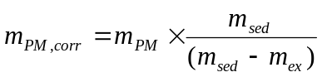

where:

m_{PM,corr} = mass of particulates corrected for extraction of particle number sample flow, g/test,
m_{PM} = mass of particulates determined according to Annex 4B paragraph 8.4.3.2.1 or 8.4.3.2.2, g/test,
m_{sed} = total mass of diluted exhaust gas passing through the dilution tunnel, kg,
m_{ex} = total mass of diluted exhaust gas extracted from the dilution tunnel for particle number sampling, kg,

Repeatability and Reproducibility

PM and PN – Repeatability
The repeatability of CVS PM measurements, expressed as CoV, was lowest for the cold WHTC cycles at ~35%, with other cycles in the range 50% to 56%. There were no labs' data that were considered outliers.
PFDS PM measurements showed CoV ranging from 20% to 30% across all cycles, with one lab’s data excluded as an outlier by the statistical analysis.
By contrast, no labs' results were excluded from the PFDS PN data set, but with CVS measurements outlier analyses excluded all hot cycle results from Ricardo and all but the cold WHTC and ESC from EMPA.

Following the exclusion of outliers, particle number repeatability levels were broadly similar: CVS CoVs ranged from ~20% to ~60% and PFDS CoVs from ~20% to ~70%.

Focusing on the Euro VI legislative cycles in isolation, shows that the CVS approach has better repeatability over the weighted WHTC (21.1% Vs. 22.8%) and over the WHSC (59.2% Vs. 74.4%) than the PFDS approach.
Taken at face value, and only using the repeatability as the assessment approach, these data might lead one to conclude that PFDS is the favoured dilution system for PM measurements, CVS is the favoured measurement system for PN and PM is the better metric, since it is more repeatable than PN. However, in reality, only the first of these statements is correct. PFDS systems, with their lower backgrounds will produce an emissions result that is lower and therefore closer to the true value.
CVS PN results were more repeatable in this programme than PFDS results, but only marginally and after 2 of 5 labs were rejected as outliers. CVSs had higher background than the PFDSs, so CVS results were in reality further from the true values.

PM measurements in this programme were more repeatable than PN measurements, but again only slightly and, in most cases, PM measurements were indistinguishable from tunnel background, which appears to be at least as repeatable as the emissions from the engine.

PM and PN – Reproducibility
CVS PM reproducibility levels were typically in the range 35% to 55%, averaging 42.7% for the 5 emissions cycles in the test matrix. PFDS PM reproducibility levels ranged from ~30% to ~45%, averaging 36.1%.
The lower PM CoVs from the PFDS systems probably reflect the greater consistency of background levels in the partial flow system compared to the CVS.

Considering just the Euro VI legislative cycles shows that the CVS approach has similar PN reproducibility over the weighted WHTC (41.4% Vs. 45.8%) and over the WHSC (81.7% Vs. 86.3%) to the PFDS approach.

The higher variation in the PN results than the PM results from the WHSC cycle is an indication that the PM method is insensitive to the effects of passive regeneration in this cycle.

Repeatability and Reproducibility Overview
When considering a measurement system it is important to consider more than just the repeatability and reproducibility. The results of this study indicate that the most repeatable and reproducible methods do not necessarily discriminate the emissions from the tunnel background nor determine a true value. However, this work does indicate that PFDS may be preferable for PM determination and that both CVS and PFDS show similar repeatability and reproducibility for the measurement of particle numbers.

Elemental carbon and non-volatile particle contributions to PM
Masses collected with TX40 filters were compared with simultaneous mass measurements from real-time instruments.
From cold start WHTC cycles, both the Dekati Mass Monitor (which calculates mass from the particle size distribution after evaporating volatile particles) and AVL483 (photoacoustic soot sensor) indicated mass levels ~10% of the filter mass. This suggests that 90% of the filter mass from this cycle is volatile and the other 10% is mostly elemental carbon. At this level of EC content, PM filters appeared slightly grey.
From all other (hot start) test cycles the DMM mass was ≤0.5% of the filter mass, indicating the volatile contribution to PM is ~99.5%. PM filters from hot start tests appeared unused.
Clearly, at a maximum of 10% EC in the PM measured on the filter, agreement between mass and number metrics would not be expected.

Filter Media Effects
In experiments at JRC, comparisons were made between PM sampled with 47mm TX40 and with 47mm Teflon membrane filters. Collected masses were always lower with Teflo filters, repeating the observations made in the light-duty PMP work.
Typical masses captured with the Teflon Membrane filters were 30% to 90% lower than recorded with TX40 filters. Considering also the observations in Section 9.5, this suggests that even the Teflon filters are still capturing some volatiles.

Other PMP type / like Systems
VPR systems which were calibrated as a whole unit either by the manufacturer (APC) or in the framework of this study (GPMS, EMPA’s homemade system, systems utilizing a thermodenuder), differed by less than ±15% when the results were corrected for the average PCRF value as described in the R83.
The observed differences were not affected by the emitted particle number concentrations (and therefore from the associated uncertainties in the dilution ratio determination) or by the CPC unit employed. Therefore, this is a PCRF related issue.
Inaccuracies in the determination of the PCRF values might have contributed to this difference. Most of the instruments used in this study were calibrated against NaCl particles which were not thermally treated. Some preliminary tests suggested a change of structure of NaCl particles when heated which leads to particle shrinkage [Error: Reference source not found].
Uncertainties associated with the operation of the DMA used for the production of the monodisperse calibration aerosol might also have contributed in the observed discrepancies. In particular, uncertainties in the charge distribution acquired in the neutralizer and therefore in the contribution of multiply charged (larger) particles in the produced monodisperse aerosol might have affected the calculated PCRF values. The relatively high concentration required for the production of monodisperse aerosol at sufficiently high concentrations might give rise to space charge fields affecting the classified particle size.
Another reason for the observed discrepancies between the various systems might be associated with the size depended losses inside the VPR systems. The calculations have been performed using the average PCRF value determined for particle mobility diameters of 30 nm, 50 nm and 100 nm, as suggested by the regulations. The correct approach, however, would be to use the PCRF value corresponding to the geometric mean diameter of the underlying distribution. This simplified approach, which is justified as the true size distributions is not generally knows, also introduces some error depending on the underlying size distribution of the sampled aerosol but also on the steepness of the penetration characteristics of the VPR system employed (that is particle losses as a function of particle size). It is worth noting that most of the VPR systems tested exhibited steeper penetration curves from what is specified in the regulations.
It is therefore important to further investigate the calibration procedure for the VPR systems.

Should Solid Particles <23nm be Considered for European PN Legislation?
Comparisons were made between non-volatile particles >3nm and non-volatile particles >23nm by using different particle counters as the counting elements of the SPCS systems. A number of different steady state and transient (including cold and hot WHTC) cycles were studied.
Irrespective of operating conditions, the number of solid particles between 3nm and 23nm, measured in the investigations of this programme, was never greater than the level of solid particles above 23nm. The highest level of particles measured between 3nm and 23nm was from the cold WHTC. Levels were ~85% of the number found above 23nm.
No measurements were made of the composition of these 3-23nm solid particles. At the upper end of the size range primary carbon spheres can be present, however it is also possible that other solid particles are present. These may derive, for example, from the lubricant as metal oxides.
While there was some evidence that solid particles <23nm were present, the levels seen were not consistent with the orders of magnitude increases relative to >23nm particles reported from US engines. On this basis, it is considered reasonable to retain the size and volatility range of particles measured for light duty vehicles in heavy-duty engines’ legislation.

Achievable PN Limit for this Engine
Across this test programme the highest single PN emissions result seen from any cycle across all labs was 7.4x10¹¹/kWh from a cold WHTC. If this engine and its DPF are considered to have representative PN emissions and both CVS and PFDS dilution approaches are used, a PN limit of 8x10¹¹/kWh would be achievable from all emissions cycles tested.

Alternatively, considering the mean results across all labs, the starting point for calculating a PN limit for both WHTC and WHSC is a mean result at or below 10¹¹/kWh.

An Alternative Approach to Sampling for PN Measurements
There is a possibility that particle number emissions from DPF equipped engines may, especially when the DPF is highly loaded, be delayed in reaching the dilution system due to transit through the filter substrate and filter cake. If this is the case, the dilution ratio in the PFDS, which varies with engine exhaust flow could be incorrect at the time (following transit delay) the particles and PM actually reach the dilution tunnel. If this is the case, there is actually no merit, specifically for post-DPF PN tests, to undertake proportional sampling. Consequently, a fixed dilution ratio PFDS measurement combined with a real-time exhaust flow measurement has potential to offer an inexpensive alternative approach which may be worthy of further investigation.
Only limited tests were undertaken in this programme, but data available suggests that PN emission levels can be determined with acceptable accuracy (better than ~15%) when sampling from the exhaust at constant dilution ratio into a PFDS. In general though, this approach seems to provide directionally lower emission levels than measured from the CVS tunnel.
Indications are, that particulate mass is underestimated by the constant dilution approach (and it can’t be corrected for real time flow because there are no real time data). However, since particulate mass emissions from many labs in this programme appear to be indistinguishable from tunnel background levels this may not be an overriding barrier to this approach.

CONCLUSIONS

Engine Operation
- Engine operation was sufficiently consistent across the test programme to enable comparisons between test laboratories

Measurement Systems
- The GPMS systems tested in this work, SPCS systems from Horiba, suffered no significant mechanical failures during the test programme and performed reliably passing all required validation checks in all test laboratories. The two SPCS systems supplied agreed to within ~5% when tested in parallel, enabling direct comparisons to be made when one was used to sample from CVS systems and the other from partial flow systems

PM Emissions
- The PMP mass method collects a large gaseous volatile fraction that may be 10 times the mass of the solid particles collected from the cold WHTC and 200 times the mass of solid particles from hot start cycles.

Levels
- PM emissions levels from CVS systems, after exclusion of labs with high PM tunnel backgrounds were <6mg/kWh from all emissions cycles. However, tunnel background levels from CVS systems in all labs were equivalent to drive cycle emissions levels for all cycles except the ESC.
- The chemistry of PM from ESC tests comprises lower volatility HCs which are more effectively retained by the sample filter.
- PM emissions from PFDS systems were generally lower than results from CVS systems – at <4mg/kWh from all emissions cycles. From PFDS too, tunnel background levels were similar to or just below sample levels on all cycles except the ESC which could be discriminated from the tunnel background in all labs.
- One lab’s PFDS was able to discriminate sample levels from tunnel background PM and this revealed all mass emissions to be <2mg/kWh. Average emissions, following tunnel background subtraction, were ~0.6mg/kWh from the weighted WHTC, and approximately 1.2mg/kWh from the WHSC.

Repeatability / Reproducibility
- PM repeatability levels from the PFDS were between 20 and 30% for all emissions cycles, while CVS repeatability was best from the cold WHTC (~35%) and 50 to 56% for other cycles.
- Reproducibility levels from the CVS were similar to the repeatability levels, ranging from 35% to 55%. PFDS PM reproducibility levels were slightly better, on average ranging from 35% to 45%.

PN Emissions
- The PMP number method determines real-time emissions that can be related to engine events with high sensitivity.

Levels
- PN emissions levels from the Cold WHTC were approximately 4x10¹¹/kWh from both full and partial flow dilution systems. At these levels of emissions the tunnel background contribution has no substantial impact on emissions
- Tunnel background PN levels in the CVS were generally higher than in PFDS systems and in two labs sufficiently high for those labs to be identified as outliers since their tunnel background levels were as high or higher than emissions from many of the hot start cycles. In these cases, emissions from hot start cycles were ~10¹¹/kWh
- Low PN tunnel background levels were seen in PDTs, and since emissions levels were similar from tunnel background levels were also similar in all PFDS
- Emissions levels from both PFDS and CVS dilution systems with low PN tunnel backgrounds were 5-9x10⁹ from hot start WHTC and ETC cycles, but higher from WHSC (2-3x10¹⁰/kWh) and ESC (6-8x10¹⁰/kWh) where passive regeneration may oxidise the filter cake and reduce the filtration efficiency of the DPF.

Repeatability / Reproducibility
- Repeatability levels for the CVS and PFDS were similar, ranging from ~20% to ~70%, with the cold WHTC most repeatable and the WHSC least repeatable.
- Reproducibility levels between CVS and PFDS systems were also similar at 41-45% for the weighted WHTC and 81 – 86% for the WHSC.
- With the particle number measurement systems, it is clear that the passive regeneration present in the WHSC leads to increased variability. This effect is not seen in the PM results.

Relationships Between Measurement Approaches

Full Vs Partial Flow Mass
- Emissions levels from PFDS systems were more repeatable and reproducible than measurements from CVS systems.
- One lab’s PFDS was able to discriminate mass emissions from tunnel background PM levels. Further research might identify procedures which will enable all labs to achieve this with their partial flow systems
- Mass emissions from PFDS and CVS did not correlate due to variations in CVS tunnel background contributions in this exercise: in most cases this was effectively attempting to correlate between systems’ backgrounds

Full Vs Partial Flow Number
- PFDS systems showed lower tunnel backgrounds than CVS systems, but when CVS system tunnel backgrounds were similar to PFDS tunnel backgrounds the correlation between PN emissions was excellent
- Higher tunnel background CVS systems still showed similar PN emissions levels to PFDS systems from cold start WHTC tests. However, across other cycles High CVS tunnel backgrounds weaken the correlation between CVS and PFDS PN measurements as the engine particle number emissions are approach the CVS tunnel background PN level

Mass Vs Number
- Mass and number methods did not correlate. The majority of mass comes from volatile materials, which are unrelated to the materials comprising solid particles.

Other PMP type / Like Systems
- The majority of the various PMP type and PMP like systems correlated closely with the GPMS, the difference being on average ±15% after accounting for the PCRF values and the slopes of the CPCs.
- Systematic differences were observed between the various PMP type and PMP like systems employed. These differences hold for emission levels spanning over 4 orders of magnitude as well as when different CPC units are employed. This points towards differences in the calibrations of the PCRF values but could also partly be associated with differences in the penetration curves (penetration as a function of particle size).
- Simplified approaches such as the use of dual ejector systems sampling directly from the tailpipe or operation of the partial flow systems at constant dilution ratios resulted in similar levels of agreement.
- The various PMP type and PMP like systems examined had almost an order of magnitude higher background levels from the GPMS. More efficient conditioning of the dilution air is necessary in order to accurately determine the emission levels over the hot start transient test cycles and the WHSC

General Conclusions
- In this work, PM emissions from an engine with an efficient wall-flow DPF, measured from both CVS and PFDSs, without any correction for dilution air background or compensation for tunnel background contribution (which is not permitted in current regulatory procedures e.g. GTR No.4), were consistently below 10mg/kWh across all the cycles tested.
- The results of this work demonstrate that the PM method is suitable to confirm that engine PM emissions levels are below the emissions levels required for Euro VI (10mg/kWh for the WHTC and WHSC cycles). However, PM measurements in this programme could not generally discriminate between actual emissions levels and dilution tunnel background levels, except in the case of measurements from one PFDS at one lab and for the ESC cycle at all labs.
- In this work, PN emissions from an engine with an efficient wall-flow DPF, measured from both CVS and PFDSs, without any correction for tunnel background, ranged from ~10⁹/kWh to >10¹¹/kWh across all the cycles tested.
- Emissions levels from every emissions cycle, with both PFDS and low tunnel background CVS systems, were substantially above tunnel background levels.
- From all PFDS systems and low tunnel background CVS systems in this work, the PN method is suitable to determine the actual emissions levels from all drive cycles tested, and at levels ≥10¹⁰/kWh. A threshold of 10¹⁰/kWh is quoted, since as shown in Figure 64, all low CVS backgrounds were beneath this level. This lower emissions threshold accounts for a PCRF correction of 1.25 to PFDS and CVS particle number data from the SPCS systems in this study.
- Considering WHTC and WHSC results, the PM emissions method may appear more repeatable and reproducible than the PN method, but a direct comparison between the two is inappropriate. In this programme PM measurements were generally indistinguishable from tunnel background levels and consequently the PM repeatability here is more indicative of the repeatability of tunnel background measurement than engine emissions measurement. In contrast the PN figures reflect the variability of emissions from an unstable DPF system

RECOMMENDATIONS
PN Tunnel Background
High dilution tunnel background PN concentrations can have a significant impact on PN results on some test cycles. Labs should monitor tunnel background levels and take steps to minimise them prior to conducting type approval tests. Use of PFDS can make minimising tunnel background contributions easier owing to the greater ease of cleaning of these systems.
Where PFDS cannot be used, labs should minimise tunnel contamination prior to type approval testing by avoiding testing high particle emissions engines in advance of DPF engine approval testing, tunnel cleaning (where possible) and pre-conditioning.
Subtraction of tunnel background PN should not be permitted for type approval testing, but should be allowed in the case of conformity of production and in service conformity testing where tunnel background levels are shown to be significant.
PN Variability on WHSC
PN repeatability levels on the WHSC test cycle appear to be higher than on other test cycles. This may be due to exhaust temperatures being sufficient for passive regeneration to occur for a significant proportion of the test cycle, reducing the soot cake on the DPF and reducing filtration efficiency. This effect needs to be considered and accounted for in setting regulatory PN limit values on the WHSC.
PNC Particle Size Cut Off
Numbers of solid particles below the 23nm PNC cut off size used in R83 were not found to be significant compared to numbers of larger than 23nm particles. It is therefore recommended that the 23nm PNC cut off is retained for heavy duty engine emissions testing.
Compensating for PN Sample Flow
Extraction of a sample from a PFDS for PN measurement needs to be accounted for in controlling the proportionality of sampling. It is recommended that where the PN sample flow exceeds 0.1% of the total dilute exhaust gas flow in the PFDS that such compensations be required. This can be achieved either by mathematical correction or physical feedback of the sample flow of (if the measurement system allows it) or by a separate feedback of an accurate flow equivalent to that drawn by the measurement system.
PN sample flow should also be mathematically compensated for in calculating PM emissions in the case of total flow type PFDS systems.

Appendices
Appendix 1: ILG_HD
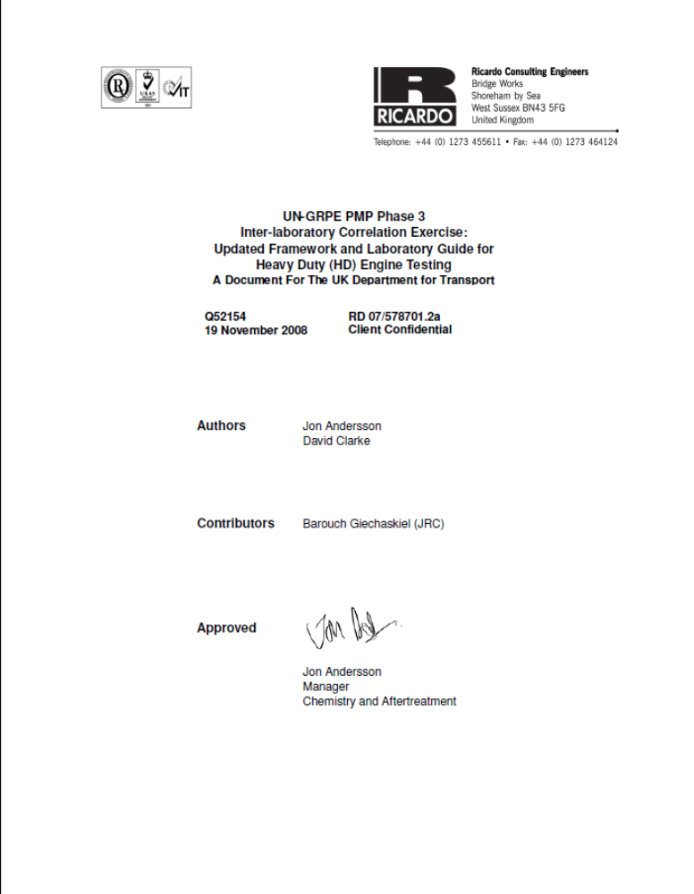
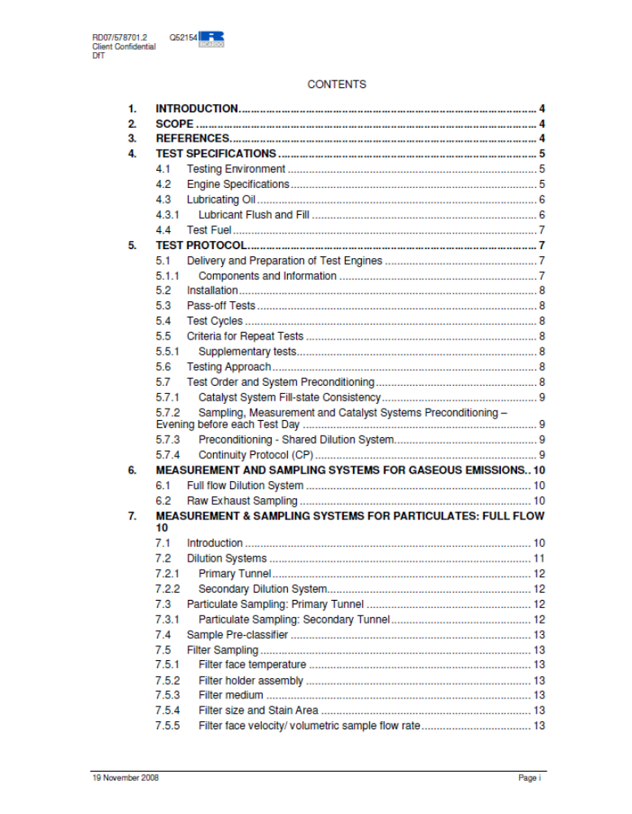
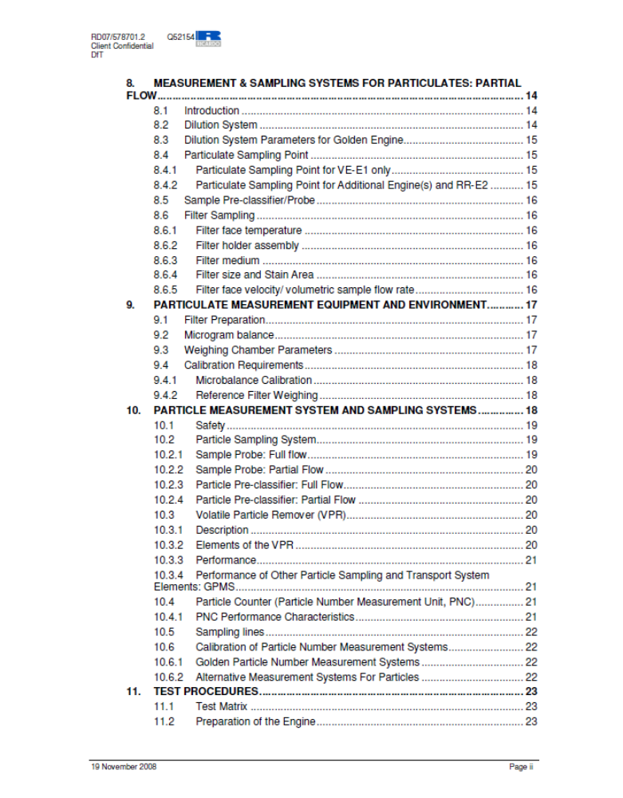
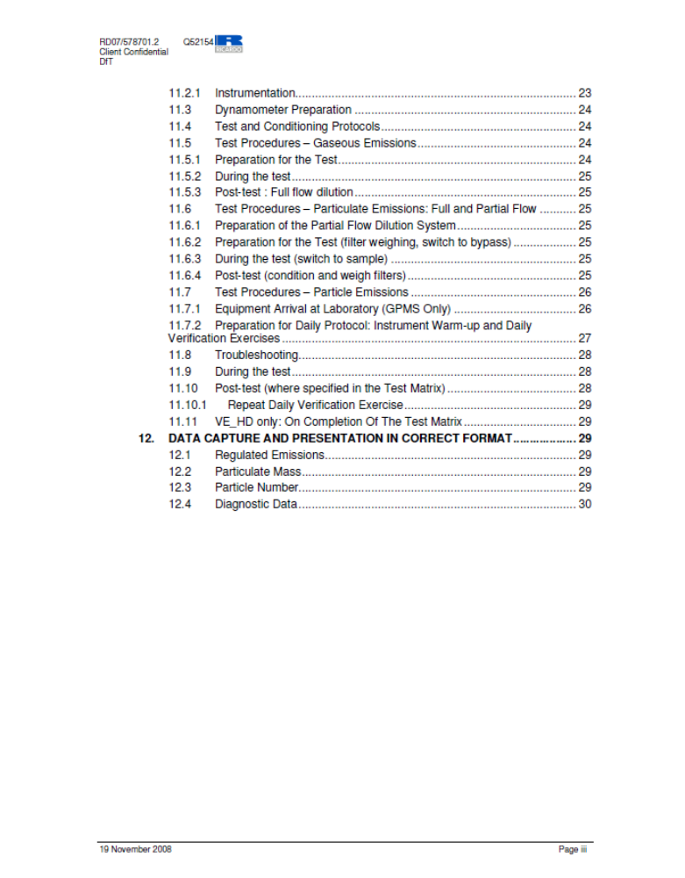
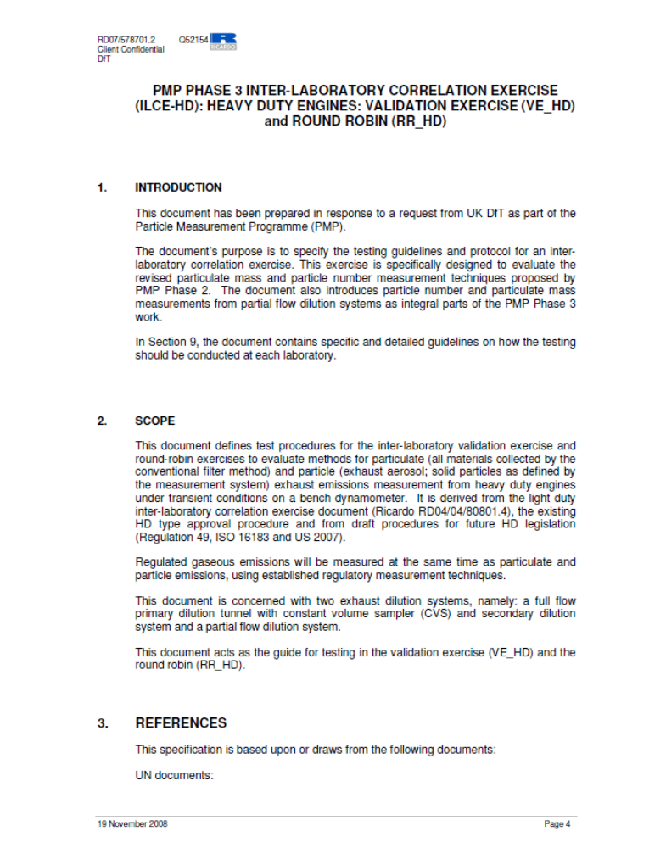

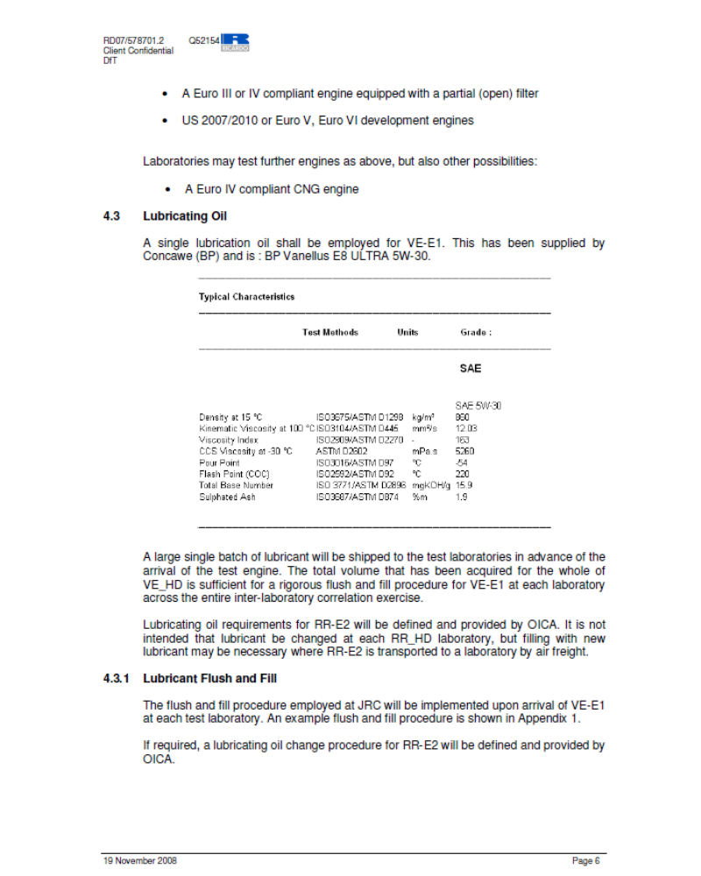

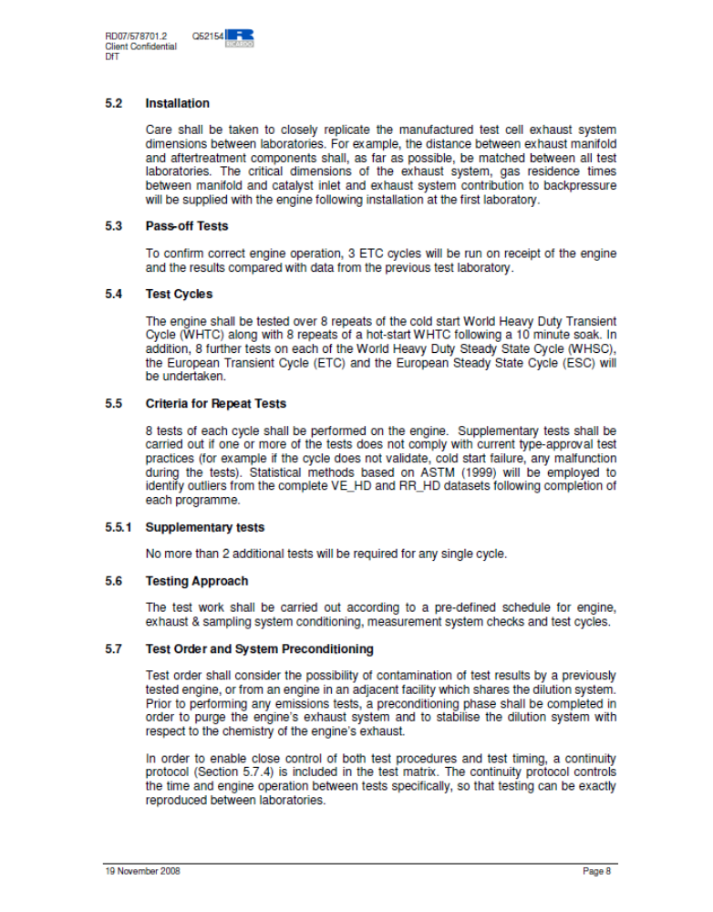
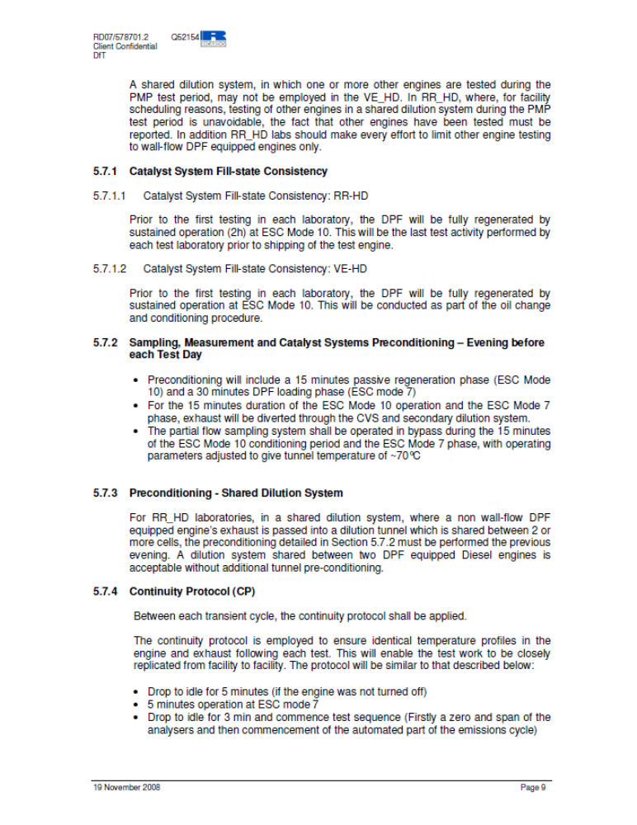

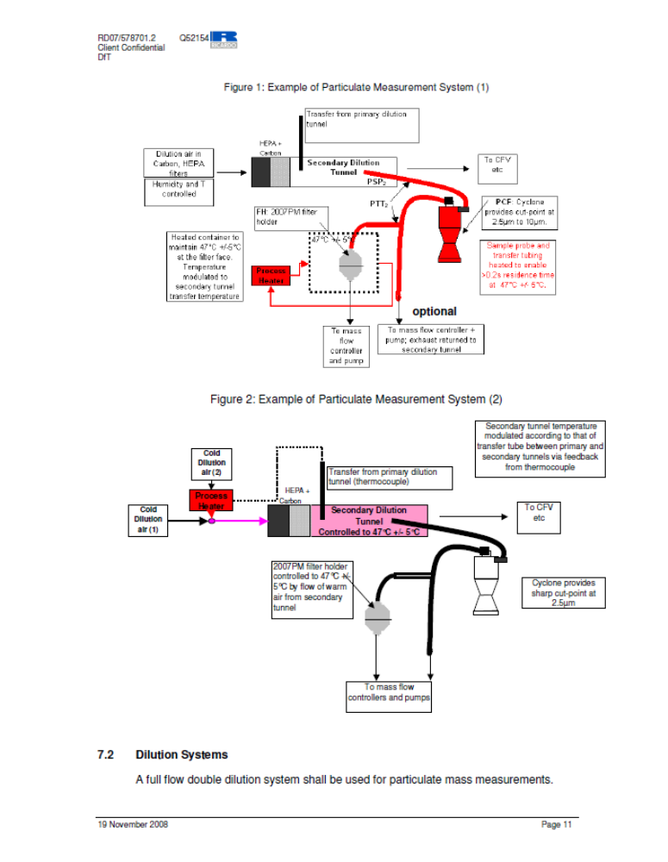
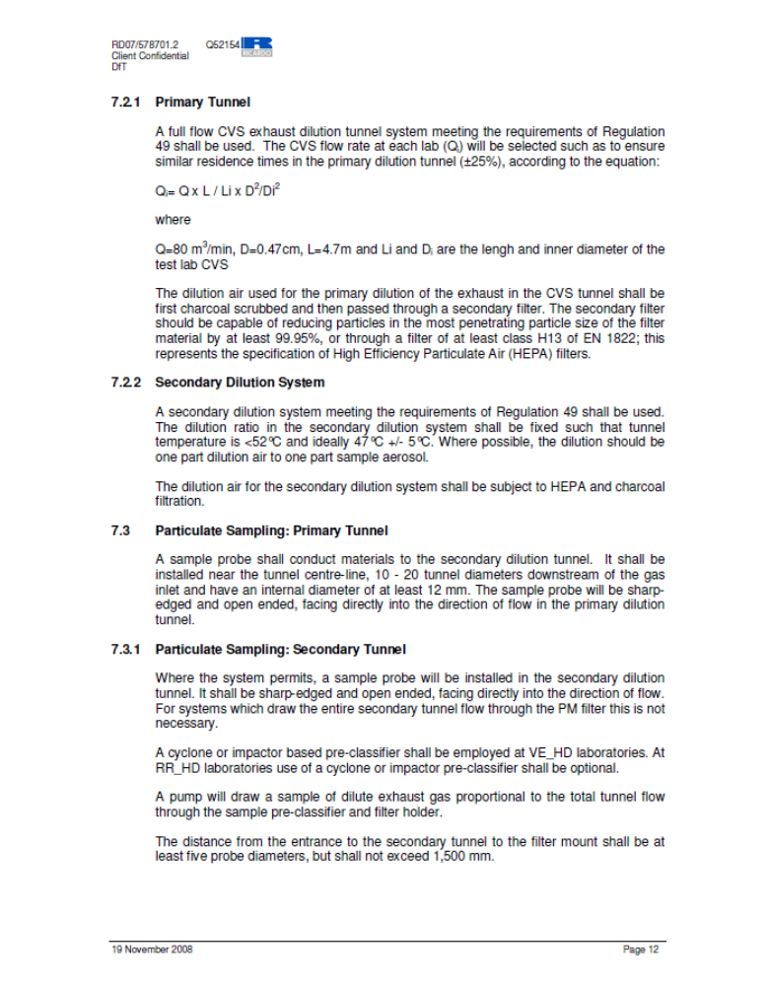
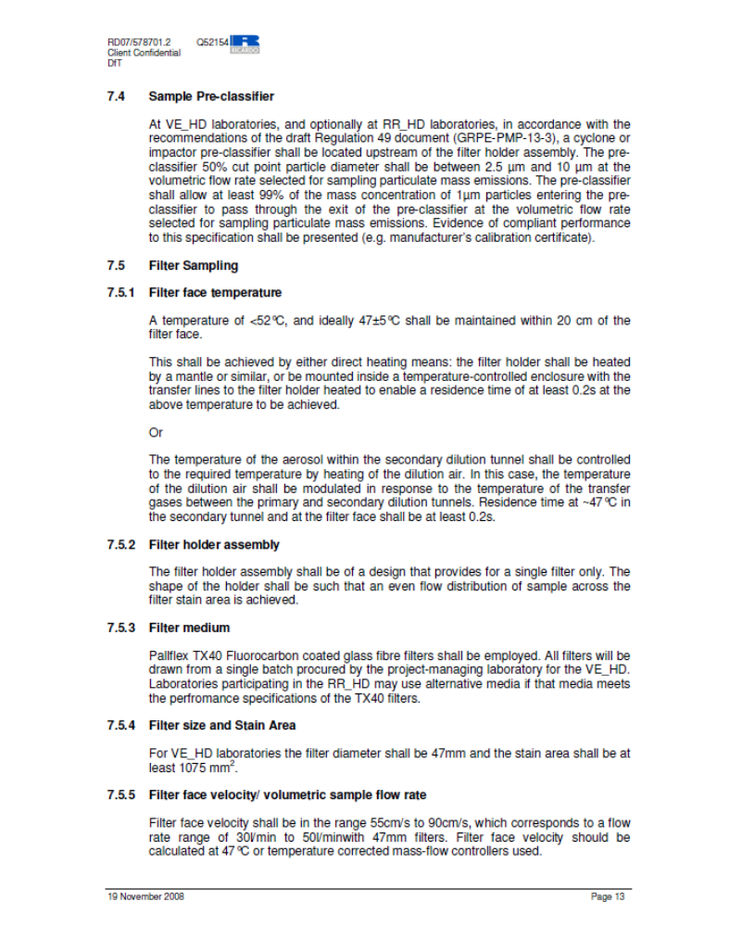
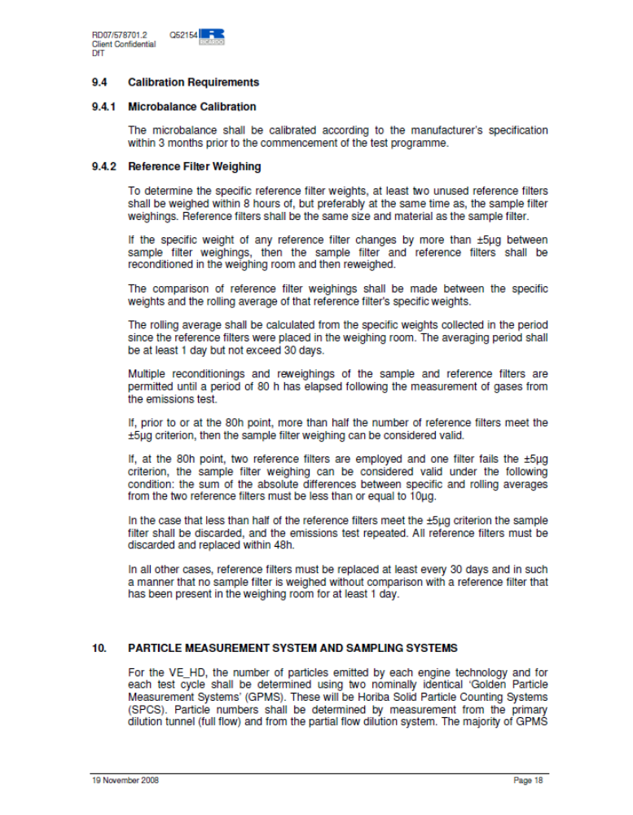
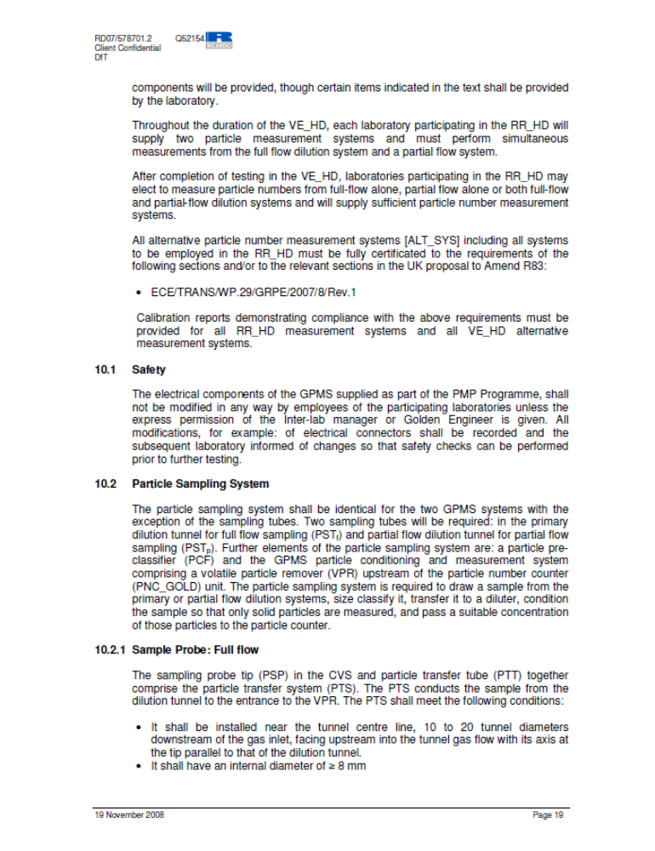
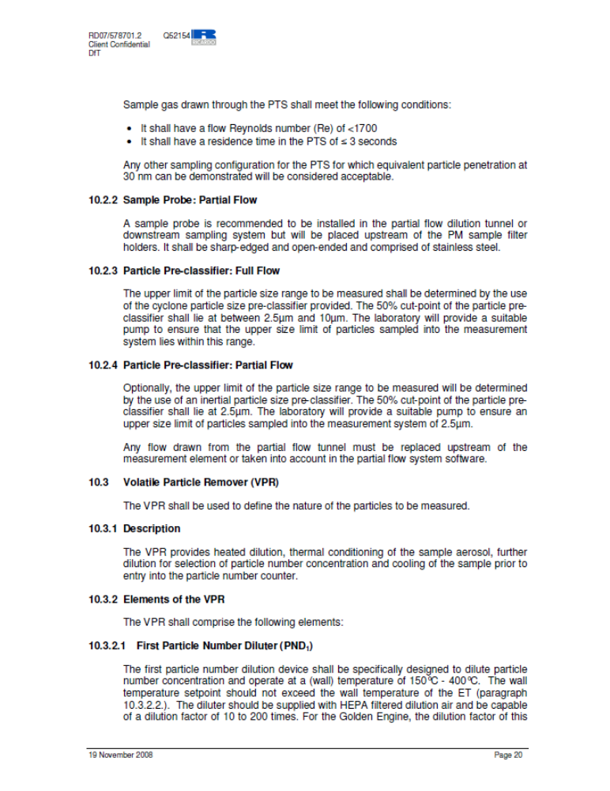
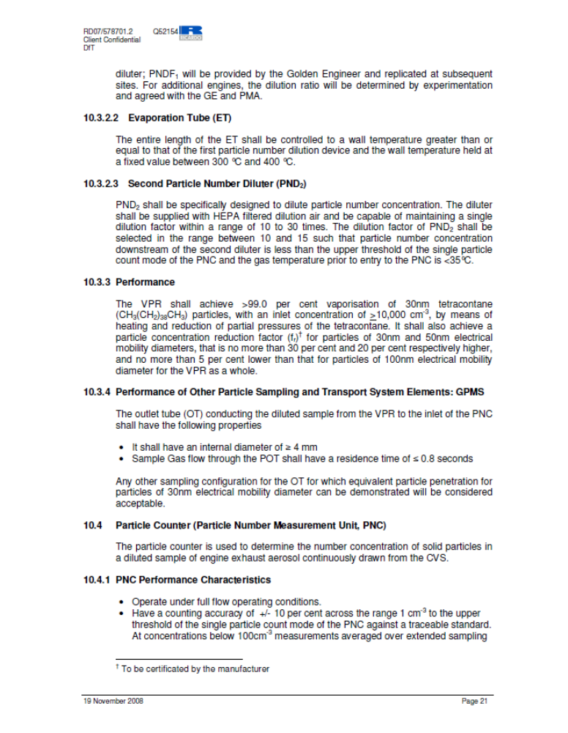
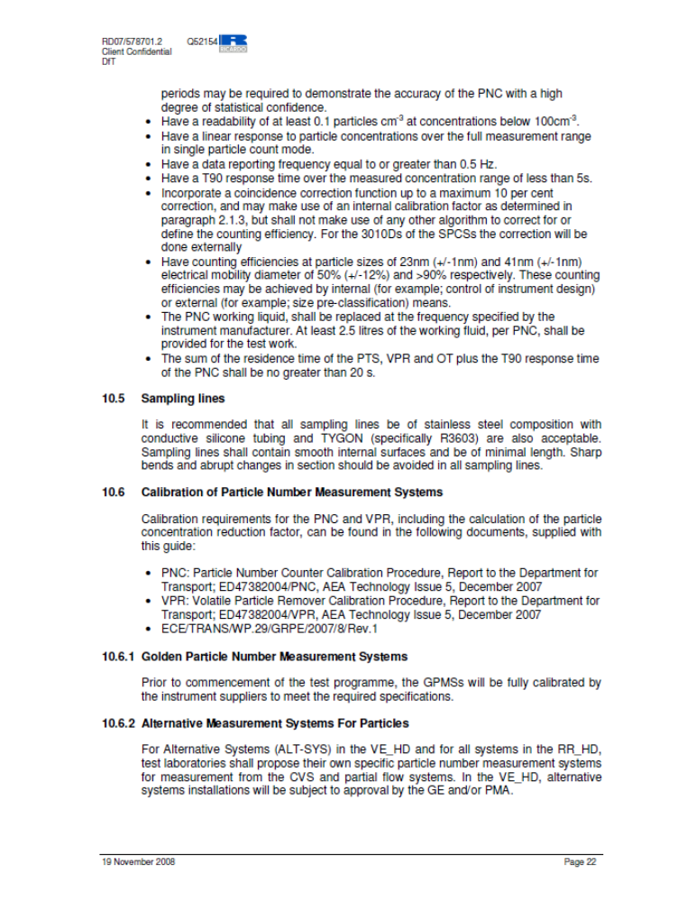
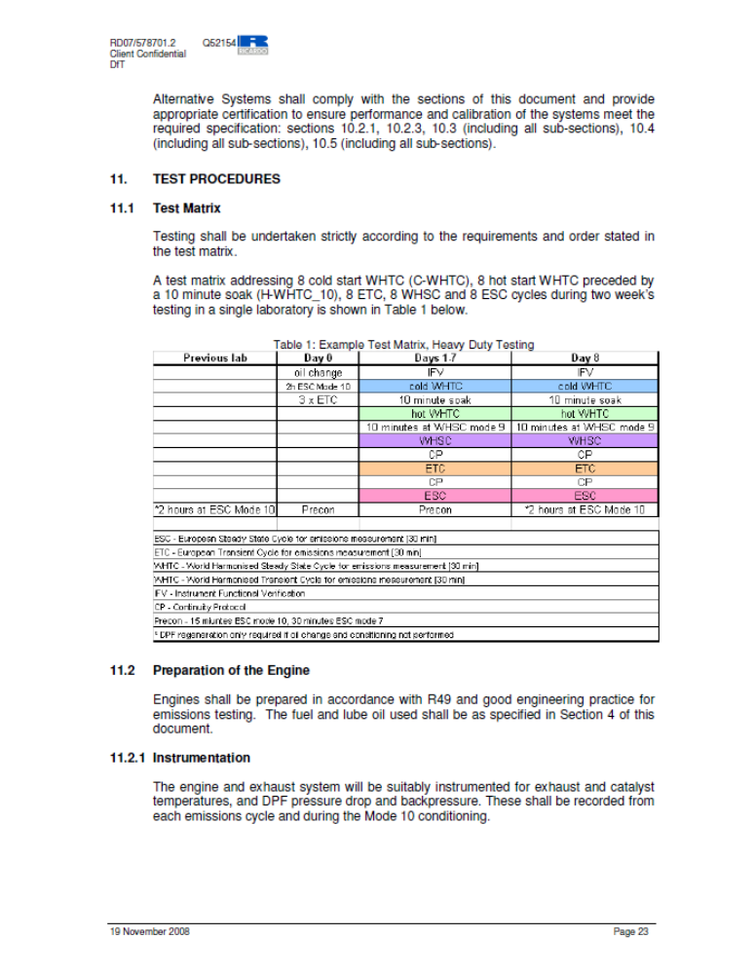

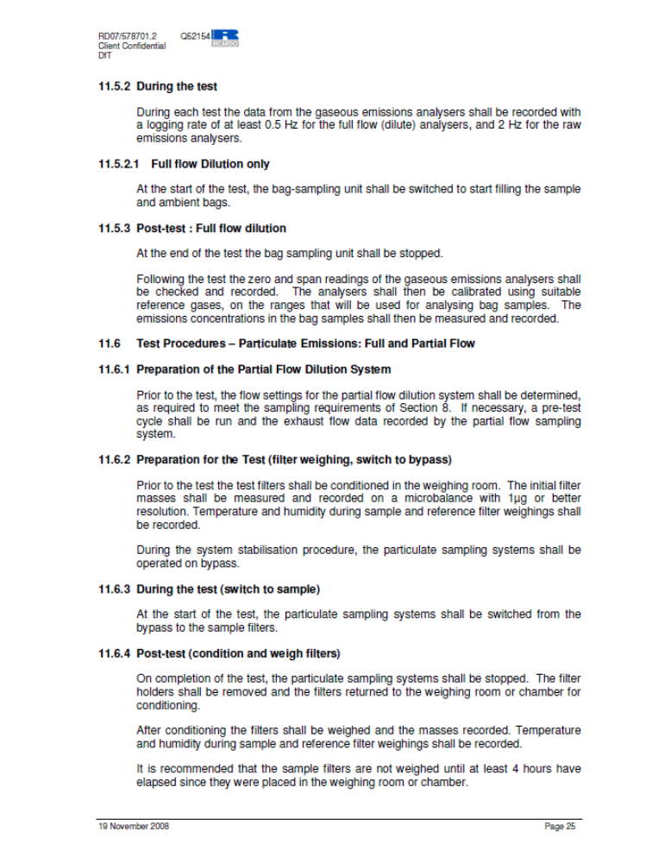
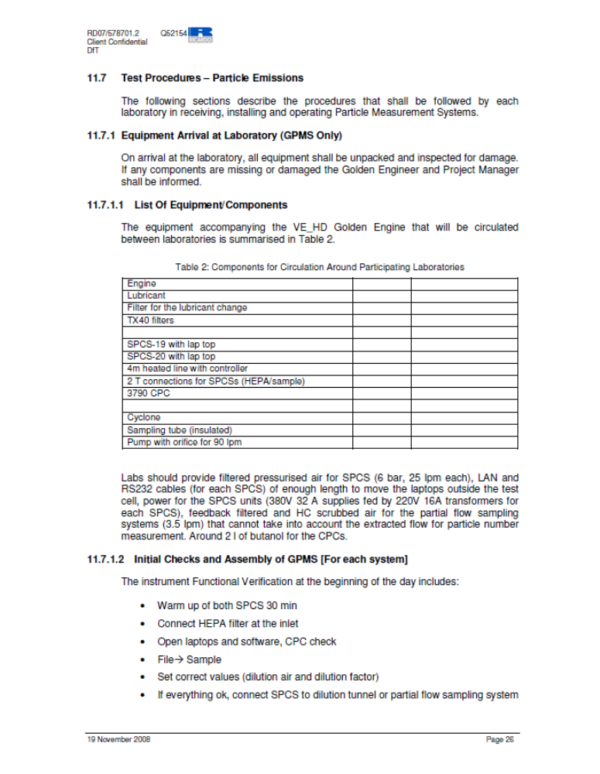
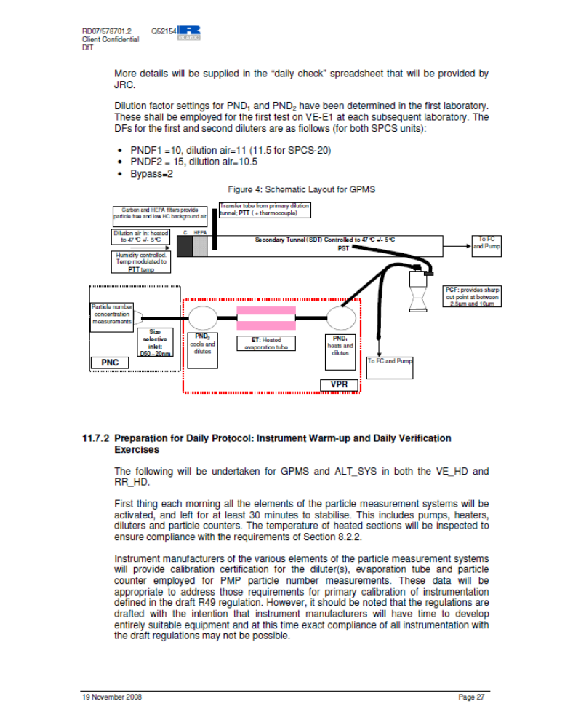
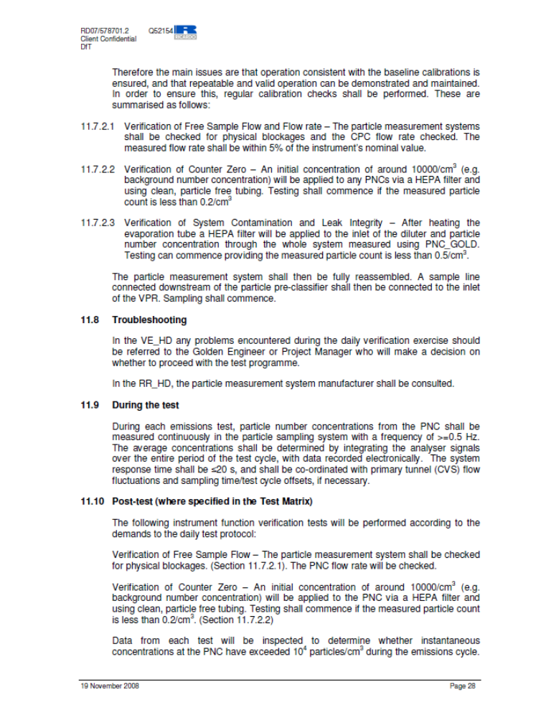
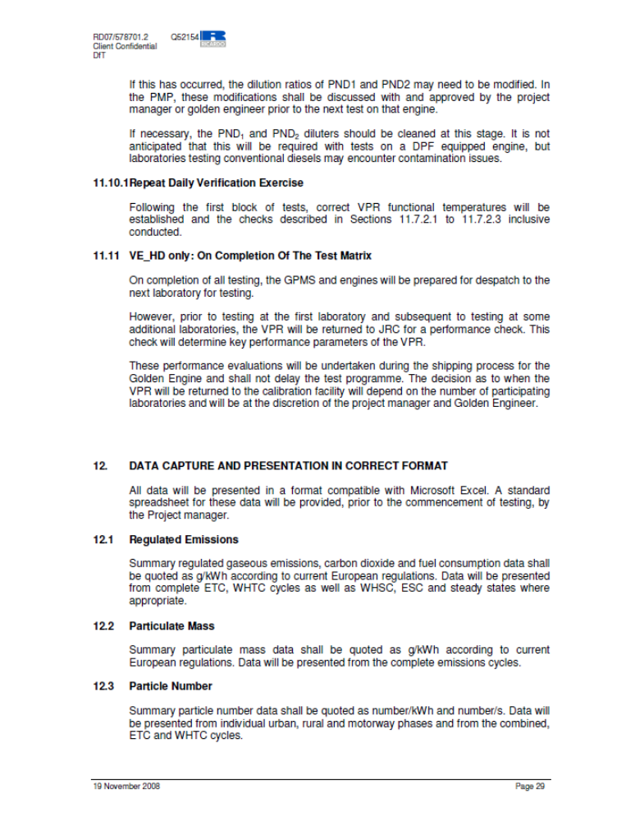


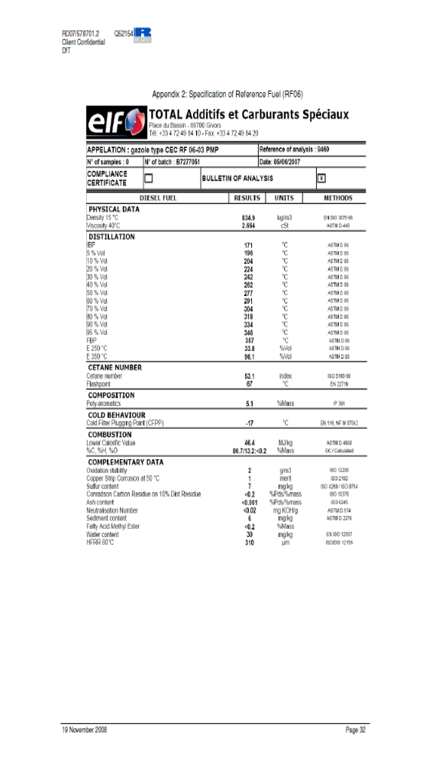

Appendix 2: Certification of PNC Performance
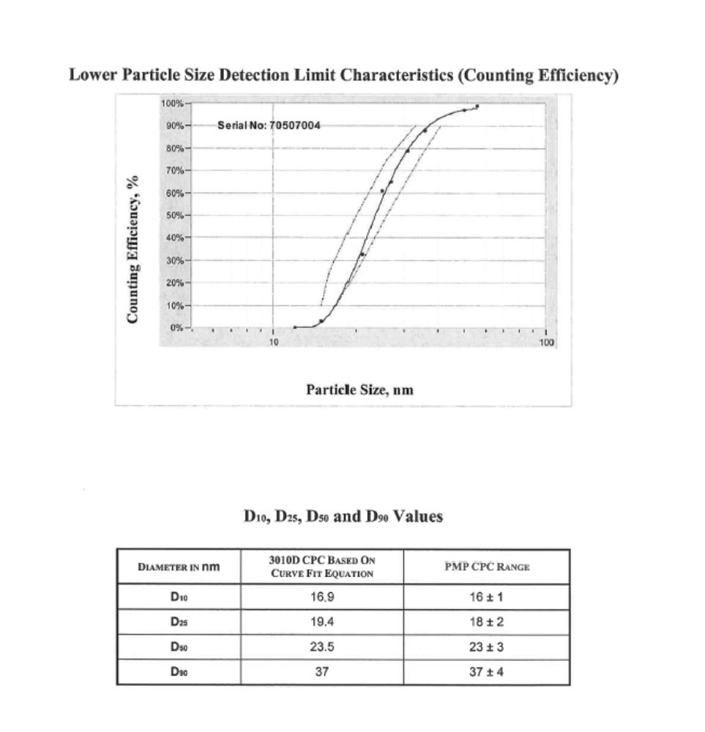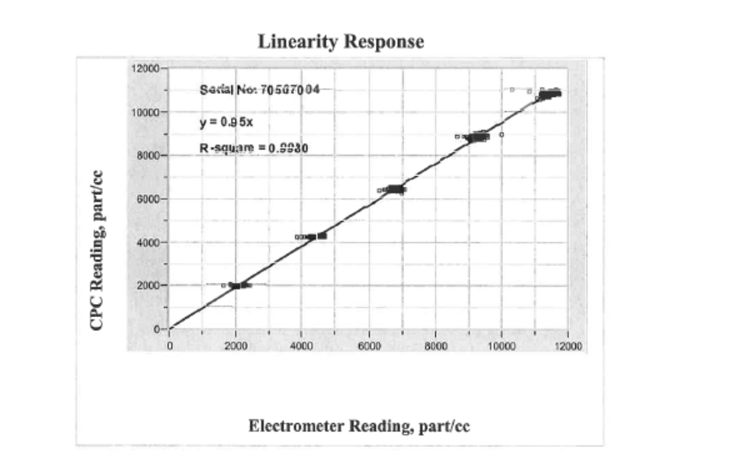
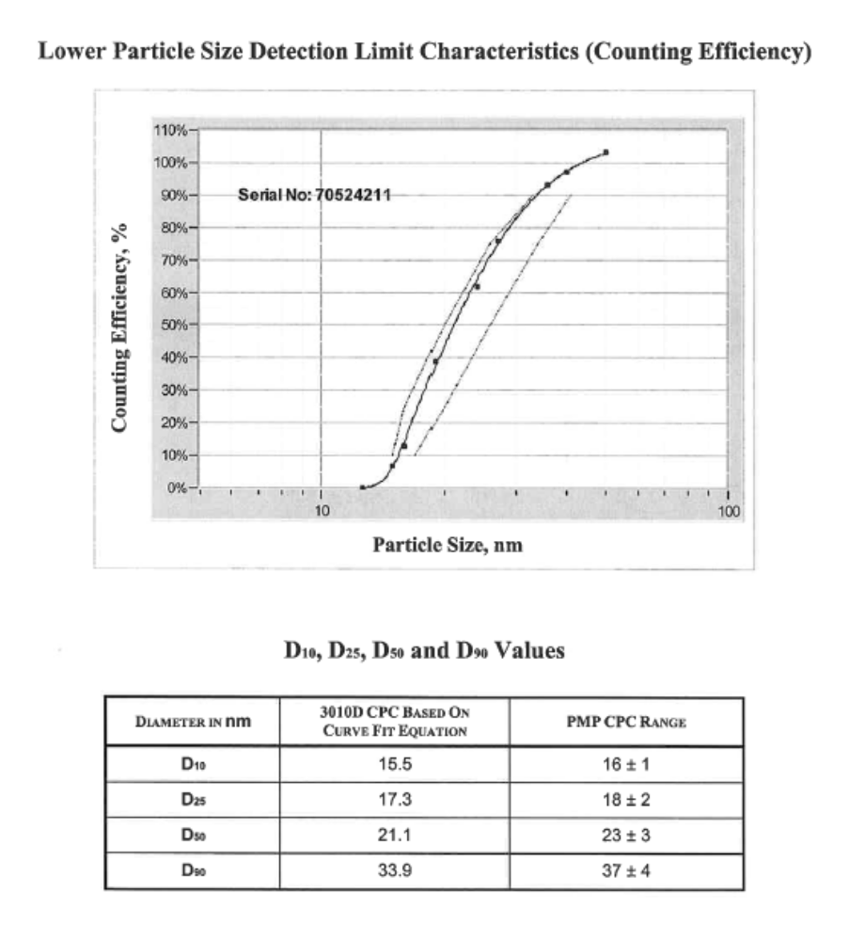
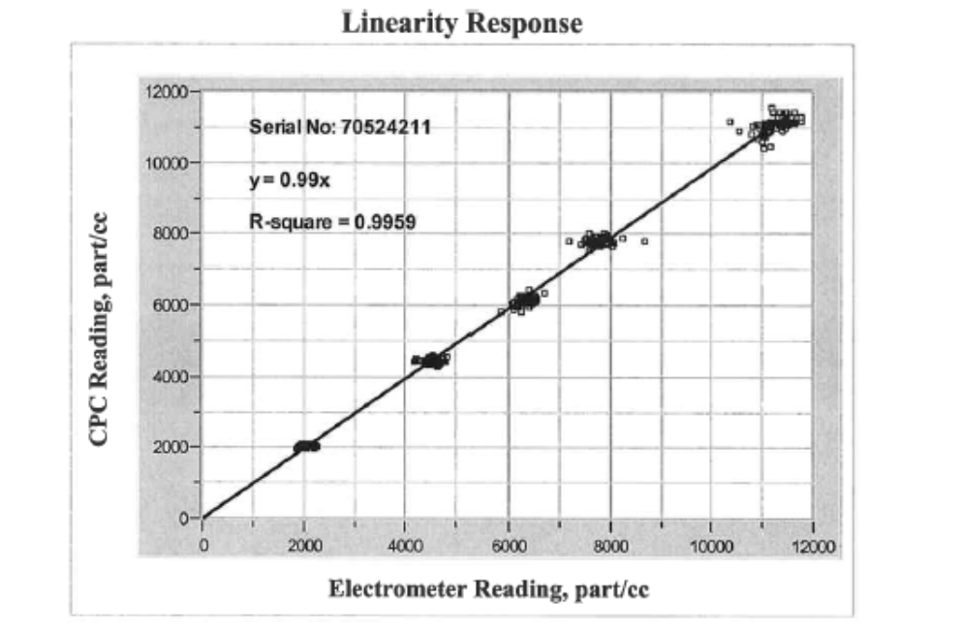

References ? Conclusions on Improving Particulate Mass Measurement Procedures and New Particle Number Measurement Procedures Relative to The Requirements of The 05 Series of Amendments to Regulation No. 83. http://www.unece.org/trans/doc/2004/wp29grpe/TRANS-WP29-GRPE-48-inf11r1e.pdf
A working document for the UK Department for Transport presenting an updated and restructured version of Regulation No. 49, Annex 4. http://www.unece.org/trans/doc/2004/wp29grpe/PMP-2004-13-03e.doc
Regulation 83: Vehicle Emissions Legislation; Light-duty vehicles and PCVs (GVW < 3.5 tonnes). http://www.unece.org/trans/main/wp29/wp29regs/r083r3e.pdf
Regulation 43: Vehicle Emissions Legislation; Heavy Duty Vehicles (GVW >3.5 tonnes). http://www.unece.org/trans/main/wp29/wp29regs/r049r3e.pdf
UN-GRPE PMP Phase 3 Inter-laboratory Correlation Exercise: Framework and Laboratory Guide, A Document For The UK Department for Transport. RD 04/80801.5 Jon Andersson and David Clarke
http://ies.jrc.ec.europa.eu/uploads/fileadmin/Documentation/Reports/Emissions_and_Health/EUR_2006-2007/EUR_22775_EN.pdf
Giechaskiel B., Dilara P., Andersson J. (2008). Particle Measurement Programme (PMP) light-duty inter-laboratory exercise: Repeatability and reproducibility of the particle number method. Aerosol Sci. Technology, 42, 528-543
Giechaskiel B., Dilara P., Sandbach E., Andersson J. (2008). Particle Measurement Programme (PMP) light-duty inter-laboratory exercise: Comparison of different particle number measurement systems. Measurement Sci. Technology, 19, 095401
http://www.unece.org/trans/main/wp29/wp29regs/r083r3a2e.doc
Exploratory experiments SAE 2009-01-1767
Particle Measurement Programme (PMP) Heavy-Duty (HD) Inter-laboratory Exercise. Exploratory work at JRC (Oct’ 07 -Dec’07). B. Giechaskiel, S. Alessandrini, F. Forni, P. Sinuez, M. Carriero, G. Martini
UN-GRPE PMP Phase 3 Inter-laboratory Correlation Exercise: Updated Framework and Laboratory Guide for Heavy Duty (HD) Engine Testing A Document For The UK Department for Transport. Ricardo Document RD 07/578701.2a. Jon Andersson and David Clarke
ISO 16183:2002 Heavy duty engines -- Measurement of gaseous emissions from raw exhaust gas and of particulate emissions using partial flow dilution systems under transient test conditions. http://www.iso.org/iso/catalogue_detail.htm?csnumber=32152
http://www.horiba.com/automotive-test-systems/products/emission-measurement-systems/dilution-sampling-systems/details/mdlt-1300t-876/
AVL SPC 472 Smart Sampler: http://www.avl.com/wo/webobsession.servlet.go/encoded/ YXBwPWJjbXMmcGFnZT12aWV3JiZub2RlaWQ9NDAwMDIwMTc0.html
http://www.controlsistem.it/data/automotive/testrig/pss20.swf
http://sierrainstruments.com/emissions/bg3.html
UK Particulate Measurement Programme (PMP): A Near US 2007 Approach To Heavy Duty Diesel Particulate Measurements - Comparison With The Standard European Method. Jon D Andersson; David P Clarke; James A Watson. SAE 2004-01-1990
Wei Q., Oestergaard K., Porter S., Asano I, Adachi M. and Rahman M., 2006. Real-time Measuring System for Engine Exhaust Solid Particle Number Emission – Design and Performance. SAE 2006-01-0864
Johnson K. C., Durbin T. D., Jung H., Chaudhary A., Cocker D. R., Herner J. D., Robertson W. H., Huai T., Ayala A. and Kittelson D., 2009. Evaluations of the European PMP methodologies during an-road and chassis dynamometer testing for DPF equipped heavy-duty diesel engines. Aerosol Science and Technology, 43, 962-969.
Johnson, Kent C., Thomas D. Durbin, Heejung Jung, Ajay Chaudhary, David R. Cocker III, Jorn D. Herner, William H. Robertson, Tao Huai, Alberto Ayala, and David Kittelson, 2009. Evaluation of the European PMP Methodologies during On-Road and Chassis Dynamometer Testing for DPF Equipped Heavy Duty Diesel Vehicles, Aerosol Science and Technology, 43:962–969, 2009.
Johnson, Kent C., Thomas D. Durbin, Heejung Jung, Ajay Chaudhary, David R. Cocker III, Jorn D. Herner, William H. Robertson, Tao Huai, Alberto Ayala, and David Kittelson, 2009. Evaluation of the European PMP Methodologies during On-Road and Chassis Dynamometer Testing for DPF Equipped Heavy Duty Diesel Vehicles, Aerosol Science and Technology, 43:962–969, 2009.
Hines W., Montgomery D., Goldsman, D. and Borror C., Probability and Statistics in Engineering. 4th edition, John Wiley and Sons, 2003.
Armstrong S., 2007. Significance tests harm progress in forecasting. International Journal of Forecasting, 23 321-327.
Mamakos A., Ntziachristos L. and Samaras Z., 2004. Comparability of particle emission measurements between vehicle testing laboratories: a long way to go. Measurement Science and Technology, 15, 1855-1866.
Penetration Calibration and Verification for the Solid Particle Counting System with Polydisperse and Monodisperse Particles. Qiang Wei, Mike Akard, Ichiro Asano , Montajir Rahman. SAE 2008-01-1178
Real-time measuring system for engine exhaust solid particle number emission – Performance and Vehicle tests.Qiang Wei, Asano Ichiro, Masayuki Adachi, Rahman M. Montajir, Takeshi Kusaka, Yuichi Goto. SAE 2006-01-0865
Calibration of Condensation Particle Counters. Wei Liu, Brian L. Osmondson, Oliver F. Bischof, and Gilmore J. Sem. SAE 2005-01-0189
Personal communication between J.Andersson and Hans-Georg Horn (TSI Europe)
Final Report For DfT On Testing In The PMP Phase 3 Heavy-Duty Validation Exercise. Ricardo Document 09_110201_2
Particle Measurement Programme (PMP) Light-Duty Inter-laboratory Exercise: Repeatability and Reproducibility of the Particle Number Method. Barouch Giechaskiel, Panagiota Dilara, Jon Andersson. Aerosol Science and Technology, Volume 42, Issue 7 July 2008 , pages 528 - 543
http://www.avl.com/wo/webobsession.servlet.go/encoded/YXBwPWJjbXMmcGFnZT12aWV3JiZub2RlaWQ9NDAwMDM5MzUy.html
http://www.dekati.com/cms/dmm
Maricq MM, Podsiadlik DH, Chase RE 1999. Gasoline vehicle particle size distributions: Comparison of steady state, FTP, and US06 measurements. Environmental Science & Technology 33(12):2007-2015.
Calibration and Validation of Various Commercial Particle Number Measurement Systems. Barouch Giechaskiel, Massimo Carriero, Giorgio Martini, Alois Krasenbrink, Daniel Scheder
Giechaskiel B., Ntziachristos L. and Samaras Z., 2004. Calibration and modelling of ejector dilutors for automotive exhaust sampling. Measurement Science and Technology 15, 2199-2206.
Personal communication between J.Andersson and Tim Johnson (Corning Inc.)
ECE/TRANS/WP.29/2009/114, Annex 4B

