Transmitted by the expert from Japan | Informal document No. GRPE-59-08  (59th GRPE, 11-15 January 2010,  Agenda item 10)

--Establishment of Methods for Measuring Exhaust Emissions and
Fuel Economy of Plug-in Hybrid Vehicles--

As part of its effort to build an environment for deploying plug-in hybrid vehicles, the Ministry of Land, Infrastructure, Transport and Tourism (MLIT) held a total of four meetings of Study Committee for Establishing Methods for Measuring Exhaust Emissions and Fuel Economy of Plug-in Hybrid Vehicles between February and December 2008 to discuss the formulation of methods for measuring exhaust emissions and fuel economy that are capable of adequately evaluating the properties of plug-in hybrid vehicles.

In July 2009, based on the results of Study Committee’s discussions, the MLIT partially amended the Announcement that Prescribes Details of Safety Regulations for Road Vehicles (MLIT Announcement No. 619, 2002; hereafter “Details Announcement”), etc. with regard to the methods for measuring exhaust emissions and fuel economy (see Attachment). This enabled type-designation of plug-in hybrid vehicles.

(Reference) What is a plug-in hybrid vehicle?

A plug-in hybrid vehicle is a vehicle equipped with both the function of running primarily on motor power generated by batteries that are recharged with electricity from an external electric power source such as a household electrical outlet (“plug-in running function”) and the functions of a hybrid vehicle.

By utilizing the “plug-in running function” mainly for running relatively short distances in urban driving, etc., the plug-in hybrid vehicles are expected to contribute significantly to the reduction of CO₂ and other air pollutants. Furthermore, since they can also function as regular hybrid vehicles, cruise distances equivalent to those of gasoline vehicles can be ensured, which is predicted to enable a wide range of utility.

- - - - -
Methods for Measuring Exhaust Emissions and Fuel Economy of Plug-in Hybrid Vehicles
Attachment
1. Background
The Ministry of Land, Infrastructure, Transport and Tourism (MLIT) held a total of four meetings of Study Committee for Establishing Methods for Measuring Exhaust Emissions and Fuel Economy of Plug-in Hybrid Vehicles between February and December 2008 and discussed the formulation of methods for measuring exhaust emissions and fuel economy that are capable of adequately evaluating the properties of plug-in hybrid vehicles with a view to building an environment for deploying plug-in hybrid vehicles. The current amendment to the legislation has been made based on the results of Study Committee’s discussion.

2. Summary of the Amendments
(1) Measurement of exhaust emissions (related to Details Announcement, Attachments 42, 48 and 49)
Measurement of exhaust emissions for plug-in hybrid vehicles shall be conducted in the same manner as that for conventional hybrid vehicles. Specifically, the exhaust emissions performance value is determined by combining the exhaust emissions performance value for hybrid running with the engine being cold and that with the engine being warm.
* However, if, during a test cycle where plug-in running with the engine being cold has started at a given battery-charge level, an exhaust emissions performance value worse than that for hybrid running with the engine being cold is observed, such value shall be used.

(2) Evaluation and indication of fuel economy performance
The combined fuel economy (“plug-in hybrid fuel economy”) shall be determined as the representative fuel economy value by combining fuel economy for plug-in running (running by using electricity in batteries charged from an external source; “plug-in fuel economy”) and fuel economy for hybrid running (“hybrid fuel economy”).
One of the characteristics of plug-in hybrid vehicles is that the actual fuel consumption and fuel economy performance of the vehicles are greatly affected by the way individual users use the vehicles, in particular, how much plug-in running they utilize in their actual driving (the percentage of plug-in running in the driving distance per day).
For this reason, the relevant basic performance values shall be indicated together with the representative value so that individual users can calculate the actual plug-in hybrid fuel economy as well as approximate annual electricity consumption rate and electricity cost, etc. for their own unique usage of the vehicles.
In addition, the fact that electricity consumption by the air-conditioner use greatly affects the cruise distance and fuel economy performance of plug-in running shall be also noted in catalogs, etc. to call for users’ awareness.

Fuel Economy Performance Information to Be Indicated
(Representative fuel economy value)
-- Combined fuel economy (Plug-in hybrid fuel economy) (km/L)
Representative fuel economy determined by combining plug-in fuel economy and hybrid
* In this case, combination of each fuel economy is made by taking into consideration the percentage of plug-in running contribution in the overall running (utility factor).

(Basic performance values necessary for calculation of other factors such as energy efficiency and fuel economy reflecting each user’s unique usage, etc.)
-- Hybrid fuel economy (km/L)
Fuel economy for hybrid running (charge-sustaining mode running)
-- Plug-in fuel economy (fuel economy for running on plug-in electricity) (km/L)
Fuel economy for plug-in running (fuel economy for running on electricity in batteries charged from an external source; charge-depleting mode running)
-- Plug-in range (cruise distance for running on plug-in electricity) (km)
Cruise distance for running on electricity in batteries charged from an external source
-- Electric fuel economy (km/kWh)
Electric fuel economy for plug-in running

(Other reference specification values: Specification values necessary for calculation of approximate annual electricity consumption rate and electricity cost and comparison of performance, etc.)
-- EV-equivalent range (EV-equivalent cruise distance) (km)
Portion of the plug-in range that corresponds with work by electricity in batteries charged from an external source (i.e., cruise distance for assumed running whose sole energy source is electricity from an external source)
-- Electricity consumption per recharge (kWh/recharge)
Rate of electricity consumed per recharge

3. Application
These amendments shall apply to motor vehicles manufactured on or after August 1, 2009.
(Reference)

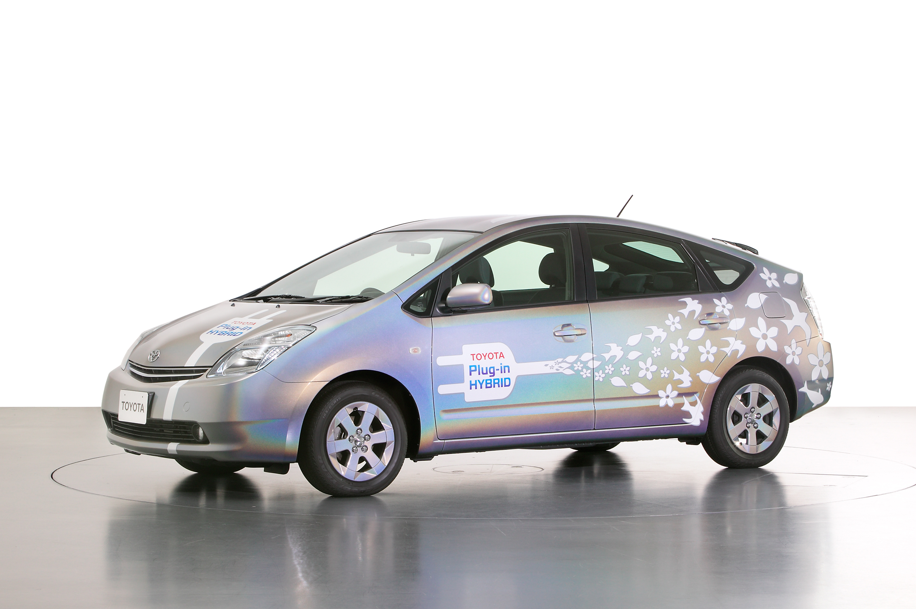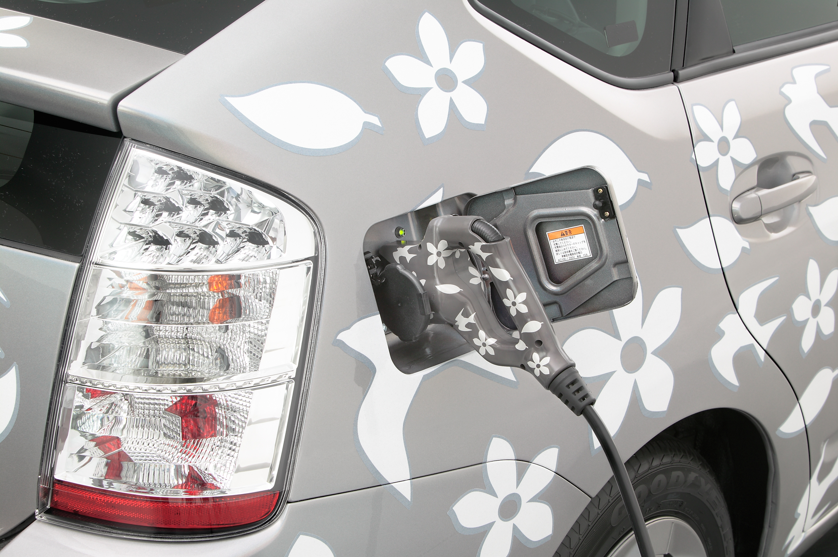
Overview of Plug-in Hybrid Vehicles Under Test

Characteristics of Plug-in Hybrid Vehicles
Control strategy (1): All-electric-type control strategy
(When in the plug-in running mode, the vehicle runs on motor only.)
Control strategy (2): Blended control strategy
(When in the plug-in running mode, the vehicle runs on combination of motor and engine.)
Battery State of Charge
(SOC) (%)
The vehicle runs by consuming electricity in batteries charged from an external source (and fuel).
Plug-in fuel economy (km/L)
Hybrid fuel economy (km/L)
The vehicle runs by consuming fuel such as gasoline, without using electricity from an external source.
Distance (km)
Plug-in range
Plug-in hybrid fuel economy (km/L)
(Representative fuel economy value)
Hybrid running
(Charge-sustaining mode)
27.0 km/l
12.6 km
2.62 kWh/recharge
40.5 km/l
Plug-in hybrid fuel economy
(based on the MLIT standards)
(Representative fuel economy value)
An example of the fuel economy indication on catalogs, etc.
54.0 km/l
13.0 km/l
4.95 km/kWh
(Basic performance values necessary for calculation of user fuel economy and evaluation of energy efficiency)
(Others: Specification values necessary for calculation of approximate annual electricity consumption rate, etc. and comparison of plug-in performance)
Hybrid fuel economy
(based on the MLIT standards)
Plug-in fuel economy
(based on the MLIT standards)
Plug-in range
(based on the MLIT standards)
Electric fuel economy
(based on the MLIT standards)
EV-equivalent cruise distance
Electricity consumption per recharge
(based on the MLIT standards)
Photos supplied by Toyota Motor Corporation

