UNITED  NATIONS |  | E
 | Economic and Social  Council | Distr.  GENERAL  ECE/TRANS/WP.29/GRE/2010/11  14 January 2010  Original: ENGLISH  ENGLISH AND FRENCH ONLY
ECONOMIC COMMISSION FOR EUROPE
INLAND TRANSPORT COMMITTEE
World Forum for Harmonization of Vehicle Regulations

Working Party on Lighting and Light-Signalling

Sixty-third session
Geneva, 29 - 31 March 2010
Item 3 of the provisional agenda

REGULATION No. 37
(Filament lamps)

Proposal for Supplement 36 to the 03 series of amendments to Regulation No. 37

Submitted by the expert from the Working Party "Brussels 1952" ∗/

The text reproduced below was prepared by the expert from the Working Party "Brussels 1952" (GTB) in order to introduce into Regulation No. 37 the provisions for a new category of filament light source H16B. The proposal is based on the current text of the Regulation. The modifications to the existing text, including draft Supplement 35 to the 03 series of amendments to the Regulation, are marked in bold characters.
A. PROPOSAL
Annex 1,

The list of categories of filament lamps, grouped, and their sheets, amend to read:

"
Group 1
Without general restrictions:
 | Category |  | Sheet number(s)
 | H1 |  | H1/1 to 3
 | ...
 | H15 |  | H15/1 to 5
 | H16 |  | H16/1 to 4
 | H16B |  | H16/1 to 4
 | H21W **/ |  | H21W/1 to 2
 | ...
"

Replace sheets H16/1 to 4 by new pages, to read (see next pages):

.
" CATEGORIES H16 and H16B Sheet H16/1
The drawings are intended only to illustrate the essential dimensions (in mm) of the filament lamp
Category H16
Figure 1 – Main drawing
Category H16B

1/ The reference plane is the plane formed by the underside of the bevelled lead-in flange of the cap.
Figure 2 - Maximum lamp outline 3/
2/ The reference axis is perpendicular to the reference plane and passing through the centre of the 19 mm cap diameter.
3/ Glass bulb and supports shall not exceed the envelope as indicated in Figure 2. The envelope is concentric to the reference axis.
4/ The light emitted shall be white or selective yellow.
5/ Notes concerning the filament diameter.
- No actual diameter restrictions apply but the objective for future developments is to have d max. = 0.9 mm.
- For the same manufacturer, the design diameter of standard (étalon) filament lamp and filament lamp of normal production shall be the same.

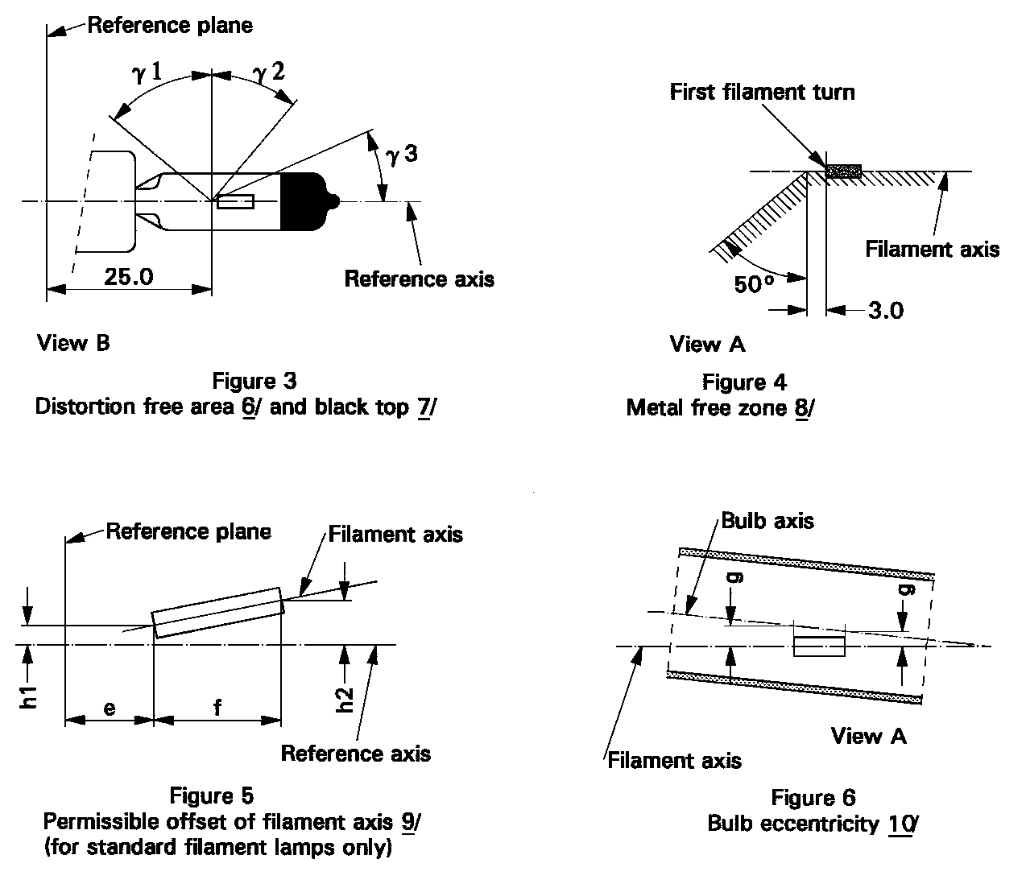 CATEGORIES H16 and H16B Sheet H16/2

6/ Glass bulb shall be optically distortion free within the angles γ1 and γ2. This requirement applies to the whole bulb circumference within the angles γ1 and γ2.
7/ The obscuration shall extend at least to angle γ3 and shall extend at least to the cylindrical part of the bulb on the whole bulb top circumference.
8/ The internal design of the lamp shall be such that stray light images and reflections are only located above the filament itself seen from the horizontal direction. (View A as indicated in Figure 1 on sheet H16/1). No metal parts other than filament turns shall be located in the shaded area as seen in Figure 4.
9/ The offset of the filament with respect to the reference axis is measured only in viewing directions A and B as shown in Figure 1 in sheet H16/1. The points to be measured are those where the projection of the outside of the end turns nearest to or furthest from the reference plane crosses the filament axis.
10/ Offset of filament in relation to bulb axis measured in two planes parallel to the reference plane where the projection of the outside of the end turns nearest to or furthest from the reference plane crosses the filament axis.

CATEGORIES H16 and H16B Sheet H16/3

Dimensions in mm |  |  |  | Filaments lamps of normal production | Standard  filament lamp
 |  |  |  | 12 V | 12 V
e 11/ |  |  |  | 25.0 12/ | 25.0 ± 0.1
f 11/ |  |  |  | 3.2 12/ | 3.2 ± 0.1
g |  |  |  | 0.5 min. | u.c.
h1 |  |  |  | 0 12/ | 0 ± 0.1
h2 |  |  |  | 0 12/ | 0 ± 0.15
γ1 |  |  |  | 50° min. | 50° min.
γ2 |  |  |  | 40° min. | 40° min.
γ3 |  |  |  | 30° min. | 30° min.
Cap: | H16: PGJ19-3  H16B: PGJY19-3 |  |  | in accordance with IEC Publication 60061 (sheet 7004-110-2)  in accordance with IEC Publication 60061 (sheet 7004-146-1)
ELECTRICAL AND PHOTOMETRIC CHARACTERISTICS
Rated  values |  |  | Volts | 12 | 12
 |  |  | Watts | 19 | 19
Test voltage |  |  | Volts | 13.2 | 13.2
Objective  values |  | Watts |  | 22 max. | 22 max.
 |  | Luminous flux |  | 500 +10% / -15 %
Reference luminous flux: 500 lm at approximately 13.2 V
Reference luminous flux: 550 lm at approximately 13.5 V

11/ The ends of the filament are defined as the points where, when the viewing direction is direction A as shown in Figure 1 on sheet H16/1, the projection of the outside of the end turns crosses the filament axis.
12/ To be checked by means of a "Box System"; sheet H16/4.

CATEGORIES H16 and H16B Sheet H16/4
Screen projection requirements

This test is used to determine, by checking whether the filament is correctly positioned relative to the reference axis and reference plane, whether a filament complies with the requirements.
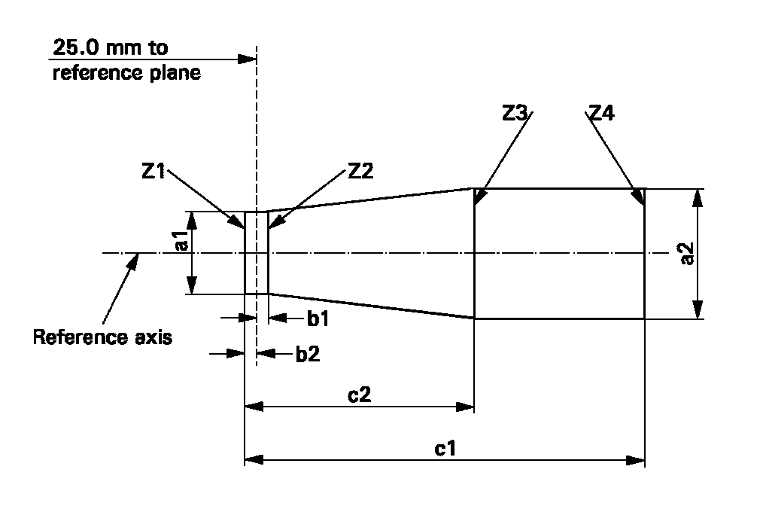

a1 | a2 | b1 | b2 | c1 | c2
d + 0.50 | d + 0.70 | 0.25 |  | 3.6 | 2.6

d = diameter of filament
The filament position is checked solely in directions A and B as shown on sheet H16/1, Figure 1.
The filament shall lie entirely within the limits shown.
The ends of the filament as defined on sheet H16/3, note 11/, shall lie between lines Z1 and Z2 and between Z3 and Z4."

B. JUSTIFICATION

A new light source based upon category H16 but equipped with a "one-touch" type cap is proposed as a new category H16B. This is a useful addition to Regulation No. 37, in the same way as the additions of H8B, H9B and H11B have proven beneficial. "One-touch" means that at insertion of the light source, mechanical and electrical contact is made during one action

- - - - -

/ In accordance with the programme of work of the Inland Transport Committee for 2006-2010 (ECE/TRANS/166/Add.1, programme activity 02.4), the World Forum will develop, harmonize and update Regulations in order to enhance performance of vehicles. The present document is submitted in conformity with that mandate.

