UN/SCEGHS/19/INF.6
Committee of Experts on the Transport of Dangerous Goods
and on the Globally Harmonized System of Classification
and Labelling of Chemicals
Sub-Committee of Experts on the Globally Harmonized
System of Classification and Labelling of Chemicals
Nineteenth session
Geneva, 30 June – 2 July 2010
Item 4 (d) of the provisional agenda
Implementation of the GHS: Miscellaneous

Dissemination of national GHS classification results via the OECD eChemPortal
Transmitted by the Organisation for the Economic Co-operation and Development (OECD)
I. Introduction
In October 2003, the OECD initiated an activity to develop and implement a globally accessible international repository for hazard data on existing chemicals. In a first phase a web application was build with simple functionalities and released in June 2007. It is called eChemPortal: The Global Portal to Information on Chemical Substances and it is accessible via the following URL: http://www.oecd.org/ehs/eChemPortal
The present document is meant as an information document to the UN Sub-Committee of Experts on the GHS. It outlines the functionalities of eChemPortal and its role in disseminating national/regional GHS classifications.
II. Outline of eChemPortal functionalities
eChemPortal is a public web site that offers free public access to information on properties of chemicals such as physical chemical properties, environmental fate and behaviour, ecotoxicity, toxicity.
eChemPortal allows for simultaneous search of chemicals contained in multiple databases and provides clearly described sources and quality of data. eChemPortal focuses on access to data from government chemical review programmes at national, regional, and international levels.
The functionalities of eChemPortal are outlined below. Annex 1 contains a few screenshots illustrating these functionalities.
After accessing the site at http://www.oecd.org/ehs/eChemPortal, the user can query the site by chemical identity, either by CAS Registry Number or by chemical name. eChemPortal has a large database of synonyms and trade names in multiple languages, so that in many cases the user can query by name in his/her national language. Approximately 1000 Chinese chemical names have recently been added to the eChemPortal index of chemical names.
For any specific chemical found in eChemPortal, the application provides a list of databases in which information for that chemical is stored and provides links with direct access to that information in the participating database.
The list of participating databases (as of April 2010) is attached as Annex 2.
III. National/regional GHS classifications in eChemPortal
eChemPortal disseminates data and assessments of the properties of chemicals. As part of this effort, eChemPortal is also disseminating national/regional GHS classifications. There are currently three participating databases that contain hazard classification information according to GHS:
(a) INCHEM by WHO/IPCS via its International Chemical Safety Cards
(b) The New Zealand Hazardous Substances and New Organisms Chemical Classification Information Database
(c) The Result of the GHS Classification by the Japanese Government
In addition, the participating database “European chemical substances information system (ESIS)” currently contains the classifications according to Annex I of Directive 67/548/EEC. These will be replaced by the corresponding GHS classifications according to Annex VI of Regulation (EC) 1272/2008 on classification, labelling and packaging of substances and mixtures (CLP). Eventually, EU GHS classifications will be made available via the REACH-IT dissemination site developed by the European Chemicals Agency and which will be a participating database in eChemPortal.
Examples of screenshots of GHS classifications from participating databases are displayed below.
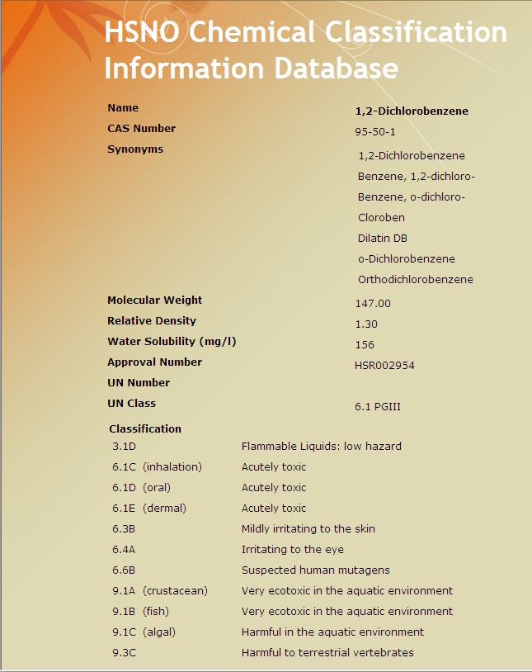
Figure 1: GHS classification of 1.2-Dichlorobenzene according to the New Zealand HSNO Classification Information Database.
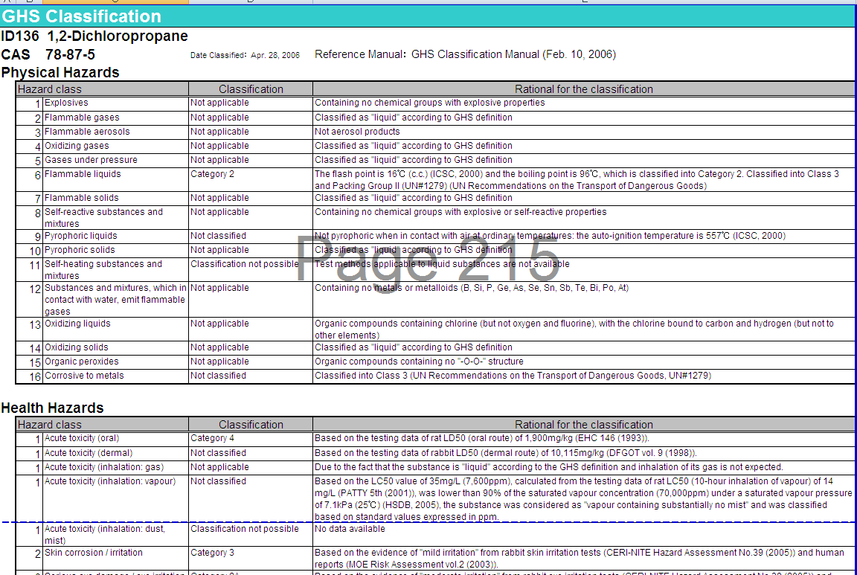
Figure 2: GHS classification of 1,2-dichlorobenzene according to The Result of the GHS Classification by the Japanese Government
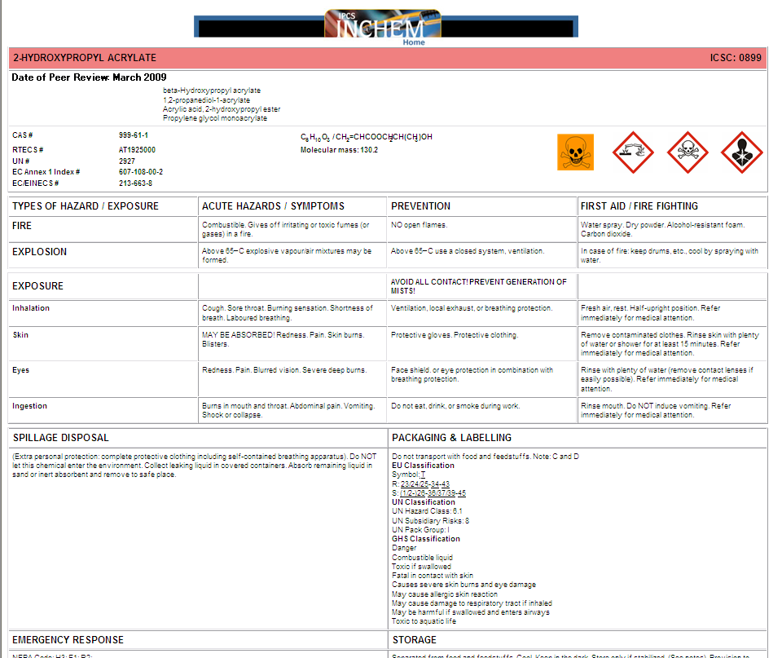
Figure 3: GHS classification of 2-hydroxypropyl acrylate according to the International Chemical Safety Card
IV. Ongoing developments
There are currently two types of ongoing developments of eChemPortal:
A. Adding new functionalities to the web application
Version 2.0 of eChemPortal is currently being built and expected to be released before the end of 2010. This version will allow users to query for properties in certain participating databases (i.e. those that are relational databases sustaining property searches themselves). In addition, it is foreseen to improve the user-friendliness of the application, to guide the user to the different types of products accessible through eChemPortal, e.g. hazard assessment, property dataset, GHS classification, etc.
B. Adding new participating databases
Independent of the version of eChemPortal, the OECD is continuously adding new participating databases and GHS classifications to eChemPortal.
V. How to participate?
OECD actively encourages participation of additional databases or collections of assessment documents or classifications. Countries having published GHS classifications on the internet can approach the OECD Secretariat to make their classifications also available via eChemPortal. The contact person is:
Sally de Marcellus
Environment, Health & Safety Division
OECD, Environment Directorate
2, rue André-Pascal
75775 Paris, Cedex 16, France
Tel: 33 1 45 24 19 42
Fax : 33 1 44 30 61 80
Email: sally.demarcellus@oecd.org
The OECD is responsible for the development of the Portal itself. The databases linked to eChemPortal are maintained by the participating organisations that create them. Each participating organisation is responsible for the software and hardware running locally and interfacing with the Portal. The data and information stored in each participating database are the responsibility of the data owner.
Annex 1
Illustration of functionalities of eChemPortal
Below the use of eChemPortal is illustrated with a few screenshots. The application is accessible via the following URL: http://www.oecd.org/ehs/eChemPortal
I. Search by chemical identity
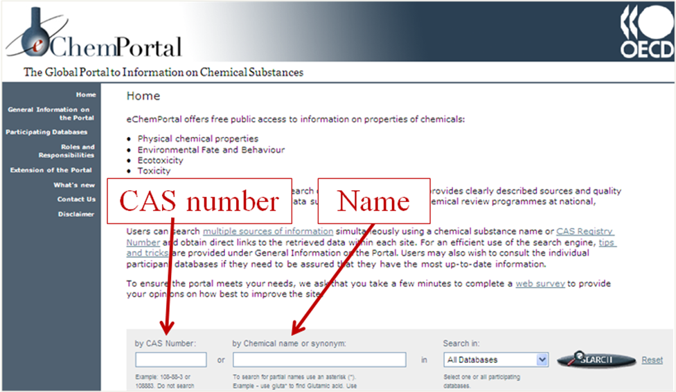
Figure A.1: The user can query for a substance by entering a CAS Number or a chemical name. eChemPortal contains a large database of synonyms and tradenames in multiple languages, so that users can search for names in their own language.
To access data for a specific substance, search "by CAS number" is recommended. Nevertheless, eChemPortal allows the user to search by chemical names and synonyms in several languages and even trade names (if available among in the list of synonyms). Please note that the main chemical name used by the Portal is usually the CAS Registry Name. Also, the search engine of eChemPortal permits searches of partial names and combinations of partial names. Below, a number of tips and tricks are outlined for an efficient use of the search facilities of eChemPortal. Please note that the number of chemicals referenced in eChemPortal is limited to those chemicals for which information exists in the participating databases. If you search for a chemical for which no information exists in the participating databases, you will receive the message "No Chemical Found".
A. Full name searches
Users can enter the full name of a chemical e.g. "Glutaric acid" and the search engine will retrieve the link for the entries of "Glutaric acid". The search engine will also retrieve other names containing the exact text "Glutaric acid", for example "Glutaric acid, ammonium salt" or "Glutaric acid, diisobutyl ester". Please note that this search is not case sensitive, i.e. the search string "glutaric acid" will also retrieve "Glutaric acid".
As indicated above, eChemPortal also recognises chemical names or synonyms in several languages. For example searching for the German or French name of "Glutaric acid" i.e. "Glutarsäure" resp. "acide glutarique" will retrieve the link for the entries of "Glutaric acid". Searching for the Japanese name of "Carbon tetrachloride" i.e. "四塩化炭素" will retrieve the link for the entries of "Carbon tetrachloride".
Please note that the length of the search string is limited to 36 characters and that you cannot use search strings containing the following characters: " ' , .
B. Partial name searches
In case you only have an incomplete name or want to find several substances which share parts of a name, you can enter partial names and logical operators.
The character "*" is used as a wildcard. For example the search string "*tert-butylphenol*" will retrieve all chemicals that have a name or synomym containing the characters "tert-butylphenol", e.g. "2,2'-Methylenebis(4-methyl-6-tert-butylphenol)monoacrylate", "2,4,6-tri-tert-butylphenol", "2,4-di-tert-butylphenol" etc. Or the search string "*tert-butylphenol" will retrieve all chemicals that have a name or synomym finishing with the characters "tert-butylphenol" e.g. "2,4,6-tri-tert-butylphenol", "2,4-di-tert-butylphenol", "2,6-di-tert-butylphenol" etc.
Furthermore the space character " " is used by the search engine as a logical AND operator by default. For example the search string "*tert-butyl* *methylbenzene*" will find names and synonyms containing both those search strings e.g. "1,3-Di-tert-butyl-2-hydroxy-5-methylbenzene", "1-tert-butyl-3,5-dimethylbenzene", "1-tert-butyl-4-methylbenzene", etc.
II. Search in multiple databases
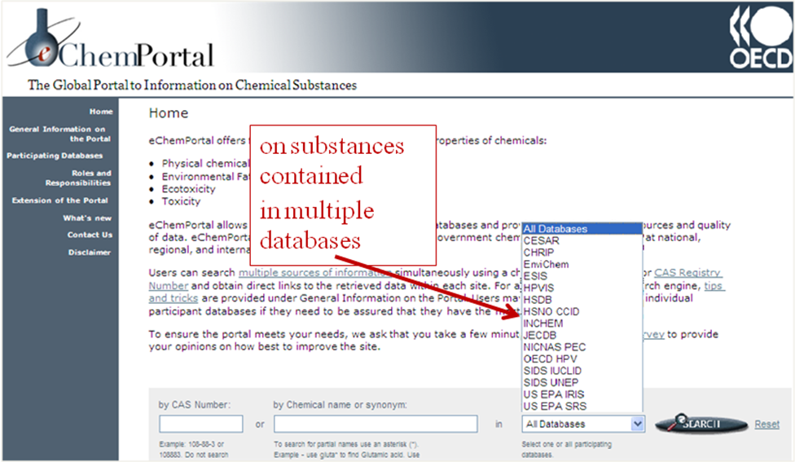
Figure A.2: The user can decide to query all participating data sources or to limit the search to a single data source.
III. Direct access to information in participating databases
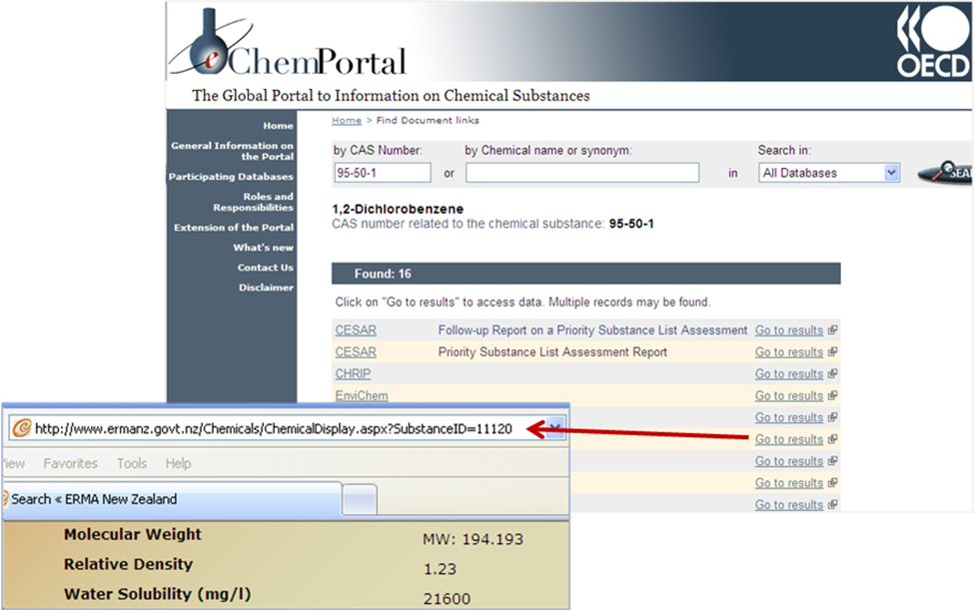
Figure A.3: For any specific chemical found in eChemPortal a list of participating data sources is provided in which information on that chemical can be found. The displayed URLs lead the user directly to the information on that chemical in the participating data sources.

Annex 2
Participating databases and collections of documents in eChemPortal (as of April 2010)
I. CESAR
Canada’s Existing Substances Assessment Repository
General information:
Canada’s Existing Substances Assessment Repository (CESAR) contains risk and other regulatory assessment reports on existing chemicals which include individual substances, groups or classes of chemicals, or effluents or wastes that are produced or imported in Canada or released into the Canadian environment. Under Canada’s Canadian Environmental Protection Act (CEPA), these assessments are aimed at determining whether or not these substances present or may present a risk to the environment and/or human health in a Canadian context. The assessments thus address common environmental and human health endpoints under four main themes: 1) the substance identity 2) the entry, fate and exposure characterization, 3) the effects characterization and 4) the risk characterization. A weight-of-evidence approach and precaution are applied throughout the assessment process. The risk assessment program under CEPA is conducted in collaboration by both Environment Canada and Health Canada. Assessments found within this repository are generally from two major initiatives from Canada: the Chemicals Management Plan, including the Challenge, as well as the Priority Substances List (PSL) Assessment Program. For more details about these two initiatives, please visit: http://www.ec.gc.ca/CEPARegistry/subs_list/Priority.cfm and http://www.chemicalsubstanceschimiques.gc.ca/en/index.html.
The risk and other regulatory assessments of existing chemicals in CESAR are useful to a diversity of audiences, including hazard assessors (in governments, industry or health organisations), educators, health and medical professionals, and the general public.
Hazard information:
The complexity and the depth of assessments can vary depending on the specific type of assessment. The repository includes PSL Assessments, which are usually more comprehensive, screening assessments such as those currently conducted under the Chemicals Management Plan, and other regulatory assessments.
The assessments in CESAR present information which may include:
- Substance identity
- Physical chemical properties,
- Use patterns and sources,
- Releases to the environment,
- Environmental fate,
- Persistence and bioaccumulation potential,
- Human health exposure characterization,
- Quantification of potential adverse effects on human health and/or non human organisms resulting from exposure to various concentrations, doses or intake rates of a substance through the exposure pathways identified in the exposure assessment,
- Risk characterization,
- Uncertainties,
- References.
Search capabilities:
No queries are possible on this site with the exception of a string search within the website. Alternatively, the repository identifies the name of the substance or group of substances and/or the Chemical Abstract Services (CAS) Number. Each assessment is available for download as a PDF file.
Maintenance:
Canada’s contribution to the eChemPortal is maintained by Environment Canada in collaboration with Health Canada.
Peer review:
The assessment reports contained within the repository are peer-reviewed by the governmental authorities and/or independent Canadian or international experts. Details of the peer-review process can be found in the introduction of each report. Additionally, under the Canadian Environmental Protection Act, the assessment reports are subject to a mandatory 60-day public comment period in which the assessments are published on the Departmental websites permitting comments from the public, stakeholders and concerned groups on the scientific findings.
Go to top
II. CHRIP
Information on Biodegradation and Bioconcentration of the Existing Chemical Substances in the Chemical Risk information platform (CHRIP)
General information:
The Chemical Risk Information Platform (CHRIP) provided by the National Institute of Technology and Evaluation (NITE) in Japan, contains information on the result of biodegradation and bioconcentration tests and the testing condition of Existing Chemical Substances under the Chemical Substances Control Law, according to the official bulletin of METI. This part of CHRIP is to be linked to the Portal.
For reference, other related information, such as related laws and regulations, physical-chemical properties, exposure information and risk assessment information are provided in a database called “TOTAL SEARCH SYSTEM” in CHRIP.
Hazard information:
There is information (data, its judgment and the date of the judgment) on biodegradation and bioconcentration and the testing conditions for target chemical substances.
Search capabilities:
The information is provided through a retrieval system based on chemical substance names, the MITI numbers in the official gazette, the CAS numbers and the data (BCF, BOD, etc) as well as lists of Existing Chemical Substances for which hazard assessments have been performed in Japan.
Maintenance:
National Institute of Technology and Evaluation (NITE)
Peer review:
The results of biodegradation and bioaccumulation tests in this database are reviewed by the Chemical Substances Council.
Go to top
III. EnviChem

Data Bank of Environmental Properties of Chemicals
General information:
EnviChem is a factual database containing test results data on ca. 3000 substances. EnviChem contains data related to the effects, fate and behaviour of chemicals in the environment. The most extensive part of the report is the toxicity data (LC/EC/IC50, LOEC, NOEC etc.) of substances to aquatic organisms. There are also data on physico-chemical properties, degradation, metabolism, bioaccumulation and the effects of the substance to terrestrial species eg. plants and mammals.
The content of EnviChem database is useful to environmental researchers, authorities, hazard assessors and companies dealing with chemicals. Correct interpretation of the core data requires some experience of environmental hazard assessment and chemistry.
Hazard information:
The original aim of EnviChem has been to facilitate the environmental hazard and risk assessment and the environmental classification of chemical substances. EnviChem contains information related to general information, physico-chemical properties, degradation, metabolism, bioaccumulation and the effects of the chemical to terrestrial and aquatic environment. The most extensive part of the report is the toxicity to aquatic organisms.
The data concerning individual substances in EnviChem is divided into the following topics:
- General information
- Physico-chemical properties
- Information about degradation
- Information about metabolism and bioaccumulation
- Effects on terrestrial ecosystem
- Effects on aquatic ecosystem
- References
A typical way of expressing acute lethal toxicity to fish is presented in the following way:
LC50 values to fishes, mg/l :
2.2 96 hr, Brachydanio rerio
0.9 96 hr, flow through, Pimephales promelas
2 96 hr, flow through, Pimephales promelas
0.46 96 hr, flow through, Ictalurus punctatus
0.9 96 hr, static, Lepomis macrochirus
0.35 96 hr, flow through, Perca flavescens
7.3 96 hr, static, Leuciscus idus
EU RA Report 2003
The list of Abbreviations and The list of species are available at the EnviChem www SEARCH-page.
Search capabilities:
Each dataset is always related to a substance. CAS-numbers or substance names can be used as search keys.
Maintenance:
The EnviChem database is maintained by Finnish Environment Institute (SYKE)
Mailing address:
SYKE-Chemicals Division
Box 140, Helsinki, 00251, Finland
Peer review:
The data in EnviChem has mainly been compiled from scientific publications, handbooks and databases in the field of ecotoxicology. The great majority of the content of EnviChem data has been stored to the data-base between the years 1985-2001. The scientific value of the compiled information has not regularly been assessed by the Finnish Environment Institute and the original published data may not have undergone any systematic peer-review process. The Finnish Environment Institute takes no responsibility for any faults/mistakes in the content of the database.
Go to top
IV. ESIS

European chemical substances information system (ESIS)
General information:
ESIS is an IT System which provides information on chemicals, related to:
- EINECS (European Inventory of Existing Commercial Substances),
- ELINCS (European List of Notified Chemical Substances),
- List of EU HPVCs (High Production Volume Chemicals) and LPVCs (Low Production Volume Chemicals) including the EU Producers & Importers
- IUCLID chemical datasets for ca. 2,500 HPVCs (data on toxicity, ecotoxicity and classification and labeling)
- EU Priority substance risk assessment reports
- Harmonised classification and labelling
Hazard information:
For High Production Volume Chemicals, the IUCLID data sets submitted by the manufacturers and importers in the context of Council Regulation (EEC) 793/93 can be downloaded as PDF files as well as IUCLID export files. These contain summaries of available studies on hazard of chemicals for numerous endpoints.
Search capabilities:
For substances listed in EINECS, the site can be queried for chemicals by CAS number, EC number, substance name and molecular formula. Substances listed in ELINCS can also be queried by trade name and registration number.
Queries for hazardous properties are not possible. The IUCLID export files can be downloaded and imported into a local IUCLID installation. Extensive query functions on chemical identifiers and hazard endpoints can be performed with the IUCLID Software.
Maintenance:
European Commission (European Chemicals Bureau)
Peer review:
The EU Priority substance risk assessment reports and the harmonised classification and labelling have undergone a peer-review by government authorities.
Go to top
V. GHS-J
The result of the GHS classification by the Japanese Government
General information:
The Ministry of Economy, Trade and Industry (METI), Ministry of Health, Labour and Welfare (MHLW), and Ministry of the Environment (MOE) classified approximately 1,500 chemicals in FY2005-2006, based on the GHS Classification Manual and Technical Guidance, which are available on the website at: http://www.safe.nite.go.jp/english/ghs_index.html#manual, aiming to help industries to prepare labels and SDS of their products in accordance with the GHS.
These results are not legally binding and are just for reference. There is a possibility of revision of the results on the basis of new information.
Hazard information:
This database contains physical hazards, health hazards and environmental hazards. But there is a lack of environmental hazard information for some of the results.
Search capabilities:
No queries are possible on this site.
The files are provided in EXCEL format.
Maintenance:
National Institute of Technology and Evaluation (NITE)
Peer review:
Peer-review by governmental authorities (The classification results are not legally binding and may change due to new data.)
Go to top
VI. HPVIS

High Production Volume Information System (HPVIS)
General information:
The USEPA High Production Volume Information System (HPVIS) provides access to select health and environmental effects information on chemicals that are produced or imported into the US in quantities of 1 million pounds or more each year. Information in this database is submitted through EPA’s High Production Volume (HPV) Challenge Program. Sponsor (company/consortium) information, test plans, robust summaries, and EPA and public comments are available in the HPVIS. In addition, HPVIS provides access to EPA Hazard Characterizations and other supporting documents for selected chemicals and chemical categories. As of October, 2009, HPVIS contains information on 1183 chemical substances reported in 444 submissions, representing 295 single chemical and 149 chemical category submissions. Some chemicals are reported in multiple submissions.
Hazard information:
Sponsors follow the Screening Information Data Set (SIDS), developed by the Organisation for Economic Cooperation and Development when submitting data to the HPVIS. HPVIS submissions contain hazard data on up to 50 endpoints organized into four disciplines: physical/chemical properties, environmental fate and pathways, ecotoxicity, and mammalian health effects. Information on use and exposure is also available in the database, if provided by sponsors.
Search capabilities:
HPVIS allows users to search for robust summary information, test plans and new data on high production volume chemicals, as well as for Hazard Characterizations and supporting documents for selected chemicals as they are developed. Searches are provided for Chemical Name or CAS Number, Category Name, Submission Name, Sponsor/Consortium Name, and Submitter Name. Users can use a query tool to create a special report for specific data elements and can also create an endpoint results report and a matrix of individual chemical members of a category to assist in performing a “read-across” analysis for those chemicals in a category for which a result was not reported for a specific endpoint.
Maintenance:
HPVIS is maintained by the United States Environmental Protection Agency.
Peer review:
HPVIS data have been entered from the robust summaries and test plans as submitted by the HPV Challenge Program sponsors. This self-reported information is also available on the USEPA HPV website at http://www.epa.gov/hpv. EPA has verified the data entered into the HPVIS to ensure that they are consistent with the information that was submitted under the HPV Challenge Program. Industry sponsors also have the opportunity to verify their submitted data in the system. HPVIS contains both initial and final submissions. EPA and public comments on the adequacy of the initial submission by the sponsor are provided as attachments to the submissions.
EPA is conducting its own review of the quality of each data submission. Each data review is being conducted according to established HPV Challenge Program guidelines and EPA risk assessment guidance. Data submitted to the HPV Challenge Program are also being reviewed and incorporated into the Agency’s enhanced existing chemicals management activities (http://www.epa.gov/oppt/existingchemicals/pubs/enhanchems.html).
Go to top
VII. HSDB
Hazardous Substance Data Bank
General information:
HSDB is a toxicology file focusing on the toxicology and environmental fate of potentially hazardous chemicals. The file contains over 5,000 records with data on human health effects, animal toxicity studies, standards and regulations, chemical/physical properties, pharmacology, emergency medical treatment, safety and handling, environmental exposure, and more.
HSDB is a valuable resource to professionals and the general public due to its comprehensiveness. HSDB allows users to access various types of data in one file. http://www.nlm.nih.gov/pubs/factsheets/hsdbfs.html
http://toxnet.nlm.nih.gov/help/HSDBhelp.htm
Hazard information:
HSDB records include the following hazard information:
(a) Human health effects
(i) Acute
(ii) Chronic
(iii) Reproductive
(iv) Carcinogenicity
(b) Physical/chemical properties
(i) Molecular formula and weight
(ii) Color/form
(iii) Odor
(iv) Taste
(v) Boiling/melting point
(vi) Corrosivity
(vii) Density/specific gravity
(viii) Dissociation constants
(ix) Heat of combustion/vaporization
(x) Solubility
(xi) Vapor pressure
(c) Occupational exposure standards and regulations
(i) PELs
(ii) TLVs
(iii) BEIs
(iv) IDLHs
(v) ERPGs
(d) Chemical safety and handling
(i) U.S. DOT guidelines
(ii) NFPA classification
(iii) Skin, eye, and respiratory irritations
(iv) Reactivities, decomposition, and polymerization
(v) Other hazardous reactions
(vi) Protective equipment/clothing
(vii) Preventive measures
(viii) Storage, cleanup, and disposal methods
This list of hazard information is a summary. HSDB contains additional hazard information in these and other categories.
Search capabilities:
HSDB is searchable by chemical name(s), synonym(s), CAS registry number(s), and/or any combination of words and/or phrase(s) such as: acetone, 107-44-8, skin tumors in mice, or biomarkers. Users may search with Boolean operators: OR, AND, NOT to limit search criteria. HSDB users may also limit searches to specific data fields such as: human health effects, metabolism, manufacturing/use, and environmental fate and exposure. The HSDB utilizes relevancy ranking based on the search terms when displaying search results to retrieve the most pertinent results for users. See http://toxnet.nlm.nih.gov/help/HSDBhelp.htm for a more detailed explanation of search capabilities.
Maintenance:
The HSDB is maintained and updated on a continuous basis as new information becomes available. These updates are done with multiple quality control measures via an electronic file maintenance system. In addition to this continuous maintenance, HSDB records undergo a peer-review process.
Peer review:
http://toxnet.nlm.nih.gov/cgi-bin/sis/htmlgen?DescSRP.htm
Go to top
VIII. HSNO CCID

New Zealand Hazardous Substances and New Organisms Chemical Classification Information Database
General information:
The CCID is a database of chemicals classified by ERMA New Zealand in accordance with the classification criteria specified in the Hazardous Substances (Classification) Regulations 2001. These regulations, under the New Zealand Hazardous Substances and New Organisms Act (HSNO), are based on the UN Globally Harmonised System for Classification and Labelling of Chemicals (GHS).
Hazard information:
Classifications are provided for both the physical hazards (explosiveness, flammability, oxidising capacity, metal corrosiveness) and biological hazards (toxicity, biological corrosiveness and ecotoxicity) of a chemical in accordance with the GHS based HSNO classification criteria.
The HSNO hazard classifications, specified in the Hazardous Substances (Classification) Regulations 2001, are represented by numbers (identifying the class and subclass of hazard), a letter (ranking the hazard) and an associated hazard phrase. For example: 3.1C Flammable liquids: Medium hazard. In general, these HSNO classifications correlate to GHS classification categories.
Search capabilities:
The CCID database can be searched by CAS number or chemical name.
Maintenance:
ERMA New Zealand
Peer review:
Some substances have been classified against the criteria from data obtained from international peer reviewed sources. In other cases substances have been classified by conversion from assigned R phrases. The assignment of classifications has been internally peer reviewed within ERMA New Zealand.
Go to top
IX. INCHEM

Chemical Safety Information from Intergovernmental Organizations - INCHEM
General information:
INCHEM provides a single consolidated collection of chemical-safety information from intergovernmental organizations; and rapid electronic access to information on chemicals used throughout the world and which may occur as contaminants in the environment and food. The collection consists of over 8000 documents in full-text format which are available free-of-charge. INCHEM is also available on a CD-ROM for those with poor internet connections.
Hazard information:
The collection includes the established series of the reports of the WHO/FAO Joint Meeting on Pesticide Residues (JMPR), the WHO/FAO Joint Expert Committee on Food Additives (JECFA), IPCS Environmental Health Criteria (EHC), IPCS Concise International Chemical Assessment Documents (CICADs), International Agency of Research on Cancer (IARC) Summaries and Evaluations, IPCS International Safety Cards (ICSC) and IPCS Poisons Information Monographs.
Search capabilities:
INCHEM allows simultaneous free-text searching across all available documents e.g. searching words in titles of documents and/or signs and symptoms of exposure. It also allows searching by chemical name, synonyms and CAS Registry Number. Synonyms used in different languages are searchable.
Maintenance:
INCHEM is maintained collaboratively by the International Programme on Chemical Safety (IPCS) at the World Health Organization and the Canadian Centre for Occupational Health and Safety (CCOHS). INCHEM was developed in the context of the Inter-Organization Programme for the Sound Management of Chemicals (IOMC) with the participation of the Food and Agriculture Organization of the United Nations (FAO); the International Labour Organization (ILO); the Organisation for Economic Cooperation and Development (OECD); the United Nations Institute for Training and Development (UNITAR) and the World Health Organization (WHO).
Peer review:
International peer review is an essential part of the process of preparing the series of intergovernmental reports included in INCHEM. This peer review includes review by government agencies and the expert committees such as those of the WHO and FAO.
Go to top
X. JECDB
Japan Existing Chemical Data Base
General information:
The Japan Existing Chemical Data Base makes available the toxicity test reports from Japan's existing chemicals safety programme. Each report consists of the nomenclature of the chemical, abstracts and summarized data from the studies in English. Individual study reports are available in Japanese.
Hazard information:
For each chemical, results are compiled from several studies, including, in most cases, a single dose toxicity test, a 28-day repeat dose toxicity test, a reproductive/developmental toxicity test and mutagenicity tests.
Search capabilities:
A search is available by CAS Registry Number, by Name, by Toxicity test. The user may also browse a list of chemical substances tested and a list of toxicity test reports.
Maintenance:
The database is maintained by the Japanese Ministry of Health, Labour and Welfare.
Peer review:
The study results are reviewed by scientists from the National Institute of Heath Sciences and other institutes.
Go to top
XI. NICNAS PEC

Australian National Industrial Chemicals Notification and Assessment Scheme (NICNAS) Priority Existing Chemical Assessment Reports
General information:
Reports on chemicals assessed as Priority Existing Chemicals under Australia’s National Industrial Chemicals Notification and Assessment Scheme (NICNAS). The scope of the assessments vary and include full risk assessments (covering risks to workers and/or the public and/or the environment), as well as assessments that are not risk assessments but which focus on particular aspects e.g. manufacture, handling, storage, uses, human or environmental exposure in a specific geographical area or in specified circumstances, toxicity/hazards of a chemical.
The reports are comprehensive and provide information on uses and exposure that would be useful to other government or industry hazard assessors and to the general public.
Hazard information:
Full risk assessment reports usually contain information on chemical/physical properties, uses, exposure, kinetics and metabolism, effects on experimental animals and in vitro test systems, human health effects, environmental release, fate and effects, and exposure. They include a human health classification, a section on human and environmental risk characterisation, risk management, and recommendations for safe use. Reports published since 2003 include an appendix containing classification of the chemical under the Globally Harmonised System for Hazard Classification and Communication.
Search capabilities:
The reports are in PDF form and can be searched via the Adobe Acrobat search functions.
Maintenance:
NICNAS
Peer review:
Reports are peer-reviewed by NICNAS and the Australian Government Department of Environment and Water Resources. Some reports or sections of reports are peer-reviewed by independent experts in Australia or overseas. Details of the peer-review process for each report can be found in the Introduction to the report.
Go to top
XII. OECD HPV

Organisation for Economic Cooperation and Development (OECD) Existing Chemicals Database
General information:
The status of all HPV chemicals within the process of investigation in the OECD HPV Chemicals Programme is recorded in the OECD Existing Chemicals Database. It contains the list of all OECD HPV chemicals together with any annotations on each chemical which has been provided by Member countries to the Secretariat. Each chemical is identified as to exactly which stage it is at in the assessment process, and for those chemicals which have been assessed, a link to internet pages where completed assessments can be downloaded is provided.
The IUCLID software is the preferred tool for entering data and developing a SIDS Dossier for High Production Volume Chemicals in the OECD HPV Chemicals Programme. For those SIDS Dossiers which were elaborated with the IUCLID software, the IUCLID files (in export format) are also available on this site. These export files can be downloaded and then imported into a local IUCLID installation.
Hazard information:
The database does not contain structured information on hazards. It contains – for those substances which have been assessed within the OECD HPV Chemicals Programme - a summary of the conclusions on the hazards as well as a link to the full SIDS Initial Assessment Report.
Furthermore, links to internet pages where completed assessments can be downloaded are included for each entry.
For those SIDS Dossiers which were elaborated with the IUCLID software, the IUCLID export file can be downloaded from this site containing Robust Study Summaries of all the key studies used in the SIDS Initial Assessment Reports.
Search capabilities:
This database can be queried for chemicals by name, synonym, CAS number as well as their status within the OECD HPV Chemicals Programme.
Maintenance:
OECD Secretariat in collaboration with OECD member countries
Peer review:
The information on the status of chemicals within the OECD HPV Chemicals Programme is continuously updated by the OECD Secretariat and verified by OECD member countries.
For those substances which have been assessed within the OECD HPV Chemicals Programme, the available summary of the conclusions on the hazards has been reviewed by experts in member countries, industry and environmental NGOs and endorsed by all OECD member countries.
Go to top
XIII. SIDS UNEP

OECD Initial Assessment Reports for HPV Chemicals including Screening Information Data Sets (SIDS) as maintained by United Nations Environment Programme (UNEP) Chemicals
General information:
This site presents the OECD Initial Assessment Reports that have been processed through the OECD HPV Chemicals Programme.
Hazard information:
The reports are initial hazard assessments and contain hazard information and conclusions on numerous endpoints. All reports are available as PDF files.
Search capabilities:
This site can be queried for chemicals by CAS number. Reports are also listed according to their chemical name. Queries for properties across all posted reports are not possible.
Maintenance:
UNEP Chemicals
Peer review:
The OECD initial assessments published by UNEP Chemicals have been reviewed by experts in OECD member countries, industry and environmental NGOs and endorsed by all OECD member countries.
Go to top
XIV. UK CCRMP Outputs
UK Coordinated Chemicals Risk Management Programme Publications
General information:
Risk Evaluation Reports contain full risk assessment for the environment, including human health hazard assessment, based on all available valid data.
In addition, two reports look at flame retardant chemicals and alkylphenols with a view to prioritisation for environmental risk assessment. The former focuses on environmental properties and hazards of known and possible chemicals used as flame retardants, while the latter addresses environmental properties and hazards of possible replacement chemicals for nonylphenol.
Hazard information:
All reports contain measured and predicted hazard information for the assessed substances. Data is assessed for validity, and the most reliable data is used in the reports.
Search capabilities:
There are unfortunately no search capabilities other than those available within the program used to read each document (the “find” function).
Maintenance:
Reports can be found on the Environment Agency of England and Wales website, and are published as final reports. They are not updated.
Peer review:
The reviews have undergone peer review by government authorities and consultation with Industry, and many have undergone external/international peer review with authorities and academia.
Go to top
XV. US EPA IRIS
United States Environmental Protection Agency Integrated Risk Information System
General information:
US EPA IRIS (United States Environmental Protection Agency Integrated Risk Information System) is a compilation of electronic reports on specific substances found in the environment and their potential to cause human health effects. IRIS was initially developed for EPA staff in response to a growing demand for consistent information on substances for use in risk assessments, decision-making and regulatory activities. The information in IRIS is intended for those without extensive training in toxicology, but with some knowledge of health sciences.
Hazard information:
Hazard information: The IRIS Summary and, where provided, the Toxicological Review, provide a hazard assessment of all cancer and noncancer endpoints identified in the scientific literature.
The quantitative dose-response information in IRIS, the oral reference doses (RfDs), inhalation reference concentrations (RfCs), cancer oral slope factors, and cancer inhalation unit risks, when combined with problem-specific exposure information, can be used to develop risk assessments, which serve as the scientific input to risk management decisions.
The RfD and RfC are estimates (with uncertainty spanning perhaps an order of magnitude of daily exposures to the human population (including sensitive subgroups) that are likely to be without appreciable risk of deleterious effects during a lifetime. RfDs and RfCs are based on an assumption of lifetime exposure and may not be appropriately applied to less-than-lifetime exposure situations.
The carcinogenicity assessment includes a weight-of-evidence judgement of the likelihood that the agent is a human carcinogen. Quantitative estimates of risk from oral and inhalation exposures may be derived if the data are sufficient. The oral slope factor is a plausible upper bound estimate of risk per mg/kg-day of oral exposure. The inhalation unit risk is a plausible upper bound estimate of risk per µg/m³ air breathed.
Search capabilities:
The database can be searched by keyword, substance name, substance CAS No., critical effect, tumor type, toxicity value, cancer weight-of-evidence descriptor, and uncertainty factor. These search capabilities can be found at http://www.epa.gov/ncea/iris/search_keyword.htm. Users can also compare values of a user-selected set of substances at http://www.epa.gov/ncea/iris/search_keyword.htm.
Search capabilities:
Maintenance: The IRIS staff and NCEA webmaster are responsible for the maintenance of the IRIS database. The database is updated on an ongoing basis.
Peer review:
The draft IRIS assessment is subject to an extensive review process. Peer review for each assessment is conducted in accordance with Agency guidance on peer review.
Internal Peer Consultation. Internal (EPA) peer reviewers are selected to provide detailed scientific review of the draft assessment.
Agency Review. The draft assessment is reviewed by a standing group of senior health scientists representing EPA’s Offices and Regions and by selected senior health scientists with scientific expertise relevant to the substance under review. The purpose of the IRIS Agency Review is to provide expert internal peer review and Agency-wide consultation to ORD on whether the draft assessment is ready for external peer review and what issues should be raised.
Interagency Review. The revised draft assessment is distributed through the Office of Management and Budget for review by other federal agencies.
External Peer Review. EPA obtains external peer review, typically via a panel meeting that is open to the public. At this time, the draft assessment is posted on the internet for public comment.
Go to top
XVI. US EPA SRS
United States Environmental Protection Agency Substance Registry Services
General information:
The Substance Registry Services (SRS) is the Environmental Protection Agency's (EPA) central system for information about regulated and monitored substances. It is the portal for discovering chemical information at EPA. The system provides a common basis for identification of chemicals, biological organisms, and other substances listed in EPA regulations and data systems, as well as substances of interest from other sources, such as publications.
For each chemical, the SRS provides basic core metadata, including Chemical Abstract Service (CAS) names and CAS numbers. SRS identifies an EPA standardized name for each chemical (e.g., “Toluene” for the chemical with CAS name “Benzene, methyl-”). SRS also includes the molecular weights, molecular formulae, former CAS numbers and descriptions (when available).
A second section of each SRS substance record provides statutory or list information on each chemical. For each US environmental statute, the SRS identifies the list of chemicals named on that statute and the synonym used. For each US EPA data system, the SRS identifies the list of chemicals in that data system and the synonym used. The SRS also has chemical lists for external organizations, such as lists maintained by other US federal agencies or lists maintained by international organizations.
A third section provides links, if available, from the SRS to other sites for additional information. These links might be to other substance registry systems, such as those managed by other federal agencies or international organizations, or to fact sheets about the chemical.
Hazard information:
Hazard information is not available in the SRS. However, the SRS provides links, when known, from each SRS substance record to external sites and fact sheets. These external sites may be for EPA programs, other U.S. agencies, or international organizations.
Search capabilities:
The SRS can be searched by name (Containing, Exact match, or Begins with), CAS number or other identifier, molecular weight, molecular formula, or list (e.g., the HPVIS list). Searches can be tailored, such as a search for chemicals that have a synonym containing the word “cadmium” that is on the HPVIS list. An Advance Search allows users to search using Boolean logic, for example searching for substances that are found on an intersection of two or more lists.
Maintenance:
United States Environmental Protection Agency (US EPA).
Peer review:
Core metadata (e.g., CAS name, CAS number, molecular weight) for a majority of the chemicals is made available from a program office at the US EPA that obtains the data from the Chemical Abstract Service. Data quality for core metadata for other chemicals is reviewed on a periodic basis. Programmatic information (e.g., the synonym used by a particular EPA program office) is managed within the SRS by designated stewards from that program office.

