UN/SCETDG/37/INF.41
Committee of Experts on the Transport of Dangerous Goods
and on the Globally Harmonized System of Classification
and Labelling of Chemicals
Sub-Committee of Experts on the Transport of Dangerous Goods 8 June 2010
Thirty-seventh session
Geneva, 21–30 June 2010
Item 2. of the provisional agenda
Explosives and related matters

On the use of the minimum burning pressure test as an alternative Series 8 Test
Transmitted by the expert from Canada
Introduction
1. There is considerable dissatisfaction with the current Series 8 tests for ANEs. The Dewar (8(a)) and Gap (8(b)) tests address the hazards posed by thermal runaway and shock initiation, respectively, but they do not address the hazards posed by exposure of ANEs to fire. The Vented Pipe Test (8(d)), which attempts to assess fire hazards, requires large test facilities due to the possibility of explosion of the large mass of sample tested (60 kg) and its repeatability is poor. The Koenen test (8(c)) also attempts to assess fire hazards but it does not work well for ANEs, in part because the orifice often becomes blocked with sample during testing. Thus, a repeatable, small-scale test that could asses the hazards posed by exposure of ANEs to fire is highly desirable. To satisfy this need, it is proposed that the Explosives Working Group considers the use of the minimum burning pressure test.
2. It has been well established that sustained combustion in ammonium nitrate water-based emulsions can only happen if the ambient pressure is above some minimum threshold value, usually referred to as the ‘minimum burning pressure’ (MBP). The Canadian Explosives Research Laboratory and an industrial partner, Orica Mining Services, have worked in partnership since 2004 to develop a small-scale test that provides repeatable and conservative estimates of the MBP. The test method has been significantly improved over the years and is presently in state where it can be readily adopted. MBP measurements are included in new draft standards for the classification and authorization for high explosives in Canada [1].
3. The MBP of a wide variety of ANE formulations have been measured. The results show a clear potential to differentiate among ANEs that would be typical precursors for “bulk” emulsion explosives and those that would be ANEs more typical of precursors to “packaged” emulsion explosives. Non-sensitized “bulk” emulsions passing Series 8 can be included in UN 3375 and Division 5.1 (1.5 in Canada). “Bulk” ANEs typically have MBPs in the range 6 - 12 MPa (855 to 1725 psig), while “packaged” ANEs have MBPs in the range 0.45 – 3 MPa (50 – 420 psig).
4. The potential utility of the MBP test within Series 8 is due to the fact that, ANEs having a high MBP are harder to ignite, support combustion less readily and show a lower propensity for deflagration-to-detonation behaviour than ANEs having a low MBP. On a more pragmatic basis, the test differentiates between those materials that have historically been considered safe to transport in bulk and those that have not.
Experimental
MBP Test Procedure
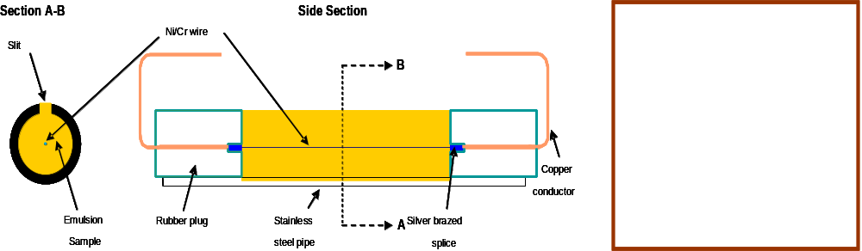
5. To perform a MBP experiment, a small quantity of explosive is enclosed in a short cylinder (the test cell, see Figure 1), with a piece of nichrome wire (so-called ‘hot-wire’) embedded into the sample, along the axis of the cylinder. The wire serves as the ignition source. It is spliced to conductive copper leg wires. The test cell is loaded horizontally into a high-pressure vessel (see Figure 2) and the leg wires are connected to electrodes that extend through the vessel’s lid.

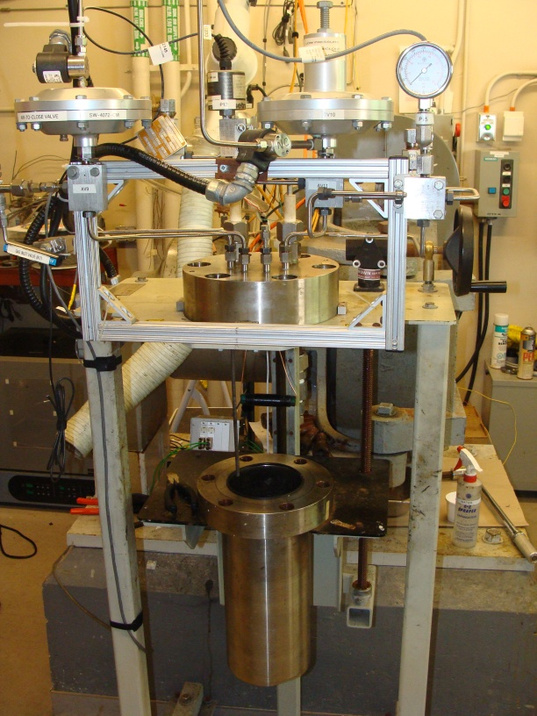
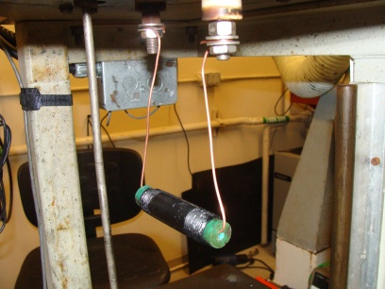
Figure 1: Schematic and picture of an empty test cell.
Figure 2: Open 4-L pressure vessel with suspended test cell and instrumentation (left) and close-up of a test cell suspended by copper leg wires connected to electrodes (right).
6. The initial test pressure is selected based on an estimate of the expected MBP. The vessel is pressurized with argon and the sample is ignited by passing a current of 10.5 A through the hot-wire. The pressure is recorded throughout the experiment (See Figure 3).
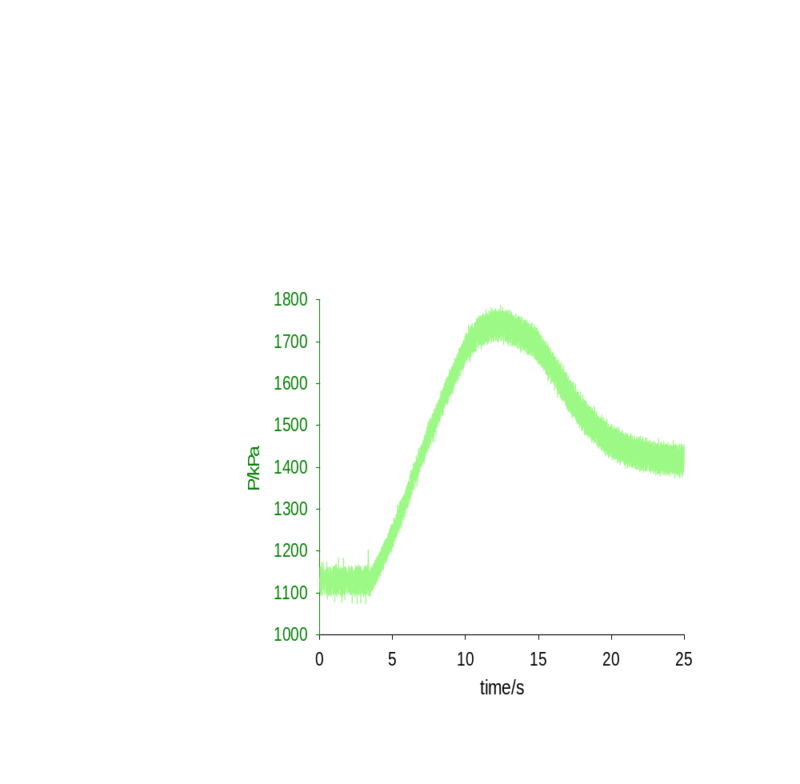
Figure 3: Pressure record of a ‘Go’ event.
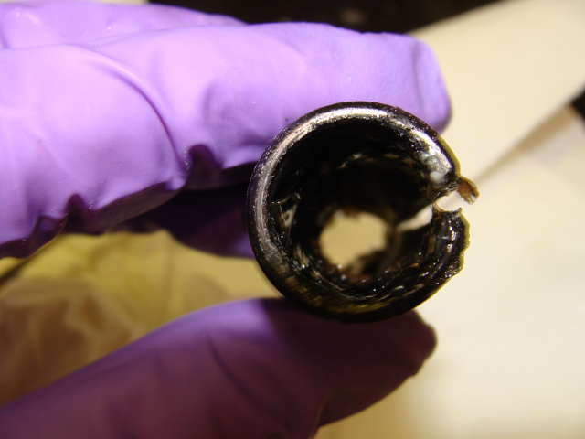
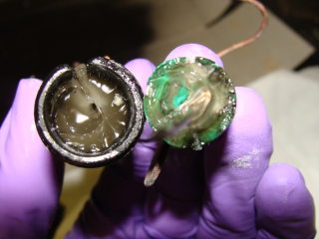
7. If a fast deflagration is observed and the sample burns completely, the experiment is deemed to be a ‘Go’ and the next experiment will be performed at a lower pressure (Fig. 4, left). Otherwise, the experiment is deemed to be a ‘No-Go’ (Fig. 4, right) and the next experiment will be performed at a higher pressure.
Figure 4: Residue left in a test cell after a ‘Go’ (left) and ‘No-go’ (right) event.
8. The test procedure is repeated with gradually decreasing pressure increments (or decrements) until the MBP has been determined to the desired degree of precision. In general, 10 – 12 experiments have been used to obtain each MBP measurement reported in this paper. One person can perform four to six experiments per day; thus, one person performing approximately two days of experiments is required to obtain a detailed MBP measurement. However, a simple go/no-go measurement at a fixed pressure using three measurements would take one person less than one day.
Additional Test Details
9. The horizontal test cells are fashioned from commercially available steel nipples that are 7.6 cm in length and have an inside diameter of 1.6 cm. Each test cell has a 3-mm wide slit machined along the axis to allow combustion gases to escape during testing. Although the ends of the nipples are threaded to accommodate caps, the cell ends are each plugged with a No. 0 neoprene stopper which has been reamed out to accommodate the copper conductor and splice connector of the hot wire ignition assembly. A filled cell typically contains only 20 g of ANE.
10. Our MBP determinations are currently performed in either a 4-L and/or 19-L pressure vessel, but the test results have been found to be independent of the size of the pressure vessel [2]. Power is delivered to the hot-wire using a DC power supply operating in constant current (i.e., variable voltage) mode.
11. Based on our research, there are no advantages to using larger sample sizes, test vessels larger than 4-L, or preheating the sample [3]. Both the ignition source power and geometry selected have been shown to be optimal [4]. The horizontal orientation of the cell has been found to produce more precise MBP measurements and simplify data interpretation for low-viscosity ANEs than when the test is conducted with a vertically-oriented cell [3].
Emulsion preparation and formulation
12. It is usually not possible to purchase a range of ANEs where one component, such as the water content, has been systematically varied. The nature of commercial emulsion formulations is such that if one variable is changed, others are also changed to re-optimize the overall formulation. As a result, for the purposes of our research work, it was necessary to set up a small-scale emulsion manufacturing facility at CERL. The set-up consists of a Hobart mixer with a heated bowl. Typical batch sizes are 2 kg. The set-up is described in detail elsewhere [4]. The appearance of typical products before the addition of aluminum, prills, or glass microballoons, is shown in Figure 5. Note that, for the purposes of classifying product for transport, the material would be tested as received, so emulsion manufacturing facilities would not be required.
13. Over 30 formulations have been tested. Due to the proprietary nature of the formulations, only generic formulations are provided here. As shown in Table 1, many formulation parameters were varied: the water content of the formulation, the composition of the oxidizer solutions (ammonium nitrate and/or sodium nitrate and/or sodium perchlorate), and the oil phase (surfactants/oil mixtures and/or waxes) used. Some formulations contained solid phase chemical additives such aluminum or ammonium nitrate prills, while others contained density modifiers/void sensitizers such as glass or plastic microspheres.

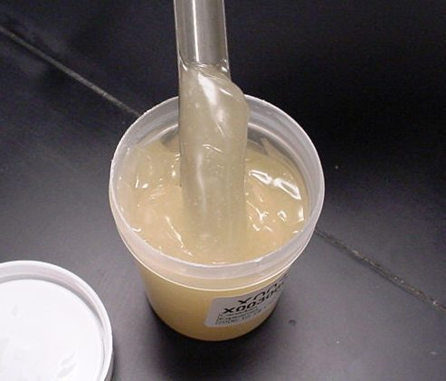
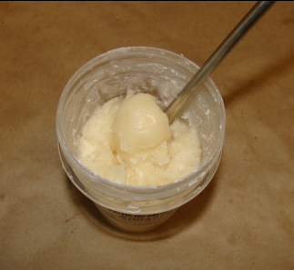
Figure 5: Typical appearance of a “bulk” ANE, left, and a “packaged” ANE, right
Table 1: Emulsion Formulations Tested
Group | Oxidizer  (AN/SN/SP range) | Oil Phase | Additives | Water Content Range | Product  Type
A | AN  SN (9 - 11%) | Oil  Wax  Surfactant | AN Prills  Aluminum  Plastic MS  Glass MS | 7 – 11% | Packaged
B | AN  SN (0 - 6%)  SP (6 – 10%) | Oil  Wax  Surfactant | Prill  Aluminum  Plastic MS  Glass MS | 8 – 10% | Packaged
C | AN  SN (10-11%) | Oil  Wax  Surfactant |  | 9 - 18% | Bulk
D | AN | Oil  Surfactant | AN Prills | 11 – 25% | Bulk
E | AN  SN (15 – 19%) | Oil  Surfactant |  | 9 – 25 | Bulk
Key: AN – Ammonium Nitrate, SN – Sodium Nitrate, SP – sodium perchlorate, MS – microspheres
Results and Discussion
14. As outlined in Table 1, the emulsions tested can be separated into five groups representing typical commercial emulsions. The A and B-series of emulsions are lower-water-content packaged products having a stiffer rheology and are typical of Division 1.1 products (formulated to be detonator sensitive). Almost all of the emulsions in the Series A and B contained sodium nitrate and included a combination of ammonium nitrate prills, aluminum, and/or glass or plastic microspheres (note that MBP measurements on “packaged” emulsions do not typically differentiate strongly between unsensitized ANEs and those that have been sensitized with voids). Additionally, the Series B contained sodium perchlorate as a chemical sensitizer. The Series D and E are typical bulk products characterized by higher water content and lower viscosities that would likely be included in UN 3375 and Division 5.1 (Division 1.5 in Canada).
15. For those emulsion formulations representative of Division 1.1, namely sensitized emulsion from Series A, B and C, the measured MBP’s were relatively low and ranged from approximately 0.45 - 3 MPa (50 – 420 psig). The range in MBP can be attributed to the vast array of typical additives used within the explosives manufacturing industry each of which contributes some influence on the MBP. It is often difficult to identify the role that individual ingredients have on the MBP primarily because commercially available products often have numerous additives. However, in this study, by manufacturing the test emulsions, we were able to systematically adjust individual ingredients in an attempt to identify trends in the MBP based on formulation changes. MBP measurements for the A-series of emulsion are shown in Figure 6; results for the B-series of emulsions are shown in Figure 7.
Effect of Aluminum on MBP
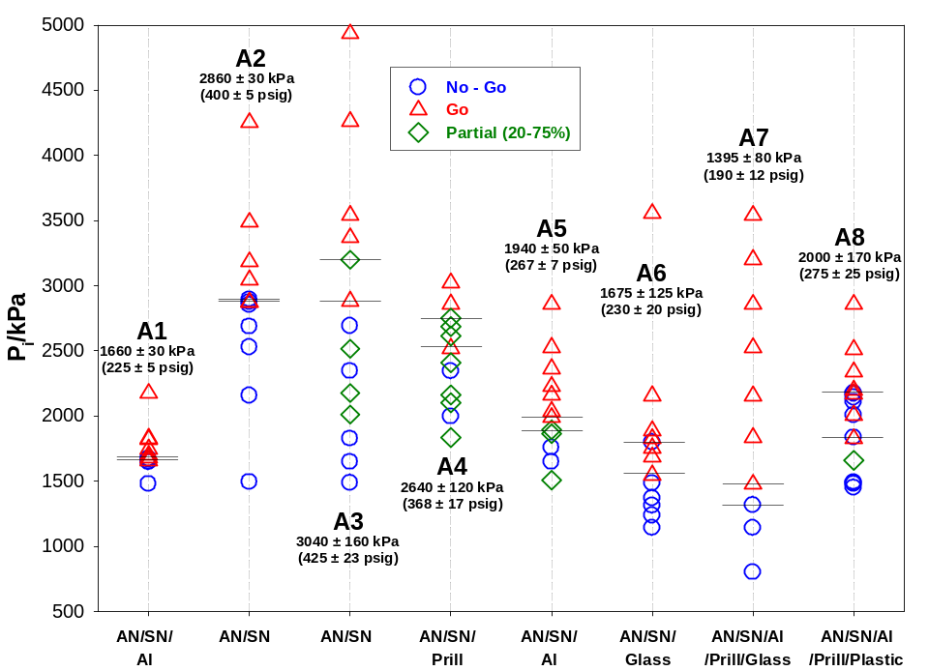
16. As illustrated in Figure 6, the MBP for emulsions which contained 5% (A5) and 6% (A1) by mass of granular aluminum is a factor of 1.6 and 1.8, respectively lower than the unsensitized version of the same emulsion (A3). It therefore appears that the addition of aluminum significantly lowers the MBP of the formulae.
Effect of sodium perchlorate on MBP
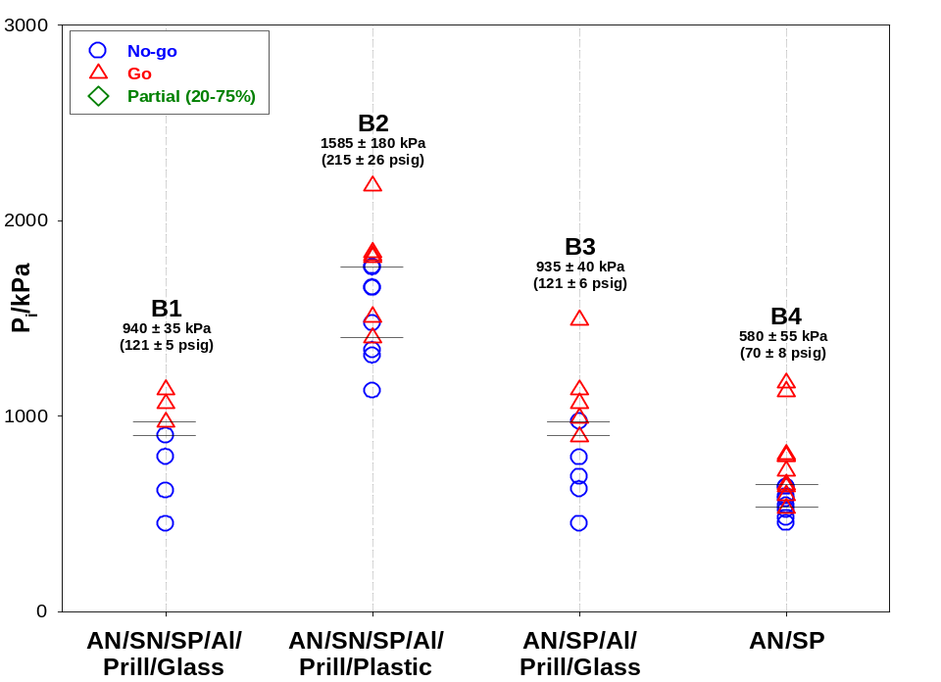
17. Another common formulation change investigated was the role sodium perchlorate has on the measured MBP. Figure 7 shows the MBP results for a series of “packaged” emulsions that were chemically sensitized with sodium perchlorate. The MBP values vary from 0.58 – 1.585 MPa (70 – 215 psig), significantly lower on the whole than for the formulations without sodium perchlorate in Figure 6, demonstrating that the MBP can be lowered dramatically. In most packaged emulsion manufacturing facilities, process pressures would often be greater than the MBP’s measured for these products containing sodium perchlorate.
Figure 7. Summary of MBP measurements for the ‘B’ series emulsions
Effect of water content and oxidizers
18. By far the most dominant factor on MBP is water content. This relationship is best illustrated looking at the simplified bulk-type emulsion formulations of series D and E. As illustrated in Figure 8, for emulsions D4 to D8, the MBP ranges from 4.5 MPa (640 psig), for a product containing 11.7% water by mass (D4), up to 14 MPa (2020 psig) for a product with 24.8% water (D8). Emulsions D1 to D3, even with a very different oil phase, follow the same linear trend. From Figure 8, for those emulsions whose oxidizer phase is composed of AN only, it is very evident that there is a strong correlation between water content and MBP. Also illustrated in Figure 8, for those emulsion formulations where ammonium nitrate is substituted by approximately 9-11% sodium nitrate, the relationship between water content and MBP, is still apparent, although much less dramatic; the effect of a low level of sodium nitrate seems to reduce the slope of the regression line. This trend is similarly evident and illustrated in Figure 8, where the MBPs for emulsions C1 and C4 are a factor of 1.6 lower than those of D3 and D6, respectively, which had similar water contents but did not contain sodium nitrate.
19. Finally, two formulations (A4, D2) displayed in Figure 8 had 20% of the AN normally in the oxidizer solution replaced by AN prills. Formula A4, which was AN/SN based, is seen to follow the same trend and the other formulae containing a low level of SN. Formula D2, which contained only AN, also follows the regression line for the all AN systems. Consequently, the effect of substituting 20% AN prills for 20% AN in the oxidizer solution does not seem to be significant in terms of the MBP.

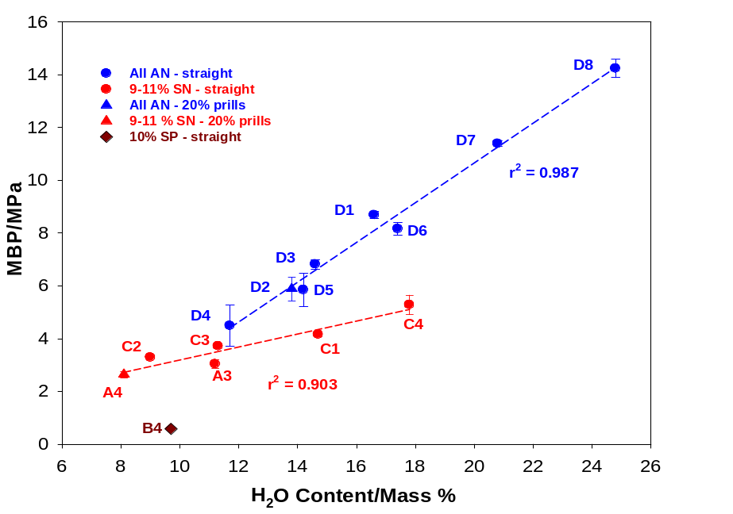
Figure 8. The effect of water content and oxidizers on the MBP of unsensitized emulsions
Conclusions
20. Years of research at CERL show that the MBP for a variety of common formulation emulsion products is consistent and repeatable using the testing methodology described. The major factor controlling the MBP for emulsion explosives does seem to be water content; however, it is clear that water is not the only variable that needs to be considered.
21. The MBP is a clear measure of the propensity of an ANE to undergo self-sustained deflagration. That being said, the application of MBP to transport classification is not totally straightforward, as the test evaluates the potential for deflagration following a localized thermal ignition event, rather than a deflagration as a result of an engulfing fire scenario. However, it is to be expected that materials with low MBP values will be most susceptible to deflagration-to-detonation behaviour in a fire scenario. Furthermore, the test clearly differentiates between products that are currently widely considered to be safe for transport and those that are not. Because of the considerable concern within the transport and explosives community that the currently adopted Series 8 tests do not adequately address ANEs in fire scenarios, adoption of a more quantitative test used in the classification process, partnered with the already established Series 8 tests, may be a good solution
Proposal
22. That the Working Group considers the potential merit of including the MBP test as an alternative to the current 8(d) test. For example, as an alternative to the 8(d) test, UN 3375 could be restricted to those products with MBP values above 5.6 MPa (800 psig).
References
[1] Type E – High Explosives, Classification and Authorization, General and Detailed Requirements for Type E explosives, Draft Revision 3, September 2009, Explosives Regulatory Division, Natural Resources Canada, Government of Canada.
[2] Goldthorp, S., Turcotte, R., Badeen, C.M., and Chan, S.K., ‘Minimum Pressure for Sustained Combustion in AN-based Emulsions’, Proceedings of the 35th International Pyrotechnics Seminar, Fort Collins, Colorado, USA, July 13-18, 2008.
[3] Turcotte, R., Goldthorp, S., Badeen, C.M., Johnson, C., Feng, H., and Chan, S.K., ‘Influence of Physical Characteristics and Ingredients on the Minimum Burning Pressure of Ammonium Nitrate Emulsions ’, Proceedings of the 36th International Pyrotechnics Seminar, Rotterdam, The Netherlands, August 23-28, 2009.
[4] Turcotte, R., Goldthorp, S., Badeen, C.M., Chan, S.K., “Hot-wire Ignition of AN-Based Emulsions”, Propellants, Explosives, Pyrotechnics, 33 (2008) 472.

