Transmitted by the expert from Hungary | Informal Document No. GRSG-97-18  (97th GRSG, 20 – 23 October 2009,  agenda item 4)

Proposal for a new draft Regulation on frontal collision of buses

(This proposal is based on document ECE/TRANS/WP.29/GRSG/2007/33)

It has to be mentioned that Hungary supports the development of this new regulation. In earlier documents (GRSG-92-7; GRSG-94-6; GRSG-95,13; GRSG-96-18; GRSG-96-19 and GRSG-96-33) Hungary made a lot of proposals to solve this problem and improve the existing text. The most important issues are reformulated below.

- Amend to read:
SCOPE
This Regulation applies to vehicles of category M₃ with a maximum mass exceeding 7,5 tonnes.
The subparagraphs shall be deleted
Argument: The driver and crew may be and has to be protected in frontal collisions with low energy level and many accident statistics proved that from this point of view the three Classes are in the same position.
5.3.1. Amend to read (the red wording is new and some wording has been deleted.
After undergoing the test referred to in paragraph 5.2., the front bodywork shall exhibit a residual space specified by the test device shown on Figure 1. The driver (or crew) seat shall be in its [median] position for the assessment of the residual space.
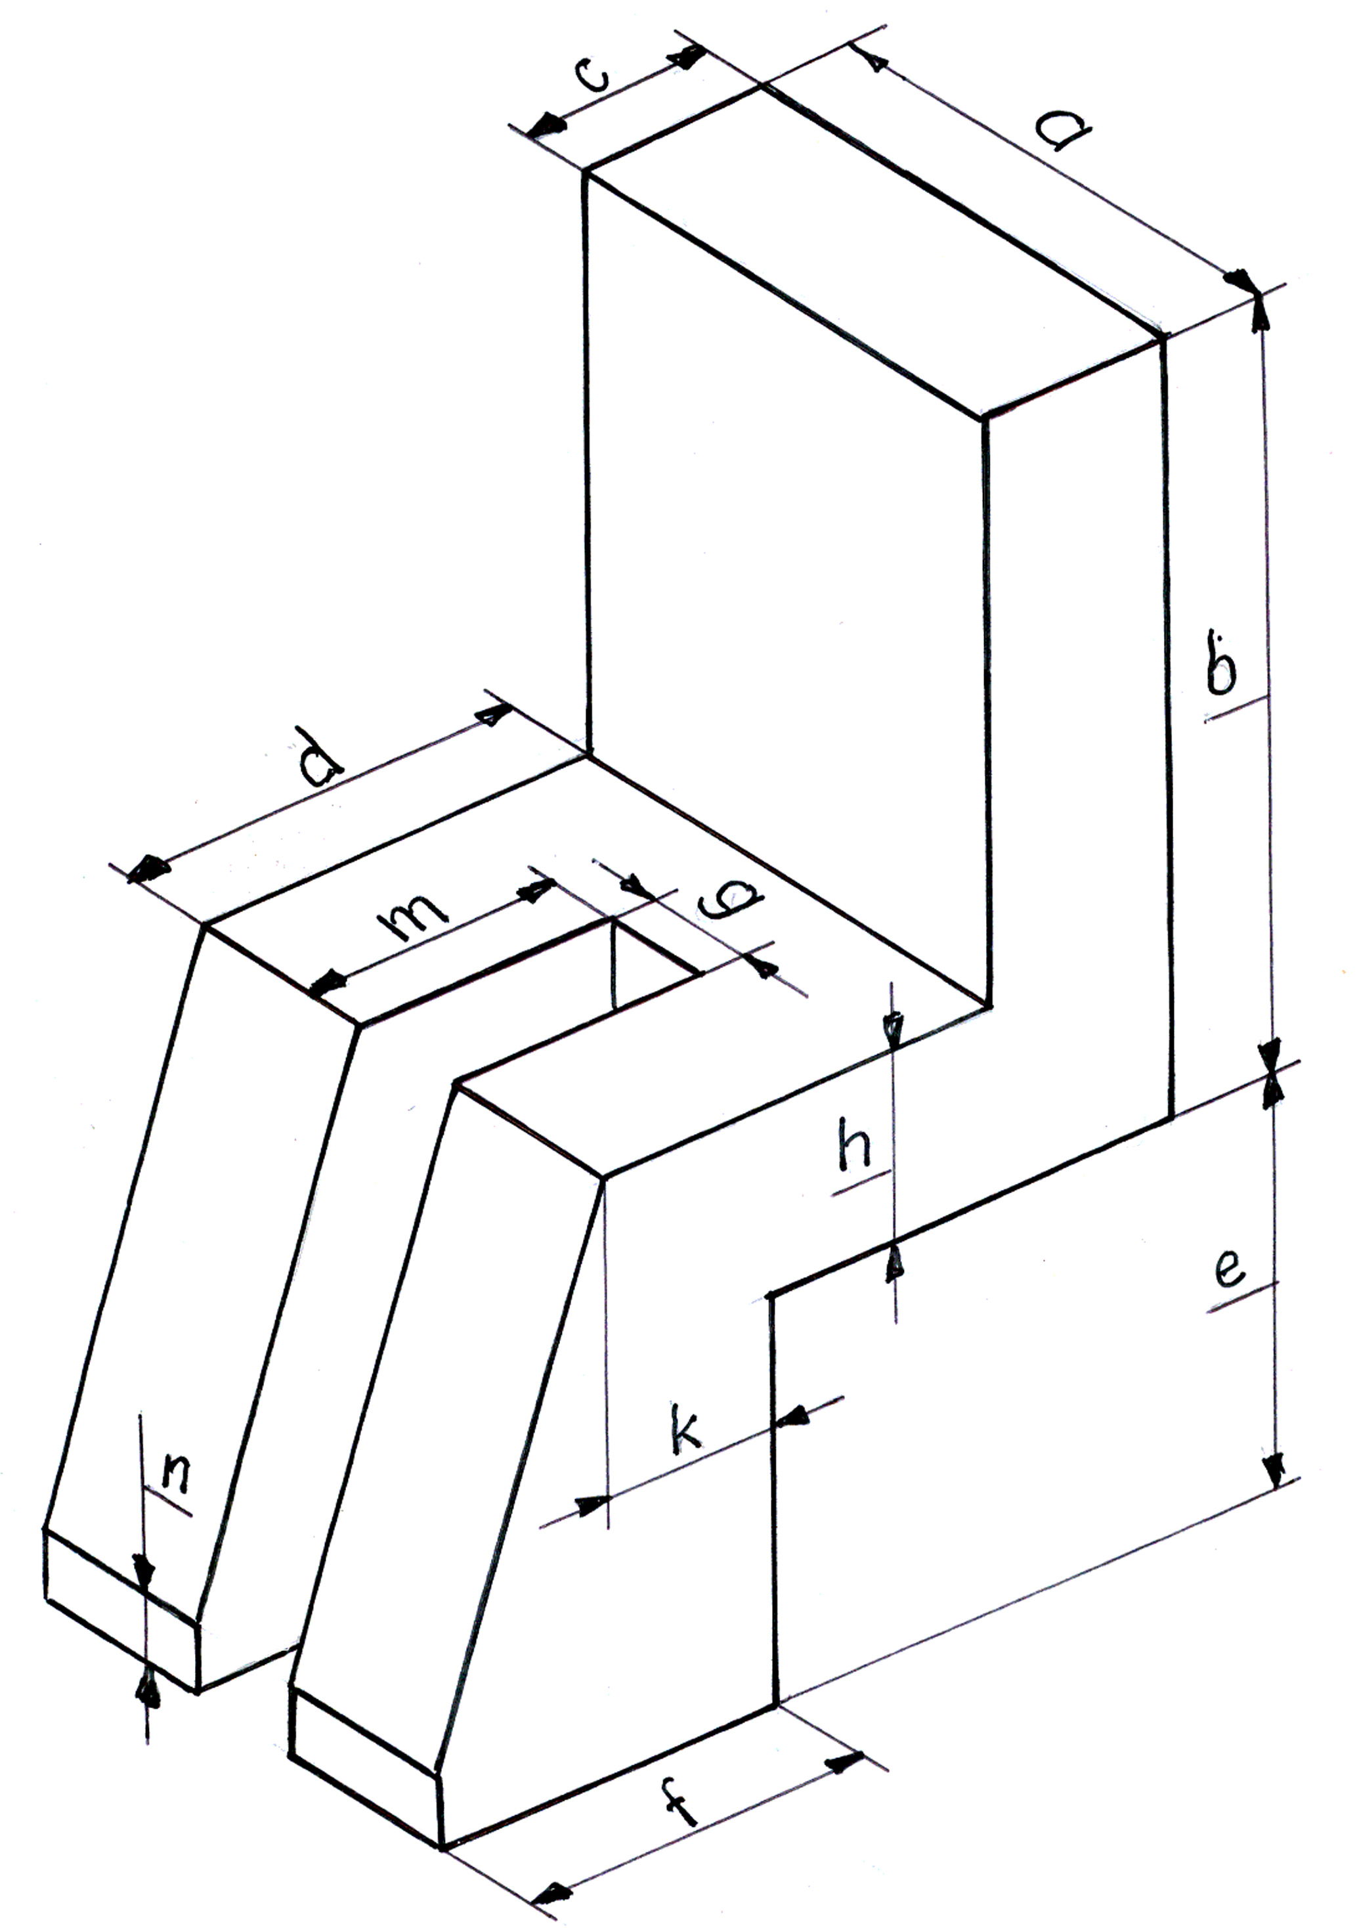
Figure 1. Test device of the residual space.
(Dimensions to be specified)

5.3.2. Add to the end of the paragraph:
That means: no structural parts, components of the driver (crew) compartment shall contact or intrude the residual space during and after the test.
Explanation: The driver (crew) may sit on the seat in different positions, so the required unharmed residual space must be bigger than the contour of a manikin. This is a strong safety issue. The test device shall be simple, cheap, and able to detect the easily the structural intrusions.
6.1.2. continue the existing text as follows:
to prove that the new vehicle type complies with the requirement of this Regulation and constitutes part of a group of vehicle types together with the approved vehicle; or
6.1.3. new sub-paragraph
refuse the extension of approval and require a new approval procedure to be carried out.
New paragraphs:

6.2. The decision of the administrative department and the technical service shall be based on the threefold criteria of the worst case:
6.2.1.the structural criterion means whether the superstructure is changed or not (see Annex 4) If no change or the new superstructure is stronger, this is favourable.
6.2.2. the residual space criterion is based on the position of the residual space related to the driver’s and crew’s compartment (Position of the driver’s and crew’s seats) If there is no change in the position, or they have better position (farther from the impact zone) this is favourable.
6.2.3.the criterion of the surroundings means all the distances of the surroundings from the residual space. Those parts, elements of the surroundings shall be considered which may intrude into the residual space in the test (e.g. instrument panel, steering wheel, parts of the inner front wall, etc.) If these are not smaller than those in the approved vehicle type, this is favourable.
6.3. If all three criteria described in paragraph 6.2. are changed favourably, the extension of the approval shall be granted without further investigation. If all three answers are unfavourable, a new approval procedure is required.
If the answers are mixed, further investigations (e.g. tests, calculation, structural analysis) will be required. These investigations shall be determined by the technical service cooperating with the manufacturer,
6.4. Confirmation or refusal of approval, specifying the alterations, shall be notified by the procedure specified in paragraph 4.3. to the Contracting Parties which apply this Regulation.
6.5. The administrative department issuing the extension of approval shall assign a series number to each communication from drawn up for such an extension.

Explanation, arguments: these paragraphs introduce the use of the worst case, the approvals under umbrella, which is a great help to the manufacturers. These paragraphs are taken from regulation R.66/Rev.1. only with the necessary modifications.

Annex 3.
1. Amend to read:
TEST METHOD
1.1 The complete vehicle or the front bodywork shall be tested using an appropriate test method: swing bob or mobile barrier having an impact plate. If there is crew compartment on the bus, both the driver and crew compartment shall be tested separately.
1.2. New sub-paragraph:
The direction of the impact speed shall be parallel to the median longitudinal plane of the vehicle (α = 0º) or having an angle of α = 45º to that. The more dangerous impact situation shall be chosen by the technical service after consulting with the manufacturer.
2. Amend to read:
ANCHORAGE OF THE TEST PIECE
The test piece shall be fixed rigidly to the ground. Displacement of the test piece after the impact is not allowed, suspension shall be excluded. The anchorage points and their construction shall be so designed that local plastic deformation, local energy absorbtion must not occur at these points during the test. The anchorage points shall be behind the R point of the driver (crew) seat and the way of anchorage must not strengthen the front bodywork.
Argument: Suspension, which means an uncontrolled energy absorption must be excluded. Only fix, well specified anchorages are acceptable.
3. Amend to read:
TEST CONDITIONS
3.1. Amend to read:
The impact plate shall be made of steel. Its striking surface, rectangular and flat shall be 1000 mn wide 800 mm high, and minimum 50 mm thick. Its edges shall be rounded to a radius of more than 2 mm.
Argument: partial impact shall be simulated, statistical data proved that this is more dangerous for the driver in case of low energy level impacts.
3.2. New paragraph
The total real impacting mass shall be 1500 ± 250 kg and shall be symmetrically distributed to vertical central plane of the impact plate.
3.3. New paragraph using the form of the original paragraph 4.1.
The impact energy shall be at least 80 kJ
Argument: It was proved earlier, this is representative for a low energy level impact (5 t vehicle impacts the bus with a speed of 25 km/h)
Renumber the following paragraphs
3.2. and 3.3. shall form a combined paragraph. Amend to read:
At the time of the impact, the plane of the impact plate shall be so positioned, that:
New sub paragraphs:
3.2.1. if the impact direction α = 0º, the vertical central plane of the impact plate shall go through the R point of the driver (crew) seat
3.2.2. if the impact direction is α = 45º, the impact plate shall strike the test piece tangentially on its corner. (See Figure 1.)
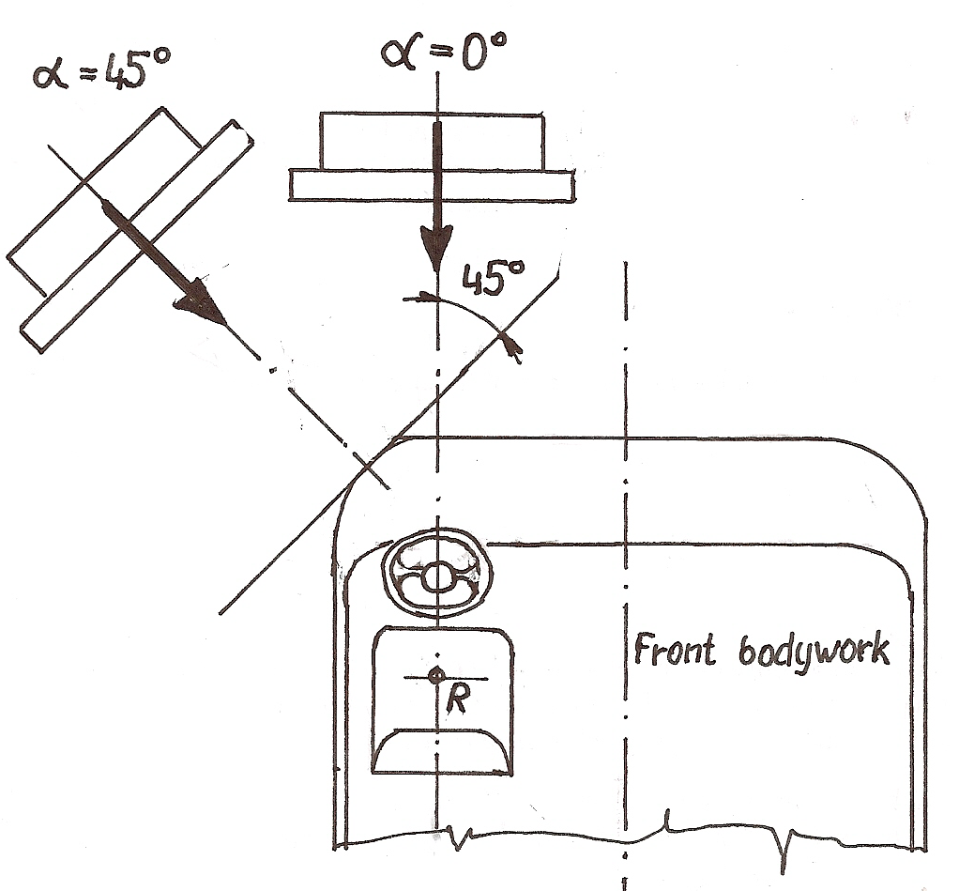
Figure 1. Positions of the impact plate

3.2.3. The central point of the impacting plate shall be in the height of the R point of the driver (crew) seat.
Argument: statistical data and many in depth accident analysis proved, that these two kinds of accidents have the same frequency and are the more dangerous front impact situations in relation to the driver’s safety.
3.4.Delete
4. Delete. It is incorporated into the new paragraph 3.3.
Renumber the following paragraphs.

5.1 and 5.2 shall be combined.
Amend to read:
The test piece to be tested shall be representative of the series production in respect of the superstructure and the surroundings of the driver (crew) seat which could intrude into the residual space during the test. Generally, any alteration from the fully finished condition is acceptable, if these are not influenced by it.
5.2. Delete
5.3. Amend to read.
If the test is performed including the doors – this is the choice of the manufacturer – the doors shall be in their closed position (operational made) In this case the doors are part of the superstructure.
  - Delete. The content of this paragraph is included into paragraph 2.

  - New paragraph.
The residual space test device shall be placed on the driver (crew) seat so that its vertical central plane shall coincide with the vertical central plane of the driver (crew) seats. It shall be firmly fixed to seat, during the impact test no displacement is allowed.
5.6. New paragraph
The test device shall be equipped with sensing elements (electrical contact, plastic cover, etc.) which detect the possible contacts between the test device and the surrounding structural elements.
Annex3. Appendix 1. Delete. It is included in para.3.
Annex3. Appendix 2. Delete
- - - - -

