INF.29
ECONOMIC COMMISSION FOR EUROPE

INLAND TRANSPORT COMMITTEE

Working Party on the Transport of Dangerous Goods

Joint Meeting of the RID Committee of Experts and the
Working Party on the Transport of Dangerous Goods

Bern, 8-11 September 2009 and
Geneva, 14-18 September 2009
Item 5 of the provisional agenda
TANKS
Manhole covers of tanks

^{Note by Germany}
SUMMARY
Explanatory Summary: | With this document, Germany would like to inform the Joint Meeting about problems as regards the leakproofness of covers of inspection openings (manholes) of atmospheric tanks in the event of tests and overturning accidents.
Action to be taken: | Discussion
Related documents: | -

Introduction

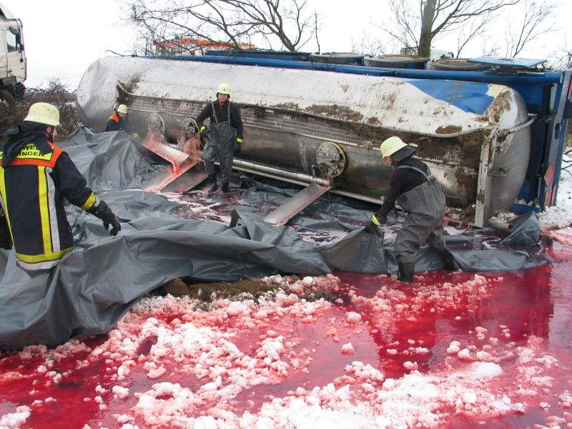  Picture 1: Leaking dome covers after an accident | The analysis of the annual reports on occurrences under 1.8.5 of ADR has revealed that in overturning accidents of mineral oil tanks the tanks were usually not damaged but the loaded goods leaked through inspection opening covers.  This condition is not permissible under 6.8.2.2.1 of ADR.

Information
In Germany, due to these irregularities, the Federal Institute for Materials Research and Testing is conducting tests on different types of dome covers. Not all the results of the tests with the test device in accordance with EN 13314 and EN 13317 are available yet. In addition, covers fitted to the tank are to be tested in an overturning test (simulation of realistic overturning accidents) in order to demonstrate the comparability of the test conditions. The test report will shortly be available after the completion of the works.
During the tests, leakages occurred especially with older covers which were not tested in accordance with standards EN 13 314 and EN 13 317. Especially covers fitted to the tank with few T-head bolts (up to 10) do not meet the current test requirements.
It is to be assumed that the test requirements to be met by dome covers in the overturning test with water filled tanks are lower than the requirements of the test with the test device in accordance with EN 13 314 and EN 13 317. The overturning tests then reproduce an exact test requirement contained in ADR until 2007 when the said standards were not yet applicable.
Should these overturning tests still reveal serious defects of the dome covers, Germany will consider replacing the old covers (which do not meet the respective requirements).
One of the covers tested within the framework of the tests was one manufactured in an ADR member state that is often used also in Germany for the construction of tanks.
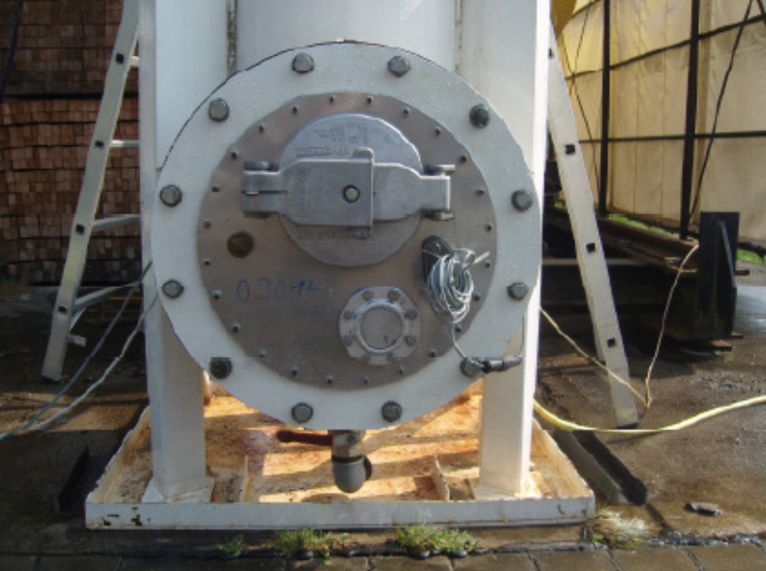  Picture 2: Dome cover manufactured in an ADR member state fitted to the test apparatus | This cover, which was fitted with a spring loaded fill hole cover, failed the drop tests conducted at the Federal Institute for Materials Research and Testing in accordance with EN 13 317 by means of the test device specified therein. Pictures 3 and 4 show how the drop test affected the cover.  The cover is from a series which, according to the test report of a major internationally operating testing company, was tested in accordance with standard EN 13 317.

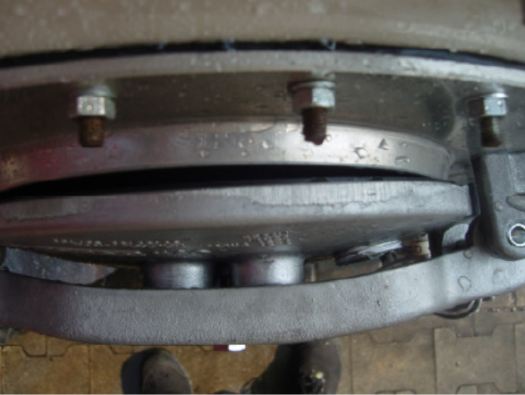  Picture 3: Failing filling hole cover after the test | 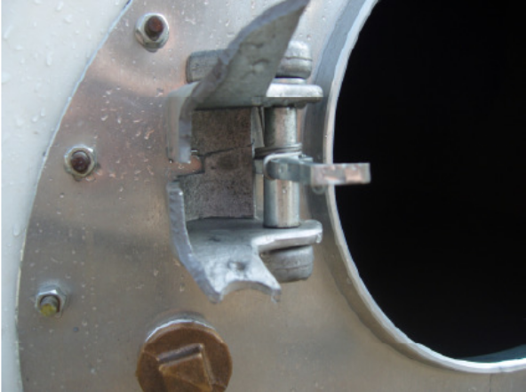  Picture 4: Broken locking device after the test

In this respect, it is deemed necessary to include an exclusion of spring-loaded filling hole covers in standards EN 13 314 and EN 13 317. This had been agreed by the Joint Meeting at the session in September of 2004 by rejecting standard EN 14 596 (see TRANS/WP.15/AC.1/96 paragraphs 46-48). The Joint Meeting did not want the filling hole cover to be used as a device for protection against excess pressure.
Currently, there are no references to standard EN 14 596 in RID/ADR but the two standards on covers, EN 13 314 and EN 13 317, do not expressly exclude these design types of spring loaded dome covers.
With this INF document, Germany would like to inform about this issue and then take it up again at the next session of the Joint Meeting in the spring of 2010 after having concluded the analysis of the own tests.
____________

