REGULATION No. 17
(Strength of seats)

Alignment to gtr No. 7 head restraints

The text reproduced below was prepared by the expert from EC and Japan in order to transpose the gtr No. 7 (head restraints) into Regulation No. 17 and introduce the use of BioRID II test dummy into the dynamic performance requirements. The modifications to the current text of the Regulation are marked in bold or strikethrough characters. The text combines GRSP/2008/11 and GRSP/2008/24, and includes some additional modifications. The modifications added to the combined text are underlined. It supersedes GRSP/2008/11, GRSP/2008/24, and GRSP-44-2.

A. PROPOSAL

Table of contents, list of annexes, amend to read:

"Annex 1 - Minimum height measurement test procedure

Annex 2 - Minimum width measurement test procedure

Annex 3 - Gap measurement procedures

Annex 4 - Backset measurement procedure

Annex 5 - Head restraint measuring device (HRMD)

Annex 6 - Displacement, backset retention and strength test procedure

Annex 7 - Energy absorption test procedure for head restraint

Annex 8 - Height retention test procedure

Annex 9 - Dynamic performance test procedure

Annex 10 - Non-use position test procedure

Annex 11 - Communication concerning the approval or refusal or extension….

Annex 12 - Arrangements of approval marks

Annex 13 - Procedure for determining the "H" point and….

Annex 14 - Test procedure for checking energy dissipation of seat back

Annex 15 - Method for testing the strength of seat anchorages and their adjustment, locking and displacement systems

Annex 16 - Test procedure for devices intended to protect the occupants against displacement of luggage"

Paragraphs 2. to 2.37.5., amend to read:

"2. DEFINITIONS

For the purposes of this Regulation

2.1. "Actual torso angle" means the angle measured between a vertical line through the H-point and the torso line using the back angle quadrant on the H-point machine. The actual torso angle corresponds theoretically to the design torso angle.

2.2. "Adjustable head restraint" means a head restraint that is capable of movement independent of the seatback between at least two positions of adjustment intended for occupant use.

2.3. "Adjustment system" means the device by which the seat or its parts can be adjusted to a position suited to the morphology of the seated occupant. This device may, in particular, permit:

(a) longitudinal displacement;
(b) vertical displacement;
(c) angular displacement.

2.4. "Anchorage" means the system by which the seat assembly is secured to the vehicle structure, including the affected parts of the vehicle structure.

2.5. "Approval of a vehicle" means the approval of a vehicle type with regard to the strength of the seats and their anchorages, the design of the rear parts of the seat-backs and the characteristics of their head restraints.

2.6. "Backlight" means rearward-facing window glazing located at the rear of the roof panel.

2.7. "Backset" means the minimum horizontal distance between the front surface of the head restraint and the rear surface of the head restraint measurement device.

2.8. "Backset reference point" means the reference point from which the measurement of backset is made.

2.9. "Bench seat" means a structure complete with trim, intended to seat more than one adult person.

2.10. "Centre plane of occupant" (C/LO) means the median plane of the H-point machine positioned in each designated seating position; it is represented by the co-ordinate of the H-point on the Y-axis. For individual seats, the centre plane of the seat coincides with the centre plane of the occupant. For other seats, the centre plane of the occupant is specified by the manufacturer.

2.11. "Design torso angle" means the angle measured between a vertical line through the R-point and the torso line in a position which corresponds to the design position of the seat-back established by the vehicle manufacturer.

2.12. "Detachable head restraint" means a head restraint consisting of a component separable from the seat, designed for insertion and positive retention in the seat-back structure.

2.13. "Displacement system" means a device by which the seat or one of its parts can be displaced and/or rotated, without a fixed intermediate position, to permit easy access of occupants to the space behind the seat concerned.

2.14. "Fiducial marks" are physical points (holes, surfaces, marks or indentations) on the vehicle body as defined by the manufacturer.

2.15. "Folding seat" means an auxiliary seat intended for occasional use and normally folded.

2.16. "Front contact surface" of a head restraint means the front surface area of the head restraint which is intended to catch the head of the seated occupant in order to limit rearward displacement of the head relative to the torso during a rear impact to the vehicle.

2.17. "H-point" means the pivot centre of the torso and thigh of the H-point machine when installed in the vehicle seat. Once determined the H-point is considered fixed in relation to the seat-cushion structure and to move with it when the seat is adjusted.

2.18. "Head Restraint" means, at any designated seating position, a device that limits rearward displacement of a seated occupant's head relative to the occupant’s torso that has a height equal to or greater than 700 mm at any point between two vertical longitudinal planes passing at 85 mm on either side of the torso reference line, in any position of height adjustment and backset.

2.19. "Head Restraint Height" means the distance from the R-point, measured parallel to the torso reference line to the top of the head restraint on a plane normal to the torso reference line.

2.20. "Head Restraint Measurement Device" (HRMD) means a separate head shaped device used with the H-point machine, fitted with a sliding scale at the back of the headform for the purpose of measuring backset.

2.21. "Integrated Head Restraint" means a head restraint formed by the upper part of the seat-back. Head restraints meeting the definitions of paragraphs 2.12. or 2.30. but which can only be detached from the seat or the vehicle structure by the use of tools or by partial or complete removal of the seat covering, meet the present definition;

2.22. "Intended for occupant use" means, when used in reference to the adjustment of a seat and head restraint, adjustment positions used by seated occupants while the vehicle is in motion, and not those intended solely for the purpose of allowing ease of ingress and egress of occupants; access to cargo storage areas; and storage of cargo in the vehicle.

2.23. "Locking system" means a device ensuring that the seat and its parts are maintained in the position of use.

2.24. "Longitudinal plane" means a plane parallel to the median longitudinal plane of the vehicle.

2.25. "Partitioning system" means parts or devices which, in addition to the seat-backs, are intended to protect the occupants from displaced luggage; in particular, a partitioning system may be constituted by netting or wire mesh located above the level of the seat-backs in their upright or folded down position. Head restraints fitted as standard equipment for vehicles equipped with such parts or devices shall be considered as part of the partitioning system. However, a seat equipped with a head restraint shall not be considered as being on its own a partitioning system.

2.26. "R-point" means a design point defined by the vehicle manufacturer for each designated seating position and established with respect to the three-dimensional reference system. The R-point:

2.26.1. establishes the rearmost normal design driving or riding position of each designated seating position in a vehicle;

2.26.2. has coordinates established relative to the designed vehicle structure;

2.26.3. simulates the position of the centre pivot of the human torso and thigh.

2.27. "Reference data" means one or several of the following characteristics of a seating position:

2.27.1. the H-point and the R-point and their relationship;

2.27.2. the actual torso angle and the design torso angle and their relationship.

2.28. "Reference line" means the line 'r' on the manikin reproduced in Annex 6, Figure 6-1 to this Regulation.

2.29. "Seat" means a structure which may or may not be integral with the vehicle structure complete with trim, intended to seat one adult person. The term covers both an individual seat or part of a bench seat intended to seat one person.

2.30. "Separate Head Restraint" means a head restraint consisting of a component separate from the seat, designed for insertion and/or positive retention in the structure of the vehicle.

2.31. "Three-dimensional H-point machine" (H-point machine) means the device used for the determination of "H-points" and actual torso angles.

2.32. "Three-dimensional reference system" means a system as described in Annex 13, Appendix 2.

2.33. "Top of the Head Restraint" means the point on the head restraint centreline with the greatest height.

2.34. "Torso-line" means the centreline of the head-room probe of the H-point machine with the probe in the fully rearward position.

2.35. "Transverse plane" means a vertical plane perpendicular to the median longitudinal plane of the vehicle.

2.36. "Vehicle measuring attitude" means the position of the vehicle as defined by the co-ordinates of fiducial marks in the three-dimensional reference system.

2.37. "Vehicle type" means a category of motor vehicles which do not differ in such essential respects as:

2.37.1. the structure, shape, dimensions, materials and the mass of the seats, although the seats may differ in covering and colour; differences not exceeding 5 per cent in the mass of the approved seat type shall not be considered significant;

2.37.2. the type and dimensions of the adjustment, displacement and locking systems of the seat-back and seats and their parts;

2.37.3. the type and dimensions of the seat anchorages;

2.37.4. the dimensions, frame, materials and padding of head restraints, although they may differ in colour and covering;

2.37.5. the type and dimensions of the attachments of the head restraint and the characteristics of the part of the vehicle to which the head restraint is attached, in the case of a separate head restraint;"

Paragraphs 4.2. to 4.3., amend to read:

"4.2. An approval number shall be assigned to each type approved. Its first two digits (at present 08, corresponding to the 08 series of amendments) …..

4.3. Notice of approval …. of a form conforming to the model in Annex 11 to this Regulation."

Paragraph 4.4.1. the footnote 2/, amend to read:

"4.4.1. a circle…. 2/
______________
2/ ……. 50 for Malta, 51 for the Republic of Korea, 52 for Malaysia, 53 for Thailand, 54 and 55 (vacant), 56 for Montenegro, 57 (vacant) and 58 for Tunisia. Subsequent numbers…"

Paragraph 4.4.3., amend to read:

"4.4.3. …………The form conforming to the model in Annex 11 to this Regulation……"

Paragraph 4.8., amend to read:

"4.8. …….. of approval marks are given in Annex 12 to this Regulation."

Paragraph 5.1.2., amend to read:

"5.1.2. …..a device as referred to in paragraph 2.13. shall be placed on the outside of ……"

Paragraph 5.1.3., amend to read:

"5.1.3. ……in accordance with the requirements of Annex 14 to this Regulation."

Paragraph 5.1.3.1., amend to read:

"5.1.3.1. ……..by the procedure specified in Annex 14 the deceleration of ..."

Paragraphs 5.1.4. to 5.1.4.1.4., amend to read:

"5.1.4. The surface…………

These areas are defined in paragraph 6.8.1.

This requirement does not apply to:
(a) the parts of the different areas exhibiting a projection of less than 3.2 mm from the surrounding surface, which shall exhibit blunted edges, provided that the height of the projection is not more than half its width;
(b) rearmost seats, to back-to-back seats or to seats that comply with the provisions of Regulation No. 21 "Uniform Provisions concerning the Approval of Vehicles with regard to their Interior Fittings" (E/ECE/324-E/ECE/TRANS/505/Rev.1/ Add.20/Rev.2, as last amended);
(c) rear parts of seats situated below a horizontal plane passing through the lowest R-point in each row of seats. (Where rows of seats have different heights, starting from the rear, the plane shall be turned up or down forming a vertical step passing through the R-point of the row of seats immediately in front);
(d) parts such as "flexible wire mesh".

Paragraph 5.1.4.2., amend to read:

"5.1.4.2. ………. test prescribed in Annex 14 to this Regulation. Moreover,………….."

Paragraph 5.1.4.3., amend to read:

"5.1.4.3. ……in accordance with the requirements of Annex 14, shall apply only ……."

Paragraph 5.1.6., amend to read:

"5.1.6. …………the tests described in paragraph 6.3. and in Annex 16, paragraph 2.1."

Paragraph 5.1.7., amend to read:

"5.1.7. After the tests,….
…………..
In the case …….after testing in accordance with Annex 6, paragraph 4., no breakage….."

Paragraph 5.3.2., amend to read:

"5.3.2. A head restraint shall be mounted on every outboard front seat in every vehicle of category M₂ with a maximum mass not exceeding 3,500 kg and of category N₁. head restraints mounted in such vehicles shall comply with the requirements of Regulation No. 25, as amended by the 03 series of amendments."

Paragraph 5.4.2.1., amend to read:

"5.4.2.1. …………….the procedure specified in Annex 7, the deceleration of ………………"

Insert new paragraphs 5.5. to 5.8., to read:

"5.5. Performance Requirements

5.5.1. General Requirements

5.5.1.1. Each front outboard head restraint shall conform to either paragraph 5.5.1.1.1. or paragraph 5.5.1.1.2.

5.5.1.1.1. The head restraint shall conform to paragraphs 5.5.2.1., 5.5.3. through 5.5.7., 5.6., 5.7., and 5.9., of this Regulation.

5.5.1.1.2. The head restraint shall conform to paragraphs 5.5.2.1., 5.5.3. through 5.5.5., 5.5.7., 5.7., 5.8., and 5.9. of this Regulation.

5.5.1.2. For vehicles equipped with front centre head restraints, the head restraint shall conform to either paragraph 5.5.1.2.1. or paragraph 5.5.1.2.2.

5.5.1.2.1 The head restraint shall conform to paragraphs 5.5.2.2., 5.5.3. through 5.5.5., 5.5.7., 5.6., 5.7., and 5.9. of this Regulation.

5.5.1.2.2. The head restraint shall conform to paragraphs 5.5.2.2., 5.5.3. through 5.5.5., 5.5.7., 5.7., 5.8., and 5.9. of this Regulation.

5.5.1.3 For vehicles equipped with rear outboard head restraints, the head restraint shall conform to either paragraph 5.5.1.3.1. or paragraph 5.5.1.3.2.

5.5.1.3.1. The head restraint shall conform to paragraphs 5.5.2.4., 5.5.3. through 5.5.5., 5.5.7., 5.6., 5.7., and 5.9. of this Regulation.

5.5.1.3.2. The head restraint shall conform to paragraphs 5.5.2.4., 5.5.3. through 5.5.5., 5.5.7., 5.7., 5.8., and 5.9. of this Regulation.

5.5.1.4. For vehicles equipped with rear centre head restraints, the head restraint shall conform to either paragraph 5.5.1.4.1. or 5.5.1.4.2.

5.5.1.4.1. The head restraint shall conform to paragraphs 5.5.2.6., 5.5.3. through 5.5.5., 5.5.7., 5.6., 5.7., and 5.9. of this Regulation.

5.5.1.4.2. The head restraint shall conform to paragraphs 5.5.2.6., 5.5.3. through 5.5.5., 5.5.7., 5.7., 5.8., and 5.9. of this Regulation.

5.5.1.5. At designated seating positions incapable of seating the test dummy specified under paragraph 5.8. of this regulation, the applicable head restraint shall conform to either paragraph 5.5.1.1.1., or 5.5.1.2.1, or 5.5.1.3.1., or 5.5.1.4.1. of this regulation, as appropriate.

5.5.2. Minimum Height:

The minimum height requirements shall be demonstrated in accordance with the provisions of Annex 1.

5.5.2.1. Front outboard designated seating positions

The top of a head restraint located in a front outboard designated seating position shall have a height of:

(a) not less than 800 mm in at least one position of head restraint adjustment; and

(b) not less than 750 mm in any position of head restraint adjustment except as provided for in paragraph 5.5.2.3. of this Regulation.

5.5.2.2. Front centre designated seating positions equipped with head restraints

The top of a head restraint located in the front centre designated seating position shall have a height not less than 750 mm in any position of adjustment, except as provided for in paragraph 5.5.2.3. of this Regulation.

5.5.2.3. Exception

The requirements of paragraphs 5.5.2.1. and 5.5.2.2. of this Regulation do not apply if the interior surface of the vehicle roofline, including the headliner, physically prevents a head restraint, located in the front designated seating position, from attaining the required height. In those instances in which the head restraint cannot attain the required height, when measured in accordance with Annex 1, the vertical distance between the top of the head restraint and the interior surface of the roofline, including the headliner, shall not exceed 25 mm in the lowest position of seat adjustment, or 50 mm in the case of convertible vehicles; in any horizontal position of seat adjustment; and the highest position of head restraint adjustment intended for occupant use.

5.5.2.4. Rear outboard designated seating positions equipped with head restraints

Except as provided in paragraph 5.5.2.5. of this Regulation, when measured in accordance with Annex 1, the top of a head restraint located in a rear outboard designated seating position shall have a height not less than 750 mm in any position of adjustment.

5.5.2.5. Exception

The requirements of paragraph 5.5.2.4. of this Regulation do not apply if the interior surface of the vehicle roofline, including the headliner or backlight, physically prevent a head restraint, located in the rear outboard designated seating position, from attaining the required height. In those instances in which this head restraint cannot attain the required height, when measured in accordance with Annex 1, the maximum vertical distance between the top of the head restraint and interior surface of the roofline, including the headliner, or the backlight shall not exceed 25 mm in the lowest position of seat adjustment, or 50 mm in the case of convertible vehicles; in any horizontal position of seat adjustment; and the highest position of head restraint adjustment intended for occupant use.

5.5.2.6. When measured in accordance with Annex 1, the top of any head restraint designed to be provided in rear centre seats or seating positions shall be not less than 700 mm.

5.5.3. Minimum width

When measured in accordance with Annex 2, the lateral width of a head restraint shall be not less than 85 mm on either side of the torso line (distances L and L' as per Annex 2) of the seat for which the head restraint is intended.

5.5.4. Gaps within head restraint

If a head restraint has any gap greater than 60 mm, when measured in accordance with Annex 3, the maximum rearward displacement shall comply with the requirements of paragraph 5.6.2. when the head restraint is tested at that gap.

In the case of head restraints integral with the seat-back, the area to be considered is:

above a plane perpendicular to the torso reference line at 540 mm from the R-point.

between two vertical longitudinal planes passing at 85 mm on either side of the reference line.

5.5.5. Gaps between head restraint and the top of the seat back

When measured in accordance with Annex 3, there shall not be a gap greater than 60 mm between the bottom of the head restraint and the top of the seat back if the head restraint is not adjustable vertically between in-use positions.

When measured in accordance with Annex 3, there shall not be a gap greater than 25 mm between the bottom of a vertically adjustable head restraint and the top of the seat back, with the head restraint adjusted to its lowest height position.

5.5.6. Minimum backset for front outboard designated seating positions

5.5.6.1. For adjustable head restraints, the requirements of this Regulation shall be met with the top of the head restraint in all height positions of adjustment between 750 mm and 800 mm, inclusive. If the top of the head restraint, in its lowest position of adjustment, is above 800 mm, the requirements of this Regulation shall be met at that position only.

5.5.6.2. At the choice of the manufacturer, the backset shall be measured using either the H-point or the R-point as the backset reference point.

5.5.6.3. The backset, when measured as specified in Annex 4, shall not be more than 45 mm, when using the R-point as the backset reference point, or 55mm when using the H-point as the backset reference point.

5.5.6.4. If the front outboard head restraint is not attached to the seat back, the head restraint cannot be adjusted such that the backset is more than required in paragraph 5.5.6.3 when the seat back inclination is positioned closer to vertical than the position specified in Annex 4.

5.5.7. The height of the intended front contact surface area of a head restraint shall be not less than 100 mm when measured on a plane parallel to the torso reference line.

5.6. Static performance requirements

Each head restraint shall conform with the following static requirements.

5.6.1. Energy absorption

When the front surface of the head restraint is impacted in accordance with Annex 7, the deceleration of the headform shall not exceed 785 m/s² (80g) continuously for more than 3 milliseconds. Moreover, no dangerous edge shall occur during or remain after the test.

5.6.2. Displacement and Backset Retention

If the head restraint has a fixed backset then the head restraint shall conform to paragraph 5.6.2.1.

If the head restraint has an adjustable backset then, at the choice of the manufacturer, the head restraint shall conform to either the requirements of paragraph 5.6.2.1. when tested in the rearmost (relative to the seat) position of adjustment or with the requirements of paragraph 5.6.2.2.

5.6.2.1. Displacement

When the head restraint is tested in accordance with Annex 6, the headform shall not be displaced more than 102 mm perpendicularly and rearward of the displaced extended torso reference line, 'r1', during the application of a 373 ± 7.5 Nm moment about the R-point.

5.6.2.2. Displacement and Backset Retention

When the head restraint is tested in any position of backset adjustment in accordance with Annex 6, the headform shall:
(a) Not be displaced more than 25 mm during the application of the initial reference moment of 37 ± 0.7 Nm;
(b) Not be displaced more than 102 mm perpendicularly and rearward of the displaced extended torso reference line, 'r1', during the application of a 373 ± 7.5 Nm moment about the R-point; and
(c) Return to within 13 mm of its initial reference position after the following sequence occurs: application of a 373 ± 7.5 Nm moment about the R-point; reduction of the moment to 0 Nm; and by re-application of the initial reference load 37 ± 0.7 Nm.

5.6.3. Head restraint and its anchorage strength

When the head restraint and its anchorage are tested in accordance with Annex 6, the load applied to the head restraint shall reach 890 N ± 5 N and remain at this load for a minimum period of 5 seconds unless any breakage of the seat or head restraint occurs.

5.6.4. Adjustable head restraint height retention

When tested in accordance with Annex 8, the mechanism of the adjustable head restraint shall not fail in such a way as to allow downward movement of the head restraint by more than 25 mm.

5.7. Non-use positions

5.7.1. A driver head restraint shall not have a non-use position

5.7.2. A front outboard passenger head restraint may be adjusted to a position at which its height does not comply with the requirements of paragraph 5.5.2.1. of this Regulation. However, in any such position, the front outboard passenger head restraint shall meet paragraph 5.7.4.1. of this Regulation.

5.7.3. All rear head restraints and any front centre head restraint may be adjusted to a position at which its height does not comply with the requirements of paragraphs 5.5.2.2., 5.5.2.4. or 5.5.2.6. of this Regulation. However, in any such position, the head restraint shall also meet one additional requirement from a set of several alternative test requirements.

The set of alternative test requirements may be, at the choice of the manufacturer, either paragraph 5.7.4.1. or paragraph 5.7.4.2. or paragraph 5.7.4.3. or paragraph 5.7.4.4. or paragraph 5.7.4.5. of this Regulation.

5.7.4. Alternative requirements for head restraints capable of a non-use position

All of the items described in paragraphs 5.7.4.1. through 5.7.4.5. are permitted as additional features.

5.7.4.1. In all designated seating positions equipped with head restraints, except the driver's designated seating position, the head restraint shall automatically return from a non-use position to a position in which its minimum height is not less than that specified in paragraph 5.5.2. of this Regulation when a 5th percentile female Hybrid III test dummy is positioned in the seat in accordance with Annex 10. At the option of the manufacturer, instead of using a 5th percentile female Hybrid-III test dummy, human surrogates may be used as specified in Annex 10.

5.7.4.2. In all rear and front centre designated seating positions equipped with head restraints, the head restraint shall, when tested in accordance with Annex 10, be capable of manually rotating either forward or rearward by not less than 60 degrees from any position of adjustment intended for occupant use in which its minimum height is not less than that specified in paragraph 5.5.2. of this Regulation.

5.7.4.3. When measured in accordance with Annex 10, the height of the lower edge of the head restraint (HLE) shall be not more than 460 mm, but not less than 250 mm from the R-Point and the thickness (S) shall not be less than 40 mm.

5.7.4.4. When tested in accordance with Annex 10, the head restraint shall cause the torso reference line angle to be at least 10 degrees closer to vertical than when the head restraint is in any position of adjustment in which its height is not less than that specified in paragraph 5.5.2. of this Regulation and its backset is not more than that specified in paragraph 5.5.6.3. of this Regulation.

5.7.4.5. The head restraint shall be marked with a label in the form of a pictogram which may include explanatory text. The label shall either provide an indication when the head restraint is in a non-use position or provide information to enable an occupant to determine whether the head restraint is in a non-use position. The label shall be durably affixed and located such that it is clearly visible by an occupant when entering the vehicle to the designated seating position. Examples of possible designs of pictograms are shown in Figure 1.

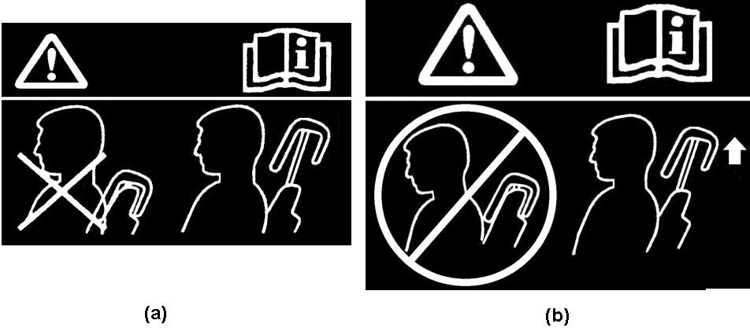
Figure 1. Non-use warning labels

5.8. Dynamic performance requirements:

5.8.1. Each head restraint, when tested during forward acceleration or deceleration of the dynamic test platform, in accordance with Annex 9, shall conform to the requirements of paragraph 5.8.2.

5.8.2. Each head restraint shall limit the maximum rearward head O.C. (occipital condyle) anterior/posterior movement, relative to T1 (First Thoracic Vertebra) adjusted by the seat back posterior inclination angle, to [52] mm for the dummy;

Paragraphs 5.5. to 5.12. (former), should be deleted

Paragraph 5.13. (former), renumber as 5.9. and amend to read:

"5.9. …………. maximum operational height, or remove it, except by …………."

Paragraph 5.14. (former), renumber as 5.10. and amend to read:

"5.10. ………….after testing in accordance with Annex 6, paragraph 4., no breakage of……. in paragraph 6.2. below without breakage."

Paragraph 5.15.1. (former), renumber as 5.11.1. and amend to read:

"5.11.1. ………….. after the test described in Annex 16, the seat-backs remain in position and …...
. ………
During the test described in Annex 16, the test blocks shall remain behind the seat-back(s) in question."

Paragraph 5.15.2. (former), renumber as 5.11.2. and amend to read:

"5.11.2. Partitioning systems

At the request of.…described in Annex 16 may be carried …………

Partitioning systems,……. to paragraph 2.2. of Annex 16.
……………..
For integrated….one defined in paragraph 5.11.1. All measurements ……….."

Paragraph 5.15.3. (former), renumber as 5.11.3. and amend to read:

"5.11.3. The requirements mentioned in paragraphs 5.11.1. and 5.11.2. above shall not apply to………………….described in paragraphs 5.11.1. and 5.11.2."

Paragraph 6.1.1., amend to read:

"6.1.1. ……..described in Annex 6, unless otherwise specified by the manufacturer."

Paragraph 6.2.1., amend to read:

"6.2.1. …….shown in Annex 13, Appendix 1, to this Regulation. In the case of ………."

Paragraph 6.3.1., amend to read:

"6.3.1. …… of Annex 15, paragraph 1. At the request of the manufacturer, the test pulse described in the Appendix of Annex 16, may be used alternatively."

Paragraph 6.3.5., amend to read:

"6.3.5. …….in paragraph 2. of Annex 15 to this Regulation……."

Paragraph 6.4.3., amend to read:

"6.4.3. Test for determining rearward displacement for head restraint.

The procedures for testing rearward displacement and strength are as specified in Annex 6."

Paragraphs 6.4.3.1 to 6.4.3.6., should be deleted

Insert a new paragraph 6.4.4., to read:

"6.4.4. Demonstrate compliance with paragraphs 5.5. through 5.7. of this Regulation with any adjustable lumbar support adjusted to its most rearward nominal design position. If the seat cushion adjusts independently of the seat back, position the seat cushion such that the lowest H-point position is achieved with respect to the seat back. These conditions, however, may be superseded by the detailed test procedures described in the Annexes."

Paragraph 6.5.1., amend to read:

"6.5.1. The height of any head restraint is determined in accordance with Annex 1."

Paragraphs 6.5.2. to 6.5.4., should be deleted.

Paragraphs 6.6. and 6.6.1., amend to read:

"6.6. Determination of the width of the head restraint
(see figure 2 of Annex 4 to this Regulation)

6.6.1. The width of any head restraint is determined in accordance with Annex 2."

Paragraphs 6.7. and 6.7.1., amend to read:

"6.7. Determination of distance "a" of head restraint gaps
(see annex 8 of this Regulation)

6.7.1. The distance "a" of head restraint gaps is determined in accordance with Annex 3."

Paragraphs 6.7.2. and 6.7.3., should be deleted

Paragraph 6.8.1.3.1., amend to read:

"6.8.1.3.1. …..or the bench seats situated above a horizontal plane through the R-point of the seat, but excluding parts situated in …."

Paragraph 6.9., amend to read:

"6.9. …..above and Annex 14 is used, its equivalence shall be proved."

Paragraph 7.1., amend to read:

"7.1. …….in paragraphs 2.12. and 2.30. above, nothing shall prevent the ………."

Paragraph 8.2., amend to read:

"8.2. ……..conforming to the model in Annex 11 to this Regulation."

Paragraph 9.3., amend to read:

"9.3. …….conforming to the model in Annex 11 to this Regulation."

Paragraph 10.1., amend to read:

"10.1. …..conforming to the model in Annex 11 to this Regulation."

Paragraphs 13. to 13.6., amend to read:

"13. TRANSITIONAL PROVISIONS

13.1. As from the official date of entry into force of the 07 series of amendments, no Contracting Party applying this Regulation shall refuse to grant ECE approvals under this Regulation as amended by the 07 series of amendments.

13.2. As from 24 months after the date of entry into force of the 07 series of amendments, Contracting Parties applying this Regulation shall grant ECE approval only if the vehicle type to be approved complies with the requirements of this Regulation as amended by the 07 series of amendments.

13.3. As from 48 months after the date of entry into force of the 07 series of amendments, existing approvals to this Regulation shall cease to be valid, except in the case of vehicle types which comply with the requirements of this Regulation as amended by the 07 series of amendments.

13.4. As from the official date of entry into force of the [08] series of amendments, no Contracting Party applying this Regulation shall refuse to grant ECE approvals under this Regulation as amended by the [08] series of amendments.

13.5. As from [24] months after the date of entry into force of the [08] series of amendments, Contracting Parties applying this Regulation shall grant ECE approval only if the vehicle type to be approved complies with the requirements of this Regulation as amended by the [08] series of amendments.

13.6. As from [48] months after the date of entry into force of the [08] series of amendments, existing approvals to this Regulation shall cease to be valid, except in the case of vehicle types which comply with the requirements of this Regulation as amended by the [08] series of amendments."
Insert new Annexes 1 to 10, to read:

"Annex 1

Minimum Height Measurement Test Procedure

1. PURPOSE

The purpose of this test procedure is to demonstrate compliance with the minimum height requirements described in paragraph 5.5.2. of this Regulation.

2. PROCEDURE FOR HEIGHT MEASUREMENT

Compliance with the requirements of paragraph 5.5.2. of this Regulation shall be demonstrated by using the height measurement apparatus defined in paragraph 2.2. below.

The seat shall be adjusted such that its H-point coincides with the R-point; if the seat back is adjustable, it is set at the design seat back angle; both these adjustments shall be in accordance with the requirements of paragraph 2.1. below. The height of the head restraint shall be the distance between point A and the intersection of lines AE and FG.

2.1. Relationship between the H-point and the R-point

When the seat is positioned in accordance to the manufacturer's specifications, the H-point, as defined by its co-ordinates, shall lie within a square of 50 mm side length with horizontal and vertical sides whose diagonals intersect at the R-point, and the actual torso angle shall be within 5 degree of the design torso angle.

2.1.1. If these conditions are met, the R-point and the design torso angle shall be used to determine the height of the head restraints in accordance with this annex.

2.1.2. If the H-point or the actual torso angle does not satisfy the requirements of paragraph 2.1., the H-point and the actual torso angle shall be determined twice more (three times in all). If the results of two of these three operations satisfy the requirements, the conditions of paragraph 2.1.1. shall apply.

2.1.3. If the results of at least two of the three operations described in paragraph 2.1.2. do not satisfy the requirements of paragraph 2.1., the centroid of the three measured points or the average of the three measured angles shall be used and be regarded as applicable in all cases where the R-point or the design torso angle is referred to in this annex.

2.2. Height measuring apparatus

The height measurement apparatus consists of (see Figure 1-1):

2.2.1. A straight edge AE. The lower point A is placed at the R-point location in accordance with paragraph 2.1. of this annex. The line AE shall be parallel to the design torso angle.

2.2.2. A straight edge FG, perpendicular to the line AE and in contact with the top of the head restraint. The height of the head restraint shall be the distance between point A and the intersection of the lines AE and FG.

2.3. Height measurement for front outboard head restraints

2.3.1. If adjustable, adjust the top of the head restraint to the highest position and measure the height.

If adjustable, adjust the top of the head restraint to the lowest position intended for normal use, other than any non-use position described in paragraph 5.7. of this Regulation, and measure the height.

2.3.2. For front outboard head restraints that are prevented by the interior surface of the vehicle roofline from meeting the required height as specified in paragraph 5.5.2.21. of this Regulation, the requirements of paragraph 5.5.2.3. of this Regulation shall be assessed by the following procedure:

2.3.2.1. Adjust the head restraint to its maximum height and measure the clearance between the top of the head restraint and the interior surface of the roofline or the rear backlight, by attempting to pass a 25 ± 0.5 mm sphere between them. In the case of convertibles, the diameter of the sphere shall be 50 ± 0.5 mm.

2.3.2.2. Adjust the top of the head restraint to the lowest position of adjustment intended for normal use, other than any non-use position described in paragraph 5.7. of this Regulation, and measure the height.

2.4. Height measurement for front centre and rear outboard head restraints

2.4.1. If adjustable, adjust the top of the head restraint to the lowest position of adjustment intended for normal use, other than any non-use position described in paragraph 5.7. of this Regulation and measure the height.

2.4.2. For head restraints that are prevented by the interior surface of the vehicle roofline or rear backlight from meeting the required height as specified in paragraph 5.5.2.2. or 5.5.2.4. of this Regulation, the requirements of paragraphs 5.5.2.3. and 5.5.2.5. shall be assessed by the following procedure:

2.4.2.1. If adjustable, adjust the head restraint to its maximum height and measure the clearance between the top of the head restraint or the seat back at all seat back angles for intended use and the interior surface of the roofline or the rear backlight, by attempting to pass a 25 ± 0.5 mm sphere between them. In the case of convertibles, the diameter of the sphere shall be 50 ± 0.5 mm.

E
R
A
F
G
Head restraint height (mm)
Design Torso
angle
Figure 1-1
Annex 2

MINIMUM WIDTH MEASUREMENT TEST PROCEDURE

1. PURPOSE

The purpose of this test procedure is to demonstrate compliance with the minimum width requirements described in paragraph 5.5.3. of this Regulation.

2. PROCEDURE FOR WIDTH MEASUREMENT

2.1. The seat shall be adjusted such that its H-point coincides with the R-point; if the seat back is adjustable, it is set at the design seat back angle; both these adjustments shall be in accordance with the requirements of paragraph 2.1. of Annex 1.

2.2. The plane S1 is a plane perpendicular to the reference line and situated 65 ± 3 mm below the top of the head restraint.

2.3. Planes P and P' are vertical longitudinal planes, tangent to each side of the head restraint to be measured.

2.4. Measure the distances L and L' in the plane S1 between the vertical longitudinal planes passing through the torso line and the planes P and P'.

65±3mm b33mm3mm
Vertical Plane P
Vertical plane P'
Plane S1
S
Torso line on vertical median plane of seat
R
L
L'
Figure 2-1
Annex 3

Gap measurement procedures

1. PURPOSE

The purpose of this test procedure is to evaluate any gaps within head restraints as well as gaps between the bottom of the head restraint and the top of the seat back, in accordance with the requirements of paragraphs 5.5.4. and 5.5.5. of this Regulation.

Any gaps within the head restraint shall be measured using the sphere procedure described in paragraph 2. below.

Gaps between the bottom of the head restraint and the top of the seat back shall be measured using the sphere procedure described in paragraph 2. below or, at the option of the manufacturer, using the linear procedure described in paragraph 3. below.

2. GAP MEASUREMENT USING A SPHERE

2.1. The seat shall be adjusted such that its H-point coincides with the R-point; if the seat back is adjustable, it is set at the design seat back angle; both these adjustments shall be in accordance with the requirements of paragraph 2.1. of Annex 1.

2.2. The head restraint shall be adjusted to its lowest height position and any backset position intended for occupant use.

2.3. The area of measurement is anywhere on the front surface of the head restraint between two vertical longitudinal planes passing at 85 mm on either side of the torso line and above the top of the seat back.

2.4. Applying a load of no more than 5 N against the area of measurement specified in paragraph 2.2. above, place a 165 ± 2 mm diameter spherical headform against any gap such that at least two points of contact are made within the area.

2.5. Determine the gap dimension by measuring the straight line distance between the inner edges of the two furthest contact points, as shown in Figures 3-1 and 3-2.

2.6. For gaps within the head restraint, not exceeding 60 mm, no further measurements shall be made.

2.7. For gaps within the head restraint, exceeding 60 mm, in order to demonstrate compliance with the requirements of paragraph 5.5.4. of this Regulation, the seat back displacement test procedure described in Annex 6 shall be performed, by applying to each gap, using a sphere of 165 mm in diameter, a force passing through the centre of gravity of the smallest of the sections of the gap, along transversal planes parallel to the torso line, and reproducing a moment of 373 Nm about the R-point.

A
A
a
165mm dia. sphere
Section A-A
Figure 3-1 - Measurement of a horizontal gap "a".

A
A
165mm dia.
sphere
Section A-A
a
Figure 3-2 - Measurement of a vertical gap "a".

3. VERTICAL MEASUREMENT OF GAP BETWEEN SEAT BACK AND HEAD RESTRAINT

3.1. The seat shall be adjusted such that its H-point coincides with the R-point; if the seat back is adjustable, it is set at the design seat back angle; both these adjustments shall be in accordance with the requirements of paragraph 2.1. of Annex 1.

3.2. The head restraint shall be adjusted to its lowest height for normal occupant use and any backset position intended for occupant use.

3.3. The gap shall be measured as the perpendicular distance between two parallel planes, described as follows (see Figure 3-3):

(a) each plane shall be perpendicular to the design torso line;
(b) one of the planes shall be tangent to the bottom of the head restraint;
(c) the other plane shall be tangent to the top of the seat back.

R
Figure 3-3
Annex 4

BACKSET MEASUREMENT PROCEDURE

1. PURPOSE

Demonstrate compliance with paragraph 5.5.6. by measurement of the backset.

Two methods are available in accordance with paragraph 5.5.6.2.:

(a) using the H-point as the backset reference point (see paragraph 2. below).
or
(b) using the R-point as the backset reference point (paragraph 3. below).

2. BACKSET MEASUREMENT USING THE H-POINT AS BACKSET REFERENCE POINT

Demonstrate compliance with paragraph 5.5.6.3. by measuring the backset of the head restraint using the three-dimensional H-point machine, defined in Annex 13, Appendix 1, and the HRMD (see Annex 5). This procedure uses the H-point as the initial backset reference point.

2.1. The test vehicle shall be levelled using the door sill (front to rear level) and centre luggage compartment (side to side level) as reference points.

2.2. The test vehicle shall be preconditioned at a temperature of 20 °C ± 10 °C to ensure that the seat material reaches room temperature.

2.3. Remove the head-room probe from the three-dimensional H-point machine and install the two washers (supplied with the HRMD) in the spaces remaining on the H point pivot.

2.4. Set up the seat as described in Annex 13, paragraph 3.3. If the seat back is adjustable, it is set at an initial inclination position closest to design angle as measured by the three-dimensional H-point machine. If there is more than one inclination position closest to design angle, set the seat back inclination to the position closest to and rearward of the design angle.

2.5. Set up the H-point machine as described in Annex 13, paragraphs 3.4. through 3.10.

2.6. Confirm the H-point assembly is level, facing directly forward and located in the centreline of the vehicle seat. As necessary reposition the seat pan.

2.7. Install the right and left buttock weights. Install four of the torso weights used in Annex 13, paragraph 3.11., and the two larger HRMD chest weights; alternating left to right. The HRMD torso weights shall be installed last and with the flat side down. Maintain H-point machine level.

2.8. Confirm the actual torso angle is ± 1° of the design torso angle by placing an inclinometer on the lower brace of the torso weight hangers. If the measured angle is outside this range, if possible adjust the seat back angle to be ± 1° of the design seat back angle. If an adjustment is made, remove the buttock and torso weights and repeat the steps contained in paragraphs 3.9. through 3.10. of Annex 13, along with steps as described in paragraphs 2.6. and 2.7. of this annex until the actual torso angle is ± 1° of the design seat back angle.

2.9. Perform the steps contained in paragraph 3.12. of Annex 13.

2.10. Attach the HRMD to the three-dimensional H-point machine.

2.11. Confirm the actual torso angle remained ± 1° of the design seat back angle by placing an inclinometer on the lower brace of the torso weight hangers. If the actual torso angle is outside this range, if possible carefully adjust the seat back angle to be ± 1° of the design seat back angle. If the legs and seat pan of the three-dimensional H-point machine move during this procedure, remove the HRMD, the buttock and torso weights, and repeat the steps contained in paragraphs 3.9. through 3.11. of Annex 13, along with steps as described in paragraph 2.6. through 2.10. of this annex until the actual torso angle is ± 1° of the design seat back angle.

2.12. Level the HRMD and extend the sliding scale on the back of the head until it contacts the head restraint. Confirm that the scale is positioned laterally within 15 mm of the head restraint centreline and take the backset measurement.

3. BACKSET MEASUREMENT USING THE R-POINT AS BACKSET REFERENCE POINT

3.1. Backset measuring apparatus

The backset measurement apparatus consists of (see Figure 4-1):

3.1.1. A straight edge (lower arm) AB. The lower point A is placed at the R point location. Point B is located at a distance of 504.5 mm from the R point. The line AB shall be 2.6 degrees forward to the design torso angle.

3.1.2. A straight edge (upper arm) BC. Point C is located at a distance of 203 mm vertically up from point B.

3.2. Adjust the seat such that its H-point coincides with the R-point, in accordance with the following requirements.

3.2.1. Relationship between the H-point and the R-point

When the seat is positioned in accordance to the manufacturer's specifications, the H-point, as defined by its co-ordinates, shall lie within a square of 50 mm side length with horizontal and vertical sides whose diagonals intersect at the R-point, and the actual torso angle shall be within 5 degree of the design torso angle.

3.2.2. If these conditions are met, the R-point and the design torso angle shall be used to demonstrate compliance with the provisions of paragraph 5.5.6. of this Regulation.

3.2.3. If the H-point or the actual torso angle does not satisfy the requirements of paragraph 3.2.1., the H-point and the actual torso angle shall be determined twice more (three times in all). If the results of two of these three operations satisfy the requirements, the conditions of paragraph 3.2.2. shall apply.

3.2.4. If the results of at least two of the three operations described in paragraph 3.2.3. do not satisfy the requirements of paragraph 3.2.1., the centroid of the three measured points or the average of the three measured angles shall be used and be regarded as applicable in all cases where the R-point or the design torso angle is referred to in this annex.

3.3. Adjust the seat back to its design angle.

3.4. Adjust the front head restraint so that its top is at any height between and inclusive of 750 mm and 800 mm. If the lowest position of adjustment is above 800 mm, adjust the head restraint to that lowest position of adjustment.

3.5. In the case of head restraint with adjustable backset, adjust the head restraint at the most rearward position, such that the backset is in the maximum position.

3.6. Establish point D on the head restraint, point D being the intersection of a line drawn from point C horizontally in the x-direction, with the front surface of the head restraint.

3.7. Measure the distance CD. The backset shall be the measured distance CD minus 71 mm.

C
R
A
B
D
504.5mm
Design Torso
Angle – 2.6°
203mm
Figure 4-1

Annex 5

Head Restraint Measuring Device (HRMD)

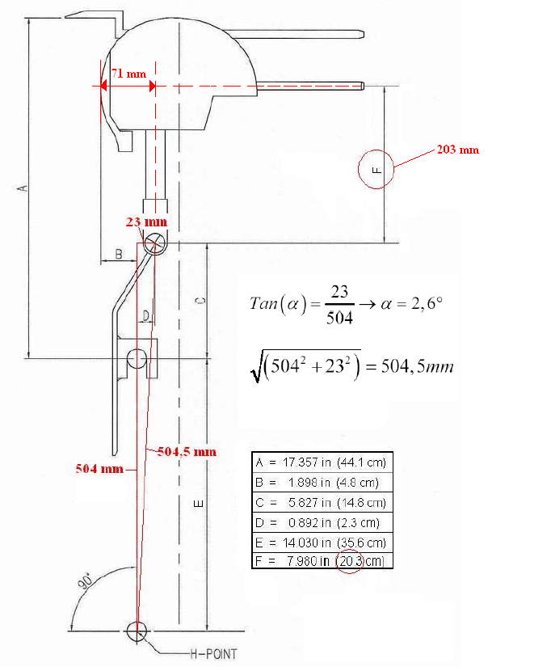

Annex 6

Displacement, Backset Retention and Strength Test Procedures

1. PURPOSE

To demonstrate compliance with the requirements of paragraphs 5.6.2. and 5.6.3 of this Regulation.

2. PROCEDURES FOR DISPLACEMENT

The load vectors that generate moment on the head restraint are initially contained in a vertical plane parallel to the vehicle longitudinal centreline.

2.1. Seat set-up

If the seat back is adjustable, it is adjusted to a position specified by the vehicle manufacturer. If there is more than one inclination position closest to the position specified by the manufacturer, set the seat back inclination to the position closest to and rearward of the manufacturer specified position. If the head restraint position is independent of the seat back inclination position, compliance is determined at a seat back inclination position specified by the manufacturer. Adjust the head restraint to the highest position of vertical adjustment intended for occupant use. Adjust the head restraint to the rearmost (relative to the seat) position of horizontal adjustment backset position.

2.2. In the seat, place a test device having, when viewed laterally, the back pan dimensions and torso reference line (vertical centre line) of the three dimensional H-point machine, as specified in Annex 13, with the head room probe in the full back position.

2.3. Establish the displaced torso reference line 'r1' by creating a rearward moment of 373 ± 7.5 Nm about the R-point by applying a force to the seat back through the back pan at the rate of 2.5 Nm/second to 37.3 Nm/second. The initial location on the back pan of the moment generating force vector has a height of 290 mm ± 13 mm. Apply the force vector normal to the torso reference line and maintain it within 2 degrees of a vertical plane parallel to the vehicle longitudinal centreline. Constrain the back pan to rotate about the R-point. Rotate the force vector direction with the back pan. (see Figure 6-1)

r₁
r: reference line
r₁: displaced reference line
r
2a
1
R
Figure 6-1.

Notes:

Position 1. Original unloaded position.

Position 2a. Displaced position by applying to the manikin's back a moment of 373 ± 7.5 Nm about the R-point, defining the position of the displaced torso reference line 'r₁'.

2.4. Maintain the position of the back pan as established in paragraph 2.3. of this annex. Using a 165 ± 2 mm diameter spherical headform establish the headform initial reference position by applying, perpendicular to the displaced torso line, a rearward initial load at the seat centreline at a height 65 ± 3 mm below the top of the head restraint that will produce a 373 ± 7.5 Nm moment about the R-point. Maintain this moment for at least 5 seconds and then record the rearward displacement of the headform with the load applied.

2.5. When determining the rearward displacement for head restraints at a gap greater than 60 mm in accordance with paragraph 5.5.4 of this Regulation, the above load shall be applied through the centre point of the smallest of the sections of the gap, along transversal planes parallel to the torso line (see Figure 6-2).

Ø165mm
F
S
r₁
65mm
X
r
2b
3
R
Tangent Y
Figure 6-2.

Notes:

Position 2b. Displaced position by applying to the 165 mm sphere a force F producing a moment of 373 ± 7.5 Nm about the R-point, keeping the displaced torso reference line 'r1' in place.

Position 3. Position after displacement by the force F increased to 890 ± 5 N.

2.6. If the presence of gaps prevents the application of the force, as described in paragraph 2.4. of this annex at 65 ± 3 mm from the top of the head restraint, the distance may be reduced so that the axis of the force passes through the centre line of the frame element nearest to the gap.

2.7. Increase the initial load at the rate between 2.5 Nm/second and 37.3 Nm/second until a 373 ± 7.5 Nm moment about the R-point is produced. Maintain the load level producing that moment for not less than 5 seconds and then measure the rearward displacement of the headform relative to the displaced torso reference line.

3. Procedure for backset retention and displacement.

3.1. If the seat back is adjustable, it is adjusted to a position specified by the vehicle manufacturer. If there is more than one inclination position closest to the position specified by the manufacturer, set the seat back inclination to the position closest to and rearward of the manufacturer specified position. If the head restraint position is independent of the seat back inclination position, compliance is determined at a seat back inclination position specified by the manufacturer. Adjust the head restraint to the rearmost (relative to the seat) position of horizontal adjustment backset position. Adjust the head restraint to the highest position of vertical adjustment intended for occupant use.

3.2. Adjust the head restraint to any backset position.

3.3. In the seat, place a test device having the back pan dimensions and torso line (vertical centre line), when viewed laterally, with the head-room probe in the full back position, of the three-dimensional H-point machine;

3.4. Establish the displaced torso line by creating a posterior moment of 373 ± 7.5 Nm about the R-point by applying a force to the seat back through the back pan at the rate between 2.5 Nm/second and 37.3 Nm/second. The initial location on the back pan of the moment generating force vector has a height of 290 mm ± 13 mm. Apply the force vector normal to the torso line and maintain it within 2 degrees of a vertical plane parallel to the vehicle longitudinal centreline. Constrain the back pan to rotate about the R-point. Rotate the force vector direction with the back pan.

3.5. Maintain the position of the back pan as established in paragraph 3.4. of this annex. Using a 165 ± 2 mm diameter spherical headform, establish the headform initial reference position by applying, perpendicular to the displaced torso line, a rearward initial load at the seat centreline at a height 65 ± 3 mm below the top of the head restraint that will produce a 37 ± 0.5 Nm moment about the R-point. Measure the rearward displacement of the headform during the application of the load.

3.6. If the presence of gaps prevents the application of the force, as described in paragraph 3.5. of this annex at 65 ± 3 mm from the top of the head restraint, the distance may be reduced so that the axis of the force passes through the centre line of the frame element nearest to the gap.

3.7. Increase the initial load at the rate of 2.5 Nm/second to 37.3 Nm/second until a 373 ± 7.5 Nm moment about the R-point is produced. Maintain the load level producing that moment for not less than 5 seconds and then measure the rearward displacement of the headform relative to the displaced torso line.

3.8. Reduce the load at the rate of 2.5 Nm/second to 37.3 Nm/second until 0 Nm. Wait 10 minutes. Re-load to 37 ± 0.7 Nm about the R-point. While maintaining the load level producing that moment, measure the rearward displacement of the headform position with respect to its initial reference position.

4. Strength.

4.1. Increase the load specified in paragraph 3.8. of this annex at a rate between 5 N/second and 200 N/second to 890 N ± 5 N and maintain the applied load for not less than 5 seconds without any breakage of the seat or head restraint.

Annex 7

Energy Absorption Test Procedure for Head Restraint

1. PURPOSE

Evaluate the energy absorption ability of the head restraint by demonstrating compliance with paragraph 5.6.1. of this Regulation in accordance with this Annex.

2. SEAT SET-UP

The seat shall be either mounted in the vehicle or firmly secured to the test bench, as mounted in the vehicle with the attachment parts provided by the manufacturer, so as to remain stationary when the impact is applied. The seat back is adjusted as specified in paragraph 6.1.1. of the Regulation. The head restraint shall be mounted on the seat-back as in the vehicle. Where the head restraint is separate, it shall be secured to the part of the vehicle structure to which it is normally attached.

3. PROCEDURES FOR ENERGY ABSORPTION

Adjustable head restraints shall be measured in any height and backset position of adjustment.

3.1. Test equipment.

3.1.1. Use an impactor with a semispherical headform of a 165 ± 2 mm diameter for the impacting part of the impactor. The headform and associated base have a combined mass such that at a speed of not more than 24.1 km/h at the time of impact an energy of 152 ± 6 Joule will be reached.

3.1.2. Instrument the impactor with an acceleration sensing device whose output is recorded in a data channel that conforms to the requirements for a 600 Hz channel class filter as specified in ISO Standard 6487 (2002); The axis of the acceleration-sensing device coincides with the geometric center of the headform and the direction of impact. As an alternative the impactor can be equipped with 2 accelerometers sensing in the direction of impact and placed symmetrically in comparison to the geometric centre of the spherical headform. In this case the deceleration rate shall be taken as the simultaneous average of the readings on the two accelerometers.

3.2. Accuracy of the test equipment.

The recording instruments used shall be such that measurements can be made with the following degrees of accuracy:

3.2.1. Acceleration:

Accuracy = ± 5 per cent of the actual value;
Cross-axis sensitivity = < 5 per cent of the lowest point on the scale.

3.2.2. Speed:

Accuracy: ± 2.5 per cent of the actual value;
Sensitivity: 0.5 km/h.

3.2.3. Time recording:

The instrumentation shall enable the action to be recorded throughout its duration and readings to be made to within one one-thousandth of a second;

The beginning of the impact at the moment of first contact between the headform and the item being tested shall be detected on the recordings used for analyzing the test.

3.3. Test procedure

3.3.1. Propel the impactor toward the head restraint. At the time of impact the impactor speed shall be not more than 24.1 km/h.

3.3.2. Impact the front contact surface of the seat or head restraint at any point with a height greater than 635 mm from the R-point and within a distance of 70 mm from the head restraint vertical centreline and measure the deceleration.

3.3.2.1. For the front face of the head restraint, the direction of impact from the front towards the rear shall be within ± 2 degrees of being horizontal and parallel to the vehicle longitudinal axis.

3.3.2.2. For the rear face, the direction of impact from the rear towards the front shall be in a longitudinal plane at an angle of 45° downwards from the vertical.

3.3.3. The front and rear zones are respectively bounded by the horizontal plane tangential to the top of the head restraint as determined in paragraph 6.5. of this Regulation.

Annex 8

Height Retention Test Procedure

1. PURPOSE

Demonstrate compliance with paragraph 5.6.4. of this Regulation in accordance with this annex.

2. PROCEDURES FOR TEST

2.1. Seat set-up.

Adjust the adjustable head restraint so that its top is at any of the following height positions at any backset position:

2.1.1. For front outboard designated seating positions:

2.1.1.1. The highest position; and

2.1.1.2. Not less than, but closest to 800 mm;

2.1.2. For rear outboard and front centre designated seating positions:

2.1.2.1. The highest position; and

2.1.2.2. Not less than, but closest to 750 mm.

2.1.3. For rear centre designated seating positions:

2.1.3.1. The highest position; and

2.1.3.2. Not less than, but closest to 700 mm.

2.2. Orient a cylindrical test device having a 165 ± 2 mm diameter in plane view (perpendicular to the axis of revolution), and a 152 ± 2 mm length in profile (through the axis of revolution) such that the axis of the revolution is horizontal and in the longitudinal vertical plane through the longitudinal centreline of the head restraint. Position the midpoint of the bottom surface of the cylinder in contact with the head restraint.

2.3. Establish initial reference position by applying a vertical downward load of 50 ± 1 N at a rate of 250 ± 50 N/minute. Determine the reference position of the cylinder after 5 seconds while maintaining this load. Mark the initial reference position for the head restraint.

2.4. Measure the vertical distance between the lowest point on the underside of the head restraint and the top of the seat back (see paragraph 2.9.).

2.5. Increase the load at the rate of 250 ± 50 N/minute to at least 500 N and maintain this load for not less than 5 seconds.

2.6. Reduce the load at a rate of 250 ± 50 N/m until the load is completely removed. Maintain this condition for no more than two minutes. Increase the load at a rate of 250 ± 50 N/minute to 50 ± 1 N and, after 5 seconds and while maintaining this load, determine the position of the cylindrical device with respect to its initial reference position.

2.7. Repeat the measurement of the vertical distance measured between the lowest point on the underside of the head restraint and the top of the seat back. (see paragraph 2.9. of this annex)

2.8. Compare the measurements from paragraphs 2.4. and 2.7. The difference is the measurement required to comply with paragraph 5.6.4. of the Regulation.

2.9. If the design of the head restraint is such that it is not possible to measure to the top of the seat then the vertical measurement shall be taken by marking a horizontal line across the front of the seat back at least 25 mm below the lowest point of the head restraint and the measurement shall be taken from this line to the underside of the head restraint.

Annex 9

Dynamic Performance Test Procedure

1. PURPOSE

Demonstrate compliance with paragraph 5.8. of this Regulation in accordance with this Annex, using a 50th percentile male BioRID II test dummy.

2. TEST CONDITIONS

The test procedure described in this annex is to be performed using any or all of the following as appropriate:

2.1 A seat equipped with its head restraint and all necessary attachment hardware, as well as all necessary equipment for the activation of dynamic head restraint which is triggered externally to the seat. Where manufacturer requests, a seat belt, equivalent of that used in the vehicle, and its anchorages may be used.

2.2 When additional support is provided by the vehicle body structures, a vehicle body in white including at least the seat to be tested and all necessary seat and head restraint equipment, as well as all necessary equipment for the activation of dynamic head restraint which is triggered externally to the seat. Where manufacturer requests, a seat belt and its anchorages may be used.

3. TEST EQUIPMENT

3.1. An acceleration or deceleration test sled

3.2. Dummy

3.2.1. The dummy shall be a BioRID II 50th percentile male test dummy.

3.3. Recording equipment required:

3.3.1. Film targets, as described in Figure 9-1 and Table9-1, shall be applied on the head, T1 bracket, seat back frame upper indication bracket and seat back recliner or lower part of the seat back frame lower, at the side which the test institutes in consultation with the manufacturer consider to be more appropriate for the test.

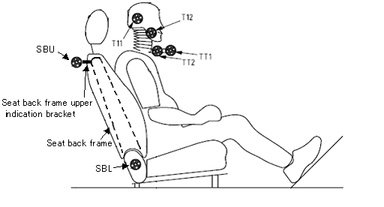
Figure 9-1 Video motion target placements

Table 9-1 Video motion target placement description
Target Number | Target location
T11 | Head centre of gravity  The detailed location of the head centre of gravity target is below. The x-axis location is 63.5±2.5 mm from the interface surface between the skull and the skull cap. The z-axis location is 35.6±2.5 mm from the bottom surface of the skull.
T12 | Head second target to determine the location of the OC position to take account of the head rotation ((ex.)Cheek).
TT1 | T1 bracket distal
TT2 | T1 bracket proximal
SBU | Seat back frame upper indication bracket.  The bracket is rigidly installed in the seat back frame upper which the test institutes in consultation with the manufacturer consider to be more appropriate for the test.
SBL | Seat back recliner

3.3.2. A camera shall be mounted off-board, perpendicular to the direction of sled travel, at the side of the sled to be tested. It shall show a side view of the torso, head, the complete seat, and video motion targets. The seat back, the head restraint, the upper body parts of the test dummy, and video motion targets shall be visible on the film/video during a time interval equal to or longer than 250 ms after the onset of the sled deceleration/acceleration (t0). The camera frame rate shall be equal to or greater than 500 frames/sec. The camera system meets the SAE J211-2 part 2.

3.3.3. Equipment for measuring and recording sled accelerations.

4. PROCEDURES FOR TEST SET-UP

4.1. Mount the seat, including all of its adjustment mechanisms and hardware that normally connects it to the vehicle floor and toe board which consists of a horizontal section and a section oriented 45° from the horizontal, or vehicle body in white as appropriate according to paragraph 2 of this Annex on a dynamic test platform so that the seat’s orientation relative to the horizontal is the same as it would be in its vehicle and so that movement between the attachment hardware and the test platform is prevented. The gap between the front of the seat and rear of the toe board shall be no more than 100 mm. Instrument the platform with an accelerometer and data processing system. Position the accelerometer sensitive axis parallel to the direction of test platform travel.

4.2. Seat Adjustment

4.2.1. For each seat to be tested, if the seat back is adjustable, it shall be set to its design angle.

4.2.2. Using any control that primarily moves the entire seat vertically, place the seat in the mid height position. Using any control that primarily moves the entire seat in the fore and aft directions, place the seat midway between the most forward and most rearward position. If an adjustment position does not exist midway between those positions, the closest adjustment position to the rear of the midpoint shall be used.

4.2.3. If the seat cushion adjusts independently of the seat back, position the seat cushion such that the highest H-point position is achieved with respect to the seat back, measured by three-dimensional H-point machine as specified in Annex 13. If the specified position of the H-point can be achieved with a range of seat cushion inclination angles, adjust the seat inclination such that the most forward part of the seat cushion is at its lowest position with respect to the most rearward part. Side bolsters shall be set to the widest position. Arm rests shall be set in the stowed position.

4.2.4. If the head restraint is adjustable, adjust the top of the head restraint to a position midway between the lowest position of adjustment and the highest position of adjustment. If an adjustment position midway between the lowest and the highest position does not exist, adjust the head restraint to the position determined by the next process. If a hard locking position exists within 10mm vertically upwards from the geometric mid-position, this shall be the test position. If no hard locking position exists within 10mm vertically upwards from the geometric mid-position then the next hard locking position down shall be the test position. When the head restraint has a locking fore-aft adjustment, it shall be in the midpoint. If non-locking, the head restraint shall be tilted fully rearward.

4.2.5. Adjustable lumbar supports shall be positioned so that the lumbar support is in its lowest retracted or deflated position.

4.3. Seat Belt Adjustment

When using the seat belt, prior to placing the seat belt around the test dummy, fully extend the webbing from the seat belt retractor(s) and release it three times to remove slack. If an upper adjustable seat belt turning loop (adjustable seat belt D-ring anchorage) exists, place it in the adjustment position closest to the mid-position. If an adjustment position does not exist midway between the highest and lowest position, the closest adjustment position above the midpoint shall be used.

4.4. BioRID II Test dummy positioning procedure.

4.4.1 The seat shall have already been set to give the design torso angle ± 1 degree measured on the H-Point machine fitted with HRMD (see Annex 5).
Place the test dummy in the seating position equipped with a head restraint after allowing the seat to recover for 15 minutes with nothing in it.

4.4.2. Place the seat belt across the dummy and lock as normal.

4.4.3. Align the test dummy’s midsagittal plane with the centerline of the seat.

4.4.4. Adjust the test dummy’s midsagittal plane to be vertical; the instrumentation platform in the head shall be laterally level.

4.4.5. Adjust the pelvis angle to 26.5 degrees from horizontal (± 2.5 degrees).

4.4.6. Position the test dummy’s H-Point 20 ± 10 mm forward and 0 ± 10 mm vertically of the H-Point location measured under the condition specified in paragraph 2.12 of Annex 4, while keeping the pelvis angle at 26.5 ± 2.5 degrees.

4.4.7. Adjust the spacing of the legs so that the centreline of the knees and ankles is 200 mm(±10 mm) apart and ensure that the knees are level.

4.4.8. Adjust the test dummy’s feet and/or the horizontal position of the adjustable toe board so that the heel of the test dummy’s shoe is resting on the heel surface. The tip of the shoe shall rest on the toe pan between 230mm and 270mm from the intersection of the heel surface and toe board, as measured along the surface of the toe board (see Figure 9-2).

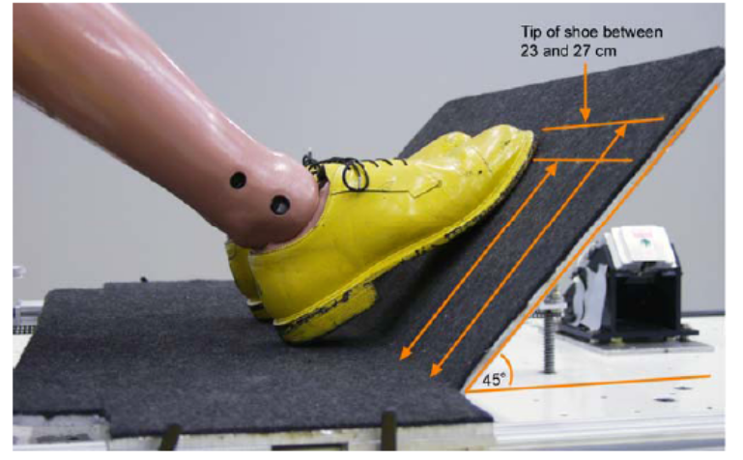
Figure 9-2 Proper positioning of the test dummy’s feet.

4.4.9. Position the test dummy’s arms so that the upper arms are as close to the torso sides as possible. The rear of the upper arms shall contact the seatback, and the elbows shall be bent so that the small fingers of both hands are in contact with the top of the vehicle seat cushion with the palms facing the dummy’s thighs.

4.4.10. Level the instrumentation plane of the head (front/rear and left/right directions) to within ± 1 degree.

4.4.11. Measure the test dummy reference backset, which is the horizontal distance between the rearmost point on the head and the same identifiable location on the head restraint. Compare the test dummy reference backset with the HRMD backset obtained by the procedure specified in paragraph 2.12 of Annex 4.

4.4.11.1. If the test dummy reference backset is different from the HRMD backset obtained by the procedure specified in paragraph 2.12 of Annex 4, then do the following:

4.4.11.1.1. Tip the head fore/aft no more than ± 1 degree from level in order to meet the backset requirement.

4.4.11.1.2. If the backset cannot be brought closer to the test dummy reference backset plus ±2mm by paragraph 4.7.10.1.1 of this Annex, adjust the pelvis angle and H-point position within their respective tolerance bands giving priority to use the pelvis angle tolerance. In this case begin at paragraph 4.7.4 of this Annex and adjust the test dummy position accordingly.

4.4.12. Remove the slack from the lap section of the webbing until it is resting gently around the pelvis of the dummy. Only minimal force shall be applied to the webbing when removing the slack. The route of the lap belt shall be as natural as possible and shall be above the pelvic angle gauge.

4.5. BioRID II dummy .

The following checks shall be made before putting the dummy in the seat for testing. The tests shall be conducted with a BioRID IIg dummy built with mould 2 jacket . The dummy shall comply with both spine stature and dynamic response specifications before the test.

4.5.1. Spine Curvature Check.
With the pelvis adapter plate placed on a level surface, the spine stature shall meet the specifications defined in Table 9-2 and Figure 9-3. The curvature check shall be performed after every 15 tests and all measurements shall be recorded and fully documented.

Table 9-2 BioRID IIg Spine Curvature Specifications

Measurement | Specification
Angle of occipital interface plate relative to horizontal | 29.5±0.5 degrees
Angle of T2 vertebra relative to horizontal | 37.0±0.5 degrees
Angle of neck plate (lateral) | 0±0.5 degrees
H-point indicator to occipital condyle pin (horizontal) | 156±5mm
H-point indicator to occipital condyle pin (vertical) | 609±5mm

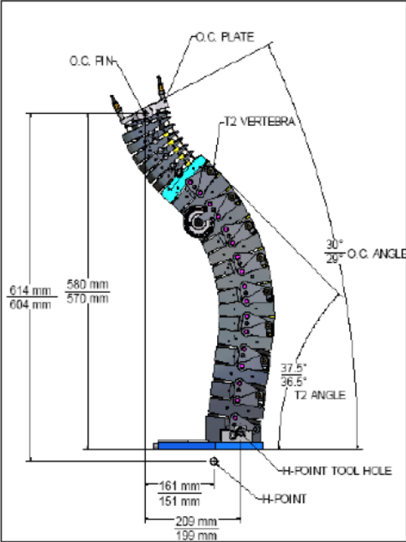
Figure 9-3 Spine curvature check

4.5.2 Calibration

The dynamic response of BioRID is checked by attaching the spine, torso, and head to a mini sled that is impacted through foam by a 33.4 kg probe at a velocity of 4.76 ± 0.1 m/s. The specified response of the dummy and detailed test specifications are described in Test Procedure: Calibration of BioRID II, available from Denton ATD, Inc. Generally, if the dummy’s spine curvature changes so that it does not meet the dimensional specifications described in section 4.8.1, then likely it will no longer meet the dynamic response specifications.

4.5.3. Adjustment of the dummy extremities

4.5.3.1. Arms

4.5.3.1.1. Extend the complete arm laterally outward to a horizontal position. Twist the arm so the elbow cannot rotate downward. Tighten the shoulder yoke clevis bolt so the arm is suspended at 1g.

4.5.3.1.2 Rotate the complete arm assembly so it points forward and is horizontal. Twist the arm so the elbow cannot rotate downward. Adjust the shoulder yoke rotation hexagonal nut so the arm is suspended at 1g.

4.5.3.1.3. Bend the elbow by 90 degrees so the hand moves toward the chest. Adjust the elbow rotation bolt through access in the upper arm to hold the lower arm horizontally suspended at 1g.

4.5.3.1.4. Reposition the arm so it points forward and is horizontal. Twist the lower arm at the elbow, so the lower arm can pivot downward to vertical. Adjust the elbow pivot bolt through access holes in the lower arm flesh at the elbow to hold the lower arm suspended at 1g.

4.5.3.1.5. Extend the arm and twist the palm so it faces down. Adjust the wrist pivot bolt at the base of the hand so it is suspended at 1g.

4.5.3.1.6. Adjust the wrist rotation bolt through access in the wrist flesh to hold it suspended at 1g.

4.5.3.1.7. Repeat the procedure for the other hand and arm.

4.5.3.2. Legs

4.5.3.2.1. Remove the jacket from the dummy.

4.5.3.2.2. With the lower leg at 90 degrees to the upper leg, and the dummy in seated position, lift the upper leg assembly above horizontal. Adjust the femur back set screw so the upper leg is held suspended at 1g.

4.5.3.2.3. Rotate the lower leg assembly so it is horizontal. Adjust the knee clevis bolt so the lower leg is held suspended at 1g.

4.5.3.2.4. Adjust the ankle ball joint screw so the foot is held suspended at 1g. The ankle adjustment is not critical and is determined by individual feet.

4.5.3.2.5. Repeat the procedure on the other leg and foot.

4.6. Dress and adjust each test dummy as follows:

The dummy shall be dressed with two pairs of close-fitting, knee-length, spandex/lycra pants and two close-fitting, short-sleeved spandex shirts. The under layer of clothes shall be worn with the shiny/smooth side of the fabric facing out and the over-clothes with the shiny/smooth side against the underclothes (i.e. dull side facing out). The dummies feet shall be fitted with size 11 (45 European or 279mm) Oxford-style, hard-soled, work shoes (e.g. MIL-S-13192P).

4.7. All tests specified in this Annex shall be conducted at an ambient temperature of 22 ± 3 °C and a relative humidity of between 10% and 70%. The dummy and seat being tested shall be soaked at this temperature at least 3 hours prior to the test.

4.8 Active elements (e.g. Active head restraint, Seat belt pretensioner) which operate in a rear impact situation shall be in an armed condition. For each element that requires a trigger, time to fire (TTF) should be specified by the vehicle manufacturer.

5. TEST PROCEDURE.

5.1. The corridors for the pulse are illustrated in Figure 9-4. The sled acceleration shall be adjusted within the corridors in Table 9-3 for the complete time interval from 0 to 0.15s. The sled pulse shall fulfil the requirements as specified in Table 9-4.

5.1.1. Data processing and definitions

5.1.1.1. Filter with CFC 60
To ensure that low level noise does not influence the results, the acceleration signal shall be filtered with a CFC60 filter. The CFC60 filter shall be used according to SAE J211, for sled acceleration signals.

5.1.1.2. T₀ definition
The T₀(T_{zero}) shall be defined as the time 5.8ms before the CFC60 filtered sled acceleration reaches a 1.0g level.

5.1.1.3. T_{end} definition
The time when the CFC60 filtered sled acceleration for the first time is < 0g shall be called T_{end}.

5.1.1.4. Time span definition
The time span for sled pulse corridor shall be defined as dT = T_{end} - T₀.

5.2. In order to track the trajectories of the test dummy and seat with reference to the sled, the following dimensions shall be recorded on the test dummy and seat at the side to be tested. All measurements shall be taken from the camera film plane to the reference targets and recorded in mm.

All target points used for analysis shall be depth scaled to compensate for any differences in the Y-coordinates. Compensation shall be included in the film analysis to taken account of parallax effects due to sled motion relative to the camera.

Using a suitable “target tracking” film analysis technique, generate traces as follows and filter these traces at [CFC30].

- T11 target displacement (absolute laboratory reference)
- T12 target displacement (absolute laboratory reference)
- TT1 target displacement (absolute laboratory reference)
- TT2 target displacement (absolute laboratory reference)
- SBU target displacement (absolute laboratory reference)
- SBL target displacement (absolute laboratory reference)

OC trace shall be produced from head target T11 and T12 traces. OC trace shall be calculated as following routine.

Record the vertical distance (OCx) and horizontal distance (OCz) from T11 to OC.

The head angle at each time step(θ_{head}(t))shall be produced from T11 and T12 .

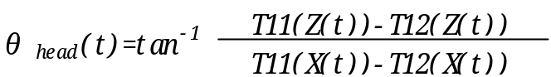
Where:
T11(X(t)) = InstantaneousT11 X position.
T11(Z(t)) = InstantaneousT11 Z position.
T12(X(t)) = InstantaneousT11 X position.
T12(Z(t)) = InstantaneousT11 Z position.

θ’_{head}(t) shall be generated by subtracting the initial head angle(θ_{head initial}) from the head angle(θ_{head}(t)).
θ’_{head}(t) = θ_{head}(t) - θ_{head initial}

OC trace is calculated.
OC(X(t)) = T11(X(t)) - OC_{X} cosθ’_{head}(t) + OC_{Z}sinθ’_{head}(t)
OC(Z(t)) = T11(Z(t)) - OC_{X} sinθ’_{head}(t) + OC_{Z}cosθ’_{head}(t)
Where:
OC(X(t)) = Instantaneous OC X position.
OC(Z(t)) = Instantaneous OC Z position.

T1 trace shall be produced from neck bracket target TT1 and TT2 traces. T1 trace shall be calculated as following routine.

Record the vertical distance (T1x) and horizontal distance (T1z) from TT1 to T1.

The neck bracket angle at each time step(θ_{neck}(t))shall be produced from T11 and T12 .
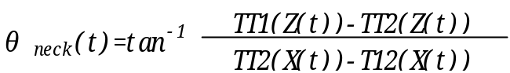
Where:
TT1(X(t)) = Instantaneous TT1 X position.
TT1(Z(t)) = Instantaneous TT1 Z position.
TT2(X(t)) = Instantaneous TT1 X position.
TT2(Z(t)) = Instantaneous TT1 Z position.

θ’_{neck}(t) shall be generated by subtracting the initial neck bracket angle (θ_{head initial}) from the neck bracket angle(θ_{head}(t)).
θ’_{neck}(t) = θ_{neck}(t) - θ_{neck initial}

T1 trace is calculated.
T1(X(t)) = T11(X(t)) - T1_{Z}sinθ’_{head}(t) + T1_{X} cosθ’_{head}(t)
T1(Z(t)) = T11(Z(t)) - T1_{X}cosθ’_{head}(t) + T1_{Z}sinθ’_{head}(t)
Where:
T1(X(t)) = Instantaneous OC X position.
T1(Z(t)) = Instantaneous OC Z position.

OC-T1 relative displacements shall be then defined as the difference between the OC displacement and the T1 displacement in the seat back coordinate system. OC-T1 relative displacement shall be calculated as following routine, for which measurement data shall be considered for evaluation until the point in time at which the head rebounds from the head restraint or at 300 ms after T-zero, whichever occurs first.

The seat back angle at each time step (θ_{SB}(t)) shall be produced from SBU and SBL target.

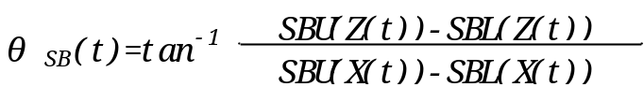
Where:
SBU(X(t)) = Instantaneous SBU X position.
SBU(Z(t)) = Instantaneous SBU Z position.
SBL(X(t)) = Instantaneous SBL X position.
SBL(Z(t)) = Instantaneous SBL Z position.

In order to make SBL the origin of the coordinate system, parallel translation of the coordinate system shall be conducted.

OC_{SBL} (X(t), Z(t)) = OC(X(t), Z(t)) - SBL(X(t), Z(t))
T1_{SBL}(X(t), Z(t)) = T1(X(t), Z(t)) - SBL(X(t), Z(t))

Where:
OC_{SBL}(X(t),Z(t)) = Instantaneous OC X,Z position from SBL.
T1_{SBL} (X(t),Z(t)) = Instantaneous T1 X,Z position from SBL.

θ’_{SB}(t) shall be generated by subtracting the initial seat back angle(θ_{SB initial}) from the seat back angle(θ_{SB}(t)).

θ’_{SB}(t) = θ_{SB}(t) - θ_{SB initial}

The coordinate transformation shall be conducted according to change of a seat back angle.

OC_{SBL} X’(t) = OC_{SBL} Xcosθ’_{SB}(t) + OC_{SBL}Zsinθ’_{SB}(t)
T1_{SBL} X’(t) = T1_{SBL} Xcosθ’_{SB}(t) + T1_{SBL}Zsinθ’_{SB}(t)

Where:
OC_{SBL} X’(t) = Instantaneous OC X position in the seat back coordinate system.
T1_{SBL} X’(t) = Instantaneous T1 X position in the seat back coordinate system.

The relative displacement between OC and T1 in the seat back coordinate system (D_{OC-T1}(t)) shall be derived from the difference between the OC displacement and the T1 displacement.
D_{OC-T1}(t) = OC_{SBL}X’(t) – T1_{SBL}X’(t)

OC-T1 relative displacement at each time step (D’_{OC-T1}(t)) shall be generated by subtracting initial D_{OC-T1}(0) from D_{OC-T1}(t).

D’_{OC-T1}(t) = D_{OC-T1}(t) – D_{OC-T1}(0)

Dynamic backset shall be calculated as the maximum absolute value of D’_{OC-T1}(t).

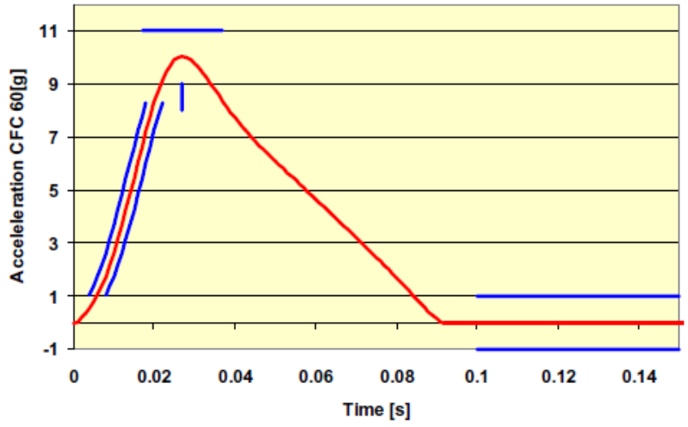
Figure 9-4 Sled pulse

Table 9-3 Sled pulse acceleration corridor.
slope A |  | slope B
time (ms) | acceleration (m/s²) | time (ms) | acceleration (m/s²)
0.004 | 1.053183 | 0.008 | 1.053183
0.005 | 1.375127 | 0.009 | 1.375127
0.006 | 1.74433 | 0.01 | 1.74433
0.007 | 2.160836 | 0.011 | 2.160836
0.008 | 2.62308 | 0.012 | 2.62308
0.009 | 3.127628 | 0.013 | 3.127628
0.01 | 3.669156 | 0.014 | 3.669156
0.011 | 4.240642 | 0.015 | 4.240642
0.012 | 4.833609 | 0.016 | 4.833609
0.013 | 5.438418 | 0.017 | 5.438418
0.014 | 6.044617 | 0.018 | 6.044617
0.015 | 6.641417 | 0.019 | 6.641417
0.016 | 7.218166 | 0.02 | 7.218166
0.017 | 7.764556 | 0.021 | 7.764556
0.018 | 8.270567 | 0.022 | 8.270567

max C |  | max D
time (ms) | acceleration (m/s²) | time (ms) | acceleration (m/s²)
0.017 | 11 | 0.027 | 8
0.037 | 11 | 0.027 | 9

1g level E
time (ms) | acceleration (m/s²)
0.1 | 1
0.14 | 1

Table 9-4 Sled pulse corridor reference point locations.
Parameter |  | Requirement | Limits +/- | Unit
Velocity change | dV | 15.65 | 0.80 | km/h
Time span | dT | 91.00 | 3.00 | ms
Mean acceleration | A mean | 47.85 | 4.00 | m/s²
Acceleration at T0 | A T0 | 0 | 2.5 | m/s²

Annex 10

Non-use position Test Procedure

1. PURPOSE

Procedures for folding or retracting head restraints in all designated seating positions equipped with head restraints, except the driver’s designated seating position.

2. Procedures to test automatic return head restraints and demonstrate compliance with paragraph 5.7.4.1.

The procedure is completed with the ignition switched "on", and using a 5th percentile female Hybrid III test dummy in accordance with paragraph 2.1. of this Annex, or a human surrogate in accordance with paragraph 2.2. of this Annex. Compliance shall be determined at a temperature of 23 ± 5 °C.

2.1. Use of 5th percentile Hybrid III Dummy.

2.1.1. Position the test dummy in the seat such that the dummy's midsagittal plane is aligned within the 15 mm of the seating position centreline and is parallel to a vertical plane parallel to the vehicle longitudinal centreline.

2.1.2. Hold the dummy's thighs down and push rearward on the upper torso to maximize the dummy’s pelvic angle.

2.1.3. Place the legs as close as possible to 90 degrees to the thighs. Push rearward on the dummy’s knees to force the pelvis into the seat so there is no gap between the pelvis and the seat back or until contact occurs between the back of the dummy's calves and the front of the seat cushion such that the angle between the dummy’s thighs and legs begins to change.

2.1.4. Note the position of the head restraint. Remove the dummy from the seat. If the head restraint returns to a retracted position upon removal of the dummy, manually place it in the noted position. Determine compliance with the height requirements of paragraph 5.5.2. by using the test procedures of Annex 1.

2.2. Human surrogate.

A human being who weighs between 47 and 51 kg, and who is between 140 and 150 cm tall may be used. The human surrogate shall be dressed in a cotton T-shirt, full length cotton trousers, and sneakers. Specified weights and heights include clothing.

2.2.1. Position the human in the centre of the seat with the pelvis touching the seat back and the back against the seat back;

2.2.2. Verify the human’s midsagittal plane is vertical and within ± 15 mm of the seating position centreline;

2.2.3. Verify the transverse distance between the centres of the front of the knees is 160 to 170 mm. Centre the knee separation with respect to the seat centreline;

2.2.4. If needed, extend the legs until the feet do not contact the floor pan. The thighs are resting on the seat cushion;

2.2.5. If the human contacts the roof interior move the seat rearward until a maximum clearance of 5 mm is achieved or the seat is in the closest detent position which does not cause human contact.

2.2.6. Passenger foot positioning.

2.2.6.1. Place feet flat on the toe board, or

2.2.6.2. If the feet cannot be placed flat on the toe board, the feet are perpendicular to the lower leg, and the heel is as far forward as possible and resting on the floor pan, or

2.2.6.3. If the heels do not touch the floor pan, the legs are vertical and the feet parallel to the floor pan.

2.2.7. Passenger arm/hand positioning.

2.2.7.1. Place the human’s upper arms adjacent to the torso with the arm centrelines as close to a vertical longitudinal plane as possible;

2.2.7.2. Place the palms of the human in contact with the outer part of the thighs;

2.2.7.3. Place the little fingers in contact with the seat cushion.

2.3. Start the vehicle engine or place the ignition in the "on" position, whichever will turn on the suppression system, and close all vehicle doors. Note the position of the head restraint. Remove the human from the seat. If the head restraint returns to a retracted position upon removal of the human, manually place it in the noted position. Determine compliance with the height requirements of paragraph 5.1.1. by using the test procedures of Annex 1.

2.4. Return the ignition switch to the "off" position.

3. 60° ROTATION EVALUATION

Procedures for the rear and front centre designated seating positions to demonstrate compliance with paragraph 5.7.4.2.

3.1. Place the head restraint in any position meeting the requirements of paragraph 5.5.2.2. or paragraph 5.5.2.4.;

3.1.1. Mark a line on the head restraint with one end at the point of rotation. Measure the angle or range of angles of the head restraint reference line as projected onto a vertical longitudinal vehicle plane;

3.1.2. Fold or retract the head restraint to a position in which its minimum height is less than that specified in paragraph 5.5.2.2. or paragraph 5.5.2.4.;

3.1.3. Determine the minimum change in the head restraint reference line angle as projected onto a vertical longitudinal vehicle plane from the angle or range of angles measured in paragraph 3.1.1. of this annex.

4. DISCOMFORT METRIC

Procedures for the rear and front centre designated seating positions to demonstrate compliance with paragraph 5.7.4.3. of this Regulation.

4.1. The HLE and S dimensions are defined in Figure 10-1 which shows a vertical fore-aft plane passing through the R-point (i.e. at the mid point of the designated seating position) intersecting the seat cushion, seat back and the head restraint.

4.2. Adjust the head restraint to the non-use position.

4.2.1. HLE is the distance from the R-point to the lower edge of the head restraint measured along the torso line.

4.2.2. S is the maximum thickness of the lower edge of the head restraint (within 25 mm of the head restraint lower edge) measured perpendicular to the torso line between TH and TS from line P.

4.2.3. P is a line parallel to the torso line which intersects the head restraint at TS.

4.2.4. TH is the line perpendicular to the torso line and tangent to the lower edge of the head restraint.

4.2.5. TS is the line parallel to and 25 mm from TH.

T_{s}
R
S
T_{h}
H_{LE}
Torso Line
≤25mm
P
Figure 10-1.

5. 10° TORSO REFERENCE LINE CHANGE

Procedures for the rear and front centre designated seating positions to demonstrate compliance with paragraph 5.7.4.4.

5.1. Place the head restraint into any position meeting the requirements of paragraph 5.5.1. of this Regulation;

5.2. Measure the torso reference line angle with the three-dimensional H-point machine defined in Annex 13;

5.3. Fold or retract the head restraint to any position in which its minimum height is less than that specified in paragraph 5.5.1. of this Regulation or in which its backset is more than that specified in paragraph 5.5.6. of this Regulation; and

5.4. Again measure the torso reference line angle."

Annex 1 (former), renumber as Annex 11 and amend to read:

"Annex 11
…..
Note: ………..defined in paragraphs 2.12. and 2.30. of this Regulation…"

Annex 2 (former), renumber as Annex 12 and amend to read:

"Annex 12

……..
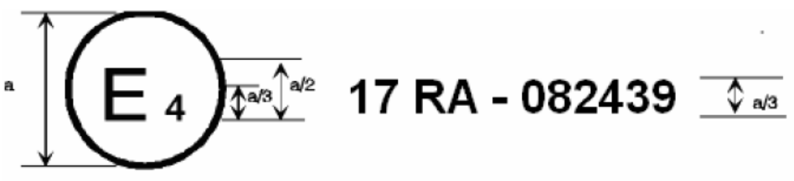
a = 8 mm min

…..number 082439. …. Regulation already contained the 08 series of amendments …..

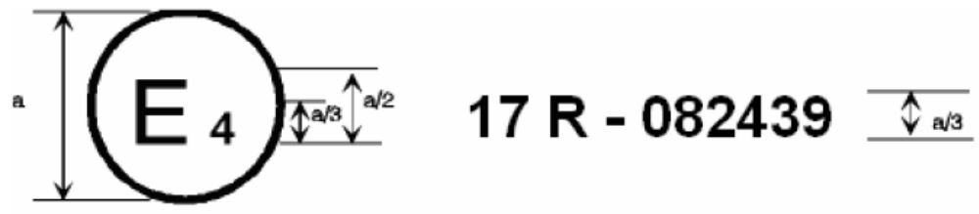
a = 8 mm min

…number 082439. …..Regulation already contained the 08 series of amendments…...

…………….

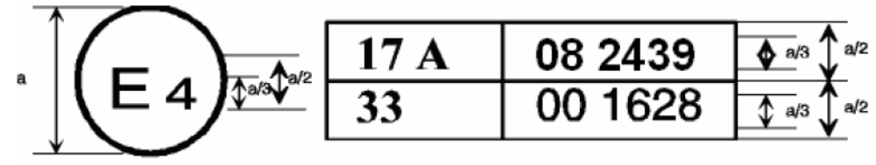
a = 8 mm min.

………….

….. the 08 series of amendments but Regulation No. 33 was still in its original form.…..
….

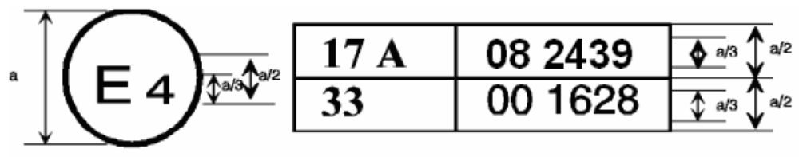
a = 8 mm min.

….the 08 series of amendments but Regulation No. 33 was still in its original form."

Annex 3 (former), renumber as Annex 13, replace all references to "3-D H-machine" as "H-point machine" and amend to read:

"Annex 13

PROCEDURE FOR DETERMINING THE "H" POINT AND THE ACTUAL TORSO ANGLE FOR SEATING POSITIONS IN MOTOR VEHICLES

1. PURPOSE

The procedure described in this annex is used to establish the "H" point location and the actual torso angle for one or several seating positions in a motor vehicle and to verify the relationship of measured data to design specifications given by the vehicle manufacturer. 1/

2. REQUIREMENTS

2.1. Data presentation

For each seating position where reference data are required in order to demonstrate compliance with the provisions of the present Regulation, all or an appropriate selection of the following data shall be presented in the form indicated in Appendix 3 to this annex:

2.1.1. the co-ordinates of the "R" point relative to the three-dimensional reference system;

2.1.2. the design torso angle;

2.1.3. all indications necessary to adjust the seat (if it is adjustable) to the measuring position set out in paragraph 3.3. below.

2.2. Relationship between measured data and design specifications

2.2.1. The co-ordinates of the "H" point and the value of the actual torso angle obtained by the procedure set out in paragraph 3. below shall be compared, respectively, with the co-ordinates of the "R" point and the value of the design torso angle indicated by the vehicle manufacturer.

2.2.2. The relative positions of the "R" point and the "H" point and the relationship between the design torso angle and the actual torso angle shall be considered satisfactory for the seating position in question if the "H" point, as defined by its co-ordinates, lies within a square of 50 mm side length with horizontal and vertical sides whose diagonals intersect at the "R" point, and if the actual torso angle is within 5 degree of the design torso angle.

2.2.3. If these conditions are met, the "R" point and the design torso angle, shall be used to demonstrate compliance with the provisions of this Regulation.

2.2.4. If the "H" point or the actual torso angle does not satisfy the requirements of paragraph 2.2.2. above, the "H" point and the actual torso angle shall be determined twice more (three times in all). If the results of two of these three operations satisfy the requirements, the conditions of paragraph 2.2.3. above shall apply.

2.2.5. If the results of at least two of the three operations described in paragraph 2.2.4. above do not satisfy the requirements of paragraph 2.2.2. above, or if the verification cannot take place because the vehicle manufacturer has failed to supply information regarding the position of the "R" point or regarding the design torso angle, the centroid of the three measured points or the average of the three measured angles shall be used and be regarded as applicable in all cases where the "R" point or the design torso angle is referred to in this Regulation.

3. PROCEDURE FOR "H" POINT AND ACTUAL TORSO ANGLE DETERMINATION

3.1. The vehicle shall be preconditioned at the manufacturer's discretion, at a temperature of 20 ± 10 °C to ensure that the seat material reaches room temperature. If the seat to be checked has never been sat upon, a 70 to 80 kg person or device shall sit on the seat twice for one minute to flex the cushion and back. At the manufacturer's request, all seat assemblies shall remain unloaded for a minimum period of 30 minutes prior to installation of the H-point machine.

3.2. The vehicle shall be at the measuring attitude defined in paragraph 2.11. above.

3.3. The seat, if it is adjustable, shall be adjusted first to the rearmost normal driving or riding position, as indicated by the vehicle manufacturer, taking into consideration only the longitudinal adjustment of the seat, excluding seat travel used for purposes other than normal driving or riding positions. Where other modes of seat adjustment exist (vertical, angular, seat-back, etc.) these will be then adjusted to the position specified by the vehicle manufacturer. For suspension seats, the vertical position shall be rigidly fixed corresponding to a normal driving position as specified by the manufacturer.

3.4. The area of the seating position contacted by the H-point machine shall be covered by a muslin cotton, of sufficient size and appropriate texture, described as a plain cotton fabric having 18.9 threads per cm² and weighing 0.228 kg/m² or knitted or non-woven fabric having equivalent characteristics.

If the test is run on a seat outside the vehicle, the floor on which the seat is placed shall have the same essential characteristics 2/ as the floor of the vehicle in which the seat is intended to be used.

3.5. Place the seat and back assembly of the H-point machine so that the centre plane of the occupant (C/LO) coincides with the centre plane of the H-point machine. At the manufacturer's request, the H-point machine may be moved inboard with respect to the C/LO if the H-point machine is located so far outboard that the seat edge will not permit levelling of the H-point machine.

3.6. Attach the foot and lower leg assemblies to the seat pan assembly, either individually or by using the T-bar and lower leg assembly. A line through the "H" point sight buttons shall be parallel to the ground and perpendicular to the longitudinal centre plane of the seat.

3.7. Adjust the feet and leg positions of the H-point machine as follows:

3.7.1. Designated seating position: driver and outside front passenger.

3.7.1.1. Both feet and leg assemblies shall be moved forward in such a way that the feet take up natural positions on the floor, between the operating pedals if necessary. Where possible the left foot shall be located approximately the same distance to the left of the centre plane of the H-point machine as the right foot is to the right. The spirit level verifying the transverse orientation of the H-point machine is brought to the horizontal by readjustment of the seat pan if necessary, or by adjusting the leg and foot assemblies towards the rear. The line passing through the "H" point sight buttons shall be maintained perpendicular to the longitudinal centre plane of the seat.

3.7.1.2. If the left leg cannot be kept parallel to the right leg and the left foot cannot be supported by the structure, move the left foot until it is supported. The alignment of the sight buttons shall be maintained.

3.7.2. Designated seating position: outboard rear

3.7.2.1. For rear seats or auxiliary seats, the legs are located as specified by the manufacturer. If the feet then rest on parts of the floor which are at different levels, the foot which first comes into contact with the front seat shall serve as a reference and the other foot shall be so arranged that the spirit level giving the transverse orientation of the seat of the device indicates the horizontal.

3.7.3. Other designated seating positions:

The general procedure indicated in paragraph 3.7.1. above shall be followed except that the feet shall be placed as specified by the vehicle manufacturer.

3.8. Apply lower leg and thigh weights and level the H-point machine.

3.9. Tilt the back pan forward against the forward stop and draw the H-point machine away from the seat-back using the T-bar. Reposition the H-point machine on the seat by one of the following methods:

3.9.1. If the H-point machine tends to slide rearward, use the following procedure. Allow the H-point machine to slide rearward until a forward horizontal restraining load on the T-bar is no longer required i.e. until the seat pan contacts the seat-back. If necessary, reposition the lower leg.

3.9.2. If the H-point machine does not tend to slide rearward, use the following procedure. Slide the H-point machine rearwards by applying a horizontal rearward load to the T-bar until the seat pan contacts the seat-back (see figure 2 of appendix 1 to this annex).

3.10. Apply a 100 ± 10 N load to the back and pan assembly of the H-point machine at the intersection of the hip angle quadrant and the T-bar housing. The direction of load application shall be maintained along a line passing by the above intersection to a point just above the thigh bar housing (see Figure 2 of Appendix 1 to this annex). Then carefully return the back pan to the seat-back. Care must be exercised throughout the remainder of the procedure to prevent the H-point machine from sliding forward.

3.11. Install the right and left buttock weights and then, alternately, the eight torso weights. Maintain the H-point machine level.

3.12. Tilt the back pan forward to release the tension on the seat-back. Rock the H-point machine from side to side through a 10 degrees arc (5 degrees to each side of the vertical centre plane) for three complete cycles to release any accumulated friction between the H-point machine and the seat.

3.12.1. During the rocking action, the T-bar of the H-point machine may tend to diverge from the specified horizontal and vertical alignment. The T-bar must therefore be restrained by applying an appropriate lateral load during the rocking motions. Care shall be exercised in holding the T-bar and rocking the H-point machine to ensure that no inadvertent exterior loads are applied in a vertical or fore and aft direction.

3.12.2. The feet of the H-point machine are not to be restrained or held during this step. If the feet change position, they should be allowed to remain in that attitude for the moment.

3.12.3. Carefully return the back pan to the seat-back and check the two spirit levels for zero position. If any movement of the feet has occurred during the rocking operation of the H-point machine, they must be repositioned as follows:

3.12.4. Alternately, lift each foot off the floor the minimum necessary amount until no additional foot movement is obtained. During this lifting, the feet are to be free to rotate; and no forward or lateral loads are to be applied. When each foot is placed back in the down position, the heel is to be in contact with the structure designed for this.

3.12.5. Check the lateral spirit level for zero position; if necessary, apply a lateral load to the top of the back pan sufficient to level the H-point machine's seat pan on the seat.

3.13. Holding the T-bar to prevent the H-point machine from sliding forward on the seat cushion, proceed as follows:

(a) return the back pan to the seat-back;

(b) alternately apply and release a horizontal rearward load, not to exceed 25 N, to the back angle bar at a height approximately at the centre of the torso weights until the hip angle quadrant indicates that a stable position has been reached after load release. Care shall be exercised to ensure that no exterior downward or lateral loads are applied to the H-point machine. If another level adjustment of the H-point machine is necessary, rotate the back pan forward, re-level, and repeat the procedure from paragraph 3.12.

3.14. Take all measurements:

3.14.1. The co-ordinates of the "H" point are measured with respect to the three-dimensional reference system.

3.14.2. The actual torso angle is read at the back angle quadrant of the H-point machine with the probe in its fully rearward position.

3.15. If a re-run of the installation of the H-point machine is desired, the seat assembly should remain unloaded for a minimum period of 30 minutes prior to the re-run. The H-point machine should not be left loaded on the seat assembly longer than the time required to perform the test.

3.16. If the seats in the same row can be regarded as similar (bench seat, identical seats, etc.) only one "H" point and one "actual torso angle" shall be determined for each row of seats, the H-point machine described in Appendix 1 to this annex being seated in a place regarded as representative for the row. This place shall be:

3.16.1. in the case of the front row, the driver's seat;

3.16.2. in the case of the rear row or rows, an outer seat."

Annex 13 (new), Appendix 1, the footnote */, amend to read:

"*/ For details of the construction of the 3-D H-point machine refer to Society of Automotive Engineers (SAE), 400 Commonwealth Drive, Warrendale, Pennsylvania 15096, United States of America. (SAE J826 1995 version). The machine corresponds to that described in ISO Standard 6549-1999."

Annexes 4, 5 and 6 (former), should be deleted.

Insert a new Annex 14, to read:

"Annex 14

Test Procedure for Checking Energy Dissipation of Seat Back

1. INSTALLATION, TEST APPARATUS, RECORDING INSTRUMENTS AND PROCEDURE

1.1. Setting up

The seat, as mounted in the vehicle, shall be firmly secured to the test bench with the attachment parts provided by the manufacturer, so as to remain stationary when the impact is applied.

The seat-back, if adjustable, shall be locked in the position specified in paragraph 6.1.1. of this Regulation.

If the seat is fitted with a head restraint, the head restraint shall be mounted on the seat-back as in the vehicle.

1.2. Test apparatus

1.2.1. This apparatus consists of a pendulum whose pivot is supported by ball-bearings and whose reduced mass */ at its centre of percussion is 6.8 kg. The lower extremity of the pendulum consists of a rigid headform 165 mm in diameter whose centre is identical with the centre of percussion of the pendulum.

1.2.2. The headform shall be fitted with two accelerometers and a speed-measuring device, all capable of measuring values in the direction of impact.

1.3. Recording instruments

The recording instruments used shall be such that measurements can be made with the following degrees of accuracy:

1.3.1. Acceleration:

accuracy = ± 5 per cent of the actual value;

frequency class of data channel: class 600 corresponding to ISO Standard 6487 (1980);

cross-axis sensitivity = < 5 per cent of the lowest point on the scale.

1.3.2. Speed:

accuracy: ± 2.5 per cent of the actual value;

sensitivity: 0.5 km/h.

1.3.3. Time recording:

the instrumentation shall enable the action to be recorded throughout its duration and readings to be made to within one one-thousandth of a second; the beginning of the impact at the moment of first contact between the headform and the item being tested shall be detected on the recordings used for analysing the test.

1.4. Test procedure

1.4.1. Tests on the seat-back

With the seat installed as indicated in paragraph 1.1. of this annex, the direction of impact from the rear towards the front shall be on a longitudinal plane at a downwards angle of 45° from the vertical.

The impact points shall be selected by the test laboratory in area 1 as defined in paragraph 6.8.1.1. of this Regulation, or if necessary in area 2 as defined in paragraph 6.8.1.2. of this Regulation, on surfaces exhibiting radii of curvature less than 5 mm.

1.4.2. The headform shall strike the test point at a speed of 24.1 ± 0.5 km/h: this speed shall be achieved either by the mere energy of propulsion or by using an additional impelling device.

2. RESULTS

The deceleration rate shall be taken as the average of the readings on the two decelerometers.

3. EQUIVALENT PROCEDURES (see paragraph 6.9. of this Regulation)."

Annex 7 (former), renumber as Annex 15 and amend to read:

"Annex 15

………
1.4. …….essential differences in the sense of paragraph 2.37. of this Regulation, the tests prescribed …….
……..
2.1. ……shall be covered with plywood boards 19 ± 1 mm thick. At least ….

2.2. …. of the collision wall shall be ± 30 cm; at the moment …."

Annex 8 (former), should be deleted.

Annex 9 (former), renumber as Annex 16 and amend to read:

"Annex 16
…..
2.1. Test of seat-backs (see figure 16-1)
…...
2.1.1.6. Seats behind …..
……………
Figure 16-1: Positions of ……

2.2. ……test on the seat-backs (see figure 16-2)
………….
Figure 16-2: Testing of a……
……
3.1. …..shall be decelerated or, …..within the area of the graph as shown in the Appendix, and the total velocity change….…"

B. JUSTIFICATION

The global technical regulation (gtr) No. 7 on head restraints was established in the Global Registry on 13 March 2008 (ECE/TRANS/180/Add.7). Under the terms of the 1998 Agreement a Contracting Party that votes in favour of establishing a global technical regulation under Article 6 of the Agreement is obligated to submit the technical regulation to the process used by that Contracting Party to adopt such a technical regulation into its own laws or regulations and shall seek to make a final decision expeditiously.

The proposed amendment provides updates to all requirements under the present Regulation No. 17 with respect to head restraints on the basis of gtr No. 7.

During the discussion on this gtr, it was agreed to allow Contracting Parties to introduce into their national or regional laws alternative procedures for use in the dynamic assessment of head restraints (paragraph 37).

Based on this agreement, the proposed amendment includes the dynamic performance requirements using the BioRID II test dummy.

-----

1/ In any seating position other than front seats where the "H" point cannot be determined using the "three-dimensional 'H' point machine" or procedures, the "R" point indicated by the manufacturer may be taken as a reference at the discretion of the competent authority.
2 / Tilt angle, height difference with a seat mounting, surface texture, etc.
*/ The relationship of the reduced mass "mr" of the pendulum to the total mass "m" of the pendulum at a distance "a" between the centre of percussion and the axis of rotation and at a distance "l" between the centre of gravity and the axis of rotation is given by the formula: mr = m * l / a

