Transmitted by the expert from the United Kingdom | Informal Document No. GRE-60-14  (60th GRE, 1 - 3 October 2008  agenda item 4(f))

PROPOSAL FOR DRAFT AMENDMENTS TO REGULATION No. 48

Note: The text reproduced below was prepared by the expert from the United Kingdom in order to permit optional additional side direction indicator lamps on long vehicles to improve the conspicuity of the drivers’ signalling intention to vulnerable road users. The modifications to existing text of the Regulation are marked in bold characters.

A. PROPOSAL

6.5. Direction-Indicator Lamp (Regulation No. 6)

    - Presence …………………………..

6.5.2. Number
According to the arrangement.

6.5.3. Arrangements (see figure below)

A: two front direction-indicator lamps of the following categories:

…………..
5
for all M1 vehicles;
for N1, M2 and M3 vehicles not exceeding 6 metres in length.

6
for all N2 and N3 vehicles;
for N1, M2 and M3 vehicles exceeding 6 metres in length.
It is permitted to replace Category 5 side direction-indicator lamps by Category 6 side direction-indicator lamps in all instances

A maximum of three optional Category 5 or one optional Category 6 device per side on vehicles of type M₂, M₃, N₂ and N₃ exceeding [ 9m] in length.
…………..

B: two rear direction-indicator lamps (Categories 2a or 2b)

two optional lamps (Category 2a or 2b) on all vehicles in Categories O2, O3 and O4.

A maximum of three Category 5 or one optional Category 6 device per side on vehicles of type O2, O3 and O4 exceeding [ 9m] in length.

6.5.4. Position

6.5.4.2.3. If the structure of the vehicle does not permit these upper limits, measured as specified above, to be respected, and if the optional rear lamps are not installed, they may be increased to 2,300 mm for side direction-indicator lamps of categories 5 and 6, and to 2,100 mm for the direction-indicator lamps of categories 1, 1a, 1b, 2a and 2b.

6.5.4.2.4. If optional rear lamps are installed, they shall be placed at a height compatible with the applicable requirements of paragraph 6.5.4.1., the symmetry of the lamps, and at a vertical distance as large as the shape of the bodywork makes it possible, but not less than 600 mm above the mandatory lamps.

6.5.4.3. In length (see figure below)

The distance between the light-emitting surface of the side direction-indicator lamp (Categories 5 and 6) and the transverse plane which marks the forward boundary of the vehicle's overall length, shall not exceed 1 800 mm. However, for M1 and N1 Category vehicles, and for all other categories of vehicles if the structure of the vehicle makes it impossible to comply with the minimum angles of visibility, this distance may be increased to 2 500 mm.

Optional Category 5 side- direction indicator lamps, shall be fitted, spaced evenly, along the length of the vehicle.

Optional Category 6 side direction indicator lamp shall be fitted in the area between the first and last quartiles of the length of a trailer

6.5.5.1. Horizontal angles: (see figure below)

Vertical angles: 15° above and below the horizontal for direction-indicator lamps of categories 1, 1a, 1b, 2a, 2b and 5. The vertical angle below the horizontal may be reduced to 5° if the lamps are less than 750 mm above the ground; 30° above and 5° below the horizontal for direction-indicator lamps of category 6. The vertical angle above the horizontal may be reduced to 5° if the optional rear lamps are not less than 2,100 mm above the ground.

    - Tell-tale

………….

For the optional direction-indicator lamps on vehicles and trailers, operating tell-tale shall not be mandatory.

B. JUSTIFICATION

It is estimated that every year, over 400 people lose their life in the EU in accidents involving side swipes from large trucks and truck trailer combinations. (See Table 1 for UK figures.) This can occur in the “so-called” blind spot on either side of these vehicles when they are turning and changing lane, especially at crossings, junctions or roundabouts when to negotiate a tight corner, the driver often has to swing out wide in order to complete a turn. A large percentage of the victims of such accidents are on two-wheelers, a particularly vulnerable category of road users.

The EU Commission, as a result of extensive consultation have issued a draft directive for improving the field of indirect vision to minimise the so-called blind spot on existing and new vehicles in the Category N3. This draft document was adopted on 5th October 2006’

As part of the above EU consultation the UK Government completed a national consultation exercise covering the potential casualty reduction from fitting blind-spot mirrors to vehicles in the Category N₃ (See Table 2 .) This consultation exercise included the large number of LHD vehicles in this category now using UK roads, where the so-called blind spot situation is exacerbated.

This proposal is intended to act as a safety improvement action complimenting the EU draft directive, and focuses on road users including motor cycles, who, when alongside long vehicles/trailers and buses may be conscious of the vehicle form adjacent to them but may not be aware of the driver’s intentions for turning / lane change

This is particularly applicable when :-

- the tractor/trailer or bus swings out wide prior to turning, or
- the motor cycle pulls alongside a tractor/trailer or bus when it is stationary at a junction etc., or
- the height and position of another road user obscures the existing installed direction indicators especially when the motor cycle is already forward of the tractor/trailer and bus rear lights

The addition, along the length of a vehicle or vehicle combination, of at least one additional side direction indicator per side will improve conspicuity of the driver’s signalling intention on long tractor-trailer combinations and buses, especially when it is driving on the opposite side of the road for which it is designed.

This safety concern will be further exacerbated should the European consideration of longer vehicle combinations up to 25.5m long as below, become accepted.
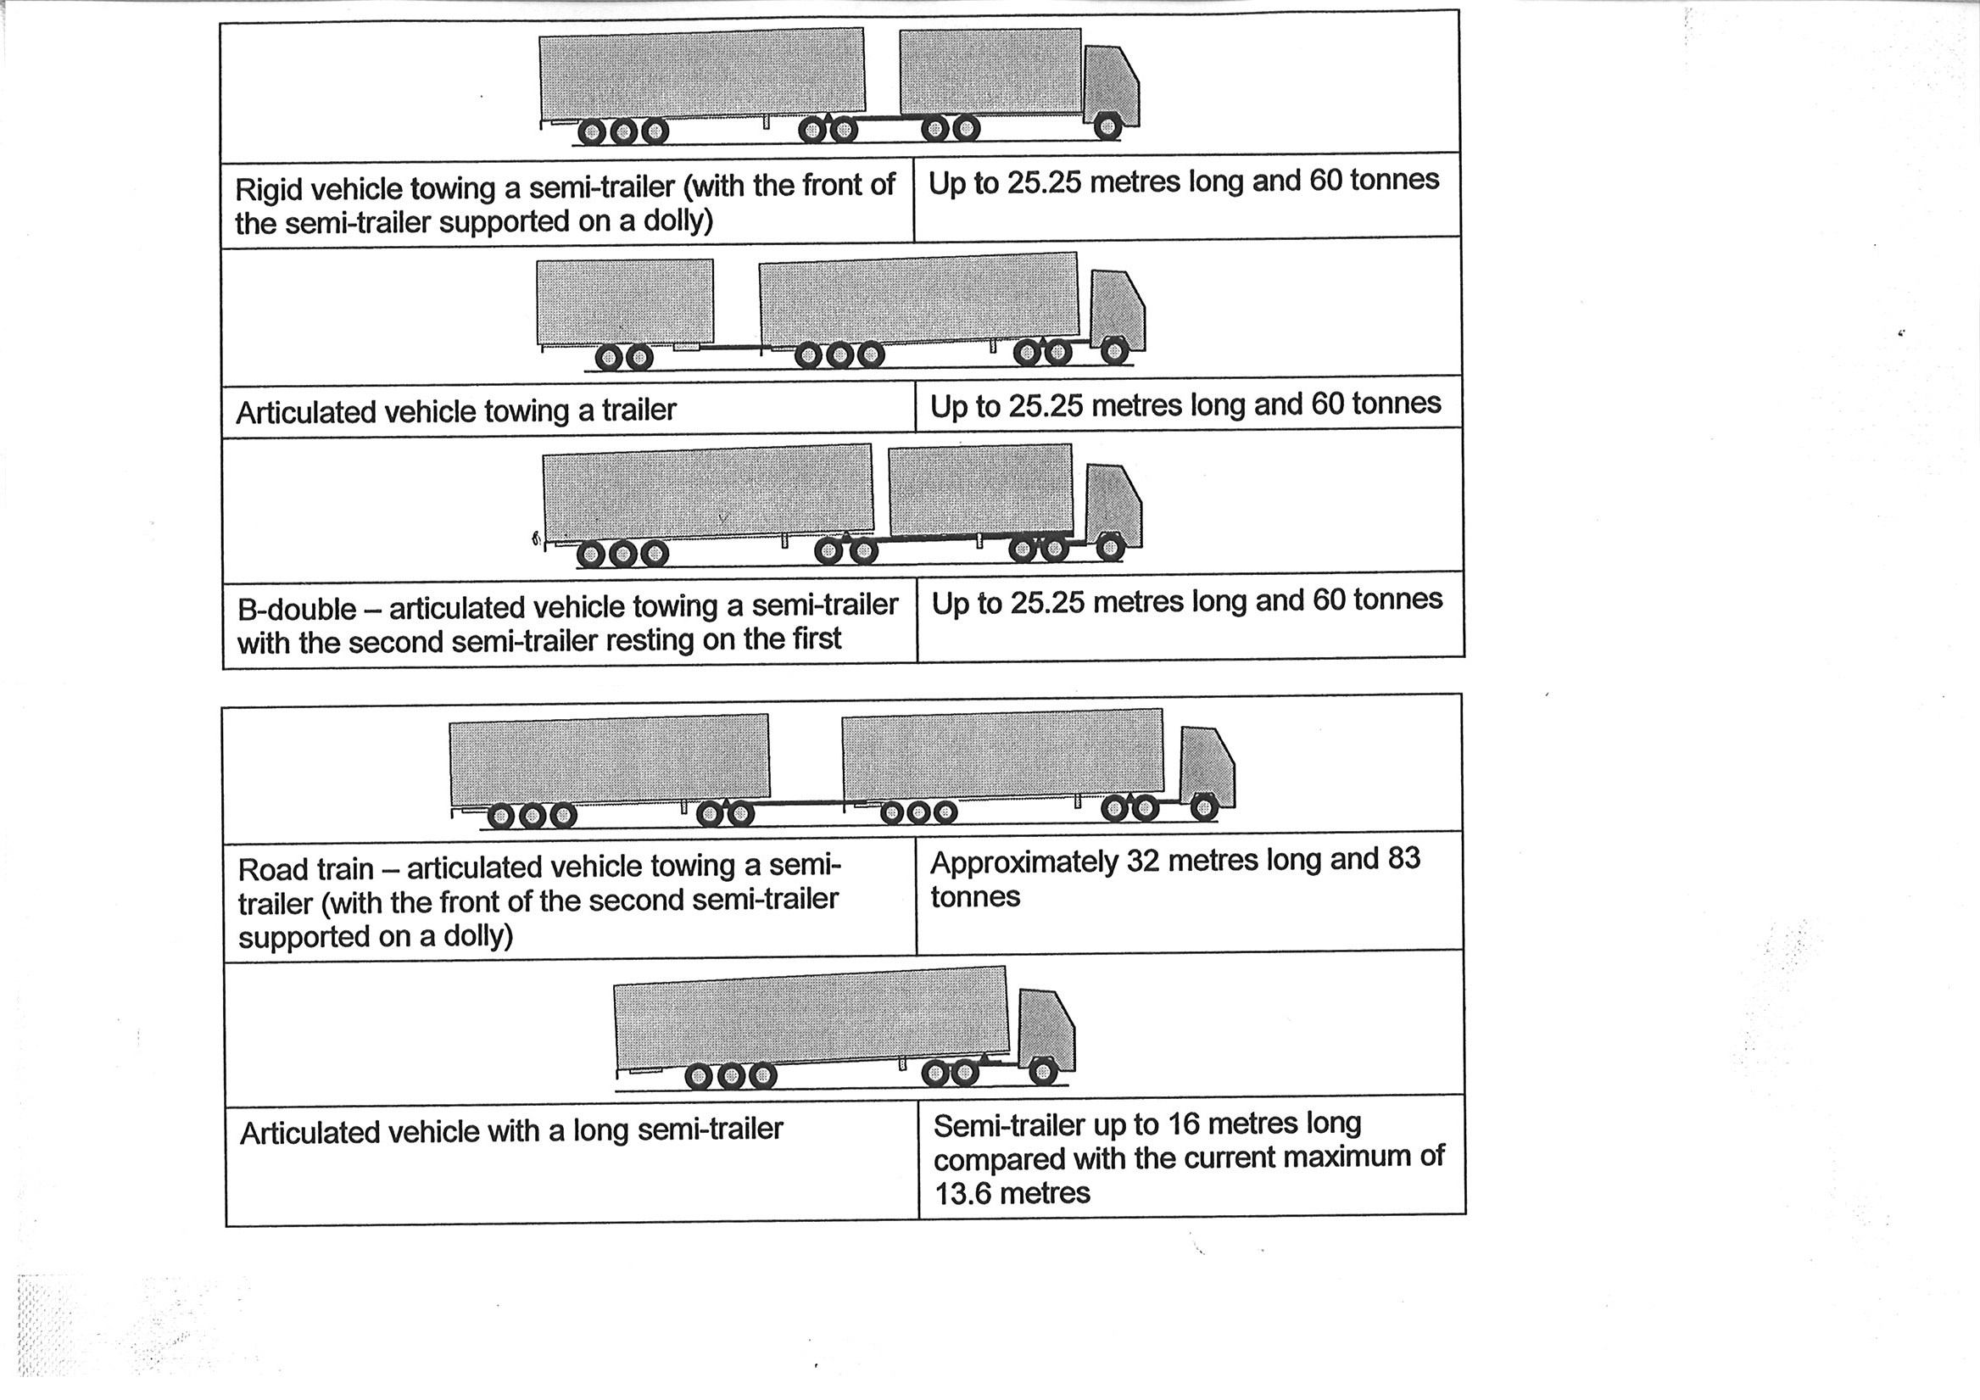
The common feature with all these combinations is the increasing distance and hence visibility between the final rear DI on a vehicle and the side direction indicator on the cab.

Table 1
Fatalities in Accidents with the Side of UK HGV’s during 2005
Accidents with Vulnerable Road Users |  |  | Side Swipe accidents (Passenger Cars on Multilane Roads) | Total
Pedestrian | Pedal Cycle | Motor Cycle
13 | 10 | 15 | 4 | 42

Table 2
Estimated Number of Lives saved per Annum due to blind spot mirrors
Accident | Vehicle Manoeuvre | Fatalities | Effectiveness of Measure | Lives Saved (Rounded)
VRU Struck by side of HGV | All | 38 | 25% | 9
Side Swipe | Changing Lane and Overtaking | 4 | 25% | 1
Total |  | 42 |  | 10

See examples of Cat 5 lamps fitted to various vehicles below:-

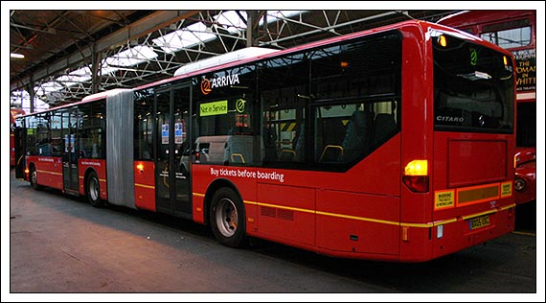

“Bendy"- bus fitted with additional Side Direction Indicator

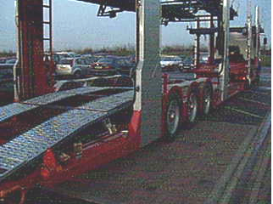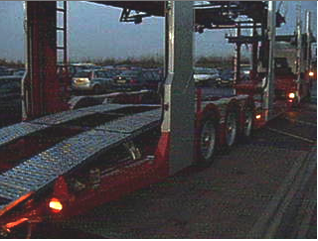

Transporter vehicle fitted with extra side direction indicator to compensate for obscuration of lights when fully laden

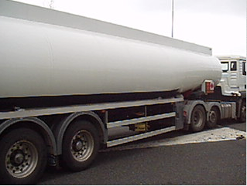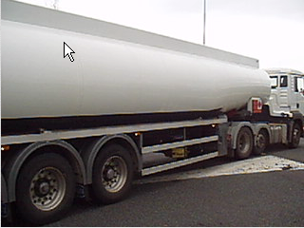

Three side direction indicators fitted to tanker note tanker rear lights obscured by semi-trailer

- - - - -

