UNITED  NATIONS |  | E
 | Economic and Social  Council | Distr.  GENERAL  ECE/TRANS/WP.29/GRB/2008/5  19 June 2008  Original: ENGLISH  ENGLISH AND FRENCH ONLY

ECONOMIC COMMISSION FOR EUROPE

INLAND TRANSPORT COMMITTEE

World Forum for Harmonization of Vehicle Regulations

Working Party on Noise

Forty-eighth session

Geneva, 1 - 3 September 2008

Item 4 of the provisional agenda

REGULATION No. 59
(Replacement silencing systems)

Proposal for draft amendments to Regulation No. 59

Submitted by the expert from the European Association of Automotive Suppliers /

The text reproduced below was prepared by the expert from the European Association of Automotive Suppliers (CLEPA). The text consolidates the comments agreed upon during the forty-seventh GRB session, about informal document No. GRB-47-3 (ECE/TRANS/WP.29/GRB/45, para.12). The amendments to GRB-47-3 are marked in bold characters. The proposal consolidates the text of the Regulation.

A. PROPOSAL

Amend the text of the Regulation to read:

"1. SCOPE

This regulation covers replacement noise reduction systems for vehicles in categories M₁ and N₁/.

2. DEFINITIONS

For the purpose of this Regulation,

2.1. "Noise reduction system" means a complete set of components necessary for limiting the noise produced by the engine of a motor vehicle and its exhaust;

2.2. "Noise reduction system component" means one of the separate components which together form the noise reduction system (e.g. silencer proper, expansion chamber, resonator);

2.3. "Noise reduction system of different types" means noise reduction systems which differ significantly in such respects as:

2.3.1. That their components bear different trade names or marks,

2.3.2. That the characteristics of the materials constituting a component are different or that the components differ in shape or size, a modification regarding the coating (galvanization, aluminium coating, etc.) is not deemed changing the type,

2.3.3. That the operating principles of at least one component are different,

2.3.4. That their components are assembled differently;

2.3.5. That the number of intake and/or exhaust noise reduction systems is different;

  - "Design family"

For noise reduction systems or noise reduction system components, containing acoustically absorbing fibrous material, different design families may be considered. Noise reduction systems or noise reduction system components belong to the same design family when all the following characteristics are the same:
(a) The exhaust gasses in contact with the absorbing fibrous material have or have not a net gas flow through this material.
(b) The type of the fibers (e.g. basalt wool, biosil wool, glass wool, E-type wool, etc);
(c) Binder material specifications (if applicable);
(d) Average fiber dimensions (thickness, length);
(e) Minimum bulk material packing density (kg/m³).
(f) Maximum contact surface between the gas flow and the absorbing material (e.g. perforation open area)

2.5. "Replacement noise reduction system or components of said system" means any part of the noise reduction system defined in paragraph 2.1. above intended for use on a vehicle, other than a part of the type fitted to this vehicle when submitted for type approval pursuant to this Regulation;

2.6. ["Noise reduction system or noise reduction system component with variable geometry" means a noise reduction system or noise reduction system component containing one or more moving parts or devices which, by changing the noise reduction system or noise reduction system component geometry, may change its noise reduction functionalities (e.g. moving parts or devices changing the noise reduction functionalities by opening or closing one or more valves in the exhaust gas flow as a function of varying driving or engine conditions (rpm, load, speed, etc.)).]

2.7. "Approval of a replacement noise reduction system or components of said system" means the approval of the whole or part of a noise reduction system adaptable to one several specified types of motor vehicles, as regards the limitation of their noise level;

2.8. "Vehicle type" means a category of motor vehicles which do not differ significantly in such respects as:

2.8.1. The lines and constituent materials of the body (more particularly the engine compartment and its soundproofing),

2.8.2. The length and width of the vehicle,

2.8.3. The type of engine (positive ignition, compression ignition, two stroke or four stroke, reciprocating or rotary, electric, hybrid), number and capacity of cylinders, number of carburettors or injection system, arrangement of valves, rated maximum horse-power and corresponding engine speed (rpm) or the type of the electric motor.

2.8.4. Number and ratios of gears, total ratio of the transmission,

2.8.5. The number, type and arrangement of the exhaust systems, and

2.8.6. The number, type and arrangement of the intake systems.

3. APPLICATION FOR APPROVAL

3.1. The application for approval of a replacement noise reduction system or components of said system shall be submitted by its manufacturer or by his duly accredited representative.

3.2. It shall be accompanied by the under mentioned documents in triplicate and the following particulars:

3.2.1. A description of the vehicle type(s) on which the system or components is intended to be mounted, with regard to the items mentioned in paragraph 2.6. above. The numbers and/or symbols identifying the engine type and the vehicle type shall be specified and the vehicle type approval number, if necessary;

3.2.2. A description of the assembled noise reduction system showing the relative position of each of its components, as well as mounting instructions;

3.2.3. Detailed drawings of each component to enable it to be easily located and identified, and a specification of the material used.

3.3. On request of the technical service conducting the tests for approval, the manufacturer of the noise reduction system shall submit:

3.3.1. A sample of the system or components submitted for approval;

3.3.2. A sample of the original noise reduction system with which the vehicle was equipped when submitted for type approval;

3.3.3. A vehicle representative of the type to which the system is to be fitted; to be acceptable this vehicle must satisfy the requirements of paragraph 8.1. of Regulation No. 51 [(Conformity of production)]. For the application of paragraph 8.1. the reference to paragraph 6 is limited to paragraph 6.1. and 6.2.

3.3.4. A separate engine, when applicable, of at least the same cylinder capacity and power as that of the above-mentioned vehicle.

4. MARKINGS

4.1. Each component of the replacement noise reduction system, excluding tubes and mounting accessories, shall bear:

4.1.1. The trade name or mark of the manufacturer of the system or its components,

4.1.2. The commercial description given by the manufacturer.

  - Such markings shall be clearly legible and indelible.
5. APPROVAL

5.1. If the type of replacement noise reduction system submitted for approval pursuant to this Regulation meets the requirement of paragraph 6. below, approval for that type shall be granted.

5.2. An approval number shall be assigned to each type approved. Its first two digits (at present 00 for the Regulation in its original form) shall indicate the series of amendments incorporating the most recent major technical amendments made to the Regulation at the time of issue of the approval. The same Contracting Party may not assign the same number to another type of replacement noise reduction system or component designed for the same type(s) of vehicle.

5.3. Notice of approval or of refusal of approval of a replacement noise reduction system or components of said system pursuant to this Regulation shall be communicated to the Parties to the Agreement which apply this Regulation, by means of a form conforming to the model in annex 1 to the Regulation, and of drawings of the noise reduction system or components supplied by the applicant for approval, in a format not exceeding A4 (210 x 279 mm) or folded to that format and on an appropriate scale.

5.4. There shall be affixed to every component of noise reduction system conforming to a type approved under this Regulation an international approval mark consisting of:

5.4.1. A circle surrounding the letter "E" followed by the distinguishing number of the country which had granted approval;

5.4.2. The number of this Regulation, followed by the letter "R", a dash and the approval number to the right of the circle prescribed in paragraph 5.4.1.;

5.4.3. The approval number shall be mentioned in the approval form, as well as the method used for approval tests.

5.5. The approval mark shall be easily legible and indelible, when the noise reduction system is mounted on the vehicle.

5.6. A component may be marked with more than one approval number if it has been approved as a part of more than one replacement noise reduction system; in this case the circle need not be repeated. Annex 2 to this Regulation gives an example of the arrangement of the approval mark.

6. SPECIFICATIONS

6.1. General specifications

6.1.1. The replacement exhaust system or components thereof must be designed, constructed and capable of being mounted so as to ensure that the vehicle complies with the provisions of this Regulation under normal conditions of use, notwithstanding any vibrations to which it may be subject.

6.1.2. The noise reduction system or components thereof must be designed, constructed and capable of being mounted so that reasonable resistance to the corrosion phenomenon to which it is exposed is obtained having regard to the conditions of use of the vehicle.

6.2. Specifications regarding noise levels

6.2.1. Conditions of measurement

6.2.1.1. The noise test of the noise reduction system and the replacement noise reduction system has to be executed with the same "normal" tyres (as defined in Regulation No. 117 paragraph 2.8.) It is not allowed to do the tests with "special use" tyres or ‘snow’ tyres as defined in Regulation No. 117 paragraphs 2.9. and 2.10. Such tyres would increase the noise level of the vehicle or would have a masking effect on the noise comparison. The tyres may be in a used condition but must satisfy legal requirements for in traffic use.

6.2.2. The acoustic efficiency of the replacement noise reduction system or components of said system shall be verified by means of the methods described in paragraphs 3.1. and 3.2. of annex 3 to Regulation No. 51.

When the replacement noise reduction system or components thereof is mounted on the vehicle described in paragraph 3.3.3. above, the noise levels obtained using the two methods(stationary and running vehicle) shall satisfy one of the following conditions:

6.2.2.1. The value measured with the running vehicle shall not exceed by more than 1 dB(A) the value obtained with the type of vehicle concerned when submitted for type approval, and the value measured with the stationary vehicle shall not exceed by more than 2 dB(A) the value obtained with the type of vehicle concerned when submitted for type approval.

6.2.2.2. The value measured with the running vehicle shall not exceed by more than 1 dB(A) the noise value measured on the vehicle referred to in paragraph 3.3.3. above, when this is fitted with a noise reduction system corresponding to the type fitted to the vehicle when submitted for type approval, and the value measured with the stationary vehicle shall not exceed by more than 2 dB(A) the noise value measured on the vehicle referred to in paragraph 3.3.3. above, when this is fitted with a noise reduction system corresponding to the type fitted to the vehicle when submitted for type approval.

Note: In the case of paragraph 6.2.2.2., where back-to-back comparison of the replacement system with the original system is chosen, for the application of paragraph 3.1.2.1.4.2. and/or paragraph 3.1.2.2.1.2. of Regulation No. 51, it is allowed to have a gear change to higher accelerations and the use of electronic or mechanical devices to prevent this downshift is not mandatory. If under these conditions the noise level of the test vehicle becomes higher than the COP values, the technical service will decide about the representativity of the test vehicle.

6.2.3. [Further to the requirements of Annex 3, any replacement noise reduction system or component has to fulfil the specifications of paragraph [XX] of Annex 10 in Regulation No. 51.]

6.2.3.1. [In case the replacement noise reduction system or component is a system or component with variable geometry, the technical service may shall request to verify the acoustic noise reduction functionality of the replacement system or component of said system by means of the methods described in paragraph [XX] of annex 10 to Regulation No. 51.]
[The specifications have to be completed later]

6.2.3.2. [If the replacement noise reduction system or component is not a system with variable geometry, it is sufficient in the application for type approval that the manufacturer provides a statement that the type of replacement noise reduction system or component to be approved complies with the requirements of paragraph XX of Annex 10 to Regulation No. 51.]

6.2.3.3. [The following is an example of compliance statement: "(Name of the manufacturer) attests that the noise reduction system of this type complies with the requirements of paragraph [XX] of Regulation No. 51. (Name of the manufacturer) makes this statement in good faith, after having performed an appropriate engineering evaluation of the sound emission performance over the applicable range of operating conditions."]

6.3. Measurement of the vehicle performances

6.3.1. The replacement noise reduction system or components thereof must be such as to ensure that vehicle performance is comparable with that achieved with the original equipment noise reduction system or component thereof.

6.3.2. The replacement noise reduction system or, depending on the manufacturer's choice, the components of said system shall be compared with an original noise reduction system or components, which are also in new condition, successively mounted on the vehicle mentioned in paragraph 3.3.3. above.

6.3.3. The verification shall be carried out by measuring the back pressure pursuant to paragraph 6.3.4. below.

The value measured with the replacement noise reduction system shall not exceed the value measured with the original noise reduction system by more than 25 per cent under the conditions mentioned below.

6.3.4. Test method

6.3.4.1. Test method with engine

The measurements shall be conducted on the engine referred to in paragraph 3.3.4. above coupled to a dynamometer. With the throttle completely open, the bench shall be adjusted so as to obtain the engine speed (S) corresponding to the rated maximum power of the engine.

For the measurement of back pressure, the distance at which the pressure tap shall be placed from the exhaust manifold is indicated in Annex 4 to this Regulation.

6.3.4.2. Test method with vehicle

The measurements shall be carried out on the vehicle referred to in paragraph 3.3.3. above. The test shall be conducted:

Either on the road,

or on a roller dynamometer.

With the throttle completely open, the engine must be loaded so as to obtain the engine speed corresponding to the rated maximum power of the engine (engine speed S).

For the measurement of back pressure, the distance at which the pressure tap shall be placed from the exhaust manifold is indicated in Annex 4 to this Regulation.

6.4. Additional specifications regarding noise reduction systems or components
containing acoustically absorbing fibrous materials

Absorbing fibrous materials may be used in noise reduction systems or components only when it is established by appropriate means of design and manufacturing, that the efficiency of the system in traffic conditions is sufficient to comply with the existing regulations. Such a noise reduction system is deemed to be effective in traffic conditions if the exhaust gas is not in contact with the absorbing fibrous materials or, if the noise reduction system is of the same "design family" (defined in paragraph 2.4.1.) as a system to which type approval has already been granted.
If one of these conditions is not fulfilled, the complete noise reduction system or noise reduction system component shall be submitted to a conventional conditioning using one of three installations and procedures described below.

6.4.1. Continuous road operation for 10,000 km

6.4.1.1. About half this operation shall consist of town driving and the other half of long-distance runs at high speed: continuous road operation can be replaced by a corresponding test-track program.

      - The two engine speeds must be alternated several times.

      - The complete test program must include a minimum of 10 breaks of at least three-hour duration in order to reproduce the effects of cooling and any condensation which may occur.

6.4.2. Conditioning on a test bench

6.4.2.1. Using standard parts and observing the vehicle manufacturer’s instructions, the silencer must be fitted to the engine, which is coupled to a dynamometer.

6.4.2.2. The test must be conducted in six six-hour periods with a break of at least 12 hours between each period in order to reproduce the effects of cooling and any condensation which may occur.

6.4.2.3. During each six-hour period, the engine shall be run under the following conditions in turn:
(a) five minutes at idling speed;
(b) one-hour sequence under ¼ load at ¾ of rated maximum speed (S);
(c) one-hour sequence under ½ load at ¾ of rated maximum speed (S);
(d) 10-minute sequence under full load at ¾ of rated maximum speed (S);
(e) 15-minute sequence under ½ load at rated maximum speed (S);
(f) 30-minute sequence under ¼ load at rated maximum speed (S);

Total duration of the six sequences: three hours.

Each period must comprise two sets of the six above-mentioned sequences.

6.4.2.4. During the test, the silencer must not be cooled by a forced draught simulation normal airflow around the vehicle.

Nevertheless, at the request of the manufacturer, the silencers may be cooled in order not to exceed the temperature recorded at its inlet when the vehicle is running at maximum speed.

6.4.3. Test method and apparatus

The exhaust system or components of said system is/are fitted to the vehicle referred to in paragraph 3.3.3. above or the engine referred to in paragraph 3.3.4. In the former case, the vehicle must be mounted on a roller dynamometer, and, in the second case, the engine must be mounted on a dynamometer.

The test apparatus described below is fitted at the outlet of the noise reduction system.

6.4.3.1. Test apparatus

The test apparatus, a detailed diagram of which is shown in Annex 3 to this Regulation must be fitted at the outlet of the exhaust system. Any other apparatus providing equivalent results is acceptable.

6.4.4. Test procedure

6.4.4.1. The test apparatus shall be adjusted in such a way that the exhaust gas flow is alternately interrupted and re-established by the quick action valve for 2.500 cycles.

6.4.4.2. The valve is opened when the exhaust gas pressure, measured at 100 mm at least downstream from the intake flange, reaches a value between 0.35 and 0.40 bar. It is closed when this pressure does not differ by more than 10 per cent from its stabilized value, measured with the valve open.

6.4.4.3. The time delay switch shall be set for the duration of gas exhaust resulting from the provisions laid down in paragraph 6.4.2.2. above.

6.4.4.4. Engine speed shall be 75 per cent of the speed S at which, according to the manufacturer, the engine develops maximum power.

6.4.4.5. The power indicated by the dynamometer shall be 50 per cent of the full-throttle power measured at 75 per cent of engine speed (S).

6.4.4.6. Any drain holes shall be closed off during the test.

6.4.4.7. The entire test must be completed within 48 hours. If necessary, one cooling period will be observed after each hour.

6.4.4.8. After conditioning, the noise level is checked pursuant to paragraph 6.2. above.

7. EXTENSION OF APPROVAL

The noise reduction system manufacturer or his duly accredited representative may ask the administrative department which has granted the approval of the noise reduction system for one or several types of vehicles, for an extension of the approval to other types of vehicles.

The procedure is that described in paragraph 3. above.
Notice of the extension of approval (or refusal of extension shall be communicated to the Parties to the Agreement which apply this Regulation in accordance with the procedure specified in paragraph 5.3. above.

8. MODIFICATION OF THE TYPE OF NOISE REDUCTION SYSTEM

8.1. Every modification of the type of replacement noise reduction system shall be notified to the administrative department which approved the type of noise reduction system. The said department may then either:

8.1.1. consider that the modifications made are unlikely to have an appreciable adverse effect, or

8.1.2. require a further test report from the technical service responsible for conducting the
tests.

8.2. Confirmation or refusal of approval, specifying the alterations, shall be communicated by the procedure specified in paragraph 5.3. above to the Parties to the Agreement applying this Regulation.

9. CONFORMITY OF PRODUCTION

The conformity of production procedures shall comply with those set out in the Agreement, Appendix 2 (E/ECE/324-E/ECE/TRANS/505/Rev.2), with the following requirements:

9.1. Every replacement noise reduction system bearing an approval mark as prescribed under this Regulation shall conform to the type of noise reduction system approved and satisfy the requirements of paragraph 6. above.

9.2. In order to verify conformity as prescribed in paragraph 9.1. above, adequate monitoring of the production shall be carried out.

9.3. The holder of the approval shall in particular :

9.3.1. ensure existence of procedures for the effective control of the quality of products;

9.3.2. Have access to the control equipment necessary for checking the conformity of each approved type;

9.3.3. Ensure that data of test results are recorded and that annexed documents shall remain available for a period to be determined in accordance with the administrative service;

9.3.4. Analyze the results of each type of product in order to verify and ensure the stability of the product characteristics, making allowance for the variation of an industrial production;

9.3.5. Ensure that for each type of product at least the tests prescribed in annex 5, point 2, are carried out;

9.3.6. Ensure that sampling or test pieces giving evidence of non-conformity with the type of test considered shall give rise to another sampling and another test. All the necessary steps shall be taken to re-establish the conformity of the corresponding production.

9.4. The competent authority which has granted type-approval may at any time verify the conformity control method applicable to each production unit.

9.4.1. At every inspection, the test books and production survey records shall be presented to the visiting inspector.
9.4.2. The inspector may take samples at random which will be tested in the manufacturer’s laboratory. The minimum number of samples may be determined according to the results of the manufacturer’s own verification.

    - When the quality level appears unsatisfactory or when it seems necessary to verify the validity of the tests carried out in application of paragraph 9.4.2. above, the inspector shall select samples to be sent to the technical service which has conducted type approval tests.

9.4.4. The competent authority may carry out any test prescribed in this Regulation.

9.4.5. The normal frequency of inspections by the competent authority shall be one every two years. If unsatisfactory results are recorded during one of these visits, the competent authority shall ensure that all necessary steps are taken to re-establish the conformity of production as rapidly as possible.

10. PENALTIES FOR NON-CONFORMITY OF PRODUCTION

10.1 The approval granted in respect of a type of noise reduction system pursuant to this Regulation may be withdrawn if the requirements laid down in paragraph 9. above are not complied with, or if the noise reduction system or components fail to pass the tests provided for in paragraph 9.2. above.

10.2. If a Party to the Agreement which applies this Regulation withdraws an approval it has previously granted, it shall forthwith so notify the other Contracting Parties applying this Regulation, by means of a copy of the approval from bearing at the end, in large letters, the signed and dated annotation “APPROVAL WITHDRAWN”.

11. PRODUCTION DEFINITELY DISCONTINUED

If the holder of the approval completely ceases to manufacture a type of replacement noise reduction system or components of the said system in accordance with this Regulation, he shall so inform the authority which granted the approval. Upon receiving the relevant communication, that authority shall inform thereof the other Parties to the Agreement applying this Regulation, by means of a copy of the approval form bearing at the end, in large letters, the signed and dated annotation: "PRODUCTION DISCONTINUED".

12. NAMES AND ADDRESSES OF TECHNICAL SERVICES RESPONSIBLE FOR CONDUCTING APPROVAL TEST, AND OF ADMINISTRATIVE DEPARTMENTS

The parties to the Agreement which apply this Regulation shall communicate to the United Nations Secretariat the names and addresses of the technical services responsible for conducting approval tests and of the administrative departments which grant approval and to which forms certifying approval or refusal or withdrawal of approval, issued in other countries, are to be sent.

Annex 1


(Maximum format: A 4 (210 x 297 mm))

Name of administration

Communication concerning the approval (or extension or refusal or withdrawal of approval or production definitely discontinued) of a type of replacement noise reduction system or components of the said system pursuant to Regulation No. 59.

Approval No.
1. Trade name or mark of the noise reduction system
2. Type of the noise reduction system
3. Manufacturer’s name and address
4. If applicable, name and address of manufacturer’s representative
5. Brief description of the noise reduction system (with/without 2/ fibrous material etc.)
6. Trade name or mark of the vehicle type for which the noise reduction system is intended
7. Vehicle type, starting from serial number
8. Kind of engine: positive-ignition, compression ignition
9. Cycles: two-stroke or four-stroke
10. Cylinder capacity
11. Engine power (kW ECE)
12. Number of gears
13. Gears used
14. Final drive ratio(s)
15. Maximum power
16. Load conditions of vehicles during test
17. Sound levels:
Vehicle in motion ……… dB(A) at steady speed before acceleration of ……… km/h
Vehicle stationary ………. dB(A) with engine running at ……… r.p.m.
18. Value of the back pressure:
19. Noise reduction system submitted: For approval on
For extension of approval on
20. Technical service responsible for conducting approval tests

___________________________
1/ Distinguishing number of the country which has granted/extended/refused/withdrawn approval (see approval provisions in the Regulation).
2/ Strike out what does not apply.
21. Date of report issued by that service
22. Number of report issued by that service
23. Approval granted/refused 3/
24. Position of approval mark on the vehicle
25. Place
26. Date
27. Signature
28. The following documents, bearing the approval number shown above, are annexed to this
communication:
………… drawings, diagrams and plans of the noise reduction system
………… photographs of the noise reduction system
………… list of components, duly identified constituting the noise reduction system

_______________

____________________
3/ Strike out what does not apply.

Annex 2

ARRANGEMENT OF THE APPROVAL MARK

(see paragraph 5.4. of this Regulation)

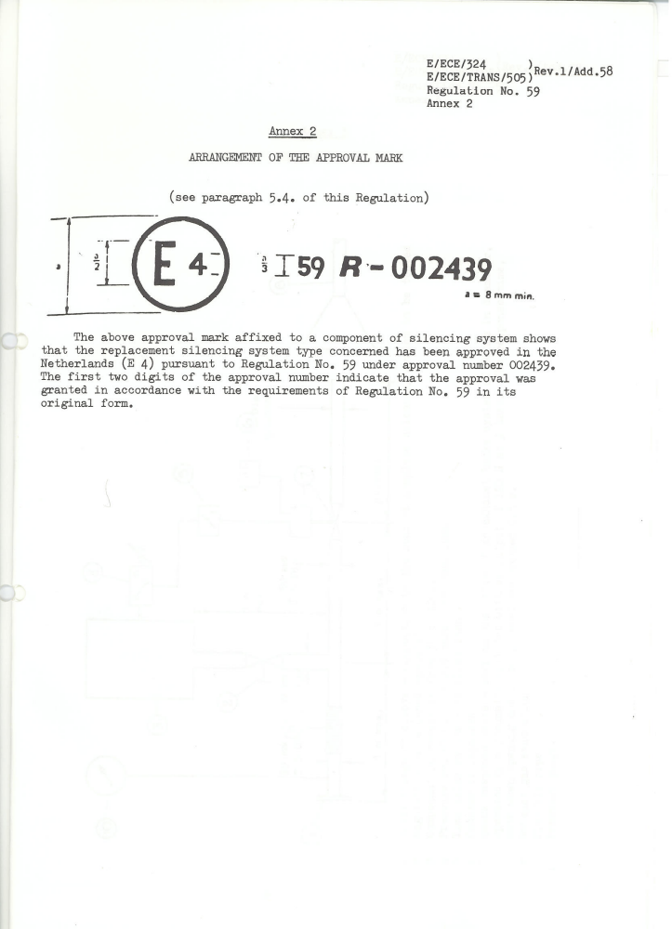
The above approval mark affixed to a component of noise reduction system shows that the replacement noise reduction system type concerned has been approved in the Netherlands (E4) pursuant to Regulation No. 59 under approval number 002439.

The first two digits of the approval number indicate that the approval was granted in accordance with the requirements of Regulation No. 59 in its original form.

Annex 3

TEST APPARATUS

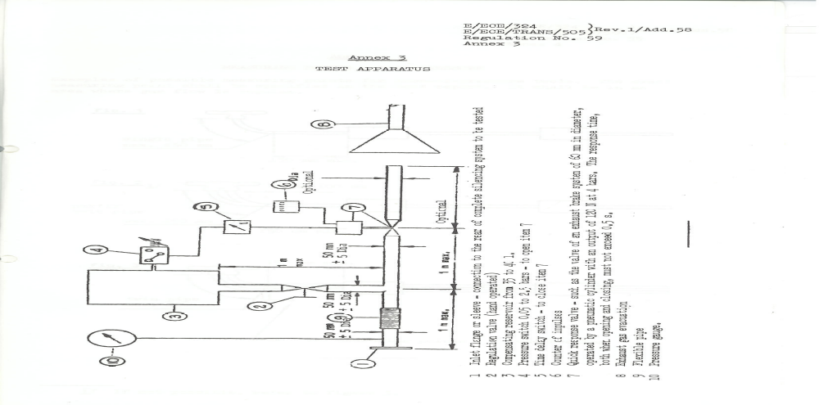

1 Inlet flange or sleeve – connection to the rear of complete noise reduction system to be Tested
2 Regulation valve (hand operated)
3 Compensating reservoir from 35 to 40 l.
4 Pressure switch 0.05 to 2.5 bars – to open item 7
5 Time delay switch – to close item 7
6 Counter of impulses
7 Quick response valve – such as the valve of an exhaust brake system of 60 mm in diameter, operated by a pneumatic cylinder with an output of 120 N at 4 bars. The response time, both when opening and closing, must not exceed 0.5 s.
8 Exhaust gas evacuation
9 Flexible pipe
10 Pressure gauge

Examples of possible measuring points for loss-of-pressure tests. The exact measuring point shall be specified in the test report. It shall be in an area where gas flow is regular.

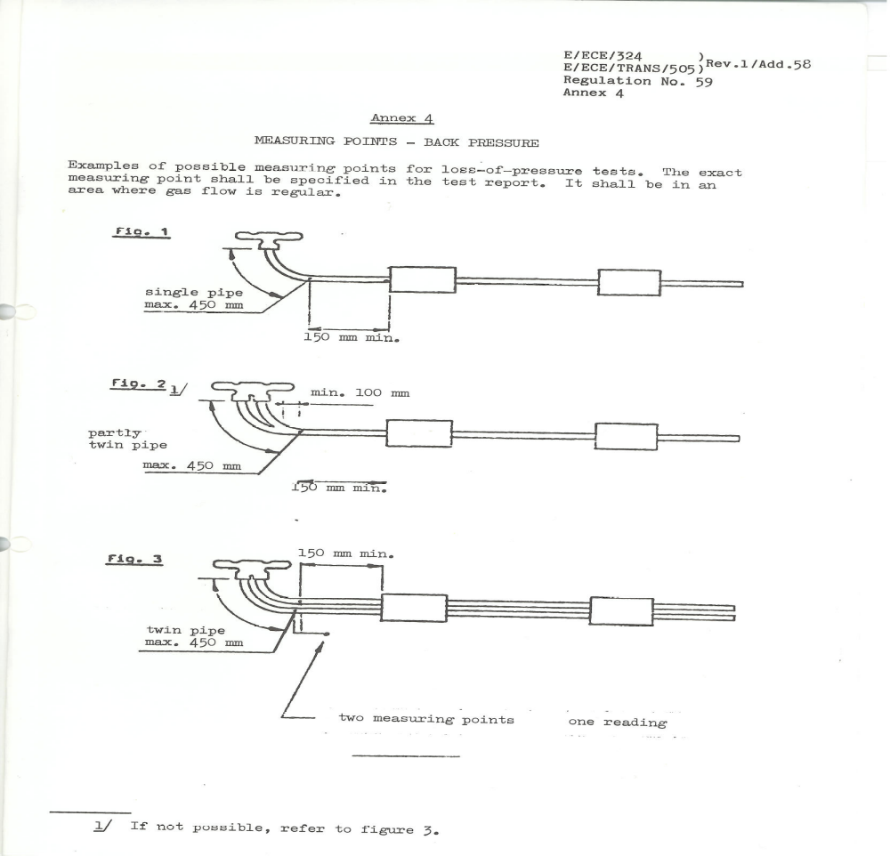
_

__________________
1/ If not possible, refer to figure 3.
Annex 5

CHECKS ON CONFORMITY OF PRODUCTION

1. GENERAL

These requirements are consistent with tests to be held to check conformity of production, according to paragraph 9.3.5 and 9.4.3. of this Regulation.

2. TESTING PROCEDURES

The methods of testing, measuring instruments and interpretation of results shall be those described in paragraph 6 above. The exhaust system or component under test shall be subjected to the test as described in paragraphs 6.2., 6.3. and 6.4. above.

3. SAMPLING

A noise reduction system or component has to be chosen. If after the test of paragraph 4.1. the sample is not considered to conform to the requirements of this Regulation two more samples have to be tested.

4. EVALUATION OF THE RESULTS

4.1. If the sound levels of the noise reduction system or component tested pursuant to paragraphs 1 and 2, measured in accordance with paragraph 6.2. above, do not exceed by more than 1 dB(A) the level measured during the type-approval tests of this type of considered to conform to the requirements of this Regulation.

4.2. If the noise reduction system or component tested according to paragraph 4.1. does not satisfy the requirements laid down in that paragraph, two more noise reduction systems or components of the same type must be tested pursuant to paragraphs 1. and 2. above.

4.3. If the sound level of the second and/or the third sample of paragraph 4.2. exceeds by more than 1 dB(A) the level measured during type- approval tests of this type of noise reduction system or component, the noise reduction system or component type shall be considered not to conform to the requirements of this Regulation and the manufacturer shall take the necessary measures to re-establish the conformity."

- - - - -

/ In accordance with the programme of work of the Inland Transport Committee for 2006-2010 (ECE/TRANS/166/Add.1, programme activity 02.4), the World Forum will develop, harmonize and update Regulations in order to enhance performance of vehicles. The present document is submitted in conformity with that mandate.
/ As defined in the Consolidated Resolution on the Construction Vehicles (R.E.3), Annex 7 (document TRANS/WP.29/78/Rev.1/Amend.2 and Amend.4.

