INF. 12

ECONOMIC COMMISSION FOR EUROPE

INLAND TRANSPORT COMMITTEE

Working Party on the Transport of Dangerous Goods

Joint Meeting of the Working Party on the Transport
of Dangerous Goods on the RID Safety Committee
(WP.15/AC.1)

Bern, 25-28 March 2008

ANY OTHER BUSINESS

Denial of shipments (radioactive material)

1. The ECOSOC Sub-Committee of Experts on the Transport of Dangerous Goods, at its thirty-second session (3-7 December 2007) took note of the action taken by the International Maritime Organization (IMO) to overcome the problem of denial of shipment of radioactive material and recommended that other modal organizations should also consider the document ST/SG/AC.10/C.3/2007/37 submitted by IMO.

2. The Joint Meeting may wish to consider the information provided by IMO, as attached to this document.

UNITED  NATIONS |  | ST
 | Secretariat | Distr.  GENERAL  ST/SG/AC.10/C.3/2007/37  28 August 2007  Original: ENGLISH

COMMITTEE OF EXPERTS ON THE TRANSPORT OF

DANGEROUS GOODS AND ON THE GLOBALLY

HARMONIZED SYSTEM OF CLASSIFICATION

AND LABELLING OF CHEMICALS

Sub-Committee of Experts on the

Transport of Dangerous Goods

Thirty-second session

Geneva, 3-12 (a.m.) December 2007

Item 11 of the provisional agenda

OTHER BUSINESS

Facilitation of shipments of radioactive material

Submitted by the International Maritime Organization (IMO) */

1. Pursuance of the specific requests of IMO resolution A.984(24) on Facilitation of the carriage of IMDG Code class 7 radioactive materials including those in packaged form used in medical or public health applications, which, amongst others, requested the Secretary-General of IMO to explore the possibility of establishing an ad hoc mechanism within the Organization to co-ordinate the speedy resolution of difficulties in the carriage of IMDG Code class 7 radioactive materials, the UN Sub-Committee of Experts on the Transport of Dangerous Goods is informed that, on a trial basis, the Secretary-General of IMO has established Class 7 Focal Point, whereby the Secretariat will monitor, facilitate and co-ordinate the resolution of such difficulties.

2. Details of mechanism within the IMO Secretariat for the resolution of difficulties in the carriage of dangerous goods including class 7 radioactive materials is set out in the annex to this document.

3. The Sub-Committee is invited to note the information provided and to take action as appropriate.

Annex

MECHANISM WITHIN THE IMO SECRETARIAT FOR THE RESOLUTION
OF DIFFICULTIES IN THE CARRIAGE OF IMDG CODE DANGEROUS GOODS INCLUDING CLASS 7 RADIOACTIVE MATERIALS

I. Introduction

1. Using the provisions of Assembly resolution A.984(24) and relevant decisions of the Facilitation Committee as guidance, the mechanism within IMO for the resolution of difficulties in the carriage of IMDG Code dangerous goods including class 7 radioactive materials is described in the ensuing paragraphs. The flowchart, as set out in appendix 1, provides a step-by-step review of the working process.

2. At this stage, the IMO Secretariat’s role will be limited to the resolution of difficulties associated with class 7 radioactive material; however, information submitted on difficulties encountered in the shipments of other dangerous goods will be compiled for consideration by the appropriate bodies.

II. Abbreviations/Definitions

3. The following abbreviations/definitions are used in this mechanism:

IAEA: International Atomic Energy Agency
IAPH: International Association of Ports and Harbors
ICHCA: ICHCA International Limited (representing cargo handlers)
ICS: International Chamber of Shipping
IMDG Code: International Maritime Dangerous Goods Code
IMO: International Maritime Organization
Involved Association: That association (VOHMA/ICS/ICHCA/IAPH) whose member has been involved in the denial/delay of shipment
Involved Organization: That organization or party which is denying or delaying the transport of the radioactive material
Manufacturer: That organization which has manufactured the finished product which is undergoing a denial or delay in transit
Competent authority: Administration associated with the difficulty in the carriage of class 7 radioactive material in the Member State concerned
Producer: That organization which has produced the radioactive material which is undergoing a denial or delay in transit
RAM: Radioactive material
Report: Report on Difficulties Encountered in Relation to the Carriage of IMDG Code class 7 Radioactive Materials
Shipper: That organization which has submitted the radioactive material for carriage which is undergoing a denial or delay in transit
VOHMA: International Vessel Operators Hazardous Materials Association, Inc.
Working Process: The process followed from the moment of shipping difficulty to the moment of reporting outcome of the IMO facilitation process

III. Working process

4. The IMO process to facilitate the resolution of difficulties encountered in the carriage of IMDG Code class 7 radioactive materials incorporates 4 essential components:

A. Notification

5. This is the initial step of the process where a shipment of IMDG Code class 7 radioactive materials has been denied or delayed for/in transport by a carrier or via a certain route or through a certain geography/port, or by a country’s regulatory restriction. Normally, it will be the Manufacturer/Producer/Shipper who will experience this denial or difficulty, either in planning a shipment or while a shipment is in transit. A denial/delay involves situations where a planned route is unavailable because of one of the restrictions noted above or where an alternate routing has had to be found and utilized at significant additional cost or administration
(e.g., a more convoluted route to the point of cargo disembarkation). The notification will occur using the Report on Difficulties encountered in relation to the carriage of IMDG Code dangerous goods including class 7 radioactive materials, as set out in appendix 2.

6. The Notification Process requires the involved Manufacturer/Producer/Shipper to prepare and submit the Report to the Maritime Administration of the country in which they reside. The Maritime Administration, or the appropriate NGO with consultative status, or the shipper/consignor shall then submit the Report (once they have investigated and reviewed it to define a potential action plan to deal with the denial) to the IMO designated contact. It is expected that the Competent Authority or the NGO will promptly submit the Report to the IMO, following receipt and review.

7. The IMO Secretariat will then interact/communicate with the appropriate designated contact within the IAEA and, if required, with another UN agency.

B. Investigation

8. This is the interim step where information is gathered and questions are asked/answered regarding the shipping denial/difficulty. This can occur between any of the parties involved, however it is expected that the IMO Member State’s Competent Authority will have reviewed and evaluated the Manufacturer/Producer/Shipper Report, upon receipt, to ensure it is complete and the information accurate and consistent. Essentially, this will be a quality control and validation step to ensure that the information and concern raised is valid and that it should be integrated into the IMO process.

9. Upon receipt, the IMO Secretariat will review the Report and clarify any questions which may exist with either or both the submitting Competent Authority and the originator of the Report. In addition, the IMO Secretariat will, as standard practice, request feedback from the organization experiencing the denial/delay as to what corrective action they see as possible and reasonable in that situation. As required and depending upon the incident, the IMO Secretariat may then discuss and plan appropriate subsequent actions (step 3), based on this review.

10. The IMO Secretariat will, upon receipt, uniquely code and classify the incident and enter the resulting data into a secure database system within the IMO. This database will be developed by the IMO (in conjunction with other organizations as deemed necessary). The coding and classification will incorporate:

(a) a reference to the specific Report code;
(b) name of country where the incident occurred;
(c) denial or delay;
(d) timing of incident (in planning, or during transit);
(e) reason for denial/delay (carrier/port or port authority/cargo handler/regulatory); and
(f) resolved/not resolved (this report will be updated throughout the working process).

11. The reference back to the detailed Report will allow additional and ongoing investigation and evaluation of the history of that incident. The unique coding will also provide IMO with the ability to maintain an essentially separate file for each incident. Coding and classification is critical to the effectiveness of the reporting mechanism described below.

12. Where the denial is due to a regulatory restriction, the IAEA will assist in the evaluation and review, and subsequent facilitation and resolution of the problem with the involved Member State. The consistent mandate of IAEA and IMO, and the reciprocal nature of these organizations, provides significant opportunity for a combination of resources and efforts which will significantly improve the possibility for resolution of shipping difficulties. The individual nature of each incident may require a specific investigation and action plan. Where the incident is not regulatory, the IMO will submit the Report to the relevant Involved Association for investigation and review.

13. It is possible that the Involved Organization in the denial is not a member of one of the referenced Involved Associations, thereby negating the Involved Association’s ability to work directly with them. In such circumstances, the Involved Association will note this to the
IMO Secretariat who will then forward the Report directly to the Maritime Administration of the country where the denial/delay occurred. That Maritime Administration will then review/discuss the denial with the organization involved.

C. Facilitation/Mediation/Action

14. This step involves the IMO Secretariat (with IAEA where appropriate) facilitating/mediating an evaluation and resolution of the issue. This will be the most time consuming step in the process as it may entail the IMO Secretariat contacting the IMO Member State representative in whose country the restriction occurred as well as the Involved Association.

15. It is foreseeable that the IMO Secretariat will also interact with the IAEA Secretariat where the restriction is due to a national regulatory restriction. Integration of the Manufacturer/Producer/Shipper and their Competent Authority will occur as required by the situation and as deemed appropriate by the IMO Secretariat.

16. Actions taken will be specific to each incident. It is also acknowledged that discussions will be detailed and iterative enough to ensure that all options and opportunities are explored and evaluated. This may mean that the process will be time intensive. Parties involved may vary from incident to incident and at various times throughout the investigation and facilitation/mediation. The IMO Secretariat, the Competent Authority (of Manufacturer/Producer/Shipper and/or of Involved Organization), the Involved Association and the Involved Organization will all form part of this process.

17. The IMO Secretariat, as the initiator of the notification and subsequent review of the incident by the Involved Association and the Involved Organization may be enough to cause the Involved.

Organization to contact and work with the affected manufacturer/producer/shipper towards a mutual agreement on course of action taken, which will lead to resolution.

18. Where this does not occur, the IMO Secretariat will encourage the Involved Association and Involved Organization to review the circumstances around the incident and to discuss any options forward which may result in a resolution. Where this does not occur, the IMO Secretariat will contact directly the Involved Organization in an effort to explore meaningful steps toward resolution.

19. Where such intervention results in progress, the IMO Secretariat will work with both the Involved Organization and the Manufacturer/Producer/Shipper to encourage discussion and problem solving. A successful resolution will be tested with subsequent shipments, whereby the Manufacturer/Producer/Shipper will notify their Competent Authority and the IMO Secretariat of the outcome so that the incident can be closed and the database updated accordingly. However, where the intervention proves unsuccessful, the Manufacturer/Producer/Shipper will produce another Report (referencing the original) and will start the notification process again.

20. Where such intervention does not result in progress, the reason may be one of corporate policy or physical inability to transport radioactive materials. This working process is not intended to compromise safety, therefore if the denial is due to lack of ability to safely transport RAM (e.g. not having the equipment, procedures or infrastructure needed), then either the decision is final or subject to discussion regarding appropriate requirements to safely handle and ship these products. Where the issue is policy driven, the Involved Organization will be requested to consider options which would allow carriage in the future. IMO will contribute to the Involved Organization’s understanding of the impact on the industry and assist in “education” regarding the regulatory environment, precautions and controls in place to help assure safe transport of these products. If this results in a solution being defined, the Manufacturer/Producer/Shipper will take the same actions as noted in the paragraph above. Where no progress is made, the incident report will be closed and the database updated accordingly.

21. It is also possible that the IMO Secretariat facilitation will result in industry associations (representing the Manufacturer/Producer/Shipper) meeting with Involved Associations to work towards a broader and more global approach to denials.

22. Where the reason for denial is based on regulation, the IMO Secretariat will work with IAEA Secretariat to identify an appropriate process forward. Progress or lack of progress will be managed as above.

23. On a broader basis, the IAEA and IMO should look for opportunities to standardize requirements in shipping, handling regulations, required processes, practices and procedures at ports and with Port Authorities around the world. An initiative to look solely at these factors would help facilitate this issue and help both organizations achieve their mandate regarding this important issue. Consistency in requirements will significantly assist in this process.

D. Reporting

24. This is the final step in the process. The outcome of the facilitation/mediation process will be recorded in the database according to success/no success, to ensure each incident is brought to closure. The IMO Secretariat shall endeavour to maintain the database current and shall prepare status reports for each Facilitation Committee (FAL) and Assembly meeting. This report may be a standing agenda item in each of these meetings, and will be drafted as submissions (from the Secretariat), are prepared in time to be considered in these meetings. The IMO Secretariat will maintain ongoing co-operation with IAEA.

25. The Working Process Flowchart, as set out in appendix 3, summarizes the actions and outcomes described above.

IV. Summary of method of operation

26. The Facilitation Committee will monitor and support the facilitation of instances of denials in the transport of radioactive material. The Facilitation Committee will not involve itself in solving individual instances of denial, but should focus on broad and long term solutions associated with underlying causes. The Facilitation Committee will review the records, will seek to determine the root causes and agree on actions intended to resolve these causes.

27. Interested UN agencies will collectively develop administrative processes, systems and a single, secure database to retain, compile and analyse the reports. The database will include fields, which permit the grouping of reports for ease of analysis.

The method of operation will be the following:

(a) Notification of instances

IMO Secretariat will:

(i) establish a point of contact to whom reports are to be submitted; and
(ii) establish a mutually agreed, upon information, sharing methodology.
Manufacturers/producers/shippers should:

(iii) utilize the standard report form for notifications of denials/delays (as shown in appendix 2); and
(iv) file the report with the relevant Competent Authority.

The Competent Authority should:

(v) validate the information in the manufacturers/producers/shippers report; and
(vi) file the report with the appropriate UN agency.

(b) Investigation of the cause of specific instances

The appropriate Competent Authorities will:

(i) work together to investigate reports on denials of shipments to determine the root cause; and
(ii) after the root cause has been determined, provide the information to the appropriate UN agency.

The IMO Secretariat will:

(iii) co-ordinate with the Competent Authorities and the manufacturers/producers/shippers, who experience difficult, to ensure the accuracy of the report;
(iv) share information with other UN agencies and coordinate on next steps; and
(v) communicate reported instances of denials to involved associations and organizations.

(c) Facilitation / Mediation of specific instances

All parties involved, including manufacturers/producers/shippers, Competent Authorities, involved associations and organizations and UN agencies will cooperate to facilitate the resolution of issues which result in the denial or delay of shipments of radioactive materials.

On this basis the involved parties should:

(i) work together to facilitate the investigation and resolution of the reason for denial/delay;
(ii) conduct open and meaningful discussions regarding the incident, with the aim of finding a resolution.

(d) Reporting of instances

The IMO Secretariat, in co-operation with other interested UN Agencies, will:

(i) ensure that the database is kept up to date, including all outcomes of the facilitation/mediation process; and
(ii) prepare a report of denial/delay incidents/status/causes/key outcomes for submission to the Facilitation Committee and to other appropriate bodies, if required.

Appendix 1

OVERVIEW OF IMO WORKING PROCESS

Report of issue prepared by Originator and forwarded to their Competent Authority (C.A.) and ultimately
to IMO Secretariat
Unresolved Shipping Issue
(Denial/Delay)
Integrated discussions/problem solving/resolution mechanism identification and action
Results reporting
IMO and Associations (VOHMA, ICHCA, IAPH) reviews and evaluates issue
Investigation
Reporting
Facilitation and mediation
Notification
IMO and
C.A. of Involved Country evaluates issue
Integrated discussions/problem solving/resolution mechanism identification and action
Results reporting

Appendix 2

REPORT ON DIFFICULTIES ENCOUNTERED IN RELATION TO THE CARRIAGE OF IMDG CODE DANGEROUS GOODS INCLUDING CLASS 7 RADIOACTIVE MATERIALS
(submitted pursuant to the provisions of resolution A.984(24) and decisions of FAL 34)

Report submitted by: Date of report:

Product name:
UN number:
Proper shipping name:
IMDG Code class or division:
Shipment reference number (consignor ID):
The carriage of the above consignment was delayed was denied
Consignor:
Consignee:
Carrier:
Name of aircraft/ship/vehicle:
Type of aircraft/ship/vehicle:
Flight/IMO Ship identification/vehicle number:
Flight number/Voyage reference/route reference:
Location and date of loading:
Date of difficulty:
Name of entity with whom the alleged difficulty:
Location(s) and date(s) of transit:
Destination:
Brief description of events:
Reasons stated for the difficulty of the carriage:
Action(s) taken to resolve the matter (if any):
Consequences of the development(s):
Other relevant information or comments:
Suggestions (if any):
Name, title and contact details of person submitting the report:
Appendix 3

IMO WORKING PROCESS FOR MONITORING, FACILITATING AND CO-ORDINATING RESOLUTION OF DIFFICULTIES IN THE CARRIAGE OF IMDG CODE CLASS 7 RADIOACTIVE MATERIALS

(see next page)
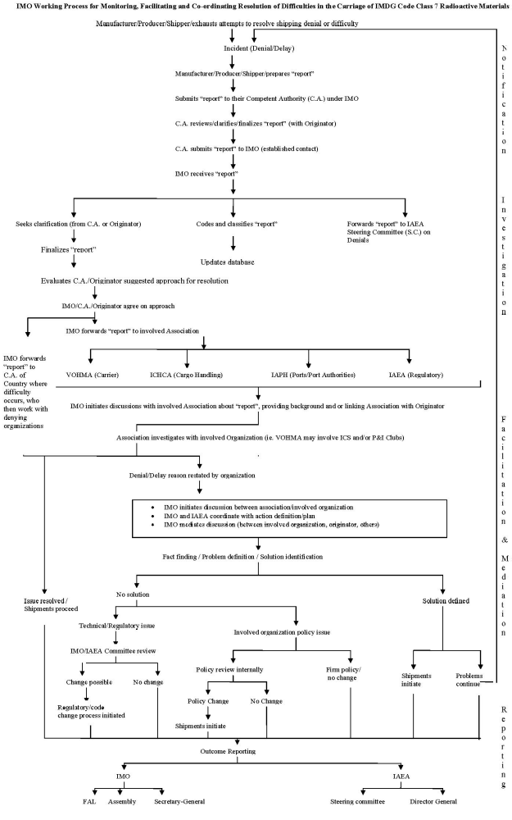
NATIONS UNIES |  | ST
 | Secrétariat | Distr.  GÉNÉRALE  ST/SG/AC.10/C.3/2007/37  28 août 2007  FRANÇAIS  Original: ANGLAIS
COMITÉ D’EXPERTS DU TRANSPORT DES
MARCHANDISES DANGEREUSES ET DU SYSTÈME
GÉNÉRAL HARMONISÉ DE CLASSIFICATION ET
D’ÉTIQUETAGE DES PRODUITS CHIMIQUES
Sous-Comité d’experts du transport
des marchandises dangereuses
Trente-deuxième session
Genève, 3-12 (matin) décembre 2007
Point 11 de l’ordre du jour provisoire
QUESTIONS DIVERSES
Facilitation des expéditions de matières radioactives
Communication de l’Organisation maritime internationale (OMI)*
1. En réponse aux demandes précises de la résolution A.984(24) de l’OMI sur la facilitation du transport des matières radioactives de la classe 7 du code IMDG, y compris celles sous emballage destinées à des fins médicales ou de santé publique, où, entre autres, le Secrétaire général de l’OMI était prié d’envisager la possibilité de mettre au point un mécanisme spécial au sein de l’Organisation, en vue d’arriver à une résolution rapide des difficultés lors du transport des matières radioactives de la classe 7 du code IMDG, le Sous-Comité d’experts du transport des marchandises dangereuses de l’ONU est informé qu’à titre expérimental le Secrétaire général de l’OMI a créé un centre de coordination pour la classe 7, grâce auquel le secrétariat suivra, facilitera et coordonnera la résolution de ces difficultés.
2. Le mécanisme au sein du secrétariat de l’OMI devant permettre de résoudre les difficultés lors du transport des marchandises dangereuses, y compris les matières radioactives de la classe 7, est décrit à l’annexe au présent document.
3. Le Sous-Comité est invité à prendre note des informations fournies et à y donner suite comme il l’entendra.
Annexe
MÉCANISME AU SEIN DU SECRÉTARIAT DE L’OMI DEVANT PERMETTRE DE RÉSOUDRE LES DIFFICULTÉS LORS DU TRANSPORT DES MARCHANDISES DANGEREUSES SELON LE CODE IMDG, Y COMPRIS LES MATIÈRES RADIOACTIVES DE LA CLASSE 7
I. Introduction
1. Pour tenir compte des dispositions de la résolution A.984(24) de l’Assemblée et des décisions pertinentes du Comité de la simplification des formalités, il a été mis au point au sein de l’OMI un mécanisme devant permettre de résoudre les difficultés lors du transport des marchandises dangereuses selon le code IMDG, y compris les matières radioactives de la classe 7, qui est décrit dans les paragraphes ci-après. L’organigramme qui figure à l’appendice 1 résume, étape par étape, le processus de travail.
2. À ce stade, le rôle du secrétariat de l’OMI se limitera à la résolution des difficultés liées au transport des matières radioactives de la classe 7; toutefois, les informations communiquées sur les difficultés rencontrées lors des expéditions d’autres marchandises dangereuses seront recueillies pour examen par les organes appropriés.
II. Abréviations et définitions
3. Les abréviations et définitions suivantes sont employées dans le cadre de ce mécanisme:
AIEA: | Agence internationale de l’énergie atomique
AIP: | Association internationale des ports
AICMM: | Association internationale pour la coordination de la manutention des marchandises
CIMM: | Chambre internationale de la marine marchande
Code IMDG: | Code maritime international des marchandises dangereuses
OMI: | Organisation maritime internationale
Association concernée: | Association (VOHMA/CIMM/AICMM/AIP) dont un membre est à l’origine d’un refus ou d’un retard d’expédition
Organisme en cause: | Organisme ou partie qui refuse ou retarde le transport de matières radioactives
Fabricant: | Organisme ayant fabriqué le produit fini qui fait l’objet d’un refus ou d’un retard au cours du transport
Autorité compétente: | Administration qui est concernée par les difficultés lors du transport de matières radioactives de la classe 7 dans l’État membre en question
Producteur: | Organisme ayant produit les matières radioactives qui font l’objet d’un refus ou d’un retard au cours du transport
Rapport: | Rapport sur les difficultés rencontrées lors du transport de matières radioactives de la classe 7 du code IMDG
Expéditeur: | Organisme ayant présenté les matières radioactives au transport qui font l’objet d’un refus ou d’un retard au cours du transport
VOHMA: | International Vessel Operators Hazardous Materials Association, Inc.
Méthode de travail: | Procédure suivie depuis la rencontre de difficultés lors de l’expédition jusqu’au rapport sur les résultats obtenus dans le cadre de la procédure de facilitation OMI
III. Processus de travail
4. Le processus OMI devant faciliter la résolution des difficultés rencontrées lors du transport des matières radioactives de la classe 7 du code IMDG comporte les quatre principales étapes suivantes:
A. Notification
5. Il s’agit de l’étape initiale du processus au cours duquel un envoi de matières radioactives de la classe 7 du code IMDG est refusé ou retardé, par un transporteur, sur un certain itinéraire ou dans un certain lieu ou port, ou bien à cause d’une restriction réglementaire nationale. Le fabricant, le producteur ou l’expéditeur est généralement celui qui subit le refus ou rencontre la difficulté, soit lors de la planification de l’expédition, soit lorsque l’envoi est en transit. Un refus ou un retard implique des situations dans lesquelles un itinéraire prévu ne peut être suivi en raison de l’une des restrictions susmentionnées ou une autre voie d’acheminement doit être trouvée et empruntée, moyennant d’importants coûts ou charges administratives supplémentaires (par exemple, un itinéraire moins direct jusqu’au lieu de débarquement du chargement). La notification se fera par le biais du Rapport sur les difficultés rencontrées lors du transport des marchandises dangereuses selon le code IMDG, y compris les matières radioactives de la classe 7, tel qu’il figure à l’appendice 2.
6. Dans le cadre de la procédure de notification, le fabricant, le producteur ou l’expéditeur concerné doit établir et communiquer le rapport à l’autorité compétente du pays dans lequel il réside. L’autorité compétente, l’ONG appropriée ayant un statut consultatif ou le chargeur ou l’expéditeur doit ensuite communiquer le rapport (après l’avoir analysé et examiné en vue de définir un futur plan d’action pour traiter le cas du refus) au correspondant habilité de l’OMI. Il est à prévoir qu’après réception et examen l’autorité compétente ou l’ONG transmettra rapidement le rapport à l’OMI.
7. Le secrétariat de l’OMI entrera ensuite en contact ou se mettra en communication avec le correspondant habilité au sein de l’AIEA et, si besoin est, avec une autre institution de l’ONU.
B. Enquête
8. Cette étape intermédiaire consiste à recueillir des renseignements, à poser des questions sur les cas de refus ou de difficultés d’expédition et obtenir des réponses. Elle peut faire intervenir chacune des parties concernées, mais il est à prévoir toutefois que l’autorité compétente de l’État membre de l’OMI aura examiné et évalué le rapport du fabricant, du producteur ou de l’expéditeur dès réception afin de vérifier qu’il est complet et que les informations sont exactes et cohérentes. Il s’agit essentiellement d’une étape de contrôle de la qualité et de validation pour s’assurer que les informations et les problèmes soulevés sont valides avant de les prendre en compte dans le processus OMI.
9. Dès réception du rapport, le secrétariat de l’OMI l’examinera et demandera des éclaircissements concernant d’éventuelles questions à l’autorité compétente qui l’a présenté ou à l’auteur du rapport, ou aux deux. En outre, le secrétariat de l’OMI demandera systématiquement à l’organisme qui a subi le refus ou le retard de donner son avis quant aux mesures correctives envisageables et raisonnables dans une telle situation. Si nécessaire, et en fonction de l’incident, le secrétariat de l’OMI pourra ensuite examiner et planifier les mesures à prendre (étape 3) sur la base de cet examen.
10. Dès réception du rapport, le secrétariat de l’OMI attribuera à l’incident un code et une classification uniques, et saisira ces données dans une base de données sécurisées de l’OMI. Cette base de données sera établie par l’OMI (en collaboration avec d’autres organismes si nécessaire). Les codes et la classification comprendront les éléments suivants:
a) Une référence au code spécifique du rapport;
b) Le nom du pays où s’est produit l’incident;
c) Le refus ou le retard;
d) Ce moment de l’incident (lors de la planification ou pendant le transport);
e) Le motif du refus ou du retard (transporteur/port ou autorité portuaire/ manutentionnaire de fret/restriction réglementaire); et
f) Cas résolu/non résolu (ce rapport sera mis à jour tout au long de la procédure).
11. La référence renvoyant au rapport détaillé facilitera l’enquête en cours ou les recherches supplémentaires et permettra d’évaluer les circonstances de l’incident. Grâce au code unique, l’OMI pourra également établir un fichier distinct pour chaque incident. Le codage et la classification sont essentiels si l’on veut que le mécanisme de compte rendu décrit ci-après soit efficace.
12. Si le refus résulte d’une restriction réglementaire, l’AIEA aidera à l’évaluation et à l’examen, puis à la facilitation et à la résolution du problème avec l’État membre concerné. Les mandats compatibles de l’AIEA et de l’OMI et les pratiques de réciprocité de ces deux organisations vont permettre de mettre en commun aisément leurs ressources et leurs efforts, ce qui facilitera considérablement la résolution des difficultés d’expédition. Le caractère unique de chaque incident peut nécessiter une enquête et un plan d’action spécifiques. Si l’incident n’est pas lié à une restriction réglementaire, l’OMI soumettra le rapport à l’association concernée pour enquête et examen.
13. Il est possible que l’organisme en cause, à l’origine du refus, ne soit pas membre de l’une des associations concernées mentionnées, ce qui rend impossible à l’association concernée une collaboration directe avec lui. Dans ce cas, l’association concernée en rendra compte au secrétariat de l’OMI, qui transmettra alors le rapport directement à l’autorité compétente du pays où a eu lieu le refus ou le retard. Cette dernière examinera le refus et en débattra avec l’organisme en cause.
C. Facilitation, médiation et action
14. Cette étape consiste pour le secrétariat de l’OMI (en liaison avec l’AIEA si nécessaire), à entreprendre des efforts de facilitation et de médiation en vue d’aider les parties à évaluer et à résoudre le problème. Elle est l’étape la plus longue de la procédure car elle nécessite que le secrétariat de l’OMI prenne contact avec le représentant de l’État membre de l’OMI dans lequel la restriction a été appliquée, ainsi qu’avec l’association concernée.
15. L’OMI aura certainement aussi à prendre contact avec l’AIEA si la restriction est une restriction réglementaire nationale. La participation du fabricant, du producteur ou de l’expéditeur et de l’autorité compétente sera sollicitée en fonction de la situation et si le secrétariat de l’OMI le juge approprié.
16. Les mesures prises seront propres à chaque incident. Les discussions seront aussi vraisemblablement suffisamment détaillées et systématiques pour garantir que toutes les options et les possibilités auront été examinées et évaluées. Cela veut dire que la procédure pourra être longue. Les parties concernées peuvent différer d’un incident à l’autre et d’un moment à l’autre au cours de l’enquête et de la facilitation ou de la médiation. Le secrétariat de l’OMI, l’autorité compétente (du fabricant, du producteur ou de l’expéditeur et/ou de l’organisme en cause), l’association concernée et l’organisme en cause participeront tous à cette procédure.
17. La notification émise par le secrétariat de l’OMI et l’examen ultérieur de l’incident par l’association concernée et l’organisme en cause peuvent suffire à inciter celui-ci à prendre contact et à coopérer avec le fabricant, le producteur ou l’expéditeur concerné en vue de se mettre d’accord sur les mesures à prendre pour résoudre le problème.
18. Au cas où il ne le ferait pas, le secrétariat de l’OMI encouragera l’association concernée et l’organisme en cause à examiner les circonstances de l’incident et à envisager toute mesure possible pouvant apporter une solution. À défaut, le secrétariat de l’OMI contactera directement l’organisme en cause en vue de rechercher des moyens efficaces de résoudre le problème.
19. Si cette intervention aboutit, le secrétariat de l’OMI collaborera tant avec l’organisme en cause qu’avec le fabricant, le producteur ou l’expéditeur en vue d’encourager le débat et la résolution du problème. C’est sur la base de nouvelles expéditions que l’on vérifiera si le problème a été résolu; le fabricant, le producteur ou l’expéditeur rendra compte du résultat à son autorité compétente et au secrétariat de l’OMI afin que, en cas de succès, l’incident puisse être clos et la base de données mise à jour en conséquence. Si l’intervention par contre se révèle être un échec, le fabricant, le producteur ou l’expéditeur devra établir un autre rapport (faisant référence au premier) et répéter la procédure de notification.
20. Si cette intervention échoue, il se peut que ce soit en raison d’une politique d’entreprise ou d’une incapacité matérielle à transporter des matières radioactives. La présente méthode de travail n’est pas censée remettre en cause la sécurité. Par conséquent, si le refus est dû à une incapacité à transporter les matières radioactives en toute sécurité (par exemple par manque d’équipement, de consignes ou d’infrastructures nécessaires), la décision est alors soit définitive, soit prise seulement après des discussions en vue de déterminer comment manipuler et expédier ces produits en toute sécurité. Si le problème résulte d’une politique d’entreprise, l’organisme en cause est invité à étudier des solutions rendant possible le transport à l’avenir. La contribution de l’OMI sera de l’aider à se faire une idée exacte de l’impact de ce problème sur le secteur et à jouer un rôle «éducatif» en ce qui concerne le cadre réglementaire, les précautions et les contrôles en vigueur pour garantir un transport sûr de ces produits. Si une solution est trouvée, le fabricant, le producteur ou l’expéditeur procèdera comme indiqué dans le paragraphe précédent. Dans le cas contraire, le rapport d’incident sera clos et la base de données mise à jour en conséquence.
21. Il se peut également que les efforts de facilitation du secrétariat de l’OMI aboutissent à une rencontre entre les associations du secteur (représentant le fabricant, le producteur et l’expéditeur) et les associations concernées pour qu’elles abordent le problème des refus d’expédition dans un cadre plus large et plus global.
22. Si le refus est lié à une restriction réglementaire, le secrétariat de l’OMI collaborera avec le secrétariat de l’AIEA pour déterminer la marche à suivre. Selon l’évolution positive ou négative de cette intervention, il sera pris les mesures énumérées plus haut.
23. Sur un plan plus général, l’AIEA et l’OMI devraient étudier les possibilités d’uniformiser les prescriptions des réglementations relatives à l’expédition et à la manutention, ainsi que les méthodes, les pratiques et les procédures requises au niveau des ports et avec les autorités portuaires du monde entier. Une initiative pour examiner ces facteurs pris séparément faciliterait la résolution du problème et aiderait les deux organisations à remplir leur mandat sur cette question importante. La cohérence des prescriptions favoriserait considérablement le bon déroulement de la procédure.
D. Établissement de rapports de situation
24. Il s’agit de la dernière étape de la procédure. Les résultats de la procédure de facilitation et de médiation seront consignés dans la base de données en fonction de la réussite ou de l’échec, de manière à garantir que chaque incident soit clos. Le secrétariat de l’OMI devra s’efforcer de tenir à jour la base de données et établir un rapport de situation pour chacune des réunions du Comité de la simplification des formalités et de l’Assemblée. Ce rapport pourra faire l’objet d’un point inscrit en permanence à l’ordre du jour de chacune de ces réunions. Il sera rédigé sous la forme de propositions (formulées par le secrétariat), établies à temps pour être examinées lors de ces réunions. Le secrétariat de l’OMI entretiendra une collaboration régulière avec l’AIEA.
25. L’organigramme du processus de travail, tel qu’il figure à l’appendice 3, résume les mesures à prendre et les résultats à obtenir tels qu’ils sont présentés ci-dessus.
IV. Résumé de la méthode de travail
26. Le Comité de la simplification des formalités suivra et aidera à résoudre les cas de refus lors du transport de matières radioactives. Il ne se chargera pas lui-même de la résolution des cas individuels de refus, mais se concentrera sur des solutions globales et à long terme, liées aux causes sous-jacentes. Il examinera les informations consignées, recherchera les causes profondes et décidera des mesures à prendre pour supprimer ces causes.
27. Les institutions de l’ONU concernées mettront au point collectivement des procédures administratives, des systèmes et une base de données sécurisée unique où pourront être conservés, classés et analysés les rapports. La base de données comportera des champs permettant de regrouper les rapports pour faciliter les analyses.
La procédure comportera les étapes suivantes:
a) Notification des cas
Le secrétariat de l’OMI devra:
i) Désigner un correspondant auquel les rapports seront présentés; et
ii) Établir une méthode de partage convenue des informations reçues.
Les fabricants, les producteurs et les expéditeurs devraient:
iii) Utiliser la formule de rapport normalisé pour les notifications des refus et des retards (qui est donnée à l’appendice 2); et
iv) Déposer le rapport auprès de l’autorité compétente pertinente.
L’autorité compétente devrait:
v) Valider les informations mentionnées dans le rapport du fabricant, du producteur ou de l’expéditeur; et
vi) Déposer le rapport auprès de l’institution de l’ONU appropriée.
b) Enquête sur les causes des cas précis
Les autorités compétentes appropriées devront:
i) Collaborer pour ce qui est de l’examen des rapports sur les refus d’expédition afin d’en déterminer les causes premières; et
ii) Après avoir déterminé les causes premières, fournir les informations à l’institution de l’ONU appropriée.
Le secrétariat de l’OMI devra:
iii) Assurer la coordination avec les autorités compétentes et les fabricants, les producteurs et les expéditeurs qui rencontrent des difficultés, pour garantir l’exactitude du rapport;
iv) Partager les informations avec d’autres institutions de l’ONU et coordonner les étapes suivantes; et
v) Communiquer les cas de refus signalés aux associations concernées et aux organismes en cause.
c) Facilitation et médiation dans les cas précis
Toutes les parties concernées, y compris les fabricants, les producteurs et les expéditeurs, les autorités compétentes, les associations concernées et les organismes en cause et les institutions de l’ONU devront coopérer en vue de faciliter la résolution des problèmes qui conduisent à un refus ou à un retard des expéditions de matières radioactives.
Sur cette base, les parties concernées devraient:
i) Collaborer en vue de faciliter l’examen et la détermination du motif du refus ou du retard;
ii) Organiser des débats ouverts et constructifs sur l’incident, dans le but de parvenir à une solution.
d) Établissement de rapports de cas
Le secrétariat de l’OMI, en collaboration avec d’autres institutions de l’ONU concernées devront:
i) Veiller à tenir à jour la base de données, en y incluant tous les résultats du processus de facilitation et de médiation; et
ii) Établir un rapport sur les incidents (refus ou retard, état d’avancement, causes et principaux résultats) pour communication au Comité de la simplification des formalités et à d’autres organes appropriés, si besoin est.
Appendice 1
VUE D’ENSEMBLE DU PROCESSUS DE TRAVAIL DE L’OMI

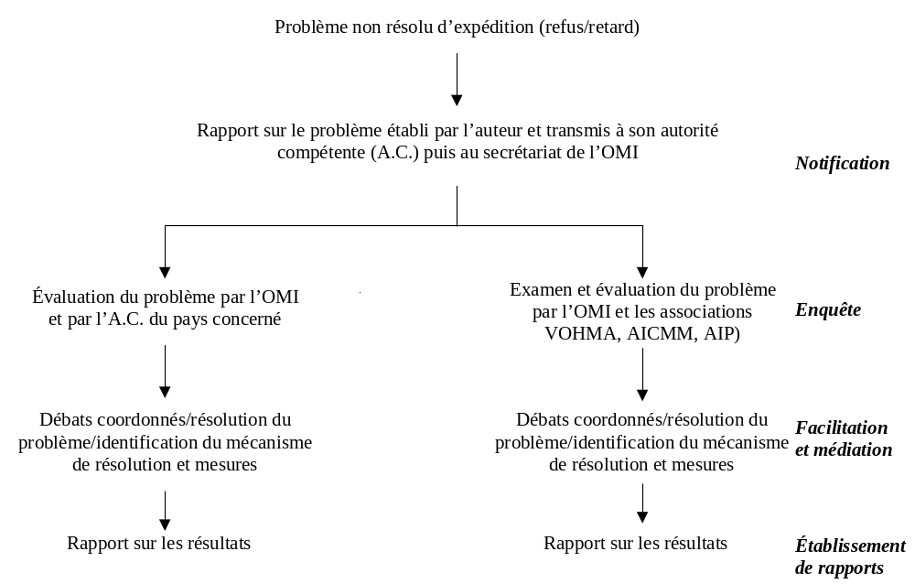

Appendice 2
RAPPORT SUR LES DIFFICULTÉS RENCONTRÉES LORS DU TRANSPORT DES MARCHANDISES DANGEREUSES SELON LE CODE IMDG, Y COMPRIS
LES MATIÈRES RADIOACTIVES DE LA CLASSE 7
(présenté conformément aux dispositions de la résolution A.984(24) et aux décisions
du Comité de la simplification des formalités 34)
Rapport présenté par1: Date:
Nom du produit:
Numéro ONU:
Désignation officielle de transport:
Classe ou division dans le Code IMDG:
Numéro de référence de l’expédition (identification de l’expéditeur):
Le transport du chargement ci-dessus a été retardé refusé
Expéditeur:
Destinataire:
Transporteur:
Nom de l’aéronef, du navire ou du véhicule:
Type de l’aéronef, du navire ou du véhicule:
Numéro de l’aéronef, numéro OMI d’identification du navire ou numéro du véhicule:
Numéro du vol, référence du voyage ou référence de l’itinéraire:
Lieu et date du chargement:
Date d’apparition de la difficulté:
Nom de l’entité avec laquelle il existerait des difficultés:
Lieu(x) et date(s) du tranport:
Destination:
Brève description des événements:
Motif invoqué de l’entrave au transport:
Mesure(s) prise(s) pour résoudre la question (le cas échéant):
Conséquences de la ou des mesures prises:
Autres observations ou renseignements pertinents:
Suggestions (le cas échéant):
Nom, fonction et coordonnées de la personne qui présente le rapport:
Appendice 3
PROCESSUS DE TRAVAIL DE L’OMI QUANT AU SUIVI, À LA FACILITATION
ET À LA COORDINATION EN VUE DE RÉSOUDRE LES DIFFICULTÉS
RENCONTRÉES LORS DU TRANSPORT DE MATIÈRES
RADIOACTIVES DE LA CLASSE 7 DU CODE IMDG
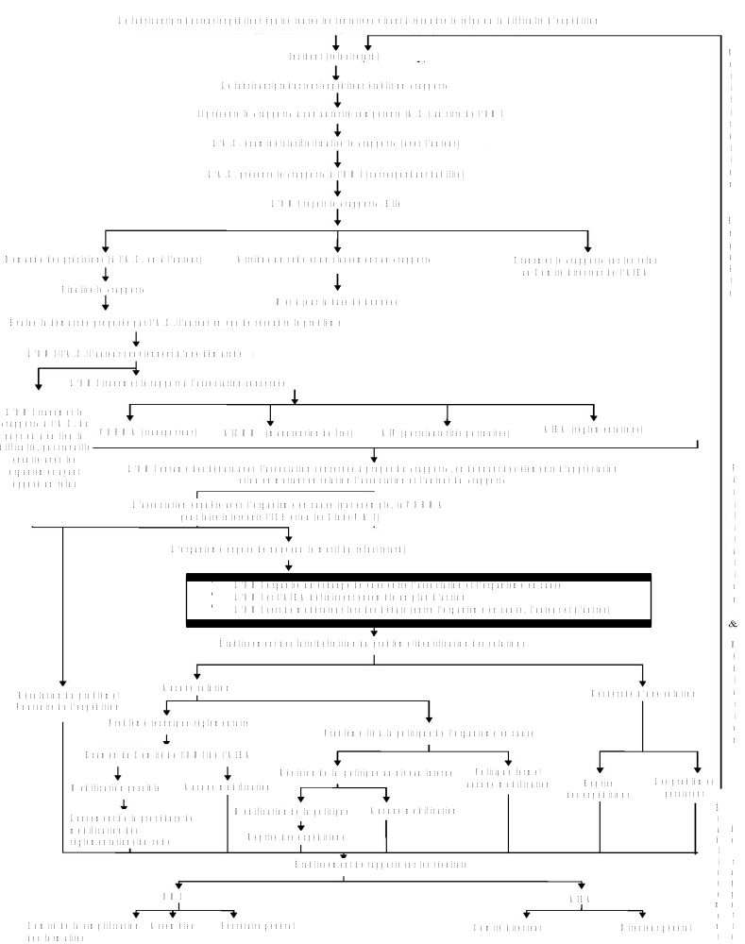

*/ In accordance with the Economic and Social Council’s resolution 2007/6, of 23 July 2007, section A, operative paragraph 5 whereby the Committee is requested to continue to study in consultation with, inter alia, the IMO, the possibilities of improving the implementation of the Model Regulations on the Transport of Dangerous Goods for the purposes of ensuring a high level of safety and eliminating technical barriers to international trade.
Name of Member Government’s Maritime Administration or Non-Governmental Organization with consultative status, Manufacturer/Producer/Shipper submitting the Report.
* En application du paragraphe 5 de la section A de la résolution 2007/6 du Conseil économique et social, en date du 23 juillet 2007, dans lequel le Comité est prié de poursuivre l’étude, en consultation avec l’OMI entre autres, des possibilités d’améliorer la mise en œuvre du Règlement type relatif au transport des marchandises dangereuses en vue de garantir un niveau de sécurité élevé et d’éliminer les entraves techniques au commerce international.
1 Nom de l’autorité compétente du Gouvernement membre, de l’organisation non gouvernementale dotée du statut consultatif ou du fabricant, du producteur ou de l’expéditeur qui présente le rapport.

