UNITED  NATIONS |  | E
 | Economic and Social  Council | Distr.  GENERAL  ECE/TRANS/WP.29/GRSG/2007/13  1 February 2007  Original: ENGLISH  ENGLISH AND FRENCH ONLY

ECONOMIC COMMISSION FOR EUROPE

INLAND TRANSPORT COMMITTEE

World Forum for Harmonization of Vehicle Regulations

Working Party on General Safety Provisions

Ninety-second session
Geneva, 16-20 April 2007
Item 3.5. of the provisional agenda

AMENDMENTS TO OTHER REGULATIONS UNDER THE 1958 AGREEMENT

Regulation No. 58 (Rear underrun protection)

Proposal for draft amendments to Regulation No. 58

Submitted by the expert from Japan

The text reproduced below was prepared by the expert from Japan in order to propose amendments to ECE/TRANS/WP.29/GRSG/2007/12, submitted by the experts from France and the European Commission, with regard the effective surface area of rear underrun protection devices. The proposed amendments to ECE/TRANS/WP.29/GRSG/2007/12 are marked in bold characters.
A. PROPOSAL

PART I., inserted new paragraph 7.4.2., amend to read:

"7.4.2. The individual elements of the underrun protection, including those outboard of the lift mechanism, where provided, must have an effective surface area, in each case, of at least 350 cm².

However, in cases where it is difficult to secure this effective surface area of the underrun protection in a truck with a gross vehicle weight (GVW) of seven tonnes or less due to its structure, Contracting Parties may specify in their national regulations the size of such area."

PART III., inserted new paragraph 25.8.2., amend to read:

"25.8.2. The individual elements of the underrun protection, including those outboard of the lift mechanism, where provided, must have an effective surface area, in each case, of at least 350 cm².

However, in cases where it is difficult to secure this effective surface area of the underrun protection in a truck with a gross vehicle weight (GVW) of seven tonnes or less due to its structure, Contracting Parties may specify in their national regulations the size of such area."

B. JUSTIFICATION

Japan is of the opinion that it is not feasible to require 350 cm² effective surface area of the underrun protection's individual elements for vehicles with a small width.

1. Bumper width direction (see Figure 1)

The outer bumpers need to be positioned in such a way that they do not interfere with the lift's arms installed at the outside of the chassis frame. If the outer bumpers are positioned in such a way that they do not protrude outside the tyre's outer edge, it will be impossible to secure sufficient length and area of bumpers for general vehicles with GVW of seven tonnes or less.

2. Bumper height direction (see Figure 1)

If the bumper height is increased in an upward direction to secure a wider area, it will interfere with the rear lamps and body structures. If the bumper height is increased in downward direction, the departure angle will decrease, which results in poor drivability.

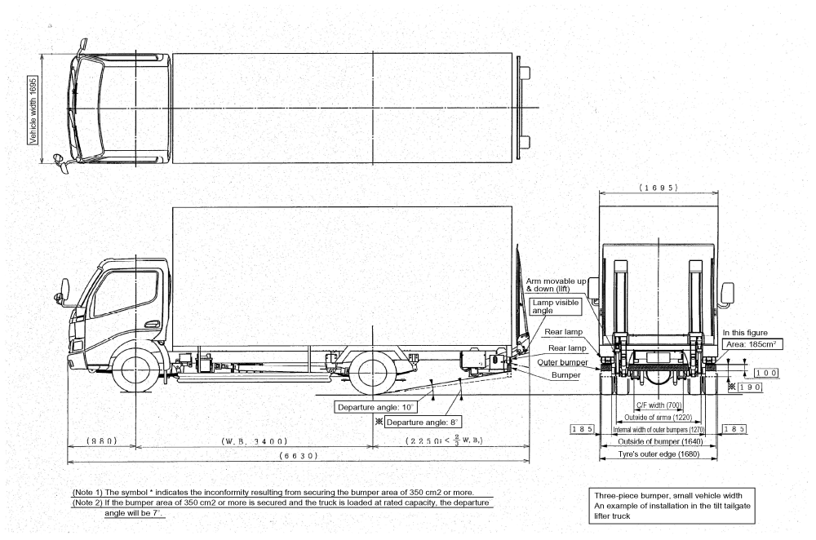
Vehicle width 1,695
Internal width of outer bumpers (1,270)
All dimensions are given in millimeters.
185
185
Tyre's outer edge (1,680)
Outside of bumper (1,640)
Outside of arms (1,220)
C/F width (700)
100

190 */

Area: 185 cm³
Rear lamp
Outer bumper

Lamp visible angle
Bumper
Rear lamp
Arm movable up and down (lift)
Departure angle 10º
Departure angle 8º*/ **/
2,250 (< ⅔ wheel base)
Wheel base 3,400
6,630
*/ Indicates inconformity resulting from securing the bumper area of 350 cm² or more.
**/ If the bumper area of 350 cm² or more is secured and the truck is loaded at rated capacity, the departure angle will be 7º.

Figure 1
980
1,695
A small vehicle with a three-piece bumper: an example of lift installation in the truck tailgate

ECE/TRANS/WP.29/GRSG/2007/13
page 3

