UN/SCETDG/32/INF.36

COMMITTEE OF EXPERTS ON THE TRANSPORT OF
DANGEROUS GOODS AND ON THE GLOBALLY
HARMONIZED SYSTEM OF CLASSIFICATION
AND LABELLING OF CHEMICALS

Sub-Committee of Experts on the

Transport of Dangerous Goods

Thirty-second session
Geneva, 3-7 December 2007
Item 3 of the provisional agenda

LISTING, CLASSIFICATION AND PACKING

Modifications to the time/ pressure test for defining flash powders

Transmitted by the expert from the United Kingdom

1. In paragraph 19 (g) of the report of the 31st Sub-Committee on the Transport of Dangerous Goods,ST/SG/AC.10/C.3/62, the expert from the United Kingdom informed the Sub-Committee that a report would be prepared detailing the research completed on the modifications to the Time/Pressure test for defining flash powders. This paper gives details of the results of this research.

2. The Time/Pressure test has been included in the definition of a ‘Flash powder’, in Note 2 to 2.1.3.5.5 as adopted at the 30th session. Other Experts have raised concerns regarding the suitability of the test for this application, in particular the small sample size and the repeatability of the results obtained.

3. The research has focused on improving the ignition system and reducing the standard deviation of the results of the time/pressure test. This has been achieved by a novel ‘cone in plug’ firing plug, figure 1.

4. The research was conducted by the Health and Safety Laboratory and was presented at the 10th International Symposium on Fireworks October 2007.

5. The Primed Cambric used in the ignition system of the standard Time/Pressure test was removed from the modified version. The ignition system consists of a single fuse head, with leads to allow the fuse head to be consistently positioned in the test chamber.

6. The ‘cone in plug’ firing plug incorporates a cone shaped into the plug body in which the sample sits. This allows for the sample to be retained at the base of the test chamber. Retaining the sample in this way allows the ignition to always initiate from the top of the sample. The fuse head is inverted above the sample, ensuring consistent ignition.

7. The firing plug was validated with the more energetic pyrotechnic substances, flash powders and black powders. It is envisaged that the modified test method would not be routinely used for the less energetic pyrotechnic substances, but only for determining whether the composition is energetic enough to be flash powder.

8. Tables 1 and 2 detail the results obtained both with the original test method and with the new firing plug. The original test method included the original ignition system with Primed Cambric. Both test methods used 0.5 g of material. The mean average rise time is quoted here rather than the fastest rise time that the test results require. This is for statistical purposes only in order to better compare the two methods.

9. Composition 3 was a ‘flash’ powder that was made in the laboratory. As such it was not representative of commercially manufactured compositions. It is suspected that it may have degraded between the original work reported in UN/SCETDG/30/INF.3 and this research.

10. Compositions 1, 2, 4 and 5 all have similar mean average rise times for both test methods. The standard deviation is lower for the modified test method.

11. The expert from the United Kingdom would welcome comments from the Sub-Committee on this work

§
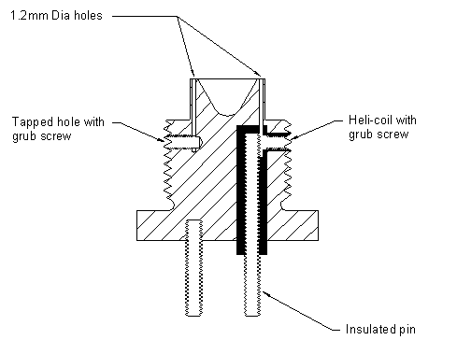

Figure 1: Diagram of ‘cone in plug’ firing plug.

Table 1 Comparison of original test method and new firing plug.
Composition | Mean rise time (ms) / Standard Deviation |  | Comments
Composition | Original method | New method | Comments
1 | 0.78 / 0.14# | 0.70 / 0.10* | *5 repeats
2 | 5.10 / 1.18# | 4.98 / 0.65* | *10 repeats
3 | 11.18 / 3.35# | 11.98 / 3.46* | *5 repeats Homemade powder
4 | 3.11 / 3.31 | 1.51 / 0.47
5 | 0.74 / 0.17 | 0.84 / 0.08
#Data previously presented in UN/SCETDG/30/INF.3

Table 2 Composition data
Composition | HSL reference | Composition (% mass)
Composition | HSL reference | Potassium perchlorate | Magnalium | Sulfur | Aluminium | Barium nitrate | Carbon | Potassium nitrate | Titanium
1 | Comp AB Flash 1 | 45 | 22 | 11 | 22 | - | - | - | -
2 | Comp W HKF BP | - | - | 10.4 | - | - | 15.6 | 74.0
3 | Comp V Flash 2 | - | - | - | 30 | 70 | - | - | -
4 | NN/6 Flash | 60 | - | - | 25 | - | - | - | 15
5 | NN/13 Flash | 45 | 22 | 11 | 22 | - | - | - | -

__________

