Proposal for amendments to ECE/TRANS/WP.29/GRSG/2006/16
(Clarification of the scope of Regulations covered by GRSG)

A.4. PROPOSAL

REGULATION No. 73 – (Lateral protection)

The list of contents, annexes, Annex 3 should be deleted.

Paragraph 1. and the corresponding footnote 1/, amend to read:

"1. SCOPE

This Regulation applies to complete vehicles of categories N₂, N₃, O₃ and O₄ 1/ with regard to the lateral protection. It does not apply to:

- Tractors for semi-trailers;

- Trailers specially designed and constructed for the carriage of indivisible loads longer than 10 m, such as timber, steel bars, etc.;

- Vehicles designed and constructed for special purposes where it is not possible, for practical reasons, to fit such lateral protection.
__________________
1/ As defined in Annex 7 to the Consolidated Resolution on the Construction of Vehicles (R.E.3), (document TRANS/WP.29/78/Rev.1/Amend.2 as last amended by Amend.4)."

Annex 3, should be deleted.

B.4. JUSTIFICATION

There is no need for a special exemption for trailers specially deigned and constructed for the carriage of indivisible loads as mentioned in the second indent in the scope. Trailers are vehicles by definition and, therefore, already included in the third indent.

Our opinion is tat if a trailer, specially deigned and constructed for the carriage of indivisible loads, cannot be equipped with lateral protection, the trailer is designed and constructed for special purposes. In that case it is covered by the exemption in the third indent.

Examples of trailers who can take long loads and are equipped with lateral protection

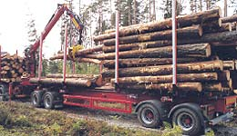

Fig. 1: 10.7 m length for the loading

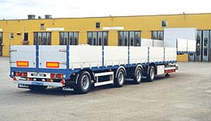

Fig. 2: 17. 3 m length for the loading

- - - - -

