Canadian comments on the proposal for Corrigendum to Regulation No. 121
(ECE/TRANS/WP.29/GRSG/2006/14)

A. BACKGROUND
OICA proposal consists of modifying footnote 10/ of Table 1 relating to item 34. of Regulation No. 121. The suggestion is the following:

"10/ Letter "D" may be replaced or supplemented by other alphanumeric character(s) or symbol(s) chosen by the manufacturer to indicate additional selection modes. The indicators may be displayed top to bottom or left to right."

B. CANADIAN COMMENTS
1. Canada believes that a harmonization issue will occur between ECE Regulation No. 121 and the global technical regulation (gtr) concerning hand controls, tell-tales and indicators. Furthermore, current U.S. regulation includes the same gearshift pattern that is specified in ECE Regulation No. 121.

The current gtr proposes the following footnote 10/:
"10/ Letter "D" may be replaced or supplemented by other alphanumeric character(s) or symbol(s) chosen by the manufacturer to indicate additional selection modes. The indicators shall be displayed top to bottom or left to right."

2. An incident occurred in Canada where a city bus did not follow the order specified in the gtr (see figures 1 and 2). As a result, a pedestrian was struck by the bus due to the fact that the driver assumed he was going forward when the bus was actually in reverse gear. We believe it is important to specify the order of the shift sequence from top to bottom or from left to right to prevent further incidents of this type.

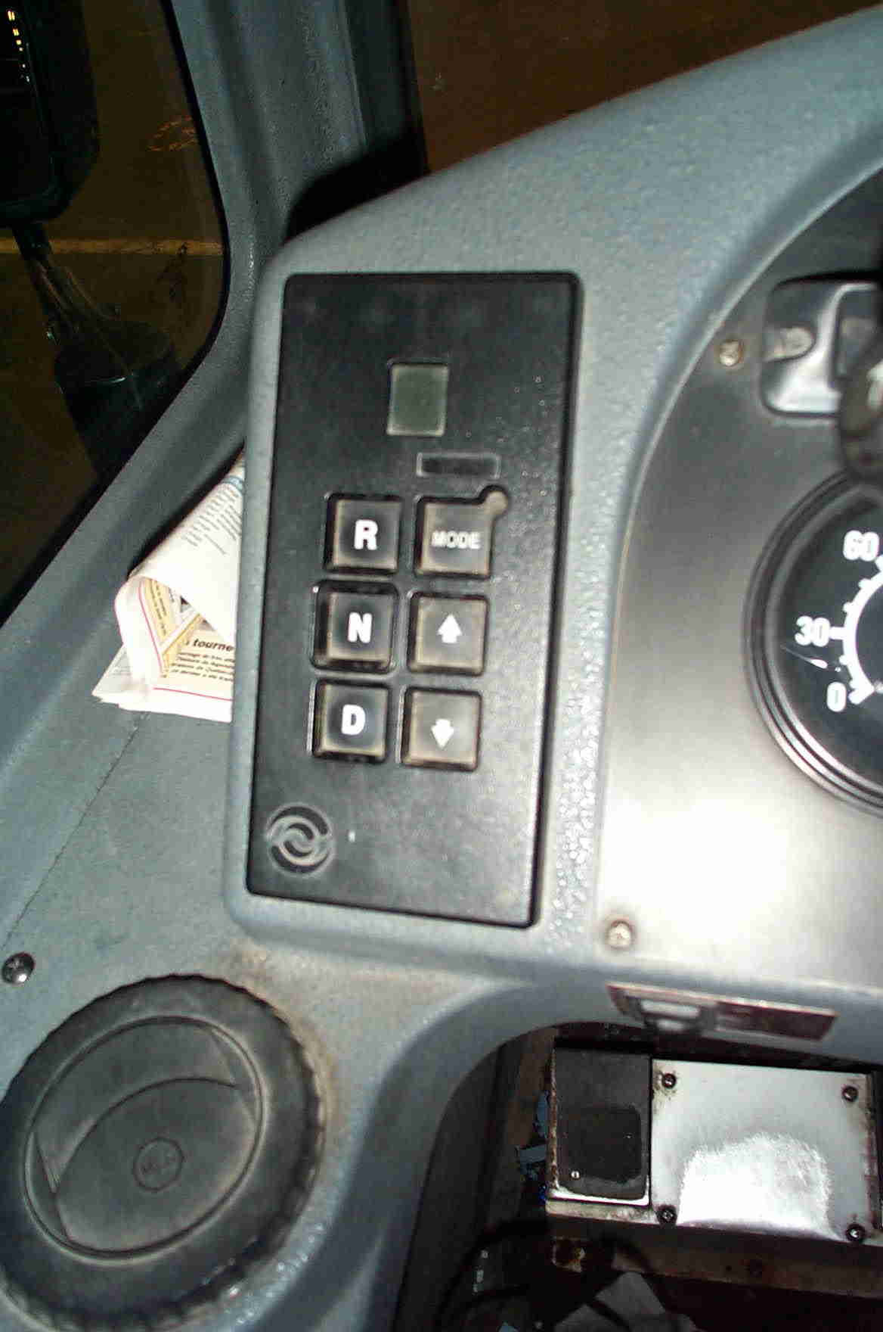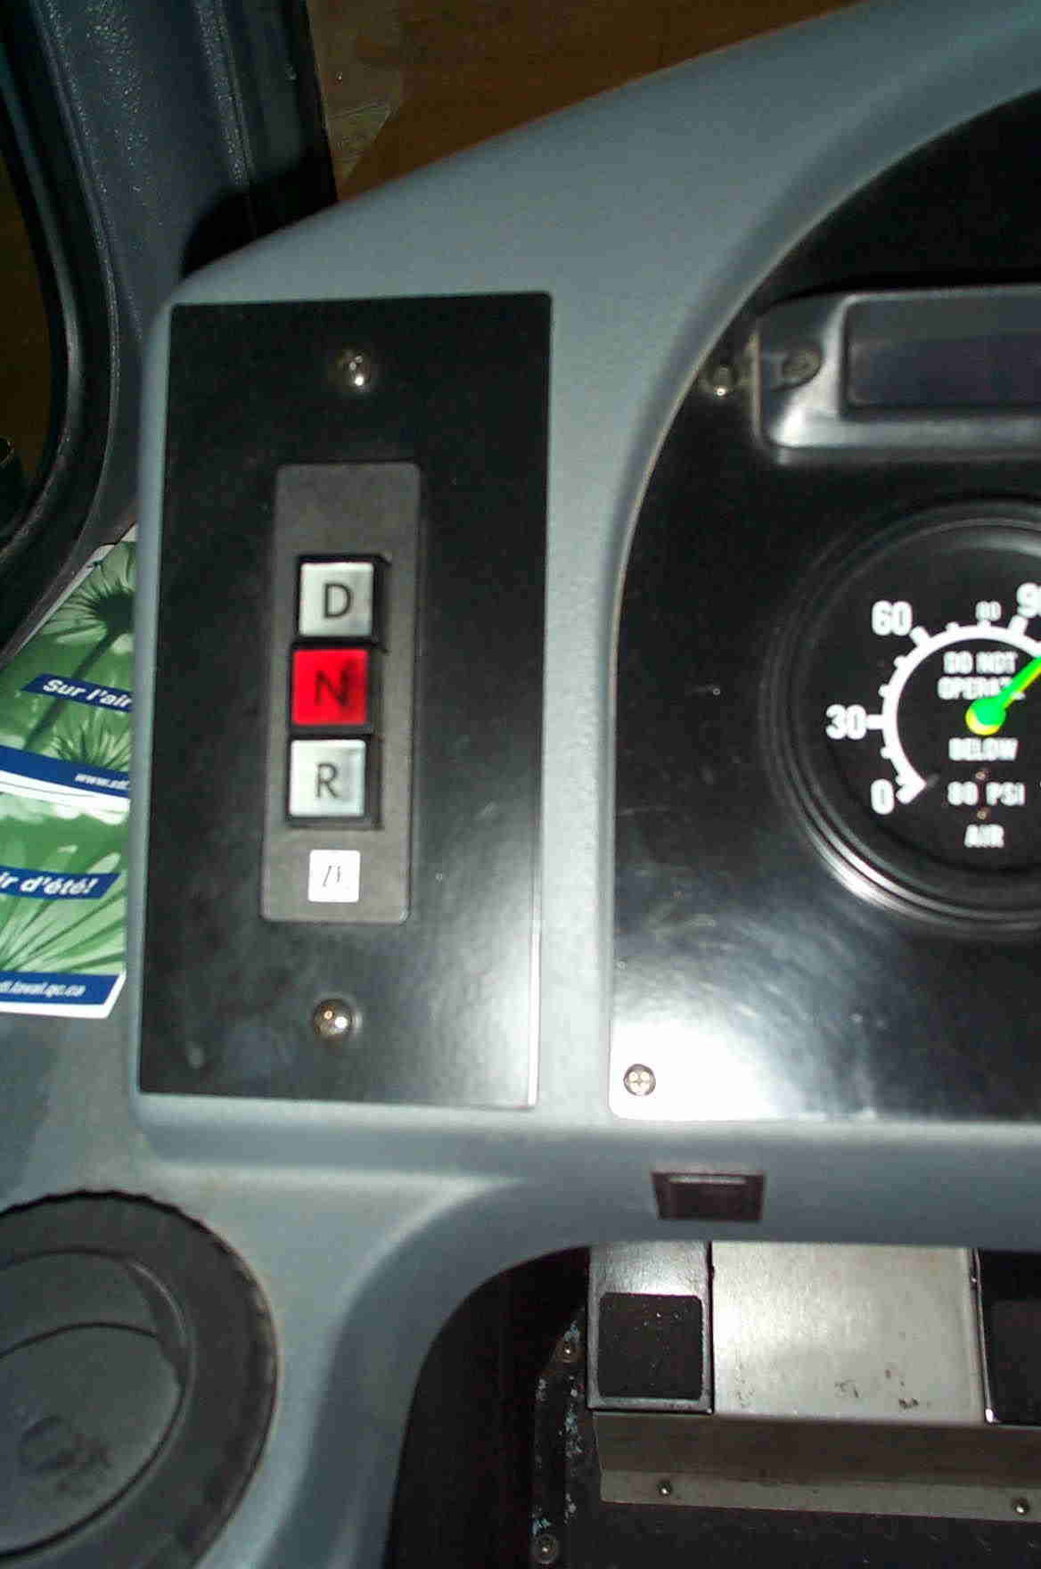
Figure 1.(Bus A following the gtr order) Figure 2. (Bus B not following the gtr order)

Note: The two pictures (Bus A and Bus B) are part of the same fleet of vehicles and are operated buy the same company. - - - - -

