Report of Two Years Activities in WP29/ITS Informal Group

1. Activities up to Now
2. Exchange of Views on In-Vehicle ITS
2.1 Reports from IHRA-ITS WG
2.2 Reports from OICA, ASV, CLEPA, eSafety
2.3 Common Understanding for In-Vehicle ITS
3. Proposals to WP29
3.1 Treatment of In-Vehicle ITS Technologies
3.2 Role of ITS Informal Group and Groups of Experts

Annex A : Document Lists
Annex B : Terms of Reference

Report of Two Years Activities in WP29/ITS Informal Group

1. Activities up to Now

With motor vehicles becoming more and more intelligent and informative, some of the In-Vehicle ITS technologies are now on the market. For instance, adaptive cruise control (ACC) systems to keep a preset distance with the car ahead, and collision-mitigation braking systems (CMBS) to reduce collision speed to mitigate damage are emerging from the development stage to the next stage of commercialization. It is hoped that these technologies will develop further, because they are expected to greatly contribute not only to the convenience and comfort of the driver but also to the improvement of traffic safety by reducing injuries to drivers, passengers, pedestrians and other valunable road users.

The issues to be addressed in relation to these technologies are, for example, that, if they are introduced into the market without appropriate safety consideration given to them, their future development may be hindered. It is necessary, therefore, to develop a common understanding on safety among countries concerning the regulation and certification of these technologies; and so on. We are now at a stage where it is essential for WP29 to make efforts to address these issues.

In view of such circumstances, WP29 organized an informal group in June 2002 and started preparations for the ITC/Round Table and, through such activities, developed its understanding of how to treat these technologies. As a result, at the ITC/Round Table held on February 18, 2004, WP29 recognized anew that it is important to keep discussing In-Vehicle ITS issues at WP29 and agreed to maintain the ITS Informal Group.

Based on this agreement, the informal group agreed in November 2004 upon a TOR on the activities of the ITS Informal Group as a group playing a strategic role at WP29 to (1) develop a common understanding of the driver assistance systems; (2) exchange information on technology trends related to In-Vehicle ITS, and (3) review its activities in the second year and report the results to WP29.

It should be noted that the Terms of Reference defines the subject of discussion as “In-Vehicle ITS, which are on-board systems for safety that utilize information that is received from direct sensing and/or telecommunications via the road infrastructure or other sources”. In other words, ITS technologies refer to all the technologies to improve vehicle safety and realize smooth and comfortable transportation by using functions of vehicles and/or surrounding environment, in particular, the infrastructure. Among these technologies, the performance of the in-vehicle systems that support the driver in interaction with him/her has direct or indirect impact on vehicle safety. Therefore, what WP29 should seek is to treat such vehicle safety performance in an appropriate manner in its regulations (See Hungary’s comments).

Accordingly, to address the above tasks including the development of a common understanding on In-Vehicle ITS, the ITS Informal Group started in March 2005 the activities shown below, which were scheduled for two years and mainly consisted in exchanging information and opinions. As a result, the group developed the following understanding that we report here to WP29 on our policy regarding driver assistance systems and how ITS should be treated at WP29: and reports it to WP29 as follows:

2. Exchange of Views on In-Vehicle ITS

What is important in discussing a common understanding of driver assistance systems is the point of view from which we should classify these technologies. In-Vehicle ITS technologies include those which support the driver by providing information for driving, those which improve the driver’s comfort by optimizing his/her workload, and those which directly improve safety by warning the driver against crash or by mitigating damage. In some cases, negative effects deserve consideration. To achieve a common understanding, it is important that In-Vehicle ITS be treated in a comprehensive manner integrating the viewpoints related to these functions.

From this perspective, the presentation made by Dr. Hiramatsu(IHRA-ITS WG/JARI) at a meeting of the ITS Informal Group held in November 2004 was to a degree suggestive. It consisted in modeling the driver’s driving behavior as a basic sequence of recognition, judgment, and operation and then applying In-Vehicle ITS technologies for information presentation, warning, and control to each of these events (See Figures 1 and 2).
He further clarified his conception at the meeting of ITS Informal Group held in March 2006, by explaining how these technologies in information presentation, warning, and control should be used to assist the driver according to the driving conditions or the sequence of a car crash (Figure 3): information presentation is made as an assistant technology under normal driving condition, warning under critical condition, and control under pre-crash as well as normal driving conditions.

Such a philosophy appropriate in understanding In-Vehicle ITS that often looks complicated, and useful in examining these In-Vehicle ITS assistant functions from the viewpoint of human machine interface (HMI).
2.1 Reports from IHRA-ITS WG

After the meeting of ITS Informal Group held in March 2005, we have received reports from organizations and associations on common understanding of driver assistance systems and current technologies. Three reports from the IHRA-ITS WG represented a large part of these reports and corresponded to the three stages of information presentation, warning, and control.

First, about information presentation, Dr. Gelau (IHRA-ITS WG/BASt) reported on the European Statement of Principles(ESoP) that prescribed the HMI requirements for onboard information systems, stating that, in Europe, the ESoP was used as voluntary standard by each member country and automaker. The report also referred to the AAM guideline used in North America and the JAMA guideline in Japan as almost equivalent guidelines used as voluntary standards in Japan, indicating that in these guidelines included the provisions on design objectives, location of installation, principle of information presentation, interaction with displays and controls, system behavior, and information about the system. In relation to this subject, Canada delivered a status report that the government and the automotive industry would be set out memorandom of understanding(MOU) to limiting driver distraction from vehicle telematics devices and negotiations are underway to reach an agreement.

Next, about warning, Dr. Burns (IHRA-ITS WG/Transport Canada) summarized current past studies of warning systems conducted by countries and organizations, indicating that they have had studied various ways to prompt the driver by auditory, visual, and/or haptic means to take necessary action in a critical condition, but, to date, they have had not set out any guidelines on these systems. In relation to this subject, OICA reported at the ninth meeting of the ITS Informal Group on lane departure warning system (LDWS). During discussion, some members expressed their concern about the driver’s confusion that might be caused when he/she was given more than one warning at the same time and stated that a certain guideline was necessary to prevent such problem. Dr. Burns also indicated that the IHRA-ITS WG plans to (1) develop a warning guide by 2007, and (2) develop assessment procedures and performance criteria by 2010.

In terms of control systems, Dr. Hiramatsu gave his opinion that, concerning control under normal driving condition, the idea of “the “Driver in the Loop” was important. The idea of “the “Driver in the Loop” says that, under normal driving condition, the driver should be involved in driving in a way or other. In-Vehicle ITS is only a system to assist, and not to replace the driver. This means that the driver should be inevitably responsible for his/her driving. As future subjects of study at IHRA, Dr. Hiramatsu cited three points: (1) presence (or absence) of driver operation in car driving; (2) transition of control behavior from system to human driver; and (3) driver override.

Other than control under normal driving condition, Dr. Hiramatsu referred to control in pre-crash condition, but this is the subject covered by the report from Mr. Fujii of ASV project to be discussed later.

2.2 Reports from OICA, ASV, CLEPA, eSafety

We have received five reports from other organizations and associations: a report from OICA on lane departure warning system (LDWS); a report from Advanced Safety Vehicles (ASV) on collision-mitigation braking systems (CMBS) and a final report on the phase 3 ASV program from the same source; a report from CLEPA on sensor technologies under pre-crash condition; and a report from EC (European Commission) on e-Safety.

Mr. Christophe(PSA) of OICA reported on a system, adopted by some vehicles on the market as option, that detects lanes with infrared sensors and warns the driver as soon as the drift from their lane by vibrating the seat. In discussion, some members expressed concern about the confusion that might be caused among drivers by the presence of various types of warning systems on the market, stating that international harmonization was necessary.

Next, Mr. Fujii(JARI) from the ASV study group reported on collision-mitigation braking systems activated under pre-crash conditions. Mr. Fujii first explained the concept of driver assistance, which represent the basic philosophy of ASV. A CMBS developed based on this philosophy activates the brakes automatically when collision is no longer avoidable to reduce the damage of the driver, passengers, and pedestrians to a minimum. The system gives a warning just before the collision becomes unavoidable to prompt the driver to put on the brakes and, at the same time, tell them that the brakes are being applied automatically. Discussion arose also as to whether the driver should be given the possibility to override the system when it is activated. The conclusion was that there is hardly room for the driver to override the CMBS, because under pre-crash condition where collision is no longer avoidable, there is hardly possibility for him/her to maneuver the vehicle in a safer direction.

Further, Mr. Halland (AUTOLIV) of CLEPA reported on integrated safety systems to be activated under pre-crash condition, indicating that CMBS and advanced air-bag systems would be effective as systems automatically activated under such condition. The import of the report regarding CMBS was mostly the same as that of the report of ASV mentioned earlier. It stated that, under condition where collision is no longer avoidable, it is effective to reduce collision speed by automatic brakes. As to advanced air-bag systems, it was of opinion that, by deploying air bags before collision, important effect might be expected on damage mitigating even in high-speed collisions. The report mentioned that the recognition of obstacles was important in both systems and hoped for further development of sensor technologies.

Mr. Vits from European Commission delivered a report on the e-Safety project that has been carried out by EC since 2002 to improve traffic safety by the use of information and communication technologies. The report said that it was important how new technologies such as ACC would penetrate the market fast and quoted ESP (Electric Stability Program), Obstacle & Collision Warning, and Lane Departure Warning as In-Vehicle ITS systems that would be marketed in the near future. The report also quoted emergency call (eCall), Real-Time Traffic & Travel Information (RTTI), and HMI as technologies to be given priority in the immediate future.

Mr. Wani from ASV/MLIT made a final report on the phase 3 ASV program being carried out in Japan. During the question-and-answer session, he mentioned the timing to activate the collision-mitigation brakes studied in the ASV program and explained how the working area was extended to the extent that this would not interfere with the driver’s operation. He added that the program also worked on the development of a system that would be effective in cases where autonomous types would not work by the use of Inter-Vehicle Communication, and mentioned a phase 4 ASV program that would be started from 2006 for a period of five years following the current program.

2.3 Common Understanding for In-Vehicle ITS

Classifying In-Vehicle ITS technologies according to the driver’s behavior and the sequence of car crash occurrence is useful in developing common understanding of these technologies. They may be thus classified into three categories: assistance by information presentation and control under normal driving condition; assistance by warning under critical condition, and assistance by control under pre-crash condition. Table 1 shows, based on this classification, the current status of In-Vehicle ITS, part of which has already been marketed. The typical examples include navigation systems in the field of information presentation, forward obstacle warning systems and LDWS in the field of warning; and ACC under normal driving condition and CMBS under pre-crash condition in the field of control.

2.3.1. Information presentation systems

Each region has set their own guideline on these systems for concern that excessive information presented visually and/or auditory during driving might distract the driver’s attention and authorizes the use of these systems based on such guideline and on a self-commitment basis.

2.3.2. Warning systems

As to these systems, we have not yet any common policy widely shared. Meanwhile, there is concern about confusion that might be caused among drivers by the presence of various types of warning systems on the market. It is hoped that a certain method for quantitatively evaluating these systems will be developed based on knowledge of HMI and in such a manner not to hinder advances in technologies. The IHRA-ITS WG currently studies the possibility of conducting part of their activities in such direction.

For example, the potential of confusing drivers is one of the subjects to be studied, including consistency with existing warning systems. Red lamps have been used, for instance, to warn against engine malfunction and brake malfunction. More recently, however, the use of colored warning signals has increased at the same rate as the increase in the number of new devices fitted into vehicles. Many of these rely upon a combination of color and symbol to describe to the driver the system that is faulty, following which the driver is expected to read the operation manual to find details of what action should be taken. While this might be acceptable for non-safety-critical systems, the basic idea of a red warning symbol is to warn the driver of an imminent danger and the indication should be clear and unambiguous.

2.3.3 Control systems

In the field of control under normal driving condition, it seems appropriate to base it on the philosophy of the “Driver in the Loop,” which means that the driver should be involved in driving operation in a way or other. Although IHRA-ITS WG has not advanced so much in quantitative approach, it has identified the following as subjects of study: (1) presence (or absence) of driver operation in car driving; (2) transition of control behavior from system to human driver; and (3) driver override.
As to control under pre-crash condition, it is understood that such control is effective as damage-mitigation technology in circumstances where collision is no longer avoidable.

3. Proposals to WP29

3.1 Treatment of In-Vehicle ITS Technologies

3.1.1 Information Presentation Technologies

As to information presentation technologies, the major tasks to be addressed are the performance requirements related to distraction, including HMI requirements. Currently, these systems are treated by each country and region on a self-commitment basis. However, the above performance requirements are mostly qualitative requirements based on human-centered design related to distraction. Considering such situation, in particular the fact that, in countries where the self-commitment principle is working, some of the information presentation systems installed on vehicles maintain a certain range of performance, we recommend that WP29 keep monitoring the situation for the time being.

3.1.2 Warning Systems

As to warning systems designed to avoid accidents, there is not yet any widely shared philosophy. But sorting out our views and identifying future tasks timely is essential in finding out how these systems should be treated from the viewpoint of safety. Such work should include HMI requirements, such as easiness to understand or recognize the warning. We recommend that WP29 maintain its cooperation with IHRA, which currently studies these subjects, and to secure their output. At the same time, one mechanism to avoid difficulties in the future will be to confirm that all new regulatory requirements are assessed against the related existing ECE regulation, R121 and respective best practice guidance on HMI. We will discuss the mechanism of the involvement of the Groups of Experts (GRs) for this purpose in 3.2.3.

3.1.3 Driver Assistance Systems by Partial Control

As to In-Vehicle ITS in the field of control under normal driving condition, various systems have been introduced into the market to improve the comfort and reduce the workload of the driver. Meanwhile, from control systems to mitigate crash severity to be activated in a pre-crash stage, we can expect a significant effect on injury mitigation. Some of the performance requirements such as recognition of the vehicle ahead and other obstacles might be addressed in the years to come.

As to these control technologies, consideration should be given to the fact that the reliability of these systems is not yet complete, as shown in the limitations of sensors, and that many people think that basically the driver must be responsible for driving. We assume therefore that the current systems are not developed and used as completely automatic systems, but as control systems to partially assist the driver.

We recommend that WP29 base its future consideration on the following:

- The control systems activated under normal driving or in a pre-crash stage should be designed in principle as systems, in which the driver is always responsible for his/her driving.
- Installation of auditory or visual announcement devices that provides the driver with necessary information on the system functioning.

- The control systems activated under normal driving condition should be in principle designed according to the “Driver in the Loop” philosophy, where driver should be involved in driving in one way or another.
- Announcement (auditory or visual) should be made when the driving initiative is transferred from the system to the driver;
- The driver should be kept involved in driving operation, e.g., the starting initiative should not be given to the system;
- System allows for switching on and off by the driver;
- System allows for overriding by the driver.

- Recognizing that crash mitigation systems activated at the Pre-Crash Stage (Figure 3), in which the collision is no longer avoidable, hold the promise of significantly reducing the impact of the crash, we should also consider that:
- The system when triggered, does not allow the driver sufficient time to override it;
- The possibility of drivers getting overly dependent on such system is minimal.

3.2 Role of ITS Informal Group and Groups of Experts

The ITS Informal Group understands its role and the involvement of Groups of Experts (GRs) as follows.

3.2.1 Role of ITS Informal Group

- The functions of In-Vehicle ITS are discussed at corresponding GRs to the extent that there are existing regulations. However, in the fields not covered by GRs or on subjects requiring strategic examination at ITS such as discussion on understanding mentioned in 3.1 above, the ITS Informal Group should play its necessary role.

- In cases where it is deemed necessary at WP.29 or GRs, or where In-Vehicle ITS may be discussed between more than one GRs, the ITS Informal Group should play its necessary role when requested specifically to do so.

- Currently, technological basis is not yet sufficiently mature to establish particular regulations or common quantitative guidelines on In-Vehicle ITS functions. However, it would be appropriate to take necessary actions in the future based on the understanding summarized in this report to develop more quantitative understanding or other conditions. Consequently, the group should play the role of rule maker on In-Vehicle ITS or equivalent role if WP29 will decide so in the future.

To play the roles mentioned above, it is recommended to maintain the ITS Informal Group, holding meetings about once a year. When holding meetings, it is hoped that WP.29 will be able to get necessary information in coordination with the IHRA-ITS WG, in particular, as to the progress of the studies on HMI.

3.2.2 Involving the GRs
A key element in the successful implementation of intelligent vehicle systems will be careful consideration of the human machine interaction aspects as new regulatory measures are developed. The WP29/GRs have an important role in this process and each group will need to ensure that correct assessments are made of those technologies that could affect the driving function or risk overloading – or even underloading – the driver.

In particular, as to warning systems, there are concerns about confusing these systems with existing warning systems. It is recommended understand that separate GRs do not work in isolation as each could implement requirements that either contradict or confuse drivers when combined into a single driver display. We believe that WP29 should develop a mechanism to ensure the assessment of existing ECE regulations related to control and display, such as R121 and the best practice related to HMI and study the establishment of the following mechanism: Chairmen of the GRs may also consider it good practice to submit draft regulatory proposals to the Group of experts on General Safety (GRSG) for a validation check prior to formal submission for voting at WP29. Alternatively, WP29 might ask the chairmen to confirm that texts comply with the regulation.

Annex A: Document Lists
- K. Wani, Overview of the Past and Future Work of WP29, MLIT, ITS/RT, February 18, 2004.
- C. Fuss, ITS Driver Assistance Systems, BMW, ITS/RT, February 18, 2004.
- V. Wiber, Driver Focus : A North American Perspective, AAM, ITS/RT, February 18, 2004.
- A. Iihoshi, Driver Assistance System : Lane Keep Assist System, JAMA, ITS/RT, February 18, 2004.
- I. Noy, Harmonized Research on ITS, IHRA-ITS WG/TC, ITS/RT, February 18, 2004.
- K. Hiramatsu, A Note for Common Understanding in Advanced Systems, IHRA-ITS WG/JARI, 8th-ITS Informal Group Meeting/WP29-134th, November 19, 2004.
- J. Christophe, Lane Departure Warning System Developed by PSA Peugeot Citroen, OICA, 9th-ITS Informal Group Meeting/WP29-135th, March 11, 2005.
- Prepared by Canadian Expert, Canadian Memorandum of Understanding(MOU) regarding Driver's Distraction Countermeasures, 9th-ITS Informal Group Meeting/WP29-135th, March 11, 2005.
- T. Fujii, Forward Collision Damage Mitigation Braking Systems on ASV, ASV/JARI, 10th-ITS Informal Group Meeting/WP29-136th, June 24, 2005.
- C. Gelau, Recent Developments of the “European Statement of Principles on HMI”, IHRA-ITS WG/BASt, 10th-ITS Informal Group Meeting/WP29-136th, June 24, 2005.
- P. Burns, ITS Warnings: Design and Performance Considerations, IHRA-ITS WG/TC, 11th-ITS Informal Group Meeting/WP29-137th, November 18, 2005.
- Y. Haland, Integrated Safety by Pre-Crash Triggering, OICA/Autoliv, 11th-ITS Informal Group Meeting/WP29-137th, November 18, 2005.
- K. Hiramatsu, The Idea of “Driver in the Loop” in Advanced Driver Assistance Systems, IHRA-ITS WG/JARI, 12th-ITS Informal Group Meeting/WP29-138th, March 10, 2006.
- A. Vits, eSafety - Status and Outlook, DG INFOSO/EC, 13th-ITS Informal Group Meeting/WP29-139th, June 23, 2006.
- K. Wani, ASV-3 Final Report, MLIT, 13th-ITS Informal Group Meeting/WP29-139th, June 23, 2006.
- Prepared by Hungarian Expert, Intelligent Systems Belonging to Road Vehicles, 13th-ITS Informal Group Meeting/WP29- 139th, June 23, 2006.
Annex B: TOR (Note: Wordings are up-dated in the report.)

Terms of Reference of WP29/ITS Informal Group

Transmitted by the representative of Japan

1. Introduction

As a result of efforts to equip motor vehicles with artificial intelligence and information, some advanced technologies for in-vehicle Intelligent Transport Systems ("ITS") were introduced into the automobile market. The acceleration of widespread use of these technologies was desired, because they would not only contribute vehicles convenience but also bring enhanced safety into road traffic.

If used without appropriate safety considerations, however, in-vehicle ITS technologies might be rejected by the market before their full development, and it was necessary to achieve among stakeholder countries a common understanding of possible regulations and certification procedures for these technologies. There were increasing expectations that the WP29 take the initiative in the building of such a consensus.

In response the WP29 established its ITS Informal Group in June 2002, began preparation for the ITC Roundtable, and deepened its understanding of in-vehicle ITS issues. Consequently at the ITC Roundtable meeting of 18 February 2004, WP29 member and organizations reconfirmed the importance of discussing in-vehicle ITS issues at the WP29 and agreed to continue the ITS Informal Group activity.

2. Role of the ITS Informal Group

The ITS Informal Group assumes the role of a "strategic group" who, for supporting the development of new technologies for enhancing safety, works to expand the knowledge of these technologies, develops a common understanding of them, discusses the course of their handling in the regulatory framework if necessary, and reports the discussion results to the WP29.

3. Understanding on the ITS Informal Group's Discussion

(1) Scope
The technologies to be discussed by the WP29/ITS Informal Group are In-vehicle Intelligent Transport Systems (ITS) which are on-board systems for safety that utilize information that is received from direct sensing and/or telecommunications via the road infrastructure or other source.
In conducting its discussion, the Informal Group observes the following understanding concerning the above-specified ITS:

- It is important to emphasize that certain ITS applications use advanced technologies to provide in-vehicle support for reducing the number of crashes and attendant injuries and deaths. Other ITS applications provide in-vehicle information for purposes other than improved safety. Whatever the primary function is, both types of ITS applications can have important unintentional influences on safety (positive and negative.)

In addition, since there are strong expectations for ITS contributions to the enhancement of vehicle safety, the following understanding is necessary at the same time.

- Certain areas of systems are expected to be discussed primarily for enhancing safety of the vehicles. They include systems that use advanced technologies for enhancing safety, and that advise/warn, and/or assist the driver with the purpose of vehicle functions and performance in driving.

In relation to the function of in-vehicle ITS for safety enhancement, the extent of system’s assistance to driver's control is an important issue to be deliberated including how far the "assist" can be extended and what is the relation with "substitution." Such discussion can be based on certain actual in-vehicle ITS systems. (Please refer to Attachment 1 for the schematic of a driving assistance system.)

(2) Points to be considered

Bearing in mind that the purpose of the ITS Informal Group will include the support of development of advanced technologies for safety enhancement, and that these technologies are still at the course of their future development, the ITS Informal Group recognize to consider the following points:

- The introduction of ITS into market shall not be hindered as far as there are no clear problems on safety.

- For encouraging introduction of ITS, role of governments in the area of safety should be considered. Such role of governments may include followings.
* If current regulations are holding back ITS from market, revisions should be studied.
* If necessary, methodologies should be developed and applied for assessing the safety impact, estimation of effectiveness and potential safety degradation.

- Also, role of industries and other means than regulations on vehicle construction should be considered (ex. civil law, industry's guidelines).

- It is preferable to get a common understanding on advanced technologies considering the above-mentioned role of governments among members.

Because in-vehicle ITS involves sophisticated technologies for warning or assisting the driver, the following special considerations are important in discussing the future course of in-vehicle ITS:

- It is important to deal with the issues from a view point of HMI and an aspect of the driver’s responsibility is duly taken into account.

- In-vehicle ITS is a newborn subject matter appearing in the WP29's agenda, and it is still difficult to predict the future course of ITS development. Accordingly, the ITS Informal Group should discuss general issues characteristic of advanced technologies and unsuitable for GRs, receiving guidance from WP29 and working in concert with GRs whenever necessary.

4. Current Situation of ITS related Activities

Concerning the new technologies included within the scope of the ITS Informal Group, attempts were made to collect information on the research and development projects, guideline formulation, and standardization and regulation discussions conducted in various countries (see Attachments 2 to 4). This information was collected to help determine the role of the WP29 and plan efficient information collection and other activities of the WP29 related to in-vehicle ITS. These schematic was produced by Japanese experts, reflecting the opinions expressed at the meetings of the ITS Informal Group till now and the ITC Roundtable of 18 February 2004.

Attachment 2 lists up the in-vehicle ITS projects in the various regions of the world. Attachment 3 introduces the categorization of in-vehicle ITS systems and their negative aspects. Attachment 4 identifies the negative factors examined in regional projects.

According to the information collected on various negative aspects(Attachment 4), guidelines on "distraction" have already been established in some regions. Although manufacturers' voluntary effort is the central approach to the issue of "reliability", there are brake by-wires and some other individual items beginning to be discussed for incorporation into ECE Regulations.

On the other hand, regarding "overtrust", “lack of trust" and "misunderstanding", attempts to qualitatively understand the concepts and organize policy are beginning in various regions. These negative aspects are issues related to driving assistance, which is one of HMI aspects (Attachment 3). What is important is to share the knowledge obtained from various projects and regions and refine it into a common understanding of issues related to driving assistance within the WP29.

Additionally, developments in in-vehicle ITS needs to be constantly monitored, and information needs to be exchanged on new ITS technologies with attention to relationships between regulations and a new ITS technology.

While IHRA is conducting research activities aiming at the harmonization of regulations and while ISO is working to formulate international technical standards, the ITS Informal Group may try to collaborate with these two organizations in striving to achieve its tasks.

5. Work Plan

Assuming the WP29/ITS Informal Group to found its activities on the Understandings on the ITS Informal Group’s Discussion defined in section 3 and on the Current Situation of ITS related Activities in section 4, the work plan below has been set for the ITS Informal Group.

(1) Short-term Tasks

1) A common understanding of driving assistance

The ITS Informal Group will identify and discuss points for ensuring the safety of various driving assistance systems. Although this discussion will not be aimed at formulating technical requirements or guidelines, it will be targeted at the establishment of a common understanding that will provide basic concepts for handling new in-vehicle ITS technologies in each country. This discussion will be terminated in two years from the accepting this TOR.

2) Information exchange

Information concerning in-vehicle ITS will be exchanged. If proposals are made to examine the conflict between a new in-vehicle ITS technology and an existing regulation, direction to dissolving the conflict will be discussed and the results of the discussion will be reported to the WP29.

(2) Medium-term Tasks

After completing the above short-term tasks, the WP29 will decide activities for the ITS Informal Group or, if the Group is deemed to have completed its mission, will discuss other approaches to addressing in-vehicle ITS issues.

ATTACHMENT 1

Driving Assistance

In driving a motor vehicle, it is the driver who observes the surroundings and the running condition of his/her vehicle, while making judgments for appropriate driving responses and operating the steering wheel, acceleration pedal and brake accordingly in the conventional driving system (Figure 1).

This driving system may be supported by a separate "driving assistance system" designed to assist part of the driver's recognition, decision-making and control by utilizing advanced technologies. The driving assistance including assistance for control should be distinguished from the driver "complete substitution" which means to take over the whole driver's functions.

Various research institutes are engaged in studies on the form, extent, timing, and other elements of appropriate driver assist. While some types of driver assist systems are already in practical use on vehicles, as a whole they are still at their developmental stage. Consequently it is good time for countries and regions to deepen their understandings of desirable technologies for driving assistance.

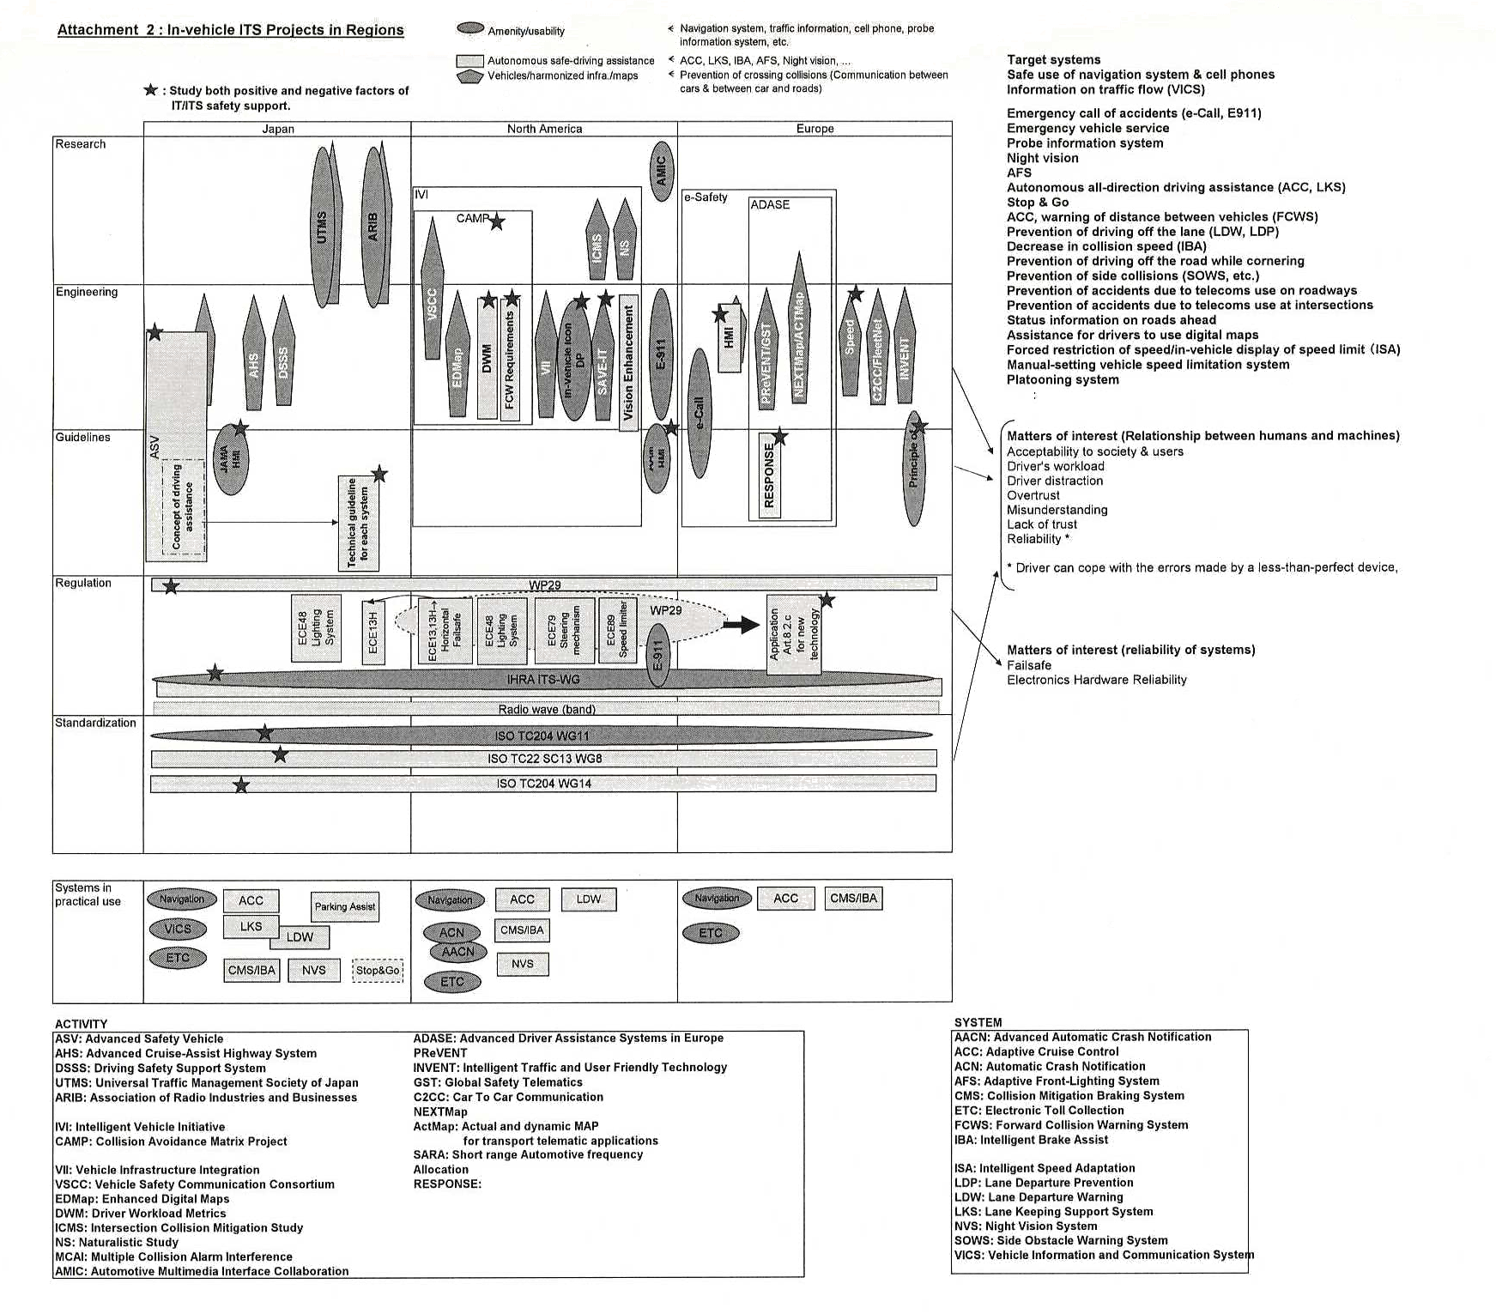

Attachment 3 : In-vehicle ITS Categories and Negative Aspects
Categories of ITS |  | Examples of systems | Examples of negative factors (concerns)
Information collection |  | Cell phone | Driver distraction
 |  | Internet, | Cognitive distraction
 |  | Navigation system, multi-media terminals | Visual distraction, etc.
 |  | etc. | etc.
Driving | Information | Navigation system, traffic information | Overtrust
assistance | support | AFS, Night Vision | Overtrust
 |  | FCW, LDW | Reduced Situation Awareness, etc.
 |  | Curving road status | Misunderstanding
 |  | Warning of crossing collision | Driver confusion
 |  | Road-ahead obstacles | Command effect
 |  | etc. | Lack of trust
 | Assistance | ACC, LKS | Lack of trust
 | for control | CMS/IBA | Increased discomfort, stress, etc.
 |  | Stop & Go | Reliability
 |  |  | Failsafe
 |  |  | Electronic hardware reliability, etc.
 |  | etc. | etc.
Automatic drive |  | Automatic drive  Convoy pilot system  etc | Responsibility of the driver  etc

Attachment 4 : Negative Factors Examined in Regional Projects
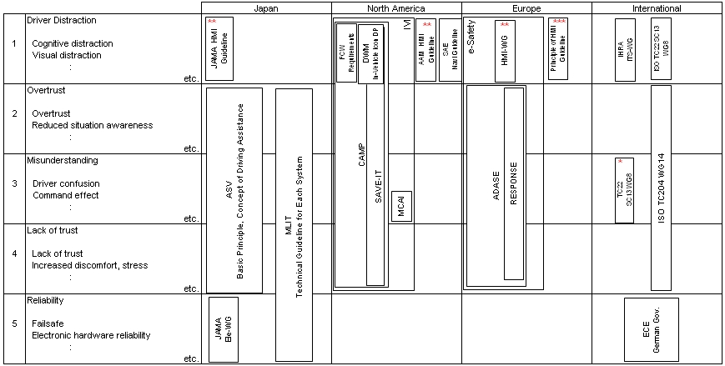

Reliability is considered to include the following 2 factors. |  |  |  | *: Warning Integration
* Failure does not impair safety./Back Up → (5) Failsafe |  |  |  | **: Limited to telematics information devices including
* The driver can cope with the errors made by a less-than-perfect device. |  |  |  | cell phones, navigation systems, and internet
→ Included in (2), (3), and (4). |  |  |  | ***: Recommendation on Safe and Efficient In-vehicle
 |  |  |  | Information and Communication Systems
ASV: Advanced Safety Vehicle
IVI: Intelligent Vehicle Initiative |  |  | ADASE: Advanced Driver Assistance Systems in Europe
CAMP: Collision Avoidance Matrix Project
DWM: Driver Workload Metrics
MCAI: Multiple Collision Alarm Interference

