UN/SCETDG/30/INF.5

UN/SCEGHS/12/INF.2

COMMITTEE OF EXPERTS ON THE TRANSPORT OF

DANGEROUS GOODS AND ON THE GLOBALLY

HARMONIZED SYSTEM OF CLASSIFICATION

AND LABELLING OF CHEMICALS

Sub-Committee of Experts on the Globally Harmonized System of Classification and Labelling of Chemicals  Twelfth session,  Geneva, 12(p.m.)-14 December 2006  Item 6 of the provisional agenda | Sub-Committee of Experts on the  Transport of Dangerous Goods  Thirtieth session  Geneva, 4-12 (a.m.) December 2006  Item 7 of the provisional agenda

Improvement of hazard communication

Systematic approach for colours and appearance of pictograms (placards)

according to the GHS classification

Transmitted by the International Technical Committee for the prevention and Extinction of Fire (CTIF)

Background

The TDG sub-committee has accepted CTIF’s proposal to include a review of the 'Provisions for labels' set out in paragraph 5.2.2.2 of the Model Regulations within its work programmes for the 2005/06 biennium.

The aim of the review would be to develop a systematic approach for colours and appearance of pictograms (placards), according to the GHS classification, in order to better meet the needs of target audiences.

The proposal to establish a working group which should carry out this review was not accepted.

Since then CTIF has received several comments on the thought starter presented in ST/SG/AC.10/C.3/2004/89 and ST/SG/AC.10/C.4/2004/18. Most important comments were that the existing labelling system should only be amended if the benefit outweighs the cost of change and effort for training of the users.

Pictograms are the most important means of hazard communication to emergency responders (police, fire service, ambulances) because they can always be found on transport units at incident sites. Therefore visibility from a distance is a very important issue.

CTIF is asking the experts of TDG to consider the following as guiding principles for drafting pictograms

Guiding principle for pictograms (labels) within the harmonized system

- Pictograms should convey information about hazards and physical states to the end users.
- Communication with pictograms should be done with
- Symbols in combination with colours and colour patterns identifying the hazard
- Symbols identifying the physical state
- A graphical scale identifying the level of hazard as it is done in class 7 in the few cases where the different levels change the first actions of emergency responders
- A numerical code for other information, e.g. Package Group, Class.
- These coded elements should be as few as possible and as simple as possible to ease the training processes required by this type of information.

Current status

Amongst the areas for consideration are:

- The similar pictograms (placards) for flammable liquids and flammable gases

- White symbol e.g. flame, on a dark background is much more visible from a distance than a black one (some colours such as red are difficult to see in low light conditions)

- The introduction of the physical state of a released product because the right measures to minimize the damage for the environment are mostly different for gases, liquids and solids.

- Information about the hazard level is only required if it would change the initial response actions. This is the case for flammable liquids depending on the ambient temperature, and substances, which in contact with water emit flammable gases.

- Deeply refrigerated, liquefied gases when releases present a sever health hazard to responders, thus they should be dealt with as an endpoint.
A symbol for these substances could be

Conclusion

CTIF ask s the TDG and GHS sub-committees for comments on the following suggestions

- As an indicator for gases a gas-cylinder should be shown on all pictograms representing gas

- Only white symbols should appear on black, green, red and blue background

- Deeply refrigerated, liquefied gases should be considered as an endpoint and communicated accordingly

Examples are given in the annex.

CTIF wants to submit a proposal for the July meetings 2007.
Annex

COMPONENTS OF PICTOGRAMS

HAZARD SYMBOL
NUMERICAL CODE
SYMBOL FOR PHYSICAL STATE
ADDITIONAL INFORMATION,
e.g. UN-No., Statements of hazard/effect, Signal Words

The physical state is communicated via the symbol:
gas cylinder

PHYSICAL  HAZARD | SYMBOL  for physical  hazard | ENDPOINT | PICTOGRAM
 |  |  | GAS | LIQUID
FLAMMABILITY | Flame
 |  | FLAMMABLE GASES | 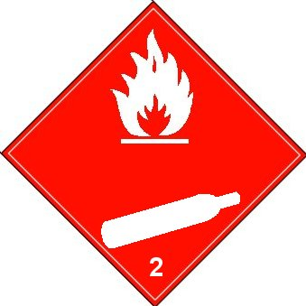
 |  | FLAMMABLE LIQUIDS |  | 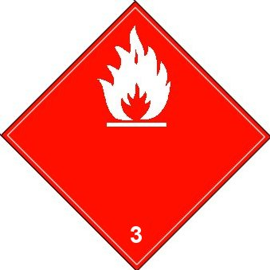
 |  | SUBSTANCES which in contact with water emit flammable gases |  | 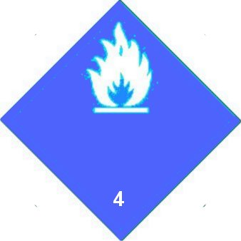
 |  | ORGANIC PEROXIDES |  | 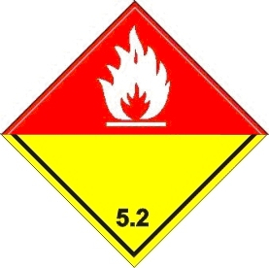

PHYSICAL  HAZARD | SYMBOL  for physical  hazard | ENDPOINT | PICTOGRAM
 |  |  | GAS
OXIDIZING | Flame over circle
 |  | OXIDIZING GASES | 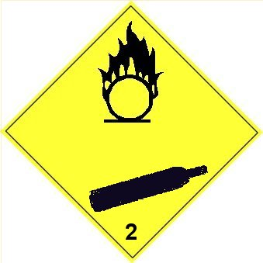
CORROSIVITY | Drops from tubes on hand and plate | CORROSIVE  GASES | 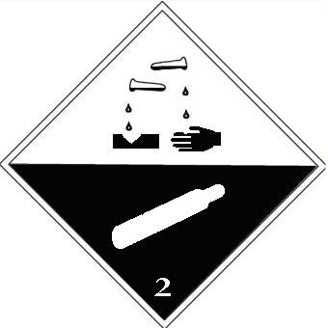

PHYSICAL  HAZARD | SYMBOL  for physical  hazard | ENDPOINT | PICTOGRAM
 |  |  | GAS
 | Gas cylinder | GASES UNDER PRESSURE | 
 | Ice crystal | DEEPLY REFRIGERATED  LIQUIFIED GASES | 

PHYSICAL  HAZARD | SYMBOL  for physical  hazard | ENDPOINT | PICTOGRAM
 |  |  | GAS
ACUTE  TOXICITY | Skull with crossed bones | ACUTE  TOXICITY  Inhalation | 



