Informal document No. GRPE-49-15
(49th GRPE, 10-14 January 2005,
agenda item 9.)

Partial Amendment to the Safety Regulations for Road Vehicles, etc.
(Establishment of Safety and Environmental Regulations for
Fuel Cell Vehicles Fueled by Compressed Hydrogen)

Transmitted by the representative of Japan

1. Background

The practical and widespread use of fuel cell vehicles (FCVs) is eagerly awaited, because such vehicles impose less environmental load, increase energy security, and strengthen Japan’s industrial competitiveness. The government therefore adopted a concept paper, “Review on comprehensive regulations for the practical use of FCVs”, created by a liaison committee on practical use of fuel cells consisting of relevant government ministries and agencies in October 2002, and decided to thoroughly review the regulations, setting FCV safety as a prerequisite. For vehicles, it was decided to provide a type approval system by establishing vehicle regulations for FCVs.

The Ministry of Land, Infrastructure and Transport has subsequently undertaken studies on possible safety and environmental regulations for FCVs fueled by compressed hydrogen, which are currently the mainstream and closest to actual use, in the “Project to Promote Practical Use of FCVs”.

Based on the results of this research, the Ministry plans to partially revise the Safety Regulations for Road Vehicles (Ordinance No. 67, 1951, of the Ministry of Transport) and the Announcement Prescribing Details of Safety Regulations for Road Vehicles (Announcement No. 619, 2002, of the Ministry of Land, Infrastructure and Transport), in order to establish safety and environmental regulations for FCVs fueled by compressed hydrogen, and to introduce the type approval system for FCVs.

A part of the regulations will be applied to relevant vehicles such as internal-combustion engine vehicles fueled by compressed hydrogen, as well as FCVs.

2. Outline of Revision

(1) Hydrogen safety

The safety concept for vehicles fueled by compressed hydrogen (in addition to FCVs, internal-combustion engine vehicles are included) is as follows.

- To prevent gas leaks; To make gas dissipate rapidly if it leaks; To detect leaks and shut off hydrogen gas in case of a leak; and
- To safely discharge gas that contains hydrogen.

Technical requirements regarding the following will be provided under the above concept:

* Performance and structure of gas containers, main stop valves, container check valves and container safety valves
* Installation and performance of excessive-flow prevention valves
* Installation position of pressure-reducing valves
* Installation and performance of pressure relief valves
* Installation positions and methods for gas containers and gas piping, etc.
* Performance and installation position of gas filling ports
* Airtightness of gas piping, etc.
* Airtightness of high-pressure gas piping, etc.
* Performance concerning emission of purged gas
* Performance concerning detection of gas leaks downstream of the main stop valve
* Installation of pressure gauge or residual fuel meter

[Reference]
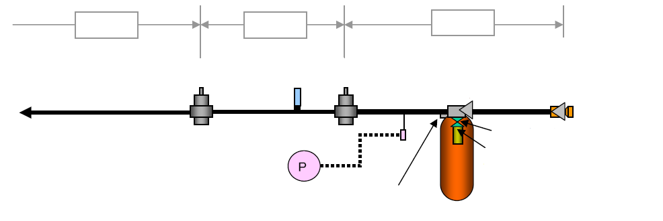
Low pressure
Intermediate pressure
High pressure
Pressure reducing valve
Pressure relief valve
Pressure reducing valve
Container check valve
Gas filling port
(with a built-in gas filling valve that prevents spills)
Excessive-flow prevention valve
Main stop valve
Container safety valve
Pressure gauge/
Residual fuel meter (at the driver’s seat)

Figure Hydrogen System (example)

(2) Safety against fuel (hydrogen gas) leak upon crashes

It is crucial to secure safety in the event of a crash-triggered fuel leak for vehicles powered by compressed hydrogen (including internal-combustion engine vehicles), equivalent to the level of safety provided for vehicles powered by gasoline or other conventional fuels. Technical requirements regarding the following will be provided:

* Prevention of fuel leaks upon frontal crashes and rear-end crashes
* Prevention of fuel leaks upon side crashes

(3) High-voltage safety (Protection from electric shocks)

As fuel cell stacks generate driving-power electricity at high voltage, FCVs (not limited to vehicles fueled by compressed hydrogen) need to be protected against electric shocks. Technical requirements are to be based on ECE Regulation No. 100 for electric vehicles, adding factors unique to FCVs. The requirements regarding the following will be provided
:

* Protection from direct contact
* Protection from indirect contact
* Maintenance of 100-ohm/Volt electrical insulation resistance
* Assurance of safety against lowered electrical insulation resistance in coolant of fuel cell stacks

(4) Noise

It is being contemplated that vehicles such as FCVs whose motor ceases to operate when they come to a stop be exempted from regulations on proximity stationary noise.

(5) Exhaust emissions

It is being contemplated that FCVs fueled by hydrogen be exempted from regulations on exhaust emissions.

(6) Others

- Pedestrian head-protection regulations for FCVs (not limited to those fueled by compressed hydrogen) will be applied to vehicles manufactured on and after September 1, 2007 for new models, and on and after September 1, 2012 for continued models, as in the case of hybrid vehicles.
- Other necessary revisions are also under consideration.

3. Schedule

The revision will be officially announced within fiscal 2004, and will apply to applications made on and after the date of official announcement.
_________

Undertaken in fiscal 2003 and 2004 with National Traffic Safety and Environment Laboratory (independent administrative institution) which is at the core of the project.
MLIT is now considering provisions requiring conformity with high-pressure gas safety regulations and other related laws and regulations.
MLIT is presently considering provisions requiring attention to hydrogen embrittlement.
Regulations based on the UN Agreement on Mutual Recognition of Approvals (1958 Agreement)
Considering provisions that demand conformity with one of the following three requirements: protection from direct contact, monitoring of electrical-insulation resistance decline, or power shutoff upon short circuit.
Officially announced on April 20, 2004.
“New models” herein do not include those whose types are newly approved solely for the change of use, kinds of engine and main construction, wheel base, and applied exhaust gas values, given in Attached Table 1, Judgment Criteria for Identity of Types of Motor Vehicles.
Electromagnetic compatibility (preventing malfunction of vehicle’s electronic devices due to external electromagnetic waves, and controlling influence of electromagnetic waves generated by vehicles on wireless equipment) is to be scrutinized apart from this revision, working toward the adoption of ECE Regulation No. 10.

