PROPOSED AMENDMENTS TO SERIES 6 OF REGULATION No. 14
– SAFETY BELT ANCHORAGES, ISOFIX ANCHORAGES SYSTEMS AND ISOFIX TOP TETHER ANCHORAGES -

Transmitted by the expert from CLEPA

Proposals

Paragraph 5.2.4.1., amend to read:

"5.2.4.1. Subject to paragraph 5.2.4.3. and 5.2.4.4., the portion of each ISOFIX top tether anchorage that is designed to bind with an ISOFIX top tether connector shall be located not further than 2000 mm far from the shoulder reference point and within the shaded zone - as shown in figures 6 to 10 of annex 9 - of the designated seating position for which it is installed, with the reference of a template described in SAE J 826 (July 1995) and shown in figure 5 annex 9, according to the following conditions:

Paragraph 5.2.4.2., amend to read:

      - The ISOFIX top tether anchorage zone may be alternatively located with the aid of the Fixture "ISO/F2" (B), as defined in Regulation No. 16 (annex 17, appendix 2, figure 2), in an ISOFIX position equipped with ISOFIX low anchorages as shown in figure 11 of annex 9.

The seating position shall be the seat's rearmost, downmost position with the seat back in its nominal position, or recommended by the vehicle manufacturer.

In the side view, the ISOFIX top tether anchorage shall lie behind a lateral plane containing the Fixture "ISO/F2" (B) vertical reference line and below a lateral plane passing through the intersection of the "ISO/F2" (B) fixture reference line and the plane containing the underside of the seat top bar, and extending rearward at an angle of 45° above the horizontal.
In the plan view, the ISOFIX top tether anchorage zone shall lie between the planes extending rearward and laterally from the tether reference point, and separated by an angle of 90°.
In the side view, the ISOFIX top tether anchorage shall lie behind the "ISO/F2" (B) fixture rear face.
The intersection between the "ISO/F2" (B) fixture rear face and the horizontal line (annex 9, figure 11, reference 3) containing the last rigid point of a hardness greater than 50 Shore A at the top of the seat back defines the reference point 4 (annex 9, figure 11) on the centreline of the "ISO/F2" (B) fixture. At this reference point, a maximum angle of 45° above the horizontal line defines the upper limit of the top tether anchorage zone.
In the top view, at the reference point 4 (annex 9, figure 11), a maximum angle of 90° extending rearward and laterally and in the rear view, a maximum angle of 40° define 2 volumes which limit of the anchorage zone for the ISOFIX top tether.
The origin of the ISOFIX top tether strap (5) is located at the intersection of the "ISO/F2" (B) fixture with a plane 550 mm distant above the "ISO/F2" (B) fixture horizontal face (1) on the "ISO/F2" (B) fixture centreline (6).
Further, the ISOFIX top tether anchorage shall be more than 200 mm but not more than 2000 mm from the origin of the ISOFIX top tether strap on the rear face of the "ISO/F2" (B) fixture, measured along the strap when it is drawn over the seat back to the ISOFIX top tether anchorage.

Paragraph 5.2.4.4., renumerate 5.2.4.5

New Paragraph 5.2.4.4. inserted:

"5.2.4.4. A tether anchorage may be recessed in the seat back, provided that it is not in the strap wrap-around area at the top of the vehicle seat back.
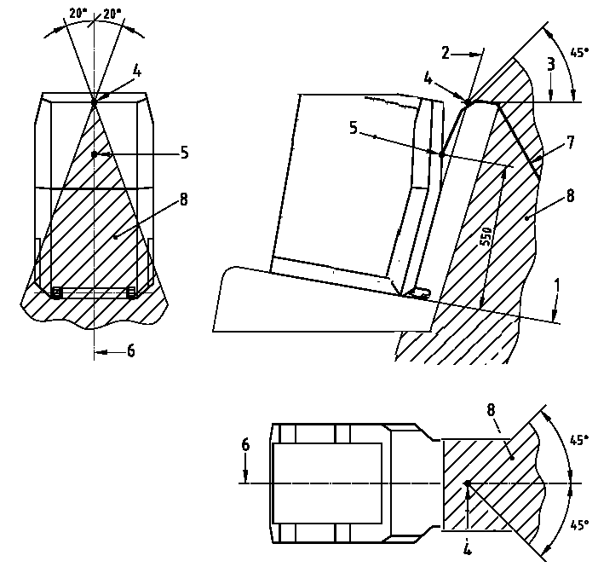

Annex 9, figure 11, amend to read :

1 "ISO/F2" (B) fixture horizontal face
2 "ISO/F2" (B) fixture rear face
3 horizontal line tangent to top
of seat back (last rigid point of a
hardness greater than 50 Shore A)
4 intersection between 2 and 3
5 tether reference point
6 "ISO/F2" (B) fixture centreline
7 top tether strap
8 limits of anchorage zone

Figure 11: Alternative method of locating the top tether anchorage using the
"ISO/F2" (B) fixture, ISOFIX zone - Side, top and rear views

B. Justifications

Justification: (5.2.4.1. and 5.2.4.4.)
Figures 6 to 11 of annex 9 describe the top tether installation area. As this area ends at the seat backs, it is not clear if the top tether anchorage could be recessed or not. There is no security reason not to allow flat floor seat backs with integrated top tether. This additional sentence would clarify this situation.

Justification: (5.2.4.2. and figure 11 of annex 9)

The construction zone described today in paragraph 5.2.4.2. and figure 11 of annex 9 is not very clear and is explained as followed :

Paragraph 5.2.4.2. requests today:

….In the side view, the ISOFIX top tether anchorage shall lie behind a lateral plane containing the Fixture "ISO/F2" (B) vertical reference line and below a lateral plane passing through the intersection of the "ISO/F2" (B) fixture reference line and the plane containing the underside of the seat top bar, and extending rearward at an angle of 45° above the horizontal.
In the plan view, the ISOFIX top tether anchorage zone shall lie between the planes
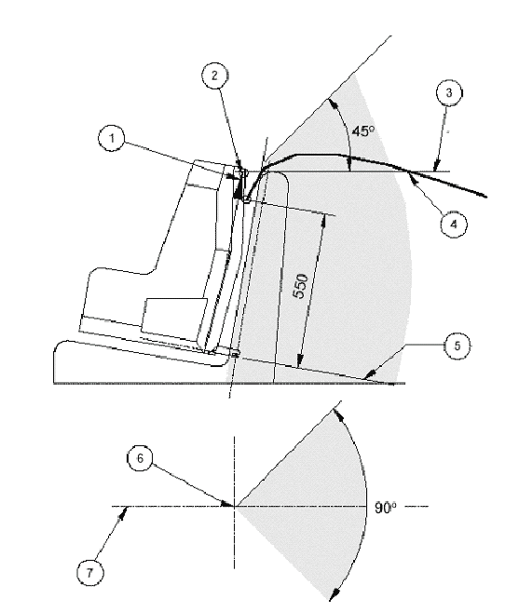
extending rearward and laterally from the tether reference point, and separated by
an angle of 90°…..

Figure 11 of annex 9 : requests today

1 CRF vertical reference probe
2 Top tether reference line
3 Horizontal line
4 Top tether wrap around length
from fixture: 200 – 2000 mm
5 CRF horizontal reference plane
6 Tether reference point
7 Centreline of CRF

Following points are not explained which are essential for the construction of the zone:
- Position of the seat for the construction of the top tether zone
- CRF vertical reference probe (point 1 in the figure)
- Isofix vertical reference line (described in paragraph 5.2.4.2.)
- Top tether reference line (point 2 in the figure)
- Horizontal line (point 3) and plane containing the underside of the seat top bar (described in paragraph 5.2.4.2.)
- Tether reference point (point 6 in the figure)
- How the line limiting the top tether zone at 45° is constructed ?

The modification of paragraph 5.2.4.2. and figure 11 of annex 9 would provide such clarifications.

____________

