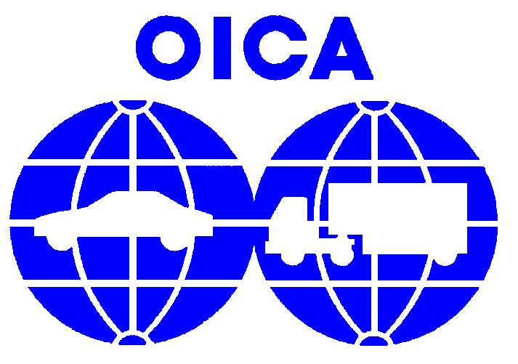

Assessement of cost/benefits in harmonizing

the braking regulations


Introduction
At the first meeting of the ad-hoc group of GRRF for establishing a GTR on braking (Geneva, 9-10 October 2003), task was given to OICA, with the help of CLEPA, to lead the cost/benefits analysis of harmonizing the worldwide braking regulations.

Definition of the task
To ensure that worldwide application of a GTR on braking will be cost effective.

Cost/benefits analysis

Savings

Administrative procedures
By administrative procedures, we mean the approval documentation to be issued to the Technical Services when homologating a vehicle and the application of the homologation tests. This kind of saving can be done mainly in countries where the Type Approval system is in application.
The example of regions like the European Community, where harmonization has been applied for several years, clearly shows the advantages of proper regulation harmonization.

For one platform, several specifications of braking system (in general, one to three) have to be approved. During the marketing life of a vehicle, one or two updates of the braking system have to be performed and hence homologated. This means at least four homologations have to be performed for one platform. For each homologation, manpower and construction of vehicle prototypes must be considered in addition to the homologation work itself.

As a consequence, for a region of e.g. 10 countries, all those costs can be divided by 10 in the case where regulations are harmonized.

Equipments and testing procedures
Having common testing procedures for the different approval markets where a vehicle is to be sold, even with different limits, permits the manufacturer to perform the internal testing only once when it must be done several times in the case of a non-harmonized environment.
In the same manner, having such common testing procedures permits use of the same testing equipment, even though the limits vary according to the particular markets. This is independent of the homologation system being applied.

Components design
Having the same requirements throughout the world permits the design of standardized components. In the case where limits are the same, identical components can be used for the same platform and even adjustments can be done in the same range. This is again independent of the homologation system being applied.

Vehicle design
The same considerations can apply to the vehicle itself, but with more weight as it concerns the whole vehicle instead of just components. While it is understood that different markets will always demand different vehicles, the design of platforms/vehicles can be done once for all markets if the approval requirements are the same. This is true for whatever the approval system, i.e. self certification and type approval.

Costs
Harmonizing will involve costs to the Industry to be set against the benefits it can provide for indeed the work toward harmonization will itself involve costs. In case the principle of "best available technology" should have to be retained, harmonizing up (to the best available technology, or the level of the most stringent current regulation in application) will cost equipment and design efforts from the automotive Industry. In addition, costs will be geographically distributed according to the regulation to which the GTR will refer, i.e. if the US regulation were to be considered the most stringent hence the reference for harmonizing up, harmonization costs (testing equipments, component & vehicle designs) would be distributed mainly amongst the non-US manufacturers.

However, the particular case of the braking regulations should not face this situation as technologies and level of stringencies are quite similar in the different regions.

Independent analysis
In January 2001, an independent consultant presented to some worldwide automotive manufacturers, an analysis "assessing the cost of differences in regional automotive regulation".
According to this independent study, worldwide harmonization will in any case decrease the administrative costs linked to the vehicle homologation (see item 3.1.1 above). In particular, homologation costs for vehicles according to their braking systems will be decreased thanks to the braking regulations. As current braking regulations are of similar level of stringency throughout the world (see item 3.2. above), harmonizing will involve quite low costs to the Industry while keeping the benefits of low variation in vehicle/component design.

Conclusion
In any case, harmonization will call on efforts from Industry that must ultimately be reflected in the vehicle price. Considering the braking regulations in particular, the effort required is of a comparatively low level because world (i.e. US–UN/ECE) regulations already include considerable harmonization.

Assessing the benefits of harmonizing the braking regulations cannot be done with precision. While the subject of the present document is not to provide any precise figure it is generally accepted that reduction of administrative costs and design/construction costs are cumulative. It can be seen that the costs have to be considered only during the short term harmonization process yet the benefits will influence the homologation procedures in the long term once the harmonization process is completed. This of course, is true provided the GTR and its legal framework are easily applicable.

Under the above conditions, harmonizing the braking regulations is beneficial to all stakeholders, i.e. customers, Industry and Administration.

