Informal document No. GRE-52-3
(52nd GRE, 30 March – 2 April 2004,
agenda items 2.7. and 3.)

INFORMAL DOCUMENT to GRE
Transmitted by the expert from IEC

Filament lamps in an Emergency Brake Light application

Introduction
The luminous intensities of a stop (/tail) lamp equipped with a P21/5W have been measured with the 21W or the 5W filament in a flashing mode of 3Hz, 4Hz, 5Hz, 6Hz and 7Hz with a duty cycle of 50% at 13.5V. The photocell was located at HV and used in its linear range. The plots of measured values are given in the annex to this document.
Comparisons of the maximum “ON” and the minimum “OFF” values, as well as the ratio of (maximum “ON”) / (minimum ”OFF”) are presented.
The objective of this document is to provide information on filament lamps performance in a flashing mode. There are no statistics behind.

Conclusions
Measurements confirm already existing data, summarised as follows:
- At increasing frequency, the luminous intensity against time is changing, as there is not enough time for the filament to heat up or cool down:
  - The maximum “ON” values are decreasing;
  - The minimum “OFF” values are no longer zero but increasing;
  - The shape of the signal is changing.
- These effects are increasing for higher wattage (thicker) filaments.

It should be noted that stop lamps are usually designed such that:
- The maximum intensity is a certain percentage below the maximum required;
- The minimum intensity is a certain percentage above the minimum required.

Recommendation
Re the physics of filament light sources, a frequency of around 3 or 4 Hz would be suitable.

Comparisons of maximum “ON” and minimum “OFF” values

In the following graphs the maximum and minimum values are given as percentages of the measured values in 13.5V DC operation.

Note: watch the different vertical scale.
Comparisons of filament lamps of different wattages

In the following graphs the maximum and minimum values are given as percentages of the measured values in 13.5V DC operation.

Annex: Plots of measured values
(all diagrams: 4.8mV offset)

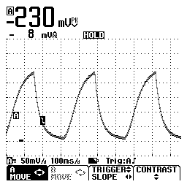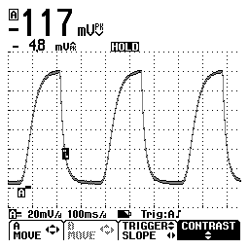
Photocell signals at 3Hz of 21W filament (left) and 5W filament (right)

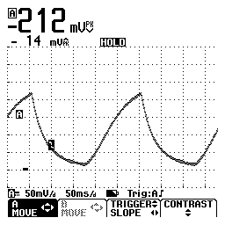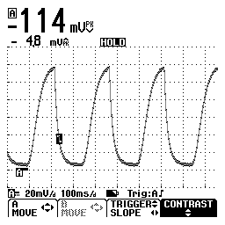
Photocell signals at 4Hz of 21W filament (left) and 5W filament (right)

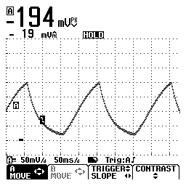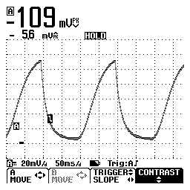
Photocell signals at 5Hz of 21W filament (left) and 5W filament (right)

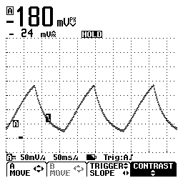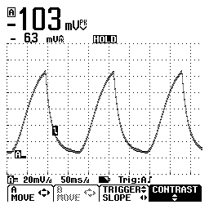
Photocell signals at 6Hz of 21W filament (left) and 5W filament (right)

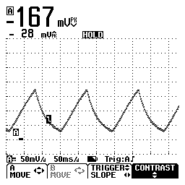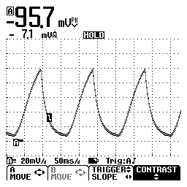
Photocell signals at 7Hz of 21W filament (left) and 5W filament (right)

