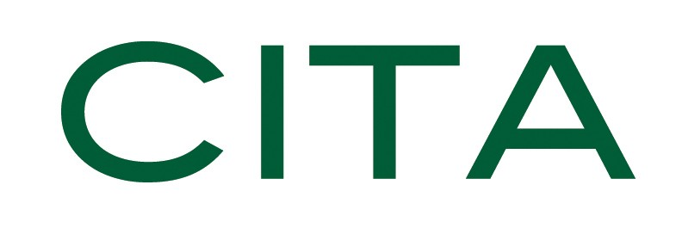
INTERNATIONAL MOTOR VEHICLE INSPECTION COMMITTEE

Ref.: L2004-044

Communication from CITA to WP.29/AC.4

Subject: 1997 Vienna Agreement on Periodic Inspection – Ad hoc group on amendments to Rule 2

- In the light of the recent communication (document 12390/04 ADD1 enclosing document SEC(2004) 1056) from the European Union Commission to the European Union Council of Ministers seeking authority to open negotiations on the possible accession of the European Union to the 1997 Vienna Agreement;

- In the light of the specific remark in paragraph 5.4 of document SEC(2004) 1056 that, if the Community accedes to the Agreement before Rule 2 is finalised, the Commission will ensure that its final drafting is compatible with directive 96/96/EC (as amended) and that if Rule 2 is finalised before Community accession, then the Commission will need to include Rule 2’s adaptation as part of its accession negotiations;

The CITA Bureau Permanent requests WP.29/AC.4 to clarify the objectives and timetable for the ad hoc group set up under the chairmanship of CITA at the 133rd meeting of WP29.

Background
At present, the objective of the ad hoc group is to consider, in conjunction with experts in periodic inspection from the Groups of Rapporteurs and from the administrations of the members of W.P29, all the amendments proposed so far to the draft of Rule 2 proposed by CITA and to propose a revised draft to WP.29. It has not been asked to consider the issue of compatibility with directive 96/96/EC.

If WP.29 considers it appropriate to extend the objective of the ad hoc group to include consideration of the compatibility of the draft of Rule 2 with the directive, the meaning of ‘compatible’ will need to be clarified. If it means ‘generally in line with the numbering and containing at least the items listed in 96/96/EC, the group can continue its work. But this may be too wide an interpretation.

On the other hand, if ‘compatible’ means ‘identical in scope and detail’, there is little work for the ad hoc group to undertake. The WP.29 secretariat could prepare a new draft based strictly on the content of the directive. However, this may be too narrow an interpretation.

With regard to timing of its work, CITA would be grateful for further guidance on the date by which the ad hoc group should complete its work. In particular, whether the imminent opening of negotiations on EU accession means that the date has changed.

Brussels
29 October 2004

Wim Labro
Executive Director

Consultative Status Category II to the Economic and Social Council of the United Nations

CITA aisbl | Rue de la Technologie 21-25 | B-1082 BRUSSELS (Belgium)
TEL. + 32 (0)2 469 06 70 | FAX + 32 (0)2 469 07 95 | cita.vehicleinspection@skynet.be
www.cita-vehicleinspection.org
VAT: BE 436.921.157 | FORTIS BANK - IBAN BE54 2100 1540 8197

