UNITED  NATIONS | E

 | Economic and Social  Council | Distr.  RESTRICTED  TRANS/WP.29/GRSG/2003/2  30 January 2003  Original: ENGLISH  ENGLISH AND FRENCH ONLY

ECONOMIC COMMISSION FOR EUROPE

INLAND TRANSPORT COMMITTEE

World Forum for Harmonization of Vehicle Regulations (WP.29)

Working Party on General Safety Provisions (GRSG)
(Eighty-fourth session, 5-9 May 2003,
agenda item 2.)

PROPOSAL FOR DRAFT AMENDMENT TO REGULATION No. 52
(Small capacity passenger vehicles, M2 and M3 category)

Transmitted by the Expert from Spain

Note: The text reproduced below was prepared by the expert from Spain in order to clarify and unify the procedure of verification of the access to the driver’s door by the passengers when the driver’s door is considered as an emergency door. It is based on a document distributed without a symbol (informal document No. 14) during the eighty-third session (TRANS/WP.29/GRSG/62, para. 6).

____________

_______________
Note: This document is distributed to the Experts on Brakes and Running Gear only.
A. PROPOSAL

Paragraph 5.6.2.5.2., amend to read (the reference to footnote 5/ and footnote 5/, should be deleted):

"5.6.2.5.2. The driver’s door shall be accepted as the emergency door for the occupants of the seats situated beside the driver’s seat provided that it is possible to move a test gauge from the occupants’ seats to the exterior of the vehicle through the driver’s door (see annex 3, figure 20).

Verification of the access to the driver’s door shall be subject to the requirements of paragraph 5.7.3.2., by using the test gauge having a dimension of 600x400 mm, as described in paragraph 5.7.3.3. The service door provided for the passengers shall be in the side of the vehicle opposite to that containing the driver’s door and shall be accepted as the emergency door for the driver;"

Paragraph 5.7.2.4.2, amend to read

" ..... defined in paragraph 5.6.2.5.2. and that the space reserved for the driver’s seat shall communicate with the main passengers’ compartment through an appropriate passage; such requirement shall be deemed to be fulfilled if the test gauge described in paragraph 5.7.5.1. can move unobstructed from the gangway, enabling that the front end of the gauge reaches the vertical plane tangential to the foremost point of the driver’s seat back this seat situated in its rearmost possible position) and, from this plane, the panel described in paragraph 5.6.2.5.2. could be moved to the emergency door in the direction established by such paragraph (see annex 3, figure 21)."

Annex 3,

Insert new figures 21 and 22, to read:

“Figure 21

Access to driver’s door
(See paragraph 5.6.2.5.2.)

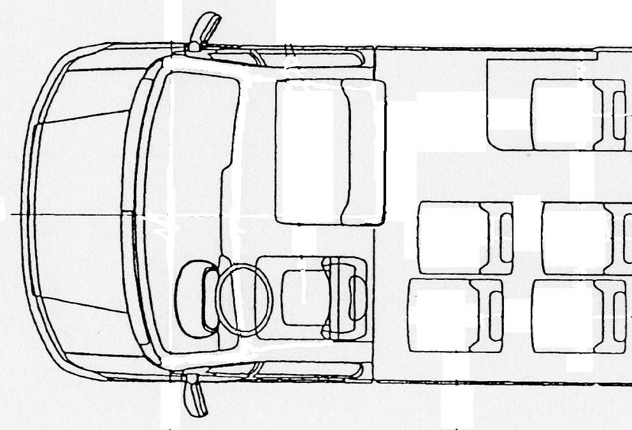
Test gauge of 60 cm x 40 cm as described in paragraph 5.7.3.3.
Gangway’s test gauge

Figure 22

Access to driver’s door
(See paragraph 5.7.2.4.2.)

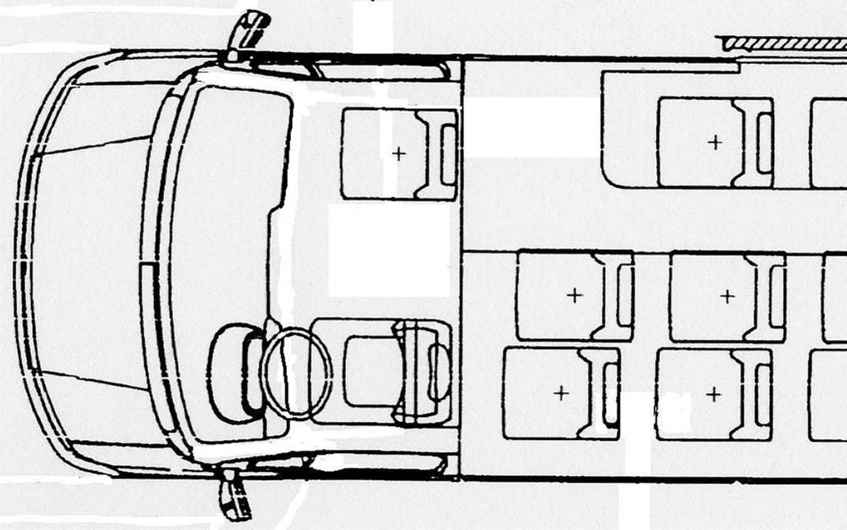
Test gauge of 60 cm x 40 cm as described in paragraph 5.7.3.3.
Gangway's test gauge

“
* * *

B. JUSTIFICATION

This proposal for amendment aims to establish an objective method of verifying the conditions specified in paragraph 5.6.2.5.2. and that the driver’s post and the accesses to the driver’s seat fulfil all the requirements to allow that the driver’s door could be considered as the emergency door for the main passengers’ compartment.

The main purpose of this proposal is to require the same safety conditions for the passengers when they pass through the driver’s seat as those when they have to use an emergency window – passing through the passengers’ seats.

_________________

