INFORMAL MEETING ON THE DEVELOPMENT OF THE GLOBAL TECHNICAL REGULATION (gtr) ON MOTORCYCLE BRAKE SYSTEMS
Blainville, Quebec
October 25, 2002

1. Canada held the first informal meeting on the development of the gtr on motorcycle brake systems on October 25th, 2002 under the chairmanship of Mr. D. Davis (Canada). Experts from the following countries participated in the meeting: Canada; United States of America. Experts from the following non-governmental organizations and manufacturers also attended the meeting: American Motorcyclist Association (AMA); Biokinetics and Associates LTD.; Federation of European Motorcycle Associations (FEMA); Harley-Davidson; International Motorcycle Manufacturers Association (IMMA); International Organization of Motor Vehicle Manufacturers (OICA); Kawasaki Canada; Kawasaki Heavy Industries; Motorcycle & Moped Industry Council (MMIC); PMG Test and Research Centre; Yamaha Canada.

Documentation: Proposed timetable for gtr development, Presentation by Mr. Davis, Presentation by Mr. Bergevin, Presentation by Mr. Rodger, informal document from Italy. The documents are in the annexes to this report.
2. The meeting was brought to order and the provisional agenda was distributed. The agenda of the meeting was approved without change.
3. Mr. Davis gave a brief presentation on the structure of WP.29 and its administrative committees, and on the gtr development process. This was followed by a presentation from Mr. Bergevin describing Canada’s process for the development of the motorcycle brake gtr, including a very brief outline of the testing of motorcycle brake systems to three different world regulations (FMVSS 122, ECE R78, Japan SS 12-61). It was explained why and how the motorcycle braking tests will be used in the process of developing the new gtr on motorcycle brake systems. A compact disc containing Mr. Davis’ and Mr. Bergevin’s presentations was distributed following the meeting.
4. Dr. Rodgers of IMMA gave a presentation on the advantages and particularities of a gtr and he also shared some results of IMMA’s previous testing and comparison analysis between the North American, European and Japanese motorcycle brake systems regulation.
5. Italy was unable to attend, however, they provided written comments dated Oct. 21, 2002. This document was distributed and discussed. The Italian position reflected the content of the previous three presentations.
6. In the ensuing discussion and question period, it was agreed to develop the gtr, which would harmonize existing regulations by adoption of the most stringent and cost effective provisions. Additional analyses would be done to adopt performance requirements related to the new technologies, including Anti-Lock Brake System (ABS) and Combine Brake System (CBS).
7. To assure that the gtr will contain meaningful provisions there is a need for world motorcycle collision statistics. These data will play an integral role in the decision making process toward gtr development. All contracting parties were asked to provide any available information to Canada.
Annex 1

Presentation by Mr. Davis

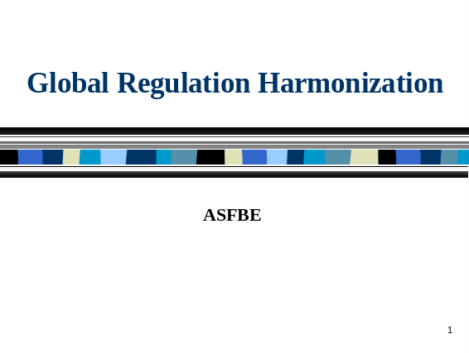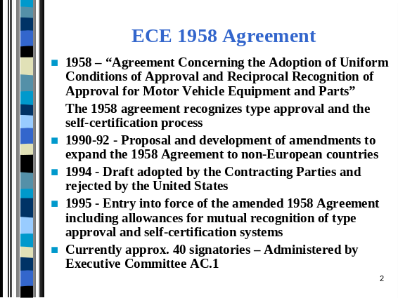

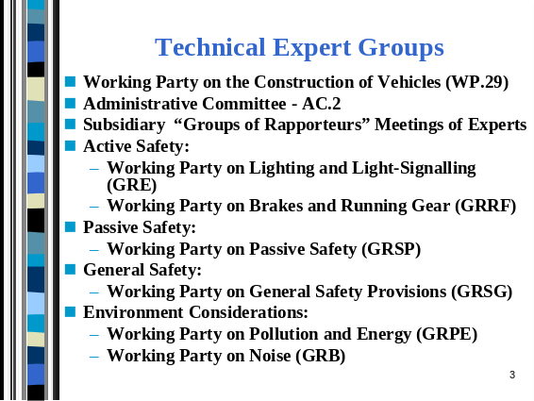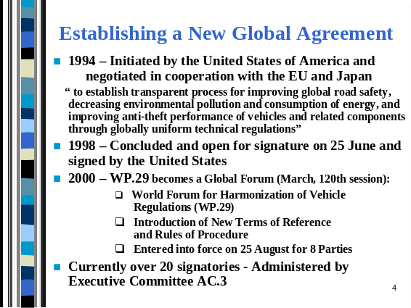

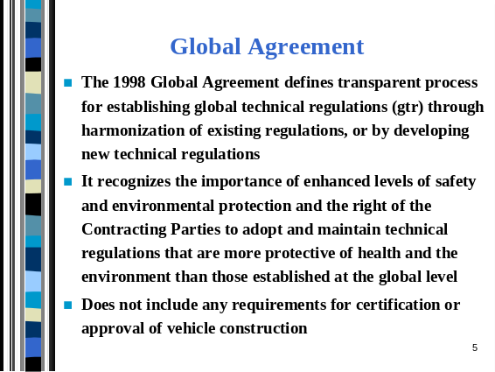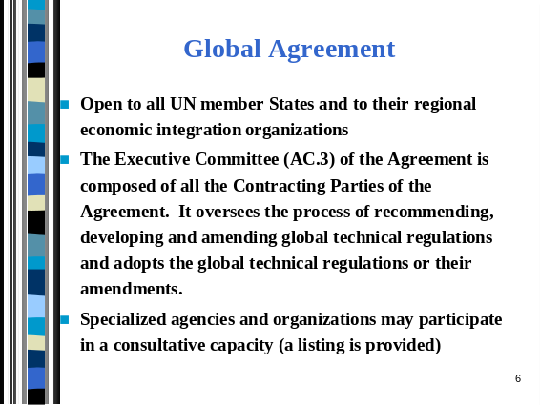

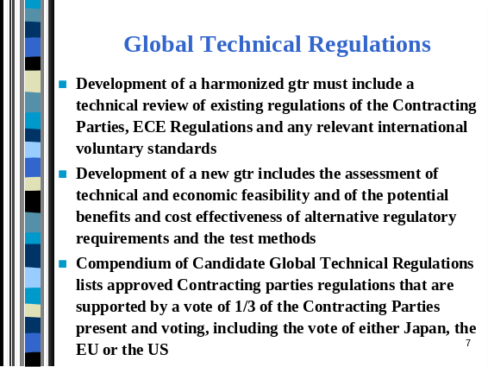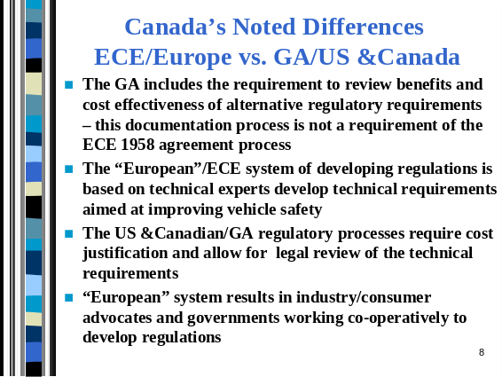

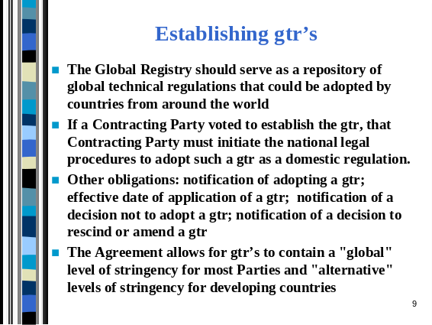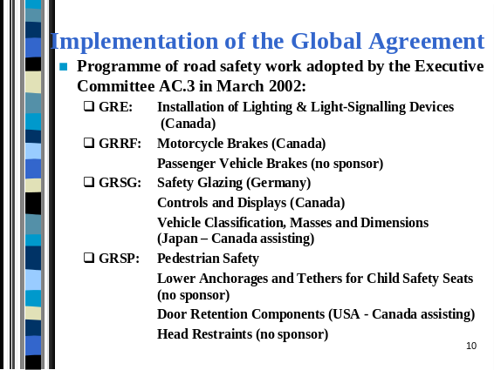

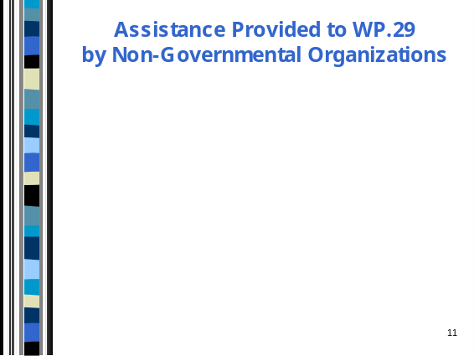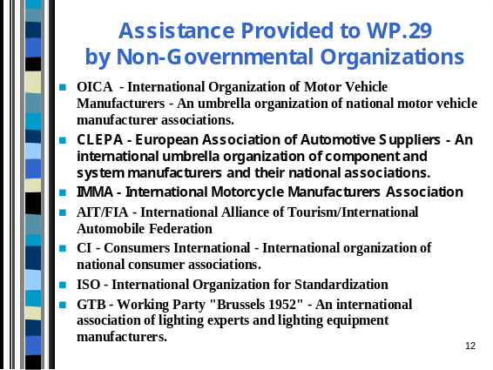
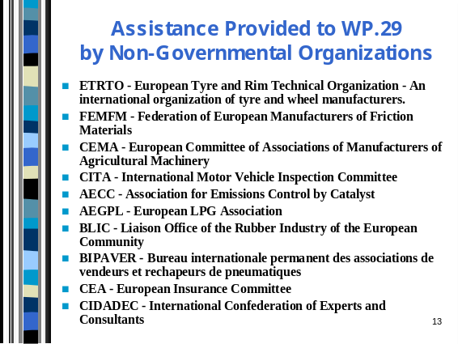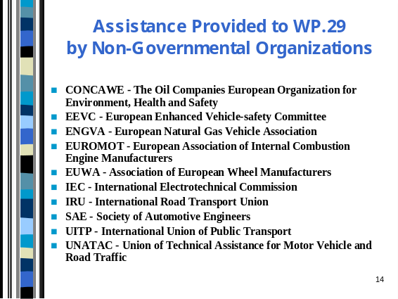

Presentation by Mr. Bergevin

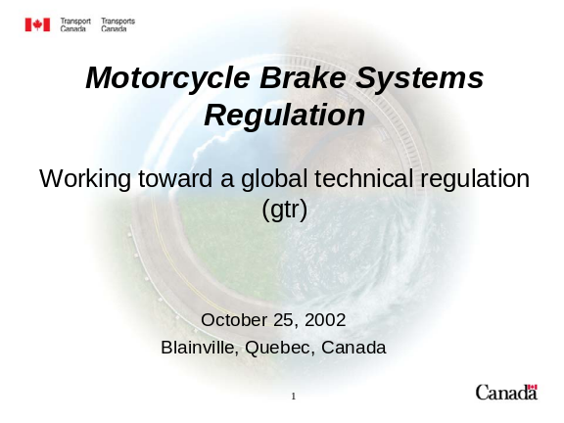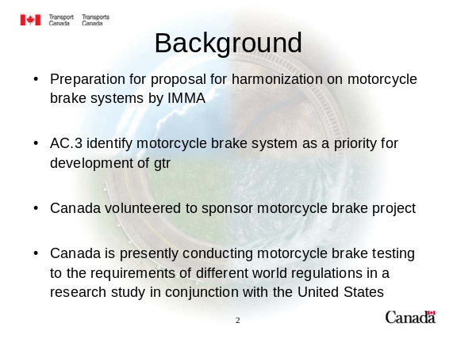

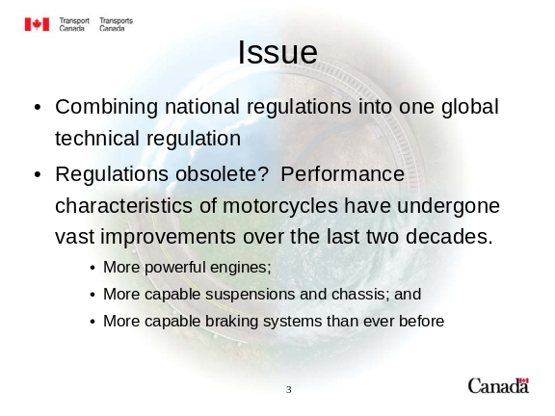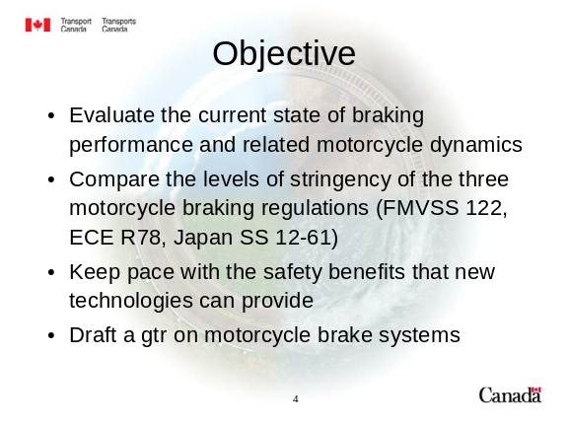

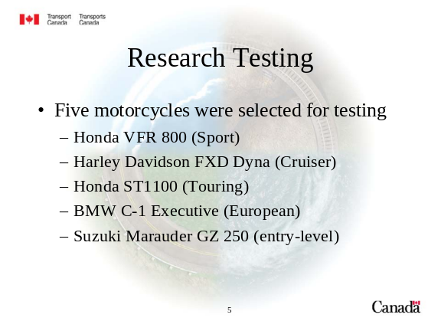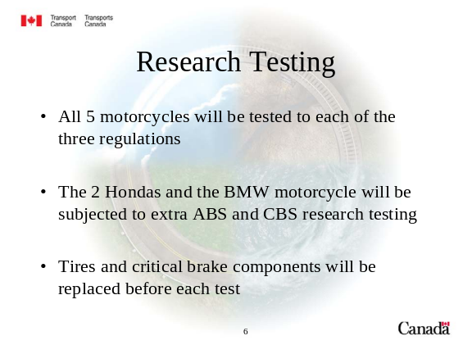

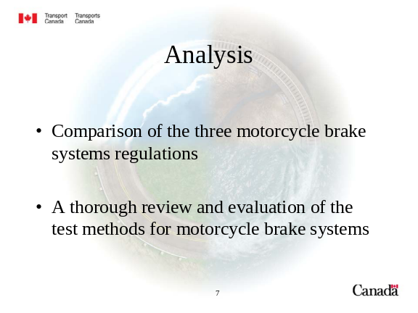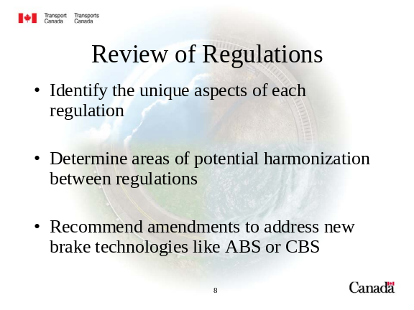

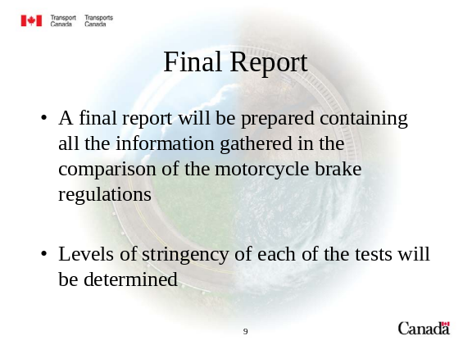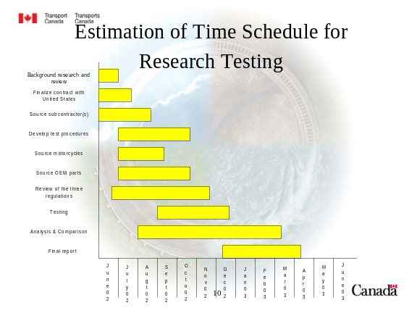

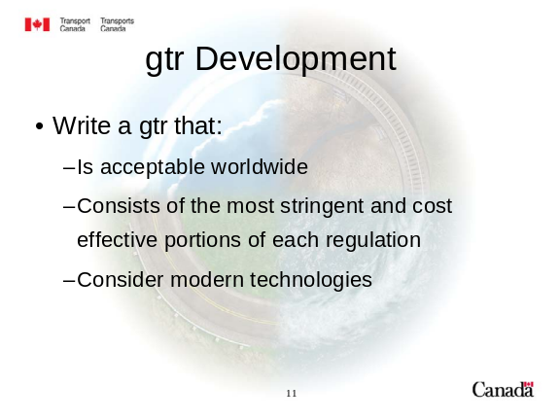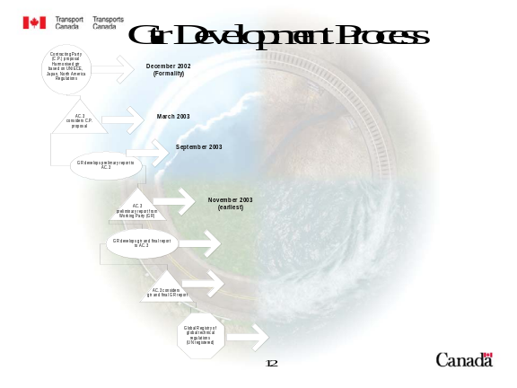

Presentation by Mr. Rodger

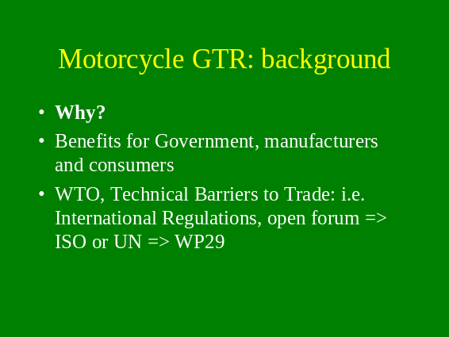

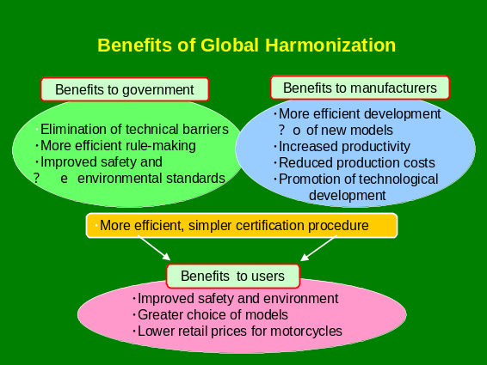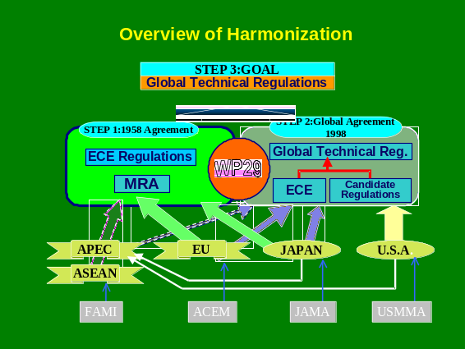
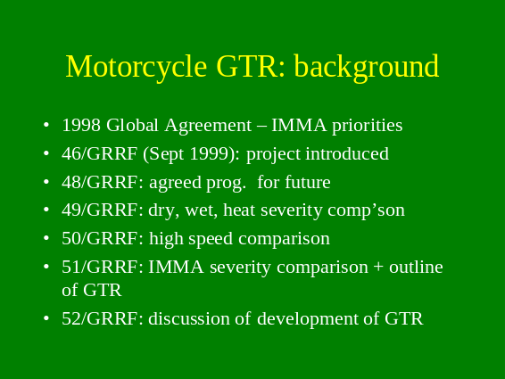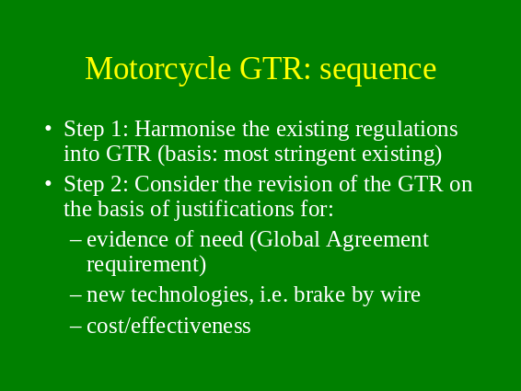

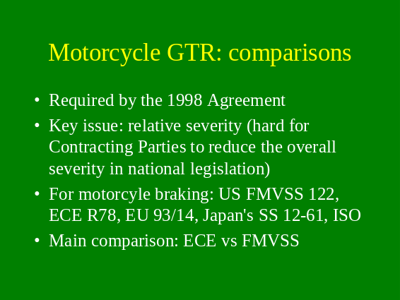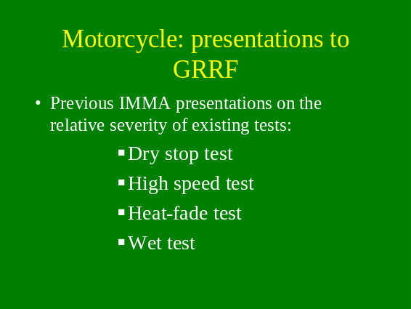

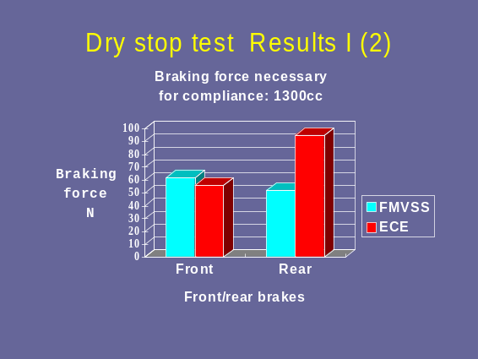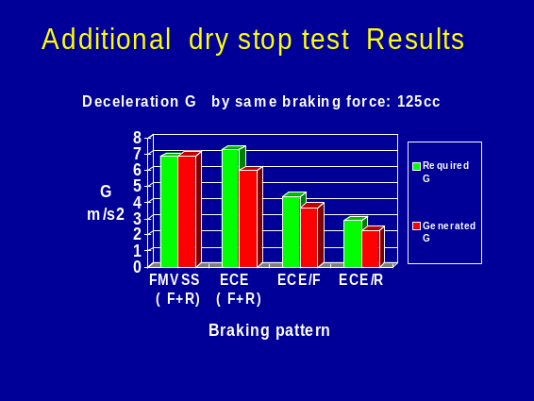

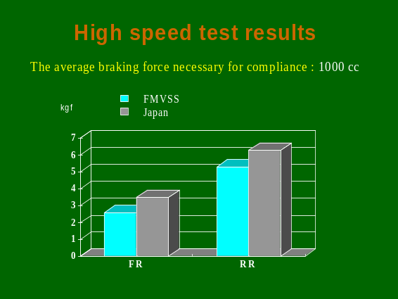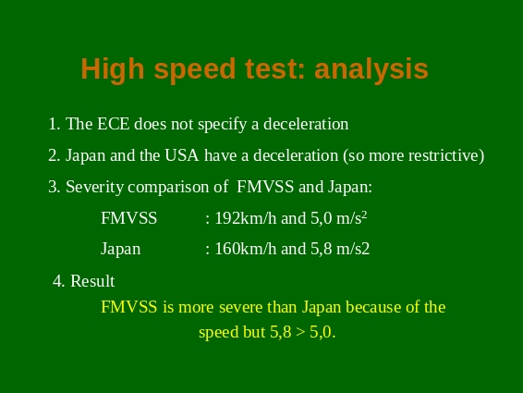

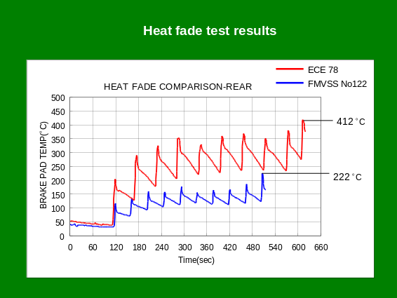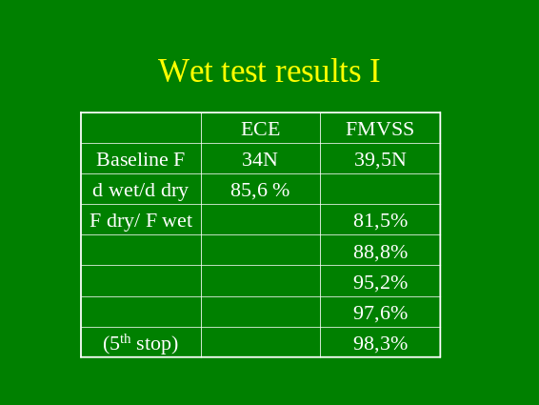

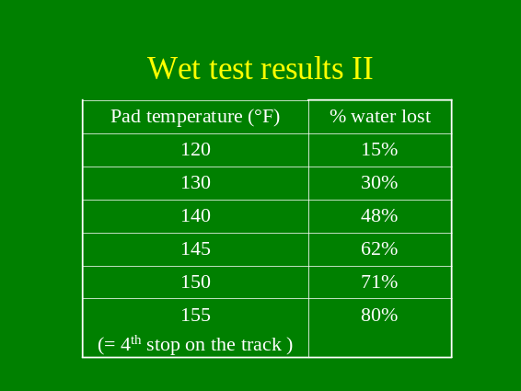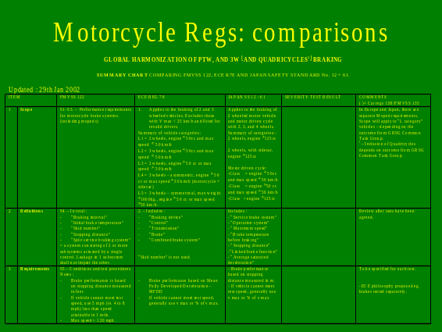
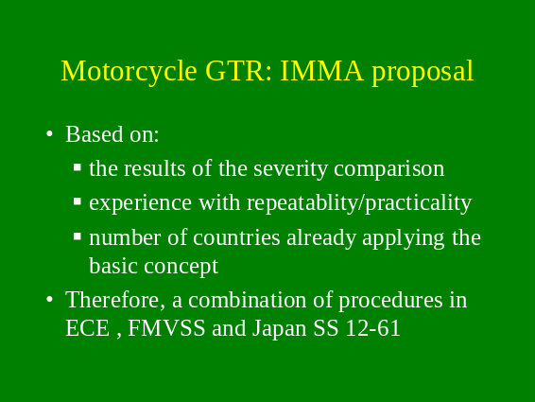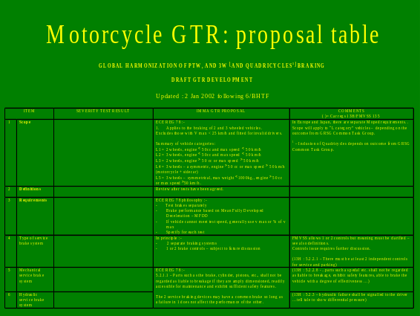

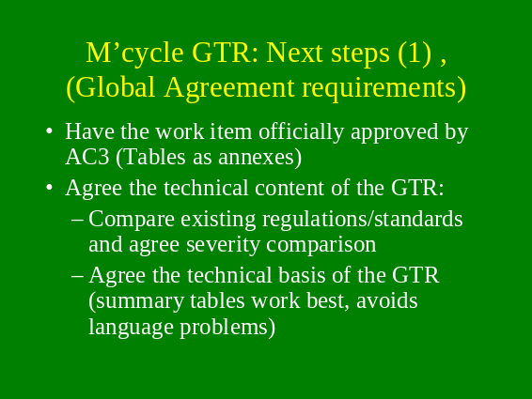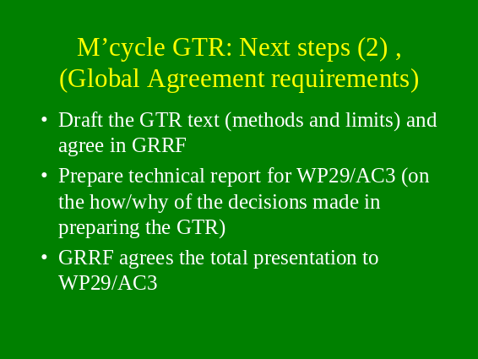

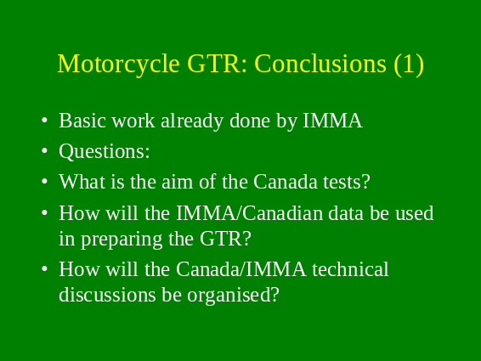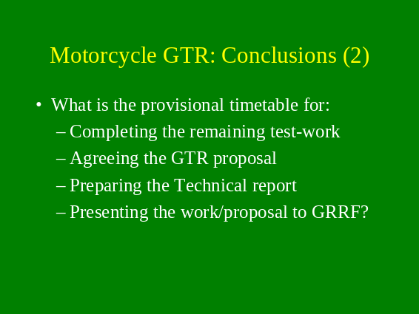

Italian Position Paper concerning

Global Technical Regulation on Moped and Motorcycle braking

Introductory note

Some data concerning the Italian market (source: National Association of two and three wheel vehicle manufacturers - ANCMA)

Powered Two Wheels production in Italy in the year 2000
- approximately 500 000 Mopeds
- over 540 000 Motorcycles

Powered Two Wheels circulating fleet in Italy in the year 2000
- Almost 10 million vehicles, subdivided in approx. 6 400 000 Mopeds and over 3 400 000 Motorcycles

Number of Powered Two Wheel Manufacturers producing in Italy
- 7 Moped Manufacturers
- 9 Motorcycle Manufacturers

Concerning braking, in Italy Mopeds and Motorcycles have to be type-approved according to the prescriptions of 93/14/EC Directive or according to the (equivalent) ECE R. 78.
No safety problems have been ever reported owing to inadequate brake systems of these vehicles.

ONU/ECE WP29/GRRF ISSUES

With reference to the discussion concerning Powered Two Wheels brakes harmonisation, which took place during the 52/GRRF meeting (Geneva, 16-18 September 2002), we would like to point out the following:

- Following the establishment of the Global Agreement, according to a GRRF request, IMMA outlined a programme of work at 46/GRRF which it would complete in order to prepare a proposal for a Global Technical Regulation (GTR) for brakes on L-category vehicles.

- The main part of the programme was the analysis of the relative severity of the existing regulations, because no Contracting Party would be able to accept a level of performance which was lower than its current requirements. Therefore, the comparison was made between the ECE R78, the Japan's Safety Standard 12-61 and the US FMVSS 122 requirements, because these three regulations represent the test procedures in all the other regulations and standards from around the world.

- The IMMA proposal derived from the above mentioned test programme is based on the results of the severity comparison and adopts the ECE testing philosophy.
The results have already been presented to GRRF but in summary they are as follows:
- for the dry stop test, ECE R78 procedure is the most severe
- for the high speed test, the Japanese procedure is the most severe
- for the heat-fade test, ECE R78 procedure is the most severe
- for the wet-test, ECE R78 procedure is the most severe
- for ABS testing the, ECE R 78 Annex 4 is the only procedure available.

- Canada volunteered to sponsor the motorcycle brakes project. As a consequence of this decision, a meeting has been called for the 25 October 2002 in Montreal, open to any GRRF delegation interested in attending, at which the Canadian administration and other participants will discuss how to pursue the GTR project. Canada expect to have a first GTR proposal ready for informal discussion in 2003.

THE ITALIAN POSITION

On the above mentioned subject the opinion of the Italian Administration is the following:

- Traditionally GRRF relies on industry for information on the future technologies and for suggestions on how the regulations could be developed. Although WP29 and AC3 are currently emphasising the formality of having an administration focus to GTR development, it is necessary to maintain the co-operative nature of GRRF's work, in which there is a blend of industry expertise and government focus

- The requirements of the Global Agreement are such that it is unlikely that an administration is able to devote the necessary time, budget and resources to fulfilling all of the points

- For the foreseeable future most of the models worldwide will be equipped with the traditional two brake systems, because they are cost-effective, in particular for developing markets

- The most effective approach for the development of a GTR should be in 2 steps:
- harmonisation on the most stringent existing regulation, and later on
- discussion on up-grading because such a harmonisation would be an improvement for many Contracting Parties

Therefore, since IMMA provided a solid foundation for a GTR discussion, based on test evidences and on logical assumptions, we fully support the IMMA approach to the GTR on Motorcycle braking, the consequent programme of work and the proposal which is derived by it.
In addition, we do hope that:

- the Canadian sponsorship of the project will consider all the activities already carried out so that a forward plan is worked out, keeping into account documents and proposals which have already been presented and discussed within GRRF.

- GRRF does not want to waste the work already carried out by IMMA and that this will be the foundation of future discussions. GRRF should critically review all research presented to it in order to satisfy itself that the final GTR proposal is properly prepared.

Roma, 21st October 2002

