UNITED
E

NATIONS


Economic and Social
Council

Distr.

GENERAL

TRANS/WP.29/2003/78

30 July 2003

ENGLISH

Original: ENGLISH AND FRENCH

ECONOMIC COMMISSION FOR EUROPE

INLAND TRANSPORT COMMITTEE

World Forum for Harmonization of Vehicle Regulations (WP.29)
(One-hundred-and-thirty-first session,
11-14 November 2003, agenda item 4.2.10.)

DRAFT CORRIGENDUM 1 TO THE 04 SERIES OF AMENDMENTS

TO REGULATION No.16

(Safety belts)

Transmitted by the Working Party on Passive Safety (GRSP)

Note: The text reproduced below was adopted by GRSP at its thirty-third session, and is transmitted for consideration to WP.29 and to AC.1. It is based on document TRANS/WP.29/GRSP/2001/15/Rev.2/Corr.1, not amended (TRANS/WP.29/GRSP/33, para.37).

____________

This document is a working document circulated for discussion and comments. The use of this document for other purposes is the entire responsibility of the user.
Documents are also available via the INTERNET:
http://www.unece.org/trans/main/welcwp29.htm

Annex 17 – appendix 2,

Paragraph 4., amend to read:

" ..........

............
............
B - ISO/F2 : Reduced-Height .........
B1 - ISO/F2X: Reduced-Height Forward Facing toddler CRS
C - ISO/R3 Full- Size .......
.............
G - ISO/L2 Right Lateral Facing position CRS (carry-cot)

Mass group | ISOFIX size class | Fixture (CRF)
0 – up to 10 kg | F | ISO/L1
0 – up to 10 kg | G | ISO/L2
0 – up to 10 kg | E | ISO/R1
0+ - up to 13 kg | C | ISO/R3
0+ - up to 13 kg | D | ISO/R2
0+ - up to 13 kg | E | ISO/R1
I - 9 to 18 kg | A | ISO/F3
I - 9 to 18 kg | B | ISO/
I - 9 to 18 kg | B1 | ISO/ F2X
I - 9 to 18 kg | C | ISO/R3
I - 9 to 18 kg | D | ISO/R2
"

Paragraphs 4.1.and 4.2., amend to read:

"4.1. Full-height forward-facing toddler child restraint systems envelope

Key

- Limits in the forward and upwards directions
2 Dashed line marks area where a support leg, or similar, is allowed to protrude
3 N/A
4 Further specifications of the connector area is given in Regulation No. 44

Figure 1 – ISO/F3 envelope dimensions for a full-height forward-facing toddler CRS (height 720 mm) - ISOFIX SIZE CLASS A

4.2. Reduced-height forward-facing toddler child restraint systems envelope

Key
1 Limits in the forward and upwards directions
2 Dashed line marks area where a support leg, or similar, is allowed to protrude
3 N/A
4 Further specifications of the connector area is given in Regulation No. 44

Figure 2 – ISO/F2 envelope dimensions for a reduced-height forward-facing toddler CRS, (height 650 mm) – ISOFIX SIZE CLASS B"

Insert a new paragraph 4.3., to read:

"4.3. Reduced-height second version back shape forward-facing toddler child restraint systems envelope

Key
1 Limits in the forward and upwards directions
2 Dashed line marks area where a support leg, or similar, is allowed to protrude
3 N/A
4 Further specifications of the connector area is given in Regulation No. 44

Figure 3 – ISO/F2X envelope dimensions for a reduced-height second version back surface shape forward-facing toddler CRS, (height 650 mm) – ISOFIX SIZE CLASS B1"

Paragraphs 4.3. to 4.6. (former), renumber as paragraphs 4.4. to 4.7., and amend to read:

"4.4. Full-size rearward facing toddler child restraint system envelope

Key
1 Limits in the rearward and upwards directions
2 Dashed line marks area where a support leg, or similar, is allowed to protrude
3 The backwards limitation (to the right in the figure) is given by the forward-facing envelope in Figure 2
4 Further specifications of the connector area is given in Regulation No. 44

Figure 4 – ISO/R3 envelope dimensions for a full-size rearward-facing toddler CRS – ISOFIX SIZE CLASS C

4.5. Reduced-size rearward-facing toddler child restraint systems envelope

Key
1 Limits in the rearward and upwards directions
2 Dashed line marks area where a support leg, or similar, is allowed to protrude
3 The backwards limitation (to the right in the figure) is given by the forward-facing envelope in Figure 2
4 Further specifications of the connector area is given in Regulation No. 44

Figure 5 – ISO/R2 envelope dimensions for a reduced-size rearward-facing toddler CRS – ISOFIX SIZE CLASS D

4.6. Rearward facing infant child restraint systems envelope

Key
1 Limits in the rearward and upward directions
2 Dashed line marks area where a support leg, or similar, is allowed to protrude
3 The backwards limitation (to the right in the figure) is given by the forward-facing envelope in Figure 2
4 Further specifications of the connector area is given in Regulation No. 44

Figure 6 – ISO/R1 envelope dimensions for an infant-size rearward-facing CRS – ISOFIX SIZE CLASS E

  - Lateral facing child restraint systems envelope

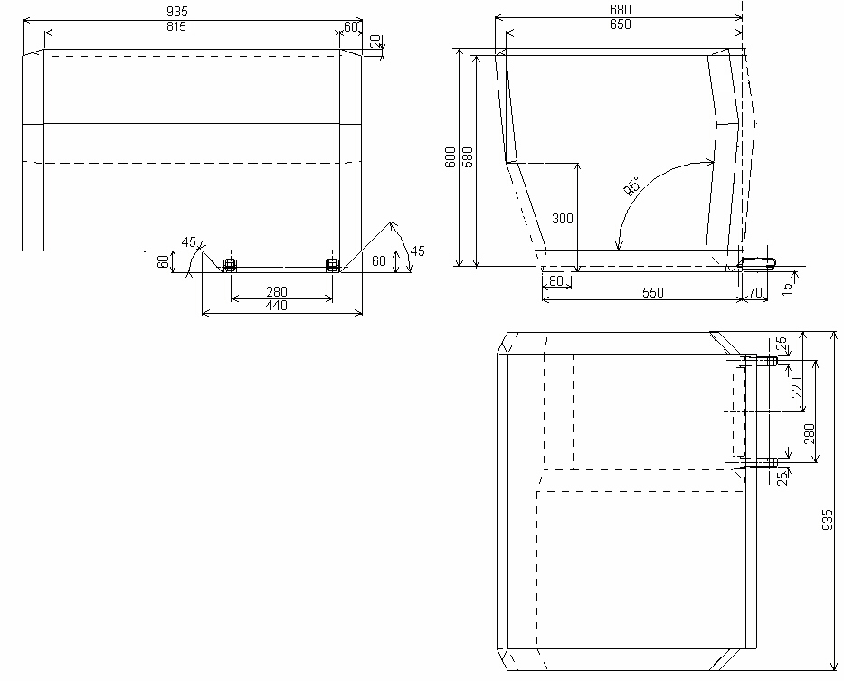

1

1

3

4

2

5

Key
1 Limits in the rearward and upward directions
2 Dashed line marks area where a support leg, or similar, is allowed to protrude
3 The backward limitation (to the right in the figure) is given by the forward-facing envelope in Figure 2
4 Further specifications of the connector area is given in ISO 13216-1, Figures 2 and 3

Figure 7 – Envelop dimensions for lateral facing position CRS - ISO/L1- ISOFIX SIZE CLASS F or symmetrically opposite – ISO/L2 – ISOFIX CLASS G"

Annex 17, appendix 3 (new), table 2, amend to read (note (1) and key of letters to be inserted in the table remains):

"Table 2

TABLE OF VEHICLE HANDBOOK INFORMATION ON ISOFIX CHILD RESTRAINT SYSTEMS INSTALLATION SUITABILITY FOR VARIOUS ISOFIX POSITIONS

Mass Group | Size class | Fixture | Vehicle ISOFIX positions
 |  |  | Front  Passenger | Rear  Outboard | Rear  Centre | Intermediate Outboard | Intermediate Centre | Other sites
carrycot | F | ISO/L1
carrycot | G | ISO/L2
carrycot |  | (1)
0 - up to 10 Kg | E | ISO/R1
 |  | (1)
0+ - up to 13 kg | E | ISO/R1
0+ - up to 13 kg | D | ISO/R2
0+ - up to 13 kg | C | ISO/R3
0+ - up to 13 kg |  | (1)
I – 9 to 18 kg | D | ISO/R2
I – 9 to 18 kg | C | ISO/R3
I – 9 to 18 kg | B | ISO/F2
I – 9 to 18 kg | B1 | ISO/F2X
I – 9 to 18 kg | A | ISO/F3
I – 9 to 18 kg |  | (1)
II – 15 to 25 kg |  | (1)
III – 22 to 36 kg |  | (1)

"

___________________

