UNITED
E

NATIONS


Economic and Social
Council

Distr.

GENERAL

TRANS/WP.29/2003/13

17 December 2002

ENGLISH

Original: ENGLISH AND FRENCH

ECONOMIC COMMISSION FOR EUROPE

INLAND TRANSPORT COMMITTEE

World Forum for Harmonization of Vehicle Regulations (WP.29)
(One-hundred-and-twenty-ninth session,
11-14 March 2003, agenda item 4.2.5.)

PROPOSAL FOR DRAFT SUPPLEMENT 8 TO THE 03 SERIES

OF AMENDMENTS TO REGULATION No. 36

(Large capacity passenger vehicles)

Transmitted by the Working Party on General Safety Provisions (GRSG)

Note: The text reproduced below was adopted by GRSG at its eighty-third session, and is transmitted for consideration to WP.29 and to AC.1. It is based on documents TRANS/WP.29/GRSG/2002/4 and TRANS/WP.29/GRSG/2002/5, both not amended (TRANS/WP.29/GRSG/62, para. 4).
____________

This document is a working document circulated for discussion and comments. The use of this document for other purposes is the entire responsibility of the user.
Documents are also available via the INTERNET:
http://www.unece.org/trans/main/welcwp29.htm

Paragraph 2.13., amend to read:

"2.13. "Gangway" means the space providing access by passengers from any seat or row of seats to any other seat or row of seats or to any access passage from or to any service door and any area for standing passengers; it does not include:"

Paragraph 2.13.2., amend to read:

"2.13.2. the space above the surface of any step or staircase at the doors, or"

Paragraph 5.7.5.1., the words "public service" should be deleted.

Paragraph 5.7.8.6.2.2., amend to read:

"5.7.8.6.2.2. Intrusion of a structural member provided that the intrusion is included within a triangle whose peak is situated 70 cm from the top and whose base is 10 cm in width and situated in the upper part of the space in question, adjacent to the side wall of the vehicle (see annex 3, figure 10);”

Annex 3, Figure 10, amend to read:

"Figure 10

PERMITTED INTRUSION OF A STRUCTURAL MEMBER
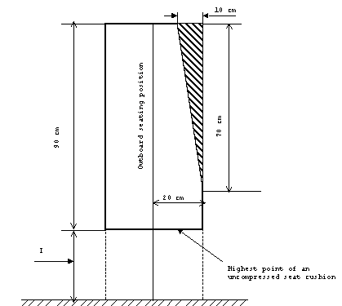
(see paragraph 5.7.8.6.2.2.)

 | I (cm) min.
Class I | 40-50  (for classes I and II min 35 cm at wheel arches and engine compartment)
Class II

Class III

"

___________

