UN/SCETDG/24/INF.46

COMMITTEE OF EXPERTS ON THE TRANSPORT OF
DANGEROUS GOODS AND ON THE GLOBALLY
HARMONIZED SYSTEM OF CLASSIFICATION
AND LABELLING OF CHEMICALS

Sub-Committee of Experts on the
Transport of Dangerous Goods
Twenty-fourth session
Geneva, 3-10 December 2003
Item 4(b) of the provisional agenda

PACKAGINGS

Performance testing (vibration)

Transmitted by the expert from FRANCE

1. In the previous sessions of the sub committee it was decided to work on a vibration test for dangerous goods packagings to be included in the model rules. In spite of this favourable principle decision, no precise testing method has been adopted.

2. On the other hand, no results were presented to evaluate the ability for UN dangerous goods packagings to withstand vibrations. Thus the French Ministry of Transport, asked to the national testing laboratory to conduct a certain number of tests on UN marked packagings. According to two different vibration tests methods.

3. The report presenting the tests results is attached as an annex to this document for information of the sub-committee. This report describes all the details and results of the testing, but some points can be highlighted:

- In spite of the use of water where the packagings were designed to contain higher density liquids, 6 design types on 15 tested showed important deformations after the vibration tests and 5 on 15 had leakages. (all testing methods included);
- The packages containing bigger quantities of dangerous goods showed less resistance to vibrations than the small ones;
- “Random frequency methods” are closer to real life and seem to be more relevant than “fixed frequency methods”.

4. At this stage there are no precise proposals, but considering the results we believe some improvements have to be made to the performance testing of UN dangerous goods packagings. A proposal for including a vibration test in the model rules will be presented at the next session of the sub-committee. According to the test report this test should be based on a random frequency test method.

5. We welcome comments from other experts on the way this work should be done.

6. Finally, if a working group on packagings performance tests is decided by the sub-committee as proposed in document ST/SG/AC.10/C.3/2003/57 we propose that the main item on the mandate and agenda of this working group to be the design of an appropriate vibration test.

TEST REPORT
Requested By: | French Ministry of Equipment, Transport, Lodging, Tourism and Sea
Request Date: | BC03000411 dated 30th April 2003
Purpose: | Vibration Tests  Comparison of 2 test methods and evaluation of the resistance of the authorised packaging for these 2 types of restraints
Reference Documents: | ASTM D 4169 Standard (random vibrations)  ASTM D 999 Standard (fixed low frequency vibrations).
Type of packaging: | Transport packaging for dangerous goods

This document may only be reproduced in its entirety.
It comprises 26 pages.

1. PURPOSE

The purpose of the first part of this study is to compare two main types of vibration tests, that is,

- Fixed low frequency vibration test according to ASTM D 999-01, method A1,
- Random vibration test according to ASTM D4169-01, § 12.4, except that the 180-minute duration has been reduced to 60 minutes,

based on a packaging type certified for transport of dangerous goods.

The purpose of the second part of this study is to evaluate the quality of the certified packages and IBC for the transport of dangerous goods based on these 2 test methods.

2. VIBRATION TEST ACCORDING TO ASTM D999, METHOD A1

Fixed frequencies

This test method has been selected according to the regulations of the United States of America (49 CFR, part 178, paragraph 178.608 for packaging and 178.819 for IBC).

The principle is as follows:

Three packages, filled and closed, are placed on the vibrating table and then wedged horizontally with the standardised slack and left loose vertically.

The vertical displacement amplitude of the table is fixed and is 25.4 mm (1 inch) from peak to peak. The packaging application is a simple sinusoidal curve, the frequency of which is determined as follows.

The displacement frequency of the table is progressively increased until the package becomes detached, such that it is possible to slide a 1.6 mm thick and 50 mm wide steel wedge under it. The wedge should slide at least 100 mm under the package. This detaching frequency for each package is maintained for one hour.

This frequency ranges between 2 and 5 Hz. Over 4.42 Hz, with an amplitude of 25.4 mm peak to peak, the maximum acceleration of the table is higher than that of the gravity.

The acceptance criteria are:

- No leak in the package,
- No rupture of the package,
- No deterioration leading to reduction in safety of transport or resistance of the package.

No temperature conditioning was carried out before or during the test. The test temperature ranges between 15 and 25°C.

3. VIBRATION TEST ACCORDING TO ASTM D4169-01, para 12.4
Random frequencies

The random vibration test principle is as follows.

Principle: Three packages, filled and closed as if they were to be transported are placed on the vibrating table. The packages are wedged horizontally and left loose vertically.

The constraint applied on the packages results in movements of the test mechanism plateau. These movements are dependant on accelerations (Power Spectral Density). The control signal is the superposition of different frequency signals defined by the test template as specified by the standard. The angular points of the template are given in the table below. These templates correspond to the spectrum in the signal frequency.

The restraint is therefore a superposition of sinusoidal curves, the frequencies of which, for road transport, range between 1 and 200 Hz.

The specified efficient values are by definition the average values, but the instantaneous temporal acceleration values show peak values which are up to three times higher than the efficient value. For example, for level I truck, the efficient value 0.731 g leads to peak values of 2.2 g, which appear randomly. This factor of 3, called the peak factor, is recommended by ASTM D 4728-01 (para 3.2.11) reference standard of ASTM D 4169-01.

Two restraint levels have been selected for this test, that is, the restraint simulating the road transport assurance levels I and II.

Level I is the strictest level and the probability of its appearance during transport is low, whereas level II is an intermediate level and corresponds to a greater probability of its appearance.

Power spectral density (g²/Hz) – Road
Frequency (Hz) | Assurance level I | Assurance level II
1 | 0.000 1 | 0. 000 05
4 | 0.02 | 0.01
16 | 0.02 | 0.01
40 | 0.002 | 0.001
80 | 0.002 | 0.001
200 | 0.000 02 | 0.000 01
Efficient acceleration | 0.73 | 0.52

The 180-minute test duration stated in the standard has been reduced to 60 minutes to enable comparison with the fixed frequency method given in the previous paragraph.

The selected acceptance criteria are similar to those in the fixed frequency method:

- No leak in the package,
- No rupture of the package,
- No deterioration leading to reduction in safety of transport or resistance of the packing.

No temperature conditioning was carried out before or during the test. The test temperature ranges between 15 and 25°C.

A test on a single sample, using the same method but with a level II aircraft type application was also conducted. The power spectral density is as follows:

Power spectral density (g²/Hz) - Air
Frequency (Hz) | Assurance level II
2 | 0.000 2
12 | 0.01
100 | 0.01
300 | 0.000 01
Efficient acceleration | 1.05

The duration has been maintained at 3 hours.

4. COMPARISON OF THE TWO METHODS

The main differences between these 2 methods are as follows:

- Frequency

Given that during actual transport, the loads and the vehicles are subject to multiple vibration frequencies having different origins (road condition, shock absorbers, vibration of the vehicle chassis) and that a package reacts differently to these restraints, it is obvious that a test at a fixed frequency, whatever the frequency, is less representative of the actual situation than a random vibration test.

In the random frequency tests, the test that most closely resembles the actual transport responses is the test according to ASTM D 4169, since the frequencies and their levels were chosen so as to reproduce the actually encountered frequencies.

The fixed frequency test may, as the case may be, be very strict or less strict. Its degree of strictness depends on the package. Indeed, each package has its own resonance frequency. If it is under 5 Hz, which corresponds to the range of applications possible under fixed frequency, the package subject to tests will be 100% on this frequency, the test will therefore be very strict. If the package resonance frequency is over 5 Hz, the fixed frequency test becomes much less strict since the package is not tested on this frequency which represents its weak point.

This problem does not exist with random frequency tests since the frequency range is much higher, the weak point of the package (resonance frequency) shall necessarily be applied, but this frequency will never comprise 100 % of the applied frequencies.

- Conducting the test:

For fixed frequency, the sliding of the wedge under the sample sometimes tends to destabilise the package while it is in the detachment stage.

Whereas, for random frequency tests, there is no intervention while the test is being conducted. No external element disturbs the test.

5. tESTS

5.1 Comparative test for the 2 methods

The purpose of this preliminary phase is to define the severity level (or assurance level) of random vibrations, which will be retained for the second part of the study.

5.1.1 Tests

The type of packaging used for these tests is a 220 litre metal drum with a cover having 2 stoppers (2" and 3/4") certified for transport of dangerous liquid goods in 1A1/ Y 1.8 / 270.

These packages were filled to 98% of their actual capacity with water and subjected to each type of restraints. A new package was used for each test.

The summarised results of these tests are as follows:

 | Sample | Fixed low frequency | Random frequencies Truck level I | Random frequencies Truck level I | Random frequencies Air* level I
Leak (time) | 1  2  3 | No  No  No | Yes (32 mn)  Yes (46 mn)  Yes (48 mn) | Yes (57 mn)  No  No | No  -  -
Permanent deformation | 1  2  3 | Yes  Yes  Yes | Yes  Yes  Yes | Yes  Yes  Yes | Yes  -  -

* : 3 hours of test for air transport

Detailed results are indicated in appendix 2.

5.1.2 Test Remarks

In case of fixed low frequency test according to ASTM D999, the drums show permanent base deformation. For a sample, high deformation leads to drum instability and stopping of the test. This failure shall endanger safety during transport. However, no leakages occurred.

In case of level I - truck random vibration test, no sample could endure the test duration without leaking. All of them had permanent base deformations.

In case of level II - truck random vibration test, the observations are the same as in level I – truck, while the lifespan of the drum was higher.

The Level II – air random vibration test was less penalizing than the road transport.

However, it is necessary to note that the packages were not tested with a liquid having the same density as that approved but with water and were not filled with an aggressive product. These 2 parameters may also have a substantial influence on the test results.

5.1.3 Conclusion

Concerning the application level during the random vibration test, the level I – road proved to be very severe for the packing. However, it must be noted that the probability of occurrence of this application level is very low compared to level II, but not zero.

Consequently the level II – truck, less severe, has been considered as the relevant level for conducting the testing. For this test, the standard 180-minute duration was reduced to 1 hour, and in spite of this reduction, one out of three packing showed a leak, and all showed permanent deformations at the base.

Concerning the random vibration test simulating air transport, this was not retained since the test results were less significant concerning the road transport simulation tests.

Given these results, the test programme retained for the second part of the study is:

- Fixed frequency vibration test with detachment
- Random vibration tests, assurance level II
- Testing time 1 hour in both cases
- Packing contents: water for packing certified for liquids and sand for packing certified or solids.

5.2 Test on UN certified packing

5.2.1 Tests

The UN certified packing were purchased randomly. These packing were subject to fixed vibration test as per ASTM D999 and random vibration test as per ASTM D4169, level II truck, which corresponds to the intermediate application level.

The certified packing for liquid was 98% filled with water whereas the certified packing for solids was filled with sand up to its gross maximum limit.

The summarised results are as follows.

plastic Jerry cans and drums
Capacity in litres | LNE  Ref | approval | Sample | Fixed frequency | Level II random frequency - Truck
20 | 502 | Y 1.9 / 150 | 1.2 and 3 | Nothing to report
20 | 510 | Y 1 / 200 | 1.2 and 3 | Nothing to report
30 | 503 | Y 1.2 / 150 | 1.2 and 3 | Nothing to report
60 | 507 | X 1.9 / 250 | 1.2 and 3 | Nothing to report
220 | 504 | Y 1.9 / 250 | 1.2 and 3 | Nothing to report

Metallic Jerry cans
Capacity in litres | LNE  Ref | approval | Sample | Fixed frequency |  | Level II random frequency - Truck
 |  |  |  | Leak | Deformation | Leak | Deformation
20 | 515 | Y 1.2 / 100 | 1.2 and 3 | Nothing to report

Metallic Drums
Capacity in litres | LNE  Ref | approval | Sample | Fixed frequency |  | Level II random frequency - Truck
 |  |  |  | Leak | Deformation | Leak | Deformation
30 | 513 | X 1.2 / 300 | 1. 2 and 3 | Nothing to report
60 | 505 | X 1.2 / 250 | 1  2  3 | No  No  No | No  No  Yes | No  No  No | No  No  Yes
60 | 512 | Y 1.2 / 100 | 1  2  3 | No  No  No | No  No  No | Yes (20 mn)  Yes (20 mn)  Yes (25 mn) | Yes  Yes  Yes
220 | 500 | Y 1.8 / 270 | 1  2  3 | No  No  No | Yes  Yes  Yes | No  No  Yes (57 mn) | Yes  Yes  Yes
220 | 508 | Y 1.6 / 200 | 1  2  3 | No  No  No | No  No  No | Yes (14 mn)  Yes (18 mn)  No | Yes  Yes  Yes
220 | 514 | X 1.2 / 250 | 1.2 and 3 | Nothing to report

IBC composite 31HA1
Capacity in litres | LNE  Ref | approval | Sample | Fixed frequency |  | Level II random frequency - Truck
 |  |  |  | recepta - cle Leak | Deforma-tion | receptacle Leak | Deforma-tion
1000 | 509 | Y 1.6 / 110 | 1  2  3 | Yes (3 mn)  Yes (3 mn)  Yes (5 mn) | Yes  Yes  Yes | No  No  No | Yes  Yes  Yes
1000 | 511 | Y / 100 | 1  2  3 | Yes (6 mn)  Yes (8 mn)  Yes (3 mn) | Yes  Yes  Yes | Yes (29 mn)  Yes (35 mn)  No | Yes  Yes  Yes

Cardboard drums
Capacity in litres | LNE  Ref | approval | Sample |  | Fixed frequency |  |  | Level II random frequency - Truck
 |  |  |  |  | Leak | Deformation |  | Leak | Deformation
220 | (501) | Y 207 |  | 1  2  3 | No  No  No | Yes (mild)  Yes (mild)  Yes (mild) | No  No  No |  | Yes (mild)  Yes (mild)  Yes (mild)

The detailed test results are indicated in appendix 3.

5.2.2 Remarks on tests

Plastic Jerry cans and drums:

No fault showed after 1 hour of test based on both the methods. As for the implementation of tests is concerned, the 220 litre drums with flat bottom show instability. The sliding of wedge increases this phenomenon; it is difficult to conduct the test at the exact frequency leading to proper detachment.

The plastic drums and Jerry cans show good resistance to both the types of tests.

Steel drums and Jerry cans:

The small capacity (30 litres) steel drum and the Jerry can (20 litres) showed good resistance to both tests.

Both 60 litre drum designs gave different results. The first design did not show any leakage in spite of deformation at the base, in fixed frequency and in random frequencies. However, the second design, though it showed good resistance to fixed frequency, all its three samples showed leakages in random frequencies after 20 or 25 minutes.

As regards the fixed frequency tests on the 220 litre steel drums, the results differed depending on the design. The first design deformed significantly at the base up to a point where it became very unstable (1 amongst the 3), whereas the other two samples resisted the test very well.

For random vibration tests, the test results were just the opposite. The drum designs that resisted the fixed frequency tests very well, proved to be less resistant in random frequencies. Actually, 2 samples leaked after 14 and 18 minutes where as only one sample of the other design leaked only after 57 minutes.

The drum design having the best fixed-frequency resistance was that which showed the least resistance during random vibrations.

We can state that on one hand the faults stated for the 220 litre drums are not inherent to this packing capacity since one design underwent all the tests successfully and on the other hand that the fixed frequency test cannot highlight some packing weaknesses.

IBC composites

The 2 IBC designs only resisted the fixed frequency vibration test for a few minutes; the plastic receptacle tore rapidly (no contact between the plastic and the frame at the rupture points). It was found to be especially difficult to close the covers to avoid leakage. During these tests, the IBC are at their resonance frequency, which proves to be very severe since they only resist for some minutes. This test is therefore not adapted to IBC and shows the limitations of the method.

The random frequency test showed poor resistance in both designs with different failure modes:

- One of the designs showed very high permanent deformation and tearing of the metallic armature after one hour of test; for example, on a sample: 6 (3 of each side) vertical posts broken due to fatigue plus 9 (4 & 5) on top and 7 (3 & 4) below whose welding points broke, as well as huge closing problems but no leakage of the skin and no degradation of the associated palette (wood).

- The other design has a metallic armature (better designed) that resists much better (light permanent deformation of the horizontal reinforcing tubes with nothing common with the previous case) but 2 of the 3 sample, show leakages after 28 and 35 minutes of test after the plastic receptacle tore localised at the same spot (on the top, diagonally in the corner. Moreover, the upper supporting rings of the skin with respect to the armature broke down after some minutes of testing and the associated palette (metallic) show deformations that hamper and/or complicate the warehousing (in 3 cases out of 3).

Cardboard drums

The cardboard drums, certified for solid materials and filled with sand for the tests, deformed a little in the lower part after the test, but overall, underwent both the tests satisfactorily.

6. CONCLUSION

These tests show that all the certified packing do not satisfy these vibration tests, even in the case of moderate level (level II) random frequencies representative of actual transport.

The random frequency test is closer to reality and allows better discrimination, it seems more relevant to evaluate the ability of packages to withstand vibrations.

The theoretical comparative analysis of the 2 methods is paragraph 4 is confirmed.

Actually, the fixed frequency test proves to be very severe for packing with resonance frequencies under 5 Hz as for IBC and the sliding of a 1.6 mm thick wedge under the packing during the test tends to destabilise it. This, in some cases, could prejudice the external packing.

However, the advantage is that this test is easier to conduct, since the testing requirements are less expensive.

For random frequency tests, the constraints are very close to that can be encountered in real life, and it is thus more representative. Moreover, the packing is tested within a frequency range adapted to the transport method (1 to 200 Hz for road), all the packing resonance frequencies included in the range are therefore called on. The packing having higher resonance frequencies do not therefore get any special treatment in this test. This was confirmed by the tests on the 60 to 200 litres metallic drums, which, generally speaking, behaved better during fixed frequency than in random frequencies.

Nethertheless, during random vibrations, the plateau movement is reached at during acceleration and therefore this leads to severity tests that can be perfectly reproduced for any sample; whereas for fixed low frequency tests of sample detachment and at a specified displacement amplitude, the plateau acceleration is proportional to the square of the frequency (of detachment) that varies from one sample to the other.

Lastly, the random test has the advantage of being modulated. This modulation may allow compensation for that fact that the packing is tested with water and meant to transport material having much higher density. We may, for example, imagine a level II application for weaker densities closer to water and level I for higher densities when the test is conducted with water. This modulation may also be applied based on the packing group. These modulations cannot be conducted with fixed frequency test.

The vibration tests allow improving the safety level of the packing and mainly the IBC composites that have proved to be the most fragile.

It appears to be judicious to adopt the random frequency test method to qualify the packing for the following reasons:

- very representative of the actual transport conditions,
- it does not punish the packing having resonance frequency under 5 Hz
- it allows testing a design over the entire frequency range, subjecting it to the resonance frequencies, that is, its weak points, but not just them
- no intervention during the test on the packing behaviour (passing of the wedge)
- it will allow increasing the safety level for some packing types that showed actual weaknesses
- the applications may be modulated based on the product density and the packing group.

As for the acceptance criteria, it is clear that the absence of leak criteria should be retained, and if level II is retained, it would be equally necessary to limit the acceptable deformation given the reasonable level of these applications.

Trappes, 20th November 2003

Head of Department for Transport Packing and Collection |  | Manager for Dangerous Products Packing Activity
Bernard Picque |  | Alain GERARD
APPENDIX 1

Level II random vibration tests - Truck
Power spectral density
Measured value

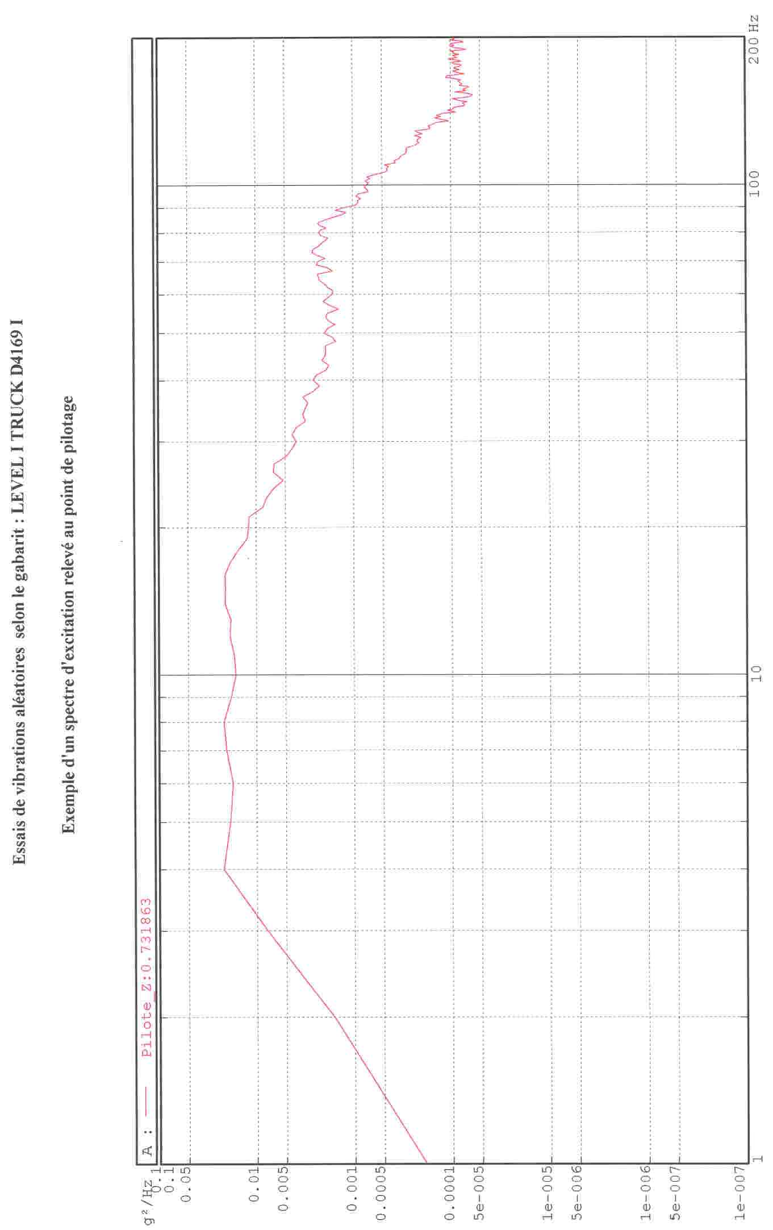

APPENDIX 2

Comparison of 2 methods

Packaging

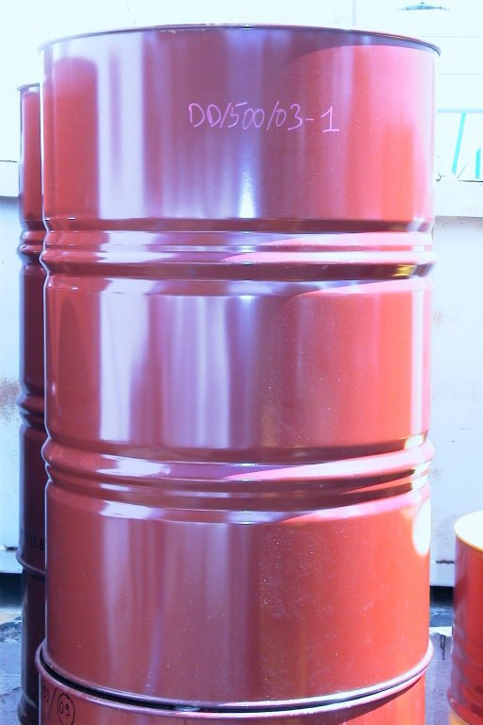

Package base before test

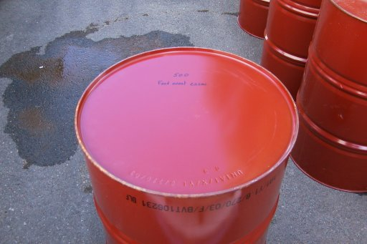

APPENDIX 2

Comparison of 2 methods

Fixed frequency vibrations

Base of the package deformed after test – No leakage

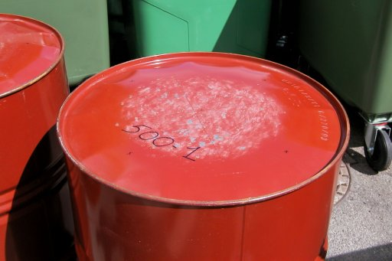 | 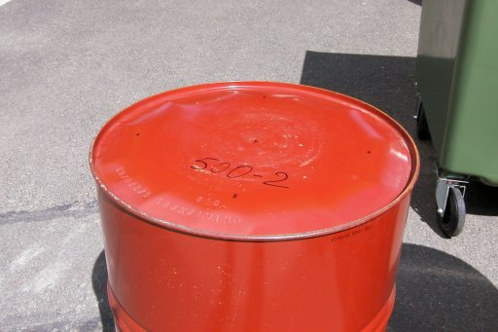 | 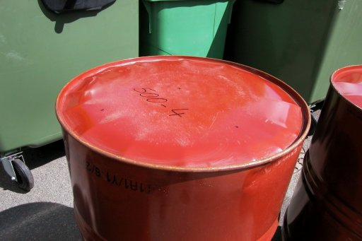

The base of drum No. 3 was highly deformed – The drum became very unstable

APPENDIX 2

Comparative of 2 methods

Random frequency vibrations

Level I - Truck

Package base deformed and leakage in every case

1st sample: leakage after 32 minutes
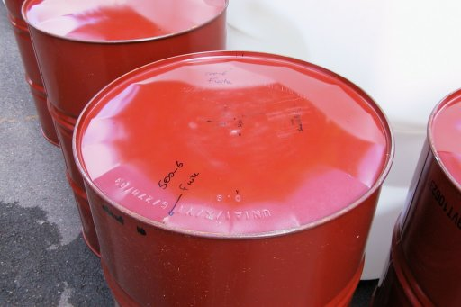 | 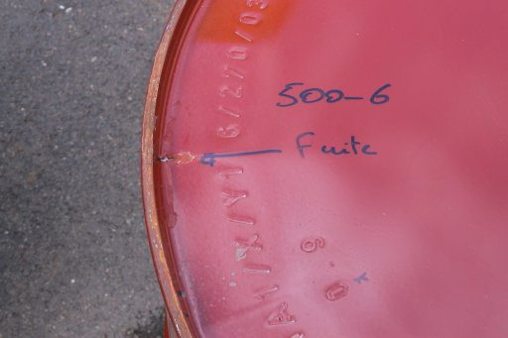

2nd sample: leakage after 46 minutes
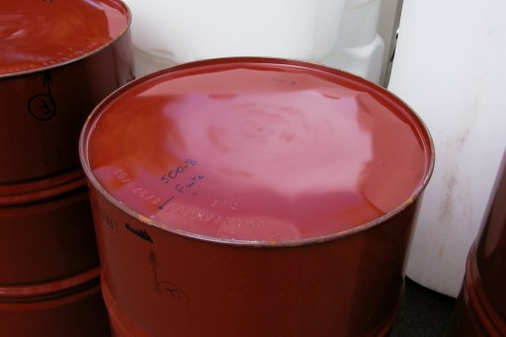 | 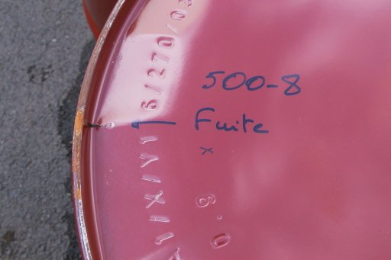

3rd sample: leakage after 48 minutes
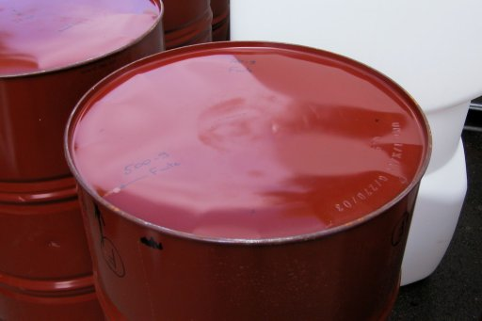 | 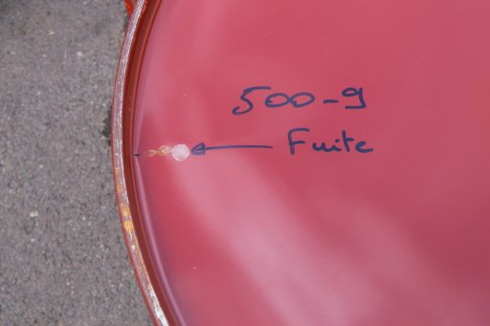

APPENDIX 2

Comparative of 2 methods

Random frequency vibrations

Level II - Truck

Package base after testing: permanent deformation

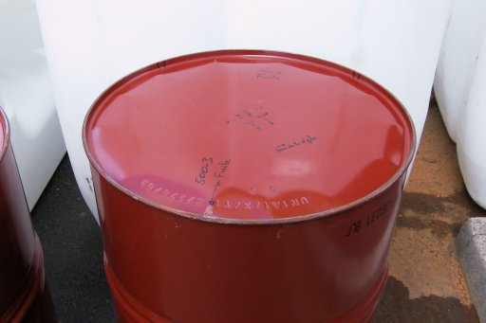 | 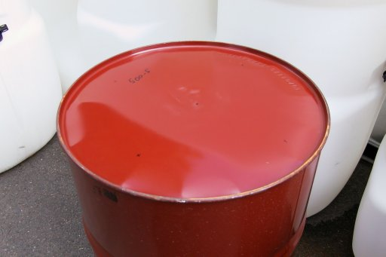 | 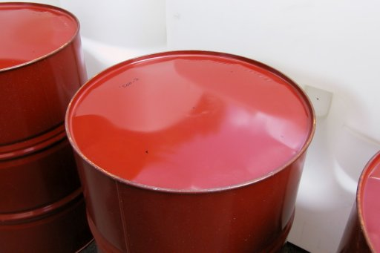

Leakage at base level in 1 package after 57 minutes of testing

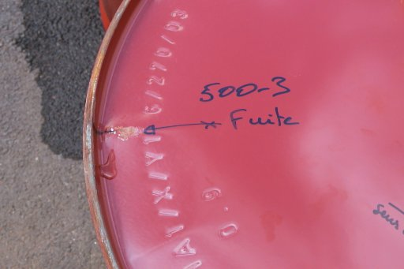

APPENDIX 3

Testing on UN authorised packaging

Plastic drums and jerricans
Model | Reference LNE | Approval | Fixed frequency | Random frequencies  level II - Truck
20 litres  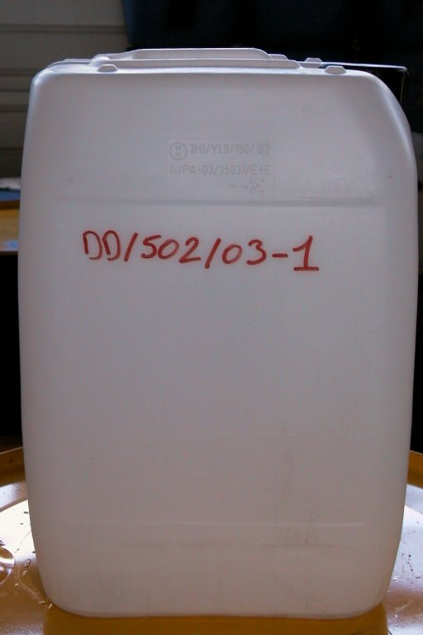 | 502 | Y 1.9 / 150 | Nothing to report | Nothing to report
20 litres  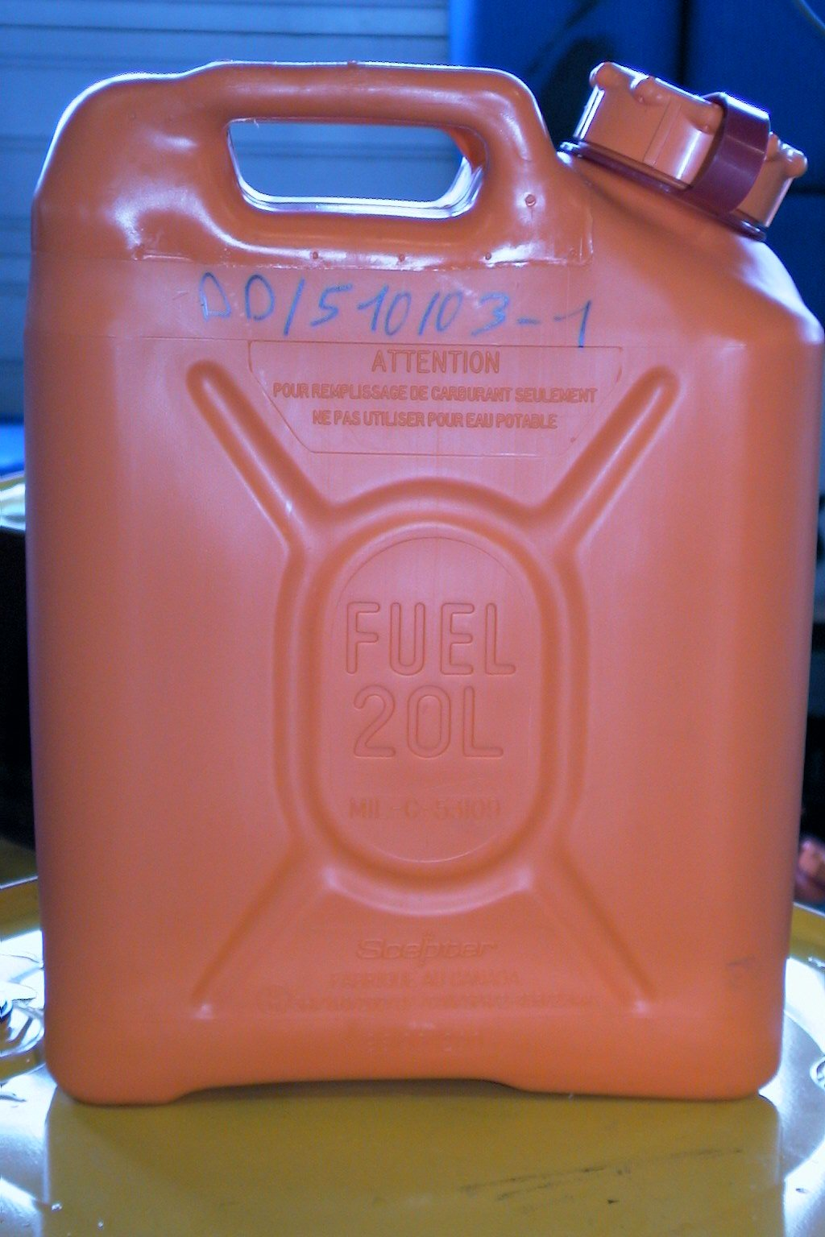 | 510 | Y 1 / 200 | Nothing to report | Nothing to report
30 litres 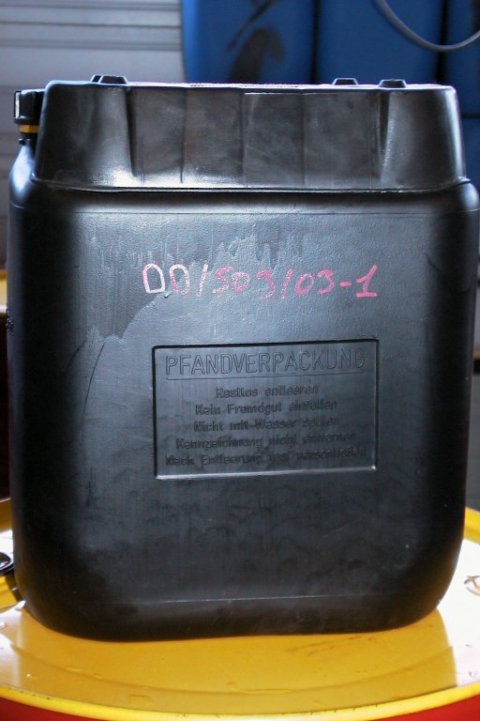 | 503 | Y 1.2 / 150 | Nothing to report | Nothing to report
60 litres 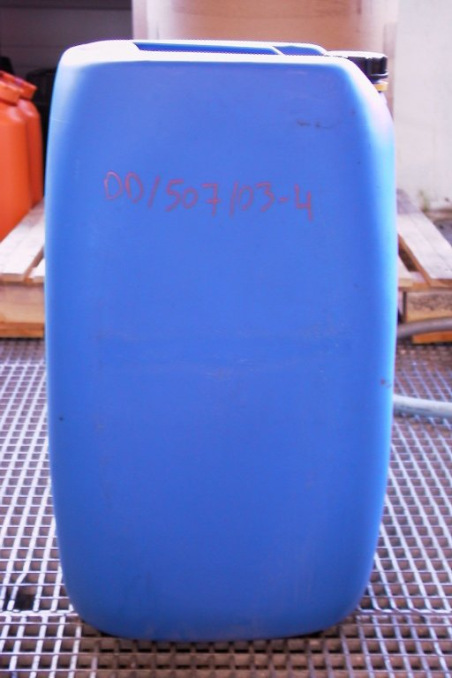 | 507 | X 1.9 / 250 | Nothing to report | Nothing to report
APPENDIX 3

Testing on UN authorised packaging

Plastic drums and jerricans
Model | Reference LNE | Approval | Fixed frequency | Random frequencies  level II - Truck
220 litres  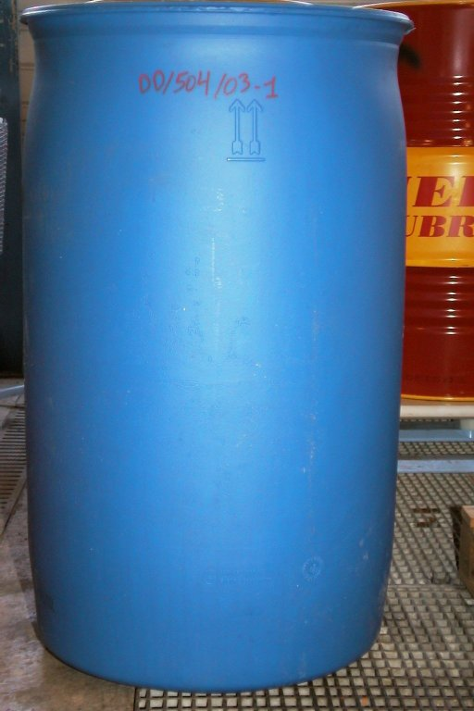 | 504 | Y 1.9 / 250 | Duration of testing: 1 hour  The base edges were detached while the centre remained in contact with the table. The increase of the frequency lead to a very high instability. The passage of the lining destabilises the packaging.  Nothing to report on the packaging resistance | Nothing to report
220 litres  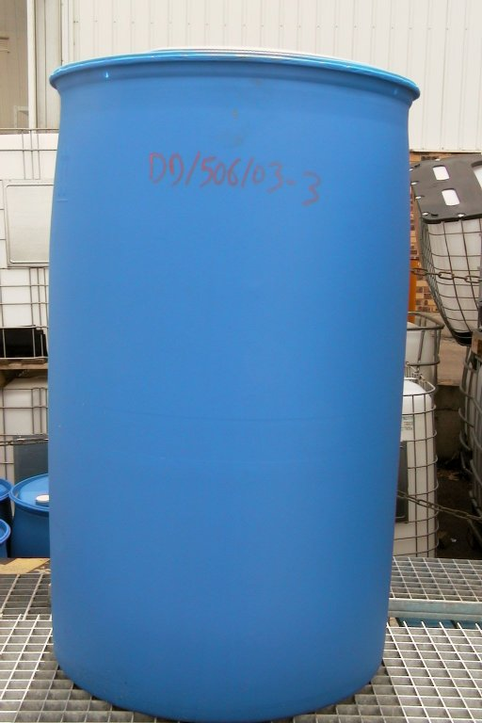 | 506 | Y 1.9 / 200 |  | Nothing to report

APPENDIX 3

Testing on UN authorised packaging

Metallic drums and jerricans
Model | Reference LNE | Approval | Fixed frequency | Random frequencies  level II - Truck
20 litres  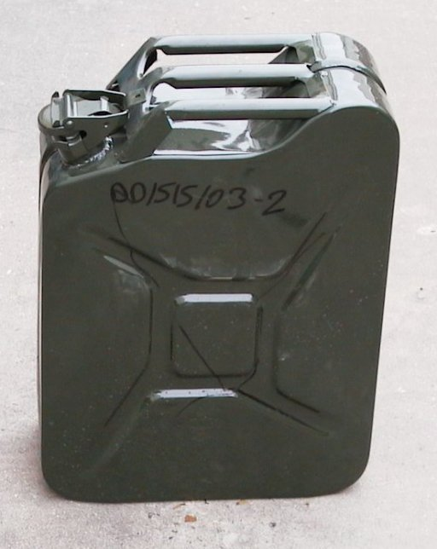 | 515 | Y 1.2 / 100 | Nothing to report | Nothing to report
30 litres  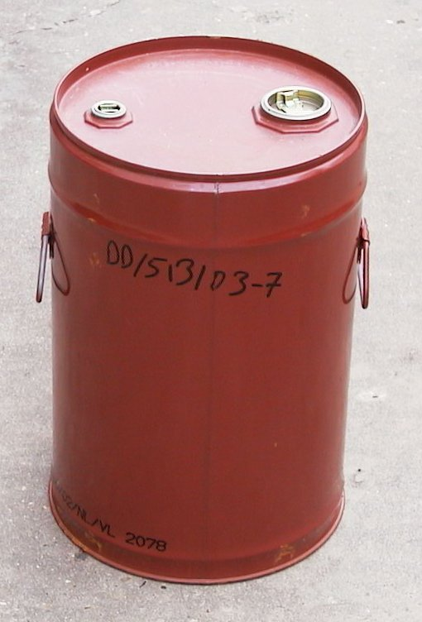 | 513 | X 1.2 / 100 | Nothing to report | Nothing to report
60 litres  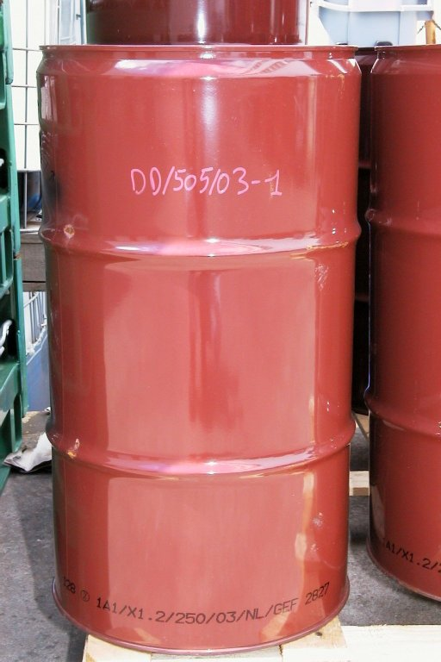 | 505 | X 1.2 / 250 | Nothing to report on 2 samples  Permanent deformation of the third sample base  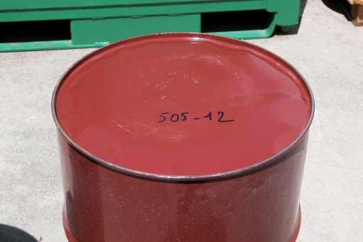 | Nothing to report on 2 samples  Permanent deformation of the third sample base  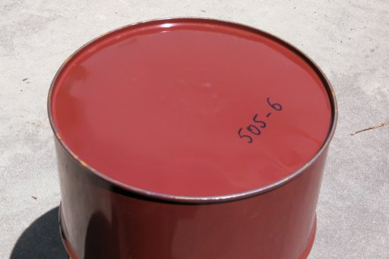

APPENDIX 3

Testing on UN authorised packaging

Metallic drums and jerricans
Model | Reference LNE | Approval | Fixed frequency | Random frequencies  level II - Truck
60 litres  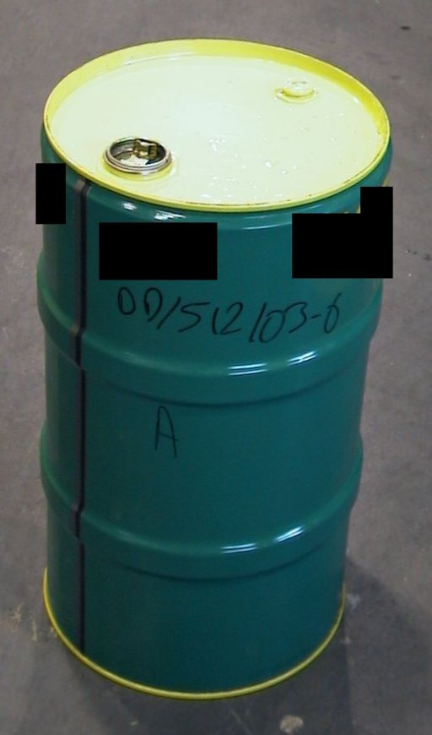 | 512 | Y 1.2 / 100 | Nothing to report | Leakage at the base level for the 3 samples
220 litres | 500 | Y 1.8 / 270 | No leakage  Permanent deformation at the base level.  A test has been stopped after 14 minutes, the drum was very unstable | Leakage after 57 minutes of a sample at the base level.  All showed permanent deformations at the base level

APPENDIX 3

Testing on UN authorised packaging

Metallic drums and jerricans
Model | Reference LNE | Approval | Fixed frequency | Random frequencies  level II – Truck
220 litres  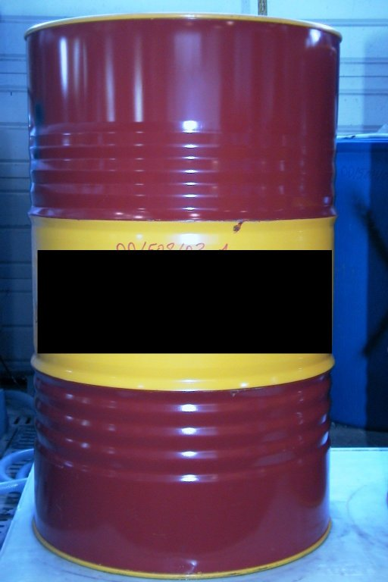 | 508 | Y 1.6 / 200 | Nothing to report | Leakage after 14 and 18 minutes of 2 samples at the base level.  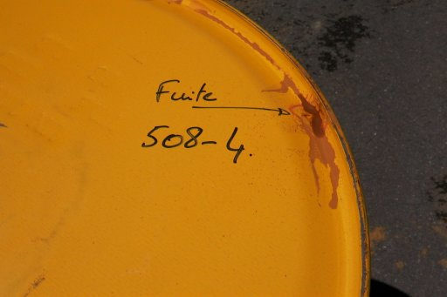  Sample No.3: no leakage after 1 hour but permanent deformation of the base.
220 litres  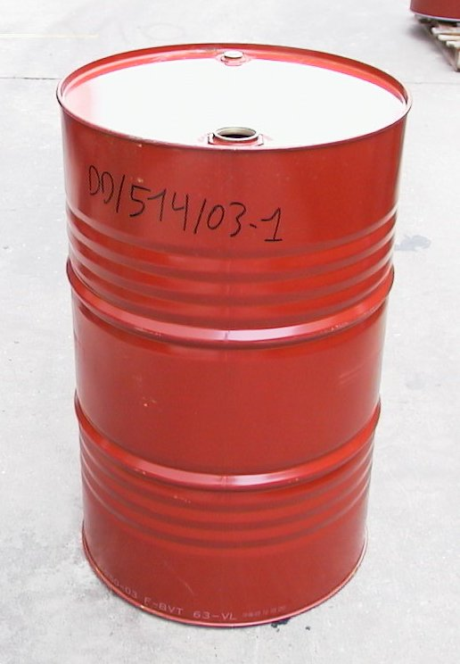 | 514 | X 1.2 / 250 | Nothing to report | Nothing to report

APPENDIX 3

Testing on UN authorised packaging

IBC composite 31HA1
Model | Reference LNE | Approval | Fixed frequency | Random frequencies  level II - Truck
1000 litres  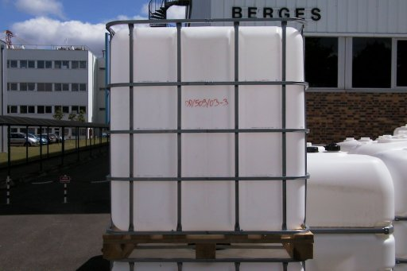 | 509 | Y 1.6 / 110 | Testing: 3 to 5 minutes  Significant leakage on a sample at the closure  Leakage over several cm at the upper part of the plastic inner receptacle.  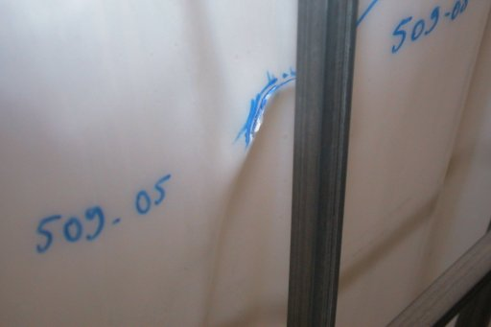  Permanent deformation of the metallic trellis and rupture of the welds  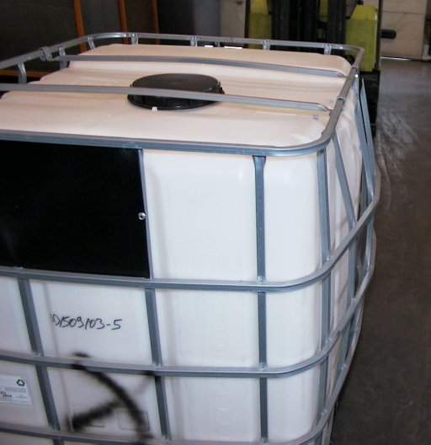  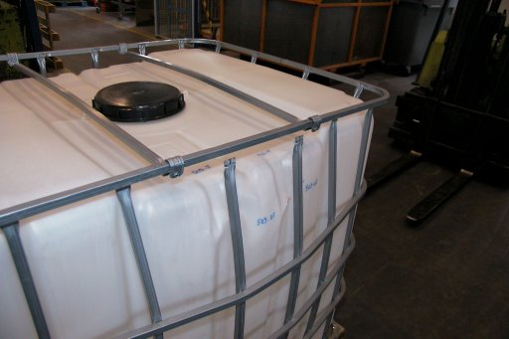 | Testing: 1 hour  in spite of a leakage within less than 10 minutes at the closure (clamping with a tool or by hand)  No leakage of the plastic inner receptacle  Broken vertical posts and welds due to fatigue.  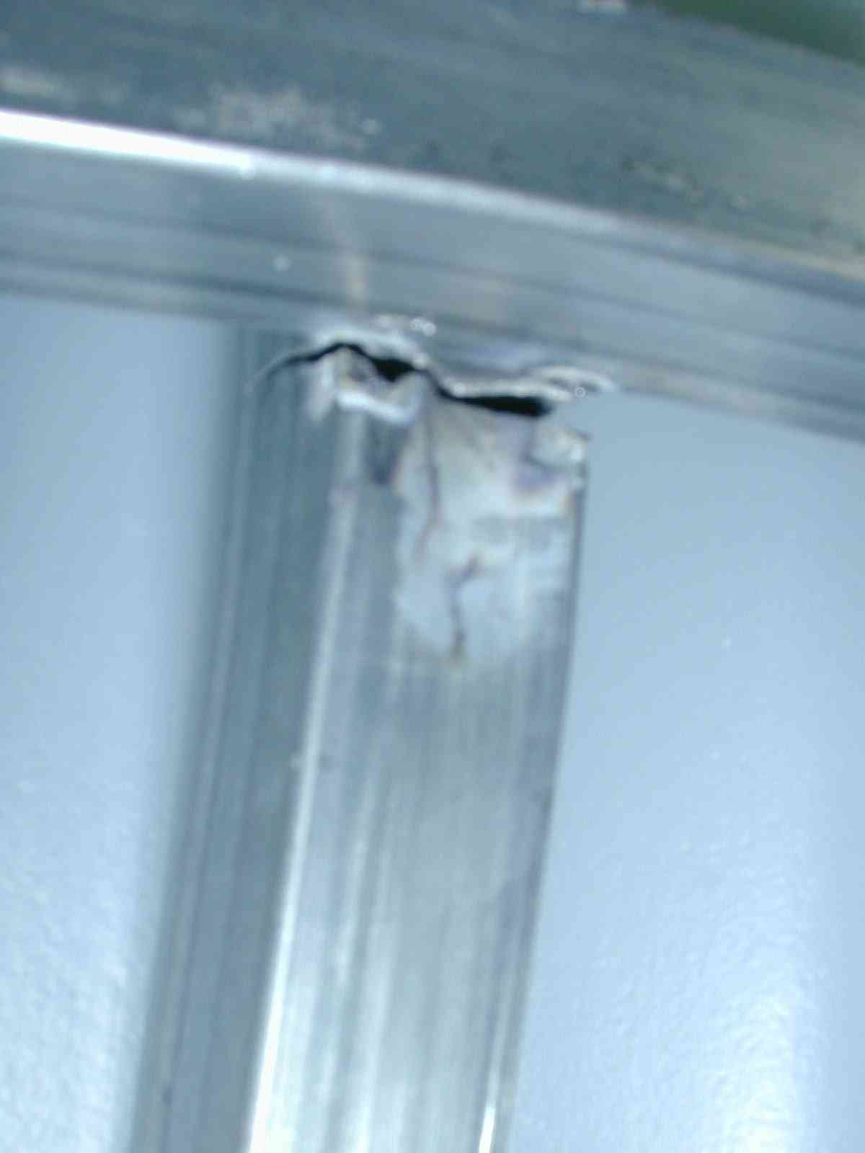  Very significant permanent deformation  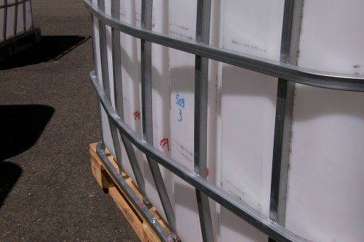

APPENDIX 3

Testing on UN authorised packaging

IBC composite 31HA1
Model | Reference LNE | Approval | Fixed frequency | Random frequencies  level II - Truck
1000 litres  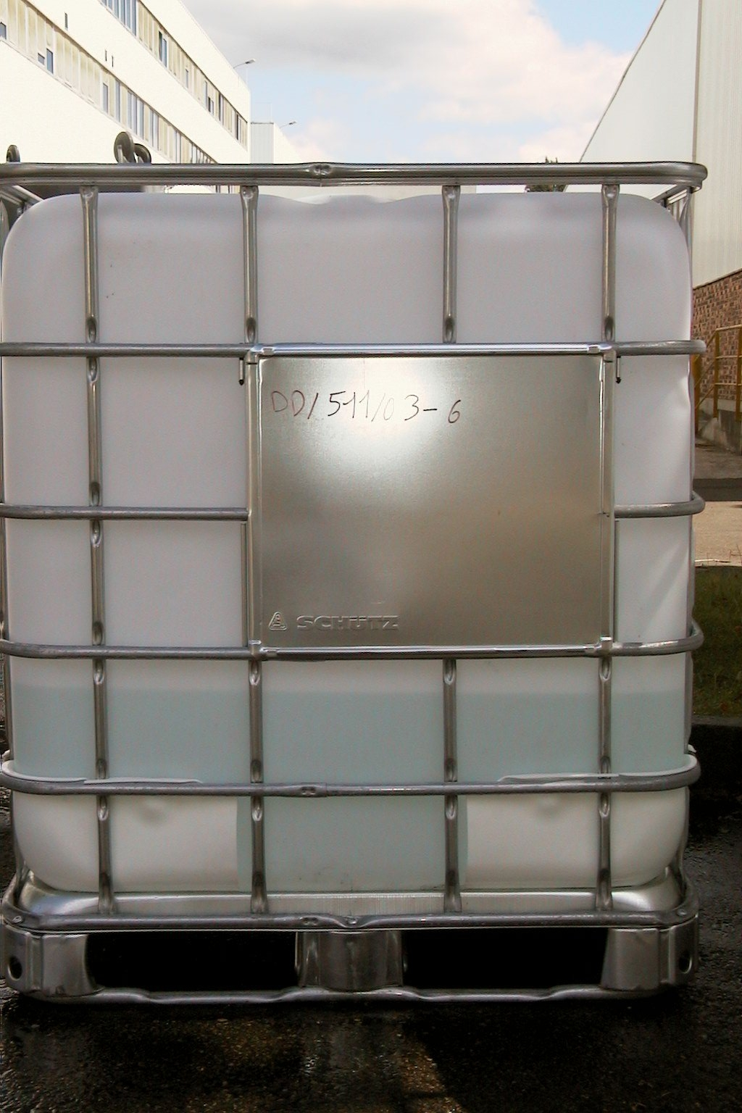 | 511 | Y / 100 | Testing: 3 to 8 minutes  Leakage over several cm at the upper part of the plastic inner receptacle    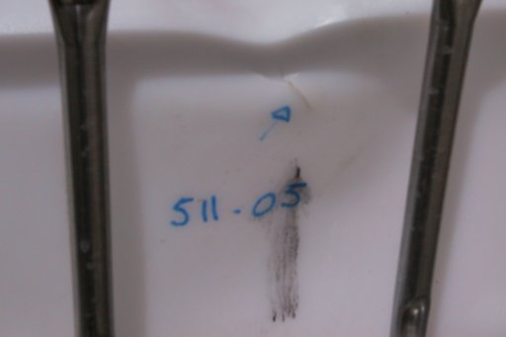  Permanent deformation of the metallic trellis.  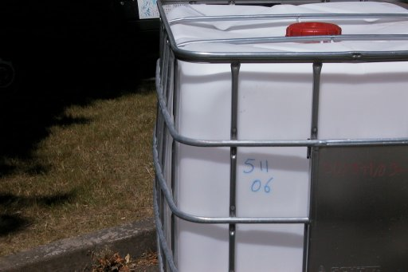 | Testing: 1 hour  in spite of a small leakage within less than 10 minutes on one sample at the closure.  Leakage of the plastic inner receptacle after 27 minutes for one sample, 35 minutes for an other. No leakage for the 3rd  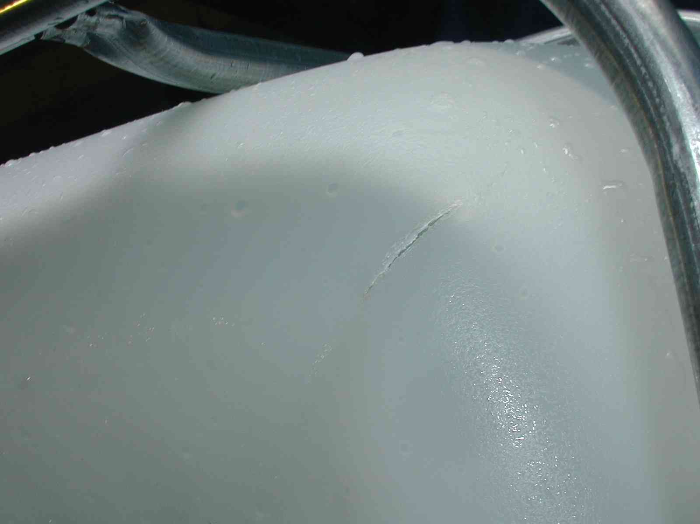  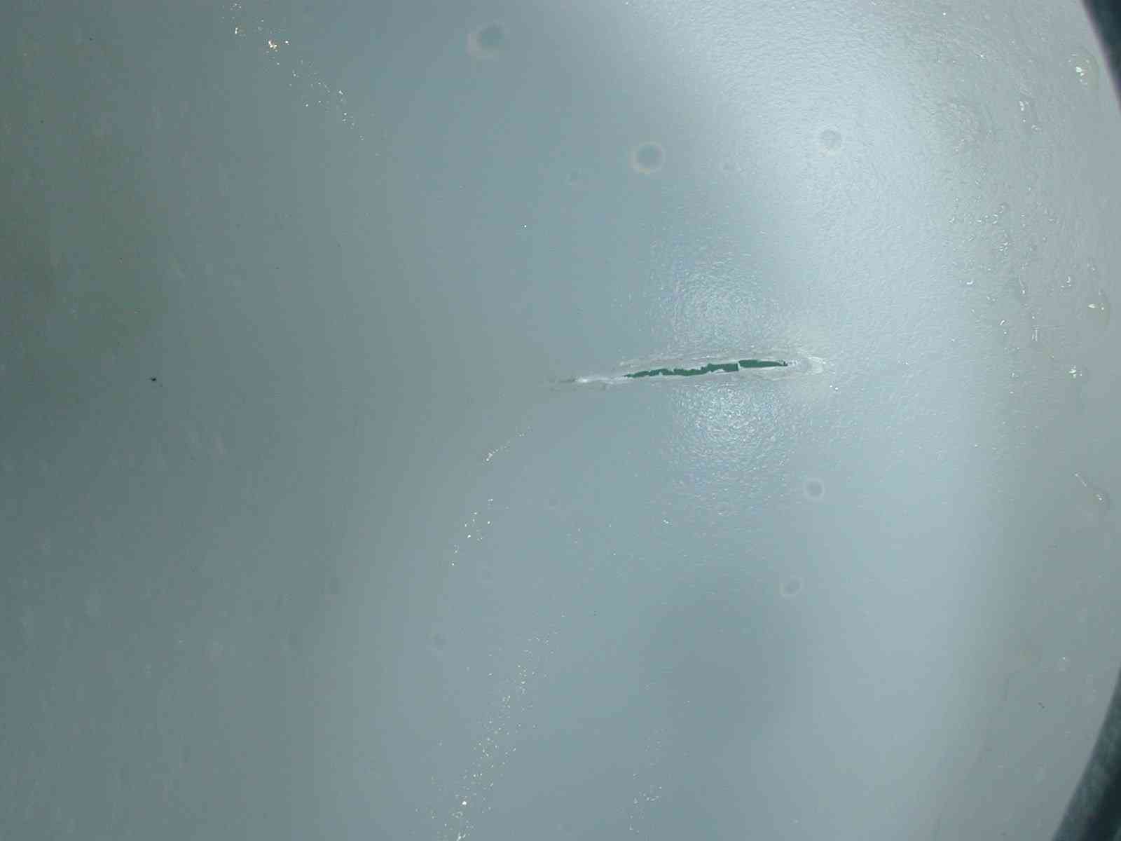  Minor permanent deformation of the metallic trellis  Significant deformation of the top of the metallic pallet on one sample. Cannot be reused on the pallet truck  Loss of clamping bolt at the pallet level
APPENDIX 3

Testing on UN authorised packaging

Cardboard drums
Model | Reference LNE | Approval | Fixed frequency | Random frequencies  level II - Truck
220 litres  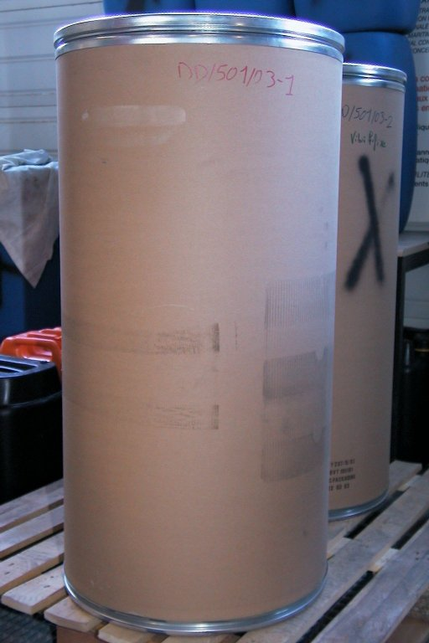 | 501 | Y 207 | Slight permanent deformation of the base ring  No leakage | Slight permanent deformation of the base ring  No leakage

This function, although it is called "power…" is not its unit of measurement. This term is used because very frequently the square of a fluctuating quantity enters into the power expression (Joule effect, …). It would be preferable to speak of "Acceleration spectral density" or even "acceleration density".
Preliminary test results included in this report
Preliminary test results included in this report

