
Informal document N° 14
(31st GRSP, 13-17 May 2002
agenda item 1.8)

ECE REGULATION 95 – LATERAL IMPACT
Proposal TRANS/WP29/GRSP/2002/11

OICA COMMENTS

OICA wishes to express some concerns with the proposal , submitted by the Netherlands, to introduce in ECE Regulation 95, the new ES-2 (Eurosid-2) side impact dummy.

As noted in the attached report, some concerns clearly remain on the technical performance of ES-2, resulting in serious doubts in the appropriateness, at this stage, of ES-2.

Furthermore, OICA recalls the ongoing activities, in the ISO framework, on the development of WorldSID; this new dummy which is expected to be finally released in 2004, clearly has global harmonization prospects and should therefore be considered carefully for introduction in the side impact rulemaking.

In conclusion, OICA considers that introduction of ES-2 in ECE Regulation 95 would at this stage be premature and counter-productive.


PSA Peugeot Citroën/RENAULT
132, rue des Suisses - 92000 NANTERRE

Xavier TROSSEILLE
01 LBL - 64284 (CTR RDS 0 20)
Ph : 01 47 77 35 16
Fax : 01 47 77 36 36

March, 26th 2002

SUBJECT : Concerns Regarding the Thoracic Response of the ES-2 Side Impact Dummy

SUMMARY

The EEVC WG12 report entitled «Development and Evaluation of the ES-2 Dummy», outlines the evaluation of the ES-2 dummy carried out in Europe in order to assess the suitability of the dummy for use in regulatory side impact test procedures.
The following report identifies some key points that have not been addressed in the EEVC report. The key points are the following:

- Variation of performance criteria between ES1 and ES2: the EEVC report explains that ES2 has lower criteria than ES1 in biofidelity tests. In fact, this depends on the test conditions, and too much data is missing from the test results to make a complete analysis possible.
- Directional sensitivity: surprisingly, higher rib deflections are observed at rearward angle impacts. Some hypotheses are given to explain this phenomenon. Unfortunately, no data exists on the production ES1, so it is not possible to compare the responses.
- Inter-rib homogeneity: the evolution of responses between ES1 and ES2 are not continuous. This aspect is not addressed and would have a greater influence on maximum deflection and V*C values for individual ribs than on the average values for the three ribs highlighted in the WG12 report.
- Thorax damping characteristics and stiffness: friction is eliminated in ES2 and compensated by increasing the tuning spring stiffness. This leads to a stiffer thorax with less overall damping. This way of decreasing friction in rib modules doesn’t seem appropriate and should be investigated more in depth.
- Interaction between body segments: apart from the thorax, other changes were performed on ES2, in particular to the pelvis segment. Their effects on thorax loading need to be investigated and biomechanical reasons have to be given before applying them in the regulation.
Concerns Regarding the Thoracic Response of the ES-2 Side Impact Dummy

The EEVC WG12 report entitled «Development and Evaluation of the ES-2 Dummy», outlines the evaluation of the ES-2 dummy carried out in Europe in order to assess the suitability of the dummy for use in regulatory side impact test procedures. Testing of the ES-2 in Europe was carried out jointly by EEVC and ACEA member organisations. This European evaluation consisted of biofidelity tests, certification tests and full-scale tests. According to the report, the responses of the ES-2 dummy are very close to those of the Eurosid-1, the objective of the ES-2 project being to develop a dummy which has the same responses as Eurosid-1 whilst overcoming certain shortcomings of the former dummy. The report argues that, based on the results of the evaluation testing, the ES-2 is suitable as a replacement for the Eurosid-1.

Although it is true to say that ES-2 responses do fall close to those of Eurosid-1 in the biofidelity testing, ACEA has pointed out that differences had been observed between the measurements obtained from the two dummies in full-scale tests. The major concern regarding these differences is that dramatic increases in thoracic deflection and V*C values are observed in some cases when testing with ES-2. The report states that, since the responses of the two dummies in biofidelity tests are similar, the effects on the thorax measurements result only from the modification of the back plate, the lack of flat-topping and an acceptable difference in the damping characteristics of the ribs. Although an explanation of the difference in damping characteristics has been included in the report, it is clear from the wording that this is a hypothesis only, which has yet to be confirmed by concrete data. Testing performed to date on the ES-1 and ES-2 does not allow the above conclusions to be confirmed.

It is stated in Annexe F of the above document that, for the full-scale testing, "Overall, normalised rib deflections have gone up by 17% (on average over three ribs) and normalised V*C by 25%". These figures represent the average (for all tests) of the average values of the three ribs. Giving an average of an average in this way masks the fact that, in some tests, the differences in V*C values are vastly superior. For example, taking the highest of the V*C values from the three ribs in the R95 and EuroNCAP tests, the value increases in every test by at least 50%. The report quite rightly points out that in the majority of cases the regulatory limit is not reached and it must be said that where the increases are highest the actual values tend to be very low. However, for a minority of cars tested, the significant increase in V*C does take the value close to the regulatory limit (e.g. a 59% V*C increase from 0.61 with E-1 to 0.97 with ES-2). There is no evidence that the increased values are purely a result of the differences noted above, the explanations presented are suppositions that are not confirmed by data. Before a new dummy is recommended for use in the European regulatory test procedure it would seem appropriate to investigate more fully the observed differences.

The following items have to be addressed:

Variation of performance criteria between ES1 and ES2
Authors of the report explain that ES2 has lower criteria than ES1 in biofidelity tests.
However, pendulum tests show an increase of criteria between ES1 and ES2: between 0 and 7% for deflection and up to 22% for VC (Figure 1), especially for the upper rib.

Figure 1: Variation of Deflection and VC for pendulum tests

In Heidelberg sled tests, results are different, but only 7,6 m/s tests are fully exploitable, since maximum deflection for the upper rib is always reached at 10.3 m/s (the author considers that «the [upper rib] peak deflection values are therefore not reliable […]. This may also affect the V*C values for the upper rib at the higher speed tests and the V*C values and curves should be treated with caution»). While the maximum deflection of each rib has to be considered, it is the maximum of the three rib deflections which is of importance. Unfortunately, this maximum is generally not available in the tests. Tests at lower velocity (for instance 8,9 m/s as defined by ISO) should be performed as well as new 7,6m/s tests with ES-1 (in order to explain the high spread between the two existing tests of the report, which cannot allows to conclude on ES1 to ES2 criteria evolution).

Directional sensitivity
The evaluation programme also included directional sensitivity pendulum testing which is particularly pertinent given that in full-scale testing the loads to which the dummy is subjected often include off-axis components. A common example of this is loading from the B-pillar which may be oriented rearward of the dummy’s y-axis.

The EEVC pendulum tests are based on those by Friedel et al. which showed that the Eurosid prototype (Eurosid0) was insensitive to impact angle. The authors of the ES-2 tests note that the ES-2 results are not directly comparable with those of the Eurosid prototype, as there are differences between this dummy and the Eurosid-1. In fact, one difference between the two dummies is that the rib displacement is measured directly on the piston of the Eurosid prototype and between the piston and the damper on the Eurosid-1.

The study shows that when impacted at angles of +10° and +20° (forward of y-axis) the measured deflection is lower than at 0° (purely lateral). This is not surprising. However, at –10° and –20° the measured deflection is higher than at 0°! (Figure 2). The authors make the following comments:

«… the rearward oblique tests resulted in greater peak rib deflections than the pure lateral tests. It is hypothesised that this may be due to the rib rotating about the damper location point. When striking laterally with the centre line of the impactor aligned with the centre line of the piston, the face of the impactor drives through the damper mounting point as well as the piston mounting point. When loading at an angle on the rearward corner of the rib, the impact is almost a point load and acts at some distance from the damper. The piston is much less stiff than the damper and whilst the piston must move linearly, the rib between the piston and damper is flexible and can bend about the damper mounting point (which has a spring mounted over a cone and therefore provides little resistance to this rotation). Alternatively, the flexion of the rib may be said to off-load the damper.»

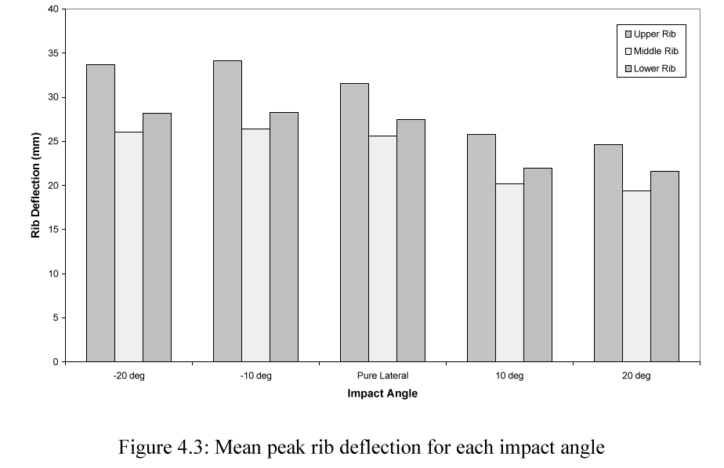
Figure 2: Mean peak rib deflection for each impact angle (from TRL ES-2 Prototype Evaluation)

The authors go on to add that the effect would be less apparent in Eurosid-1 than in ES-2 since the displacement transducer of the latter is mounted rearward of the piston. If this is true, the difference could be an increase in deflection for the ES-2 of 10%. The problem is that no data exist on ES-1 at –10° and –20°.

It seems likely that the change in position of the rib displacement point of measurement can have an effect on the measured values of the displacement when oblique loading components are present on the dummy. This may affect the results of regulatory and EuroNCAP full-scale testing.

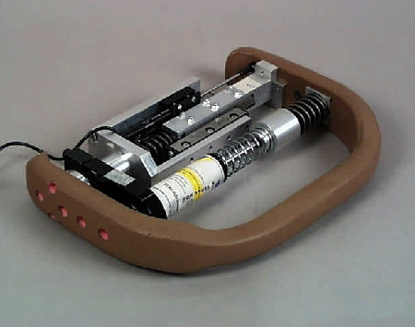
Displacement transducer
Figure 3: ES-2 rib module

Inter-rib homogeneity
One aspect of the thorax response not taken into account by the report is the lack of inter-rib homogeneity in the responses despite the three ribs being identical. This can be seen in the biofidelity testing by looking at the actual deflections and V*C values for individual ribs and in each test (additional data not shown in the report has been made available by TNO). For example, in the sled tests (all configurations) it can be seen, in some cases, that whilst the average deflection and V*C of the lower two ribs decrease with ES-2, the values recorded on the uppermost rib increase. Where this is not the case, all three ribs show decreased values but the decrease is less significant on the upper rib. This aspect is not addressed and would have a greater influence on maximum deflection and V*C values for individual ribs than on the average values for the three ribs.
An illustration of this in-homogeneity is given by Figure 2 where the middle rib deflection is always lower than other ribs, while one should expect to have a continuous evolution from lower to upper rib, as with Eurosid0 [Friedel et al].

Thorax damping characteristics and stiffness
ES2 demonstrates less overall damping than ES1, as shown in Figure 4.
Overall damping is constituted by damper and friction or structural damping. Friction is eliminated in ES-2 and compensated by increasing the tunning spring.

Figure 4: Force-deflection curves of Thorax for pendulum tests

The unloading behaviour of ES-2 is, as expected by the rib module design, quite elastic. Indeed, the damper is ineffective in the unloading phase and only friction in ES1 allowed to have a more realistic unloading behaviour. The author explains that «the stiffer tuning spring even resulted in a more biofidelic rebound». We do not agree with this statement: only being in the corridor doesn’t mean to be biofidelic. In fact, the unloading corridor should not be reached thank to a smaller hysteresis, which is not realistic, but by a smaller thorax stiffness which will increase the overall period. ES2 makes the contrary: the stiffness is increased (Figure 5) and hysteresis is decreased, which leads to increase the period of force-time history.

Figure 5: Pendulum time history curves for pendulum tests

The observed frequency (Figure 6) in the Renault Megane full-scale test (as well as other full-scale tests like VW Lupo and Audi) is a consequence of elastic rebound of the thorax, governed by the natural frequency of the rib module (which is higher than 26Hz during unloading phase, seeing that the stiffness of the rib itself was missed in the calculation). The author explains that «the elimination of the friction in the guide system makes the ES-2 thorax more discriminating against different types of loading». That is true, but the question is then to know if the human body is so discriminating.

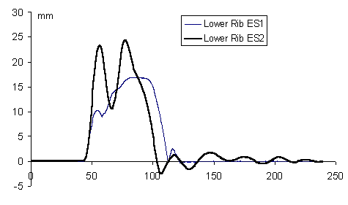
Figure 6: Lower rib deflection time histories (Renault Mégane full-scale tests)

This way of decreasing friction in rib modules doesn’t seem appropriate and should be investigated more in depth.

Interactions between body segments
The thorax loading doesn’t only depend on thorax behaviour, but also on the relative behaviour of other body segments: a decrease of pelvis or abdomen loading results in a greater rib loading.
Figure 7 illustrates the evolution of pelvis loading between ES1 and ES2 where a delay in pelvis loading (max delayed about 5ms) can be observed on rigid wall. (a time-shift appears at 7,6m/s, which would have to be explained, but anyway, pelvis stiffness is lower for ES-2).

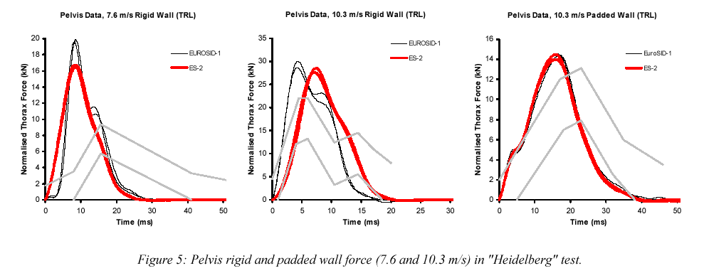
Figure 7: Pelvis wall force in Heidelberg tests (from Annex B of EEVC report on Development and Evaluation of the ES-2 Dummy)

The effect of pelvis behaviour changing on thorax loading has to be investigated and biomechanical reasons have to be given before changing this point in regulation.
An additional concern on the pelvis is the difference between ES1 and ES2 for pelvis sensitivity to angle (Figure 8). The cumulative effect at 20° is 30%. As above, investigations and explanations have to be given.

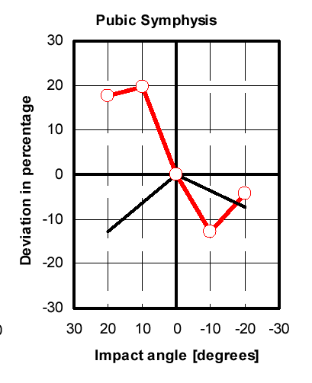
Figure 8: Pubic Symphisis sensitivity to angle (from Annex D of EEVC report on Development and Evaluation of the ES-2 Dummy)

CONCLUSION
The objective of this analysis is to raise some questions in order to have explanations on some key points that are likely to affect the ability of this new dummy to improve real safety. If the changing of the back plate doesn’t permit question, other changes are not so obvious.

Friedel, B. et al ., The European side-impact dummy ‘EuroSID’: proceedings of the seminar held in Brussels, 11th December 1986, Office for Official publication of the European Communities, Luxembourg, 1997

