ECONOMIC COMMISSION FOR EUROPE INF.6

INLAND TRANSPORT COMMITTEE

Working Party on the Transport
of Dangerous Goods
(Seventy-third session,
Geneva, 4-8 November 2002)

Report of the Informal Working Group on the transport of
small amounts of dangerous goods

Transmitted by CEFIC

At the seventy-second session of WP.15 in May 2002, CEFIC and AISE proposed document TRANS/WP.15/2002/7. The Working Party admitted that the present provisions of ADR were not wholly adapted to the logistical practices of retailing, particularly in the context of the supply of craftsmen, shops, farmers or retailers.

The Working Party also noted that while problems arose for the most part in the context of domestic traffic, industry preferred a global, international, harmonized solution in the context of ADR to the various derogations negotiated nationally on a case-by-case basis.

After exchanging views on the subject, the Working Party accepted an offer by CEFIC to organise an informal working group to draw up proposals for settling these problems.

This working group met in Brussels on 26 and 27 September 2002 under the chairmanship of S Benassai (Italy). Representatives of Germany, Belgium, Portugal, UK, the European Commission, CEFIC, CEPE, AISE, ECPA and EIGA participated.

Two issues were defined:
- the transport of small amounts of dangerous goods by persons such as farmers, painters, etc for professional use
- the transport of small amounts of dangerous goods from local distribution depots to retailers or users, or from retailers to end users (“round-robin tour”)

Issue 1 “Transport for professional use”

In view of the fact:
- that subsection 1.1.3.1 (a) exempts from ADR provisions the carriage of dangerous goods by private individuals for personal or domestic use and
- that subsection 1.1.3.1 (c) exempts from ADR provisions the carriage of a limited amount of dangerous goods by enterprises if this carriage is ancillary to their main activity and does not constitute supply, internal nor external distribution
it was felt that professional users such as farmers, painters or welders, who transport a limited amount of materials, needed for the execution of their profession (e.g. pesticides or fertilisers by the farmer, paints by the painter) or for establishing a limited stock at their premises, should also benefit from an exemption under certain conditions.
This situation is illustrated in figure 1.

The following proposal for amending 1.1.3.1 (c) was agreed upon (except by Germany)

1.1.3.1 Exemptions related to the nature of the transport operation

The provisions laid down in ADR do not apply to:
…

(c) the carriage, [ancillary to their main activity,] undertaken by enterprises, which are the end users of the goods concerned [, such as deliveries to or returns from building or civil engineering sites, or in relation to surveying, repairs and maintenance]. Quantities shall not exceed 450 litres per packaging nor the maximum quantities specified in 1.1.3.6. Measures shall be taken to prevent any leakage of contents in normal conditions of carriage. These exemptions do not apply to Class 7.
Carriage undertaken by such enterprises for their supply or external or internal distribution does not fall within the scope of this exemption.

- The same limiting quantities have been maintained i.e. 450 litres per packaging as well as the maximum quantities specified in 1.1.3.6.
- The definition of Enterprise in 1.2.1 (“any natural or legal person, any association or group of persons …”) clearly includes professional users such as painters, farmers, etc
- The introduction of the requirement “which are the end users of the goods concerned” guarantees that this clause cannot be used for exempting further distribution for third parties. As a consequence:
- The last sentence “Carriage undertaken … this exemption” is proposed to be deleted.
- The deletion of the sentence “ancillary to their main activity” is put up for consideration by WP.15
- The wording “returns from” is an amendment which was provisionally adopted by the Joint Meeting of September 2002.
- The relevance of maintaining the examples “such as deliveries to or returns from building or civil engineering sites, or in relation to surveying, repairs and maintenance” in the text, was questioned and is put up for consideration by WP.15

Germany, which did not support the proposal to amend 1.1.3.1 (c), stated that private and professional transport has to be judged differently (as like in other legal areas) and that exempted transport shall strictly be limited to the working site needs of professionals.

The WG draws the attention of WP.15 that this amendment may have to be considered also by the RID experts and may therefore have to be brought to the Joint Meeting.

Issue 2 “Transport from depots to retailers”

This issue relates to the transport of small quantities of dangerous goods in the last stages of the distribution chain where small shops or retailers are supplied with a number of inner packagings taken from combination packagings. These small shops cannot always take in full combination packagings (e.g. products of different colours or perfumes) and therefore inner packagings are taken from combined packagings and are distributed to different shops during a so-called “round-robin tour”. Re-packing the different items is nearly impossible from a practical point of view and would only help to increase the amount of packaging waste.
Figures 2 and 3 illustrate the situation.

Although there was not enough time to draft a proposal, there was general agreement that the following elements should be included in a new section 3.4.x
- The goods involved should be limited to goods of transport categories 2, 3 and 4 and should exclude goods of classes 1, 6.2 and 7.
- The maximum contents of inner packagings, taken out of combination packagings, should be in accordance with the values in column (4) of the Table in 3.4.6.
- Only inner packagings that could be used as part of combination packagings according to chapter 3.4, would be considered as acceptable for such a carriage
- The maximum load per transport unit should be x kg/l or, in case of different goods, a total quantity of x kg/l, weighted according to 1.1.3.6.4. A value of x=50 was suggested by industry but this was not further discussed nor agreed upon.
- All goods should be loaded at 1single point and the carriage should be limited to the transport from local distribution depots to retailers or end users, or from retailers to end users.
- Some form of document should be available with the driver listing the dangerous goods on board.
- Regarding the need for marking, there was no agreement but several opinions were expressed: a representative pointed out the need for some kind of marking (e.g. LQ marking), another representative mentioned that the user label may be sufficient, several representatives indicated that the amount of dangerous goods involved would be very low anyhow and would present a negligible risk.

The representative of Germany questioned the need for any additional provisions as subsection 1.1.3.6 and chapter 3.4 already offer less restrictive provisions to deal with industry needs. Referring to the French study on Limited Quantities, presented at the last Joint Meeting, he also doubts if any further simplification can be justified on the basis of safety. Indeed he claims that the study points out that small amounts in particular might cause higher risks. He reserved therefore the right for further consultation.

Figure 1

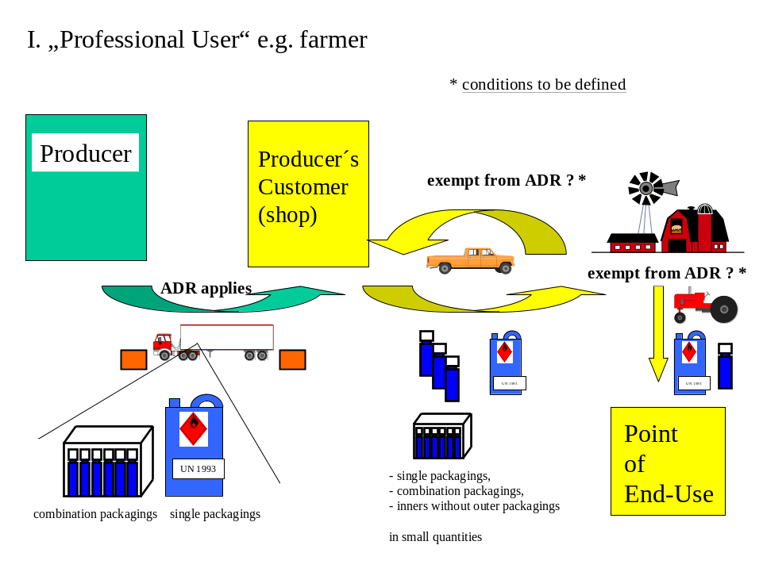

Figure 2

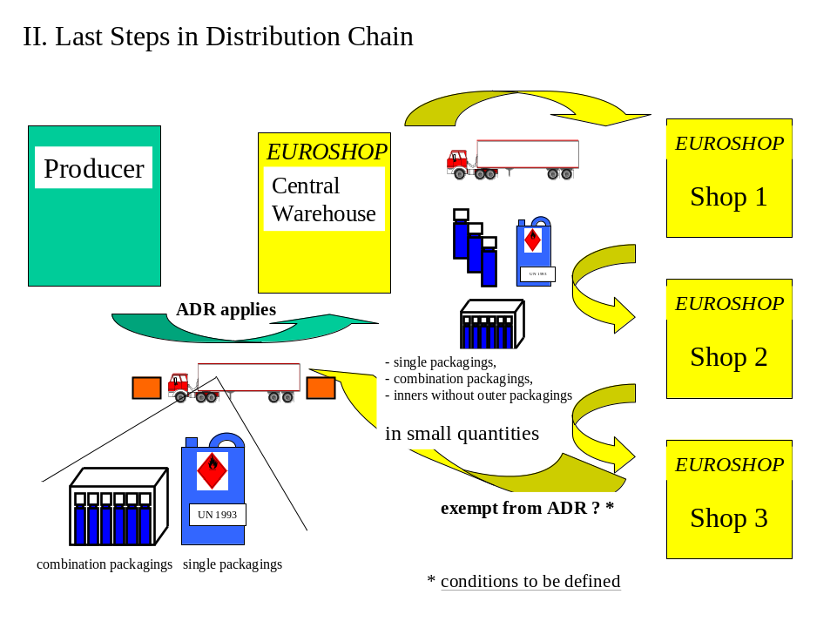

Figure 3



