UNITED  NATIONS |  | E
 | Economic and Social  Council | Distr.  GENERAL  ECE/TRANS/WP.29/GRE/2008/57  17 July 2008  Original: ENGLISH  ENGLISH AND FRENCH ONLY
ECONOMIC COMMISSION FOR EUROPE
INLAND TRANSPORT COMMITTEE
World Forum for Harmonization of Vehicle Regulations

Working Party on Lighting and Light-Signalling

Sixtieth session
Geneva, 1 - 3 October 2008
Item 4(d) of the provisional agenda

REGULATION No. 48
(Installation of lighting and light-signalling devices)

Interpretation of paragraph 5.7. of the Regulation
(Possibility of reciprocally incorporated lamps with stop lamps)

Proposal for Supplement 3 to the 04 series of amendments to Regulation No. 48

Submitted by the expert from Germany ∗/

The text reproduced below was prepared by the expert from Germany in order to clarify the provisions relating to the arrangement of stop and direction indicator lamps. This proposal complements the amendment proposed by the expert from Japan (Informal document GRE-59-09), adopted by the Working Party on Lighting and Light-Signalling (GRE) during the fifty-ninth session, as reproduced in Annex I to the report (ECE/TRANS/WP.29/GRE/59, para. 13). The modifications to the current text of the Regulation, including the draft Supplement 2 to the 04 series of amendments, are marked in bold or strikethrough characters.
A. PROPOSAL

Paragraphs 2.7.3. to 2.7.6., amend to read:

"2.7.3. "Independent lamps" means devices having separate apparent surfaces in the direction of the reference axis, 2/ separate light sources and separate lamp bodies;

2.7.4. "Grouped lamps" means devices having separate apparent surfaces in the direction of the reference axis 2/ and separate light sources, but a common lamp body;

2.7.5. "Combined lamps" means devices having separate apparent surfaces in the direction of the reference axis, 2/ but a common light source and a common lamp body;

2.7.6. "Reciprocally incorporated lamps" means devices having separate light sources or a single light source operating under different conditions (for example, optical, mechanical, electrical differences), totally or partially common apparent surfaces in the direction of the reference axis 2/ and a common lamp body;"

Footnote 2, amend to read:

2/ In the case of lighting devices for the rear registration plate and the direction-indicators of ( categories 5 and 6 ), replace by the "light-emitting surface" in the absence of an illuminating surface shall be used.

Paragraph 2.8., amend to read:

2.8. "Light emitting surface" of a "lighting device", "light-signalling device" or a retro-reflector means the surface as declared in the request for approval by the manufacturer of the device on the drawing, see Annex 3;

This shall be declared according to one of the following conditions:

a) in the case where the outer lens is textured, the declared light emitting surface shall be all or part of the exterior surface of the outer lens

b) in the case where the outer lens is non-textured the outer lens may be disregarded and the light emitting surface shall be as declared on the drawing, see Annex 3.

Paragraphs 5.7.1.2. to 5.7.2.1., amend to read:

"5.7.1.2. Stop lamps and direction indicator lamps are not permitted to be reciprocally incorporated.

5.7.1.3. Where stop lamps and direction indicator lamps are grouped, the following conditions shall be met:

5.7.1.3.1. any horizontal or vertical straight line passing through the projections of the apparent surfaces of these functions on a plane perpendicular to the reference axis, shall not intersect more than two borderlines separating adjacent areas of different colour;

5.7.1.3.2. their apparent surfaces in the direction of the reference axis, based upon the areas bounded by the outline of their light emitting surfaces, are continuous and do not overlap.

5.7.2. Where the apparent surface of a single lamp is composed of two or more distinct parts, it shall satisfy the following requirements:

5.7.2.1. Either the total area of the projection of the distinct parts on a plane tangent to the exterior surface of the transparent material outer lens and perpendicular to the reference axis shall occupy not less than 60 per cent of the smallest quadrilateral circumscribing the said projection, or the distance between two adjacent/tangential distinct parts shall not exceed 15 mm when measured perpendicularly to the reference axis."

B. JUSTIFICATION

During its fifty-ninth session, GRE adopted GRE-59-09 tabled by the expert from Japan relating to the reciprocal incorporation of stop lamps and direction indicators. Having now fully studied the adopted change to paragraph 5.7.1. in conjunction with the definitions of "reciprocally incorporated", "illuminating surface" and "light emitting surface", it has been found that many arrangements of direction indicator and stop-lamps that are proven to be operating satisfactorily in service will be not allowed when the amendment will enter into force.

The amendments in this proposal are intended to clearly indicate the conditions when stop lamps and direction indicator lamps shall, or shall not be, considered to be "reciprocally incorporated" and to clarify the associated definitions.

In developing this proposal, care has been taken to ensure that the essence of the proposal by the expert from Japan is maintained. Additionally, account has been taken of the serious concerns expressed in published reports concerning the problem of overlapping functions and the issue that overlapping illuminating surfaces of functions of similar intensity result in significant delay in perception.

Here below some examples of arrangements are provided to show what shall not, and shall be allowed by the amendments proposed.

a) Examples of arrangements that shall not be allowed

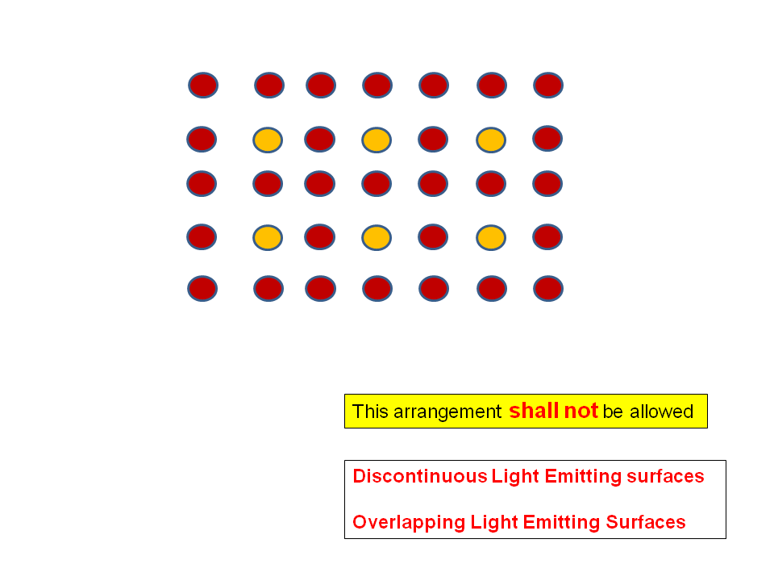

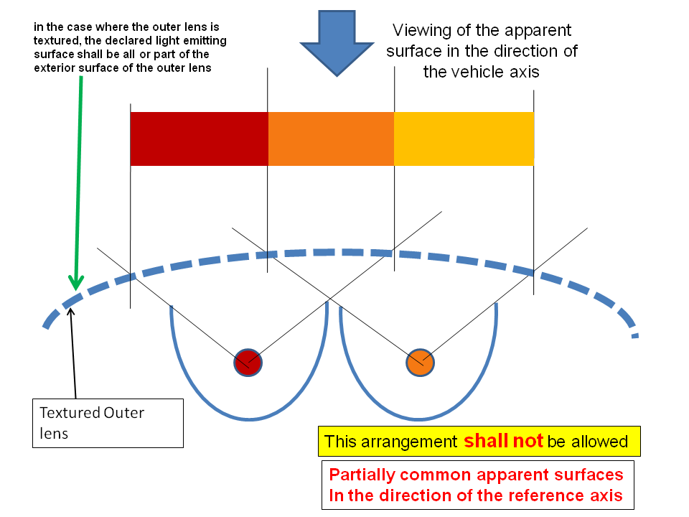
b) Examples of arrangements that shall be allowed
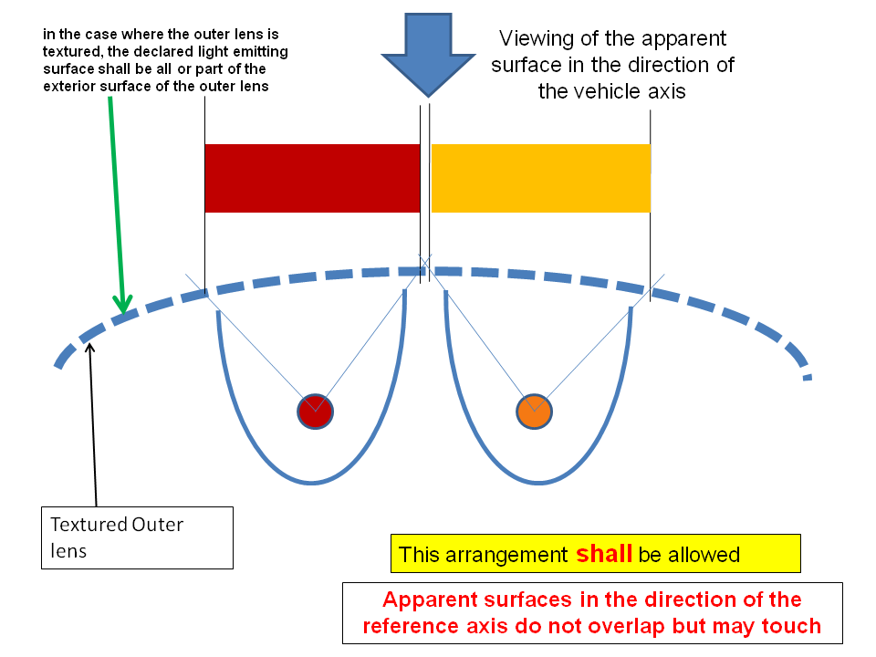

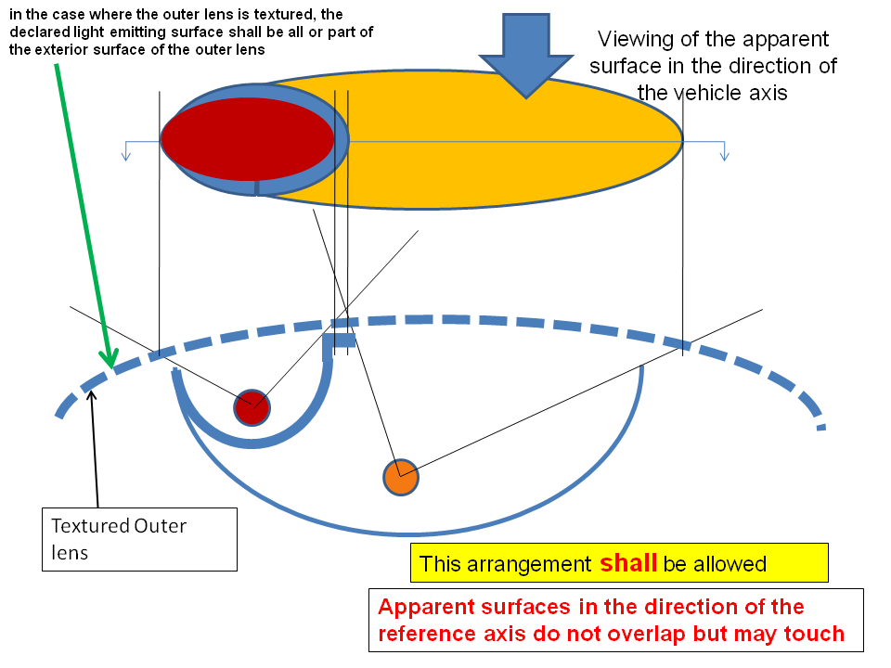
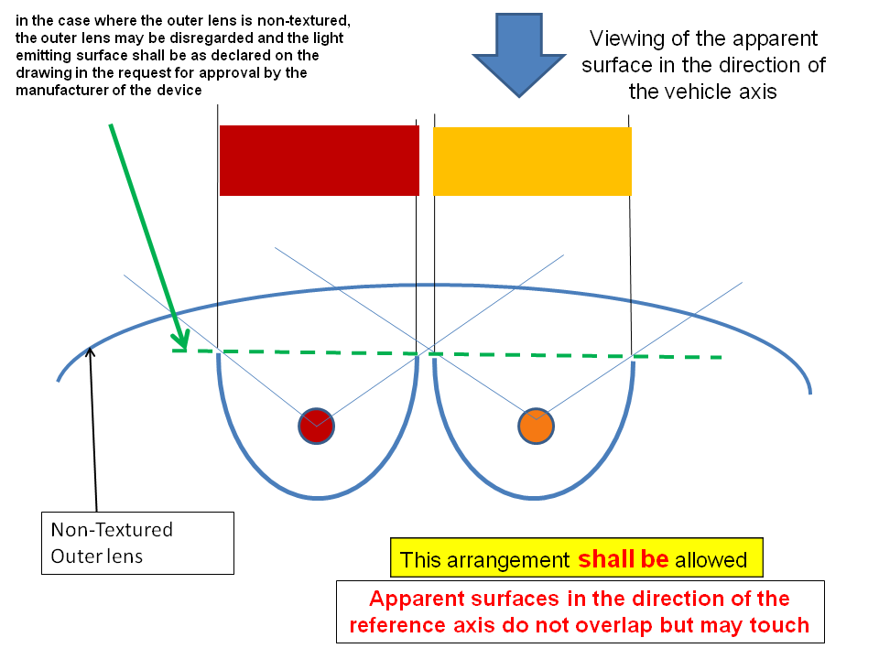

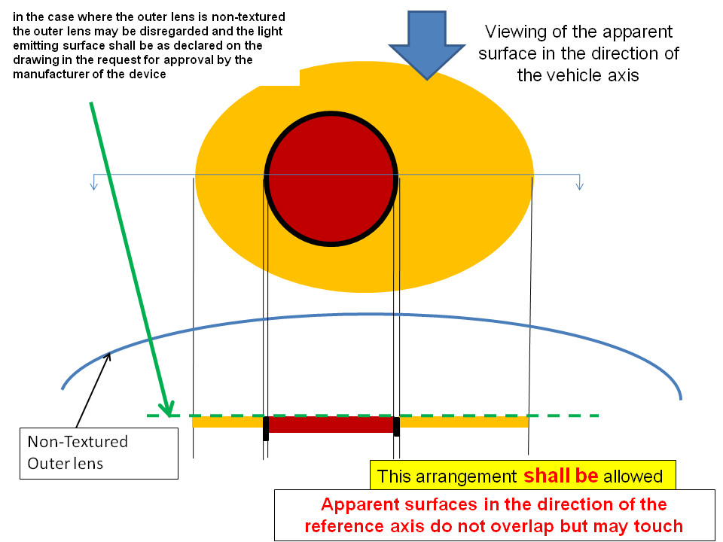
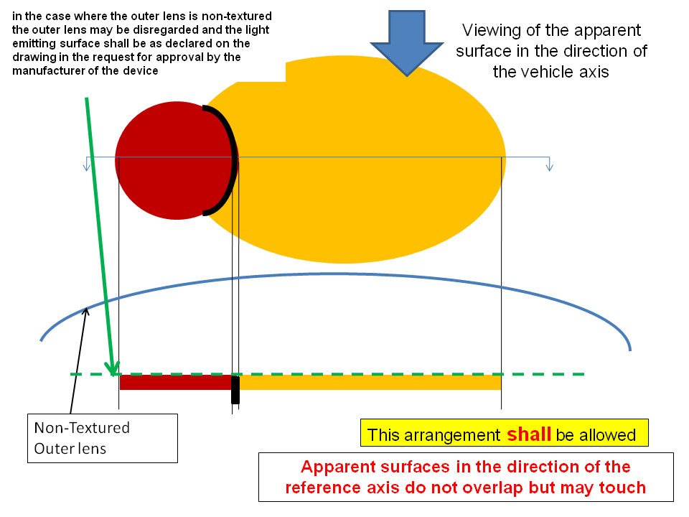

- - - - -
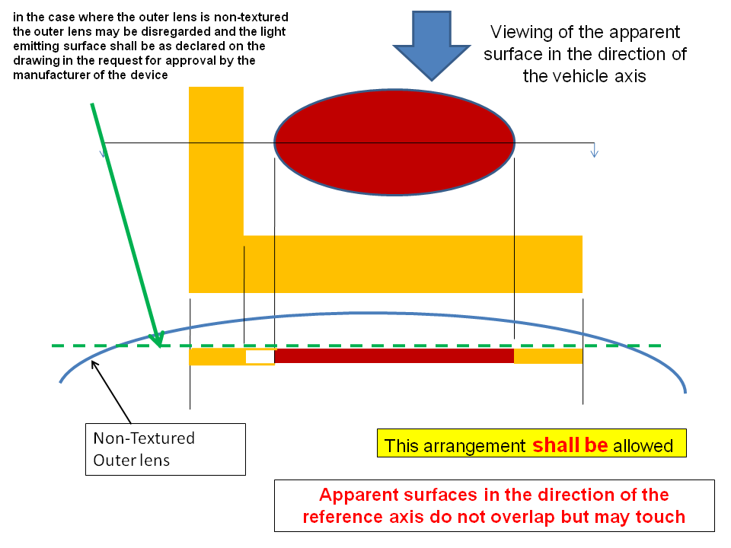

/ In accordance with the programme of work of the Inland Transport Committee for 2006-2010 (ECE/TRANS/166/Add.1, programme activity 02.4), the World Forum will develop, harmonize and update Regulations in order to enhance performance of vehicles. The present document is submitted in conformity with that mandate.

