UNITED  NATIONS |  | E
 | Economic and Social  Council | Distr.  GENERAL  ECE/TRANS/WP.29/GRE/2008/34  11 July 2008  Original: ENGLISH  ENGLISH AND FRENCH ONLY
ECONOMIC COMMISSION FOR EUROPE
INLAND TRANSPORT COMMITTEE
World Forum for Harmonization of Vehicle Regulations

Working Party on Lighting and Light-Signalling

Sixtieth session
Geneva, 1 - 3 October 2008
Item 5(h) of the provisional agenda

COLLECTIVE AMENDMENTS

Regulations Nos. 48 and 98

Proposal for draft collective amendments to Regulations Nos. 48 and 98

Submitted by the expert from the Working Party "Brussels 1952" ∗/

The text reproduced below was prepared by the expert from the Working Party "Brussels 1952" (GTB) in order to align the provisions concerning the maximum intensity of the main beam of Regulations Nos. 48 and 98 with those of Regulations Nos. 112 and 123. The modifications to the current text of the Regulations are marked in bold or strikethrough.
A. PROPOSAL

A.1. PROPOSAL TO AMEND REGULATION No. 48 (Installation of lighting and light-signalling devices) (The following text is based upon Corrigendum 1 to Supplement 1 to the 04 series of amendments to the Regulation)

Paragraph 6.1.9.1., amend to read:

"6.1.9.1. The aggregate maximum intensity of the main-beam headlamps which can be switched on simultaneously shall not exceed 225,000 300,000 cd, which corresponds to a reference value of 75 100."

A.2. PROPOSAL TO AMEND REGULATION No. 98 (Headlamps with gas-discharge light sources) (The following text is based upon Corrigendum 1 to Supplement 9 to the Regulation)

Paragraphs 6.3.3. to 6.3.3.2., amend to read:

"6.3.3. The illumination produced on the screen by the driving beam shall meet the following requirements:

6.3.3.1. The point of intersection (HV) of the lines HH and VV shall be situated within the isolux representing 80 per cent of the maximum illuminance. This maximum illuminance, hereunder designated as E_{max}, shall lie between 70 and 180 345 lux.

6.3.3.2. The reference mark referred to in paragraph 4.2.2.7. above shall be obtained by means of the formula:

Reference mark = 0,208 0.146 E_{max}

This value shall be rounded off to the value: 17.5 - 20 - 25 - 27.5 - 30 - 37.5 - 40."

B. JUSTIFICATION

Currently there is an inconsistency between Regulation No. 48 and the headlamp Regulations relating to the provision limiting the total maximum intensity of all main beams that may be operated simultaneously on the vehicle.

This proposal is intended to increase the maximum value in Regulations Nos. 48 and 98 to 300,000 candela (relating to an aggregate reference mark of 100) to align with the existing provisions of Regulations Nos. 112 and 123.

Regulation No. 48 currently limits the total intensity of the main beam to 225,000 cd (relating to an aggregate reference mark of 75). This was introduced at a time when installation of the class "A" headlamp was permitted on M₁ and N₁ vehicles. Due to the low photometric performance of the passing beam of the class "A" headlamp it was necessary to limit the driving beam intensity to avoid an unacceptable contrast when switching from driving to passing beam. Following the deletion of the class "A" headlamp and improvements in passing beam performance of modern headlamps, it is now appropriate to raise the limit of the maximum driving beam intensity and so remove a restriction to the optimisation of headlamp system performance.

There is also an inconsistency between the requirements of Regulations Nos. 98 and 123 resulting in a situation where the same gas discharge driving beam headlamp approved according to regulation No. 123 cannot be approved according to Regulation No. 98. This also means that this gas discharge driving beam is compelled to have a lower performance than a halogen driving beam.

This inconsistency can be eliminated by aligning the maximum intensity of the driving beam headlamp in Regulation No. 98 with the corresponding values in Regulations Nos. 112 and 123.

The interrelationship of the relevant provisions is shown below.
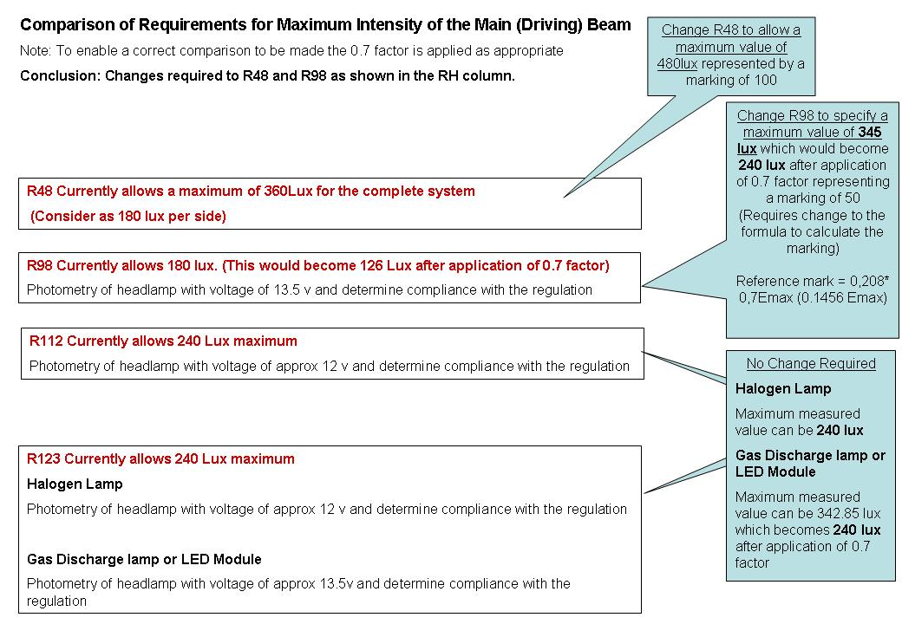

- - - - -

/ In accordance with the programme of work of the Inland Transport Committee for 2006-2010 (ECE/TRANS/166/Add.1, programme activity 02.4), the World Forum will develop, harmonize and update Regulations in order to enhance performance of vehicles. The present document is submitted in conformity with that mandate.

