UNITED  NATIONS |  | E
 | Economic and Social  Council | Distr.  GENERAL  ECE/TRADE/C/WP.7/2007/3  21 September 2007  ENGLISH  Original: ENGLISH, FRENCH and RUSSIAN

ECONOMIC COMMISSION FOR EUROPE

COMMITTEE ON TRADE

Working Party on Agricultural Quality Standards

Sixty-third session
Geneva, 5-9 November 2007
Item 3 of the provisional agenda

LIST OF DISEASES AND PESTS

Note by the secretariat

This document is based on ECE/TRADE/C/WP.7/GE.6/2006/9. It contains an amended bibliography and pictures of diseases and pests.

NOTE: This text presents a list of the major diseases affecting potatoes, as well as a basic description of each disease and the extent of certification measures for each disease. More detailed information on the symptomology and epidemiology of the diseases can be obtained from the following textbooks:

Compendium of Potato Diseases (2001, 2nd edition). W.R. Stevenson and others, eds. St. Paul, Minnesota, USA, American Phytopathological Society.

European Handbook of Plant Diseases (1998). I.M. Smith and others, eds. Oxford, UK, Blackwell Scientific Publications.

Diseases, Pests and Disorders of Potatoes in Israel (2006, 2nd edition). L. Tsror and S. Warshavsky, eds. Israel Vegetable Growers Organization. Website: www.yerakot.il. E-mail: irgun@yerakot.org.il.

Fiches descriptives des maladies et ravageurs de la pomme de terre (2000). France, FNPPT (Fédération Nationale des Producteurs de Plants de Pommes de Terre)/GNIS (Groupement National Interprofessionel des Semence et Plants).

Kartoffel-Krankheiten, Schädlinge und Unkräuter (2003). W. Radke, W. Reickmann and F. Brendler, eds. Gelsenkirchen, Verlag Thomas Mann.

Maladies et ravageurs de la pomme de terre (1991). W. Radke and W. Rieckmann, eds. Translated and adapted into French by M. Magnenat. Gelsenkirchen-Buer, Verlag Thomas Mann.

Potato Diseases (2005). A. Mulder and L.J. Turkensteen, eds. The Hague, NIVAP. Website: www.nivap.nl.

Disease |  | French name |  | Agent |  | Status in UNECE Standard | Recommended diagnostic method |  |  | General disease description |  | Tuber symptoms |  | Plant symptoms |  | Comment
FUNGUS
Potato wart disease |  | Galle verruqueuse |  | Synchytrium endobioticum |  | Zero tolerance | Visual observation of tubers and stem base |  |  | Tuber: tumours  Plant: tumours and galls on stolons and stem base |  | 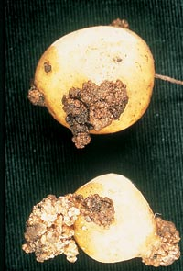
Late blight |  | Mildiou |  | Phytophthora infestans |  | Tolerance for wet or dry rot | Visual observation of plants and tubers |  |  | Tuber: rot at harvest and in storage  Plant: necrosis of leaves and stems |  | 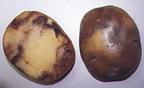 |  | 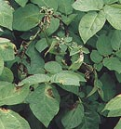
Dry rot |  | Fusariose |  | Fusarium solani var. coeruleum, F. sulphureum, F. avenaceum and other F. spp. |  | Tolerance | Visual observation of tubers and identification on selective medium |  |  | Tuber: storage rot  Plant: non-emergence or weak plants |  | 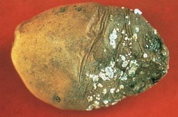
Gangrene |  | Gangrène |  | Phoma foveata and other Phoma spp. |  | Tolerance for dry rot | Visual observation of tubers and identification on selective medium |  |  | Tuber: storage rot |  | 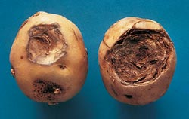 |  |  |  | May be regulated without tolerance in some regions  ECE/TRADE/C/WP.7/2007/3  Page 3
Leak and pink rot |  | Pythiales |  | Pythium spp, (wet rot agent), Phytophthora erythroseptica (pink rot agent) |  | Tolerance for wet rot | Visual observation of tubers and identification on selective medium |  |  | Tuber: rot, primarily soon after harvest |  | 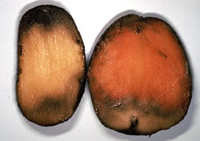
Rubbery rot |  |  |  | Goetrichum candidum |  | Tolerance for wet rot | Visual observation of tubers and identification on selective medium  ECE/TRADE/C/WP.7/2007/3  Page 4 |  |  | Tuber: storage rot
Rhizoctonia Black scurf (on tuber)/ Stem canker (on the plant) |  | Rhizoctone brun |  | Perfect state: Corticium;  imperfect state: Rhizoctonia solani |  | Tolerance on tubers (black scurf) | Visual observation of plants and tubers |  |  | Tuber: surface blemish  Plant: uneven emergence, wilting and stunting |  | 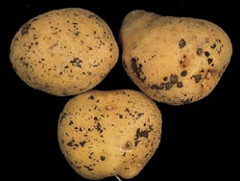 |  | 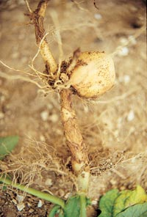  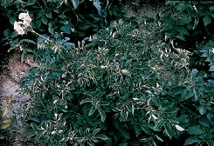 |  | Stem canker regulated in some regions. No need for general regulation because regulation of black scurf is seen as more effective
Silver scurf |  | Gale argentée |  | Helminthosporium solani |  | Treated indirectly through tolerance for shrivelled tubers | Visual observation of tubers and identification on selective medium |  |  | Tuber: skin blemish |  | 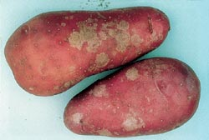 |  |  |  | Regulated with tolerance in some regions
Black dot |  | Dartrose |  | Colletotrichum coccodes |  | Treated indirectly through tolerance for shrivelled tubers | Visual observation of tubers and identification on selective medium |  |  | Tuber: skin blemish  Growing plant: may contribute to early dying disease in warm climates |  | 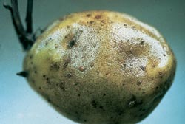 |  |  |  | Regulated with tolerance in some regions
Skin spot |  | Oosporiose |  | Polyscytalum pustulans |  | Not regulated | Visual observation of tubers |  |  | Tuber: skin blemish and death of eyes  Plant: uneven and non-emergence |  | 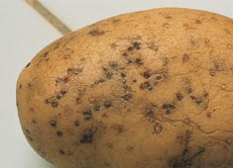 |  |  |  | Regulated with tolerances in some regions. No need for a general regulation, not a barrier to trade.
Early blight |  | Alternariose |  | Alternaria solani and Alternaria alternata |  | Treated indirectly through tolerances for dry rot | Visual observation of leaves and tubers |  |  | Tuber: largely superficial rot  Plant: necrosis of leaves |  | 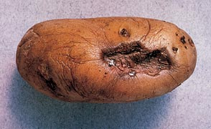 |  | 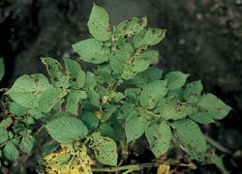
White mould |  | Sclerotiniose |  | Sclerotinia sclerotiorum |  | Not regulated | Visual observation of stem |  |  | Tuber: rot, rare  Plant: wilting and death of individual stems |  |  |  | 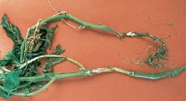  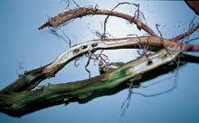 |  | Not to be regulated. Infection is from soil inoculum and not from the tuber  ECE/TRADE/C/WP.7/2007/3  Page 5
Powdery scab |  | Gale poudreuse |  | Spongospora subterranea |  | Tolerance | Visual observation of tubers with confirmation by microscope |  |  | Tuber: surface scab and cankers at rose end |  | 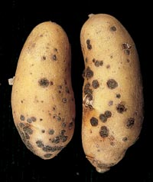 |  |  |  | May be regulated with tolerance in some regions
Verticillium wilt |  | Verticilliose |  | Verticillium dalhiae and V. alboatrum |  | Not regulated | Visual observation of leaves and plant |  |  | Tuber: vascular discolouration  Plant: wilting and death |  | 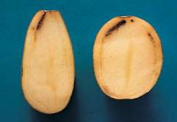 |  | 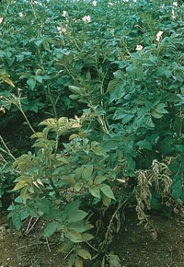 |  | No need for regulation in UNECE standard because path of infection is primarily though infested soil and not the seed tuber  ECE/TRADE/C/WP.7/2007/3  Page 6
VIRUS
Severe mosaic |  | Virose grave |  | Potato viruses Y (all strains), A, V and M, and in combination with PVX and S |  | Tolerance for severe virus | Visual observation of plant and ELISA test |  |  | Plant: with or without discolourations of the foliage. Deformation can be rugosity, crinkle, rolling and rigidity of the leaves or dwarfing of plant  Tuber: superficial necrosis caused only by PVY^{NTN} |  | 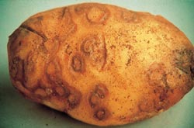 |  | 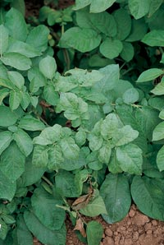 |  | Tuber symptoms, regulated with tolerance in some regions
Mild mosaic |  | Virose légère |  | PVX, PVS and PVY strains, especially PVY^{N} |  | Tolerance for mild mosaic | Visual observation of plant and ELISA test |  |  | Plant: discolouration or mottle of leaves without distortion  Tuber: superficial necrosis caused only by PVY ^{NTN} |  |  |  | 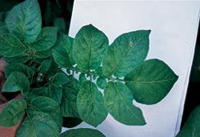  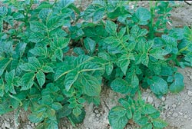 |  | Tuber symptoms, regulated with tolerance in some regions
Leafroll |  | Enroulement (Virus E) |  | Potato leafroll virus (PLRV) |  | Tolerance for severe virus | Visual observation of plant and ELISA test |  |  | Plant: rolling of leaves and stunting  Tuber: net necrosis in flesh |  |  |  | 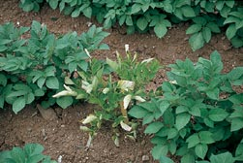
Mop top  (Spraing in tubers) |  | Mop top |  | Potato mop top virus (PMTV) |  | Not regulated | Visual observation of plant and tubers, ELISA test and PCR |  |  | Plant: marked mottling of leaves and stunting of all or some stems  Tuber: necrotic rings or arcs on surface and in flesh |  | 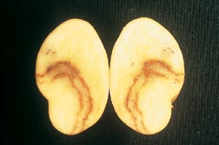 |  | 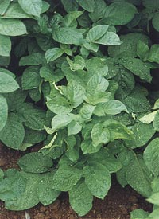 |  | Regulated with a zero tolerance in some regions  ECE/TRADE/C/WP.7/2007/3  Page 7
Tobacco rattle virus (Spraing in tubers) |  | Rattle |  | Tobacco rattle virus |  | Not regulated ¹ | Observation of tubers and PCR |  |  | Plant: mottling and distortion of leaves and stunting of some or all stems  Tuber: internal discoloured arcs and rings, rarely visible on the surface |  | 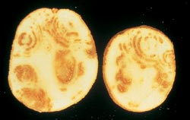 |  |  |  | Regulated in some regions with tolerances
Tomato spotted wilt virus |  | TSWV |  | Tomato spotted wilt virus |  | Not regulated |  |  |  | Plant: leaf spotting and necrosis  Tuber: skin blemish and internal necrotic spotting |  | 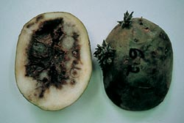 |  | 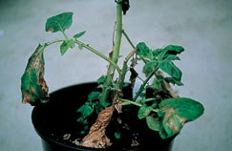 |  | Regulated in some regions  ECE/TRADE/C/WP.7/2007/3  Page 8  with zero tolerance
BACTERIA
Blackleg | Jambe noire |  | Pectobacterium  atrosepticum (syn. Erwinia carotovora subsp. atroseptica) and Pectobacterium carotovorum (syn. E. carotovora subsp. carotovora), Dickeya spp. (syn. E. chrysanthemi) |  | Tolerance for crop and tuber for wet rot |  |  | Observation of plant and tuber | Plant: stem rot  Tuber: soft rot |  | 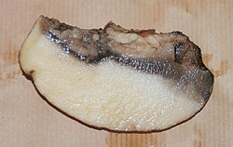  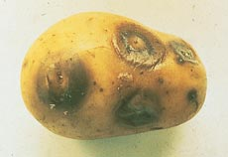 |  | 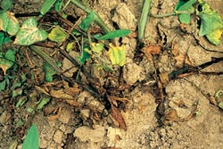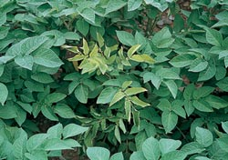
Ring rot | Flétrissement bactérien, pourriture annulaire |  | Clavibacter michiganensis subsp. sepedonicus |  | Zero tolerance |  |  | Observation of plant and tuber, test by IF and PCR | Tuber: vascular soft rot  Plant: wilting and death |  | 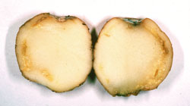 |  | 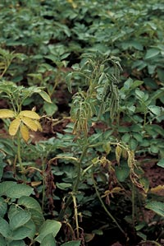
Brown rot | Pourriture brune |  | Ralstonia solanacearum |  | Zero tolerance |  |  | Observation of plant and tuber, test by IF and PCR | Tuber: vascular soft rot  Plant: wilting |  | 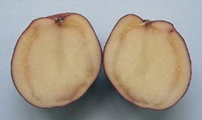 |  | 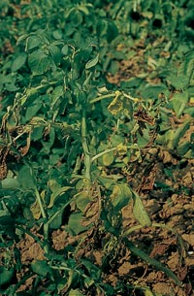
Common scab | Gale commune |  | Streptomyces scabiei and other S. strains, e.g. Streptomyces europaeiscabiei and S. stelliscabiei. |  | Tolerance on the tuber |  |  | Observation of tuber | Tuber: scabs |  | 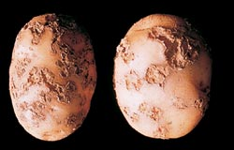
Netted scab | Gale plate |  | Streptomyces  europaeiscabiei and  Reticuliscabiei |  | Tolerance  on the tuber |  |  | Observation of tuber | Tuber: superficial netted scabs |  | 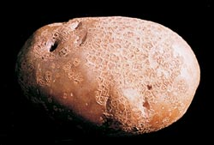 |  |  |  | ECE/TRADE/C/WP.7/2007/3  Page 9
VIROID
Potato spindle tuber viroid | Viroïde des tubercules en fuseau |  | Potato spindle tuber viroid (PSTV) |  | Zero tolerance |  |  | Observation of plant and tuber. Test by molecular hybridization and PCR | Tuber: elongation of tuber  Plant: stunting and leaf rolling |  | 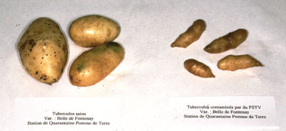
PHYTOPLASMA
Stolbur | Stolbur |  | Phytoplasma .  [The principal vectors are leafhoppers (Macrosteles spp, Hyalestes spp)] |  | Zero tolerance |  |  | Visual observation of leaves and tubers | Plant: stunting and leaf rolling |  | 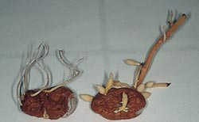 |  | 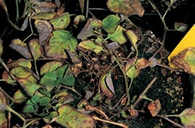 |  | In some regions regulated, zero tolerance  ECE/TRADE/C/WP.7/2007/3  Page 10
NEMATODES
Cyst nematodes | Nématodes à kystes |  | Globodera rostochiensis and Globodera pallida |  | Zero tolerance |  |  | Visual observation of the field and testing of soil | Plant: wilting and death |  | 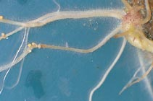 |  | 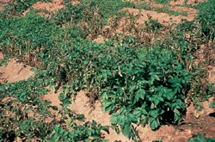
Root knot nematodes | Nématodes à galle |  | Meloidogyne chitwoodi and fallax |  | Zero tolerance |  |  | Observation of tuber, microscopic examination of cut tuber, and PCR test | Tuber: surface galls and internal necrotic spots |  | 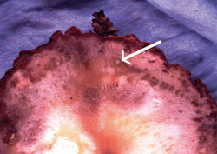  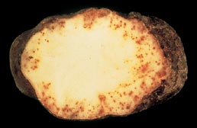 |  |  |  | In some regions regulated, zero tolerance
Potato rot nematode | Nématodes libres |  | Ditylenchus destructor |  | Zero tolerance |  |  | Observation of tuber | Tuber: surface cracking and cortical spotting |  | 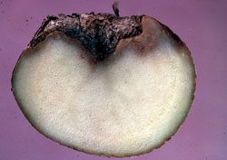 |  |  |  | In some regions regulated, zero tolerance
PESTS
Colorado beetle | Doryphore |  | Leptinotarsa decemlineata |  | Unregulated |  |  | Visual observation of eggs, larvae and adults | Plant: leaf damage |  |  |  | 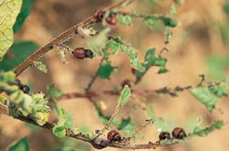 |  | In some regions regulated, zero tolerance
Wireworms/ slugs | Taupin |  | Agriotes sp.: A obscurus,  A. sputator,  A. lineatus/ Tandonia budapestensis, Arion hortensis |  | Unregulated |  |  | Visual observation of tubers | Tuber: tunnels and holes |  | 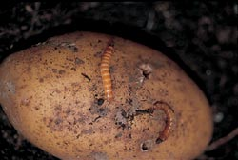  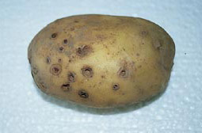 |  |  |  | ECE/TRADE/C/WP.7/2007/3  Page 11
Tuber moth | Teigne |  | Phthorimea opercullella |  | Unregulated |  |  | Visual observation of leaves and tubers | Tuber: leaf  Plant: tunnels in flesh damage |  | 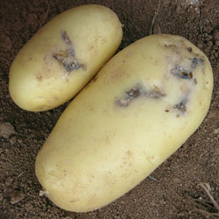  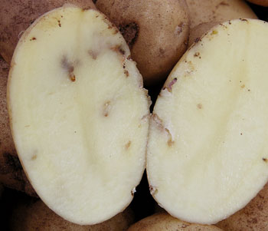  ECE/TRADE/C/WP.7/2007/3  Page 12 |  |  |  | In some regions regulated, zero tolerance

***

According to experience in certain areas, the disease can eradicate itself due to low transmission rates.

