UNITED  NATIONS |  | E
 | Economic and Social  Council | Distr.  GENERAL  ECE/TRADE/C/WP.7/GE.11/2010/4  2 February 2010 Revised 8.09.2010  Post-session document Nov. 2010  Original: ENGLISH
ECONOMIC COMMISSION FOR EUROPE
COMMITTEE ON TRADE
Working Party on Agricultural Quality Standards
Specialized Section on Standardization of Meat
Nineteenth session
Geneva, 19-23 April 2010
Item 6 (b) of the provisional agenda
Proposals for new UNECE Standards

POST-SESSION DOCUMENT

DRAFT NEW UNECE STANDARD FOR GOOSE MEAT – CARCASES AND PARTS

Submitted by China

The following draft proposal for a UNECE Standard for Goose Meat – Carcases and Parts has been prepared by China. The paper should serve to initiate discussions to define a new standard for goose meat. The document was discussed at the Rapporteurs’ meeting on Goose, at Nanjing, China, 11 to 13 May, 2009.

The document is prepared in accordance with paragraph 5 of the Working Party’s Terms of Reference.
CONTENTS (to be adjusted at the end)
Page
1. Introduction 4
1.1 UNECE standards for meat products 4
1.2 Scope 4
1.3 Application 5
1.4 Adoption and publication history 5
2. Minimum requirements 5
3. Purchaser-specified requirements 6
3.1 Additional requirements 6
3.2 Species 6
3.3 Product/part 6
3.3.1 Product/part code 6
3.3.2 Bone 6
3.3.3 Skin 7
3.4 Refrigeration 7
3.5 Production history 9
3.5.1 Traceability 9
3.5.2 Goose category 9
3.5.3 Production system 10
3.5.4 Feeding system 11
3.5.5 Slaughter system 12
3.5.6 Chilling system 12
3.5.7 Anti-microbial treatments 13
3.6 Quality level 13
3.7 Labelling information to be mentioned on or affixed to the marketing units of goose carcases and parts 14
3.7.1 Mandatory information 14
3.7.2 Other product claims 14
3.8 Provisions concerning conformity-assessment requirements 15
3.9 Provisions concerning packing, storage, and transport 15
3.9.1 Piece weight 15
3.9.2 Primary packaging 16
3.9.3 Consumer labelling 16
3.9.4 Weight of the primary package 16
3.9.5 Secondary packaging 18
3.9.6 Secondary package weight 18
3.9.7 Goose meat packaging and packing coding format 19
4. UNECE Code for purchaser requirements for goose meat 19
4.1 Definition of the code 19
4.2 Example 20
5. Carcases and Parts descriptions 20
5.1 Multilingual index of products 20
5.2 Goose skeletal diagram explanation 23
5.3 Goose meat parts 24

Annexes
Codification system 43
Addresses 49

UNECE STANDARD
FOR GOOSE MEAT CARCASES AND PARTS

1. Introduction

1.1 UNECE standards for meat products

The purpose of UNECE standards for meat products is to facilitate trade by recommending an international language for use between buyer and seller. The language describes meat items commonly traded internationally and defines a coding system for communication and electronic trade. As the texts will be updated regularly, meat industry members who believe that additional items are needed or that existing items are inaccurate or no longer being traded are encouraged to contact the UNECE secretariat.

The text of this publication has been developed under the auspices of the UNECE Specialized Section on Standardization of Meat. It is part of a series of standards that UNECE has developed or is planning to develop.

The following table contains the species for which UNECE standards exist/or are being developed and their code for use in the UNECE meat code (see section 4).

For further information please visit the UNECE website at: http://www.unece.org/trade/agr

Annex I contains a description of the codification system, which includes a specific application identifier for the implementation of the UNECE Code.

Species | Species code  (data field 1)
Bovine (Beef) | 10
Bovine (Veal) | 11
Porcine (Pork) | 30
Ovine (Sheep) | 40
Caprine (Goat) | 50
Llama | 60
Alpaca | 61
Chicken | 70
Turkey | 71
Duck | 72
Goose | 73
Edible meat co-products | 90
Retail meat cuts | 91

1.2 Scope

This Standard recommends an international language for raw (unprocessed) goose (anser and branta) carcases and parts (or cuts) marketed as fit for human consumption. Products with added ingredients or “goose preparations” are not included. It provides a variety of options to purchasers for meat handling, packing and conformity assessment, which conform to good commercial practice for meat and meat products intended to be sold in international trade.

To market goose carcases and parts across international borders, the appropriate legislative requirements of food standardization and veterinary control must be complied with. The Standard does not attempt to prescribe those aspects, which are covered elsewhere. Throughout the Standard, such provisions are left for national or international legislation, or requirements of the importing country.

The Standard contains references to other international agreements, standards and codes of practice that have the objective of maintaining the quality after dispatch and of providing guidance to governments on certain aspects of food hygiene, labelling and other matters which fall outside the scope of this Standard. Codex Alimentarius Commission Standards, Guidelines, and Codes of Practice www.codexalimentarius.net should be consulted as the international reference concerning health and sanitation requirements.

1.3 Application

Contractors are responsible for delivering products that comply with all contractual and specification requirements and are advised to set up a quality control system designed to assure compliance.

For assurance that items comply with these detailed requirements, buyers may choose to use the services of an independent, unbiased third party to ensure product compliance with a purchaser’s specified options. The Standard includes illustrative photographs of carcases and selected commercial parts/cuts to make it easier to understand the provisions.

1.4. Adoption and publication history

The first edition of this standard was adopted by the Working Party on Agricultural Quality Standards at its xx session in 20XX (reference ECE/TRADE/C/WP.7/XXX).

UNECE standards for meat undergo a complete review three years after publication. Following the review, new editions are published as necessary. Changes requiring immediate attention are published on the UNECE website at: http://www.unece.org/trade/agr/standards.htm

2. Minimum requirements

All meat must originate from animals slaughtered in establishments regularly operated under the applicable regulations pertaining to food safety and inspection.

Carcases and parts must be:

- Intact, taking into account the presentation
- Free from visible blood clots or bone dust
- Free from any foreign material (e.g. glass, rubber, plastic, metal)
- Free of foreign odours
- Free of faecal contamination
- Free of improper bleeding
- Free of viscera, trachea, esophagus, mature reproductive organs, and lungs
- Practically free of feathers and haemorrhaging
- Free of freezer-burn
- Free of gall discoloration³.

3. Purchaser-specified requirements

The following subsections define the requirements that can be specified by the purchaser together with the codes to be used in the UNECE goose code (see section 4). The UNECE code for goose meat packing is described in section 3.9.

3.1 Additional requirements

Additional purchaser-specified requirements, which are either not accounted for in the code (e.g. if code 9 “other” is used) or that provide additional clarification to the product or packing description, shall be agreed between buyer and seller and be documented appropriately.

3.2 Species

The code for goose in data field 1 as defined in section 1.1 is 73.

3.3 Product/part

3.3.1 Product/part code

The four-digit product code in data field 2 is defined in section 5.

3.3.2 Bone

Goose carcases and parts vary in presentation for bone as follows:

Bone code  (data field 3a) | Category | Description
0 | Not specified
1 | Bone-in | Product has no bones removed
2 | Partially boneless | Product has some, but not all bones removed
3 | Boneless | Product has all bones removed
4 – 9 | Codes not used

3.3.3 Skin

Goose carcases and parts vary in presentation for skin as follows:

Skin code  (data field 3b) | Category | Description
0 | Not specified
1 | Skin-on | Product with skin (figure 1)
2 | Skinless | Product with all skin removed (figure 2)
3 – 9 | Codes not used

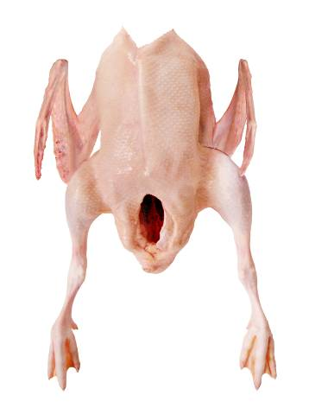 | 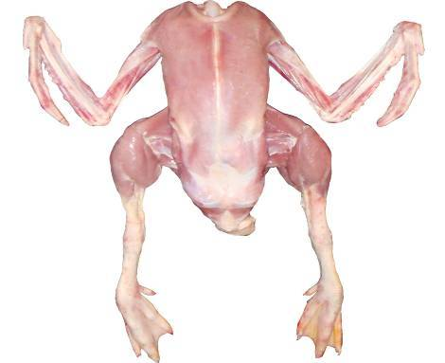
Figure 1: Whole bird with skin | Figure 2: Skinless whole bird

3.4 Refrigeration

Refrigeration used in this Standard refers to methods used for reducing the internal temperature of a food product for the purposes of preservation and microbial control. Goose carcases and parts may be presented chilled, chilled with ice packed in the container, chilled with dry ice packed in the container, lightly frozen, frozen, deep frozen, individually (quick) deep frozen without ice glazing, or individually (quick⁵) deep frozen with ice glazing. Not all categories may be used by all regions. Depending on the refrigeration method used, tolerances for product weight are to be agreed between the buyer and seller. It is the responsibility of the operator to ensure that ambient temperatures are such throughout the supply chain as to ensure uniform internal product temperatures of all parts of the product as follows:
Refrigeration code  (data field 4) | Category | Description
0 | Not specified | No category specified
1 | Chilled | Internal product temperature (muscle) maintained at not less than -1.5° C or more than + 4.0° C at all times following the post-slaughter chilling process
2 | Chilled, with ice added | Internal product temperature (muscle) maintained at not less than -1.5° C or more than +4.0° C at all times following the post-slaughter chilling process and packed in a container with ice (frozen water, not dry ice)
3 | Chilled, with dry ice (CO₂) added | Internal product temperature (muscle) maintained at not less than -1.5° C or more than + 4.0° C at all times following the post-slaughter chilling process and packed in a container with dry ice (CO₂)
4 | Lightly frozen | Internal product temperature (muscle) maintained at not less than -12.0° C or more than -1.5° C at all times after freezing
5 | Frozen | Internal product temperature (muscle) maintained at -12° C or less at all times after freezing
6 | Deep frozen | Internal product temperature (muscle) maintained at -18° C or less at all times after freezing
7 | Individually (quick) deep frozen, without ice glazing | Product is individually frozen before packing and maintained at an internal temperature (muscle) -18° C or less at all times after freezing
8 | Individually (quick) deep frozen, with ice glazing | Product is individually frozen before packing and maintained at an internal temperature (muscle) -18° C or less at all times after freezing. Ice glazing methodology and labelling terminology must be agreed between the buyer and seller. The methodology used and any weight pick-up due to ice glazing must be declared on the product description/label
9 | Other | Can be used to describe any other refrigeration agreed between buyer and seller

The definitions of the above terms must be in conformity with the legislation of the importing country.

3.5 Production history

3.5.1 Traceability

The requirements concerning production history specified by the purchaser require traceability systems to be in place. Traceability requires a verifiable method of identification of products or batches of products at all relevant stages of production. Traceability records must be able to substantiate the claims being made and the procedures used to certify conformity must be in accordance with the provisions concerning conformity assessment requirements of section 3.8.

3.5.2 Goose category

The purchaser may specify a category of goose that indicates sex, weight range, or age.

Category code (data field 5) | Category | Description
0 | Not specified
1 | Young geese | Less than 10 weeks of age. Tip of sternum is flexible
2 | Reserved geese | Between 10 and 22 weeks of age
3 | Mature geese | More than 20 weeks of age
4 | Egg-laying geese | More than 22 weeks of age
5 | Breeding male and female geese | More than 10 weeks of age
6 | Fat geese used for production of foie gras | Age - as agreed between buyer and seller and must be in accordance with the requirements of the importing country  Breeds include, for example, Landaise, lion headed and Rhin that have relatively fast growth rate and a large scale body. Live body weight can amount to 4.5 kg to 5.0 kg at 8 weeks of age / Note: To be reviewed at the next session in June 2011  Live body weight can amount to approximately 4.0 kg when starting restricted feeding and around 5.0 kg at the slaughter age".  Note: Alternative proposal by China – Nov 2010 post-session
7 | Oats-fed geese | Minimum 16 weeks of age. Breeds include those where the geese are fed during the finishing stage of minimum three weeks not less than 500 g of oats per day.
8 | Code note used
9 | Other | Can be used to describe any other category of goose  agreed between buyer and seller

The definitions of the above terms must be in conformity with the legislation of the importing country.

3.5.3 Production system

The purchaser may specify a production system. In any case the production has to be in conformity with the regulations in force in the importing country. If no such regulation exists, the production system shall be agreed between buyer and seller.

Production system code  (data field 6) | Category | Description
0 | Not specified
1 | Free range | Geese are raised in heated and either ventilated or open-sided growing houses with access to the outdoors
2 | Pastured/pasture-raised | Geese are raised outdoors utilizing movable enclosures located on grass after 3 weeks
3 | Special for foie gras | Geese are raised for the first 100 days conventionally or in a free range. And then they are restricted indoors and fed with feedstuffs containing increasing yellow maize for two weeks. In the next three weeks, they are manually or mechanically filled with cooked yellow maize, 3 to 4 times per day, of 100g to 150g for one week, and of 300g to 400g for another week, and then of 400g to 500g for the last week.
4 | High quality | Geese are raised with grass and feeds that do not contain pesticides, growth promoters and products derived from genetically modified organisms.
5 | Superior quality | Geese are raised under special conditions and feeding regime, with grass and feeds that do not contain pesticides, growth promoters and products derived from genetically modified organisms.
6 | Organic | Production methods conform to the legislation of the importing country concerning organic production
7– 8 | Codes not used
9 | Other | Any other production system agreed between buyer and seller

3.5.4 Feeding system

The purchaser may specify a feeding system. In any case the feeding has to be in conformity with the regulations in force in the importing country. If no such regulation exists, the feeding system shall be agreed between buyer and seller.

Feeding system code  (data field 7) | Description
00 | Not specified
01 | Conventional
02– 09 | Codes not used
10 | FM free
11 | FM & IAO free
12 | FM, IAO & GP free
13 | FM, IAO, GP & GMO free
14 | FM & GP free
15 | FM, GP & GMO free
16 | FM & GMO free
17 – 29 | Codes not used
30 | IAO free
31 | IAO & GP free
32 | IAO & GMO free
33 | IAO, GP & GMO free
34 – 49 | Codes not used
50 | GP free
51 | GP & GMO free
52 – 59 | Codes not used
60 | GMO free
61 – 98 | Codes not used
99 | Can be used to describe any other feeding system agreed between buyer and seller.

FM free Free from fish meal.
IAO free Free from ingredients of animal origin.
GP free Free from growth promoters∗.
GMO free Free of products derived from genetically modified organisms.

The definitions of the terms above must be in conformity with the legislation of the importing country.

3.5.5 Slaughter system

The purchaser may specify a slaughter system. The slaughter always has to be in conformity with the regulations in force in the importing country. If no such regulation exists, the slaughter system shall be agreed between buyer and seller.

Slaughter system code  (data field 8) | Category | Description
0 | Not specified
1 | Conventional | Stunned prior to bleeding
2 | Kosher | Appropriate ritual slaughter procedures used
3 | Halal | Appropriate ritual slaughter procedures used
4 – 8 | Codes not used
9 | Other | Any other authorized method of slaughter must be agreed between buyer and seller

3.5.6 Chilling system

The purchaser may specify chilling systems as indicated in the table below.

The following chilling systems may cause weight gain through technically unavoidable water retention. The product description/label must contain the percentage of water contained in the product if it exceeds the technological limits as defined in the legislation of the importing country. If such legislation does not exist, those limits must be agreed between buyer and seller. The methods used for the determination of the water content must be agreed between buyer and seller.

Chilling system code  (data field 9) | Category | Description
0 | Not specified
1 | Immersion chilled  (no additives) | Product chilled by movement through reverse-flowing cold water
2 | Immersion chilled (additives) | Product chilled by movement through reverse-flowing cold water containing anti-microbial agents
3 | Air chilled  (no additives) | Product chilled by cold air
4 | Air chilled (additives) | Product chilled by cold air containing anti-microbial agents
5 | Air-spray chilled (no additives) | Product chilled by cold air interspersed with fine water spray
6 | Air-spray chilled (additives) | Product chilled by cold air interspersed with fine water spray containing anti-microbial agents
7 – 8 | Codes not used
9 | Other | Can be used to describe any other chilling system agreed between buyer and seller

3.5.7 Anti-microbial treatments

The following treatments may take place before or after chilling. These can include physical, chemical or biological treatments either separately or in combination, meeting relevant legislation in the importing country.

Treatment code  (data field 10) | Category | Description
0 | Not specified
1 | Without any anti-microbial treatment | No anti-microbial treatment has been used
2 | With specified anti-microbial treatment(s) | The specific treatment(s) must be agreed upon between buyer and seller
3 – 9 | Codes not used

3.6 Quality level

A quality level for carcases or parts can be specified as follows:

Quality code  (data field 11) | Category | Description
0 | Not specified | The minimum requirements in section 2 have to be complied with
1 | Quality level 1 | Product meets highest quality level
2 | Quality level 2 | Product meets second quality level ¹⁰
3 – 8 | Codes not used
9 | Other | Other quality level or system agreed between buyer and seller

3.7 Labelling information to be mentioned on the packaging or affixed to the marketing units of goose carcases and parts

All labelling information must be verifiable (see also 3.5.1)

3.7.1 Mandatory information

Without prejudice to national requirements of the importing countries, the following list contains information that must be listed on product labels on packed goose carcases and parts:
- Name of the product
- Health stamp / inspection stamp
- Sell-by/use-by date as required by each country
- Storage conditions: e.g. “Store at or below XX ° C”
- Appropriate identification of packer, distributor or dispatcher
- Net weight in kilograms (kg) and optionally pounds (lb)

3.7.2 Other product claims

Other product claims may be listed on product labels as required by the importing country’s legislation, or at the buyer’s request or as chosen by the processor. If listed, such product claims must be verifiable (see also 3.5.1).

Examples of such product claims include the following.
- Country of birth
- Country (ies) of raising
- Country of slaughter
- Country (ies) of processing/cutting
- Country (ies) of packing
- Country of origin: In this standard the term “country of origin” is reserved to indicate that birth, raising, slaughter, processing/cutting and packing have taken place in the same country.
- Production and feeding systems
- Processing/packaging date
- Quality/grade/classification
- Slaughtering procedures
- Chilling system
- Goose breed

3.8 Provisions concerning conformity-assessment requirements

The purchaser may request third-party conformity assessment of the product’s quality/grade/classification, purchaser-specified options of the trade standard, and/or animal identification. Individual conformity assessments or combinations may be selected as follows:

Quality/grade/classification conformity assessment (quality): a third party examines and certifies that the product meets the quality level requested. The name of the third-party certifying authority and quality grade standard to be used must be designated as noted in 3.1.

Trade standard conformity assessment (trade standard): a third party examines and certifies that the product meets the purchaser-specified options as specified in this trade standard, except for quality level. The name of the third-party certifying authority must be designated as noted in 3.1. Optionally, the purchaser may indicate specific purchaser specified options to be certified after the name of the third-party certifying authority.

Goose or batch identification conformity assessment (goose/batch ID): a third party examines and certifies that the product meets specified requirements. The name of the third-party certifying authority and the requirements must be designated as noted in 3.1.

Conformity assessment code  (data field 14) | Category
0 | Not specified
1 | Quality/grade/classification (quality) conformity assessment
2 | Trade standard conformity assessment
3 | Goose /batch identification (goose/batch ID) conformity assessment
4 | Quality and trade standard conformity assessment
5 | Quality and goose/batch ID conformity assessment
6 | Trade standard and goose/batch ID conformity assessment
7 | Quality, trade standard, and goose/batch ID conformity assessment
8 | Code not used
9 | Other

3.9 Provisions concerning packing, storage, and transport

The conditions of storage before dispatch and the equipment used for transportation shall be appropriate to the physical and, in particular, to the thermal condition of the goose carcases and parts (chilled or frozen) and shall be in accordance with the requirements of the importing country. Attention is drawn to the provisions of the UNECE Agreement on the International Carriage of Perishable Foodstuffs and on the Special Equipment to be Used for Such Carriage (ATP) (ECE/TRANS/165).

3.9.1 Piece weight

A “piece” is a whole bird, a bird cut into pieces, or a part from a bird as specified by the product description. Piece weight shall not include the weight of packaging materials. The weight can also be indicated as a weight range. In this case, the definition of the weight ranges and their application and verification must be agreed between buyer and seller.

Buyer and seller may agree on individual product piece weight as follows:

Piece weight code  (data field P1) | Category/Description
0 | Not specified
1 | Weight range specified
2 | Weight specified
3 – 8 | Codes not used
9 | Other

3.9.2 Primary packaging

The primary packaging is in direct contact with the product and is used to segregate the product into consumer- or institutional -sized units, and is placed inside a shipping container during transport. One or more pieces may be enclosed in a primary packaging. The primary packaging may be specified as follows:

Primary packaging code  (data field P2) | Category | Description
00 | Not specified
01 | Plastic bag | Packaging made from flexible, plastic film to enclose product that is closed by commercial methods. A plastic-film liner in a box is considered part of the shipping container and not an internal package.
02 | Plastic bag, vacuum packaged | A plastic bag or other similar material that adheres to the product through the removal of air by vacuum and a heat-sealing closure.
03 | Plastic bag, resealable | A plastic bag or other similar material that has an interlocking seal that can be repeatedly opened and closed.
04 | Plastic bag, with modified atmosphere | A plastic bag or other similar material that is filled with a gas and sealed to assist in maintaining product quality.
05 | Bubble pack, portion control | A plastic bag or other similar material that is used to enclose individual servings of product.
06 | Tray pack | A flat bottom, tray-shaped container made of polystyrene or other similar plastic material. Product is placed in the tray and then over-wrapped with a plastic film that encloses the product. A moisture-absorbing pad may be placed in the tray under the product to absorb excess moisture.
07 | Tray pack, with modified atmosphere | A shallow, flat bottom container made of polystyrene or other similar plastic material. Product is placed in the tray over a moisture-absorbing pad, then over-wrapped with a plastic film that encloses the tray and the product, and gas is added and the package sealed to assist in maintaining product quality.
08 | Cup/tub | Container made of paper, plastic, or other rigid, waterproof material with a flat bottom and a lid closure.
09 | Carton | A paper container that holds the product and is packed inside a packing container. The carton may: (1) have an impregnated and/or coated wax surface, or (2) be lined with a plastic-film or other polyethylene bag. The carton is closed using commercial methods. If this packaging is selected, the purchaser must also specify the type of packing container into which the carton is placed.
10 – 97 | Codes not used
98 | Not packaged | Product is not packaged into consumer- or institutional-sized units (e.g. product is packed directly in a packing container such as a returnable plastic container, lined box, or bulk bin).
99 | Other

3.9.3 Consumer labelling

Consumer labelling of the primary package may be specified as follows:

Consumer labelling code (data field P3) | Category/Description
0 | Not specified
1 | Labelled: consumer labels shall be present on packages. They must be in accordance with the requirements of the country of destination.
2 | Not labelled
3 – 9 | Codes not used

3.9.4 Weight of the primary package

The weight of the primary package contents is the sum of the weight of the pieces contained, as defined in 3.9.1. The weight can also be indicated as a weight range. In this case, the definition of the weight ranges and their application and verification must be agreed between buyer and seller.

Primary package weight code  (data field P4) | Category/Description
0 | Not specified
1 | Weight range specified
2 | Weight specified
3 – 8 | Codes not used
9 | Other

3.9.5 Secondary packaging

Secondary packaging is used to protect and identify the product during transport. Secondary packages consist of one or more primary packages. They must be labelled in accordance with the requirements of the country of destination. Secondary packaging may be specified as follows:

Secondary packing code  (data field P5) | Category | Description
0 | Not specified
1 | Box, unlined and unwaxed | Container made from corrugated paper. Closed using tape, straps, or other commercially acceptable methods
2 | Box, lined and unwaxed | Corrugated paper container that has a plastic-film bag lining the inside of the container. Closed using tape, straps, or other commercially acceptable methods
3 | Box, unlined and waxed | Corrugated paper box impregnated and/or coated with wax to waterproof the container. Closed using tape, straps, or other commercially acceptable methods
4 | Container, returnable | Container or “tote” made of plastic or other authorized material that is recovered by the processor after delivery.
5 | Bulk bin, non-returnable | Large corrugated paper container that is not recovered by the processor after delivery, which may or may not be wax impregnated or lined with a plastic-film bag.
6 | Bulk bin, returnable | Large container made of plastic or other authorized material that is recovered by the processor after delivery.
7 – 8 | Codes not used
9 | Other

3.9.6 Secondary package weight

Secondary package weight is specified as five digits with one decimal place (0000.0kg). Secondary package weight tolerances and weight ranges to be determined by the buyer and seller as noted in 3.9.1.

Secondary package weight code  (data field P6) | Category/Description
00000 | Not specified
00001 – 99999 | Specify five-digit piece weight (0000.0) in kilograms

3.9.7 Goose meat packaging and packing coding format

The following table demonstrates the general application of the coding format for describing packaging and packing for goose:

Data field | Description | Section | Code range
P1 | Piece weight | 3.9.1 | 0-9
P2 | Primary packaging | 3.9.2 | 00-99
P3 | Primary packaging consumer labelling | 3.9.3 | 0-9
P4 | Primary package weight | 3.9.4 | 0-9
P5 | Secondary packaging | 3.9.5 | 0-9
P6 | Secondary package weight | 3.9.6 | 00000-99999

4. UNECE Code for purchaser requirements for goose meat

4.1 Definition of the code

The UNECE code for purchaser requirements for goose meat has 14 fields and 20 digits (2 digits unused) and is a combination of the codes defined in sections 3 and 5.

No. | Name | Section | Code Range
1 | Species | 3.2 | 00 – 99
2 | Product/part | 5 | 0000 – 9999
3a | Bone | 3.3.2 | 0 – 9
3b | Skin | 3.3.3 | 0 – 9
4 | Refrigeration | 3.4 | 0 – 9
5 | Category | 3.5.2 | 0 – 9
6 | Production system | 3.5.3 | 0 – 9
7 | Feeding system | 3.5.4 | 00 – 99
8 | Slaughter system | 3.5.5 | 0 – 9
9 | Chilling system | 3.5.6 | 0 – 9
10 | Anti-microbial treatment | 3.5.7 | 0 – 9
11 | Quality | 3.6 | 0 – 9
12 | Field not used | – | 0 – 9
13 | Field not used | – | 0 – 9
14 | Conformity assessment | 3.8 | 0 – 9

4.2 Example

The following example describes a deep-frozen, whole young goose with head, neck and feet that was organically grown and raised, with no fishmeal used in the feed, air chilled without additives, and without anti-microbial treatments. The goose is of the highest quality and the quality and trade standard are to be certified by a company specified by the buyer.

This item has the following UNECE Goose Meat Code: 73010111615100311004

No. | Name | Requirement | Value
1 | Species | Goose | 73
2 | Product/part | Whole goose with head, neck and feet | 0101
3a | Bone | Bone-in | 1
3b | Skin | Skin-on | 1
4 | Refrigeration | Deep frozen | 6
5 | Category | Young geese | 1
6 | Production system | Organic | 5
7 | Feeding system | Fish meal free | 10
8 | Slaughter system | Not specified | 0
9 | Chilling | Air chilled, no additives | 3
10 | Anti-microbial treatments | Without any anti-microbial treatment | 1
11 | Quality | Quality level 1 | 1
12 | Field not used | – | 0
13 | Field not used | – | 0
14 | Conformity assessment | Quality and trade standard conformity assessment | 4

5. Carcases and Parts descriptions

5.1 Multilingual index of products

Item | English | Page | Chinese | French | Russian
0101 | Whole goose, without giblets, with head and feet |  | 带头带爪白条鹅
0102 | Whole goose without giblets, with head |  | 带头去爪白条鹅
0103 | Whole goose without giblets, with whole neck |  | 全脖白条鹅
0104 | Whole goose without giblets, with half neck |  | 半脖白条鹅
0105 | Whole goose with giblet |  | 整鹅
0106 | Whole goose without giblet |  | 光鹅
0201 | 2-piece cut-up (split goose) |  | 鹅半胴体（半片鹅）
0202 | 4-Piece cut-up (quartered goose ) |  | 四分体
0203 | 6-Piece cut-up |  | 六分体
0204 | 8-Piece cut-up |  | 八分体
0301 | Front half |  | 前二分体
0302 | Front half with first segment wings |  | 带翅根前二分体
0303 | Front half without wings |  | 去翅前二分体
0304 | Front half without back |  | 去背前二分体
0305 | Front half without back with first segment wings |  | 去背带翅根前二分体
0306 | Front half without back and wings |  | 去背去翅前二分体
0401 | Back half (saddle) |  | 后二分体
0402 | Back half without tail |  | 去尾后二分体
0501 | Front quarter |  | 前四分体
0502 | Front quarter with first segment wing |  | 带翅根前四分体
0503 | Front quarter without wing |  | 去翅前四分体
0504 | Front quarter without back with first segment wing |  | 去背带翅根前四分体
0505 | Front quarter without back and wing |  | 去背去翅前四分体
0601 | Whole breast |  | 全胸
0602 | Skinless whole breast |  | 去皮全胸
0603 | Boneless whole breast |  | 去骨全胸
0604 | Boneless, whole breast without skin |  | 去骨去皮全胸
0605 | Boneless whole breast without tenderloins |  | 大胸肉
0606 | Tenderloins, tendon tip on |  | 带筋里脊（鹅柳）
0607 | Tenderloins, tendon tip off |  | 精修里脊（鹅柳）
0608 | Boneless breast strips |  | 鹅肉条
0609 | Boneless whole goose |  | 无骨全鹅
0701 | Back quarter |  | 后四分体
0702 | Back quarter without tail |  | 去尾后四分体
0801 | Whole leg (short-cut leg) |  | 全腿
0802 | Whole leg processed |  | 精修全腿
0901 | Thigh |  | 大腿
0902 | Thigh with back portion |  | 带背大腿
0903 | Boneless thigh |  | 去骨大腿
1001 | Drumstick |  | 小腿
1002 | Drumstick processed |  | 精修小腿
1003 | Slant-cut drumstick |  | 斜切小腿
1101 | Whole wing |  | 全翅
1102 | First and second segment wing (V-wing) |  | V形翅（第1和2节）
1103 | Second and third segment wing (2-joint wing, wing portion) |  | 上半翅（第2和3节）
1104 | First segment wing (Wing drummette) |  | 翅根（第1节）
1105 | Second segment wing (Wing flat, mid-joint) |  | 翅中（第2节）
1106 | Third segment wing (Wing tip, flipper) |  | 翅尖（第3节）
1201 | Whole back |  | 全背
1202 | Upper back |  | 前背
1203 | Lower back |  | 后背
1204 | Lower back with thigh |  | 带大腿后背
1301 | Head |  | 带舌鹅头
1302 | Head without tongue |  | 去舌鹅头
1303 | Head with whole-neck |  | 全脖鹅头
1304 | Head with half-neck |  | 半脖鹅头
1305 | Tongue |  | 鹅舌
1401 | Neck |  | 鹅脖
1501 | Tail |  | 鹅尾
1601 | Paws, processed |  | 去皮鹅掌
1602 | Feet, processed |  | 去皮鹅爪
1603 | Paws, unprocessed |  | 带皮鹅掌
1604 | Feet, unprocessed |  | 带皮鹅爪
1701 | Gizzards, butterfly-cut |  | 蝴蝶形鹅肫
1702 | Gizzards, V-style cut |  | V型鹅肫
1801 | Liver |  | 普通鹅肝
1802 | Fat goose liver |  | 鹅肥肝
1901 | Hearts, cap-off |  | 去冠鹅心
1902 | Hearts, cap-on |  | 鹅心
2001 | Breast skin |  | 胸皮
2002 | Thigh/leg skin |  | 腿皮
2003 | Body skin |  | 体皮
2004 | Neck skin |  | 颈皮
2101 | Abdominal (leaffat) |  | 腹脂
2201 | Testes |  | 睾丸
2301 | 2-product combinations (2- product combo) |  | 2件套
2302 | 3-product combinations (3- product combo) |  | 3件套
2303 | 4-product combinations (4-product combo) |  | 4件套
2401 | Trimmings |  | 碎肉
2402 | Breast trimmings |  | 胸碎肉
2403 | Thigh trimmings |  | 大腿碎肉
2404 | Drumstick trimmings |  | 小腿碎肉
2405 | Ilium meat (oyster) |  | 牡蛎肉
2406 | Intestines (chitterlings) |  | 鹅肠
2407 | Blood, unprocessed |  | 生鹅血
2408 | Blood, processed |  | 熟鹅血

5.2 Goose skeletal diagram explanation

Two of the three skeletal diagrams of a whole adult goose shown below are used to illustrate the composition of each goose product. These three diagrams show the major bones of the goose in dorsal or back view (in red), ventral or breast view (in green), and lateral or side view (in yellow). The shaded areas of views for the particular product represents the portion and muscles of the goose included in that product.

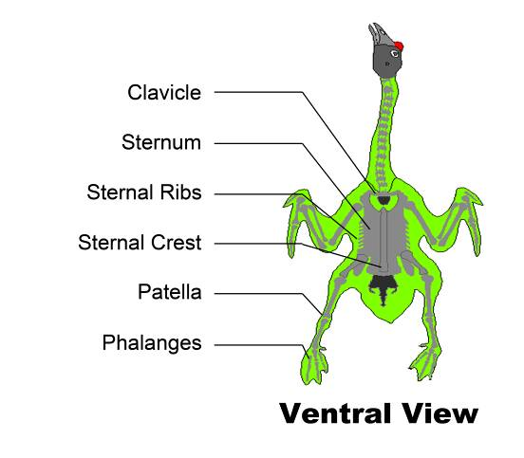 | 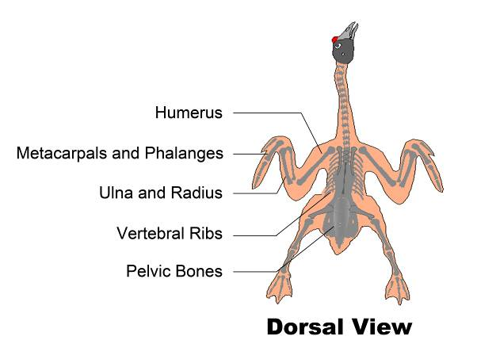
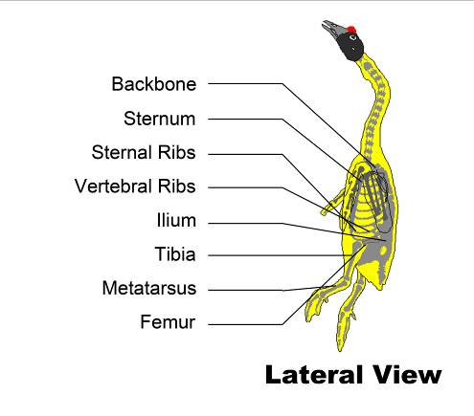

5.3 Goose meat parts

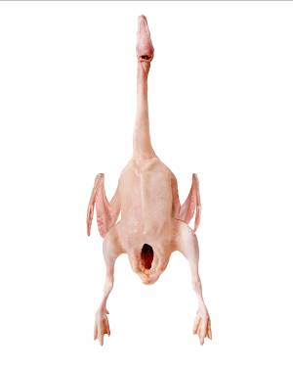 | 0101 WHOLE GOOSE WITHOUT GIBLETS, WITH HEAD AND FEET  A “whole goose without giblets, with head and feet” consists of an intact carcase with the head and feet attached. All parts, including the breast, thighs, drumsticks, wings, back and abdominal fat are also attached. The gizzard, heart and liver are removed. The oil gland and tail may or may not be present. | 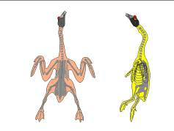
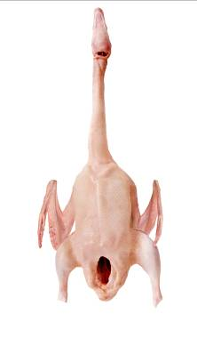 | 0102 WHOLE GOOSE WITHOUT GIBLETS, WITH HEAD  A “whole goose without giblets, with head” consists of an intact carcase with the head attached with all parts, including the breast, thighs, drumsticks, wings, back and abdominal fat. The feet, gizzard, heart and liver are removed. The oil gland and tail may or may not be present. | 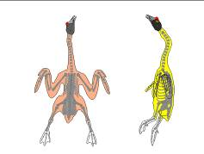
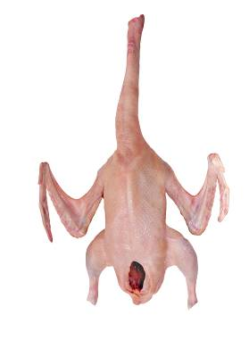 | 0103 WHOLE GOOSE WITHOUT GIBLETS, WITH WHOLE NECK  A “whole goose without giblets, with whole neck” consists of an intact carcase with the whole neck attached with all parts, including the breast, thighs, drumsticks, wings, back and abdominal fat. The head, feet, gizzard, heart, and liver are removed. The oil gland and tail may or may not be present. | 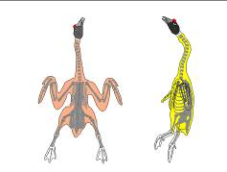
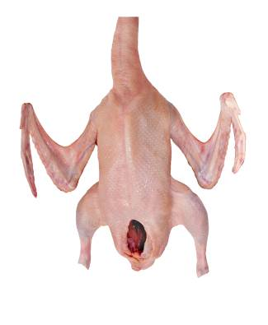 | 0104 WHOLE GOOSE WITHOUT GIBLETS, WITH HALF NECK  A “whole goose without giblets, with half neck” consists of an intact carcase with one-half of neck attached with all parts, including the breast, thighs, drumsticks, wings, back and abdominal fat. The head, one half of neck, feet, gizzard, heart, and liver are removed. The oil gland and tail may or may not be present. | 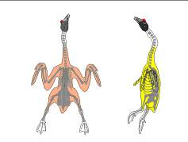
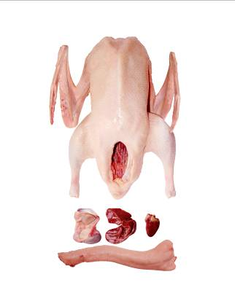 | 0105 WHOLE GOOSE WITH GIBLETS  A “whole goose with giblets” consists of an intact carcase with all parts, including the breast, thighs, drumsticks, wings, back, and abdominal fat. The head and feet are removed, and the tail may or may not be present. The gizzard, heart, liver and neck with or without skin (giblet pack) are included as separated parts. | 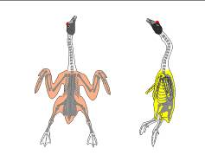
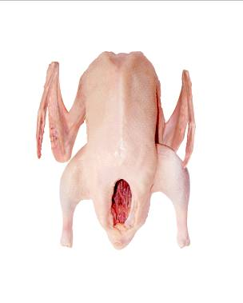 | 0106 WHOLE GOOSE WITHOUT GIBLETS  A “whole goose without giblets” consists of an intact carcase with all parts, including the breast, thighs, drumsticks, wings, back, and abdominal fat. The neck, feet, gizzard, heart and liver are removed, and the tail may or may not be present.
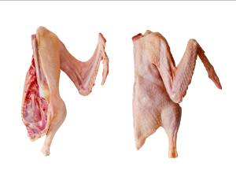 | 0201 TWO-PIECE CUT-UP (SPLIT GOOSE)  A “2-piece cut-up” is produced by splitting a whole goose without giblet (0106) end to end through the back and breast to produce approximately equal left and right carcase halves. The oil gland, tail and abdominal fat may or may not be present. Individual parts may or may not come from the same bird. | 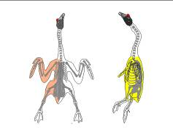
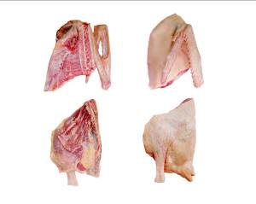 | 0202 FOUR-PIECE CUT-UP (QUARTERED GOOSE)  A “4-piece cut-up” is produced by cutting a whole goose without giblet (0106) into 2 breast quarters with wings attached and 2 leg quarters. The oil gland, tail and abdominal fat may or may not be present. Individual parts may or may not come from the same bird. | 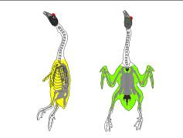
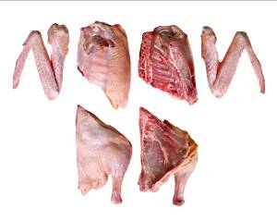 | 0203 SIX-PIECE CUT-UP  A “6-piece cut-up” is produced by cutting a whole goose without giblet (0106) into 2 split breasts with back, wings and rib portions, 2 whole wings and 2 whole legs with back portion. The oil gland, tail and abdominal fat may or may not be present. Individual parts may or may not come from the same bird. | 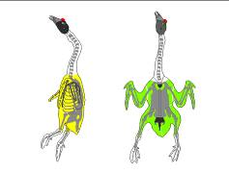
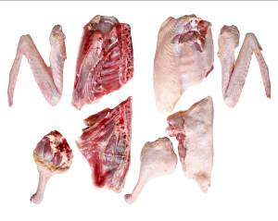 | 0204 EIGHT-PIECE CUT-UP  An “8-piece cut-up” is produced by cutting a whole goose without giblet (0106) into 2 split breasts with back and rib portions, 2 drumsticks, 2 thighs with back portion, and 2 whole wings. The oil gland, tail and abdominal fat may or may not be present. Individual parts may or may not come from the same bird. | 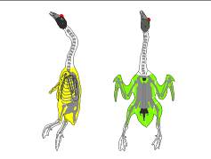
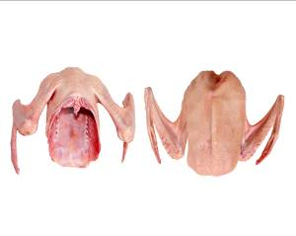 | 0301 FRONT HALF  A “front half” is produced by cutting a whole goose without giblet (0106) perpendicular to the backbone at the ilium just above the femur and downward to the tip of the metasternum. The front half consists of a full breast with the adjacent back portion and the whole wings. | 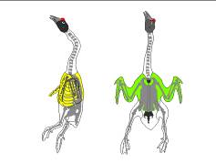
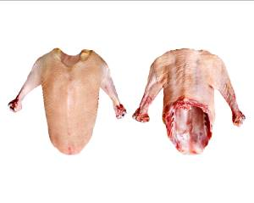 | 0302 FRONT HALF WITH FIRST SEGMENT WINGS  A “front half with first segment wing” is produced by cutting a whole goose without giblet (0106) perpendicular to the backbone at the ilium just above the femur and downward to the tip of the metasternum. The second and third wings are removed. The product consists of a full breast with the adjacent back portion and the first wing. | 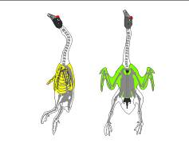
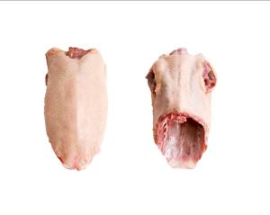 | 0303 FRONT HALF WITHOUT WINGS  A “front half without wings” is produced by cutting a whole goose without giblet (0106) perpendicular to the backbone at the ilium just above the femur and downward to the tip of the metasternum. All the wings are removed. The product consists of a full breast with the adjacent back portion. | 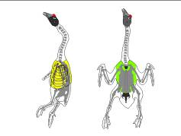
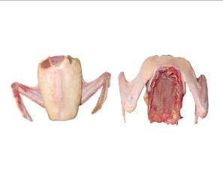 | 0304 FRONT HALF WITHOUT BACK  A “front half without back” is produced from a front half (0301) by separating the entire breast from the back by cutting along the junction of the vertebral and sternal ribs. The neck skin and back are removed. The front half without back consists of the entire breast with ribs, tenderloins and whole wings. | 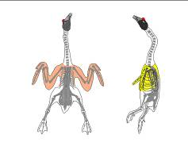
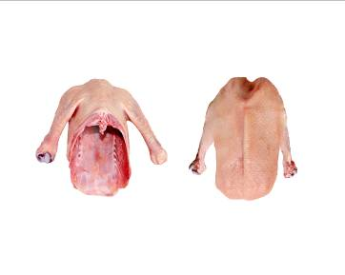 | 0305 FRONT HALF WITHOUT BACK WITH FIRST SEGMENT WING  A “front half without back with first segment wing” is produced from a front half (0301) by separating the entire breast from the back by cutting along the junction of the vertebral and sternal ribs and removing the second and third segment wings. The neck skin and back are removed. The product consists of the entire breast with ribs, tenderloins and the first wings. | 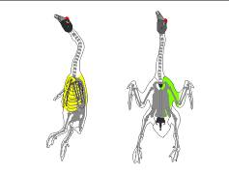
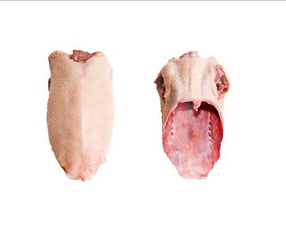 | 0306 FRONT HALF WITHOUT BACK AND WINGS  A “front half without back and wings” is produced from a front half (0301) by separating the entire breast from the back by cutting along the junction of the vertebral and sternal ribs and removing all the wings. The neck skin and back are removed. The product consists of the entire breast with ribs and tenderloins. | 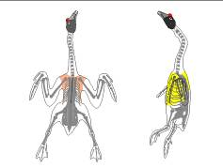
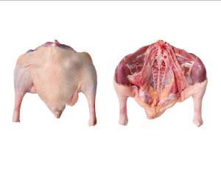 | 0401 BACK HALF (SADDLE)  A “back half” is produced by cutting a whole goose without giblets (0106) perpendicular to the backbone at the ilium just above the femur and downward to the tip of the metasternum. The back half consists of both legs with the adjoining portion of the back and adjacent abdominal fat. The oil gland may or may not be removed. The tail is attached. | 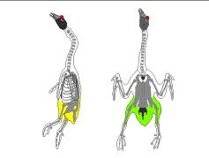
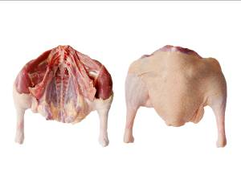 | 0402 BACK HALF WITHOUT TAIL  A “back half without tail” is produced from back half (0401) by removing tail at the joint connecting the vertebrae (back bones) and the coccygeal vertebra. The product consists of both legs with the adjoining portion of the back and adjacent abdominal fat. The tail is not attached. | 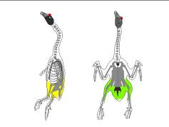
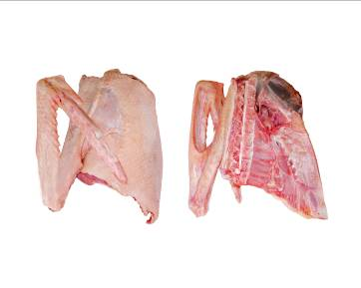 | 0501 FRONT QUARTER  A “front quarter” is produced by cutting a front half (0301) into two approximately equal portions along the center of the sternum. The front quarter consists of one half of whole breast with attached rib meat, tenderloin, bones and the whole wing. | 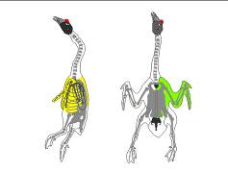
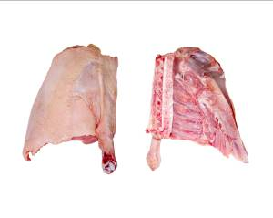 | 0502 FRONT QUARTER WITH FIRST SEGMENT WING  A “front quarter with first segment wing” is produced by cutting a front half (0301) into two approximately equal portions along the center of the sternum. The second and third wings are removed. The product consists of one half of whole breast with attached rib meat, tenderloin, bones and the first segment wings. | 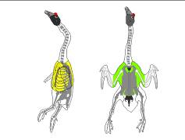
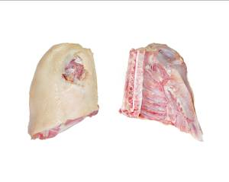 | 0503 FRONT QUARTER WITHOUT WING  A “front quarter without wing” is produced by cutting a front half (0301) into two approximately equal portions along the center of the sternum. All the wings are removed. The product consists of one half of whole breast with attached rib meat, tenderloin, and bones. | 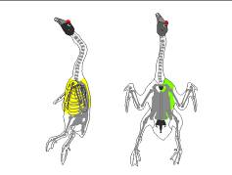
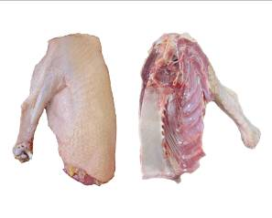 | 0504 FRONT QUARTER WITHOUT BACK WITH FIRST WING  A “front quarter without back with first wing” is produced by cutting a front half without back (0305) into two approximately equal portions along the center of the sternum. The first segment wing remains attached. | 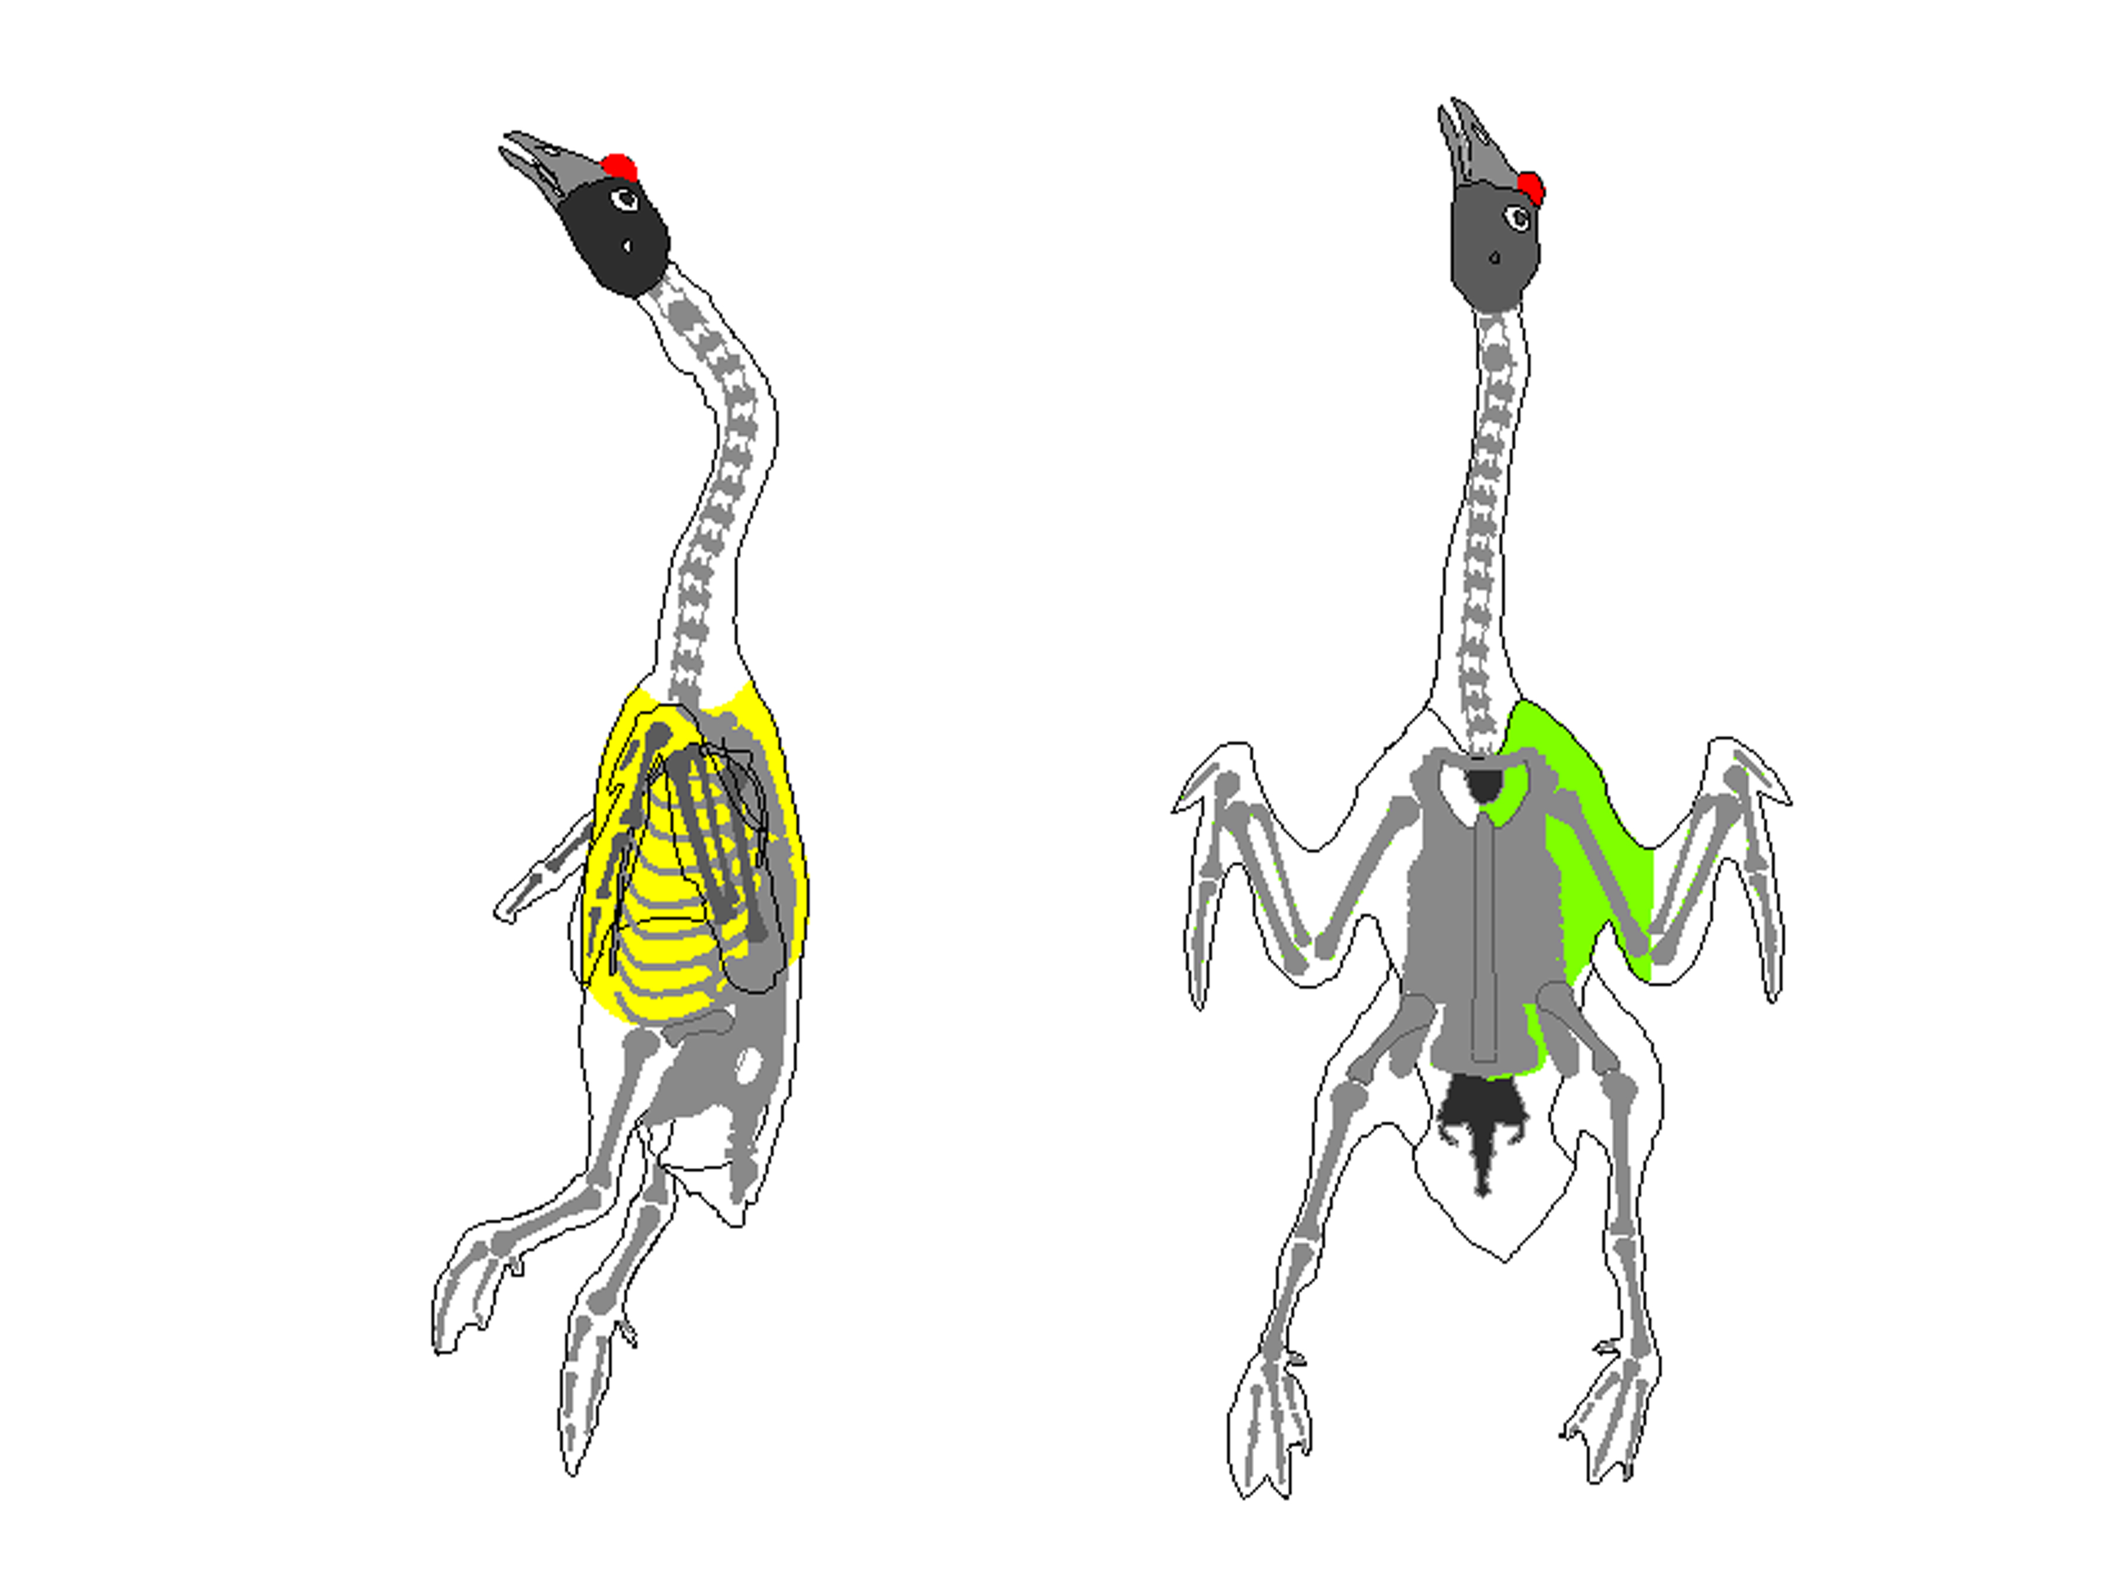
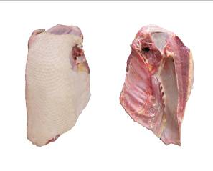 | 0505 FRONT QUARTER WITHOUT BACK AND WING  A “front quarter without back and wing” is produced by cutting a front half without back (0306) into two approximately equal portions along the center of the sternum. | 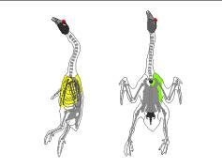
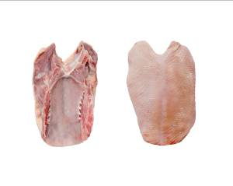 | 0601 WHOLE BREAST  A “whole breast” is produced by cutting horizontally a front half (0301) at the joint of humerus and clavicle. The whole breast consists of intact breast meat (pectoralis major and minor), wishbone, ribs and the attached skin. | 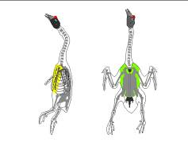
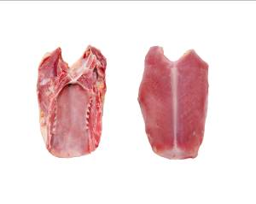 | 0602 SKINLESS WHOLE BREAST  A “skinless whole breast” is produced by cutting horizontally a front half (0301) at the joint of humerus and clavicle and removing the skin. The whole breast consists of intact breast meat (pectoralis major and minor), wishbone and ribs. The skin is removed.
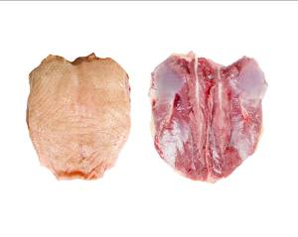 | 0603 BONELESS WHOLE BREAST  A “boneless whole breast” is produced from whole breast (0601) by removing all bones. The boneless whole breast consists of intact breast meat (pectoralis major and minor) and the attached skin.
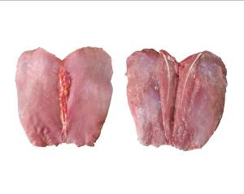 | 0604 BONELESS WHOLE BREAST WITHOUT SKIN  A “boneless whole breast without skin” is produced from whole breast (0601) by removing all bones. The boneless whole breast consists of intact breast meat (pectoralis major and minor). The skin is removed.
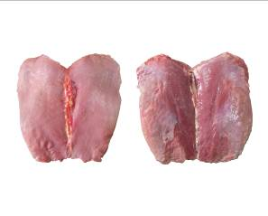 | 0605 BONELESS WHOLE BREAST WITHOUT TENDERLOINS  A “boneless whole breast without tenderloins” is produced from boneless whole breast without skin (0604) by removing tenderloins. The product just consists of intact pectoralis major muscles.
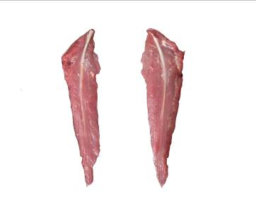 | 0606 TENDERLOINS, TENDON TIP ON  A “tenderloin with tendon tip on” is produced by separating the inner pectoralis muscle from the breast and the sternum. The product consists of a single intact muscle with embedded tendon. | 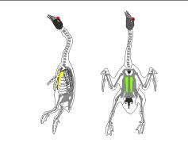
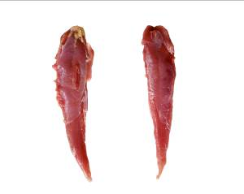 | 0607 TENDERLOINS, TENDON TIP OFF  A “tenderloin with tendon tip off” is produced by separating the inner pectoralis muscle from the breast and the sternum. The protruding portion of tendon is removed.
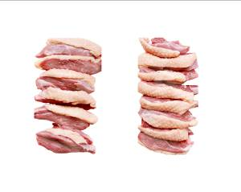 | 0608 BONELESS BREAST STRIPS  “Boneless breast strips” are produced by cutting boneless whole breasts (0603) into small long pieces. Thickness should be between 0.5 cm to 1.0 cm.
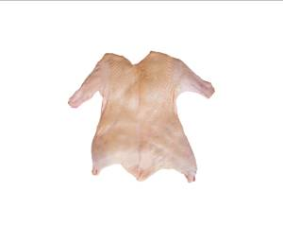 | 0609 BONELESS WHOLE GOOSE  “Boneless whole goose” consists of a carcass with the breast, thigh, and drumstick meat intact. The head and neck with skin, feet, gizzard, heart liver, oil gland and tail are removed. The wings may or may not be removed. But all bones are removed. | 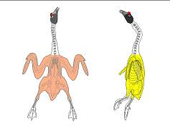
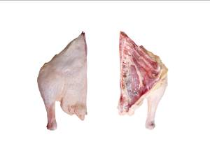 | 0701 BACK QUARTER  A “back quarter” is produced by cutting a back half (0401) into two approximately equal portions along the center of the backbone. The back quarter consists of a leg with the adjoining portion of the back and adjacent abdominal fat. The oil gland may or may not be removed. The tail is attached. | 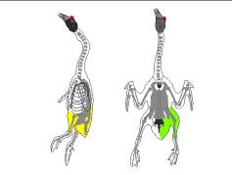
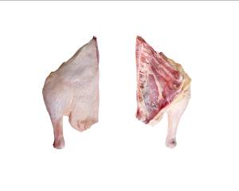 | 0702 BACK QUARTER WITHOUT TAIL  A “back quarter without tail” is produced by cutting a back half without tail (0402) into two approximately equal portions along the center of the backbone. The back quarter consists of a leg with the adjoining portion of the back and adjacent abdominal fat. The oil gland and the tail are removed. | 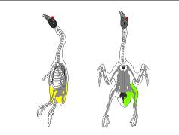
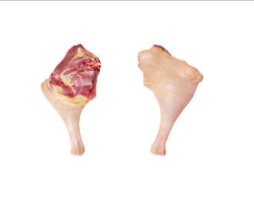 | 0801 WHOLE LEG (SHORT-CUT LEG)  A “whole leg (short-cut leg)” is produced by separating a leg from a back half (0401) between the junction of the femur and pelvic bone. The back is removed. The whole leg consists of the thigh and drumstick with associated skin and abdominal fat. | 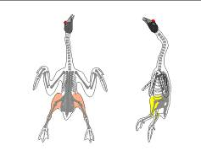
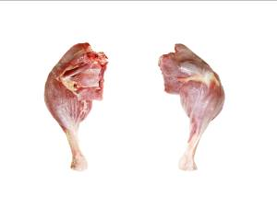 | 0802 WHOLE LEG, PROCESSED  A “processed whole leg” is produced from the whole leg (0801) by removing the abdominal fat and skin.
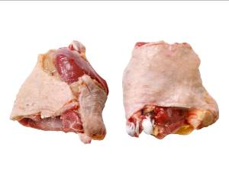 | 0901 THIGH  A “thigh” is produced by cutting a whole leg (0801) at the joint between the tibia and the femur. The drumstick and patella are removed. Meat adjacent to the ilium (oyster meat) may or may not be present. | 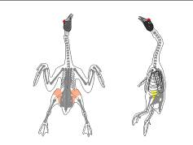
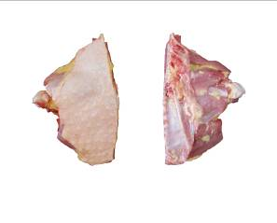 | 0902 THIGH WITH BACK PORTION  A “bone-in thigh with back portion” is produced by cutting a back quarter (0701) at the joint between the tibia and the femur. The drumstick, patella, and abdominal fat are removed. The bone-in thigh with back portion consists of the thigh, attached back portion, and associated fat. The tail and meat adjacent to the ilium (oyster meat) may or may not be present.
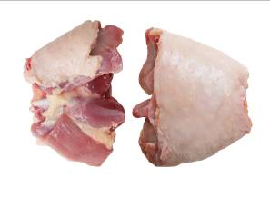 | 0903 BONELESS THIGH  A “boneless thigh” is produced by cutting a whole leg (0801) at the joint between the tibia and the femur. The drumstick, patella, femur bone, and meat adjacent to the ilium (oyster meat) are removed. The boneless thigh consists of the thigh meat.
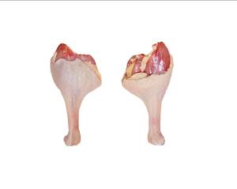 | 1001 DRUMSTICK  A “drumstick” is produced by cutting a whole leg (0801) through the joint between the tibia and femur. The thigh is removed. The drumstick consists of the drumstick and patella. The skin is attached. | 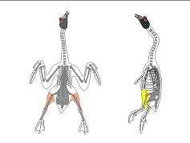
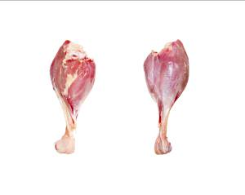 | 1002 DRUMSTICK, PROCESSED  A “processed drumstick” is produced from drumstick (1001) by removing the skin and fat.
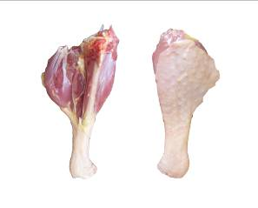 | 1003 SLANT-CUT DRUMSTICK  A “slant-cut drumstick” is produced by cutting whole leg (0801) along the tibia of the drumstick and through the joint between the tibia and femur. The thigh and a portion of the meat on one side of the drumstick are removed. The slant-cut drumstick consists of a portion of the tibia, fibula, patella and associated muscles.
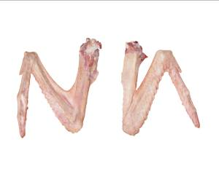 | 1101 WHOLE WING  A “whole wing” is produced by cutting the wing from a whole bird without giblets (0106) at the joint between the humerus and the backbone. The whole wing consists of the first segment (drummette) containing the humerus that attaches the wing to the body, and second segment containing the ulna and radius, and the third segment (tip) containing the metacarpals and phalanges. | 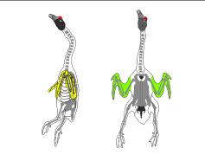
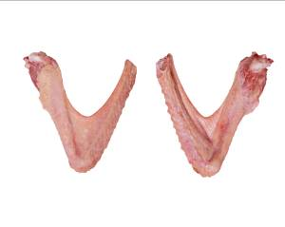 | 1102 FIRST AND SECOND SEGMENT WING (V-WING)  A “first and second segment wing” is produced by cutting a whole wing (1101) between the second and third wing segment. The third segment (tip) is removed. The first and second segment wing consists of the segment containing the humerus that attaches the wing to the body (drummette), and the segment containing the ulna and radius (flat). | 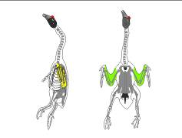
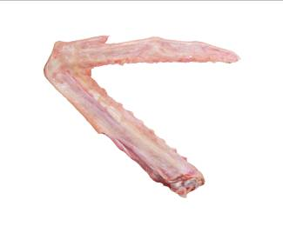 | 1103 SECOND AND THIRD SEGMENT WING (2-JOINT WING, WING PORTION)  A “second and third segment wing” is produced by cutting a whole wing (1101) between the first and second wing segment. The first segment (drummette) is removed. The second and third segment wing consists of the segment containing the ulna and radius (flat), and the segment containing the metacarpals and phalanges (tip) | 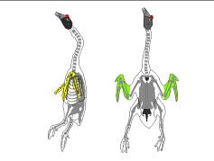
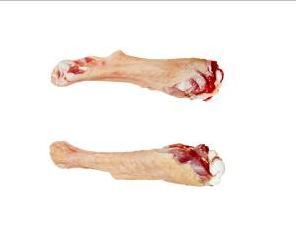 | 1104 FIRST SEGMENT WING (WING DRUMMETTE)  A “first segment wing” is produced by cutting a whole wing (1101) between the first and second segments. The second and third segments are removed. The first segment wing consists of the first segment containing the humerus that attaches the wing to the body. | 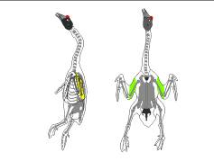
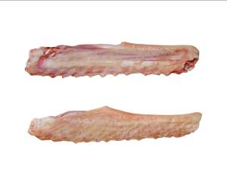 | 1105 SECOND SEGMENT WING (WING FLAT, MID-JOINT)  A “second segment wing” is produced by cutting a whole wing (1101) between the first and second segments and the second and third segments. The first and third segments (drummette and tip) are removed. The second segment wing consists of the second segment containing the ulna and radius. | 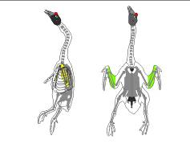
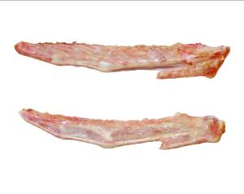 | 1106 THIRD SEGMENT WING (WING TIP, FLIPPER)  A “third segment wing” is produced by cutting a whole wing (1101) between the second and third segments. The first and second segments (drummette and flat) are removed. The third segment wing consists of the third segment containing the metacarpals and phalanges. | 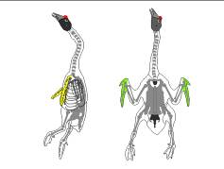
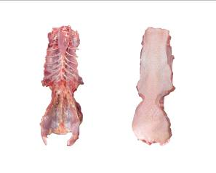 | 1201 WHOLE BACK  A “whole back” is produced by cutting a whole bird without giblets (0106) perpendicular to the backbone at the junction of the neck. A cut is then made parallel along each side of the backbone through the vertebral ribs down to the base of the ilium, and along the outer edge of the pelvic bones. The whole back consists of the entire backbone, ilium, and pelvic bones with attached meat and skin. The tail, abdominal fat, and portions of the kidneys and testes may or may not be present. | 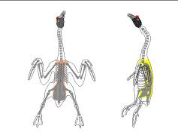
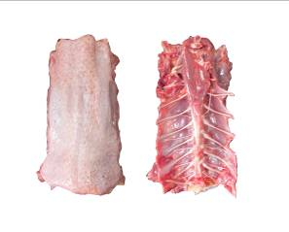 | 1202 UPPER BACK  An “upper back” is produced by cutting a front half without wings (0303) along each side of the backbone to remove the breast and vertebral ribs. The upper back consists of the upper backbone (approximately 1.6 cm (5/8 inch) in width) with attached meat and skin. | 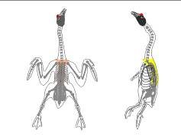
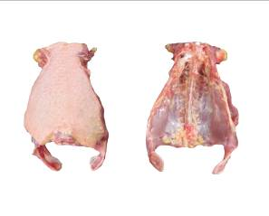 | 1203 LOWER BACK  A “lower back” is produced by cutting a back half (0401) through the joint between the femur and the pelvic bone to remove each of the legs. The lower back consists of the lower backbone, ilium, and pelvic bones with attached meat and skin. The tail, abdominal fat, and portions of the kidneys and testes may or may not be present. | 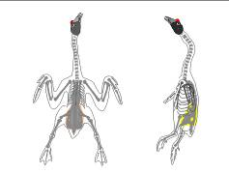
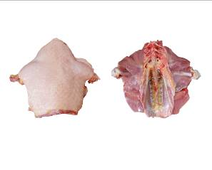 | 1204 LOWER BACK WITH THIGH  A “lower back with thigh” is produced by cutting a back half (0401) through the joint between the thigh and drumstick to remove each of the drums. The lower back with thigh consists of the lower backbone, thighs, ilium, and pelvic bones with attached meat and skin. The tail, abdominal fat, and portions of the kidneys and testes may or may not be present. | 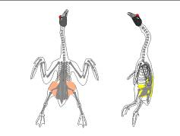
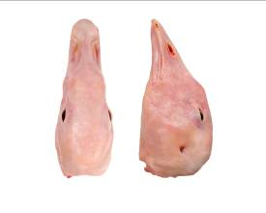 | 1301 HEAD  A “head” is produced by cutting the carcase at the upper neck and removing the carcase. The head consists of the skull bones and contents with attached beak, meat, and skin. | 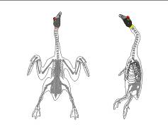
1302 HEAD WITHOUT TONGUE
A “head without tongue” is produced by from a head (1301) by removing tongue. The head without tongue consists of the skull bones and contents with attached beak, meat and skin. The tongue is not attached.
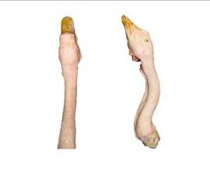 | 1303 HEAD WITH NECK  A “head with neck” is produced from a whole goose with head (0102) by cutting at the shoulder joint after separating the whole goose without neck (0106). The head with neck consists of the skull bones, beak and the whole neck with meat and skin. The tongue may or may not be attached. | 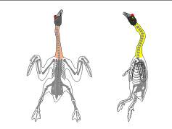
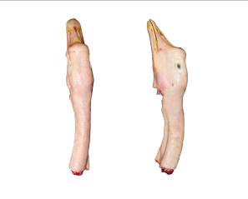 | 1304 HEAD WITH HALF NECK  A “head with half neck” is produced from a whole goose with head (0102) by cutting at the half of neck after separating the whole goose with half neck (0105). The head with half-neck consists of the skull bones, beak and a portion of neck with meat and skin. The tongue may or may not be attached. | 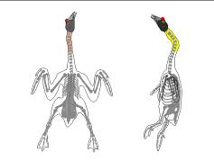
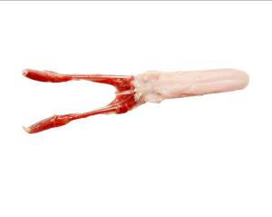 | 1305 TONGUE  A “tongue” consists of the tongue blade with the hyoid bones (without the stylohyoid). The larynx, three tracheal rings, lymph nodes, salivary glands, fat and associated fat on the lateral and ventral surface of the tongue must be trimmed.
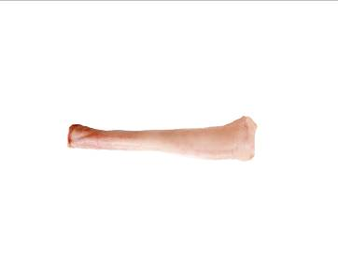 | 1401 NECK  A “neck” is produced by cutting the neck from the carcase at the shoulder joint and removing the head. The neck consists of the neck bones with attached meat and/or skin. | 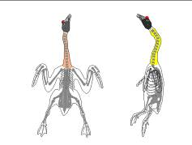
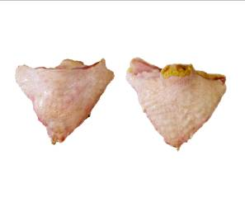 | 1501 TAIL  The “tail” is produced by cutting the carcase through backbones and the base of the ilium, and removing the carcase. The tail consists of the tailbones with attached meat and skin.  The oil gland is usually removed. | 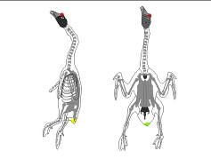
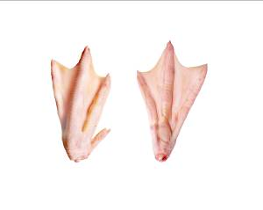 | 1601 PAWS, PROCESSED  A “processed paw” is produced by cutting a carcase leg through the metatarsus approximately at the metatarsal spur. The nail sheaths, thin yellow epidermal skin covering the paw, and carcase are removed. A processed paw consists of a portion of the metatarsus and four digits (phalanges) with attached meat and skin. | 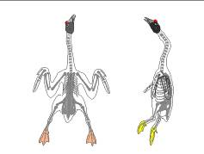
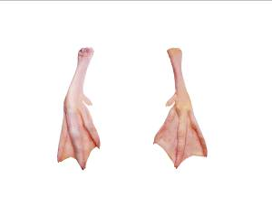 | 1602 FEET, PROCESSED  A “processed foot” is produced by cutting a carcase leg at the joint between the metatarsus and the tibia. The carcase is removed. The nail sheaths and thin yellow epidermal skin covering the foot are removed. A processed foot consists of the metatarsus and four digits (phalanges) with attached meat and skin. | 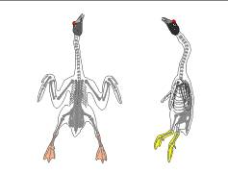
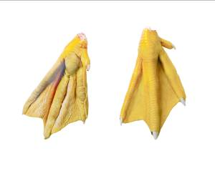 | 1603 PAWS, UNPROCESSED  An “unprocessed paw” is produced by cutting a carcase leg at the joint between the metatarsus approximately at the metatarsal spur. The carcase is removed. A paw consists of a portion of the metatarsus and four digits (phalanges) with attached meat and skin. The nail sheaths and thin yellow epidermal skin covering the paw are not removed.
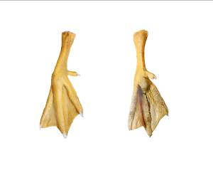 | 1604 FEET, UNPROCESSED  An “unprocessed foot” is produced by cutting a carcase leg at the joint between the metatarsus and the tibia. The carcase is removed. A foot consists of the metatarsus and four digits (phalanges) with attached meat and skin. The nail sheaths and thin yellow epidermal skin covering the foot are not removed.
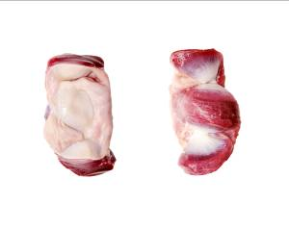 | 1701 GIZZARDS, BUTTERFLY-CUT  The “butterfly-cut gizzard” is removed from a carcase body cavity. Gizzards are cut open horizontally and processed by removing the inner lining and contents. Fat and other adhering organs are removed. The butterfly-cut gizzard consists of one slightly irregularly shaped, muscular portion of the digestive canal.
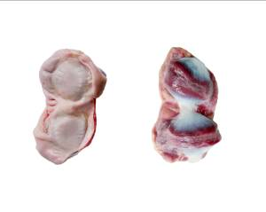 | 1702 GIZZARDS, V-STYLE CUT  The “v-style cut gizzard” is removed from a carcase body cavity. Gizzards are cut open vertically and processed by removing the inner lining and contents. Fat and other adhering organs are removed. The v-style cut gizzard consists of one slightly irregularly shaped, muscular portion of the digestive canal.
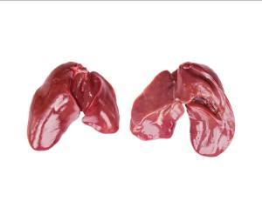 | 1801 LIVER  The “liver” is removed from a carcase body cavity. The bile sac (gall bladder) is removed. The liver consists of a smooth brownish to reddish coloured organ with one or more lobes that is irregular in shape and size.
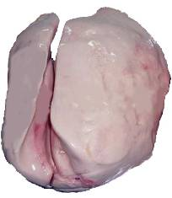 | 1802 FAT GOOSE LIVER  The “fat goose liver” is removed from a carcase body cavity. The bile sac (gall bladder) is removed. The liver consists of a smooth yellowish to white coloured organ with one or more lobes that is irregular in shape and size. The liver is used for the production of foie gras, which contains high level of fat and its weight is usually higher than 500 grams.
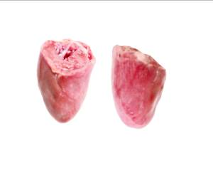 | 1901 HEARTS, CAP-OFF  The “cap-off heart” is removed from a carcase body cavity. Fat attached to the heart and the pericardial sac is removed. The cap-off heart consists of a muscular organ that circulates blood.
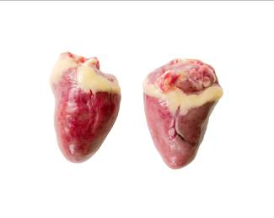 | 1902 HEARTS, CAP-ON  The “cap-on heart” is removed from a carcase body cavity. Fat attached to the heart, the pericardial sac and the aortal cap are not removed. The cap-on heart consists of a single muscular piece that circulates blood with associated heart tissue.
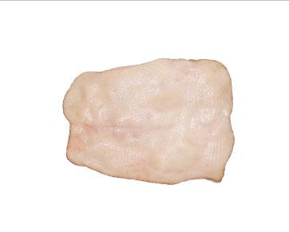 | 2001 BREAST SKIN  “Breast skin” consists of the exterior layer of tissue that encloses the breast area from a carcase, whole breast, or split breast. The neck skin is not present.
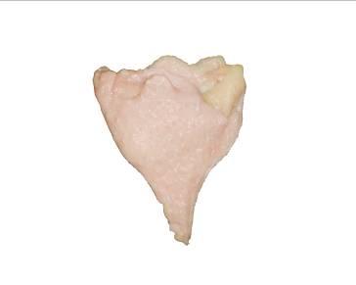 | 2002 THIGH/LEG SKIN  “Thigh/leg skin” consists of the exterior layer of tissue that encloses the thigh or leg area of a carcase, back half, or leg.
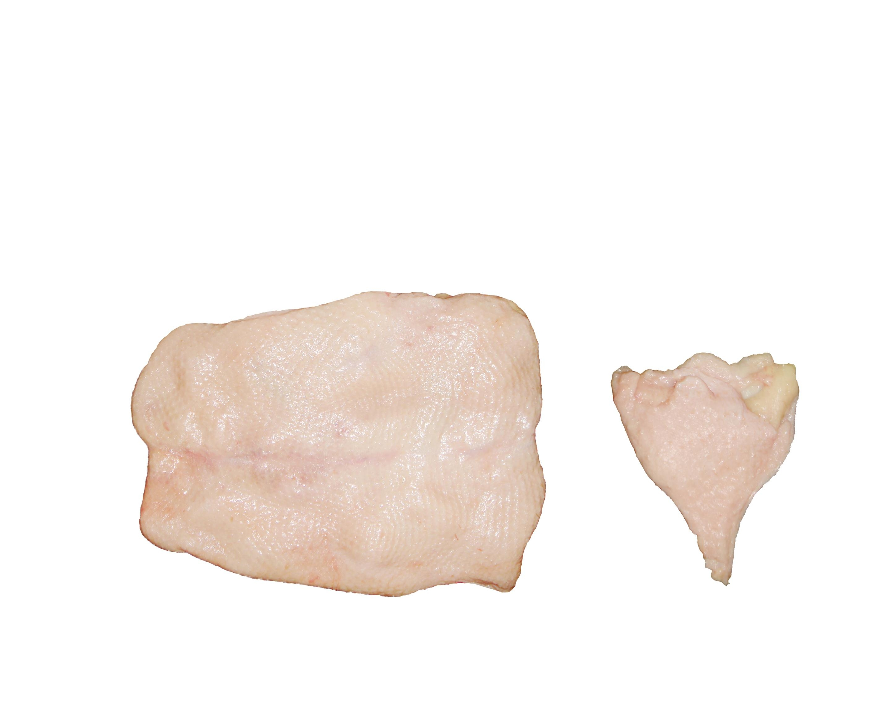 | 2003 BODY SKIN  “Body skin” consists of the exterior layer of tissue that encloses the entire carcase, excluding the neck area.
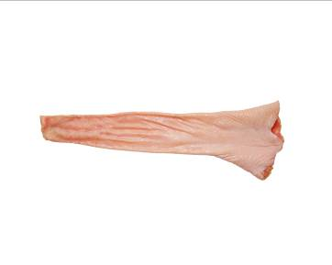 | 2004 NECK SKIN  “Neck skin” consists of the exterior layer of tissue that encloses the neck area of a carcase.
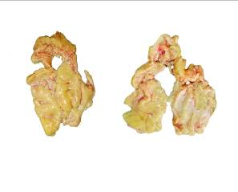 | 2101 ABDOMINAL FAT (LEAF FAT)  “Abdominal fat” consists of a mass of adipose tissue located in the abdominal cavity adjacent to the pelvic bones.
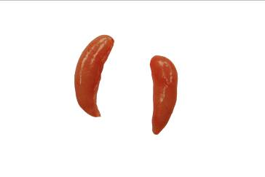 | 2201 TESTES  “Testes” are removed from a carcase body cavity. Testes consist of membrane-covered, bean-shaped bodies that are the male goose reproductive organs.
2301 2-PRODUCT COMBINATIONS (2-PRODUCT COMBO)
A “two-product combination” consists of two goose parts (e.g. drumsticks and thighs) or products (e.g. gizzards and livers) that are packaged together or packed in the same package or shipping container.
When placing an order, indicate in writing the product/part code for each product to be delivered, and include the product ratio (e.g. 2 drumsticks per 1 thigh, or equal proportions (1:1) of gizzards and livers).
2302 3-PRODUCT COMBINATIONS (3-PRODUCT COMBO)
A “three-product combination” consists of three goose parts (e.g. drumsticks, thighs, and wings) or products (e.g. necks, gizzards, and livers) that are packaged together or packed in the same package or shipping container.
When placing an order, indicate in writing the product/cut code for each product to be delivered, and include the product ratio (e.g. 2 drumsticks and 2 wings, per 1 thigh, or equal proportions (1:1:1) of necks, gizzards, and livers).
2303 4-PRODUCT COMBINATIONS (4-PRODUCT COMBO)
A “four-product combination” consists of four goose parts (e.g. breast, drumsticks, thighs, and wings) or products (e.g. necks, gizzards, livers, and hearts) that are packaged together or packed in the same package or shipping container.
When placing an order indicate in writing the product/cut code for each product to be delivered, and include the product ratio (e.g. equal proportions (1:1:1:1) of breasts, drumsticks, thighs, and wings).
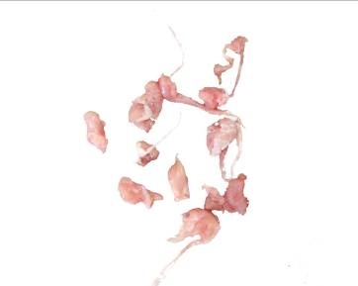 | 2401 TRIMMINGS  “Trimmings” are produced by removing all small portions of meat from carcases or parts. The bones are removed. The trimming consists of random size pieces of boneless meat. All trimmings are covered.
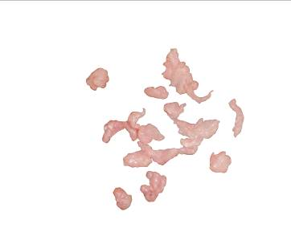 | 2402 BREAST TRIMMINGS  “Breast trimmings” are produced by removing small portions of breast meat from breasts from carcases or parts. The bones are removed. The breast trimming consists of random size pieces of boneless breast meat.
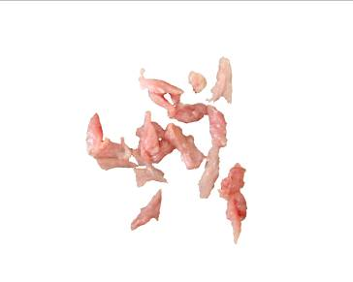 | 2403 THIGH TRIMMINGS  “Thigh trimmings” are produced by removing small portions of thigh meat from thighs from carcases or parts. The bones are removed. The thigh trimming consists of random size pieces of boneless thigh meat.
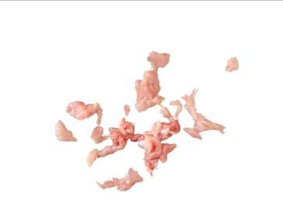 | 2404 DRUMSTICK TRIMMINGS  “Drumstick trimmings” are produced by removing small portions of drumstick meat from drumsticks from carcases or parts. The bones are removed. The drumstick trimming consists of random size pieces of boneless drumstick meat.
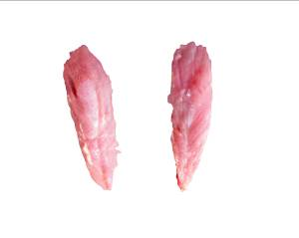 | 2405 ILIUM MEAT (OYSTER)  “Ilium meat” consists of the boneless meat adjacent to the ilium bone.
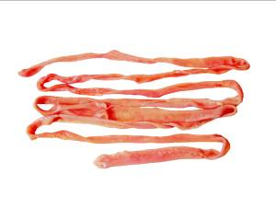 | 2406 INTESTINES (CHITTERLINGS)  The “intestines” are produced by removing the digestive tube from the carcase. The intestines consist of the alimentary canal, which extends from the stomach to the anus emptied of their content and processed.
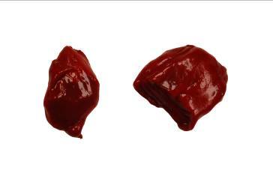 | 2407 BLOOD, UNPROCESSED  The “unprocessed blood” is produced by removing blood from the live goose during bleeding. The unprocessed goose blood consists of the blood cells, sarcoplasm, and other contents. The blood may or may not be coagulated.
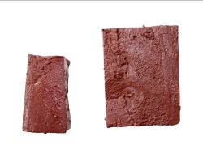 | 2408 BLOOD, PROCESSED  The “processed blood” is produced by removing blood from the live goose during bleeding and heating in a boiling water bath.

Annex I

Codification system

1. Purpose of the GS1 system

The GS1 system is widely used internationally to enhance communication between buyers and sellers and third-party conformity assessment entities. It is an identification and communication system standardized for use across international borders. It is managed by GS1 Global Office, together with national GS1 member organizations around the world.

The system is designed to overcome the limitations of using company, industry or country-specific coding systems and to make trading more efficient and responsive to trading partners. The use of the GS1 standards improves the efficiency and accuracy of international trade and product distribution by unambiguously identifying trade items, services, parties, and locations. GS1 identification numbers can be represented by data carriers (e.g. bar code symbols) to enable electronic reading whenever required in the trading process.

GS1 standards can be used in Electronic Data Interchange (EDI) and the GS1 Global Data Synchronization Network (GDSN). Trading partners use EDI to electronically exchange messages regarding the purchase and shipping status of product lots. Trading partners use GDSN to synchronize trade-item and party information in their back-end information systems. This synchronization supports consistent global product identification and classification, a critical step towards efficient global electronic commerce.

2. Use of the UNECE code in the GS1 system

GS1 uses application identifiers as prefixes to identify the meaning and format of the data that follow it. It is an open standard, which can be used and understood by all companies in the international supply chain, regardless of the company that originally issued the codes.

The UNECE purchase specification code defined in section 4.1 has been assigned the GS1 application identifier (7002) to be used in conjunction with a Global Trade Item Number (GTIN) and represented in the GS1-128 bar code symbology. This allows the UNECE code information to be included in GS1-128 bar code symbols on shipping containers along with other product information (see examples 1 and 2).

UNECE meat-cut definitions are also being proposed for use by suppliers as an attribute of the GDSN global product classification system. In this way, suppliers can use the UNECE meat-cut code to globally specify the cut of each product GTIN in the GDSN. Once defined by the supplier, all interested buyers will know the exact UNECE cut of each product published in the GDSN (see example 3).

Example 1:

(01) Global Trade Item Number (GTIN)
(3102) Net weight, kilograms
(15) Use-by date
(7002) UNECE purchase specification code
(10) Batch number

Example 2:

(01) Global Trade Item Number (GTIN)
(3102) Net weight, kilograms
(13) Slaughter/packing date
(21) Serial number

Other data, such as the UNECE code, refrigeration, grade and fat depth can be linked to the GTIN via Electronic Data Interchange (EDI) messages.

3. Application of the system in the supply chain
(1) Customers order, using the UNECE standard and the coding scheme. | 
(2) On receipt of the order, the suppliers translate the UNECE codes into their own trade item codes (i.e. Global Trade Item Number). | 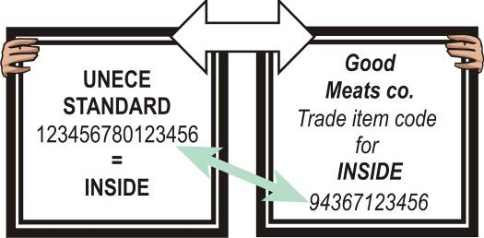
(3) Suppliers deliver the order to the customers. The goods are marked with the GS1-128 bar code symbol. | 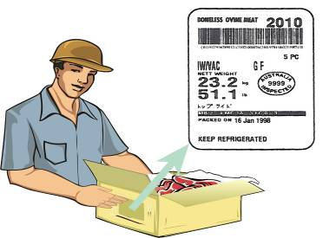
(4) Customers receive the order and the GS1-128 bar code symbol scanned, thus allowing for the automatic update of commercial, logistics and administrative processes. | 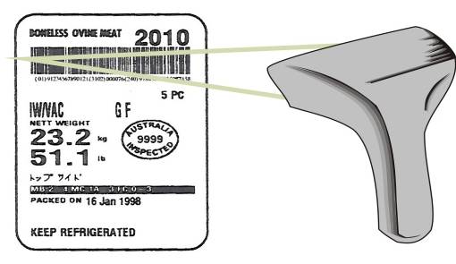
(5) The physical flow of goods, marked with GS1 standards, may be linked to the information flow using Electronic Data Interchange (EDI) messages.
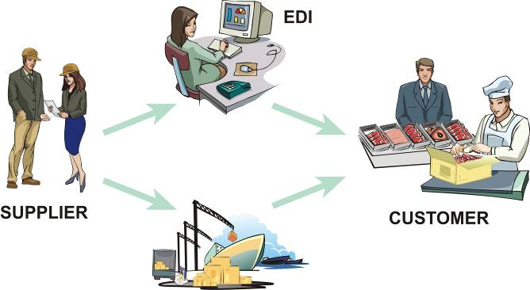
Example 3:

4. Use of UNECE meat-cut definitions in the GDSN

(1) Suppliers publish or update information about a product in the GDSN and use the appropriate UNECE meat-cut definition to define the meat cut of the product using the GDSN meat cut attribute.

(2) Interested buyers use the UNECE meat cut and other product information published in the GDSN to synchronize product information in their own information systems.

(3) Buyers use UNECE meat-cut information in their information systems to identify by GTIN which products they wish to order.

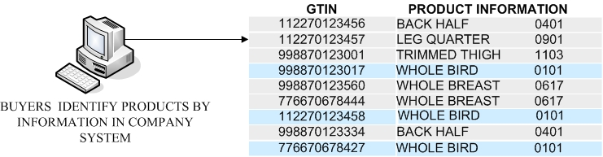

(4) Buyers use product GTIN and related information to order product from supplier using EDI or GDSN-compatible data pool service providers.
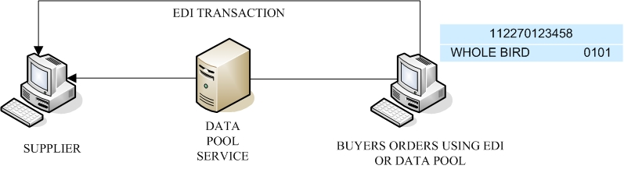
Annex II

Addresses

United Nations  Economic Commission for Europe  Agricultural Standards Unit  Palais des Nations  CH – 1211 Geneva 10  SWITZERLAND  Tel: +41 22 917 1234  Fax: +41 22 917 0629  e-mail: agristandards@unece.org  http://www.unece.org/trade/agr/ | GS1 International  Blue Tower  Avenue Louise, 326  BE 1050 Brussels  BELGIUM  Tel: +32 2 788 7800  Fax: +32 2 788 7899  http://www.gs1.org/contact/
AUS-MEAT Ltd  Unit 1 / 333 Queensport Road North  Murarrie  Queensland 4172  AUSTRALIA  Tel: +61 7 33 61 92 00  Fax: +61 7 33 61 92 22  E-mail: ausmeat@ausmeat.com.au  http://www.ausmeat.com.au/ | Poland  Poland  Ministry of Agriculture and Rural Development  30 Wspolna St.  00-930 Warsaw  POLAND  Tel: +48 22 623 20 61  Fax: +48 22 623 23 00  e-mail: joanna.trybus@minrol.gov.pl  integracja@ijhar-s.gov.pl
France  Direction générale de la consommation, de la concurrence et de la répression des fraudes  Cité Administrative,  Bd de la Liberté - CS92104  Rennes Cédex 9  CP 35021  FRANCE  Tel: +33 2 99 29 76 00  Fax: +33 2 99 29 80 05  E-mail: alain.boismartel@dgccrf.finances.gouv.fr | United States Department of Agriculture (USDA)  Agricultural Marketing Service  Poultry Program  1400 Independence Ave., S.W.  Washington D.C. 20250 0249  UNITED STATES  Tel: +1 202 690 3148  Fax: +1 202 690 0941  E-mail: David.Bowden@usda.gov  http://www.ams.usda.gov
China  National Center of Meat Quality and  Safety Control  Nanjing Agricultural University  1 Weigang St.  210095 Nanjing  CHINA  Tel: +86 25-84395376  Fax : +86 25-84395939  E-mail : ghzhou@njau.edu.cn  http://www.meat-food.com | All Russian Research Institute for the  Poultry Industry  VNII Ptitsepererabatyvayuschei Promychlennosti  P/o Rzhavki  Rzhavki Village  141552, district of Solnechnogorski  Region of Moscow  RUSSIAN FEDERATION  Tel: +7 (495) 944 6403  Fax: +7 (495) 944 6352  E-mail : vniipp@orc.ru

------

When specified by the purchaser, meat items will be subject to metal particle detection.
Unless these organs are inherent to the item specified.
This can only be allowed if disclosed by the seller and as permitted by national legislation and by the quality or grade selected.
Freezer-burn is localized or widespread areas of irreversible surface dehydration indicated, in part or all, by changes from original color (usually paler), and / or tactile properties (dry, spongy).
The dry ice shall not be in direct contact with the product.
This method of refrigeration shall only be used for short-term storage for retail.
Special diet or feeding regime for this category.
In order to indicate types of farming on the labelling, this should be conformed to relevant legislation of the importing country.
Organic production systems include specific feeding systems. The option “organic” is therefore not repeated under feeding system.
 Growth promoters include hormones or antibiotics in excess of veterinarian recommended dosages.
If used, the quality level should conform to relevant legislation of the importing country. If such legislation does not exist, the definition of the quality level should be agreed between buyer and seller.

