UNITED  NATIONS |  | E
 | Economic and Social  Council | Distr.  GENERAL  ECE/TRADE/C/WP.7/GE.2/2008/4  18 April 2008  Original: ENGLISH
ECONOMIC COMMISSION FOR EUROPE

COMMITTEE ON TRADE

Working Party on Agricultural Quality Standards

Specialized Section on Standardization of Dry and Dried Produce

Fifty-fifth session
Geneva, 23-27 June 2008
Item 6(b) of the provisional agenda
Revised version
(June, 2008)

NEW UNECE StandardS

whole dried chilli peppers

Document submitted by Mexico

This document has been prepared following the decision by the Working Party to initiate work on a new Standard for whole dried chilli peppers (ECE/TRADE/C/WP.7/2007/27, para. 32).

UNECE STANDARD DDP- ...
concerning the marketing and commercial quality control of

WHOLE DRIED CHILLI PEPPERS
(ancho, de árbol, guajillo, mulato, pasilla and puya)

I. DEFINITION OF PRODUCE

This Standard applies to whole dried chilli peppers of varieties (cultivars) grown from Capsicum annuum L., (Commercial types: ancho, de árbol, guajillo, mulato, pasilla and puya), intended for direct consumption or for food when intended to be mixed with other products for direct consumption without further processing. This Standard does not apply to whole dry chilli peppers for industrial processing.

II. PROVISIONS CONCERNING QUALITY

The purpose of the Standard is to define the quality requirements of whole dried chilli peppers at the export-control stage, after preparation and packaging.

However, if applied at stages following export, the holder shall be responsible for observing the requirements of the standard. The holder/seller of products not in conformity with this standard may not display such products or offer them for sale, or deliver or market them in any other manner.

A. Minimum requirements

In all classes, subject to the special provisions for each class and the tolerances allowed, the whole dried pepper must display the following characteristics:

- intact; however, slight superficial damage is not considered as a defect
- sound; produce affected by rotting or deterioration such as to make it unfit for consumption is excluded
- clean, practically free of any visible foreign matter
- sufficiently developed with attached peduncle

- present characteristic shape of the type and colour in accordance with section “D. Colour”
- free from living pests whatever their stage of development
- free from damage caused by pests, including the presence of dead insects and/or mites, their debris or excreta
- free from blemishes, areas of discolouration or spread stains in pronounced contrast with the rest of the produce affecting in aggregate more than … per cent of the surface of the produce
- free from mould filaments visible to the naked eye
- free of abnormal external moisture
- present taste (pungency or hotness) characteristic in accordance with section “E. Pungency” (ref. Table 3)
- present the characteristic odour
- free of foreign smell and/or taste; free from any toasted or burnt taste.

The condition of the whole dried chillies must be such as to enable them:

- to withstand transportation and handling
- to arrive in satisfactory condition at the place of destination.

B. Moisture content

The whole dried chillies shall have a moisture content depending on the type, according to the following table:

TABLE 1

Maximum moisture content in percentage
Ancho | 12.5
De árbol | 9.0
Guajillo | 13.5
Mulato | 12.5
Pasilla | 13.5
Puya | 10.0

C. Classification
In accordance with the defects allowed in section “IV. Provisions concerning tolerances”, whole dried chilli peppers of varieties (cultivars) grown from Capsicum annuum L., (ancho, de árbol, guajillo, mulato, pasilla and puya) are classified into the following classes:

Extra Class, Class I and Class II.

The classified product is designed by name, type, size and quality.

The defects allowed must not affect the general appearance of the produce as regards quality, keeping quality and presentation in the package.

D. Colour
Colour classification for whole dried chillies is mandatory, depending on the type, based on the colours defined below:
[
TABLE 2

Colour
Type | Colour  (°Hue) | Extra | Class I | Class II
Ancho | 54.07 - 59.21 | Uniform; light red to dark red, free from discolouring | Uniform; intense red to dark red with no discoloration. | Uniform; intense red to dark red slightly discoloured.
De árbol | 46.74 - 57.23 | Not applicable | Uniform; intense red without any discolouration | Intense red. May present discolouring stains.
Guajillo | 47.33-56.96 | Uniform; intense or dark red with no discoloration | Uniform; intense or dark red with no discoloration | Uniform; intense or dark red with slight discoloration
Mulato | 70.54 – 71.27 | Uniform; intense black, free from discolouring | Uniform; intense black, free from discolouring | Non-uniform; black, discoloured.
Pasilla | 70.28 – 74.66 | Uniform intense black without discolouration | Uniform black without discolouring. | Non-uniform; black or greenish. Slightly discoloured.
Puya | 45.48 -46.51 | Uniform; intense or dark red with no discoloration | Not totally uniform; intense or dark red with no discoloration | Not totally uniform; intense or dark red slightly discoloured
]

E. Pungency
Pungency is analysed using the Scoville scalecomplying with the following parameters:

TABLE 3

Pungency intensity (Scoville units)
Ancho | 1 000 – 1 500
De árbol | 5 000 – 30 000
Guajillo | 3 000 – 5 000
Mulato | 1 000 – 1 500
Pasilla | 1 000 – 1 500
Puya | 5 000 – 30 000

III. PROVISIONS CONCERNING SIZING

Sizing is mandatory, size being a commercial differentiation parameter.

Sizing is determined according to the length (measure from the apex of the fruit without considering the peduncle), width (at the broader part of the fruit - shoulder) and weight (including the peduncle).
Sizing is designated according to the following:

TABLE 4
Type | Class | Length  (cm) | Width  (cm) | Weight  (g) | Flesh weight  (g)
Ancho | Extra | > 10 | > 6 | > 22 | = ((0.7364)(weight) - 0.0898)) (0.85)
Ancho | Class I | 7 – 10 | 5 – 6 | 20 – 22 | = ((0.7364)(weight) - 0.0898)) (0.85)
Ancho | Class II | 7 – 10 | < 5 | < 20 | = ((0.7364)(weight) - 0.0898)) (0.85)
De árbol | Extra | Not applicable | Not applicable | Not applicable | ----------
De árbol | Class I | 9 – 11 | > 1.0 | 1.0 – 1.5 | ----------
De árbol | Class II | 7 < 9 | < 1.0 | < 1.0 | ----------
Guajillo | Extra | > 14 | > 3 | > 9 | = ((0.7298)( weight) - 0.2372)) (0.85)
Guajillo | Class I | 10 – 14 | 2.5 – 3 | 5 – 9 | = ((0.7298)( weight) - 0.2372)) (0.85)
Guajillo | Class II | < 10 | < 2.5 | < 5 | = ((0.7298)( weight) - 0.2372)) (0.85)
Mulato | Extra | > 10 | >7 | > 17 | = ((0.7643)(weight) - 0.1653)) (0.85)
Mulato | Class I | 7 – 10 | 5 – 7 | 14 – 17 | = ((0.7643)(weight) - 0.1653)) (0.85)
Mulato | Class II | < 7 | < 5 | < 14 | = ((0.7643)(weight) - 0.1653)) (0.85)
Pasilla | Extra or “Flower” | > 20 | > 3 | > 7.5 | = ((0.6889)(weight) + 0.1187)) (0.85))
Pasilla | Class I | 14 – 20 | 2.5 – 3 | 7.0 – 7.5 | = ((0.6889)(weight) + 0.1187)) (0.85))
Pasilla | Class II | < 14 | < 2.5 | < 7.0 | = ((0.6889)(weight) + 0.1187)) (0.85))
Puya | Extra | > 10 | > 1.5 | > 3.5 | = ((0.7906)(weight) - 0.5948)) (0.85)
Puya | Class I | 8 – 10 | 1.0 – 1.5 | 3.0 – 3.5 | = ((0.7906)(weight) - 0.5948)) (0.85)
Puya | Class II | < 8 | < 1.0 | < 3.0 | = ((0.7906)(weight) - 0.5948)) (0.85)

[IV. PROVISIONS CONCERNING TOLERANCES

Tolerances in respect of quality and size shall be allowed in each lot for produce not satisfying the requirements of the class indicated.

A. Quality tolerances

The allowed percentage refers to the lot. The percentage that does not correspond to the designation declared will be evaluated by weight.

Defects allowed | Tolerances allowed  percentage of defective produce, by weight
Defects allowed | Extra | Class I | Class II
- Tolerances for whole dried chillies not satisfying the minimum requirements

of which no more than
- Not sufficiently developed | 2 | 2 | 2
- Mouldy | 0 | 0 | 0
- Fragmented or broken | 5 | 5 | 5
- Damaged by pests | 0 | 0 | 0
- Rotting | 0.5 | 1 | 1.5
- Living pests | 0 | 0 | 0
(b) Size tolerances
- For produce not conforming to the size indicated, if sized | 5 | 15 | Not applicable
(c) Tolerances for other defects
- Foreign matter, including rachis, pits, fragments of pits and dust (by weight) | 1 | 1 | 1
- Whole dried chillies belonging to other varieties {or commercial types} other than that indicated | 0 | 0 | 0
- Loose capstems or peduncules | 5 | 5 | 5
- Slight defects: stains, burns, scrapes and deformations in no more than 5% of the surface of the product | 2 | 10 | 100
- Serious defects in guajillo chillies: stains, burns, scrapes, scars and deformations in more than 5% of the surface and less than 30% of it, that affect the flesh of the product | 0 | 0 | 40
- Serious defects in all other chillies (ancho, mulato, de árbol, puya and pasilla): stains, burns, scrapes, scars and deformations in more than 5% of the surface and less than 30% of it that affect the flesh of the product | 0 | 0 | 100
]

V. PROVISIONS CONCERNING PRESENTATION

A. Uniformity

The contents of each package must be uniform and contain only whole dried chillies of the same origin, quality, size (if sized) and variety or commercial type (if indicated).

The visible part of the contents of the package must be representative of its entire contents.

B. Packaging

Whole dried chillies must be packed in such a way as to protect the produce properly.

The materials used inside the package must be clean and of a quality so as to avoid causing any external or internal damage to the produce. The use of materials, particularly of paper or stamps bearing trade specifications, is allowed, provided the printing or labelling has been done with non-toxic ink or glue.

Packages must be free of all foreign matter in accordance with the table of tolerances in section “IV. Provisions concerning tolerances”.

VI. PROVISIONS CONCERNING MARKING

Each package must bear the following particulars in letters grouped on the same side, legibly and indelibly marked and visible from the outside:

A. Identification

Packer and/or Dispatcher: Name and physical address (e.g. street/city/region/postal code and, if different from the country of origin, the country) or a code mark officially recognized by the national authority.

B. Nature of produce

- name of the produce
- name of the variety and commercial type

C. Origin of produce

─ country of origin and, optionally, district where grown or national, regional or local place name.

D. Commercial specifications

- class
- size (if sized); expressed in accordance with section III

- code or lot number
- crop year and month (optional)
- “Best before” followed by the date.

E. Official control mark (optional)

ANNEX I

Description of Commercial types and Commonly used terminology for whole dried chillies

A. Description of commercial types

Ancho chilli:
Fruits have a conical shape, with sizes that vary in longitude and width. The base of the insertion of the peduncle can be flat or with indented shoulders; the body is generally flattened; the apex is pointed or round, and presents from two to four loculi. Its production as dry chilli pepper is achieved mostly by artificially dehydrating the fruits, although a large part of this type of chilli is commercialized fresh.

De árbol chilli:
Small fruits, with a uniform intense or dark red coloration, with no discoloration, cylindrical, with a shape prominently long and pointed, characterized by their high pungency.

Guajillo chilli:
Also known as mirasol. Generally, it is long, with a sharp end; its body is cylindrical, smooth and with slight undulations. It has two to three loculi; its position is hanging, even when there are some variants with erected fruits. This type of chilli is moderately pungent and its commercial production is in its majority dried in the plant in a natural way.

Mulato chilli:
With a shape similar to the ancho chilli, it has the same variation in the growth habit and shape of the fruit, but generally less pungent. The basic difference with ancho chilli is the colour, which is dark brown when ripe and blackish brown once it is dehydrated.

Pasilla chilli:
Fruit with a long undulated body that ends in a flat or pointed apex; it presents from two to three loculi. Its production is mainly destined for dehydrating, with a small amount consumed fresh.

Puya chilli:
Elongated fruit, medium size, smaller than mirasol chillies and bigger than de árbol chillies, with a uniform intense red or dark red colour, with no discoloration. Its production is dehydrated mainly in a natural way in the plant before use in salsas. After the de árbol chilli, it is considered highly pungent.

B. Commonly used terminology for whole dried chillies

Dried chilli (Dehydrated):
Fruit that has undergone a process of water loss by natural or artificial means.

Essential and/or volatile oils:
These are chemical components that give the fruits their characteristic smell and taste. The main components are the capsaicinoids and the oleoresins.

Fruit contaminated by animals:
Fruit that contains proof that it has been chewed or bitten by rodents, birds or other animals; or contains particles of bird feathers or animal hair.

Fruit contaminated by micro-organisms:
Fruit in which sign of mould, mycelium and/or bacteria are found.

Fruit in physiological ripe or in season:
Fruit that has completed its development and has reached the level of ripeness characteristic of the type of chilli that makes it suitable for the dehydrating process. In guajillo, ancho, puya and de árbol chillies, the fruit has an intense red colour, while in the mulato and pasilla chillies it is dark red.

Fruit infested by insects:
Fruit that contains insects, live or dead, or insect debris, or that it has evidently served as food to some insect.

Capsaicinoids:
Compounds responsible for the pungent or hot flavour in the chillies. The main and most pungent of all capsaicinoids is the Capsaicin, which is found in the seeds and placenta of the peppers.

Loculus:
Small chamber or cavity of the fruit that is formed by the arranging of the walls of the ovary; it is observed by making a transversal cut.

Oleoresins:
The liquid extract of chilli in form of intense red oil with the typical smell of the chilli that contains all the extracted pigments and capsaicinoids.

Pungency:
Sharp or intense sensation caused by the effect of the capsaicins after the ingestion of chilli or its sub-products.
ANNEX II

Whole dried chillie peppers - Examples of colour and visual quality

 | GUAJILLO PEPPER
 | 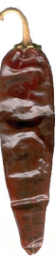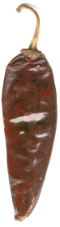 | 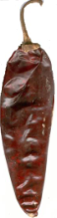 | 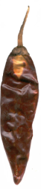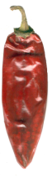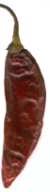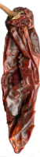
 | EXTRA CLASS | CLASS I | CLASS II

 | ANCHO PEPPER
 | 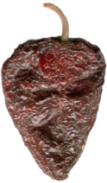 | 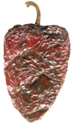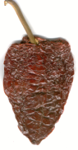 | 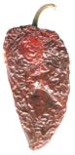
 | EXTRA CLASS | CLASS I | CLASS II

 | MULATO PEPPER
 | 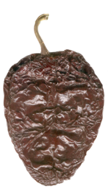 | 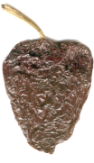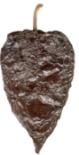 | 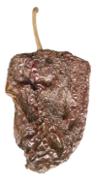
 | EXTRA CLASS | CLASS I | CLASS II

 | PASILLA PEPPER
 | 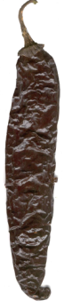 | 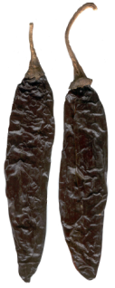 | 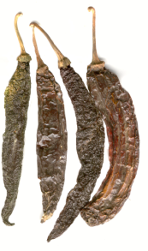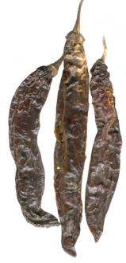
 | EXTRA CLASS OR FLOWER | CLASS I | CLASS II

 | PUYA PEPPER
 | 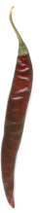 | 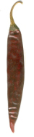 | 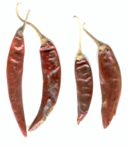
 | EXTRA CLASS | CLASS I | CLASS II

 | DE ÁRBOL PEPPER
 | DOES NOT APPLY | 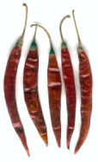 | 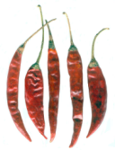
 | EXTRA CLASS | CLASS I | CLASS II

REFERENCES

ISO 972: 1997 Chillies and capsicums, whole or ground (powdered) - Specifications.
ISO 930: 1997 Spices and condiments - Determination of acid-insoluble ash
ISO 3513 Chillies - Determination of Scoville index.
ISO 7543-1 Chillies and chilli oleoresins - Determination of total capsaicinoid content - Part 1: Spectrometric method
ISO 7543-2 Chillies and chilli oleoresins - Determination of total capsaicinoid content -- Part 2: Method using high-performance liquid chromatography
Instituto Nacional de Investigaciones Forestales, Agrícolas y Pecuarias. Centro de Investigación Regional del Noreste. Campo Experimental Palma de la Cruz. Nuevas Variedades del Chile Mirasol para el Centro Norte de México. Folleto Técnico Nro. 21, Marzo 2001.
Pozo Campodónico, Octavio. Descripción de Tipos y Cultivares de Chile (Capsicum spp.) en México. Secretaría de Agricultura y Recursos Hidráulicos/Instituto Nacional de Investigación y Tecnología Agraria y Alimentaria (SARH/INIA). Folleto Técnico Nro. 77, Octubre 1981.

For the correct application of this Standard, see other definitions contained in annex I.
Definitions of terms and defects are listed in annex III of the Standard Layout – Recommended terms and definition of defects for standards of dry (Inshell Nuts and Nut Kernels) and dried produce <http://www.unece.org/trade/agr/standard/dry/StandardLayout/StandardLayoutDDP_e.pdf>
For examples of colour and visual quality, see annex II.
The moisture content is determined by one of the methods given in annex I of the Standard Layout – Determination of the moisture content for dried produce <http://www.unece.org/trade/agr/standard/dry/StandardLayout/StandardLayoutDDP_e.pdf>. The laboratory reference method shall be used in cases of dispute.
It is recommended to perform the determination by colorimetry using the Extractable Colour in Capsicums and their Oleoresins according to the Official Analytical Methods of the American Spice Trade Association Inc. (ASTA) method 20.1
The Scoville scale is a system to measure the pungency in chillies. High resolution chromatography of liquids (HPLC) can also be used to measure content of capsaicin in chillies.
Package units of produce prepacked for direct sale to the consumer shall not be subject to these marking provisions, but shall conform to national requirements. However, the markings referred to shall in any event be shown on the transport packaging containing such package units.
The national legislation of a number of countries requires the explicit declaration of the name and address. However, in cases where a code mark is used, the reference “packer and/or dispatcher” (or equivalent abbreviations) must be indicated in close connection with the code mark, and the code mark should be preceded by the ISO 3166 alpha country code of the recognizing country, if not the country of origin.

