ECE/TRADE/C/WP.7/GE.1/2008/INF.14

Specialized Section on Standardization of Fresh Fruit and Vegetables

Fifty-fourth session
Geneva, 26-30 May 2008
Item 4(g) of the provisional agenda

REVISION OF UNECE STANDARDS

This document presents Belgian proposal to add “lettuce with root ball” to the produce not covered by the Standard for Lettuce.
Note by the Secretariat:
The text is based on document TRADE/WP.7/2001/9/Add.3

UNECE STANDARD FFV-22
concerning the marketing and commercial
quality control of

LETTUCES, CURLED-LEAVED ENDIVES AND
BROAD-LEAVED (BATAVIAN) ENDIVES
moving in international trade between and to
UNECE member countries

I. DEFINITION OF PRODUCE

This standard applies to

- lettuces of varieties (cultivars) grown from:
- Lactuca sativa L. var. capitata L. (head (cabbage) lettuces including crisphead and "Iceberg" type lettuces),
- Lactuca sativa L. var. longifolia Lam. (cos or romaine lettuces),
- Lactuca sativa L. var. crispa L.(leaf lettuces),
- crosses of these varieties and
- curled-leaved endives of varieties (cultivars) grown from Cichorium endivia L. var. crispa Lam. and
- broad-leaved (Batavian) endives (escaroles) of varieties (cultivars) grown from Cichorium endivia L. var. latifolium Lam.

to be supplied fresh to the consumer.

This standard does not apply to produce for industrial processing, produce presented as individual leaves, lettuces with root ball or lettuces in pots.

II. PROVISIONS CONCERNING QUALITY

The purpose of the standard is to define the quality requirements for produce at the export control stage, after preparation and packaging.

A. Minimum requirements

In all classes, subject to the special provisions for each class and the tolerances allowed, the produce must be:

- intact
- sound; produce affected by rotting or deterioration such as to make it unfit for consumption is excluded
- clean and trimmed, i.e. practically free from all earth or other growing medium and practically free of any visible foreign matter
- fresh in appearance
- practically free from pests
- practically free from damage caused by pests
- turgescent
- not running to seed
- free of abnormal external moisture
- free of any foreign smell and/or taste.

In the case of lettuce, a reddish discolouration, caused by low temperature during growth, is allowed, unless it seriously affects the appearance of the lettuce.

The roots must be cut close to the base of the outer leaves and the cut must be neat.

The produce must be of normal development. The development and condition of the produce must be such as to enable it:

- to withstand transport and handling, and
- to arrive in a satisfactory condition at the place of destination.

B. Classification

The produce are classified in two classes defined below:

(i) Class I
Produce in this class must be of good quality. It must be characteristic of the variety or commercial type, especially the colour.

The produce must also be:

- well formed
- firm , taking into account the cultivation methods and the type of produce
- free from damage or deterioration impairing edibility
- free from frost damage.

Head lettuces must have a single well-formed heart. However, in the case of head lettuces grown under protection, the heart may be small.

Cos lettuces must have a heart, which may be small.

The centre of curled-leaved endives and broad-leaved (Batavian) endives must be yellow in colour.

(ii) Class II
This class includes produce which do not qualify for inclusion in Class I, but satisfy the minimum requirements specified above.

The produce must be:

- reasonably well-formed
- free from damage and deterioration which may seriously impair edibility.

The following defects may be allowed provided the produce retain their essential characteristics as regards the quality, the keeping quality and presentation:

- slight discolouration
- slight damage caused by pests

Head lettuces must have a heart, which may be small. However, in the case of head lettuces grown under protection, absence of heart is permissible.
Cos lettuces may show no heart.

III. PROVISIONS CONCERNING SIZING

Size is determined by the weight of one unit.

A. Minimum weight

The minimum weight for Classes I and II is:

 | Open grown | Grown under protection
Head lettuces (excluding crisphead and “Iceberg” type lettuces) and Cos or romaine lettuces (excluding “Little gem” type lettuces) | 150g | 100g
Crisphead and “Iceberg” type lettuces | 300g | 200g
Leaf lettuces and “Little gem” type lettuces | 100g | 100g
Curled-leaved endives and broad-leaved endives | 200g | 150g

B. Uniformity

(a) Lettuces

In all classes, the difference between the lightest and heaviest units in each package must not exceed:

- 40 g when the lightest unit weighs less than 150 g per unit
- 100 g when the lightest unit weighs between 150 g and 300 g per unit
- 150 g when the lightest unit weighs between 300 g and 450 g per unit
- 300 g when the lightest unit weighs more than 450 g per unit.

(b) Curled-leaved and broad-leaved (Batavian) endives

In all classes, the difference between the lightest and heaviest units in each package must not exceed: 300g

IV. PROVISIONS CONCERNING TOLERANCES

Tolerances in respect of quality and size shall be allowed in each package for produce not satisfying the requirements of the class indicated.

A. Quality tolerances

(i) Class I
10 per cent by number of units not satisfying the requirements of the class, but meeting those of Class II or, exceptionally, coming within the tolerances of that class.

(ii) Class II
10 per cent by number of units satisfying neither the requirements of the class, nor the minimum requirements, with the exception of produce affected by rotting or any other deterioration rendering it unfit for consumption.

B. Size tolerances

For all classes: 10 per cent by number of units not satisfying the requirements as regards sizing, but weighing no more than 10 per cent over or under the size in question.

V. PROVISIONS CONCERNING PRESENTATION

A. Uniformity

The contents of each package must be uniform and contain only produce of the same origin, variety or commercial type, quality and size.

However, a mixture of the various types of produce described in this standard may be packed together, provided they are uniform in quality and, for each type concerned, in size. In addition, the types should be clearly distinguishable from one another and the proportion of each type in the packages should be visible without damaging the package.

The visible part of the contents of the package must be representative of the entire contents.

B. Packaging

The produce must be packed in such a way as to protect it properly. It must be reasonably packed having regard to the size and type of packaging, without empty spaces or crushing.

The materials used inside the package must be new, clean and of a quality such as to avoid causing any external or internal damage to the produce. The use of materials, particularly paper or stamps bearing trade specifications is allowed provided the printing or labelling has been done with non-toxic ink or glue.

Packages must be free of all foreign matter.

C. Presentation

Produce presented in more than one layer may be packed base-to-heart provided the layers or heads are suitably protected or separated.

VI. PROVISIONS CONCERNING MARKING

Each package must bear the following particulars in letters grouped on the same side, legibly and indelibly marked, and visible from the outside:

A. Identification

Packer ) Name and address or
and/or ) officially issued or
Dispatcher ) accepted code mark.

B. Nature of produce

- "Lettuces", "butterhead lettuces", "batavia", "crisphead lettuces (Iceberg)", "cos lettuces", “leaf lettuce” (or, for example and if appropriate, “Oak leaf”, “Lollo bionda”, “Lollo rossa”),"curled-leaved endives" or "broad-leaved (Batavian) endives", or other synonyms if the contents are not visible from the outside
- “Little gem” where appropriate or other synomyms
- An indication "grown under protection", or other appropriate indication, where appropriate
- Name of the variety (optional)
- Where different types of produce are mixed together:
- the indication “Mixed salads”, or,
- the indication of each type of produce, and, where the contents are not visible from the outside, the indication of the number of pieces of each type.

C. Origin of produce

- Country of origin and, optionally, district where grown, or national, regional or local place name.

D. Commercial specifications

- Class
- Size, expressed by the minimum weight per unit, or number of units
- Net weight (optional).

E. Official control mark (optional)

Published 1961
Revised 1991, 2001
The UNECE Standard for Lettuces
has led to an explanatory brochure published by the OECD Scheme
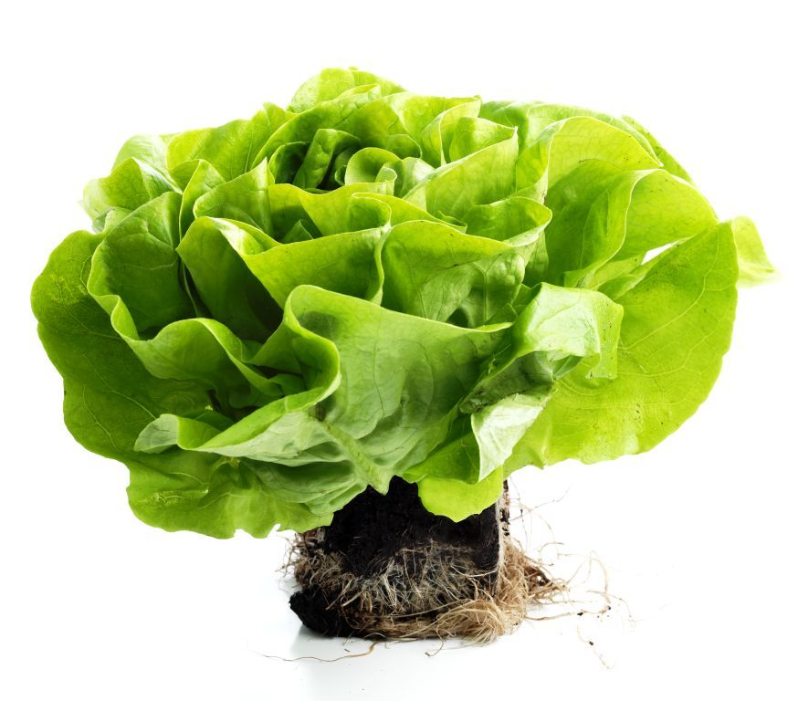

Package units of produce prepacked for direct sale to the consumer shall not be subject to these marking provisions but shall conform to the national requirements. However, the markings referred to shall in any event be shown on the transport packaging containing such package units.
The national legislation of a number of countries requires the explicit declaration of the name and address. However, in the case where a code mark is used, the reference "packer and/or dispatcher (or equivalent abbreviations)" has to be indicated in close connection with the code mark.

