SPECA/PWG-Trade/2007/EN/5rev.1

SPECIAL PROGRAMME FOR THE ECONOMIES OF CENTRAL ASIA (SPECA)
Project Working Group on Trade

Second session
Berlin, Germany, 12 November 2007

“DOCUMENT SERVER” MODEL
(concept paper)

- Introduction
Participants in foreign trade in the Central Asian countries still face specific problems in trade procedures related to the official controls of trade information and goods. Information on required data and forms/documents as well as the procedures concerning the use of these documents is still insufficient, and thus makes trade inefficient. Another problem relates to the diversity of the required trade and transport documents in the various countries. The documents have different content and different structure. This creates obstacles for the further development of foreign trade of these countries, and also for possible investors in the region. Those who are most seriously hurt from the lack of easily available information on forms and document procedures are small and middle-sized enterprizes (SME).

A “Document Server”, as defined in this Concept Paper, is a web site, managed by a trade control agency (Customs or a Ministry) or a public-private partnership body, which provides the forms/documents necessary for carrying out export and import operations, as well as box-completion guidelines and description of the procedure of filing these forms. The Server will provide a possibility that an administrating organization (or government agency) can upload: (1) all document forms required by control agencies in the respective country; (2) box completion guidelines; and (3) description of the documentary procedures in the country.

This Concept Paper will present a blueprint for developing an actual web site template, which will be offered to the Central Asian countries. The idea is to build similar and simple Document Servers in the SPECA countries, thus serving a double objective: (1) providing transparent information on documentary requirements and procedures for carrying out international trade operations in the Central Asian countries; (2) making an easy information tool available to traders and potential investors in the region. This product possibly will become an instrument in achieving greater regional economic integration and a first step in building the environment for a Single Window for export and import clearance in the countries. The the proposal takes into account existing best practice (e.g. the “Formular Server” of German Customs at www.zoll.de); and possibilites to work further on possible implementation in collaboration with the Central Asian Governments and aid agencies active in Central Asia, such as GTZ (active in Kyrgyzstan and Tajikistan).

- Objectives
The objectives of the document server are to:
  - Offer information about documents necessary to execute foreign trade operations, and about the way of their completion and procedures concerning their use.
  - Strengthen the cooperation among institutions administering these trade and transport documents and controlling business and transport procedures.

- Model Template for a Document Server
The document server will consist of several interconnected web pages:
  - Home page, providing the list of forms/documents
  - Pages dedicated to each form/document, which also contain box completion guidelines and information on documentary procedures

Home web page
A list of all available forms/documents will be provided at this web page. The names of these documents will form a hyperlink and will refer to the pages with further information concerning the specific documents.
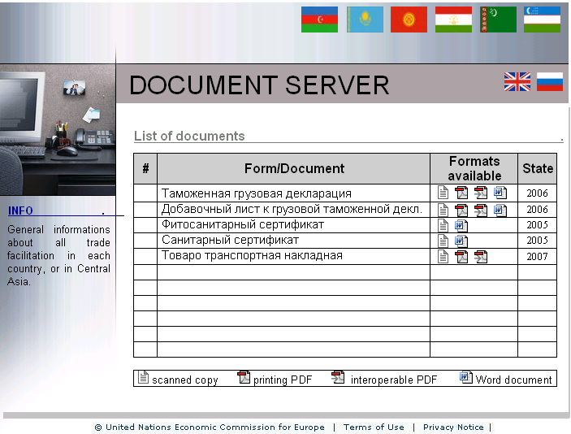

Web pages of the specific documents
At each web page there will be the name of the document mentioned in the page heading and then further information shall follow:

  - The document in available format: each format will be provided as a hyperlink, which will open the document in respective format. In case the document is managed by an agency other than the one managing the Document Server, a hyperlink to the web site where the original document is available in electronic format will be the best possible option.

We suggest that countries should consider preparing the forms/documents in the following formats:
    - Scanned copy
    - Printing PDF
    - Interoactive PDF
    - XML
    - Other formats (MS Word, etc.)
The documents in various formats can be stored directly on the document server (in a database) or a hyperlink can be created to the pages of their administrators (customs, transport companies), where these documents will be stored. A combination of the two methods is also possible.

  - Box completion guidelines
The instructions how complete the forms will be available already in some of the documents, depending on their format (e.g. interoperable PDF or XML). Separate instructions will be provided for other formats (scanned copies, printing PDF).

  - Description of the procedures (how to use the documents)
For each document the description of the documentary procedure (how to obtain and fill in, where to file, what fees to pay, to whom, waiting time, etc.) will be available. GTZ has already started a project on gathering this information in Kyrgyzstan and Tajikistan.

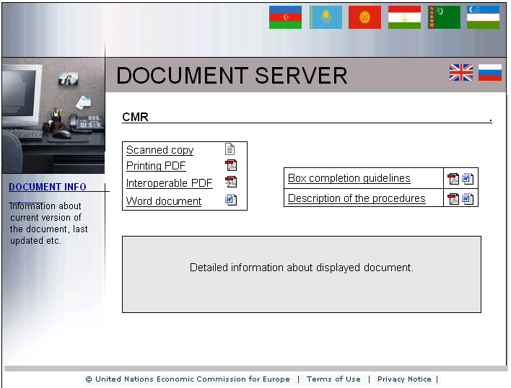
- Administration of Document Server
As for the document server administration, it is necessary to solve the question of responsible administrator. There are the following possibilities:
  - National Custom Agency
  - Other national agency (Ministry of Finance, Ministry of Trade, Chamber of Commerce, etc).
  - A public-private partnership body
  - A private company
  - International Agency (EurAsEc, UNECE, UNDP, aid agencies, etc)
We would suggest that the first two options have definite advantage, as they maintain the sovereign character of the process of gathering and controlling international trade information.

Technical administration of the document server
The way of document server administration depends on the chosen platform. There is a wide selection of possibilities:
  - Open source platform (Wiki etc.)
  - Freeware Webdesign Tools (BlueVoda, ….)
  - Customized solution

Wiki … based
Open source platform, available in various languages (including Russian). Various variants are available, focused on the particular purpose of information administration. For example the system TWikiTM (www.twiki.org) is suitable for the document management.
  - Advantage: cheap, easy design of pages, easy content administration.
  - Disadvantage: open solution, graphically very simple.

Freeware Webdesign Tools
This solution is based on freeware tools, enabling quality design of the web pages for all kinds of use. The prearranged templates are used for the graphical design of the web pages. They can be partially adapted. These tools are available for free, mostly with the condition of webhosting at the webdesign tool provider. Suitable system is e.g. BlueVodaDesigner^{TM.} (www.bluevoda.com).
  - Advantage: easy webpage creation with the help of ready template, strong user support.
  - Disadvantage: fixed webhosting, more demanding administration (at the beginning).

Customized solution
This solution is financially more demanding, but enables the creation of a structure and a form of “document server” exactly corresponding to the requirements.
  - Advantage: “tailor-made” solution, “Word-like” easy administration of the content, easy management of the access rights.
  - Disadvantage: higher price.

- Promotion and other tools

There will be a need to disseminate information on the “document servers”, and it can be made with the help of the following promotion tools:
  - Offline CD
  - Webinars (online seminars)
  - Presentations (PowerPoint) at workshops and seminars

During the introduction of the document server in various countries, the consulting and methodical guidance can be provided.

- Existing best practice
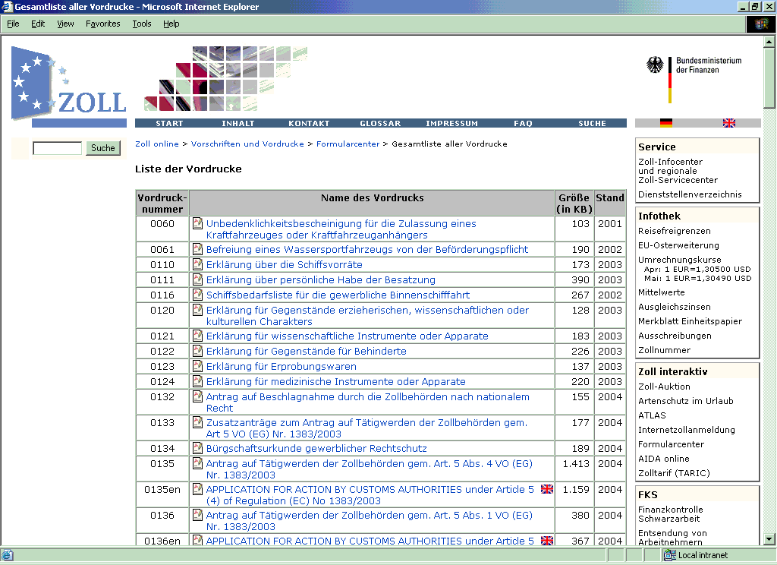
The creation of the model template for a document server can be based on existing best practices, such as the “Formular Server” of German Customs:

This concept paper describes the requirements to create a model “Document Server” for the transition economies in Central Asia. It was prepared by Jan Placek, UNECE consultant. It is designed to assist countries with economies in transition, especially in Central Asia, to establish Document Server facilities.

