Security Identification Section
ENTRY/EXIT CARS AND PEDESTRIANS
Open 0800 – 1700 non stop
SALLE DES ASSEMBLEES
& Salle 16
DOOR 13 OR 15

DOOR 11

Security

SALLES
4 TO 12

IV TO XII

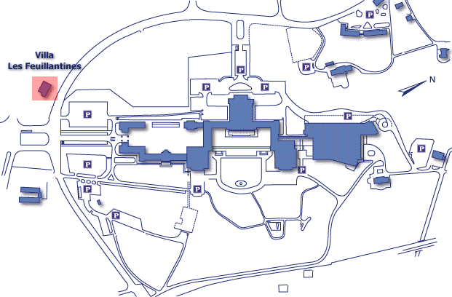
DOOR 6
NAVILLE
POSTE
BANK

SALLES
1 TO 3
H3 & F3
Entry for authorized persons only
on foot
Security ID
Section Entry
DOOR 40

ROOM
22

XXII
DOOR 2
MEDICAL
SERVICE

SALLE
C3 & A-R

DOOR 20
BIBLIOTHEQUE
LIBRARY
VILLA
LE BOCAGE
DOOR 1 SAFI
LA PELOUSE
ENTRY FOR AUTHERIZED PERSONS
ON FOOT ONLY

