United States Forest Products

Market Review

and Prospects, 2013-2017

James L. Howard, Economist
Shaobo Liang, PostDoc Scientist
Forest Products Laboratory, Madison, Wisconsin USA

Abstract

This paper describes the current state and near term prospective of the United States economy supported by general and statistical information on forest products markets in terms of production, trade, consumption, and prices. Market developments are described for sawn softwood, sawn hardwood, softwood log trade, wood-based panels, paper and paperboard, fuelwood, forest product prices, and housing starts. Policy initiatives that can affect domestic markets and international trade in wood products are also discussed in some detail. Data are provided through the end of the year 2015 with estimates for 2016 and forecasts for 2017.

Keywords: production, trade, prices, forest products

Acknowledgement

This publication contains contributions from Shaobo Liang, Economics Assistant who organized and compiled much of the data contained in this report.

Executive Summary

Economic activity in the U.S. exhibited resiliency over the first three quarters of 2016 even though economic growth slowed, and the outlook for growth into 2017 is weaker than previous forecast. This outlook is confirmed by the decrease in the estimated annual rate of real gross domestic product (GDP) to 2.6% in 2016 down from the previously expected 2.8%. Economic activity during 2017 is projected to decrease to an annual rate of 2.5%. The rate of growth in the U.S. economy will likely remain flat in the first half of 2017 then decrease slightly in the second half of 2017 as predicted by 40 forecasters surveyed by the Federal Reserve Bank of Philadelphia (FRB) (AUG 2016). The flat rate of growth in the U.S. economy predicted for 2017 is inconsistent with the growth in the forest sector as exports for the U.S. economy to China and Europe have increased. The indications are that global trade is increasing; increasing prospects that exports will buoy the U.S. economy in the coming months as exports to China improves. Growth in U.S. real output looks weaker and inflation constant over the near term compared to previous estimates. Forecasters expect the labor market to remain nearly unchanged to slightly lower in 2017, measured on an annual-average basis. Unemployment is expected to fall from 4.7% in the 4th quarter of 2016 remaining flat the 1st quarter of 2017 then declining to 4.6 percent in the 2nd quarter of 2017. The unemployment rate was 8.1% at the beginning of 2012 because many unemployed stopped looking for work and the unemployment rate have declined on average a full percentage point each year since. The forecasters see prices unchanged in the first quarter of 2017 which is a slightly lower rate than previously expected, and then staying flat in the 2nd and 3rd quarter of 2017. New and existing home sales surged by over 12 percent in July 2016 to the highest level since October 2007. The housing recovery after losing momentum during the 2nd half of 2015 have remained strong over the first 2 quarters of 2016 and into the first month of the 3rd quarter. New home sales in July 2016 have averaged an annualized rate of 654,000 homes, up 12.4 percent from June and up 31.3 percent from July 2015. Sales of existing single-family homes, condominiums and townhouses fell 3.2 percent in July 2016 to an annual rate of 5.39 million units (NAHB 2016). Sales were down in all regions except the West. The industry finds this decrease discouraging and anticipate a rebound in sales in August.

The growth in the housing sector continued to have a positive effect on softwood lumber consumption in 2016. According to the Western Wood Products Association (WWPA 2016), during the first 6 months of 2016, softwood lumber consumption increased 14.5% from the same period in 2015, and shipments of softwood lumber from western mills increased 0.9% during the first 6 months of 2016 compared with the same period in 2015. The Southern region continues to have the highest levels of production and shipments of softwood lumber.

Total structural panel production increased 3.4 percent over the first two quarters of 2016 when compared to the same time period in 2015. Structural panel consumption over the first two quarters in 2016 increased 999 thousand cubic meters when compared to the same time period of a year ago representing a 7.4 percent increase from 2015 (APA 2016).

Roundwood production for pulp and wood-based panel mills was 144 million cubic meters in 2015 up slightly from 2014. It is forecast that roundwood pulpwood consumption will increase during 2016. Pulpwood supplied from residues could continue to increase in 2016 relative to Roundwood due to and increased housing construction and wood products industry. It is also possible that supply from residues could increase with increased competition for residues to produce pellets or biomass for power.

U.S. lumber and log exports to China have followed a similar pattern, increasing throughout the first 6 months of 2016. U.S. timber product exports to China have increased when compared to the previous year. Lumber shipments over the first 6 months of 2016 were 11.5 percent above the 2015 volume compared to a year ago (WWPA 2016).

The U.S. furniture industry production was up 0.6 % in August over a month earlier in July. The weakness in production when compared to a year ago is not surprising as sales at furniture stores in August were up just 1.4 percent and furniture imports are up 6 percent in 2016 compared to 2015. Employment in the domestic furniture industry has fallen more than 50% since 1999.

General Economic and Major Market Trends

According to 40 forecasters surveyed by the Federal Reserve Bank of Philadelphia (FRB 2016) the U.S. economy grew at a weaker rate during the 2nd quarter of 2016 than during the 1st quarter and the expectations of continued growth into 2016 are good. The forecasters expect real gross domestic product (GDP) to grow at an annual rate of 2.3% in 2017. The continued optimism about the labor market accompanies the outlook for stronger output growth. Average unemployment is forecasted to be 4.8% in 2016. The 40 forecasters expect unemployment to improve to 4.6% in 2017. This decline in unemployment equates to nonfarm payroll employment growing at a rate of 183,700 jobs per month during the third quarter 2016 and 169,800 jobs per month during the fourth quarter 2016. On an annual-average basis, the forecasters expect job gains of 204,600 per month in 2016 and 1961,100 per month in 2017. During the recession from 2007 to 2009 the impact on the job market was 8 million jobs lost in the worst economic downturn since the 1930’s Great Depression. Almost every sector experienced job cuts: construction lost 2 million jobs, financial services lost 800,000 jobs and the auto sector where thousands of jobs were lost. There were already about 7 million adults looking for full-time employment before the recession hit in December 2007. The U.S. economy must create about 125,000 new jobs per month just to keep up with population growth and to prevent unemployment from rising. The strength of GDP growth will be the major determinant of when the U.S. economy reaches full employment. With strong GDP growth full employment could be maintained over the next in 2 years.
Core inflation, as measured by the Price Index for personal consumption expenditures, is expected to average 1.6% in 2016 then increase to 1.8% into 2017. On an annual-average over annual-average basis, inflation in the core consumer Price index is projected to remain around 1.8% in 2016 staying level at 1.9% in 2017 (FRB 2016).

New housing construction slowed during the 3th quarter of 2016 when 1,142,000 units were started in August at a seasonally adjusted annual rate (NAHB 2016). The decline in August was due to lower single and multi-family starts. For the 3th quarter Single family starts averaged an annual rate of 722,000 units, down 6.0% from July. Multifamily starts in the 3rd quarter averaged an annual rate of 420,000 units in August, down 5.4% from July. August was driven by an 18% drop in starts in the South. Starts in the West were off 5.6% in July. Builders remain upbeat because on a 4 month moving average basis there was an upward trend indicative of the strength in demand for rental housing. Although the authorization of multifamily permits was off in August, the decline occurred entirely in the South, where they were off 17.3% from July. Otherwise, the number of permits were unchanged or up slightly in the other three regions of the U.S. New single-family units completed decreased slightly in August falling to 752,000 from July when 754,000 units were completed. Total housing starts for 2016 is forecast to grow to 1,190,000 units up 7.1% from 2015 and the expectations for 2017 are for continued improvement.

In July 2016, the annual rate for total value of all new construction in the U.S. was $1,153 billion, $17 billion above the annual July 2015 value of $1,136 billion (NAHB 2016). When comparing 2015 to 2016 month over month the seasonally adjusted annual rate for the total value of new construction was above the 2015 annual rate for each month through July in 2016. Residential construction was $445 billion in July 2016, $8 billion above the $437 billion annual rate of residential construction in 2015. Nonresidential construction accounts for approximately 25 to 35 percent of all construction value in the U.S. It too was affected by the distant economic recession but not so severely as residential construction. Nonresidential construction is typically divided between the construction of buildings (stores, offices, schools etc.) and structures other than buildings (dams, bridges, etc.) The construction of buildings, which are the largest market for wood in nonresidential construction, in 2016 was at an annual rate of $307 billion, unchanged from 2015. The highest rate ever achieved was in 2008 when the construction of nonresidential buildings was nearly $409 billion. The National Association of Home Builders 2016 forecast calls for the housing sector to improve in the 3rd and 4th quarter and starts and sales overall for 2016 will end the year above 2015 levels (NAHB 2016).

With a large forest resource and high production and consumption of wood products, the United States continues to play an important role in world forest product markets. The United States is a world leader in the consumption of paper and paperboard (about 71 million metric tons in 2015), which is mostly supplied by domestic production and imports from Canada (AF&PA 2016). Domestic paper and paperboard production for the first 8 months of 2016 was about 1.1% below the production for the first 8 months of 2015. This decline is mainly reflected in the printing and writing grades of paper as electronic media continues to grab market share from printed media. The U.S. solid wood industry manufactured about 76 million cubic meters of lumber and 21 million cubic meters of structural panel products in 2015. For the first 6 months of 2016 softwood lumber production was 4.4% above 2015 production and for all of 2015, structural panel consumption was 4.4% above 2014 levels. The U.S. forest products industry’s annual harvest was 446 million cubic meters in 2015, exceeding the 445 million cubic meters harvested in 2014. Domestic roundwood timber harvest in 2016 that supports domestic consumption is expected to be above the 2015 harvest level.

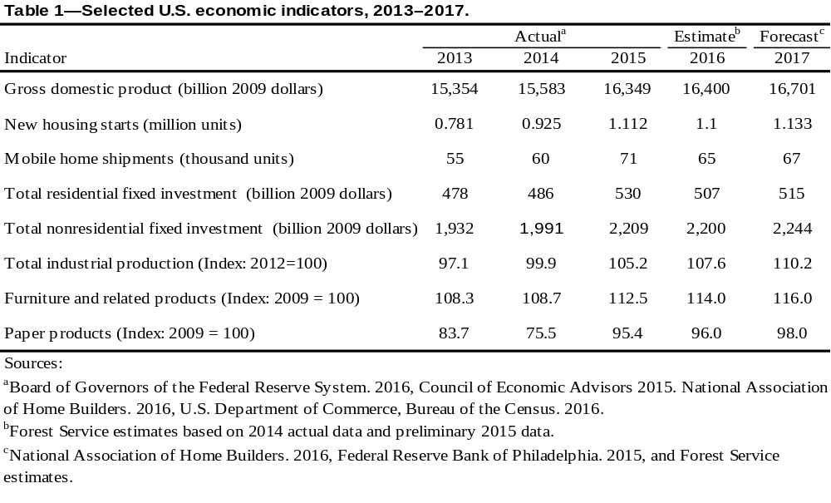

Expenditures for residential repair and remodeling decreased in 2014 to $103 billion down 22.0% from one year ago and well below the record high years of 2006 and 2007. The continued recovery in the housing market isn’t reflected in residential remodeling averaging $100 million monthly for the first two quarters of 2015 down from the 2014 average. In 2007 the U.S. Department of Commerce stopped collecting residential repair and remodeling data. The estimates for 2014 and 2015 presented here are Forest Service estimates based on private residential construction expenditures. The National Association of Home Builders Remodeling Market Index (RMI) fell to 53.0 in the 2nd quarter 2016 down from 59.0 in the 2nd quarter of 2016. This index level is above the record level in 2004 prior to the housing market crash. During this same period new residential construction exhibited strength and continues do so into the 2nd quarter 2016. Expenditures for maintenance and repairs to all existing residential properties have averaged about 33% of total expenditures, with the remaining 67% for improvements. The unprecedented levels of home foreclosures in the United States in recent years have helped cause residential improvements and repairs to become a larger part of the economy than usual. Many foreclosed homes needed significant maintenance to become marketable. Expectations are for continued but declining investments in existing residential properties as low mortgage rates keep new home buying attractive.

The three major indicators of demand for wood products—furniture and related products, paper products output, and total industrial production—were lower during the first 6 months of 2016 relative to 2015.

- Industrial production, an important demand determinant for pallet lumber, containerboard, and some grades of paper, decreased .7% during the first 6 months of 2016 when compared to the annual level for 2015.

- Furniture and related products output, a determinant of high-grade lumber production, was up 0.9%during the first 6 months of 2016.

- Paper products output, a determinant of pulpwood and wood residue use, as well as recycled fiber availability and use, decreased during the first 6 months of 2016 compared with the 2015 average. The index (2007 = 100) of paper products output for the first 6 months of 2016 was 1.1% below the 2015 average for the comparable time period.

In summary, the housing sector gained strength during the first 2 quarters of 2016 but weakened somewhat in the 3rd quarter of 2016. This strength is expected to continue into 2017. Housing starts in 2016 will probably exceed year-ago levels significantly. Even with the slow rate of growth in GDP 2016 has been a good year overall as noted by the growth in timber markets. Selected U.S. economic indicators are shown in Table 1.

Timber Products Production, Trade, and Consumption

Statistics and Prospects

Prospects for wood and wood products are shown in Table 2. All volumes are reported in 1,000 cubic meters. Data for 2016 are preliminary estimates, data for 2017 are forecasts.
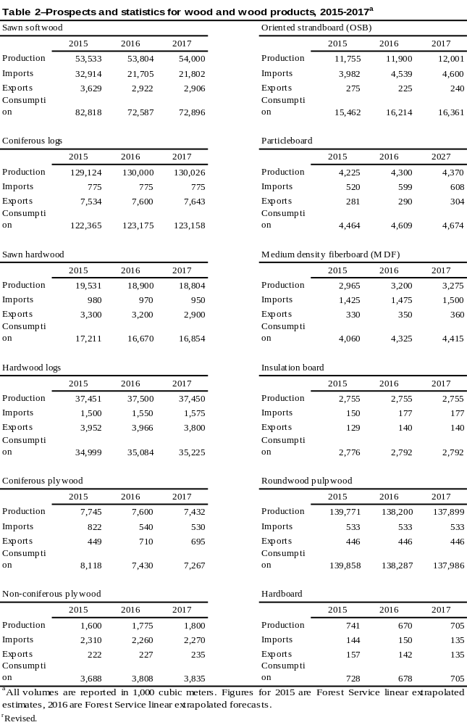

U.S. Wood Product Market Shares

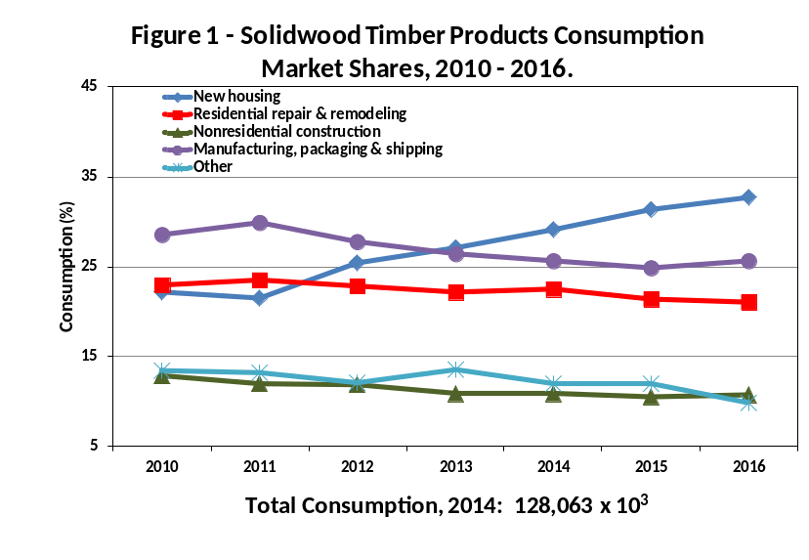Annual U.S. solid wood products production and foreign trade data are collected annually by governmental agencies and industry associations. This information provides an overview of how robust the wood using sectors of the U.S. economy are, and how their performance has changed over time (Howard 2013). It does not provide detailed information specific to individual end-use markets needed to further evaluate changing patterns of consumption. End-use markets of interest include new single family, multifamily, and mobile home construction, repair & remodeling of existing residential structures, low-rise nonresidential building and other types of nonresidential construction, furniture and other manufactured wood products, and packaging and shipping. These end-use markets typically account for 80 to 90 percent of all solid wood products consumption. Market share estimates presented here are based on findings from limited public and private research reports that were related to more readily available, annual economic indicator data specific to each end-use market. Consumption was balanced over all end uses, and market shares developed. These estimates provide a consistent, reliable look at solid wood products markets in the U.S. (McKeever and Howard 2011).

Table 3 presents annual balanced wood products consumption by end use for sawn wood, structural panels, and nonstructural panels for the period 2010 through 2014, with preliminary estimates for 2015 and forecasts for 2016. Figure 1 shows market shares for all solid wood products combined for the same time period.

Sawn Softwood

Housing and other construction markets started off strong in 2016 but showed weakness into the 3rd quarter 2016. The housing market is likely to finish the year at a higher level than recorded a year ago. The housing sector is improving as evidenced by its overall increasing market share and is having a positive effect on softwood lumber consumption (Fig. 1, Table 3). According to the Western Wood Products Association), during the first 6 months of 2016, softwood lumber consumption increased 14.5% from the same period last year, and shipments of softwood lumber from western mills also increased 0.9% during the first 6 months of 2016 compared with the same period in 2015 (WWPA 2016). Production increased during this period in the South 6.9%. Apparent consumption for the first 6 months of 2016 was 42.4 million cubic meters, 14.5% above the 37.0 million cubic meters for the first 6 months of 2015. As predicted, the U.S. housing construction industry grew over the 1st half of 2016. Timber production as a result of a strengthening domestic market continued to increase in 2016 slightly above the 2015 timber growth level. Production of sawn softwood for 2016 is forecast to exceed 2015 levels, and then continue to rebound with a gradual increase in 2017.

Sawn softwood imports increased 38.0% during the first 6 months of 2016 relative to the same time period a year ago. The volume of Canadian imports, which constituted 98% of all sawn softwood imports, increased by 21.8% over this period. Total sawn softwood imports were 22.5 million cubic meters in 2015.

During the first 6 months of 2016, U.S. sawn softwood exports decreased 0.1% compared with exports for the same period in 2015. Exports to Canada decreased by 7.7%, while exports to china increased 11.5 % and exports to Mexico increased 3.6%.

Sawn Hardwood

Sawn hardwood production is expected to decrease to 19.0 million cubic meters in 2016. Imports in 2016 are expected to decrease from one year earlier. Given the decrease in U.S. production and imports and despite a strengthening housing market, apparent consumption for 2016 is forecast to fall below the 2015 volume.

Softwood Log Trade

Softwood log exports to China increased over the first 6 months of 2016 when compared with exports in the same period of 2015 increasing by 11.9%. Softwood log exports to Canada decreased by 11.9% in the same period. Softwood log exports to all other countries decreased by 10.4% during the first 6 months of 2016 when compared with the same time period of one year ago. Most of the U.S. export increase has been centered in Asia. Overall, the volume of U.S. logs shipped to China fell by 1,103,700 cubic meters in 2015 to an estimated 2.1 million cubic meters in 2015, or about 51% of the region’s total log production. Softwood log imports decreased by 29.4% over the first 6 months of 2016 compared with a year earlier. During 2015, the timber harvest surpassed the 2014 harvest and the forecast calls for a further rise in harvest in 2016.

Hardwood Log Trade

Hardwood log exports increased by 0.4% and imports rose by 3.3% during 2016 compared with 2015. Canada traditionally provides about 95% of U.S. imports. The trend in hardwood log exports was down from a year ago through the first 6 months of 2015. Hardwood log imports were also up slightly through the first 6 months of 2016 when compared to 2015.
Pulpwood

Roundwood production for pulp and wood-based panel mills was 139 million cubic meters in 2016, down slightly from 2015. Roundwood pulpwood consumption is expected to decrease during 2016 as indicated by a 1.1 % decline in paper and paperboard production over the first 7 months of 2016. Pulpwood supplied from residues continued to decrease relative to roundwood. This is a result of declining residual production and competition for residuals for pellets and biomass and not out of preference on the part of pulp producers. The residue portion of pulpwood was 21.0 million cubic meters in 2015, up slightly from 2014 (Howard 2015). Trade patterns have continued to have a significant impact on paper and paperboard production and have affected pulpwood use, but the significant decline in U.S. paper and board production and consumption that occurred over the past decade was largely due to a downturn in consumer spending associated with the United States and global recession. Exports of paper, paperboard, and converted products decreased by 5.1% to 8.8 million metric tons, while imports of paper and paperboard decreased by 4.4% to 7.8 million metric tons during the first 7 months of 2016. Paper and paperboard production decreased by 1.0 % in 2015 falling to 72.3 million metric tons. The production of paper and paperboard in 2016 is forecast to be down from 2015 production as reflected in the annual year to date rate for July 2015 of 47.3 million metric tons, which is down 1.1% from 2015 when paper and paperboard was produced at a level of 47.9 million metric tons.

Structural Panels

Structural panel production in 2015 was basically unchanged from 2014, while consumption was 4.4% above consumption in 2014 (APA 2016, Elling 2016). Structural panel production in 2015 was 19.5 million cubic meters which is about level with 2014. Structural panel market shares move in the same direction as any economic downturn. New residential construction which, in 2006, captured 46% of all structural panel consumption, fell to 35% in 2011, but it is expected to rebound and continue increasing in 2016 (Table 3)

In 2015, 11.8 million cubic meters of oriented strandboard (OSB) were produced (APA 2016) (Table 2). OSB consumption totaled 16.0 million cubic meters in 2015 and constituted 60% of the structural panel market (Table 3). This represented a 4% share increase from 2008. Consumption is expected to further increase in 2016. The continuing economic growth and growing residential construction sector was as expected increased OSB consumption in 2015 to near 16 million cubic meters.

Softwood plywood production was 7.7 million cubic meters in 2015 (Table 2) (APA 2016). This level of production was slightly below 2014. The volume of softwood plywood production fell throughout the 1990s, and the decline continued into 2012 before improving in 2013 before declining in 2014. Softwood plywood imports decreased in 2015 by 3.9% compared with 2014 data, while softwood plywood exports in 2015 declined by 3.5% compared to that of 2014. Plywood exports to Canada increased by 22.6% during the first 2 quarters in 2016 compared with a year earlier, and plywood imports from Canada decreased 31.7%. Softwood plywood consumption was 4.3 million cubic meters at the end of the 2nd quarter 2016 which was 7.1% above last year. Apparent consumption of softwood plywood increased 2.2% in 2015 compared to 2014.

Hardwood Plywood

Hardwood plywood production, including core material such as particleboard and medium density fiberboard, was estimated at 1.6 million cubic meters in 2015, up slightly from 2014 production. Hardwood plywood imports increased 4.1% in 2015 climbing to 2.3 million cubic meters when compared to 2014. Hardwood plywood exports rose in 2015, increasing 7.8% to 222 thousand cubic meters. Production and consumption of hardwood plywood in 2015 and 2016 is forecasted to steadily rise (Table 2). These increases are a result of rising Total Industrial Production and Furniture and Related Products production (Table 1), coupled with the U.S. housing market rebound.

Particleboard and Medium Density Fiberboard

Information from the Composite Panel Association (CPA 2016) indicates that both particleboard and medium density fiberboard (MDF) production increased in 2015 compared to 2014. Particleboard production was 4.2 million cubic meters, an increase of nearly 2%; MDF production was 3.0 million cubic meters, an increase of nearly 9% (Table 2). Both imports and exports of particleboard and MDF increased in 2015 over 2014, resulting in increased total consumption in 2015 when compared to 2014. Particleboard and MDF account for well over one-half of all nonstructural panels consumed in the U.S., being used principally for furniture, fixtures, millwork and other manufactured products. Markets for particleboard and MDF are expected to increase modestly in 2016 (Table 3).

Hardboard

Based on data from the Composite Panel Association (CPA 2015), 741 thousand cubic meters of hardboard were produced in 2015 in the U.S and Canada; this level of production is expected to increase slightly in 2016. Hardboard imports and exports are expected to remain flat over the next two years.

Insulation Board

Information from the American Forest & Paper Association (AF&PA 2015) showed that 2.7 million cubic meters of insulation board was produced in 2015, unchanged from 2014. Production of insulation board has been flat for several years, resulting in a stable level of apparent annual consumption of about 3.0 million cubic meters.
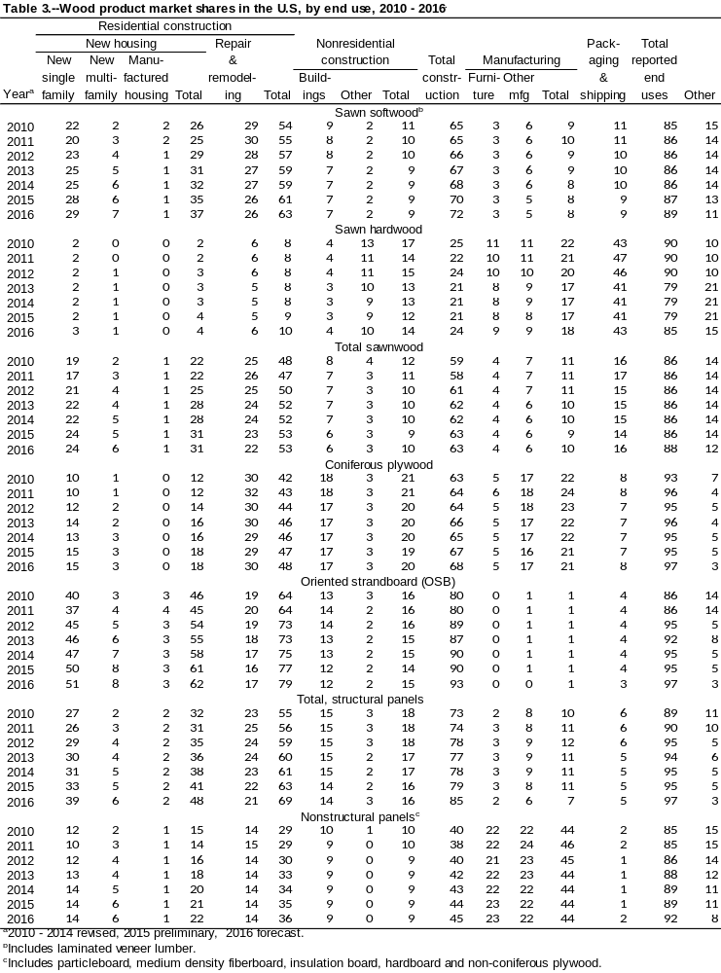

Fuelwood

Using data from the 2015 Energy Information Administration report (EIA 2015) and adjusting for the 2015 winter weather and a increasing trend in fuelwood use per household, fuelwood consumption estimated to be 44.0 million cubic meters in 2015—a increase of 2.4% from 2014. Households use most fuelwood for heating and aesthetic enjoyment. Some forest products manufacturing facilities use mill residues rather than roundwood for fuel. A small portion of roundwood fuelwood is used for electric power production. Use for heat and/or electricity production electric power is limited by the low cost of coal and natural gas alternatives. Fuelwood consumption for 2015 was above the level for 2014 and the forecast calls for increased fuelwood consumption through 2016. Renewable Fuel Standards and other biomass-related energy policies are unlikely to increase the growth rate for fuelwood production and consumption, but likely to increase other forms of wood energy use such as Pellets. The U.S. produced 6.9 million tonnes of wood pellets in 2014, of which about 42% was consumed domestically (UNECE/FAO, 2015).

Forest Products Prices

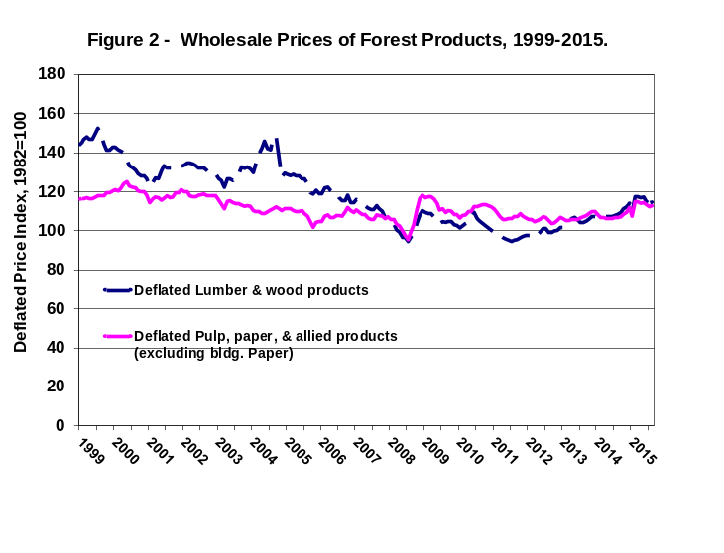Trends in the wholesale price of forest products are different across two broad categories: lumber and wood products (such as lumber and wood-based panels) and pulp and paper products (Fig. 2). Throughout the late 1990s, the producer price of lumber and wood products as reflected by the producer price index (PPI) continued to fluctuate around a level reached by the mid-1990s before peaking during the second half of 1999 (USDL 2011). The PPI for lumber and wood products continued to decrease during the 1st quarter of 2008, but rose and peaked in the 3rd quarter, and then declined again in the 4th quarter. The PPI for lumber was down 7.3 points in 2009 from 2008. Changes in the price of softwood lumber and a depressed lumber market accounted for much of this change and most of the volatility in the index. In 1999, the deflated composite price index reached an all-time high (at a level more than 50% higher than that of the base year, 1982), followed immediately by a sustained decline that continued throughout 2000 and into 2011. The PPI for both lumber and pulp paper and allied products have been increasing since 2011, throughout 2015, and into 2016. Because of these sustained low prices, U.S. demand for lumber and wood products during 2000 and into 2005 remained near record levels. But the current strengthening in the housing market has caused an uptick in the price levels and has fueled the current resurgence in lumber and wood products demand. In contrast, the PPI of prices in the pulp and paper sector has exhibited considerably less short-term volatility. In deflated terms, the composite index began 2008 with a flat to declining trend, before undergoing an upturn in the third quarter of 2008 that became flat in the first quarter of 2009 before fluctuating throughout 2013 before increasing in 2014 then declining into 2015. The first two quarters of 2016 lumber prices are have been steady to increasing while paper and paperboard prices have shown a slight decline..

Energy Policy Initiatives

Wood Energy

The wood energy market in the US is composed of four major sectors: industrial (68%), residential (20%), electricity (9%), and commercial (3%). The industrial sector represents the wood products, pulp and paper industry; and the amount of wood energy it consumes has been mainly linked to wood product output rather than public policies. The other three sectors have been where public policy is focused at the state and federal level. Historically, public policy was focused on promoting the use of biomass for electricity while, in recent years, there has been a shift to greater support for liquid fuels for transport.

The most effective federal incentives introduced since 2004 according to recent publications appear to be (a) the Renewable Energy Production Tax Credits, (b) Clean Renewable Energy Bonds, (c) Qualified Energy Conservation Bonds, (d) Investment Tax Credits (Aguilar et al., 2011). All of these incentives are tailored to the electricity generation sector. Recent publications also suggest that the eligibility of open-loop biomass plants (i.e. not relying on bio-energy dedicated crops, but instead on material harvested from working forest and industry co-products) for Renewable Energy production Tax Credits have favored the greater use of woody materials, especially in the electricity sector.

Biomass Crop Assistance Program (BCAP) implementation guidelines (section 9.4.1.2) have been recently updated. BCAP, a policy established to help meet US Federal Renewable Fuel Standards, mandates increased national biofuel use to reach 36 billion gallons a year by 2022, with 21 billion gallons per year from advanced biofuels (US Public Law 110-140).

Wood pellet manufacturing is the most dynamic wood energy sector in the US because of increases in capacity and production of industrial pellets for export in the European Union (EU). EU bioenergy demand and supply are influenced by policies that seek to ensure use of biomass for energy results in real GHC emission reductions and do not imperil the sustainability of bioenergy feedstock. US export capacity has increased from less than 100,000 tonnes in 2008 to more than 3 million tonnes in 2015 coming from the newly operating regional pellet plants in the U.S. Gulf Coast region, according to the North American Wood Fiber Review (NAWFR) www.woodprices.com. North American overseas pellet exports declined in the 1st quarter 2015 falling 14% from the previous quarter to 1.3 million metric tons but rebounded to 1.7 million metric tons in the 4th quarter. The US overseas pellet exports are nearly all flowing to Europe, principally to the UK from the US South industrial pellet sector. In the United States, pellet exports to Europe, which had been growing with 12 consecutive quarters of volume increases, declined 15% to 962 thousand metric tons in the 1st quarter but rebounded to 1.3 million metric tons in the 4th quarter of 2015 (North American Wood Fiber Review 2016).

The pellet fuels Institute was created as a North American trade association to promote energy independence through the efficient use of densified biomass fuel.

It has become clear that falling oil prices have affected the forest products and bioenergy sector, because a number of pulpmills are returning to use of less expensive natural gas instead of woody biomass, slowing the utilization of that material. Reduced diesel prices for harvest and transportation resulting in lower delivered wood costs is a positive result from the drop in fossi0l fuel prices.

Biomass Energy

The renewed growth in the world economy has had a significant impact on wood and energy demand with the near-term future of U.S. wood and energy markets tied to the United States domestic upturn from the recession that started in 2008. The growing concern about greenhouse gas (GHG) emissions along with their effect on climate change and its effect on energy investment decisions, the increasing use of renewable fuels, the increasing production of unconventional natural gas, the shift in the transportation fleet to more efficient vehicles, and improved efficiency in end-use appliances are the result of U.S. energy concerns. The continued improvement of the world’s financial markets is especially important for the wood and energy supply outlook, because the capital-intensive nature of most large projects makes access to financing a critical necessity.

Although the electricity sector has been a major beneficiary of federal public policy support, it has recently been facing increased scrutiny because of Greenhouse Gas (GHG) emissions. Whether power generation using woody feedstock is considered a GHG carbon-neutral option is undergoing debate. On January 12, 2011, the US Environmental Protection Agency (EPA) announced its plan to defer for three years the requirement for GHG permits for CO2 emissions from biomass-fired and other biogenic sources (EPA, 2011b). Since the deferral in 2011 Electricity and Heat Production is 25% of GHG emissions, Industry 21%, Agriculture, Forestry, and Other Land use is 24%, Transportation is 14%, Buildings 6% and Other Energy is 10%, each is a percent of the 2010 GHG emissions (IPCC 2014).

The EPA has been developing guidelines to restrict emissions from certain stationary sources, such as electric power plants. The EPA has suggested the possibility that emissions from biomass might be treated on the same terms as emissions from fossil fuels. At the same time it recognized the uncertainty about the carbon offset benefits of wood and other biomass sources (EPA, 2010). Biogenic CO2 emissions being reviewed include diverse sources such as those derived from combustion of biological material, including all types of wood and wood co-products, forest residues, and agricultural material (EPA, 2011a).

The U.S. Energy Information Administration has released the August edition of its short-term Energy Outlook, predicting total renewables used in the electric power generation sector will increase by 1.2 percent this year. Across all sectors, the U.S. is expected to consume 1.980 quad of wood biomass this year, down from 2.041 quad last year. Consumption is expected to fall to 1.998 quad in 2017. Across all sectors, the U.S. is also expected to consume 0.502 quad of waste biomass this year, up from 0.494 quad last year. In 2017, consumption of waste biomass is expected to increase to 0.511 quad.

Softwood Lumber Agreement

On October 12th 2015 the Softwood Lumber Agreement (SLA) ended except for a clause prohibiting the filing of a new trade case for one year. An immediate renewal of the agreement was in the works. Absent a renewal, Canadians had at least one year of unfettered access to the US lumber market. In North America, U.S. mills continue to outperform Canadian mills in overall earnings, which have been occurring since 2008 where managed trade under the SLA appeared to be a key factor. Sawmills in the U.S. West performed well in 2015 and into 2016, but earnings were lower than the U.S. South and were more similar to the earnings results achieved by Canadian mills (Spelter 2015).

Summary of Timber Products and Energy Policy

The past year has been less volatile for United States wood and energy markets; with oil prices rising throughout 2014 before declining in 2015. Those markets became more stable into 2014 and 2015 with wood markets gaining strength. Economic activity in the United States was improving in 2015 and has shown strength during the first two quarters of 2015 as evidenced by the increase in real GDP growth to 2.3 % in the 2nd quarter 2015, signaling renewed strength in major sectors of the economy. With stronger GDP growth during the first half of 2015, resulting partly from the continued improvement in the housing sector as reflected in the rise in building permits, increasing employment, and renewed confidence about the financial system, there is increased enthusiasm and expectations to expect better economic conditions into 2016. Also, with more new home purchases instead of home refinancing and stronger GDP growth which is an indicator of employment growth, the recovery of the U.S. economy seems on track. The current inflationary pressures remain in check and unemployment is falling, leading to higher expectations for the U.S. economy. The future strength for other domestic and foreign trade sectors of the wood products industry also depends on the general economy, future lumber prices (which are stronger in 2015), the improving housing sector, and the value of the dollar. U.S. timber exports to China were strong in 2014 but have fallen over the last half of 2014 into 2015. The future strength of the U.S. trade sector is also buoyed by surging exports to Mexico. If the surge in exports to Mexico is sustained and if the housing market continues to rebound throughout 2015, 2016 could be a good year for the U.S. wood industry.

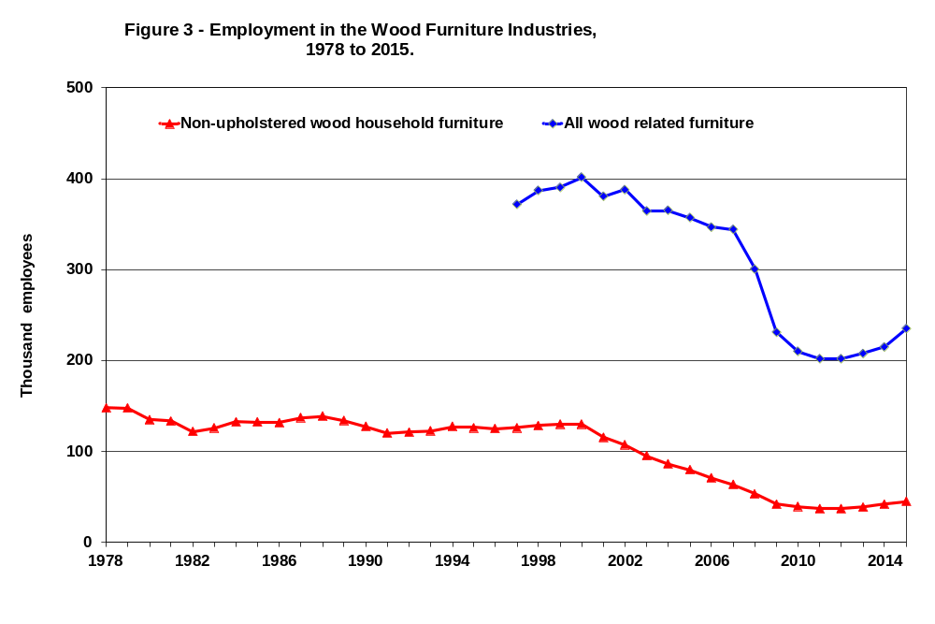
The United States furniture industry, in retreat since 1999, continued declining in 2011 as low-cost furniture imports and the global economic recession continue to erode the domestic industry market share. Employment in the domestic furniture industry has fallen more than 50% since 1999 (Fig. 3). The United States furniture industry stabilized in 2012 and has shown continued strength into 2015 with production growing about 2.9 percent at an annual rate.

Sources of Information

- AF&PA. December 2015. Paper, Paperboard, and Wood Pulp—Monthly Statistical Summary. Washington, D.C.: American Forest and Paper Association.

- APA. 2016. Engineered Wood Statistics, Fourth Quarter 2015. Tacoma, WA: APA – The Engineered Wood Association. 9 p.

- Board of Governors of the Federal Reserve System. 2016. Statistical Releases and Historical Data. Industrial Production and Capacity Utilization - G.17. Washington, D.C. http://www.federalreserve.gov/releases/G17/Current/table1.htm Accessed -2/23/2016.

- Composite Panel Association. 2015. Particleboard and medium-density fiberboard annual production and shipments. [Annual]. Silver Spring, MD: Composite Panel Association.

- Council of Economic Advisors. 2015. Economic Indicators. United States Government Printing Office [Monthly]. November 2015. Washington, D.C. https://www.whitehouse.gov/administration/eop/cea/economic-indicators Accessed 02/23/2016.

- EIA. Annual Energy Outlook 2015 with projections to 2040. DOE/EIA-0383(2015), April 2015. www.eia.gov/forecasts/aeo

- Elling, Joe. 2015. 2014-2019. Market Outlook & Regional Production Structural Panel & Engineered Wood Products. APA Economics Report E81. Tacoma, WA: APA – The Engineered Wood Association. 75 p.

- EPA, 2010. Prevention of Significant Deterioration and Title V Greenhouse Gas Tailoring Rule. Available at: www.epa.gov/nsr/documents/20100413final.pdf. Accessed 11/06/2012.

- EPA. 2011a. Fact Sheet: Proposed Rule – Deferral for C0₂ emissions from bioenergy and other biogenic sources under the prevention of significant deterioration (PSD) and Title V programs. Available at: www.epa.gov/nsr/ghgdocs/biogenicfs.pdf. Accessed 11/06/2012.

- EPA. 2011b. Guidance for determining best available control technology for reducing carbon dioxide emissions from bioenergy production. Office of Air and Radiation. March 2011. Available at: http://www.epa.gov/nsr/ghgdocs/bioenergyguidance.pdf. Accessed 11/06/2012.

- Federal Reserve Bank of Philadelphia. 2015. Economic Research, Survey of Professional Forecasters, Fourth Quarter 2015. http://www.phil.frb.org/research-and-data/real-time-center/survey-of-professional-forecasters/ Accessed 02/11/2016.

- Howard, James L. 2016. U.S. Timber Production, Trade, Consumption, and Price Statistics 1965-2013, February 2016. Madison, WI: U.S. Department of Agriculture, Forest Service, Forest Products Laboratory. FPL-RP-679.

- McKeever, David B.; Howard, James L. 2011. Solid wood timber products consumption in major end uses in the United States, 1950–2009; A Technical Document Supporting the Forest Service 2010 RPA Assessment. General Technical Report FPL-GTR-199. Madison, WI: U.S. Department of Agriculture, Forest Service, Forest Products Laboratory. 41 p. http://www.treesearch.fs.fed.us/pubs/39746 Accessed 02/23/2016

- National Association of Home Builders. 2014. Executive-Level Forecast. David Crowe. Washington, D.C.: National Association of Home Builders. Eye on the Economy. http://www.nahb.org/reference_list.aspx?sectionID=869&channelID=311 Accessed 10/20/2014.

- National Association of Home Builders. January 2016. Housing Economics. Washington, D.C.: https://www.nahb.org/en/research/housing-economics.aspxAccessed 02/23/2016.

- North American Wood Fiber Review. June 2015. Volume 18 Number 2. ISSN 1098-5093. Wood resources International LLC. www.woodprices.com.

- Spelter, H. 2012. Timber Processing Magazine, April 2012. www.timberprocessing.com/magazine.issue/April-2012/.

- Spelter, Henry. 2015. Lumber Markets Status and Trends. September 9, 2015. (vol 11, #6). Topic of the month. The SLA Ends, Then what?

- United Nations Economics Commission Europe and the Food Agriculture Organization. Forests Products Annual Market Review, 2014-2015. P. 96-99. http://www.unece.org/forests/fpamr2015.html Accessed 02/23/2016

- U.S. Department of Commerce, Bureau of the Census. 2016. Manufacturing & Construction Statistics. Washington, DC. http://www.census.gov/mcd/ Accessed 02/23/2016.

- U.S. Department of Labor, Bureau of Labor Statistics. 2015. Producer Prices and Price Indexes. [Monthly and annual]. Washington, DC. http://www.bls.gov/ppi. Accessed 10/2/2015.

- WWPA. 2016. Lumber Track. [Monthly]. February 10th 2016. Portland, OR: Western Wood Products Association.

Figure Captions

Figure 1—Solidwood timber products consumption market shares, 2000 - 2015.
Figure 2—Wholesale prices of forest products, 1999 - 2015.
Figure 3—Employment in the wood furniture industries, 1978 - 2015.

