United Nations
_____________

Economic Commission
for Europe

Sustainable Energy Division

Use of clean, renewable and/or alternative energy technologies in rural districts of Kyrgyzstan

Shamil Dikambaev

Bishkek 2015

Contents

Introduction 3
1. Assessment of proposed decisions for autonomous and network access to power services in rural and remote districts of Kyrgyzstan 5
1.1. General description of power generation and consumption 5
in Kyrgyzstan 5
1.2. Issues of power supply to rural and remote districts of Kyrgyzstan 10
1.3. Assessment of using renewable power technologies for rural districts of Kyrgyzstan in the current conditions 21
2. Assessment of political measures, advanced practices and business models for support of rendering sustainable power services in the rural areas of Kyrgyzstan 26
3. Potential places for development of project for renewable energy sources use in rural and remote districts. 29
4. Recommendations for introduction of the most sustainable mechanisms of renewable power technologies use in the remote districts with autonomous and network access to power supply. 31
References 32
Appendix 1 34
Appendix 2 35
Appendix 3 37
Appendix 4 39

Introduction
Kyrgyz Republic is a country, greater part of which is surrounded by mountains, the population is 5.3 million people, and the area is 200,000 sq. km. It is located in the eastern part of Central Asia and shares borders with Kazakhstan, China, Tajikistan and Uzbekistan. Mountains cover 94% of the territory of Kyrgyzstan.
Power industry is the basic sector in the economy of the Kyrgyz Republic. Profitable and reliable operation of power sector contributes to wellbeing of people and successful economic development of the country.
The main source of power in the republic is water resources; their power potential is 142 billion kWh of possible power generation per year, thereof only 10% are used.
Kyrgyz Republic is the third among the CIS countries after Russia and Tajikistan in its water-power potential. Development of water-power potential in Kyrgyzstan is the main objective of the program on power sector development in the republic.
Kyrgyzstan possesses significant power resources and is able to satisfy its own need to a large extent. However, currently, potential of the fuel and power sector (hereinafter referred to as FPS) is not adequately realized, the efficiency of many energy companies decreased, this sector is suffering significant financial and economic difficulties. The republic is dependent on imported coal, natural gas, and petroleum products. The share of import constitutes more than 50% in the structure of fuel and power balance of the republic.
Expected reserves of 70 major coal deposits are estimated at the level of more than 2.2 billion tons. According to the forecasts, the reserves of undiscovered resources of oil and gas constitute approximately 289 tons of reference fuel. 15 oil and gas deposits are developed in the south of the country, where the volume of produced commercial oil reserves makes 11.6 million tons and natural gas makes 4.9 billion cubic meters.
Development of water-power potential in Kyrgyzstan is the main objective of the program on power sector development in the republic. 20 power plants with total capacity of 3,786 MW are operating in the energy sector, while the capacity of hydropower plants is 3,070 MW and two heat and power plants with capacity of 716 MW.
Annual average power generation constitutes 12-15 billion kWh. The basic share of power generation at hydropower plants is accounted for a cascade of Toktogulskiy hydropower plant with the Toktogulskiy water storage reservoir, the hugest over-year water storage basin, water volume – 19.5 billion cubic meters, which provides Kyrgyzstan and the neighboring countries of Central Asia with power and water for irrigation of the most important agricultural crops.
Approximately 5% of GDP, 16% of the industrial output and 10% of the state budget revenue are accounted for the power industry. Power network provides access to electric energy for almost all population. Water-power potential of 252 large and medium rivers is estimated as follows: capacity - 18.5 million kW, electric energy – more than 160 billion kWh. Water-power potential of small rivers and water streams is approximately 5-8 billion kWh per year, thereof only 3% are used.
Electric power system of Kyrgyzstan is an independent organization, which operates in parallel with the total power system of Central Asia and includes:
- 18 power plants with total installed capacity of 3,666 MW, of which the installed capacity of hydraulic power plants is 2,950 MW and the installed capacity of two heat and power plants is 716 MW. The available capacity of energy system is 3,135 MW for the current period, taking into account exhaustion of generating capacities. The average annual power generation is approximately 12 billion kWh;
- 513 electric substations with voltage of 35-500 kW;
- 64,993 kilometers of transmission lines with voltage of 0.4-500 kW.
The major hydropower plants of the republic, located on Naryn river, which flows in the valley of the south-west part of the country, form a group of stations on 5 dams (with total capacity of 2,870 MW).
More than 70 thousand kilometers of transmission lines with voltage of 0.4-500 kW are put into operation in the electric power system of Kyrgyzstan, whereof 546 kilometers are lines with voltage of 500 kW, 1,714 kilometers – lines with voltage of 220 kW and 4,380 kilometers – lines with voltage of 110 kW, as well as approximately 490 of transforming sub-stations with voltage of 35-500 kW, the total capacity is more than 8,000 MVA. However, these facilities are outdated part thereof shall be replaced or upgraded.
The Kyrgyz Republic is among the countries possessing huge potential of renewable energy. First of all, it is the solar, water streams, wind and biogas energy. Potentially, renewable energy sources (RES) can satisfy 50% of the county’s demand for fuel and power resources.
Use of RES shall be considered as the most promising in the remote mountainous and rural districts, which have no centralized power supply: farms and cattle breeding complexes, mining enterprises, road services, tourism and ecological facilities, pumping stations, the facilities of the forest and hunting farms, etc.; dwelling houses, social amenities, the facilities of culture and sport, sales outlets, health-related institutions, etc.
Currently, practical use of RES is not significant and constitutes less than 1% in the power balance of the country. The aforementioned situation is connected with different facts and the major one is weak mechanism of economic stimulation in use of RES. The Ministry of Energy and Industry is planning to increase the share of renewable energy sources up to 4% by 2025.
It is necessary to use RES due to peculiarities of the natural landscape. More than 90 % of the territory is covered by mountains. More than 60% of the population lives in rural districts of piedmont and mountain areas, where traditional fuel supply is very complicated. Under such conditions, application of local autonomous RES systems, which do not require connection to the existing power system, is very profitable. Application of wind power plants and micro-HPPs for power supply to such consumers will be less cost-intensive. RES is the only one available opportunity to resolve energetic, social and economic problems of the population. Thus, application of solar heating systems will contribute to funds saving for purchase of traditional fuel and improving living conditions by means of hot water supply necessary for household needs. Application of biogas plants will allow the inhabitants of villages to produce inflammable gas and high efficient fertilizers improving yielding capacity of crops and population quality of life. Moreover, application of wind energy or micro-HPPs contributes to creation of new jobs.
However, despite huge potential of renewable energy sources in the republic, creation and introduction of RES is still less cost-effective and more capital intensive as compared to traditional methods. Till present, there was no practical requirement for RES application, primarily, due to significantly low value of power generated by traditional methods as compared to the value of power generated by means of RES application. Currently, the situation is changing significantly and increased need in such energy application can be expected.

1. Assessment of proposed decisions for autonomous and network access to power services in rural and remote districts of Kyrgyzstan

General description of power generation and consumption

in Kyrgyzstan

Power sector in the republic is among the most significant spheres of economy and plays an important role in development of the country as the main supplier of power for enterprises and population.
However, nowadays this sector suffers difficulties and is not able to satisfy demand of consumers for power completely.
“The Medium-Term Development Program of the Kyrgyz Republic for 2012-2014” [1], adopted in 2012, reflects perspectives and medium-term priorities of development of the Kyrgyz Republic for 2012-2014. Sector 5.6.1 “Power sector” provides the following information:
- Power sector of the Kyrgyz Republic suffered numerous difficulties over the years. The level of commercial and technical losses is unacceptably high. Financial situation of energy providers is unfavorable. This is resulted from high and sometimes unreasonable business costs.
- Obsolence and physical deterioration of equipment has reached the level, which cause high risks for sustainable operation of the sector. Number of accidents and failure of power-generating equipment exceeds all standard and norms, particularly during the period of peak seasonal overload.
The Medium-Term Power Sector Development Strategy of the Kyrgyz Republic for 2012-2017 [2], adopted in 2012 as well, specifies the main objectives for improvement of energy providers’ efficiency and formation of conditions for their sustainable development.
The main objective of this Strategy is “provision of power supply security in the Kyrgyz Republic, sustainable economic growth and development of power sector in the republic through strengthening power supply and economic security, achievement of financial and economic rehabilitation, as well as competitive advantage of the Kyrgyz Republic in the power export markets by increasing generating and processing capacities through re-equipment”.
Annual power generation in Kyrgyzstan is within the range from 12 billion kWh to 15 billion kWh, Fig. 1 (depending on water content of Naryn river). Currently, available capacity of power plants in Kyrgyzstan is 3,587 MW. The list of main power generating sources is given in Table 1.
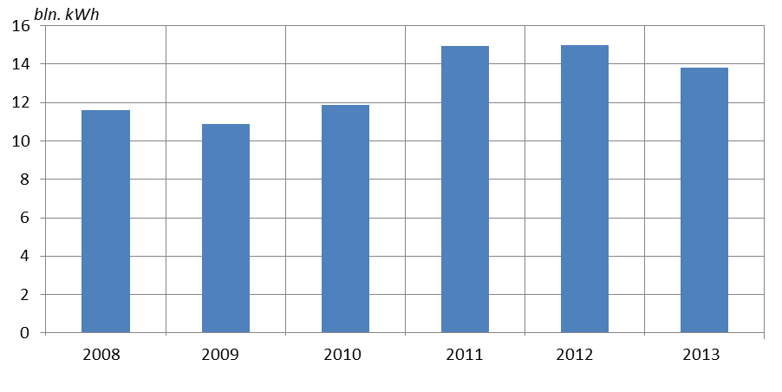
Figure 1 – Power generated by power plants in 2008-2013

Table 1 – Generating capacities of Kyrgyzstan
Name | Year of putting into operation | Installed capacity,  MW | Available capacity, MW
Toktogulskiy HPP | 1975 | 1,200 | 1,200
Kurpsaiskiy HPP | 1981 | 800 | 800
Tash-Kumyrskiy HPP | 1985 | 450 | 450
Shamaldy-Saiskiy HPP | 1994 | 240 | 240
Uchkurganskiy HPP | 1961 | 180 | 175
At-Bashinskiy HPP | 1970 | 40 | 37
Kambaratinskiy HPP 2 | 2010 | 120 | 100
Small HPP – 12 units | 1940-1960 | 42 | 30
CHPP of Bishkek city | 1961 | 666 | 520
CHPP of Osh city | 1966 | 50 | 35
Total |  | 3,788 | 3,587
The peculiarity of power sector of Kyrgyzstan is as follows: 90% of generating capacities is accounted for hydropower plants located in the south of the republic; however 70% of power is consumed in the north. Such structure of generating capacities creates such circumstances, when power generation by a cascade of Toktogulskiy hydropower plants becomes directly dependent of the water volume in Toktogulskiy water storage reservoir.
Over the last years, significant growth in power and capacity consumption was observed in the north and south of Kyrgyzstan.
In January 2014, maximum power consumption in the republic reached 3,139 MW, as well as 2,045 MW in the north of the republic, 1,094 MW in the south of the republic, i.e. generating capacity reserve has almost been exhausted.
Dynamics of power consumption growth is given in Figure 2.

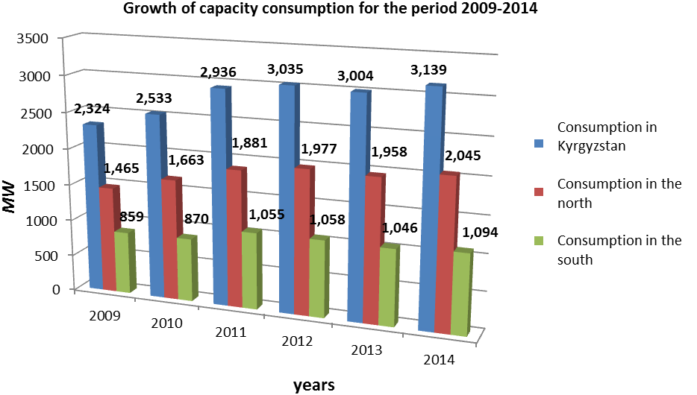

Figure 2 – Dynamics of growth in capacity consumption

In early 90s, the population of the Kyrgyz Republic consumed up to 16% of the whole power supplied to the domestic market; state-funded organizations – 19%; industry, agriculture, commercial consumers – 65% (Fig. 3). It was conditioned by the circumstances, when coal mining made more than 5 million tons per year, thereof 4.5 million tons were consumed in the republic, the volume of natural gas constituted more than 2.5 billion cubic meters, heating oil – 600 thousand tons. Currently, the structure of power consumption has changed oppositely, thus the population consumes approximately 60.5% of the whole power supplied to the domestic market; budget – 10.5%; industry, agriculture, commercial consumers – 29% (Fig. 4).
The structure of typical daily power consumption in the autumn and winter of 2013-2014 by regions of Kyrgyzstan in denominate and relative units (%) is given in Figures 5 and 6. The major share of power (66%) is consumed in the north of Kyrgyzstan, 34% – in the south.

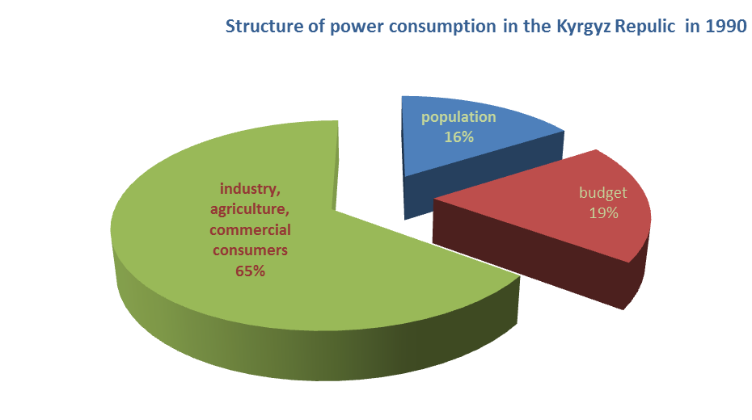

Figure 3 – Structure of power consumption in the Kyrgyz Republic in 1990

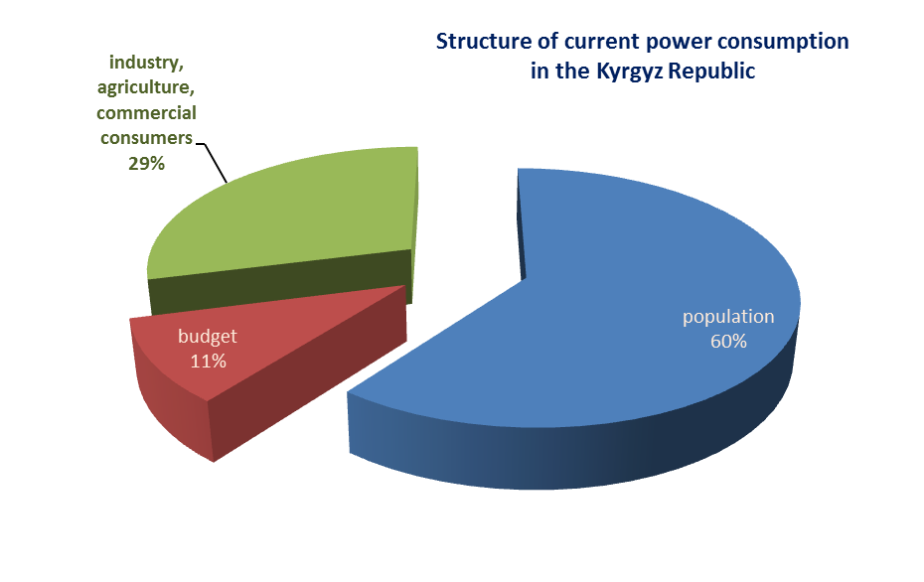

Figure 4 – Structure of power consumption in the Kyrgyz Republic in 2014
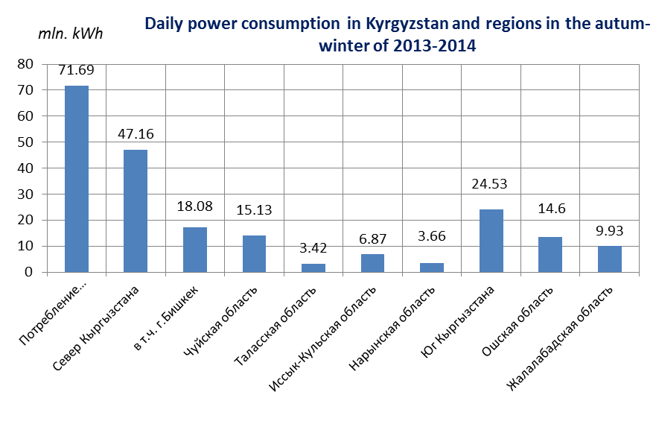
Consumption | South of Kyrgyzstan | Including Bishkek city | Chui region | Talas region | Issyk-Kul region | Naryn region | South of Kyrgyzstan | Osh region | Jalal-Abad region

Figure 5 – Structure of typical daily power consumption
(mln. kWh) in the regions of Kyrgyzstan in the autumn-winter of 2013-2014

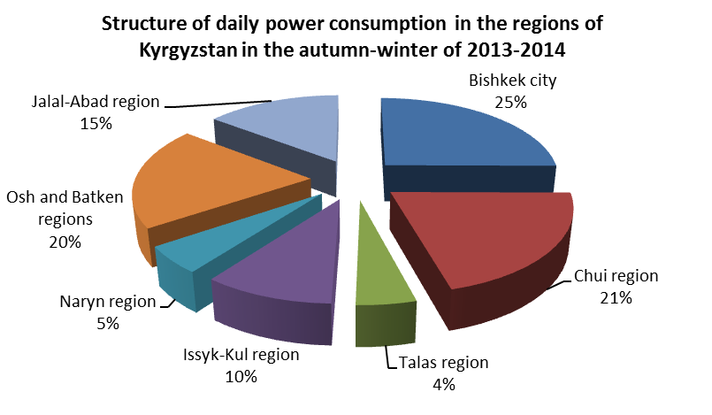

Figure 6 – Structure of typical daily power consumption (in %) in the regions of Kyrgyzstan in the autumn-winter 2013-2014

Annual growth of power consumption by 3-5% outpaces growth of new capacities. The share of power consumption by the population has increased by 8 per cent over the last years.
According to M. Cholponkulov, head of the electricity distribution department of the Ministry of Energy and Industry, the main current issue for the power regulators remains growth in power consumption. In 3-4 years, when “Datka-Kemin” power transmission lines with capacity of 500 kW are put into operation, HPPs are constructed and ungraded, the situation will be improved. “Meanwhile, our main objective consists in reduction of power consumption, where possible.” (http://www.knews.kg/ru/econom/26348/ January 11, 2013)
Due to lack of water in the water storage reservoir of Toktogulskiy HPP (generating up to 70% of power produced in the republic) observed during the last years, the level of water decreased significantly, it caused decline in the volume of power generation. In order to partially compensate power deficit, the government took a series of measures: social limit on power consumption was introduced and agreement was reached with Kazakhstan on purchase of insufficient volume of power in this country.

1.2. Issues of power supply to rural and remote districts of Kyrgyzstan

More than 60% of population in Kyrgyzstan lives in the rural districts. Some settlements in such rural districts are deprived of elementary conveniences; the most significant one is power supply, it results in impossibility to exercise the main rights of the population for proper health care and education. Although, the National strategy of the Kyrgyz Republic “Complex development of village till 2010” [30], approved by the Decree of the President in 2004, for provision of sufficient level of power supply and arrangement of proper conditions for living and self-development of the population, stipulated as follows:
- Involvement of population funds for construction of transmission networks with capacity of 6.10-0.4 kW by means of “ashar” method, as well as individual construction;
- Development of networks for reliable power supply to each rural administrative district;
- Provision of villages with the projects for construction of power supply networks;
- Development of financial, lending and investment mechanisms for purchase and construction of power supply networks and transformer substations;
- Implementation of measures for formation and mobilization of local communities and population participating in the activities on improvement of power supply network;
- Provision of uninterrupted power supply to the population of rural districts and other consumers located in the rural areas, including farm households;
- Development of alternative ecological methods of heat supply to the rural districts;
- Introduction of cost-effective power-saving technologies of construction and operation of gas supply systems, highly-efficient and ecologically safe equipment for use of gas fuel.”
Topicality of this issue still remains very acute. The current system of power supply to agricultural districts is a structure, which has been operating without any changes for several decades. Insufficient rates of development and reconstruction of power distribution systems, physical depreciation of equipment, constant overloading results in emergency shutdowns. The first fall of temperature in November 2014 detected issues in the power supply sector of the country. Power cutoffs were observed in the remote districts; according to power distribution companies the number of emergency shutdowns within 12 months of 2014 in the power supply systems with capacity of 6/10 kW made 9,216 cases, this indicator decreased by 652 cases or by 6.6% compared to the same period of 2013.
Despite the fact that Kyrgyzstan sometimes exports power to the neighboring countries, there are rural settlements, which are not provided with power supply. For example, Jaz-Kechuu village of Bazar-Korgonskiy district, Jalal-Abad region has never been connected to power supply system, people live here since the beginning of the XX century, and their style of living has not been changed within the years. More than five hundred people live in this small village in the mountains, in the cold winter months these people are disconnected from civilization. Jaz-Kechuu village is surrounded by mountains; local people are primarily engaged in animal breeding, rarely in agriculture.
Tiurdiuk village of Aksyiskiy district, Jalal-Abad region was provided with power for the first time within 70-year period. M. Aidaraliev, akim (governor) of the district told about it to news agency “24.kg 08.04.2014”, Tiurdiuk is a small village currently inhabited by 70 households, it was established in the Soviet Union period, people of this village had been living for more than 70 years without electricity.
“Ken-Suu village of Jumgalskiy district, Naryn region, which consists of 40 households, has not been provided with electric energy since the Soviet period”, - said experts of the working group on improvement of legal framework of the Kyrgyz Republic for attraction of investments to small HPPs.
Kyzyl-Beiit and Kyrgultu villages of Ak-syiskiy district are located close to Kurpsaiskiy HPP; power is not supplied to these villages although they are located at the distance of 8 km from the largest HPP of Kyrgyzstan.
Table 2 gives more complete list of non-electrified settlements and supposed improvement measures.
Due to lack of sufficient power supply, development of rural districts of Kyrgyzstan slowed down, as well as such key sectors as primary health care and education. Health of population in Kyrgyzstan and their possibilities to be educated are rather restricted without necessary conditions for vaccines and other medicines storage, lack of elementary diagnostic equipment, means of communication and mass media, which depend on power supply.
Acuteness of issue settlement related to power supply, including rural districts, increases due to growth in the quantity of population, as well as increase in the number of new families, transformation of land plots for individual housing construction.
According to sociological research “Assessment of power distribution system” conducted by the Public fund “YUNISON” in 2013, demand for connection to power supply system by the regions is as follows:
- there are 52 housing estates in the suburbs of Bishkek city (there are more new housing develoments in the Chui region compared to the other regions, as migration to the region is more large-scale);
- there are 8 new housing developments around Osh city (Furkat, Yuzhnyi, Tashlak, Zhapalak, Dacha community, Ak-Tilek, etc.);
- there are 10 new housing developments around Jalal-Abad, the number of new housing developments is not clarified;
- Issyk-Kul region: Karakol town – 6 new housing developments, Balykchy town – 4, all shall be electrified, additionally by regions: Issyk-Kulskiy – 13, Tonskiy – 9, Dzhety-Oguzskiy – 15, Aksuiskiy – 10, Tiupskiy – 181;
- Naryn region is characterized by migration to other regions, however, despite this fact, insignificant new housing developments in the region can be seen in all settlements due to growth in the quantity of population and creation of new families. The total number of new housing developments is approximately 100;
- In Batken and Talas regions, the issues of half-official new settlements are accompanied by the aspects of boundary sharing with other country, where such issues are more topical,
or in percent to the total number of new housing developments:
- suburbs of Bishkek city – 32.7%;
- Jalal-Abad region – 28.7%;
- Chui region – 13.9%;
- Osh region – 8.9%;
- Naryn region – 5%
- Issyk-Kul region – 3%;
- Batken region – 3%.

Table 2 – List of non-electrified settlements and measures taken for their electrification

№№ | Name of settlement | Obligatory measures |  |  |  |  | Estimated cost, mln. KGS | Note
№№ | Name of settlement | HV line 10 kW, km | HV line 0.4 kW,  km | PTS 10/0.4 kW, package | Capacity of PTS, kVA |  | Estimated cost, mln. KGS | Note
Naryn region
1 | Ken-Suu (Dzhumgalskiy district) | 12.0 | 1.0 | 1 | 100 |  | 12.59
2 | Kotur-Suu  (Dzhumgalskiy district) | 16.0 | 2.8 | 2 | 63 |  | 18.16
3 | Chontalga (Dzhumgalskiy district) | 17.0 | 1.6 | 1 | 100 |  | 17.85
4 | Kara-Unkur (Narynskiy district) | 15.0 | 2.6 | 1 | 63 |  | 48.00 | Construction of substation is obligatory  110/10
5 | Orto-Syrt  (Ak-Talinskiy district) | 60.0 | 1.0 | 1 | 63 |  | 58.00
6 | Ak-Kol (Dzhumgalskiy district) | 14.0 | 1.0 | 1 | 63 |  | 14.40
Issyk-Kul region
7 | Bel (Tonskiy district) | 28.2 | 4.0 | 6 | 63 |  | 33.00
Jalal-Abad region
8 | Kyzyl-Beiit  (Aksyiskiy district) |  |  |  |  |  |  | Villages are located on the right bank of the Naryn river. Taking into account mountain, rocky relief, construction of HV lines is impossible. The issue of wind-driven generators application is studied.
9 | Kurp (Aksyiskiy district)
10 | Kurkoktu (Aksyiskiy district)
11 | Shynsai (Nookenskiy district) | 12.0 | 2.0 | 1 |  | 100 | 7.70
12 | Sary-Kamysh  (Nookenskiy district) | 8.0 | 2.0 | 1 |  | 100 | 5.70
13 | Shaidan (Nookenskiy district) | 23.0 | 3.0 | 1 |  | 100 | 13.90
14 | Zhazykechuu (Bazar-Korgonskiy district) |  | 4.6 | 1 |  | 100 | 1.66
15 | Kotormo (Toktogulskiy district) | 6.0 | 2.0 | 1 |  | 250 | 6.50
16 | Esh-Sai (Toktogulskiy district) | 3.0 | 1.0 | 1 |  | 160 | 4.30
17 | Bekechal (Toktogulskiy district) | 2.0 | 0.4 | 1 |  | 100 | 1.50
Batken region
18 | Zardaly (Batkenskiy district) | 20.0 | 0.8 | 1 | 100 |  | 18.00
19 | Sary-Kamysh  (Kadamzhaiskiy district) | 8.0 | 3.0 | 1 | 160 |  | 12.00
20 | Teskei (Kadamzhaiskiy district) | 2.5 | 1.9 | 1 | 160 |  | 2.30
Osh region
21 | Kyzyl-Oi (Alaiskiy district) | 1.2 | 1.0 | 1 | 100 |  | 0.86
New housing development of Chui region
Yssyk-Atinskiy district
22 | Novo-Pokrovka |  | 3.55 | 5 | 250 |  | 5.473
23 | Milianfan |  | 6.24 | 6 | 250 |  | 7.285
24 | Luxemburg |  | 1.6 | 1 | 250 |  | 1.95
25 | Budenovka |  | 1.43 | 1 | 160 |  | 0.792
26 | Krasnaya rechka |  | 1.11 |  |  |  | 0.514
27 | Ivanovka station |  | 4.76 | 1 | 160 |  | 2.679
28 | Ken-Bulun |  | 2.92 |  |  |  | 1.548
 | Sokulukskiy district
29 | Voenno-Antonovka | 0.1 | 2.0 | 1 | 250 |  | 2.34
30 | Novo-Pavlovka |  | 12.74 | 3 | 250 |  | 22.323
30 | Novo-Pavlovka |  |  | 3 | 160
31 | Kashka-Bash | 0.3 | 2.0 | 2 | 160 |  | 2.60
32 | Dzhal (southern side) | 0.4 | 1.2 | 1 | 250 |  | 1.95
33 | Sarban |  | 0.8 |  |  |  | 0.624
34 | Selektsionnoye (buffer area) | 1.5 | 0.6 | 5 | 160 |  | 4.355
35 | Ismail (eastern side) |  | 0.6 |  |  |  | 0.468
36 | Kuntuu | 0.15 | 0.9 | 1 | 250 |  | 1.599
37 | Shalta |  | 3.0 | 1 | 250 |  | 3.848
37 | Shalta |  |  | 1 | 160
38 | Ak-Jol | 0.3 | 0.95 |  |  |  | 0.975
39 | Uchkun |  | 0.4 |  |  |  | 0.312
40 | Romanovka | 1.0 | 0.1 | 1 | 160 |  | 1.261
41 | Sokuluk |  | 1.5 | 1 | 250 |  | 2.574
42 | Milling plant behind railway |  | 7.5 | 6 | 250 |  | 10.062
43 | Depovskaya str. |  | 0.5 | 1 | 160 |  | 0.793
44 | Shkolnaya str. behind filling station |  | 0.4 | 1 | 160 |  | 0.715
45 | Unnamed str. (towards north) |  | 0.4 | 1 | 160 |  | 0.715
46 | Pogranichnaya str., Western str. |  | 0.4 | 1 | 160 |  | 0.715
47 | V-Orok (northern side) |  | 1.5 | 2 | 250 |  | 2.574
48 | Druzhba str. |  | 3.92 | 1 | 250 |  | 3.759
49 | Frunze farm | 0.3 | 0.8 | 1 | 250 |  | 1.56
Alamudunskiy district
50 | Kok-Dzhar | 0.25 | 0.2 | 2 | 160 |  | 1.183
51 | Kara-Dzhigach | 0.3 | 0.4 | 2 | 160 |  | 1.534
52 | Koi-Tash, Zapadnaya str. | 0.03 | 0.1 | 1 | 250 |  | 0.978
53 | Besh-Kungei | 0.3 | 0.05 | 1 | 100 |  | 0.707
54 | Arashan |  | 0.1 | 1 | 100 |  | 0.481
55 | Baitik | 0.2 | 0.1 | 1 | 250 |  | 0.936
56 | Kashka-Suu | 0.25 | 0.15 | 1 | 250 |  | 1.014
57 | Lebedinovka, new housing development | 6.0 | 18.0 | 4 | 250 |  | 21.528
58 | Mayevka new housing development, 23 ha | 1.0 | 6.0 | 4 | 250 |  | 8.268
59 | Mayevka new housing development, 12 ha | 0.8 | 3.0 | 2 | 250 |  | 4.368
60 | Mayevka new housing development, 7 ha | 3.0 | 2.0 | 1 | 250 |  | 4.602
61 | Mayevka new housing development, 8 ha | 1.0 | 1.0 | 1 | 250 |  | 2.262
62 | Mramornoye new housing development, 20 ha | 0.3 | 6.0 | 4 | 250 |  | 7.722
63 | Mykan | 0.4 | 2.0 | 1 | 250 |  | 2.574
64 | Leninskoye | 0.3 | 1.2 | 1 | 250 |  | 1.872
65 | Lugovoye | 0.4 | 0.2 | 1 | 250 |  | 2.574
66 | Konstantinovka | 0.3 | 1.0 | 1 | 250 |  | 1.716
67 | Prigorodnoye | 1.3 | 3.5 | 3 | 250 |  | 5.85
Chuiskiy district
68 | Birimdik | 0.4 | 1.57 | 2 | 160 |  | 2.392
69 | Karoi | 0.3 | 1.13 | 1 | 160 |  | 1.674
70 | Burana |  | 0.8 |  |  |  | 1.365
71 | Chui | 1.0 | 0.4 | 1 | 160 |  | 1.495
Moskovskiy district
72 | Aleksandrovka  (eastern side) |  |  | 4 | 400 |  | 2.683
73 | Stretenka, 3 sheep sheds, 3 houses | 1.5 | 2.3 | 1 | 100 |  | 3.289
74 | Petrovka, 27, Partsyezd str. |  | 0.6 |  |  |  | 0.468
75 | Chon-Aryk dacha community | 0.5 | 0.9 | 1 | 100 |  | 1.417
Keminskiy district
76 | Kaindy |  | 2.3 | 1 | 250 |  | 2.464
77 | Tarsuu |  | 2.3 | 2 | 160 |  | 2.6
78 | Shabdan |  | 0.55 | 1 | 100 |  | 1.183
79 | Kemin, Gagarin str. |  | 1.0 | 1 | 100 |  | 0.832
80 | Kichi-Kemin, Tursun-Osmon str. |  | 0.6 | 1 | 100 |  | 0.832
81 | Beisheke, new street |  | 0.3 | 1 | 160 |  | 0.871
82 | Kichi-Kemin, Bektenova str. |  | 0.5 | 1 | 100 |  | 0.905
83 | Chym-Korgon |  | 0.6 | 1 | 100 |  | 0.793
84 | New housing development, Osh city | 30.0 | 58.0 | 32 | 3.200 |  | 58.4
 | Total | 301.8 | 218.4 | 155 | 16.325 |  | 516.615

These issues shall be settled by means of complex state approach, particularly on the part of the government and government body authorized for development of policy in the sphere of power sector.
Article 14 of the Law of the Kyrgyz Republic “On power sector” [4] stipulate, that “license holders shall be liable for provision of power supply to all clients located on the territory of their activity, who forward a request for power supply, including provision of power to the clients located in remote districts.” Despite the corresponding article on power supply to the customers, power distribution companies either don not comply this regulation, or interpret thereof otherwise (power distribution companies consider that Article 14 covers only existing consumers), or this regulation is openly ignored due to lack of funds.
According to current legislation, the authorities of state agencies, including power distribution companies and self-government (SG) bodies, on arrangement and provision of power supply to new consumers are not clearly described, which is reflected on citizens, who are not provided with power supply. Thus, the Law of the Kyrgyz Republic “On local self-government” [5] stipulates that the local self-government bodies shall be liable for social and economic development of the territory and shall contribute to settlement of local issues. However, the local issues comprise only arrangement of public facilities lightening; provision of power supply to population is not included in the category of local issues and is not envisaged in the delegated state authorities. Thus, the issue of power supply to the new consumers was not taken into account by the legislators.
Due to complicated financial conditions of SG bodies, which are generally subsidized and require additional financing from the republican budget, it is too early to impose full responsibility on SG bodies regarding power supply to new consumers.
On December 26, 2014, the Committee of Jogorku Kenesh on fuel, energy complex and subsoil use together with the Project of the Institute for Policy Development (IPD) “the Voice of citizens and the accountability of SG bodies: budgetary process”, financed by the Government of Switzerland, in cooperation with the United Kingdom Department for International Development conducted a round-table conference devoted to the topic: “Problems of the legislation of the Kyrgyz Republic in the sphere of power supply provision to new consumers.”
Discussion concerned the issues of power supply to the new consumers, who are not provided with access to power, as well as the bill aimed at settlement of this issue, which was initiated by K. Bokoev and K. Ryspaev, the deputies of Jogorku Kenesh. The bill is provided with particular importance due to its connection with the section about power sector of the National strategy for sustainable development of the Kyrgyz Republic for 2013-2017 (regarding provision of reliable and uninterrupted power supply, primarily, to internal consumers) [6]. Deputies have submitted amendments introduced in the Laws “On power sector” and “On town-planning and architecture of the Kyrgyz Republic” for public discussion.
This discussion has become more acute due to participation and position of the Minister of Energy and Industry, K. Turdubaev: “Electrification of new housing developments is a very topical issue, which has not been raised at such high level yet.” He acknowledged with much regret, than nowadays power distribution companies are not capable to electrify new housing developments, as funds for such purposes are not included in their budgets. “Expenditure budget of power distribution companies amounts to KGS 4 billion 412 million. Currently, according to our preliminary estimates, the amount of KGS 4 billion 474 million is necessary to provide power to new housing developments. Therefore, the funds of power distribution companies are sufficient only for keeping existing systems in working order. It is obvious that these companies will not be able to settle independently the issue related to power supply to new housing developments,” – said head of the Ministry of Energy and Industry. He also added that it was not “fair” to impose all expenses on the budget, thus they shall be partially included in the tariff.
Head of Kol-Tokskiy aiyl-okmotu (village council) of Tonskiy district, Issyk-Kul region, K. Azimov said that “due to lack of clearly set rules and authorities responsible for settlement of this issue, SG bodies find themselves in a difficult situation, as quantity of population increases, new housing estates are built and finally the issue of their electrification is raised. Population turns to district power supply authority (DPSA), however, DPSA considers this problem as an issue of local significance and directs people to aiyl-okmotu. If this issue is settled by means of local budget, one can get pulled due to inappropriate use of funds of the local budget, if some authority rejects resolving this issue, people and deputies of the local kenesh will hate it. Endless circle!”
The necessity of full-scale electrification of rural areas in Kyrgyzstan is obvious, the current situation and physical characteristics of the country favor to use of various types of renewable energy. Such technologies have been developed and are widely used around the world contributing to implementation of development projects, and they are affordable for small settlements of rural areas.
Prospects of renewable energy sources (RES) use in Kyrgyzstan are more significant; the population living in mountains suffers from frequent stoppage of power supply, 50 % of demands could be satisfied by means of RES, currently less than 1% thereof is used.
However, despite increased interest of the population to alternative energy sources (primarily due to continuous power crisis) the state energy providers do not provide the possibility to stimulate development of autonomous power supply systems. The prices for power in Kyrgyzstan are the lowest in all Central Asia.

1.3. Assessment of using renewable power technologies for rural districts of Kyrgyzstan in the current conditions

In the materials widespread at a business forum “Kyrgyzstan – Tatarstan” held on March 3, 2015, it was noted, that potential resources of nontraditional renewable energy sources in Kyrgyzstan are estimated in 840 million tons of equivalent fuel per year. Among them 570.5 million tons are accounted for solar power, wind power – 246 million tons, geothermal power – 21 million tons, biomass – 1.8 million tons and small water streams – 0.7 million tons.
If RES use in the industrialized countries is defined basically by the issues of environment protection and requirements of search, first of all, for additional power resources, it is necessary to consider RES in respect of Kyrgyzstan use as settlement, first of all, of social and economic problems of rural population.
The most part of the population (more than 60 %) lives in rural and mountain areas where frequently supply of traditional fuel is complicated due to absence of good roads in the mountains, their insufficient extent and branching makes delivery of traditional fuel and power resources expensive. For a poor population such expensive fuel will not be affordable. These circumstances stimulate use of the local autonomous RES systems, which do not require connection to existing power supply systems, and in some cases it is the only available possibility of settlement issues related to power supply to rural people. Application of wind power plants, solar energy collecting panels and photovoltaic systems or micro-HPPs for power supply to such consumers will be less cost-intensive in some circumstances.
Currently, Kyrgyzstan possesses its own innovation technologies based on application of the solar, wind, biomass, and small water flows power. Thus, production of solar thermal batteries for water heating and cooking by the population of rural areas was implemented within the framework of Kun project. Production of such batteries is fulfilled in Karabalta town.
Centre for RES development specializes in improvement and introduction of “green” technologies as follows:
• Biogas technologies
• Solar technologies
• Micro-, mini-HPP
• Heat pumps
• Wind power
• Power efficiency
Use of wind power in the Kyrgyz Republic is considered perspective in case small wind-driven power plants with low capacity of 1-5 kW are used for power generation and supply to individual consumers.
Scientific development on wind-driven power plants attracts practical interest. These units can operate at wind speeds 2 times lower and generate regular capacity for wind-driven power plants. Double-wheel wind-driven power plant DWPP-0.25 for power supply to not energy intensive agricultural consumers and individual residential houses. This plant is developed particularly for the climate conditions of mountainous areas of Kyrgyzstan and is meant for autonomous work. Technical solutions are protected by several patents. Work was carried out in joint cooperation with OREMI JSC and the Institute of Automation of the National Academy of Sciences.
Preproduction models of heat-pump systems (HPS) with capacity of 2 and 15 kW were produced in cooperation with Agrohladremmash JSC and passed industrial tests at this enterprise. HPS-12 was developed in cooperation with Zhanar JSC. HPS is considered as one of the most effective and potentially productive directions for conversion of RES and application of low-potential and secondary energy sources for residential houses and premises heating.
Introduction of biogas technologies in the agriculture of the Kyrgyz Republic is a real opportunity for settlement of issues on power supply to rural population, including significant decrease of load on ecology of the country by preventing from methane emissions into the atmosphere. Use of biomass for production of inflammable gas – methane. A number of research, development and experimental works were carried out in this direction, which allowed creating 2 types of biogas plants. The first one – biogas plants for rural areas, the second one – of industrial type.
Use of biogas improves living conditions in the households. People living in rural areas of Kyrgyzstan, particularly women, who spend a lot of time and money for procurement of wood and coal. Application of biogas provides more free time and at the same time, reduces the need for performing heavy physical work, improves the living conditions of women and vulnerable groups of society, as biogas is used for domestic purposes – cooking and heating.
Development of biogas technologies in the Kyrgyz Republic was initiated 12 years ago, currently, about 70 biogas plants have been installed and put into operation primarily by means of donors funds: JICA (Japan International Cooperation Agency), UNDP and European Commission. These plants can produce from 20 cubic meters up to 400 cubic meters of gas (methane) per day depending on loaded raw materials (dung). About 25 biogas plants located in Chui and Issyk-Kul regions were constructed for the last years within the framework of different projects and with assistance of individuals. 12 biogas plants were constructed within the framework of JICA projects (Japan International Cooperation Agency). The major enterprises which introduce biogas plants are the following: Fluid Public Fund, Zhaz JSC and the Renewable Energy Source Center.

Fluid Public Fund is the most active in construction of biogas plants; it possesses production capacities and scientific base. Biogas plants of Fluid PF allow heating farms and individual houses of farmers out of nothing, i.e. cow dung, which is regarded as wastes in the villages of Kyrgyzstan.

In Kochkorskiy district, Naryn region, farmer Tologon Zhamalov installed portable biogas plant БЭМ-5М (Fig. 7), which processes dung and turns it into fertilizers and methane. According to its engineer, Aleksey Vedenev, head of Fluid Public Fund, this unit is “the first in the world” portable biogas plant.

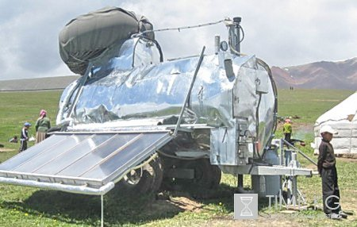

Figure 7 – Portable biogas plant БЭМ-5М

Biogas plant of such type attracted interest of the representatives from South Korea. Specialists of Fluid Public Fund designed and constructed portable biogas plant БЭМ-50 for rural cooperative from South Korea. This plant will allow processing up to three tons of dung per day and generate up to 120 cubic meters of biogas within the same period of time. This plant will provide 20 families with power necessary for cooking and hot water supply, as well as heating of their houses. Another product of processing is bio-fertilizers, which can increase yielding capacity of crops by 2-3 times. Export of biogas plant to DPRK was fulfilled with assistance of UNDP; the cost of this plant is KGS 600-700 thousand.
Use of solar power for provision of standby power supply, heating and hot water supply is very necessary in the regions located far from central power supply systems. According to BIOM employees, currently, solar power plants with the total area of 60 thousand square meters have been installed in the Kyrgyz Republic.
BIOM Ecological Movement within the framework of the project “Power efficiency for sustainable future” of the programs “Clean power” implements plans on power saving and power efficiency in local communities. Owing to efforts of BIOM Movement the handbook “Power saving and renewable power: goods and services in the market of Kyrgyzstan” has been developed in the Kyrgyz Republic, in this handbook it is possible to find information on the expert and scientific community working in RES sphere. BIOM specialists train rural people, how to install water heating unit (solar power collecting units), which can heat water up to 80 degrees. Moreover, they suggest vacuum collectors, solar furnaces and solar barrels for feldsher-midwife stations (FMS) and family physicians groups (FPG). All these units were used and approved as they are simple in use, maintenance and repair. 35 solar barrels, 2 power efficient furnaces, 15 solar power plants and 3 solar furnaces were introduced within the framework of the project in the pilot villages. Several additional solar barrels and furnaces, vacuum flasks and rucksacks were presented to administrations in order to attract interest of local authorities to new RES. There is visual information regarding six villages, which were turned into exhibitions of solar technologies in Kyrgyzstan. Upon 3-day training, the inhabitants of Ak-Terek village, Dzheti-Oguzskiy district, assembled independently 10 solar barrels and installed thereof on the roof of local school. Inhabitants of Tuze village assembled 7 solar power collecting units and installed thereof in the organizations under the guidance of the project trainers.
In recent years, hospitals, FMS, health centers with alternative power supply are being built and re-equipped in the cities and villages, including the most remote ones, thanks to donor support. In 2012, PVS were installed in the territorial hospitals of Tonskiy district of Issyk-Kul region, At-Bashinskiy district of Naryn region, Alaiskiy district of Osh region and in the hospital of Jalal-Abad region. New technologies of power supply were introduced within the framework of the projects “Provision of uninterrupted power supply to feldsher-midwife stations” and UNDP/GEF project “Improvement of energy efficiency in buildings”. Upon installation of photovoltaic stations, conditions for rendering medical assistance were created in FMS taking into account scheduled outages and emergencies. Solar equipment and micro-HPP provided complete satisfaction of FMS requirements in power, independence and continuous power supply.
Ministry of Energy and Industry in cooperation with the European Bank for Reconstruction and Development (EBRD) implements the project “Strategic planning for developing small-scale power sector in the Kyrgyz Republic.” This project is implemented by Mercados EMI Consortium (Spain) and RusHydro OJSC (Russia) by means of grant funding provided by the EBRD. 20 small perspective HPPs among 88 potential sites were selected, existing mechanisms of support and integration of renewable energy sources were reviewed within the framework of the project. 4 small HPPs were selected among 20 potential sites, terms of reference were elaborated for them (Orto-Tokoiskiy – 20 MW, Oi-Alma – 7.7 MW, Sokulukskiy -5 – 1.5 MW, Tortgulskiy – 3.0 MW).
Efficiency of small hydropower plants directly depends on net cost of power generation, quantity of consumers, remoteness between consumers and the main power transmission lines. With an increase in quantity of consumers and distances from the main power transmission lines the net cost of the power generation decreases. Calculations show, if investments amount to USD 500 per 1 kW of the installed capacity of small hydropower plant, net cost is lower, than in the central power supply system in case the consumer is located at the distance of 5-10 km from provided that more than 20 consumers are available. Use of such approach and calculations carried out with reference to natural and climatic conditions of the Kirghiz Republic indicate that in these conditions practically all the consumers located in decentralized areas can be effectively provided with the power supply generated by small hydropower plant.
Medium-scale grant project “Development of small HPPs” is implemented in cooperation with UNDP. The main objective of the project is to create conditions to attract investors in the small hydropower sector, creation and development of the legal framework in the field of RES and small HPPs, public awareness of the renewable energy sources potential. Experts of the project “Development of small HPPs” consider that the main objective of their work in this area is reconstruction of operating SHPPs; rehabilitation of small HPPs (introduction of new capacity of 22 MW); construction of small HPPs in the new sections of the rivers (178 MW); construction of SHPPs on existing water management objects (75MW).
According to Bogombaeva, the Manager of the UN project on construction of small HPPs (with capacity from 5 up to 300 kW) for rural households and settlements located in the immediate vicinity of rivers, 5-kW HPP can provide power to small farm, but in view of the fact that the construction and installation of such equipment cost thousands of dollars, such initiatives need donor funding.
Within the framework of the project micro-HPP was installed for feldsher-midwife station in Kommuna village of Sokulukskiy district, Chui region, in 2013, thereby all conditions were created for rendering medical assistance even in case of scheduled outage and in emergency situations. Micro-HPP with capacity of 5 kW is a backup power source for rural FMS and will ensure its uninterrupted operation. The FMS is rebuilt using energy-saving technologies. Photovoltaic converters are mounted on the building, with a total area of 12.8 square meters and installed capacity of 300 watts, it enough to provide power to a refrigerator and lighting two rooms of healthcare institution during outage from standard power supply system. Vacuum solar collector, with surface area of 8 m², is installed on the roof; it provides hot water for medical needs. Clean technologies, used in construction of FMS in Kommuna village allow significantly reduce carbon dioxide emissions, which has a positive effect on climate change. The annual expenses for electricity and heating are expected to be reduced by 40-50%.
The project “Provision of sustainable power supply to feldsher-midwife stations” has been implemented by four United Nations organizations since 2010: UNDP, United Nations Volunteers (UNV), WHO, United Nations Industrial Development Organization (UNIDO). Project is funded by the One UN Program. The total amount of granted funds is USD 665 thousand. The project partners are the Ministry of Energy and Industry, the Ministry of Health, Public Foundation “Centre for Development of RES and EE”, “BIOM” Ecological Movement.
The program of small grants of the Global Environment Facility’s Small Grants Program (GEF/SGP) and Public Association of social protection named after Fomova (PASP) in cooperation with the OSCE Centre in Bishkek. As a result of the project “Implementation of renewable energy sources and energy efficiency of the center for children-orphans and children from socially vulnerable families of Orlovka town” launched in February 2013, solar water-heating systems that will satisfy the needs of the children and teachers in hot water all year round were installed. Such system is easy to install, it requires almost no maintenance.
Unison PEF implements projects for sustainable development since 2002, one of which is to ensure the sustainable power supply to the communities of remote regions, while minimizing poverty and social tension (the basic components of conflict); and mitigating their negative effects on the environment at the local level.
Major energy company of Bavaria, Rhine-Main-Danube JSC was suggested to review several construction projects of small and medium-sized HPPs in Kyrgyzstan. This issue was discussed during the meeting of Vice-Prime Minister Valery Diehl with the President of Rhine-Main-Danube JSC Albrecht Schleih. Vice-Prime Minister V. Diehl noted that in order to attract investors survey of promising 23 plots for the construction of small HPPs was carried out with assessment of hydroelectric potential, a list of HPPs in need of investment and with initial feasibility study, business plan or preliminary draft was prepared. On the basis of these materials digital maps are to be created with drawing objects of small HPPs, with coordinates and distance to the nearest settlement with brief of hydro-energy characteristics.

2. Assessment of political measures, advanced practices and business models for support of rendering sustainable power services in the rural areas of Kyrgyzstan

The legal basis for development of RES and sustainable power supply to rural and remote areas of Kyrgyzstan are as follows [1-10]:
Laws:
• “On energy sector” (October 30, 1996);
• “On power sector” (January 28, 1997);
• “On power saving” (July 7, 1998);
• “On renewable energy sources” (December 31, 2008);
• “On introduction of amendments and additions in the Law of the Kyrgyz Republic “On renewable energy sources” (August 3, 2012).
Programs and Resolutions of the Government of the Kyrgyz Republic:
- National energy program of the Kyrgyz Republic for 2008-2010 and the strategy of the development of the fuel and power sector until 2025.
- National strategy of the Kyrgyz Republic “Integrated rural development up to 2010” (June 23, 2004).
- Medium-term program of development of the Kyrgyz Republic for 2012-2014 (approved by the Resolution of the Government dated April 12, 2012).
- Resolution of the Government of the Kyrgyz Republic dated May 28, 2012 “On medium-term strategy for power sector development in the Kyrgyz Republic for 2012-2017”.
In accordance with approved documents the Government policy should be focused on the following main areas:
- improvement of state regulation of the power sector;
- Improvement of management in power providers, enhancing the transparency of their activities;
- growth of power production and exports, improving the sustainability of power supply, efficient implementation of ongoing projects and programs.
- small- and medium-scale power sector development will be encouraged through the adoption of legislative measures aimed at increasing the economic attractiveness of development of small HPPs, and the use of non-conventional renewable energy sources, as well as development of the coal industry. One of the tools will become tariff compensation mechanism in power generation by mini-HPPs with use of renewable energy sources.
Law of the Kyrgyz Republic “On renewable energy sources” is a fundamental instrument in the field of RES. Act stipulates the legal, organizational, economic and financial framework, mechanisms for regulating relations between the state, producers, suppliers and consumers of renewable energy sources, equipment for production and systems for use of RES.
The objective of the law is development and use of RES, improvement of energy structure, diversification of power resources, improvement of social situation of the population, energy security, environmental protection and sustainable development of the economy.
It should be noted that the law provides for provisions essential for development of RES, and in particular exemption from customs duties of installations and equipment for RES production, as well as the fact that tariffs for energy from RES should ensure cost recovery and recovery of investments in less than 8 years. However, in order to implement the law, it was necessary to develop by-laws and provide mechanism for implementation of specific steps, including the calculation of tariffs for different producers of green electricity, taking into account cost-effectiveness and environmental benefit.
In this connection, the Resolution of the Government of the Kyrgyz Republic No 476 dated July 28, 2009 approved the Regulation on the procedure of construction, acceptance and technological connection of small hydropower plants to power supply systems. The Law of the Kyrgyz Republic “On introduction of amendments and additions to the Law of the Kyrgyz Republic “On renewable energy sources” was adopted on August 3, 2012.
The main objective of this law is to improve the economic mechanisms of stimulating the use of renewable energy sources, including small HPPs, in order to attract investments. The law stipulates supplement to the tariff for electricity produced from RES and small HPPs, during the payback period of projects using RES. This allowance will be made by multiplying the maximum current electricity tariffs approved by the appropriate coefficient approved for each type of RES:
• for units that use the power of water, the coefficient is equal to 2.1;
• for units using power of the Sun, the coefficient is equal to 6.0;
• for units that use biomass power, the coefficient is 2.75;
• for units using wind power, the coefficient is equal to 2.5;
• for units that use the power of the Earth, the coefficient is equal to 3.35.
Proposed allowances were determined on the basis of the analysis of special tariffs for RES in some other countries. The ultimate payback period for the projects on RES use is not more than 8 years, i.e. a grace period is determined for establishment of special tariffs for RES units, during this period such RES units should be paid off.
Also, according to this law the power distributing companies shall purchase excess electricity generated by RES and small HPPs, as well as the power not sold to other customers on a contractual basis, i.e. the buyers of electricity produced by RES units and small hydroelectric power plants, there should be power distributing company, which occupies a dominant position in the market of electrical energy in the administrative-territorial formation, where RES unit or small HPP is located. This provision corresponds to the international practice and creates conditions for the marketing of power generated by RES units.
Use of this mechanism combines the transparency and clarity for a potential investor, as the rates of allowances are envisaged in the law and the buyer to purchase the power generated by RES units is determined. This situation provides competitiveness of RES on the background of using traditional sources of energy.
Reflecting the global trend, these amendments increased the rates at which manufacturers of such power can sell its surplus to the national grid that can help relieve the pressure on the system. The regulating authorities are in the process of elaboration of necessary details.
According to the press service of the Kyrgyz Republic Government on October 1, 2014, the Vice-Prime Minister of the Kyrgyz Republic Valery Diehl carried out meeting on renewable energy sources, current situation and prospects for development, which focused on the current situation in the power sector of the country, current developments in the field of renewable energy sources, tariff policy, barriers, which prevent from intensification of work on RES use, both in industry and in the domestic sector. It was emphasized in the course of the meeting that given the sharp deficit of electricity it is necessary to establish a working group with involvement of specialists in the field of renewable energy sources in order to develop a plan of action on the use of existing RES developments and prospects, improvements of legal and regulatory frameworks to attract investors to this sector.
And, as it was noted above, it is necessary to introduce amendments to the Laws “On power sector” and “On town-planning and architecture of the Kyrgyz Republic” to improve the legal framework for development of power supply to rural and remote areas and connection of new consumers to the existing power supply system.
State Secretary of the Ministry of Energy and Industry Batyrkul Baetov, informed that up to 2025, the Government will take measures to improve the indicator on use of solar, wind and hydro power, as well as to promote biogas industry.
As the impact and aspects of biogas technologies are relevant to a variety of governmental authorities (for example, agriculture, environment, energy sector, economy), it is necessary to identify and include all responsible government authorities, as well as the civil sector in the process of distribution of information about biogas technologies and enhancing their status.
Promotion of biogas technology must occur in parallel to construction and introduction of biogas plants. Without awareness of the population in Kyrgyzstan of feasibility of biogas technologies introduction, benefits and limitations of their application, it is impossible to introduce biogas technologies at the level of farmers. However, awareness in the Government of the country is also necessary.
According to Fluid Public Fund, in order to ensure widespread dissemination of biogas technologies having positive impact on the state economy, the government can provide the following support:
- to adopt the state program on introduction of biogas technologies.
- to create or modify existing structural conditions in order to attract farmers and peasants to the process of building biogas plants. For example, the adoption of legislation on recycling and waste management, control over consumption of wood and forest clearing.
- to subsidize the construction of private or community-based biogas plants through grants or cheap loans.
- allocate funds for construction and operation of biogas plants on the basis of public, state and municipal enterprises.

3. Potential places for development of project for renewable energy sources use in rural and remote districts.

In conditions of the Kirghiz Republic as it was mentioned above, decentralized agricultural areas located in separate mountain and foothill areas, cattle-breeding complexes, individual part-time farms, therapeutic establishments, rest houses and children’s camps shall be considered as the most perspective areas for RES use.
Priority sites for NRES use are as follows:
- zones of decentralized power supply where because of low population density the construction of traditional power plants and high-voltage power transmission lines is economically unprofitable or is impracticable;
- zones of centralized power supply where because of unsatisfactory condition of power supply systems or deficiency of capacity or energy there are frequent outages, it results in significant economic damage and negative social consequences;
- settlements and places of mass rest of the population, where complex ecological conditions are created due to harmful emissions of industrial and city boiler-houses, operating on organic fuel, to the atmosphere;
- settlements and places of temporal stay of people where there is a problem of heating, power supply and hot water supply to individual houses, sites of seasonal work and rest, cabbage-patches, individual habitation and temporary structures.
Potential sites for development of primary projects for use of renewable energy sources in the rural and remote areas are as follows:
- Construction of 4 small HPPs:
- Sokulukskiy HPP-5-1.5 MW (Chui region, Sokuluk river);
- Oi-Alma HPP-7.7 MW (Osh region, Kara-Kuldzha river);
- Ortho-Tokojskiy HPP-20 MW (Issyk-Kul region, Orto-Tokoiskiy water storage reservoir);
- Tortgulskiy HPP-3 MW (Batken region, Tortgulskiy water storage reservoir).
2. The most perspective small HPP:
а) Issyk-Kul region:
- Chon-Aksu (Chon-Aksu river) – capacity of 10 MW;
- Akbulun HPP No 1 and 2 (Turgenaksu river) – 1,200 and 1,350 kW; Darkhan (Dzhuuku river) – 3,200 kW;
- Kuiliuskiy (Kuiliu river) – 1,910 kW;
- Turasu (Turasu river) – 500 kW.
б) Naryn region:
- Kochkor (Chu river) – 5,650 kW;
- Zhumgal (Zhumgal river) – 1,650 kW;
- Minkushskie (3 HPPs) (Minkush river) – 2,300 kW;
- Bashkaindy (Atbashy river) – 3,200 kW;
- Iirisu (Malyi Naryn river) – 3,400 kW;
- Toguzbulak (Kurtka river) – 1,300 kW.
в) Jalal-Abad region:
- Syny (Karasu-pravaya river) – 4,400 kW;
- Mogol (Tentisksai river) – 4,680 kW;
- Dzhangi-Dzhol (Chichkan river) – 3,500 kW;
- Bala-Chichkan (Chichkan river) – 4,800 kW;
- Sary-Bulak (Kugart river) – 2,000 kW.
г) Osh region (including Batken region):
- Daraut-Kurgan (Kyzylsu river) – 2,000 kW;
- Karatash (Tar river) – 3,000 kW, Oialma (Karakuldzha river) – 4,800 kW, Salamalik (Iassy river) – 3,000 kW;
- Arpatekti (Kurshab river) – 2,000 kW;
- Austan (Isfairamsai river) – 3,000 kW.
д) Chui region:
- Alamedinskiy HPP No. 1, 2 and 3 (Alamedin river) – 3,200 kW;
- Alaarchinskiy HPP No. 1 and 2 (Ala-Archa river) – 2,200 kW;
- Dzhardy-Su (Aksu river) – 2,400 kW.
3. Use of renewable energy sources for power supply:
- to Kyzyl-Beyit and Kyrgultu villages of Ak-syiskiy district, Jalal-Abad region;
- to Ken-Suu village of Jumgalskiy district, Naryn region;
- Jaz-Kechiuu village of Bazar-Korgonskiy district, Jalal-Abad region.
Appendices are provided with 4 project proposals for development and putting into operation of: biogas plant (Appendix 1), micro-HPP (Appendix 2), photovoltaic station (Appendix 3) and small HPP (Appendix 4).

4. Recommendations for introduction of the most sustainable mechanisms of renewable power technologies use in the remote districts with autonomous and network access to power supply.

With a view of increase of efficiency of power supply to the rural and remote districts and for introduction of advanced technologies in the sphere of renewable energy sources in the republic it is necessary:
- To provide widespread use of the units using solar power for heating of water and for heating of buildings as simple, cheap power generation systems for remote rural areas of the republic and to adjust their manufacture as such units are not manufactured in the republic.
- To expand preferential and long-term crediting of renewable energy sources for the consumers of rural and remote districts.
- To expand educational work among the population for distribution of information about advanced technologies in the sphere of RES. To organize practical trainings with demonstration of the equipment for promotion of RES use.
- To organize training of local specialists capable to provide design, construction and operation of simple in design micro-HPP, solar power and biogas plants.
- To continue development of the international cooperation in the sphere of using RES and alternative energy sources.
Power efficient decisions for sustainable economic development assist in implementation of the Program on financing of sustainable power in Kyrgyzstan (KyrSEFF). Solemn ceremony was held on April 25, 2013, it was devoted to launching of credit line in the amount of USD 20 million provided by the European Bank for Reconstruction and Development for support of improvements in the sphere of power saving in the dwelling houses and private enterprises of Kyrgyzstan. These credits are accompanied by the grants provided by the Investment Facility of the European Union for Central Asia (IFCA). The general volume of financing allocated for rendering technical assistance and grants, offered alongside with KyrSEFF credit line, makes EUR 6.8 million.
Kyrgyz and Japanese Center for Human Development contributes to development of private sector in the Kyrgyz Republic as well. Businessmen receive up-to-date information and practical skills in conducting entrepreneurial business in the course of business trainings and during traineeship in Japan.

References

1. Medium-term program for development of the Kyrgyz Republic for 2012-2014 was approved by the Resolution of the Government of the Kyrgyz Republic № 239 dated April 12, 2012.
2. On medium-term strategy of power sector development in the Kyrgyz Republic for 2012-2017. RESOLUTION OF THE GOVERNMENT OF THE KYRGYZ REPUBLIC N 330 dated May 28, 2012.
3. NATIONAL STRATEGY OF THE KYRGYZ REPUBLIC “Complex development of villages up to 2010” approved by the Decree of the President of the Kyrgyz Republic № 210 dated June 23, 2004.
4. Law of the Kyrgyz Republic “On power sector” was adopted by the legislative meeting of Jogorku Kenesh of the Kyrgyz Republic on January 23, 1997 (version №85 dated May 16, 2008).
5. Law of the Kyrgyz Republic “On local self-government” was adopted by Jogorku Kenesh of the Kyrgyz Republic on June 16, 2011.
6. NATIONAL STRATEGY of sustainable development of the Kyrgyz Republic for 2013-2017. It was approved by the Decree of the President of the Kyrgyz Republic № 11 on January 21, 2013.
7. Law of the Kyrgyz Republic “On power sector” was adopted by the legislative meeting of Jogorku Kenesh of the Kyrgyz Republic on October 17, 1996 (version of the KR laws № 85 dated May 16, 2008, version of the KR laws № 93 dated May 23, 2008).
8. Law of the Kyrgyz Republic “On power supply” Bishkek city, dated July 7, 1998, was adopted by the legislative meeting of Jogorku Kenesh of the Kyrgyz Republic on June 12, 1998.
9. Law of the Kyrgyz Republic “On renewable energy sources” N 283 dated December 31, 2008.
10. National power generation and supply program of the Kyrgyz Republic for 2008-2010 and the strategy of fuel and power complex development up to 2025 (Resolution of Jogorku Kenesh of the Kyrgyz Republic N 346-IV dated April 24, 2008).
11. B.M. Kasymova, B.I. Bayetov Power generation and supply strategy of Kirgizia today and tomorrow // World power sector, 2007. – №9 (45). – P. 62– 64. – №10 (46). – P. 76–72.
12. National report on development of technologies in the sphere of energy efficiency and renewable energy sources in the Kyrgyz Republic. UNECE “Analysis of development and distribution of advanced technologies in the sphere of energy efficiency and renewable energy sources within the framework of the project “Global energy efficiency 21.”
13. A.G. Vedenev Manual on biogas technologies. – B. Publishing house: DEMI, 2011.
14. A.G. Vedenev, T.A. Vedeneva, Fluid Publc Fund Biogas technologies in the Kyrgyz Republic. — B. Printing house “Evro”, 2006. — 90p.
15. A.G. Vedenev, A.N. Maslov Construction of biogas plants Brief manual. Bishkek: “Evro”, 2006, 28 p.

Appendix 1

Project proposal “Biogas plant” for the farm located near Kant town, Chui region
Biogas plant shall be mounted on the territory of commercial dairy farm.
There are 500 cows in the farm. Dung is washed out from the cowsheds to the dung pit, where it rots through, thereafter by means of wheel transport it is taken out to the fields.
Milk processing plant operates on the territory of the farm; it is serviced by the boiler running on diesel fuel. The settlement is located near the farm.
Only 7-8% of sown areas of all croplands are fertilized during the last 10 years with due to lack of funds for purchase of mineral fertilizers, crop yields therefore systematically decrease and the poverty rate of rural population can only increase. The situation is not expected to improve in the short-run perspective, unless the inhabitants of villages organize production of liquid organic fertilizers in biogas plants from their own resources by their own efforts.
In the republic, more than 50% of farmland is occupied by pastures, so the livestock farming is the main sector in agriculture. Meanwhile, within a year, 2.5 -3.5 million tons of wastes are accumulated in the republic, which decompose in the open air and emit up to one billion cubic meters of methane and carbon dioxide, which are officially listed as gases polluting the atmosphere.
Animal wastes runoff into creeks and ditches, contaminate surface and ground waters.
100 thousand cubic meters of ozone-depleting gases are emitted out of dung and 30 thousand cubic meters of gases as a result of oil combustion in a boiler room at the farm every year. 2.5-3 thousand tons of dung are transported from the farm every year and they are used as fertilizers in the fields.
Scattering it through the fields contributes to spreading of weed seeds and spread of zone for possible human and animal infection.
Biogas plants, processing fresh cow dung, allow eliminate storage it in the dung pits. Thus the effectiveness of the dung as fertilizer increases ten times, thereby providing all fields with organic fertilizers. The methane gas produced in bioreactors, is used as ecologically clean fuel in the boiler room.

Project manager - A. Dzh. Obozov

Appendix 2

Project proposal: Micro-HPPs for rural population of Kyrgyzstan

Duration of the project: 18 months
Total budget of the project: EUR 140,000
Project rationale:
Living conditions in Kyrgyzstan, which is primarily covered by mountains, have worsened since its independence, especially in rural areas. Today households must pay for energy use, and these costs are a significant part of their budgets, but insufficient supply and lack of money has transformed all this into a continuous ongoing struggle. In many mountainous regions population density is less than 1 person per square kilometer. Here power supply systems are weak. There are a large number of small scattered consumers of electricity in the mountainous part of the country. For most of them it is vitally important to use alternative sources of energy to provide their homes and farms with electricity and heating. Often, these consumers are located beyond the central power supply zone and at a considerable distance from the power grid. Application of micro-HPPs is an effective and profitable solution to provide power to small and dispersed consumers. Efficient use of local energy resources and reduction of harmful effects on the environment is one of the important tasks of power supply to remote rural areas and mountain regions.
Objective of the project:
Support of pilot villages in Kyrgyzstan by creating a framework for promotion, training, distribution and exchange of experiences in use of micro-HPPs to improve the living conditions of the people and conservation of the natural resources of the people living in the mountain regions of Kyrgyzstan.
Types of activities:
- Basic study of micro-HPPs for rural areas.
- Design and creation of the experimental groups.
- Elaboration of manuals, booklets and posters describing the use of micro-HPPs.
- Development of training and promotion program.
- Training of local specialists, students, engineers, members of NGOs, etc.
- Implementation of the program of practical training in the villages.
- Shooting educational films “Micro-HPPs for rural areas”.
- Informative campaign - a dialogue and exchange of experience.
- Monitoring of project implementation and evaluation of project impact.
- Presentation of the project results to the partners, stakeholders, organizations and the public.
Beneficiaries:
Villagers, craftsmen, experts in the field of using renewable energy sources, representatives and/or responsible experts from the administrations of districts and regions, relevant ministries and other governmental and non-governmental organizations.

Project initiator A. Dzh. Obozov

Appendix 3

3. Name of the project: Autonomous photovoltaic stations for rural districts of Kyrgyzstan.

Duration of the project: 18 months.

Budget of the project: EUR 140,000

Project rationale:
The major part of the population of Kyrgyzstan lives in valleys and foothills of the middle and high mountain regions. More than 70% of the total population of the republic live in the valleys and mountain hollows (up to 1,500 m above the sea level), which cover not more than 15% of the territory of the republic. Valley part of the territory is provided with developed power supply system of Kyrgyzstan. The density of population in mountain areas is not less than 1 inhabitant/km². Here power supply systems are poorly developed. In the mountainous part of the country there are a lot of small scattered consumers of electrical energy, most of them have a vital need for alternative sources of energy for power supply to their households and heating thereof. Often, these customers are located beyond the zones of central power supply systems, and far removed from them. Weak energy base in rural areas of Kyrgyzstan with multiple dispersed small energy consumers, slows down development and improvement of living conditions of the local population. Methods of centralized power supply, which are currently widely used, are not capable to provide power to the majority of private facilities in rural areas. The effective and feasible solution for supply of power to such small dispersed consumers is the use of photovoltaic converters (PVC). Use PVC gives a considerable economic effect. The need is great, and the conditions of use are extremely diverse. Therefore, the extensive use of technological and easy-to-use PVC will settle both power supply, and social issues, the results is creation of more comfortable conditions of work and life for thousands of breeders, geologists, meteorologists and people of other professions, living in isolated and remote areas.
Use of PVC in the current socio-economic situation is the most attractive. The following issues will be settled for remote consumers: independence from centralized power supply; creation of new jobs; primary energy sources saving; formation of sedentary lifestyles in the mountain regions; reducing migration of rural population to the cities; environmental protection.

Objective of the project:
Support of pilot villages in Kyrgyzstan through creation of a platform for the promotion, dissemination and exchange of experiences in use of PVC to improve the living conditions of the local population and conserve natural resources in the mountainous rural areas of Kyrgyzstan.

Major events:
- Basic research;
- Creation of an experimental samples of PVC;
- Design and issue of manuals, leaflets, posters and other information materials;
- Development of training and informative modules and programs;
- Training of professionals, students, engineers on design, installation and maintenance of PVC on site;
- Carrying out of practical trainings in pilot villages;
- Shooting of training and informative films about PVC;
- Informative campaign - a dialogue and exchange of experience;
- Monitoring of activities and evaluation of the project impact;
- Presentation of the project results to the partners and stakeholders;

Target group, beneficiaries:
Villagers, masters, experts in RES, representatives of aiyl-okmotu (village council) and district administrations, representatives of ministries and departments, representatives of NGOs and the public sector.

Project manager - A. Dzh. Obozov

Appendix 4

4. Proposal on construction of small HPP “Kurkureu” in Karabuurinskiy district, Talas region of the Kyrgyz Republic

Objectives of the project: improving the system of power supply to the consumers of Karabuurinskiy district through construction of small HPP “Kurkureu” with installed capacity of 4.8 MW on the Kurkureu-Suu river upstream from Kok-Sai village.
Technical-economic indices of the object:
а) construction of HPP - design and survey works, waterworks, diversion channel, integration and procurement of equipment and materials, installation and commissioning of 6 units with the total capacity of 4.8 MW (with installed capacity of 6 × 800 kW), annual average generation of electricity is 35 million kWh; expenses for these works make USD 4.0 million (amount is approximate);
б) construction duration is 16 months;
в) payback period of expenses for HPP with capacity of 4.8 MW with average tariff for electric energy for the whole period of operation - 2.5 US cents for 1 kWh is 8 years, if the price for electricity is 3.5 US cents per 1 kWh, payback period is 5 years.
Financial plan:
А) payback period of expenses for HPP with capacity of 4.8 MW and average annual electricity generation of 35 million kWh (electricity production calculation:
- duration of station operation during the year – 24 hours x 360 days = 8,640 hours;
- electricity generation – 4,800 kW x 8,640 hours × 0.85 = 35,000,000 kWh) with average price for electricity - 2.5 US cents per 1 kWh (taking into account payment for consumed capacity) will be 8 years:
1) use of electricity for a year-35,000,000 kWh x USD 0.025 per 1 kWh = USD 750,000 for 1 year;
2) sale of electricity for 8 years - USD 750,000 x 8 years = USD 6,000,000.
Calculation of invested funds repayment is fulfilled provided that investments in the amount of USD 4 million are attracted for the period of not less than 8 years.
Б) payback period of expenses for HPP with capacity of 4.8 MW and average annual electricity generation of 35 million kWh (calculation of electricity generation: duration of station operation during the year – 24 hours x 360 days = 8,640 hours; electricity generation – 4,800 kW x 8,640 hours × 0.85 = 35,000,000 kWh) with average price for electricity - 3.5 US cents per 1 kWh (taking into account payment for consumed capacity) will be 5 years:
1) use of electricity for a year-35,000,000 kWh x USD 0.035 per 1 kWh = USD 1,225,000 for 1 year;
2) use of electricity for 5 years - USD 1,225,000 x 5 years = USD 6,125,000.
Calculation of invested funds repayment is fulfilled provided that investments in the amount of USD 4 million are attracted for the period of not less than 5 years.

Project manager Sh. Mavlianbekov

