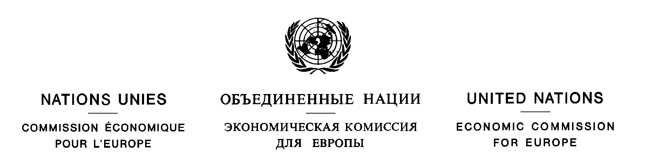
Environment and Human Settlements Division  Bureau 332  Palais des Nations  CH-1211 Geneva 10  Switzerland | Phone: +41-22-917 2384  Fax: +41-22-917 0107  E-mail: jeremy.wates@unece.org  Website: www.unece.org/env/pp
14 July 2005

Attn. Ms. Saltanat Abdikarimova
National Focal Point for the Aarhus Convention
Deputy Director
Environmental Policy and Sustainable Development Department
Ministry of Environmental Protection
Pr. Pobeda 31, office 304, Astana
473000, Kazakhstan
Fax: +7 3172 59 19 52/73

Dear Ms. Abdikarimova,

Re: Decision II/5a of the Meeting of the Parties to the Aarhus Convention concerning compliance by Kazakhstan with its obligations under the Convention

Hereby I would like to draw your attention to decision II/5a adopted by the Parties to the Aarhus Convention at their second meeting on 27 May 2005 in Almaty, Kazakhstan, concerning compliance by Kazakhstan with its obligations under the Convention (ECE/MP.PP/2005/2/Add.7). The decision was adopted in accordance with article 15 of the Convention and decision I/7 of the Meeting of the Parties on review of compliance. The text of decision II/5a is enclosed.

The report of the second meeting of the Parties (ECE/MP.PP/2005/2) and its addenda are available on the website (http://www.unece.org/env/pp/mop2.htm).

Please do not hesitate to contact me or my colleague Ms. Marianna Bolshakova (marianna.bolshakova@unece.org, ph. +41-22-917-2650, fax +41-22-917-0107) if you require any further information.

Yours sincerely,

[Original signed]
_________________________

Jeremy Wates
Secretary
Convention on Access to Information, Public Participation in Decision-making
and Access to Justice in Environmental Matters

