HOW NOT TO CONDUCT AN
ENVIRONMENTAL IMPACT ASSESSMENT

SHORTCOMINGS IN THE ROSIA MONTANA EIA
REPORT PROCEDURE

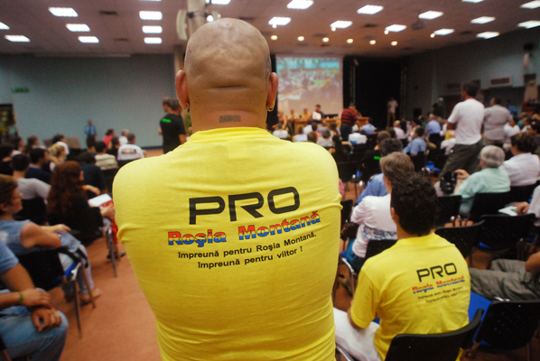 | 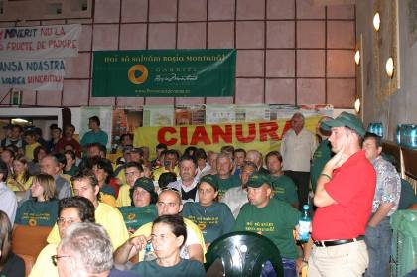
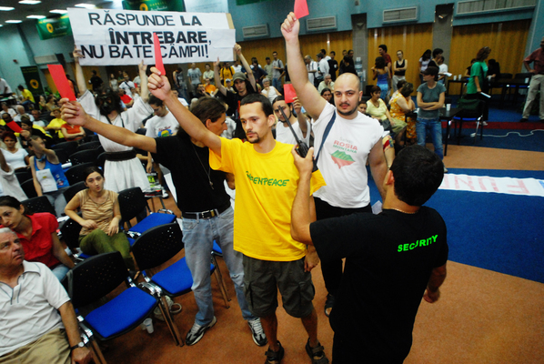 | 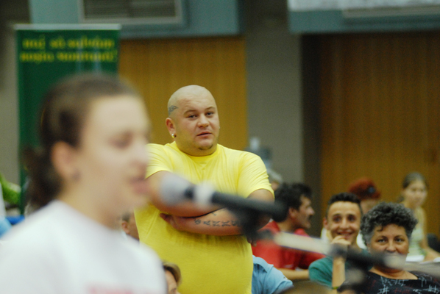

SUBMISSION TO THE AARHUS CONVENTION
COMPLIANCE COMMITTEE

ALBURNUS MAIOR – FEBRUARY 2007

1: INTRODUCTION

This submission relates to the Rosia Montana Environmental Impact Assessment (EIA) procedure. In the main it is focused on the events regarding events that occurred between April 2006 and February 2007. The document details the many shortcomings in the EIA Report procedure, shortcomings which amplify the initial complaint brought by Alburnus Maior against Romania’s Ministry for the Environment (MMGA) at the Aarhus Convention Compliance Committee (ACCC). The report demonstrates how the EIA report procedure undermined the public’s right to access environmental information and to participation in decision-making, the principal’s at the core of the Aarhus Convention. We call on the ACCC to hold the Romanian Government to account, to notify the European Union, and to insist that, at a minimum, the entire EIA procedure is repeated, this time in compliance with the relevant environmental legislation.

2: CONTEXT

The Rosia Montana EIA procedure has generated unprecedented and ongoing public opposition to the Rosia Montana mine proposal from within Romania. It has also revealed great solidarity with Romanian civil society on the part of individuals and organizations outside Romania. For example, the Project Presentation Report which launched the EIA procedure in December 2004 triggered 7,000 contestations, the great majority of which were submitted by Romanian citizens. The subsequent EIA report itself triggered over 21,000 contestations against the mine proposal, which were submitted individuals, organisations, and municipalities from Romania and abroad.

Public interest in the Rosia Montana EIA report procedure has been high. For instance, the Cluj-Napoca public consultation started at 4.00pm in the afternoon and did not finish until 4.00am the following morning, due to the number of people who wanted to challenge the mine proposal. According to a recent on-line consultation conducted by a deputy chamber of Romania’s parliament over 96% of the more than 7,000 respondents who took part answered “no” to the question “Do you agree with the Rosia Montana mine proposal?”

Against this backdrop of public concern it is particularly disturbing that Romania’s environmental authorities are making it difficult for the public to actively and effectively participate in decision making. In Romania the voice and rights of civil society in decision-making only seem to matter when they are useful to top-level political decision makers, as has for example been the case in Romania’s dispute with Ukraine over the Bastroe Channel.

A recent study on public consultations in Romania conducted by The Resource Centre for Public Participation describes the problem in the following terms: “The implementation mechanisms for the laws on public consultation are formal and are unevenly applied, thus allowing for the possibility that consultation processes are manipulated by the public administration.”

Indeed the Romanian Government seems to be heading in a diametrically opposite direction to the Aarhus Convention process and EU environmental legislation in relation to public involvement in decision-making. In January 2007, in an extraordinary development, the National Environmental Protection Agency (an institution under the direct control of MMGA) wrote a letter to all local environmental protection agencies (EPAs), ordering that EIA reports should in the future not be made public in their entirety, and that only their conclusions should be released.

One theme that emerges clearly in this report is that civil society organizations working on the Rosia Montana issue have had to repeatedly try to prize open the decision-making process. This requires considerable resources and frequently leads to ‘remedies’ that are retrospective and too late.

A second theme is the contrast between the way in which the Hungarian Government has handled its involvement in the Rosia Montana EIA procedure and the actions of the Romanian state. Indeed in October 2006 the Hungarian Ministry for the Environment published an expert analysis of the Rosia Montana EIA report and called on its Romanian counterpart not to grant the environmental permit for the proposed Rosia Montana gold/silver mine. This was due to the significant deficiencies in the EIA report. Amongst other things, the Hungarian Government states that: “The EIA report fails to provide an objective picture of the planned proposal’s environmental effects, it does not discuss the impacts of the planned investment in an appropriate professional manner. The material uses the terms ‘very low probability’ or ‘very unlikely’ in relation to risks, which is not in conformity with any scientific approach, particularly if the essential final conclusions are drawn in such a manner… Finally, the EIA report does not provide a full and satisfactory answer to the questions raised in the scoping list submitted.”

Is it a coincidence that MMGA has failed to properly implement the Rosia Montana EIA report procedure when through the state-owned company Minvest the Romanian state has a stake of approximately 20% stake in the mine venture? In addition to the revenues the project owners have promised to pay during construction, operation and closure, the Romanian state has since at least 2003 been receiving from Gabriel Resources via Minvest an annual sum of roughly USD $ 95,000 in the form of an non-interest bearing loan. We believe that these conspicuous conflicts of interest go a long way to explaining MMGA’s failure to properly implement the Aarhus Convention and other relevant environmental laws.

It is important to note that Romania’s environmental authorities cannot argue that they lack the institutional capacity to enforce applicable legislation and standards in respect of the Rosia Montana EIA procedure. Indeed in early 2003 a PHARE team funded by the European Union elaborated a step-by-step manual on how the Rosia Montana EIA should be conducted to meet the relevant national, European and international legislation. The Ministry for the Environment’s explicit refusal to follow the PHARE guidelines, makes their attitude towards the Rosia Montana proposal and the involvement of the public in environmental decision-making crystal clear.

3: SUMMARY OF FAILURES IN EIA PROCEDURE

A: PROJECT PRESENTATION REPORT

- Lack of time for interested parties to comment on the Project Presentation Report.

B: SCOPING

- Lack of public consultation at the ‘scoping’ stage of EIA procedure.

- Exclusion of the scoping recommendations submitted by Romanian NGOs and an international mining expert from the list of Annex Questions to the EIA report.

C: URBANISTIC CERTIFICATE & ZONAL PLANS

- The lack of a valid Urbanistic Certificate should have led to suspension of the EIA procedure.

- The lack of a valid environmental permit for the Urbanistic Zonal Plan of the Rosia Montana industrial area should also lead to the suspension of the EIA procedure.

D: DIFFICULTIES IN ACCESSING EIA DOCUMENTATION

- Access to EIA documents was limited, particularly for non-Romanian speakers.

- The EIA report was not accessible at the places mentioned by the MMGA.

- The Security Report for the EIA was not published until 5 weeks after the process had been initiated, and then only in Romanian on the MMGA website, discriminating against non-Romanian speakers.

- Senior civil servants within MMGA misrepresent what is required in an EIA report.

E: HUNGARIAN PUBLIC INVOLVEMENT IN THE EIA PROCEDURE

- Key EIA texts were not translated into Hungarian and/or were only made available at the last minute.

F: PUBLIC CONSULTATIONS IN ROMANIA

- The choice of locations for public consultations in the EIA procedure omitted communities that will be directly impacted if the project were to go ahead.

- Transcripts from the public consultations show that on many occasions representatives of the project owners refused to directly answer questions posed by members of the public.

- Speakers were limited to five minutes which is clearly insufficient to address a document of 3,500 pages.

- There was no effective dialogue during the public consultation meetings.

- The moderators of the public consultation meetings were not impartial.

- Participants requested to write down their name and address by project owner before being granted access to a public consultation meeting, and opponents of the project physically searched on entering the venue.

- At several hearings the recording of the names and details of speakers were taken down by RMGC employees.

- RMGC employees wearing “security” t-shirts managed the events and intervened to stop members of the public challenging the project owners on their failure to answer questions directly.

G: MINUTES OF CONSULTATION MEETINGS AND LIST OF QUESTIONS FROM MMGA

- The minutes of public consultation meetings published by the Romanian Ministry for the Environment (MMGA) do not correspond to the audio and audio-visual recordings of the hearings, or to the transcripts provided by the project owner. This is particularly the case when criticisms of the project are being made from the floor.

- The list of questions from the public consultation process that is published by MMGA is deficient in many respects.

- Some of the questions posed by members of the public do not appear in MMGA’s list of questions for the project owner to address.

- MMGA’s summaries of the points raised by the public are deficient.

- Deliberate omission of comments on Project Presentation Report (PPR) and scoping process.

4: DETAIL OF FAILURES IN EIA PROCEDURE

A: PROJECT PRESENTATION REPORT

- Lack of time for interested parties to comment on the Project Presentation Report.

As has been mentioned in previous communications submitted to ACCC, Alburnus Maior can show that the Aarhus Convention was violated from the inception of the Rosia Montana EIA procedure. Prior to the launch of the procedure in December 2004 around 120 NGOs and individuals from Romania and abroad officially registered at the Alba Iulia regional Environmental Protection Agency as ‘consulted parties’ for the Rosia Montana EIA procedure. Shortly after the submission of the Project Presentation Report (PPR), which initiated the EIA procedure several announcements were published in the Romanian media and on the environmental authorities’ websites. However the authorities failed to notify any of the consulted parties about the inception of the EIA procedure. Applicable legislation provides for a thirty day comment period in relation to the submission of a PPR, but the consulted parties were not given this opportunity.

Amazingly, in just two weeks approximately 7,000 people sent contestations, comments and observations on the PPR to MMGA. These included Alburnus Maior. The Minister for the Environment, Sulfina Barbu, replied, promising that these contestations and comments would be collected and submitted to the project owner who would need to reply to these at a later and appropriate point of time. However none of these contestations have been included in the list of annex questions sent by MMGA to the project owner in February 2007. Why is this? Where are these contestations now?

In parallel to Alburnus Maior’s complaint procedure to the ACCC, a court action was also initiated against the Alba Iulia Environmental Protection Agency in respect of the Agency’s clear failure to provide proper notification of the PPR to the registered ‘consulted parties,’ invoking Article 6 of the Aarhus Convention. In its final verdict, the competent court irrevocably decided that there was no infringement. English and Romanian copies of the court’s verdict can be accessed at http://www.rosiamontana.ro/Aarhus2/Alba_Iulia_Court_verdict_Aarhus_engl.pdf and http://www.rosiamontana.ro/Aarhus2/Alba_Iulia_Court_verdict_Aarhus.pdf respectively. The contradictory and decidedly confused verdict from this local court casts doubt on the competence of Romania’s legal institutions to implement the country’s environmental law, which is one of the reasons why Alburnus Maior appealed to the ACCC in the first place. Moreover, the Romanian ‘competent’ courts have violated Article 6 of the Aarhus Convention.

B: SCOPING

- Lack of public consultation at the ‘scoping’ stage of EIA procedure.

In contrast to the procedure undertaken in Hungary, the Romanian Government refused to allow public consultation during the ‘scoping’ phase of the Rosia Montana EIA procedure. This decision fundamentally weakened the quality of both the consultation process and of the EIA report. It was taken despite the submission of a contestation by 37 Romanian NGOs and individuals demanding that the public be allowed to participate. Indeed it was this failure on the part of the Romanian Government that led Alburnus Maior to initially file its complaint with the Aarhus Convention Compliance Committee (ACCC). Although MMGA claimed at the time that the applicable legislation did not require public participation they have subsequently changed the Romanian law to make public participation a requirement at the scoping stage of future EIA procedures (GD 1213/2006). Indeed MMGA point to the need to be in compliance with the Aarhus Convention as a key reason for effecting this legislative change. It is therefore completely clear that the lack of public participation during the scoping stage of the Rosia Montana EIA procedure contravenes the Aarhus Convention.

What makes this all the more striking is that the Romanian authorities had the legal base for allowing public consultation in the scoping phase of the EIA procedure (in the form of Law 86/2000 for ratification of the Aarhus Convention), but they chose instead to violate the public’s procedural rights. One can only conclude that this was done because of an institutional bias by MMGA in favor of the Rosia Montana project, for the reasons highlighted above.

- Exclusion of the scoping recommendations submitted by Romanian NGOs and an international mining expert from the list of Annex Questions to the EIA report.

The scoping comments/suggestions made by the NGOs have not been included in the list of questions submitted by MMGA to the project owner in February 2007. Indeed Mrs. Angela Filipas from MMGA sent a letter to the project owner on 30th May 2006 asking Rosia Montana Gold Corporation to add the NGO comments and suggestions to the list of issues it should address in an Annex to the EIA report. Whilst the scoping comments were intended to improve the quality of the EIA report and their inclusion in the list of Annex Question is rather pointless at this stage. Despite Mrs. Filipas’ letter, MMGA has not included the NGO comments on scoping in the list of questions submitted to the project owner in February 2007.

C: URBANISTIC CERTIFICATE & ZONAL PLANS

- The lack of a valid Urbanistic Certificate should have led to suspension of the EIA procedure.

In May 2005 the Alba County Tribunal accepted Alburnus Maior’s request for suspension of the Urbanistic Certificate that had been granted to RMGC. Given that possession of a valid Urbanistic Certificate is mandatory during an EIA procedure this decision should have led to suspension of the EIA procedure. However MMGA refused to suspend the procedure despite several official notifications and petitions, until Environment Minister Sulfina Barbu had to appear in public alongside EU Environment Commissioner Stavros Dimas on the 11th April 2006. Only then was she willing to announce the suspension of the EIA procedure.

RMGC’s response was to seek a new Urbanistic Certificate from Alba County Council, which was granted on 27th April 2006. However the new Urbanistic Certificate is fundamentally flawed in that it fails to include major parts of the proposed mine project, such as the entire tailings management facility that will flood the Corna valley should the mine go ahead. In response to Alburnus Maior’s official request to MMGA pointing out the shortcomings of this new Certificate, Minister of the Environment Sulfina Barbu replied that this matter can’t be dealt with until after the conclusion of the EIA public consultation procedure! This despite the fact that the Certificate is a requirement for initiating the EIA report process.

- The lack of a valid environmental permit for the Urbanistic Zonal Plan of the Rosia Montana industrial area should also lead to the suspension of the EIA procedure.

The problem is compounded by the failure of Romania’s environmental authorities to properly apply the legal procedures governing the granting of environmental permits, specifically for the Urbanistic Zonal Plans (PUZ) for the Rosia Montana Modified Industrial Development Area and the Rosia Montana Historic Centre. On the 20th September 2006 the Alba Iulia Environmental Protection Agency and the Sibiu Regional Environmental Protection Agency announced that they had approved RMGC’s two PUZ’s. This announcement was made despite the fact that there had been no application of the Strategic Environmental Assessment (SEA) procedure, as is required for the approval of plans. In addition the project owner had also failed to adequately inform the public regarding the PUZ process.

Following the announcement on the 20th September 2006, Alburnus Maior and 17 other Romanian NGOs submitted a contestation to both Environmental Protection Agencies and to MMGA. On the 30th October 2006, the Alba Iulia Environmental Protection Agency officially replied to confirm that the modified PUZ submitted for environmental approval by the project owner would have to go through the Strategic Environmental Assessment procedure. Since the environmental permit for the PUZ is supposed to have been obtained before the environmental permit for the project it is clear that the EIA procedure for the project itself should be suspended, pending the approval of the environmental permit for the PUZ. However MMGA has not done this.

D: DIFFICULTIES IN ACCESSING EIA DOCUMENTATION

- Access to EIA documents was limited, particularly for non-Romanian speakers.

On 12th June 2006 MMGA notified the interested parties individually in electronic format in both the Romanian and English language about the EIA public consultation period (English version, Annex 1) scheduled from 5th June – 25th August 2006, providing information on where to access the EIA report. The list of interested parties contains a total of 114 parties of which 58 are Non-Romanian speakers.

On the 18th August, one week before the end of the public consultation period, MMGA issued a communiqué clarifying the places at which the public could consult the underlying EIA report. These were said to include the websites of the following organisations: i) MMGA; ii) RMGC; iii) the National Agency for Environmental Protection; iv) Sibiu Regional Environmental Protection Agency; v) Cluj Regional Environmental Protection Agency; vi) Alba Iulia Environmental Protection Agency; vii) Hunedora Environmental Protection Agency; and viii) Arad Environmental Protection Agency. According to the communiqué the report was also said to be available to the public at the Bucharest Mayor’s Hall, the ASE Library, the library of Romania’s Academy, the Central University Library and the National Library.

In reality, English versions of the EIA report were only accessible at the two following websites: www.gabrielresources.com and www.povesteaadevarata.ro, both websites belonging to the project sponsor. Whilst the English version of the report was posted to the MMGA website it was impossible for a non-Romanian speaker to access the report as the access routes on the site were all in Romanian only. A number of the Romanian government websites listed in the communiqué had no copies of the EIA report on them, either in Romanian or English.

- The EIA report was not accessible at the places mentioned by the MMGA.

The situation was similar in respect to physical locations for accessing paper copies of the EIA report in the Romanian language. MMGA’s initial announcement regarding the public consultation period mentioned 47 physical locations where the public could access the documents. Twenty one of these were libraries, and enquiries by Alburnus Maior showed that during part or all of the public consultation period many were closed, including: i) Vasile Goldis University Arad; ii) Romania’s National Library; iii) Municipal Library Ovid Densusianu; iv) University Library Petrosani; v) University Library Baia Mare; vi) University Library Alba Iulia; vii) Central University Library Bucharest. Compounding the problem is the fact that members of the public who are not students at a university are sometimes unable to gain access to that university’s library. Statements from members of the public who had difficulty accessing the EIA report can be accessed via the hyperlinks in Annex B below.

- The Security Report for the EIA was not published until 5 weeks after the process had been initiated, and then only in Romanian on the MMGA website, discriminating against non-Romanian speakers.

Under the SEVESO Directive on the use and storage of toxic substances MMGA is required to publish the so-called Security Report as submitted to them by the project owner. MMGA received a copy of this report on the 5th May 2006, but failed to make it publicly accessible until the 19th July 2006, more than two months later. The report was posted on the MMGA website, but without any explanation as to its purpose or how the public could comment. This only occurred after the ‘Save Rosia Montana’ campaign had filed a contestation with MMGA requesting that the Security Report be published. The MMGA website only contains a Romanian copy of the Security Report, thus discriminating against non-Romanian interested parties. These actions constitute two violations of the Aarhus Convention as the Security Report has to be made public at the time of the EIA report being filed, and in a non-discriminatory way. The way in which the report was released violated the public’s right to have access to environmental information in sufficient time to evaluate this information, make comments, and so shape the outcome of the final decision.

- Senior civil servants within MMGA misrepresent what is required in an EIA report.

MMGA’s bias in favour of the project owner is further revealed by the claims made by State Secretary for the Environment Attila Korodi (responsible for the Rosia Montana dossier at MMGA) that the baseline studies of Rosia Montana do not form part of the EIA report and that their authors should not have been covered by the certification procedure. These baseline studies, on issues including aquatic systems, hydrology, air quality, noise and vibrations, soil evaluations, biodiversity, and health and cultural patrimony are an essential part of an EIA report, since without a reliable baseline it is impossible to assess the likely impact of a proposed project. This is recognized in law OM 863/2002, which Mr. Korodi is either unaware of or is blatantly ignoring.

Similar problems have arisen with this official in respect of the application of the EU Landfill Directive in relation to the Rosia Montana mine proposal. Written responses given by Mr. Korodi deny the applicability of this legislation, and borrow arguments directly from submissions made by the project owner, rather than being neutral as is required of public officials.

E: HUNGARIAN PUBLIC INVOLVEMENT IN THE EIA PROCEDURE

- Key EIA texts were not translated into Hungarian and/or were only made available at the last minute.

Given the size of the proposed mining project and its potential transboundary impact, the Romanian authorities had to notify potentially affected neighbouring countries in order that they could participate in the EIA procedure, as stipulated under the ESPOO Convention. Hungary consequently became an official party to the EIA procedure, and with good reason, given that the January 2000 accident at the Baia Mare cyanide gold mine in northern Romania led to the contamination of Hungarian rivers, the death of 1,240 tonnes of fish, and pollution of the drinking water supplies of 2.5 million people. Public and political opposition to the Rosia Montana proposal is strong in Hungary and this led the Hungarian Ministry for Environment and Water Management to formally submit 60 requirements to its Romanian counterpart, for inclusion in the final scoping list. As noted above, in contrast to what happened in Romania, the Hungarian ministry invited the public to make comments and proposals and these are included in the 60 recommendations made to the Romanian government.

Given the level of public interest in Hungary, and the fact that this is an affected population, it is significant that just 24 pages of the Rosia Montana EIA report (the chapter on Transboundary Impacts) were translated into Hungarian and made publicly available by the Hungarian Ministry for the Environment (out of a total of 3,500 pages). This represents less than 1% of the total report. RMGC translated the “non-technical summary” of the report into Hungarian but released it to the Hungarian Ministry of the Environment only on the day of the public consultation in the town of Szeged, making it impossible for participants at that meeting to analyse the text in time. As this was one of the only two public consultation meetings organized in Hungary (which themselves only resulted from sustained pressure from Hungarian NGOs), it is abundantly clear that members of the Hungarian public were not given equivalent opportunities or adequately consulted on the project.

More worryingly, it has become clear that other chapters of the Rosia Montana EIA report were translated into Hungarian, but that the public was not given access to these. For example, the Independent Group of International Experts (IGIE) which evaluated the EIA report for the ‘Hungarian-Romanian Ad-Hoc Committee On Rosia Montana’ makes the following remark in their report: “The translation of the Chapter 2 - Technological Processes - into Hungarian is poor. The level of importance that this part of the operation has indicates that it should be given much higher attention than this appears to have been given.” Given that there exists a translation of this important chapter, why wasn’t it provided to the interested public? A central principle of the Aarhus Convention is that the maximum possible amount of information should be made available in order for the public to help a better decision to be reached.

In summary, neither the two public debates organized on Hungary’s territory (in comparision to the 14 debates organized in Romania), nor the publicity around the public debates in Hungary, nor the information in Hungarian at the disposal of the Hungarian public meets the principle of equivalent opportunities stipulated by the ESPOO Convention, and/or the principle of non-discrimination and access to environmental information as stipulated in the Aarhus Convention.

F: PUBLIC CONSULTATIONS IN ROMANIA

Whilst members of the Romanian public clearly had a greater number of opportunities to comment on the EIA report than their Hungarian counterparts there are numerous shortcomings in the way that the Romanian public consultations were organized. The most serious problems are summarized in this section. It is very important to note that, as with the scoping phase of the
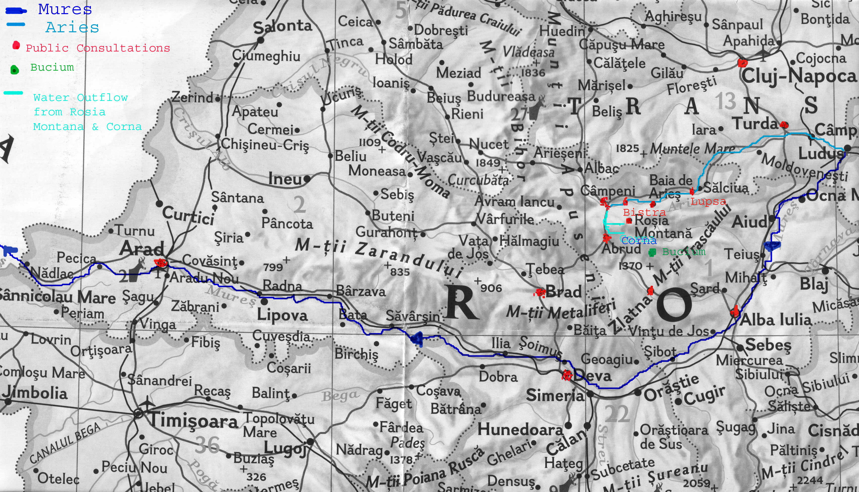

Image: Location map of the public consultations in Romanian territory in relation to the proposal’s geographic location; also see image legend
EIA report, civil society organizations in Romania were given no opportunity to comment on the quality of the Public Disclosure Plan prior to its approval.

- The choice of locations for public consultations in the EIA procedure omitted communities that will be directly impacted if the project were to go ahead.

According to the Public Disclosure Plan (PDP), the choice of the 14 locations (a full list is provided in Annex A) seems to have been based on two criteria: a) the proposal’s significant impact and importance, hence the consultation in the capital Bucharest; b) its impact on affected populations (those directly affected by the mine’s proximity or its impact on waterways)

Despite the fundamental need to consult communities directly affected by the mine proposal no consultations were held for the Bucium Commune, which comprises of 7 villages/hamlets. Bucium is the valley adjacent to Corna Valley where the project owner intends to place the Tailings Management Facility. The Urbanistic Certificate for the Rosia Montana EIA includes the construction of a road between Bucium and the Corna Valley Tailings Management Facility as well as the construction of a topsoil dump at Bucium. According to the Public Disclosure Plan there were three EIA ‘info points’ in the direct project area: Rosia Montana, Abrud and Bucium. The Urbanistic Certificate denominates Bucium as a ‘host community’, just as it does for Abrud and Campeni (where EIA public consultations took place). The Urbanistic Zonal Plan for the Rosia Montana Modified Industrial Development Area also includes changes to the current urbanistic plan of the Bucium Commune. The project owner also holds a significant mining concession in the Bucium valley and the development of this concession is dependent upon approval of the Rosia Montana project. Given these vital facts, why was no public consultation meeting held in Bucium?

The consultations at Arad, Deva and Alba Iulia (shown on the above map) took place because they are the main cities that lie along the Mures River, into which the surface and groundwater streams of the Rosia Montana and Corna Valley ultimately flow, via the Aries River.

The choice of Zlatna and Brad as locations for public consultation meetings makes no sense, however, as they lie much further away from Rosia Montana than communities like Bucium, and they do not lie on waterways that could be directly impacted by the mine proposal. It would seem that the only reason why Zlatna and Brad were selected by MMGA is that they are important and historic mining towns, where the project owner has been promising jobs to the miners. The mining unions from Zlatna and Brad are outspoken supporters of the Rosia Montana project.

It is clear that the choice of locations for public consultations didn’t cover all of the population directly affected by the mine proposal but instead covered two locations that have no relationship with the mine proposal’s environmental impact. This in return caused prejudice in terms of violating the directly affected public’s right to participate in environmental decision making.

- Transcripts from the public consultations show that on many occasions representatives of the project owners refused to directly answer questions posed by members of the public.

According to the Public Disclosure Plan approved by Romania’s ministry for the Environment the proposed Agenda for the Public Debates included the following: a) RMGC will answer questions linked to details of the project from the public; and b) RMGC will provide documented responses to the proposals and comments from the public received in writing prior to the respective public hearing.

Despite these vital ground rules having been agreed before the public consultations started in practice there were numerous occasions on which the project owner did not answer questions asked by the public about the details of the project. Furthermore, the project owner did not provide any responses to the proposals and comments from the public received in writing prior to the respective public hearing. These shortcomings clearly diminished the consultation’s quality and violated the public’s right to obtain information about the proposal under public scrutiny.

- Speakers were limited to five minutes which is clearly insufficient to address a document of 3,500 pages.

In order to restrict public participation in the consultation meetings MMGA and the project owner took the decision to limit each speaker to five minutes floor time, regardless of whether or not they had technical expertise that was relevant to the process. After five minutes had passed the microphone was simply turned off, with some participants being left mid-sentence. Raising questions on a 3,500 page EIA report in just five minutes is clearly a daunting challenge.

This problem was made much worse by the lack of rules on how many different times the same member of the public could speak at different public consultation meetings. This led to the phenomenon of “public debates tourism,” where the project owner employed roughly 100 people during the whole period of the public debates, and then transported them to each town where debates were being organized. At least 15 of these ‘hired guns’ spoke at every public debate, making the same points over and over again, in order to minimize the time available for the ‘real’ public to speak.

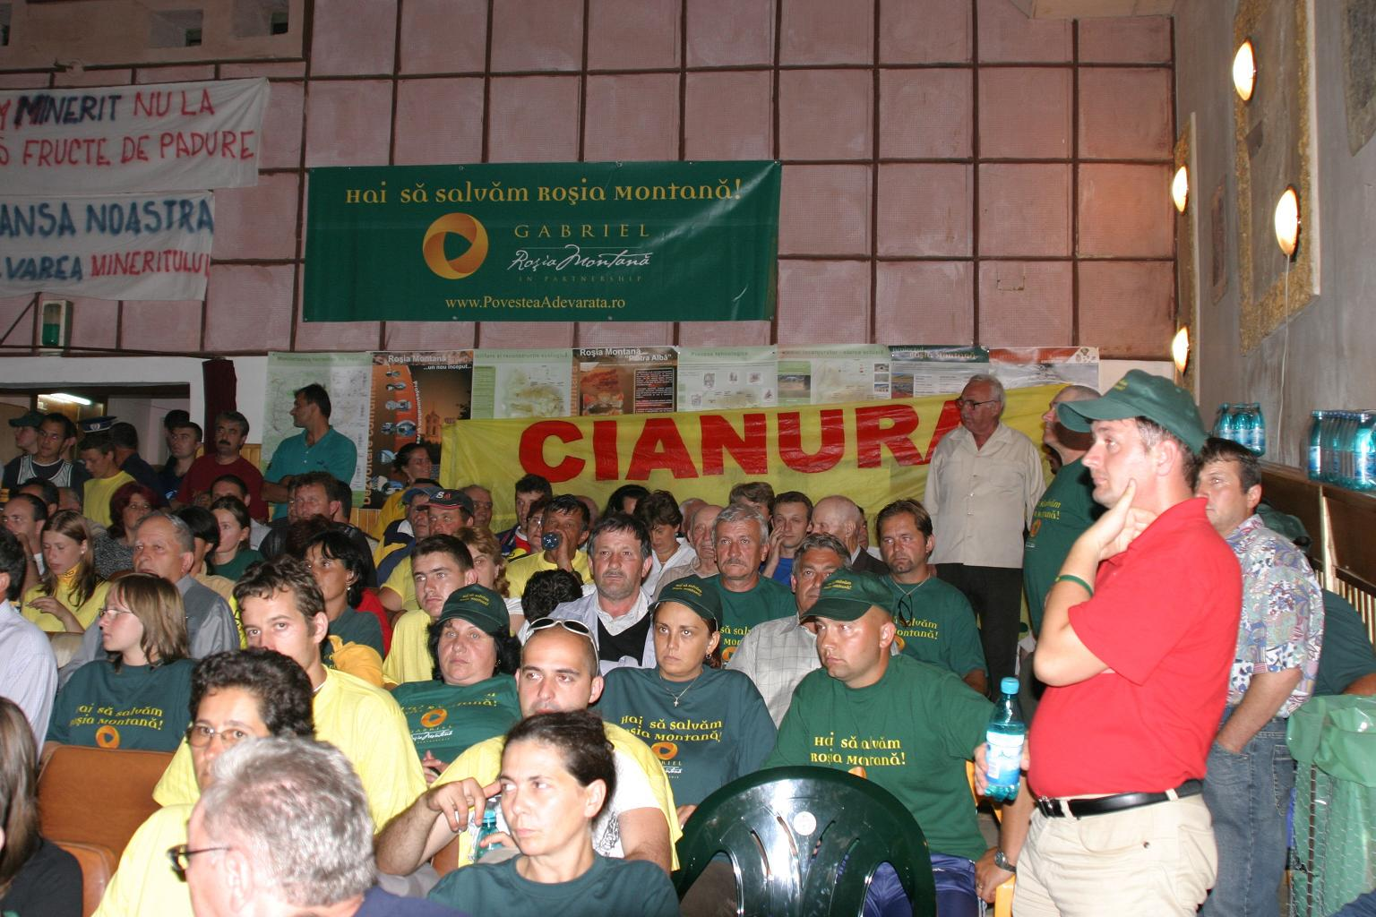

RMGC employees and supporters (in green, yellow and red t-shirts) pack the public consultation meeting in Campeni, in front of a banner produced by the mining company

To give an example of how this played out in practice, at the first public debate in Rosia Montana a total of 37 people spoke, of whom 25 were opposed to the mining proposal, and 12 were in favour of it. Those opposing the project posed a total of 35 different substantive questions regarding the proposals, whilst those in favour made just three types of statements.
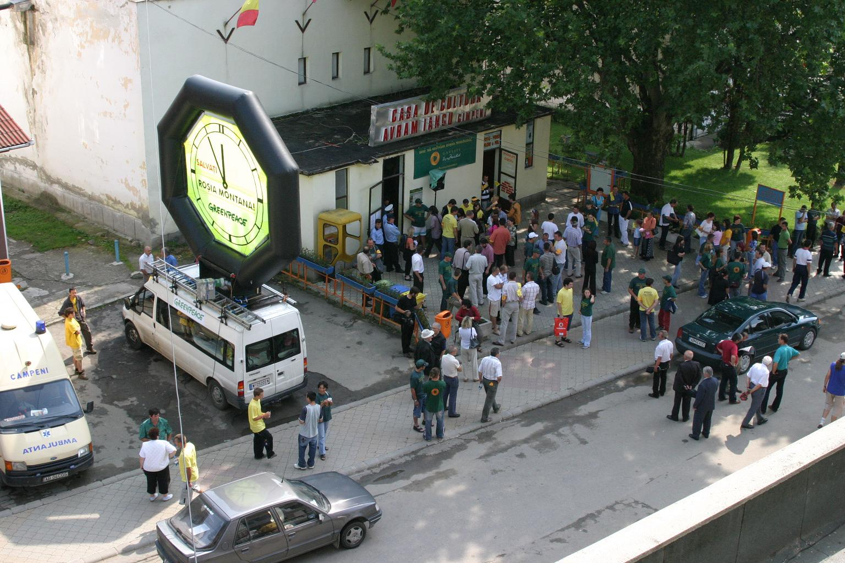

So many RMGC employees attend the Campeni public meeting that members of the public have to stand outside in the street to try and hear the proceedings.

- There was no effective dialogue during the public consultation meetings.

In order to minimize the need for the project owner to engage in real debate with the public, one of the rules of the consultation meetings stipulated that speakers had to pose all of their questions during their allotted five minutes, instead of receiving an answer after each question. This of course makes it very difficult to have any kind of effective dialogue, as the project owner can avoid the most difficult points raised. It is notable that although the transcripts from the events list the questions raised by members of the public they do not include the answers given by the project owner. However the audio and audio-visual recordings of the meetings clearly show that the project owner’s answers to the questions were often deliberately misleading, patronizing, or intimidating. The recordings from the Cluj-Napoca and Rosia Montana meetings are particularly revealing in this respect, and well worth watching in their entirety. At the Cluj-Napoca meeting, for example, Professor Ionel Haiduc, the president of the Romanian Academy and his wife, Iovanca Haiduc, a very well-know chemistry professor, walked out in protest at the way the meeting was being conducted. More then 1,000 people who participated in the public consultation in Cluj-Napoca were disappointed and frustrated because they were not able to find real information on the project and answers to their questions. In this way the sham public consultation process had the effect of severely damaging in two months the years and years of work by civil society groups to engage the public more in decision-making processes.

The frustration caused to members of civil society is captured well in the following quote from Codruta Nedelcu, at the Cluj-Napoca meeting: “I would ask Mr. Aston [of RMGC] to stop saying that he will provide written answers, because we have not come here to receive written answers, but we have come to see how he answers in front of the public. We could have all sent written letters to the company or to the ministry and the meetings wouldn’t have been organized any more. We have come here to receive verbal answers, here in this place.”

Despite repeated complaints from civil society groups to the project owners, MMGA representatives, and the moderators of the debates, no action was taken to improve the quality of the dialogue as the series of public consultation meetings continued. By the time of the final Bucharest meeting civil society groups resorted to producing a banner which simply stated “Answer the questions.” When the project owner still refused to do this, members of the public stood up and held out red cards, as are used at football matches. These can be seen in the picture below, and prompted an intervention by the “security” who are RMGC staff and are dressed in black “security” t-shirts in the picture.
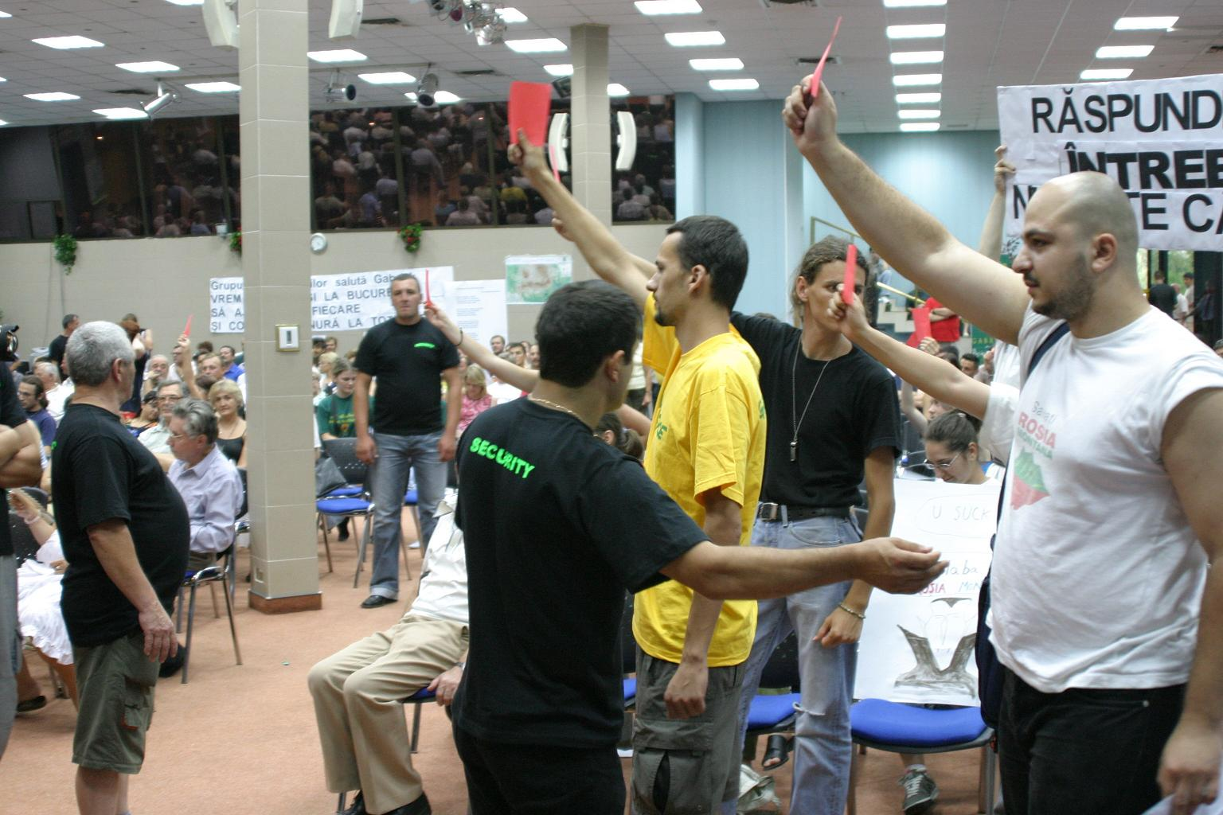

‘Security’ staff hired by RMGC intervene to try and stop members of civil society registering their frustration at the refusal of the project owner to directly answer questions from the floor - Bucharest public consultation meeting.

Even though Romanian Environmental law stipulates that the presentation of false information and conclusions in the EIA process should be penalised, MMGA did not apply the law with regards to the statements made during the public debate procedure. It is clear that during the public debates the quality of the answers given by the project owner is of the highest importance, as this is one of the few opportunities that people affected by the proposed project have in order to gather information on the impacts. It is completely unacceptable that in the Rosia Montana EIA procedure these events were used as propaganda exercises and not to answer the large number of legitimate questions raised by members of civil society.

- The moderators of the public consultation meetings were not impartial.

Perhaps the reason why it was not possible for civil society organizations to get their concerns taken seriously during the public consultation process was that the two moderators appointed by MMGA and the project owner were not impartial. Indeed both are directly associated with the Rosia Montana mining project, remarkable though this may seem!

Nicolae Heredea PhD. Eng, the manager of SC NHN ECOINVEST SRL, is accredited by MMGA as an expert in the implementation of environmental balances and in environmental impact assessments in the fields of geology and radiological protection. In 2003 Mr. Heredea conducted geophysical research for RMGC to identify and recover archaeological vestiges at Rosia Montana. Mr. Heredea has also published a paper entitled Approach methodology for environmental protection issues for the Rosia Montana gold mining project. This paper sets out conditions that would need to be met for the Rosia Montana project to be considered as ecologically safe as well as a contribution to sustainable development. Since late autumn 2005, Mr. Heredea is the General Director of the MMGA’s Directorate for Biodiversity, Bio-security, Soil and Subsoil.

Mr. Stefan Mihailescu, the second moderator, is a representative of Bucharest’s Technical University. This institution is one of the main designers of RMGC’s mine proposal!

The video tapes of public consultation meetings including the one that took place in the town of Campeni show that the moderators were not impartial in the way they managed the proceedings. This is a clear violation of the general rules of public consultations. Unfortunately the comments of the moderators are not registered in the minutes of the meetings, nor in the transcripts, so it is necessary to view the video tapes to see this process at work.

- Participants requested to write down their name and address by project owner before being granted access to a public consultation meeting, and opponents of the project physically searched on entering the venue.

A public hearing should be accessible to anyone without any conditions on entry being imposed. However, the Rosia Montana project owner’s attempted to get all participants at the public consultation meetings to write their name and address down before being given access to the meeting venue. This was done in order to intimidate members of the public and to dissuade them from speaking up against the project. The illegality of this registration process was brought to the attention of the representatives of MMGA and the moderators of the meetings, but, as usual, no action was taken by them.
To make matters worse, opponents of the project were physically searched before they were allowed to enter the public debate venues. The intention of the project owner was to create the impression that opponents might be violent in some way.

- At several hearings the recording of the names and details of speakers were taken down by RMGC employees.

According to Article 42 of O.M. 860/2002 the president and secretary nominated for the hearings are the ones to register the participants wishing to speak. This was not the case for the EIA public hearings where at several occasions RMGC employees recorded the names and details of the speakers, again with the intention of trying to intimidate opponents of the project.

- RMGC employees wearing “security” t-shirts managed the events and intervened to stop members of the public challenging the project owners on their failure to answer questions directly.

An additional form of intimidation of the public came from the use by the project owner of RMGC “security” staff and the positioning of “Pro Rosia Montana” personnel close to those opposing the mine project. A good example of the dynamic can be seen in the photo below.

Bucharest public consultation – Greenpeace member Natalia Dorca experiences intimidation by RMGC employee and member of Pro Rosia Montana.

At the Bucharest public consultation meeting the “security” staff intervened to try and stop members of the public registering their frustration at the project owner’s refusal to answer pertinent questions in public. These same “security” staff did not intervene if speakers from the floor were expressing support for the mine proposal.

G: MINUTES OF CONSULTATION MEETINGS AND LIST OF QUESTIONS FROM MMGA

- The minutes of public consultation meetings published by the Romanian Ministry for the Environment (MMGA) do not correspond to the audio and audio-visual recordings of the hearings, or to the transcripts provided by the project owner. This is particularly the case when criticisms of the project are being made from the floor.

In December 2006 thirteen of the NGOs which had taken part in the public consultation meetings officially warned MMGA that its official minutes of the hearings do not correspond to the transcripts based on audio and audio-visual recordings, and therefore do not provide a true record of what took place. Comparison with the way in which the Hungarian authorities handled the minutes is again instructive, and suggests that MMGA is deliberately attempting to trivialize public opposition to the Rosia Montana proposal. It is hard to avoid the conclusion that the Ministry’s minutes deliberately aim to distort the arguments and issues raised by members of the public. MMGA ‘s reply seems to suggest that it did not even make transcripts of the hearings.

- The list of questions from the public consultation process that is published by MMGA is deficient in many respects.

Further compelling evidence of MMGA’s bias emerged on 1st February 2007 when the Ministry published on its website the list of questions that resulted from the EIA public consultations and to which the project owner needs to reply to in an annex to the EIA report. According to MMGA it received a total of 6,510 individual comments during the public consultation phase. The list also serves as a registry for the comments/suggestions received and includes summaries of comments/ suggestions submitted. The list exists in the Romanian language and for the questions raised during the consultations in Hungary in Hungarian.

Alburnus Maior and partner NGOs have conducted a preliminary analysis of the information released by MMGA, details of which are provided in Annex C below. At the time of writing there is already evidence that the information provided by MMGA has serious deficiencies, including the way in which suggestions and comments are registered. Going through the list of submissions one finds repeatedly that comments submitted by a range of different individuals, often from different countries, are registered by MMGA under just one single entry. More details are provided in Annex C, but as an example comments submitted by 457 different people from locations as diverse as Calarasi, Oradea, Baia Mare, Buzau, Bacau, Poland, Barcelona, Amsterdam, Ploiesti, Prahova, Dambovita, Brasov, Hunedoara, Belgium, Botosani, Slatina, Sighisoara, Rosiori de Vede, Focsani, Bucuresti, Timisoara, Bistrita, Falticeni, Mures, Berlin, Luxemburg, Germany, Ireland, USA, and Portugal are registered as one single entry (No. 1116119/ 25.08.06 (nr. 2446))!

If one counts the total number of people who submitted comments and suggestions, then one arrives at a figure of 21,425 persons, organisation and municipalities from Romania and abroad, more than three times the figure given by MMGA.

- Some of the questions posed by members of the public do not appear in MMGA’s list of questions for the project owner to address.

Further evidence of MMGA massaging the process comes from the fact that submissions to MMGA that were copied to Alburnus Maior at the time of submission do not appear in the Ministry’s published list of questions for the project owner, i.e. it is clear that MMGA’s documents from February 2007 do not contain all the questions raised by members of the public.

- MMGA’s summaries of the points raised by the public are deficient.

Further problems result from the fact that comments raised by members of the public are incorrectly summarized and/or recorded in the list of questions published by MMGA. Alburnus Maior can prove that this is the case as we have copies of the original submissions from ECOVAST (European Council for the Village and Small Towns), Miningwatch Canada, and Mr. Eugen Melinte, a Canadian citizen. None of these are correctly recorded by MMGA (more details are available at Annex C).

Despite the fact that many non-Romanian organizations and/or citizens submitted comments and suggestions during the public consultation process, the documents published by MMGA provide summaries of the comments only in Romanian (for Romanian submissions) or Hungarian (for the Hungarian consultations). The list from the Ministry is not available in English. It is therefore impossible for the non-Romanian speaking public and interested parties to check whether their comments and suggestions were correctly interpreted and taken into account. For the Romanian public it is impossible to find out what issues were raised by the Hungarian public during the public consultation period and for the Hungarian public it is impossible to find out what issues were raised by the Romanian public. This is restrictive, discriminatory, non-transparent and completely unacceptable.

- Deliberate omission of comments on Project Presentation Report (PPR) and scoping process.

The publication of the list of questions to which the project owner needs to reply to in an annex of the EIA report correctly excludes comments/suggestions submitted by the public regarding the PPR and scoping list. The ministry should have submitted these to the project owner at their relevant time in the overall Rosia Montana EIA chronology. This would have allowed the public to shape the proposal and the decision making procedure at a time when these comments were pertinent and when the options to embrace these comments/suggestions were still open. The ministry for the Environment instead claimed that it would include these comments in the questions to which the project owner would need to reply to in an Annex to the EIA report.

As can be seen from the list of questions submitted to the project owner this is not even the case. Importantly however, in light of the quality of the EIA report its quality would have been greatly improved had it included the comments/suggestions made by the public for the PPR and during scoping. Whilst the options now are far narrower, the quality of the EIA report as well as the quality of the relevant list of questions point to a decision making procedure where public participation was undermined and discouraged. This in return has already led to important prejudices and may ultimately lead to an erroneous decision.

It is clear that MMGA’s actions would constitute a violation of any licensing procedure in terms of the correct processing of the information received by the interested public during an entire EIA procedure.

5: CONCLUSION

As this report has shown, the entire Rosia Montana EIA procedure has been riddled with fundamental irregularities, deficiencies, and failures to comply with important environmental legislation, notably the Aarhus Convention. Therefore it is vital for the future development of informed and independent public decision-making in Romania that the EIA procedure be completely re-started in order that cynicism does not persist. This is all the more important in light of the unprecedented level of public opposition to the Rosia Montana mine proposal. The Romanian authorities need to be held accountable for the violations they have committed. We respectfully request that the Aarhus Convention Compliance Committee uses its authority to this end.

Alburnus Maior – February 2007

ANNEX A

EIA Chronology

December 2004 - Rosia Montana Gold Corporation (RMGC) submits the so-called ‘Project Presentation Report’ (PPR) and a request for an environmental accord for the Rosia Montana gold mine proposal to Romania’s environmental authorities. This officially launched the EIA procedure for the Rosia Montana gold mine proposal.

Prior to the inception of the EIA procedure, roughly 120 NGOs and individuals from all over the world officially registered at the Alba Iulia regional environmental protection agency to be ‘consulted parties’ during the Rosia Montana EIA procedure. Shortly after the submission of the PPR, several announcements were published in the Romanian media and on the environmental authorities’ websites. However the environmental authorities failed to notify any of the consulted parties about the inception of the EIA procedure.

14.01.2005 - Roughly seven thousand people send contestations/ comments/ observations on the PPR to the ministry for the Environment. This also included ‘Alburnus Maior.’ The ministry replies; saying these contestations /comments will be collected and submitted to the project owner who would need to reply to these at a later and appropriate point of time.

Given the size of the mining proposal and its potential transboundary impact, the Romanian environmental authorities notified potentially affected neighboring countries to participate in the EIA procedure; as is stipulated in the ESPOO Convention on a transboundary EIA. Of all countries notified, Hungary replied positively to the notification and thus became an official party in the EIA procedure.

5.03.2005 - The Hungarian ministry for the Environment and Water management submits to its Romanian counterpart 60 requirements to be included in the final scoping list. In order to compile this list, the Hungarian ministry invited the public to make comments and proposals. Hungary’s scoping list proposal thus includes comments/ suggestions made by the public.

10.05.2005 - The Romanian authorities finalize the so-called scoping stage and communicate to the project owner a list of questions to be addressed in the EIA report. In Romania, the scoping stage was carried out in absence of any public consultations.

16.06.2005 - ‘Alburnus Maior’ and 36 additional NGOs and individuals submit a contestation to the ministry for the Environment asking it to restart the scoping stage; this time ensuring public participation. The petition includes a list of motivated questions/suggestions drawn up by a mining expert for the ministry to include in the official scoping list.

20.06.2005 – ‘Alburnus Maior’ initiates an official complaint at the Aarhus Compliance Committee regarding the complete lack of public participation in the scoping stage of the Rosia Montana EIA procedure.

11.08.2005 - The ministry for the Environment replies to Alburnus Maior’s scoping complaint; claiming that applicable legislation does not stipulate public participation in the scoping procedure.

15.06.2005 - The Alba County Tribunal admits Alburnus Maior’s request to suspend the urbanistic certificate granted to RMGC. Given that an urbanistic certificate is a mandatory administrative act for the inception of an EIA procedure, this suspension should have suspended the EIA procedure. In spite of several official notifications and petitions, the ministry did not suspend the EIA procedure.

11.04.2006 - Romania's Minister for the Environment announces in the presence of Stavros Dimas, European Commissioner for the Environment, that the EIA procedure for the Rosia Montana gold mine proposal is suspended due to the suspension of the project owner’s urbanistic certificate 68/ 20.08.2004.

27.04.2006 - RMGC obtains a new urbanistic certificate from the Alba County Council with No. 78/ 26.04.2006. The EIA procedure continues.

15.05.2006 - The project owner submits the Environmental Impact Assessment Study Report for the “Rosia Montana Project, Alba County” to the ministry for the Environment. At the same time the project owner also submits the so-called Security Report; as required by the SEVESO procedure.

24.05.2006 – ‘Alburnus Maior’ submits an official request to the ministry for the Environment to ascertain that the new urbanistic certificate is incompatible with the project owner’s request for an environmental accord and to therefore reject it. The ministry’s official position, communicated to Alburnus Maior with letter No. 25986/I.A./14.07.2006 is that the issue of ‘compatibility’ between the new urbanistic certificate and the proposed project can not be evaluated before the termination of the public consultation procedure.

05.06.2006 – The ministry for the Environment announces the inception of the Public Consultation Procedure for the Rosia Montana EIA report.

12.06.2006 - The ministry for the Environment individually notifies the interested parties to the Rosia Montana EIA about the inception of the Public Consultation Procedure for the Rosia Montana EIA report.

15.06.2006 – The ministry for the Environment officially transmits the Rosia Montana EIA report to its Hungarian counterpart.

13.07.2006 – Hungary’s ministry for the Environment publishes on its website the translation it made of Chapter 10 - Transboundary Impact - of the EIA report.

16.07.2006 - The ‘Save Rosia Montana!’ campaign releases an initial evaluation of the Rosia Montana EIA report in the form of a contestation; encouraging the interested public to do likewise. The contestation includes the fact that the Security Report submitted by the project owner to the ministry for the Environment on 15.05.2006 is not publicly accessible.

19.07.2006 - The ministry for the Environment publishes the Security Report on its website; with no explanation whatsoever on i.e. the purpose and role of this document, whether the public can comment on it etc.

24.07.2006 - Tthe first public debate takes place in Rosia Montana. The subsequent debates in Romania were as follows: Abrud - 25.07.2006; Campeni - 26.07.2006; Alba Iulia - 31.07.2006; Zlatna - 2.08.2006; Brad - 4.08.2006; Cluj Napoca - 7.08.2006; Turda - 9.08.2006; Bistra - 14.08.2006; Baia de Aries - 15.08.2006 ; Lupsa - 16.08.2006; Bucharest - 21.08.2006; Deva - 23.08.2006; Arad - 25.08.2006.

06.08.2006 - Numerous Romanian NGOs and citizens write an open letter to the Minister for the Environment and to the Minister for European Integration highlighting the fact that the consultations are not used to inform the public about the impact and risks associated with the mine development but instead are a disingenuous public relations approach organized by the project owner. The letter includes several declarations made by members of the interested public who tried to consult the EIA Report at the locations indicated on the ministry for the Environment's website and experiences several important shortcomings regarding the documentations' accessibility. At the time of writing the ministry for the Environment has still not replied to this letter.

13.08.2006 – Hungary’s ministry for the Environment announces the dates of the public debates in Hungary: 28.08.2006/ Szeged and 29.08.2006/ Budapest. At the time of the announcement, the exact location of the Budapest public debate is not known.

18.08.2006 - Several Hungarian NGOs release a statement/communiqué complaining at the Hungarian ministry for the Environment that it only translated 24 pages of the EIA report (Chapter 10 – ‘Transboundary Impact’) into Hungarian and that the exact location of the public debate in Budapest was only announced 14 days prior to the respective event.

24.08.2006 - Alburnus Maior releases an independent expert analysis of the Rosia Montana EIA report. On that same day it was hand-delivered to Romania's ministry for the Environment in the form of Alburnus Maior's official contestation.

28.08.2006 - Public debate in the town of Szeged. This is also the first day when the Hungarian translation of Chapter 9 – Non-technical summary is available in electronic format on the Hungarian ministry for the Environment’s website. The translated document was provided by RMGC. The later distributes Hungarian versions of the Non-Technical Summary at the Szeged public debate.

29.08. 2006 - Public debate in the town of Budapest.

25.09.2006 - A new Romanian EIA procedure for public and private projects (GD 1213/2006) comes into force. The legislative change was prepared by the ministry for the Environment and it now explicitly includes public participation during the scoping stage.

02.10.2006 - Hungary’s ministry for the Environment publishes its analysis of the EIA report which it submitted to its Romanian counterpart on 29.09. 2006. Hungary’s ministry for the Environment officially asks the Romanian authorities not to grant the environmental accord for the for the Rosia Montana gold/silver mining proposal due to the major deficiencies and false conclusions at the base of the EIA report.

12.10.2006 - Alburnus Maior and 17 Romanian environmental NGOs release a contestation to Romanian environmental authorities involved in the Rosia Montana EIA procedure. The letter highlights how Romania’s environmental authorities are illegally fast-tracking the licensing procedure for the Rosia Montana gold mine proposal by not applying the legal procedures governing the granting of environmental permits. The NGOs specifically refer to the environmental licensing procedure for the Urbanistic Zonal Plan of the Rosia Montana Modified Industrial Development Area. According to the NGO’s contestation such decisions are also taken to avoid lengthy and costly consultations with the Romanian and Hungarian public and their authorities.

23.10.2006 – The Alba Iulia’s environmental protection agency announces that it changed its decision regarding the licensing procedure for the Urbanistic Zonal Plan of the Rosia Montana Modified Industrial Development Area; now requesting the application of the so-called Strategic Environmental Assessment procedure (SEA).

07.12.2006 - 13 NGO’s which took part in the public consultations for the Rosia Montana EIA procedure officially warn the ministry for the Environment that the ministry's official minutes of the consultations organized on Romanian territory in summer 2006 are not according to the transcripts based on audio and audio-visual recordings of the hearings and therefore do not provide a true record of what took place. The NGO’s official contestation includes examples highlighting the nature of the discrepancies and request the ministry for the Environment to confirm that its official minutes are not the source for drawing up the list of questions that resulted from the public hearings and to which the project sponsor will need to reply to in an Annex of the EIA report.

18.12.2006 - The ministry for the Environment replies to the NGO’s contestation. The reply indicates that the ministry does not seem have made transcripts of the public debates according to audio and audio visual recordings.

01. 02. 2007 – The ministry for the Environment publishes the list of questions that resulted from the public consultation procedure and to which the project owner needs to reply to in an annex of the EIA report. An initial analysis of it by several NGOs reveals amongst others, significant errors in the registering the contestations; deliberate confusion between the number of comments and the number of addressers; discriminatory treatment for the foreign public by not publishing the information also in English; incomplete documentation of the registrations as well as omitting to register contestations submitted to the ministry.

ANNEX B

Accessibility to the EIA report in Electronic Format via websites:
According to the announcement, the EIA report in electronic format was thus accessible at the following website locations:
- www.mmediu.ro is the website address of Romania’s ministry for the Environment (see Annex 2). It has no English language section and whilst it is difficult for the Romanian speaker to find the Rosia Montana subsection and EIA report; it is certainly impossible for the non-English speaker.
- www.anpm.ro is the website address of Romania’s National Agency for Environmental Protection. It has no English section. The announcement of the accessibility of the Rosia Montana EIA report is on the home page and in Romanian language only. It reads’PROIECTUL ROSIA MONTANA - Studiul de evaluare a impactului asupra mediului .
- www.apm-alba.ro is the website of the Environmental Protection Agency in Alba Iulia, the county where Rosia Montana is situated. It has no English section.. In the middle section of the home page there is a title reading ‘MMGA anunta publicul interesat asupra dezbaterilor publice ale Raportului la studiul de evaluare a impactului asupra mediului privind proiectul Rosia Montana, necesare obtinerii acordului de mediu, ce vor avea loc incepand cu orele 16.30, in localitatile: .... detalii When one clicks ‘detalii’ one sees the Romanian public announcement. At the bottom of the page there is a sentence that reads "RAPORT DE EVALUARE A IMPACTULUI ASUPRA MEDIULUI" (link site S.C. Rosia Montana Gold Corporation. S.A.) ...... detalii When one clicks ‘detalii’ it takes one to
http://www.povesteaadevarata.ro/rosia_montana.php?page=raport&id=85.
- www.rmgc.ro is a website maintained by the project owner. It takes you to the Romanian (www.povesteaadevarata.ro ) and/or English (www.truestory.ro) section of Gabriel’s PR – Information website.
- www.gabrielresources.com is a main website of the Project sponsor. It is in English language only. The EIA report in English is accessible via an announcement in English language in the ‘What’s New’ section.
- www.povesteaadevarata.ro is a website that belongs to the project sponsor. Here the EIA report is available in Romanian. The top right hand corner indicates an ‘English’ version, which takes you to www.truestory.ro – the English mirror. Here the EIA report is available in English.
- www.apmhunedoara.ro is the website of the Hundedoara County Environmental Protection Agency. It has no English section. The Public Announcement is posted in the ‘Anunturi’ section, but there exists no download-able version of the EIA report, neither in Romanian nor in English language.
- www.apmar.ro is the Environmental Protection Agency of Arad. It has no English section. Here one can not find the Ministry for the Environment’s announcement about the public consultation procedure and meetings – neither in English nor in Romanian. Nowhere on this website can one down-load or find a link down load the EIA report; neither in English nor in Romanian.
- www.arpmnv6.ro is the website of the Regional Environmental Protection Agency of Cluj. It has no English section. Here one can not find the Ministry for the Environment’s announcement about the public consultation procedure and meetings – neither in English nor in Romanian. Nowhere on this website can one down-load or find a link down load the EIA report; neither in English nor in Romanian.

- www.arpm7.ro is the Sibiu Regional Environmental Protection Agency. Both the public announcement and the EIA Report are posted in Romanian in the ‘Anunturi’ section, which is a sub-section of ‘Noutati’ main section.

The electronic EIA report in Romanian language was thus unavailable at the following website locations: www.apmhunedoara.ro , www.apmar.ro, www.arpmnv6.ro and www.gabrielresources.com

The electronic English version of the EIA report was unavailable at: www.apmhunedoara.ro, www.apmar.ro, www.arpmnv6.ro

Accessibility of the EIA report in paper and/or CD format:
The ministry’s public announcement regarding the public consultation period and access to the EIA report mentions 47 physical places including their postal addresses to access to the EIA report from 5th June to 25th August 2006 between the hours 9.00 and 16.00.

On 15 January 2007 Alburnus Maior wrote to the 21 libraries that according to the Ministry for the environment’s announcement displayed the EIA report and asked them to indicate their opening program for the year 2006. Out of the 21 requests send by fax, 15 replies arrived at the time of writing. Noteworthy excerpts are translated below (for the originals see Annex B, C, D1, D2, E, F, G, H):

- Library of the Vasile Goldis University/ Arad: “We would like to mention that between 8 August and 25 September 2006 the library was closed for inventory. …”
- Romania’s National Library: “during the month of August our library was closed for cleaning. …”
- Municipal Library Ovid Densusianu: 2 fax replies. The first dated 16.01.2007. “During 2006 the County Library Ovid Densusianu changed its premises, the documentation regarding Rosia Montana could be consulted at our branch Nr.1 This branch was open during the whole year with the exception of Saturdays, Sundays and official holiday periods. “
The second reply is dated 17.01.2006 “With regards to your message 74/17.01.2006 we would like to inform you that the actual premises of the County Library Ovid Densusianu (str. 1 December Nr. 26) were closed for the whole of 2006 because we moved into new premises. The contacts for our Branch No.1 is Deva, str. 22 December, Bloc 41, ground floor.”
- University Library Petrosani: “During the holiday period from Monday to Friday from 7.00-15.00. Holiday periods: 1- 22.01.06
27.02- 05.03.06
24.07- 30.09.06 …”
5. University Library Baia Mare: “In 2006, the library was closed during the official holiday period and during the whole month of August. …”
6. University Library Alba Iulia (University 1 December 1918): “from 01. July to 01.October 2006 the library was closed (to the public) for reorganization. …”
7. Central University Library Bucharest: “In 2006 BUC-Bucharest was closed for users in the following periods:
01 - 03.01.2006
19 - 26.04.2006
10.07 – 20.08. 2006
22 – 31.12 2006 …”

Noteworthy to add here is that all university libraries are opened to their students. Some of them accept members of the public (i.e. ASE library) who in return need to go through an application procedure which may also include costs; others don’t accept members of the public (i.e. Technical University Library Cluj).

Below 6 statements made by members of the interested public who attempted to access and consult the EIA report at the places indicated in the ministry’s announcement during the public consultation period in the cities of Arad, Cluj-Napoca and Bucharest.

- Codrutsa Nedelcu: Bucharest Romanian Original English
- Radu Bona: Bucharest Romanian Original English
Letter to the Ministry for the Environment
2b. Radu Bona: Bucharest Romanian Original English Complimentary message posted on the NGO list server
- Elvira Dumbravescu: Bucharest Romanian Original English
- Sonia Stupariu: Arad Romanian Original English
- Demis Nemet: Cluj Romanian Original English
- Roxana Pencea: Cluj Romanian Original English

Based on the statements made by members of the interested public, the EIA report was not available or available with time constraints at 4 places in Bucharest (incl.Bucharest City Hall), 4 places in Cluj-Napoca (incl. Cluj EPA) and 4 places in Arad (incl. Arad EPA, Arad County Library, Arad Town Hall).

ANNEX C

i. Numeric registration of suggestions/comments submitted:
- Registered as one single entry (74721/ 16.08.06 (nr. 475)) one finds comments submitted by 42 different persons from Switzerland, Belcean, UK, Chad, France, Italy, Belgium, the Philippines and Germany.
- Registered as one single entry (109705/ 21.08.06 (nr. 478)) one finds comments submitted by 203 different persons for Argetoaia, Bucovat, Bailesti, Scaiesti, Izvoare, Unirea, Gangeova and Murgeoi.
- Registered as one single entry (1116119/ 25.08.06 (nr. 2446)) one finds comments submitted by 457 different persons from Calarasi, Oradea, Baia Mare, Buzau, Bacau, Poland, Barcelona, Amsterdam, Ploiesti, Prahova, Dambovita, Brasov, Hunedoara, Belgium, Botosani, Slatina, Sighisoara, Rosiori de Vede, Focsani, Bucuresti, Timisoara, Bistrita, Falticeni, Mures, Berlin, Luxemburg, Germany, Ireland, USA, Portugal etc.
- Registered as one single entry (111774/ 25.08.2006, (nr. 3027) one finds 12000 comments from Hungary and additional comments submitted by Hungarian NGO’s, individuals and the municipalities which geographically lie closest to Romania.

If one was to count the total number of people who submitted comments/ suggestions, one could come to a total of 21 425 persons, organisation and municipalities from Romania and abroad.

ii. Omitting comments/suggestions submitted in writing:
Numerous of the letters/contestations send to the ministry were also copied to Alburnus Maior. Amongst them are some that are not registered in the ministry’s published list of questions. Amongst the ones not being registered are as follows:
1. Romanian-American League (USA); cc’d to Alburnus Maior
2. Robert Downing (USA); cc’d to Alburnus Maior
3. Sabine Thiery (France); cc’d to Alburnus Maior
4. Cristian Mihai Timar (Oradea/Romania); cc’d to Alburnus Maior
5. Robert E.Rutkowski (USA); cc’d to Alburnus Maior
6. Ava Hatfield (USA); cc’d to Alburnus Maior
7. Christine Klein (Switzerland); cc’d to Alburnus Maior

iii. Quality of the comments summaries:
Under No. 110783/ 25.08.06 (nr. 1710) one finds Philip Turner, president of the European Council for the Village and Small Towns (ECOVAST). In the section where his comments are summarized one finds the following: ”Petentul nu este de acord cu promovarea proiectului Rosia Montana.” Mr Turner submitted a letter commenting his opposition because amongst other, the mine proposal foresees the elimination of the locals, the destruction of important archaeological treasures etc. The letter also comments on the EIA report’s content in terms of credibility and contradiction. None of these reasons are not listed in the comment summary section.

Under No. 110787/ 25.08.06 (nr 1686) one finds Joan Kuyek from Miningwatch Canada. In the section where his comments are summarized one finds the following: ”Petentul nu este de acord cu promovarea proiectului Rosia Montana.” Mrs Kyuek submitted a ‘Type 1’ contestation and her entry should thus have been registered as such.

Given different contestation ‘types’ compiled by various NGOs, the ministry named them Annex 1,2,3,4,5. A prototype of each of these annexes are not included in the material accessible to the public. In case of Eugen Melinte (Canada) the situation is as follows: Mr Melinte (nr.110596/ 25.08.06) used the contestation type complied by Alburnus Maior (10 pages – type 1) as a frame an added numerous additional concerns/suggestions. The document submitted by Mr Melinte contained a total of 25 pages. The ministry registered Mr Melinte’s contestation and remarked ‘idem’ (to type 1) in the contestation summary. Click here to access Mr Melinte’s subsequent complaint to the ministry for the environment.

Access the report entitled ‘Public Participation in Romania – Reality of Fairy Tale?’ on http://www.ce-re.ro/doc/study%20on%20public%20participation%20in%20Romania.pdf
Romanian original Alba-Iulia EPA letter no 419/29.01.2007 can be accessed on http://www.rosiamontana.ro/Aarhus2/letter_APM_EIA_confidentiality.jpg
See http://www.rosiamontana.org/documents/pdf/comments_Hungarian_MoEW_ENG.pdf
See www.kvvm.hu
Project Number RO 006.14.02.01. Access it in English on http://www.rosiamontana.org/documents/pdf/manualphare.pdf
http://www.apm-alba.ro/Rosia%20Montana/rmgc_sesiz_tab1.htm
http://www.mmediu.ro/dep_mediu/rosia_montana/Formularul_IV.zip
It’s contestation can be accessed on http://www.rosiamontana.org/documents/pdf/AM%20contestation%20PPR%20RMGC.pdf
http://www.rosiamontana.ro/doc/request_MOEW_to_reject_EIA.pdf
Letter to Mr. Relu Fenechiu, president of the Romanian Parliament’s Public Administration, Territorial Planning and Ecological Balance Commission signed by Ms. Sulfina Barbu, Minister for the Environment and Water Protection and Mr. Attila Korodi, Secretary of State, Ministry for the Environment and Water Management, 6 November 2006; translation by Alburnus Maior from a Romania original, [online] available from http://www.cdep.ro/img/rosiam/pdfs/mmga.pdf, [23 Jan 2007]
Ibid.
http://www.rosiamontana.org/documents/pdf/PropEIA_report.pdf
The Hungarian Ministry’s invitation can be accessed on http://www.greenfo.hu/hirek/hirek_item.php?hir=9741 An English translation of it can be accessed on http://www.rosiamontana.ro/Aarhus2/HuMin_ann_Jan05.doc
Evaluation report: Environmental Impact Assessment Study for The Roşia Montană Project; page 6 at http://www.rosiamontana.ro/Aarhus2/rm_IGIE_Final_report_01_12_06.pdf
Page 33 see under “6.4 Information Centres/points and Exhibitions”
Page 30 Box 5.2. ‘Proposed Agenda for Public Hearings’
Cluj Napoca Public Debate Transcripts, Page 47
Law 195/2005, Art 98 (2) 8
http://www.nhn.ro/en/article/article1.htm
Non-Technical Summary, Page –vii-
http://www.apm-alba.ro/Rosia%20Montana/rmgc_sesiz_tab1.htm
http://www.mmediu.ro/dep_mediu/rosia_montana/Formularul_IV.zip
It’s contestation can be accessed on http://www.rosiamontana.org/documents/pdf/AM%20contestation%20PPR%20RMGC.pdf
http://www.rosiamontana.org/documents/pdf/PropEIA_report.pdf
The Hungarian Ministry’s invitation can be accessed on http://www.greenfo.hu/hirek/hirek_item.php?hir=9741 An English translation of it can be accessed on http://www.rosiamontana.ro/Aarhus2/HuMin_ann_Jan05.doc
http://www.mmediu.ro/dep_mediu/rosia_montana/indrumar%20Rosia%20Montana%20-%20engleza.pdf
It can be accessed on http://www.rosiamontana.org/documents/pdf/CONTESTATION.pdf
The list can be accessed on http://www.rosiamontana.org/documents/pdf/Alburnus%20Maior%20scoping%20list.pdf
http://www.rosiamontana.ro/doc/request_MOEW_to_reject_EIA.pdf
The Ministry’s public announcement (in Romanian only) was available on www.mmediu.ro
One such example can be accessed on http://www.rosiamontana.ro/Aarhus2/standard_individual_notification.pdf
The chapter can be accessed on www.kvvm.hu/cimg/documents/KHT_10fej_ford_kimen_06j_l12.doc
http://www.rosiamontana.org/documents/english/openletter082006.htm
http://www.rosiamontana.ro/acces_EIA/
The public announcement in Hungarian can be accessed on http://www.greenfo.hu/hirek/hirek_item.php?hir=13780 An English translation (made by Alburnus Maior) of the announcement can be accessed on http://www.rosiamontana.ro/Aarhus2/HU_publicannouncement.doc
The press release in Hungarian can be accessed on http://www.greenfo.hu/hirek/hirek_item.php?hir=13829 An English translation (made by Alburnus Maior) of the press release can be accessed on http://www.rosiamontana.ro/Aarhus2/GreensProtest_18Aug06.doc
http://www.rosiamontana.ro/index_en.shtml?x=2044&cmd[77]=x-77-2044
The official minute of the Szeged public debate can be accessed (in Hungarian only) on http://www.rosiamontana.ro/EIA_MINUTES/szeged/
http://www.kvvm.hu/cimg/documents/RMP_EIAch9_NonTechSummary_May06_20magyar.pdf
The official minute of the Budapest public debate (in Hungarian only) can be accessed on http://www.rosiamontana.ro/EIA_MINUTES/budapesta/
http://www.rosiamontana.org/documents/pdf/comments_Hungarian_MoEW_ENG.pdf
http://www.rosiamontana.org/documents/english/HUMoE_EIA.htm
http://www.rosiamontana.ro/SEA_RosiaMontana/contestation_SEA_RosiaMontana_engl.pdf
The announcement (in Romanian only) can be accessed on http://www.apm-alba.ro/Anut/anunt%20sea/decizie%20incadrera%20puz%20zona%20ind%20rm.htm
The NGOs’ official contestation can be accessed on http://www.rosiamontana.org/documents/pdf/Contestation_MOEWM_AM_PC_Dec2006_engl.pdf
A detailed fact-sheet containing all irregularities found can be accessed on http://www.rosiamontana.ro/neregularitati_Formular_MMGA/FACT_SHEET_120207_EN.doc

