|  |  |  |  |
| --- | --- | --- | --- |
|  | United Nations | ECE/TRANS/WP.29/GRSP/2021/6 | |
| _unlogo | **Economic and Social Council** | | Distr.: General  2 March 2021  Original: English |

**Economic Commission for Europe**

Inland Transport Committee

**World Forum for Harmonization of Vehicle Regulations**

**Working Party on Passive Safety**

**Sixty-ninth session**

Geneva, 17-21 May 2021

Item 12 of the provisional agenda

**UN Regulation No. 129 (Enhanced Child Restraint Systems)**

Proposal for draft Supplement 6 to the 03 series of amendments to Regulation No. 129 (Enhanced Child Restraint Systems)

Submitted by the expert from Spain[[1]](#footnote-2)\*

The text reproduced below was prepared by the expert from Spain on behalf of the Technical Services Group (TSG) on UN Regulation No. 129. The modifications to the current text of the UN Regulation are marked in bold for new or strikethrough for deleted characters.

I. Proposal

*Paragraph 7.1.3.,* amend to read:

"7.1.3. Dynamic Testing for Frontal, Rear and Lateral Impact:

(a) Frontal impact tests shall be performed on all Enhanced Child Restraint Systems within the scope of this regulation.

(b) ~~Rear impact tests shall be performed on all Rearward and Lateral facing Enhanced Child Restraint Systems within the scope of this regulation;~~

**Lateral impact tests shall be performed on all enhanced child restraint systems within the scope of this regulation, except for built in enhanced child restraint systems, Universal booster cushion Enhanced Child Restraint Systems and Specific vehicle booster cushion Enhanced Child Restraint Systems.**

(c) ~~Lateral impact tests shall be performed on all Enhanced Child Restraint Systems within the scope of this regulation, except built-in systems and booster cushions;~~

**Rear impact tests shall be performed on all rearward and lateral facing Enhanced Child Restraint Systems within the scope of this UN Regulation.**

(d) ~~The ECRS shall be tested in its most upright used position. If this upright position falls outside the Seat Fixture, this position shall still to be chosen. However with width positions outside the Seat Fixture, for the lateral test the width position of lateral shock absorbers that still fit in the Vehicle Seat Fixture shall be chosen;~~

**The frontal and rear impacts shall be performed on the test bench (trolley plus standard seat) or in the vehicle bodyshell, according to paragraph 6.6.4.1 table 3, or in a complete vehicle according to paragraph. 7.1.3.3. The lateral impact tests shall be performed on the test bench only, according to paragraph 6.6.4.1 table 3,**

(e) ~~The lateral dynamic test(s) will be performed in this(ese) arrangement(s);~~

**For lateral impacts tests the Enhanced Child Restraint Systems shall be tested in its most upright used position. If this upright position falls outside the Vehicle Seat Fixture, this position shall still be chosen.**

**For Enhanced Child Restraint Systems that fit into any of the vehicle seat fixtures where the lateral shock absorbers can be adjusted outside the Vehicle Seat Fixture, the width position of the lateral shock absorbers that still fit in the Vehicle Seat Fixture shall be chosen;**

**For Enhanced Child Restraint Systems that do not fit into any of the vehicle seat fixtures, a lateral test shall be performed for each listed vehicle.**

**For each test, the initial position of the side impact door panel relative to the bench shall be adjusted according to the minimum distance between the vehicle's door panel and the centre of the seating position as shown in figure 6.**

Figure 6   
**Minimum distance for lateral impact** 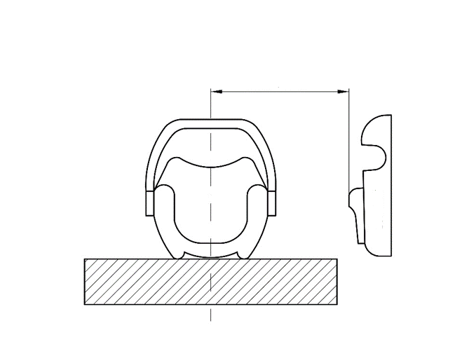

Minimum distance

Door Panel

(f) For frontal and rear impacts, the tests shall be performed with the Ehanced Child Restraint Systems adjusted to the size of the dummy(ies) selected to cover the entire size range, in the child seating position representing ~~the worst case for this dummy and impact orientation;~~ **the most upright position and the most reclined position for each dummy and impact orientation.**

**If not yet covered by the previous configurations, the Technical Service may test the Enhanced Child Restraint Systems in a position defined by the Technical Service that it fits in the Vehicle Seat Fixture.**

**(g)** **For frontal, rear and lateral tests** ~~An~~ **an** anti rebound device acting on the vehicle seatback shall stay inside the seat fixture in one position, but may protrude beyond the ~~seat fixture~~ **Vehicle Seat Fixture** in its adjusted position according to the user manual."

*Paragraph 7.1.3.5.2.2., Figure 6 (former),* renumber as Figure 7 and amend to read:

"7.1.3.5.2.2. …

Fit load cell 1 to the outboard position as shown Figure ~~6~~ **7**. Install the Enhanced Child Restraint System in the correct position. If a lock-off device is fitted to the Enhanced Child Restraint System and acts upon the diagonal belt, place load cell 2 at a convenient position behind the Enhanced Child Restraint System between the lock-off device and the buckle as shown above. If no lock-off device is fitted or if the lock-off device is fitted at the buckle, position the load cell at a convenient position between the pillar loop and the Enhanced Child Restraint System.

…"

*Paragraph 7.2.8*., amend to read:

"7.2.8. The complete seat, or the component fitted with ISOFIX attachments (e.g. ISOFIX base) if it has a release button, is attached rigidly to a test rig in such a way that ISOFIX connectors are vertically aligned as shown in Figure ~~3~~ **8**. A 6 mm diameter bar, 350 mm long, shall be attached to the ISOFIX connectors. A mass of 5 kg shall be attached to the extremities of the bar."

*Paragraph 7.2.8.5., Figure 7 (former),* renumber as Figure 8.

II. Justification

Paragraph 7.1.3. covers the test configurations that shall be used during the type approval process. This proposal clarifies the application of the dynamic test procedures for Enhanced Child Restraint Systems. It specifies the installation configurations to be tested and aims to clarify the tests conducted in a consistent way by Technical Services.

1. \* In accordance with the programme of work of the Inland Transport Committee for 2021 as outlined in proposed programme budget for 2021 (A/75/6 (Sect.20), para 20.51), the World Forum will develop, harmonize and update UN Regulations in order to enhance the performance of vehicles. The present document is submitted in conformity with that mandate. [↑](#footnote-ref-2)