This informal document is submitted by the Informal Working Group (IWG) Particle Measurement Programme to inform and update the GRPE of the work of the IWG on the proposals for solid particle number (SPN) measurements for the type approval of heavy-duty engines. The proposals have the following objectives:

* Modify the existing solid PN measurement methodology having a 50% cut-off size at 23 nm (SPN23) in order to allow the use of catalysed evaporation device in volatile particle remover (VPR) and introduce minor improvements
* Include as a second alternative option a solid PN measurement methodology with a 65% cut-off size at 10 nm (SPN10).
* Allow direct SPN sampling from the tailpipe with fixed dilution ratio.

This is an explanatory note accompanying the consolidated document addressing (i) the changes to the current SPN23 methodology, (ii) the proposed changes for the second alternative option to extend the particle size detection range to 10 nm particles, (iii) the proposed changes to allow direct SPN sampling with fixed dilution ratio.

________________________

## Purpose and summary of the SPN23 & SPN10 modifications

The submitted proposal aims mainly at introducing as an alternative option a solid particle number (SPN) measurement procedure with a cut-off size of approximately 10 nm (SPN10) differing in this from the existing procedure laid down in UNCE Reg. 49 which has a cut-off size at approximately 23 nm (SPN23).

The facts that the PN measurement methodology for the type approval of HD engines is not included in any GTR but only in Reg. 49 and that the post-Euro VI legislation is currently under discussion in Europe, led to the decision to present this proposal exclusively as a technical working document. Any decision on how and when this procedure may be integrated in a legislative act is left to GRPE.

This proposal stems from the evidence that CNG (compressed natural gas) fuelled engines may exhibit, in some cases, particle emissions close to the existing emission limit and at the same time a significantly high fraction of sub-23 nm particles [1,2]. In view of a possible extension of the particle number limit to all light-duty and heavy-duty combustion engines, the European Commission and other Contracting Parties had expressed the interest in a test procedure with a lower cut-off size in order to improve the control of particle emissions whatever the average size of the particles emitted. The PMP IWG concluded that it would be extremely challenging to develop a reliable particle counting methodology with a cut-off size of approximately below 10 nm while a cut-off size at approximately 10 nm would be achievable by properly adapting the existing methodology [3].

For this reason, the PMP IWG has worked to identify the necessary changes which would allow an increase of the size range of the particles counted, whilst maintaining an appropriate level of repeatability/reproducibility, and at the same time trying to reduce as much as possible the impact on the testing burden and on the measuring equipment required. The new proposed procedure has been assessed first by means of an inter-laboratory exercise with a light-duty vehicle that has involved several laboratories located in Europe and Asia. This exercise showed that the variability level of SPN10 results is at the same level as the SPN23 values. A dedicate inter-laboratory comparison exercise with heavy-duty engines confirmed the robustness of the SPN10 and that the variability remained at the same levels of the SPN23 variability, even though the sub-23 nm particles were up to 4 times higher than the >23 nm particles [2].

Since a few Contracting Parties have asked to maintain the existing methodology with the 50% cut-off size at 23 nm in the GTR15 for light duty vehicle, the same approach has been followed also in the proposal for HD engines. Both the changes to the existing methodology and the changes to extend the particle size detection range to 10 nm are summarized and explained in the Table 1 [4].

One of the most debated points in the PMP IWG concerned the volatile particle remover and more specifically whether for SPN10 this should be based on a catalytic stripper or whether also the usual evaporation tube should be allowed. The results of the light-duty inter-laboratory correlation exercise did not provide clear evidence that one solution is definitely better than the other. The heavy-duty inter-laboratory comparison exercise showed that there could be cases that the catalytic stripper was more efficient in removing the volatile particles (e.g. during regenerations) [2]. A review of methods removing volatiles concluded that the catalytic stripper was more efficient that the evaporation tube, especially when sulphuric acid was present in the exhaust [5]. For these reason it was decided to allow only the use of the catalytic stripper for SPN10. However, in order to maintain the possibility of using sampling systems designed for SPN10 also for SPN23 measurement, the IWG proposed to modify also the existing procedure by removing the restriction that the sampling system parts shall not react with the exhaust gas components. In this way a sampling system with a catalytic stripper fitted with a condensation particle counter with the proper calibration can be used for the SPN23 measurement. As supported by several experimental data, the different losses between catalytic stripper and evaporation tube become important only below 23 nm and therefore, allowing the use of both devices for SPN23, should not result in an increased variability of the measurements [6].

Table 1: Main changes to SPN23 and changes/additions for SPN10

|  |  |  |  |  |
| --- | --- | --- | --- | --- |
| **Subject** | **GTR 15, Annex 5 – Original requirements** | **Proposed changes for SPN23** | **Proposed changes for SPN10** | **Reasoning** |
| PNC efficiency | 50±12 % @ 23 nm, >90% @ 41nm | None | 65±15 % @ 10 nm, >90% @ 15nm | Typical PNC-efficiency, well tested in the field. |
| Maximum VPR-loss requirement | @ 30nm 30% and @ 50 nm 20% higher than @ 100 nm | None | Addition  @15 nm 100 % higher than at 100 nm | No additional requirement below 15 nm since generation of particles < 15 nm challenging, uncertainties high |
| Polydisperse validation of VPR | a polydisperse 50 nm aerosol may be used for validation | None | Removed | Uncertainties @ 15 nm or below high 🡪 test serves no purpose |
| VPR validation | > 99.0 % vaporization of 30 nm tetracontane particles, with an inlet concentration of ≥ 10,000 per cm³  **(Monodisperse)** | None | > 99.9 % removal efficiency of tetracontane particles with count median diameter > 50 nm and mass > 1 mg/m3.  **(Polydisperse)** | Secure the functioning of VPR also for PNC with 65±15 % @ 10 nm, >90% @ 15nm |
| Volatile Particle Remover (VPR) | All parts (of SPN-system) -- shall not react with exhaust gas components | -- VPR may be catalyzed (both heated evaporation tube and catalytic stripper allowed) | - the VPR shall be catalyzed (use of catalytic stripper only) | Minimize the risk of artefacts for SPN10. Comparability of PNC10 and PNC23 and possibility of using new sampling systems with CS also for SPN23 by fitting a PNC with a D50 @ 23 nm. |

A specific technical issue stemmed from the concern that to certify an engine for two different regions applying different SPN limits (i.e. SPN10 and SPN23) either two different instruments or double testing might be required. This would lead in any case to increased testing costs and burden. Both those situations might be avoided if a test performed using the SPN10 measurement procedure could also cover the SPN23 nm test.

In principle measuring SPN10 should result in higher PN values and therefore if the SPN23 limit is met it can be concluded that the same limit would be more easily met when using the SPN23 procedure (see picture below). The PMP IWG believes that this option is acceptable if any party would like to implement it.

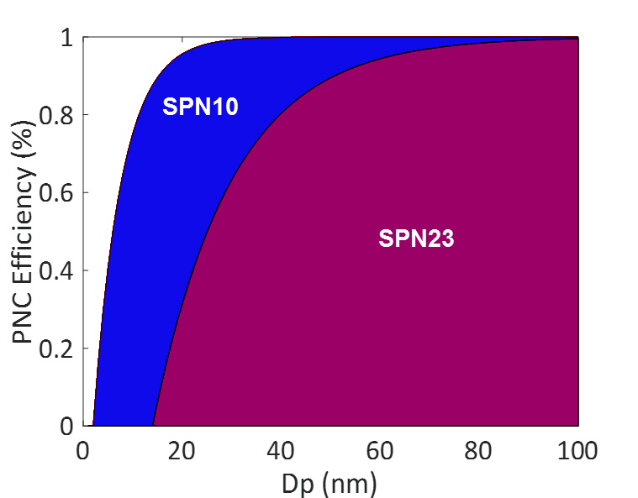

As explained above, the proposed amendment does not just contain a second option for SPN10 measurement, but also includes a number of corrections/improvements to the existing and the proposed methodology.

The proposed changes can be found at GRPE-XX-YY.

## Purpose and summary of the direct SPN tailpipe measurements with fixed dilution option

The submitted proposal aims mainly at introducing as an alternative option measuring solid particle number (SPN) directly from the tailpipe with fixed dilution, in addition to the currently allowed options of measuring from a proportional partial flow system or the full dilution tunnel.

The facts that the PN measurement methodology for the type approval of HD engines is not included in any GTR but only in Reg. 49 and that the post-Euro VI legislation is currently under discussion in Europe, led to the decision to present this proposal exclusively as a technical working document. Any decision on how and when this procedure may be integrated in a legislative act is left to GRPE.

This amendment stems from the need of simpler procedures that need less space and do not require the use of a partial or full flow dilution system. Direct tailpipe sampling of gaseous pollutants is allowed in the heavy-duty engines regulations, thus permitting SPN measurements is a natural consequence. Particles however can be lost or transformed in the sampling lines, thus special attention is needed for the sampling conditions. Based on the experience with light-duty SPN measurements from the tailpipe [7], portable emission measurement systems for light-duty [8,9] and heavy-duty vehicles [10], it was assumed that SPN measurements directly from the tailpipe with fixed dilution would be feasible for type approval of heavy-duty engines. The two possible approaches are: Direct hot dilution with existing PMP systems or use of a cold pre-diluter, both with fixed dilution ratio.

An inter-laboratory exercise was conducted, where a “Golden” system measuring directly from the tailpipe with “hot” (150°C) fixed dilution was compared with the laboratory regulated systems. The results of the “Golden” instruments were within 25% in most cases, reaching 40% in two laboratories for both >23 nm and >10 nm. The repeatability of the measurements (10% to 40%) remained the same for both systems with both cut-off sizes. Another system measuring from the tailpipe with a fixed “cold” (at ambient temperature) dilution gave differences of up to 50% in most cases (on average +26%). Dedicated tests with this system showed that the differences were the same with fixed or proportional dilution, indicating that it is not the concept that resulted in the overestimation, but the calibration of the system [2].

Table 2 summarises the major additions for the new option of direct SPN sampling from the tailpipe with fixed dilution. The major was the technical requirements for the “cold” pre-diluter, whenever used.

Table 2: Main additions the procedure laid down in Reg. 49 for direct SPN sampling

|  |  |  |
| --- | --- | --- |
| **Subject** | **Proposed changes for direct SPN sampling with fixed dilution ratio** | **Reasoning** |
| Pre-diluter | A cold or hot pre-diluter may be located at the end of the particle sampling probe and in front of the PTT. A fixed dilution ratio >5:1 shall be applied to the cold or hot dilution stage. Cold dilution is defined as a dilution with (unheated) dilution air and/or diluter temperature ≥20°C. | Cold dilution similar to proportional partial flow system’s should be acceptable |
| Losses | The penetration for each model (definition in A.8.1.2.5) of pre-diluter shall be determined as described in A.8.1.3.3.7 The final system penetration (pre-diluter and VPR) shall fulfil the requirements of A.8.1.3.3.6.  The particle concentration reduction factors of each pre-diluter shall be determined as described in A.8.2.2.2. The complete system (pre-diluter and VPR) shall fulfil the requirements of A.8.1.3.3.4. | The pre-diluter needs to be characterised |
| Sampling line | When sampling directly from the tailpipe the residence time until the pre-diluter or the VPR shall be ≤ 1 seconds. The tubing shall be heated at ≥150°C if >10 cm, otherwise only insulated. Any unheated parts shall be <10 cm. | Reduced residence time, hot sampling line to avoid condensation and minimise particle losses |

Examples of different SPN sampling configurations:

From full dilution tunnel From proportional partial flow system

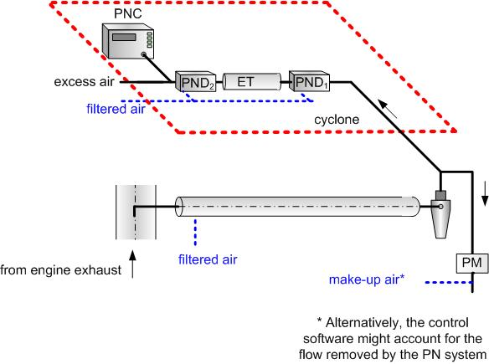 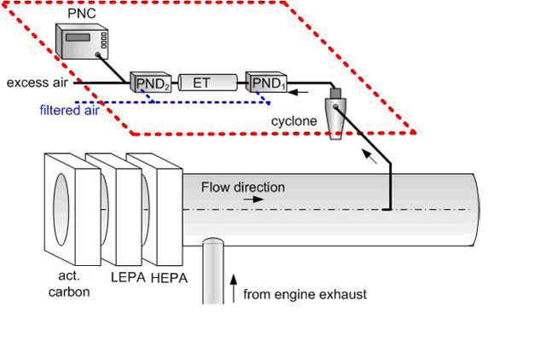

Directly from the tailpipe (hot dilution) Directly from the tailpipe via cold pre-diluter



References

1. Giechaskiel, B. Solid Particle Number Emission Factors of Euro VI Heavy-Duty Vehicles on the Road and in the Laboratory. *IJERPH* **2018**, *15*, 304, doi:10.3390/ijerph15020304.

2. Giechaskiel, B.; Lähde, T.; Schwelberger, M.; Kleinbach, T.; Roske, H.; Teti, E.; van den Bos, T.; Neils, P.; Delacroix, C.; Jakobsson, T.; et al. Particle Number Measurements Directly from the Tailpipe for Type Approval of Heavy-Duty Engines. *Applied Sciences* **2019**, *9*, 4418, doi:10.3390/app9204418.

3. Giechaskiel, B.; Martini, G. Engine Exhaust Solid Sub-23 Nm Particles: Ii. Feasibility Study for Particle Number Measurement Systems. *SAE International Journal of Fuels and Lubricants* **2014**, *7*, 935–949, doi:10.4271/2014-01-2832.

4. Lahde, T.; Giechaskiel, B.; Martini, G. Development of Measurement Methodology for Sub 23 Nm Particle Number (PN) Measurements.; SAE International: Virtual, 2020; pp. 2020-01–2211.

5. Giechaskiel, B.; Melas, A.D.; Lähde, T.; Martini, G. Non-Volatile Particle Number Emission Measurements with Catalytic Strippers: A Review. *Vehicles* **2020**, *2*, 342–364, doi:10.3390/vehicles2020019.

6. Giechaskiel, B.; Woodburn, J.; Szczotka, A.; Bielaczyc, P. Particulate Matter (PM) Emissions of Euro 5 and Euro 6 Vehicles Using Systems with Evaporation Tube or Catalytic Stripper and 23 Nm or 10 Nm Counters.; September 15 2020; pp. 2020-01–2203.

7. Giechaskiel, B.; Lähde, T.; Drossinos, Y. Regulating Particle Number Measurements from the Tailpipe of Light-Duty Vehicles: The next Step? *Environmental Research* **2019**, *172*, 1–9, doi:10.1016/j.envres.2019.02.006.

8. Giechaskiel, B.; Mamakos, A.; Woodburn, J.; Szczotka, A.; Bielaczyc, P. Evaluation of a 10 Nm Particle Number Portable Emissions Measurement System (PEMS). *Sensors* **2019**, *19*, 5531, doi:10.3390/s19245531.

9. Giechaskiel, B.; Lähde, T.; Gandi, S.; Keller, S.; Kreutziger, P.; Mamakos, A. Assessment of 10-Nm Particle Number (PN) Portable Emissions Measurement Systems (PEMS) for Future Regulations. *IJERPH* **2020**, *17*, 3878, doi:10.3390/ijerph17113878.

10. Giechaskiel, B.; Schwelberger, M.; Delacroix, C.; Marchetti, M.; Feijen, M.; Prieger, K.; Andersson, S.; Karlsson, H.L. Experimental Assessment of Solid Particle Number Portable Emissions Measurement Systems (PEMS) for Heavy-Duty Vehicles Applications. *Journal of Aerosol Science* **2018**, *123*, 161–170, doi:10.1016/j.jaerosci.2018.06.014.